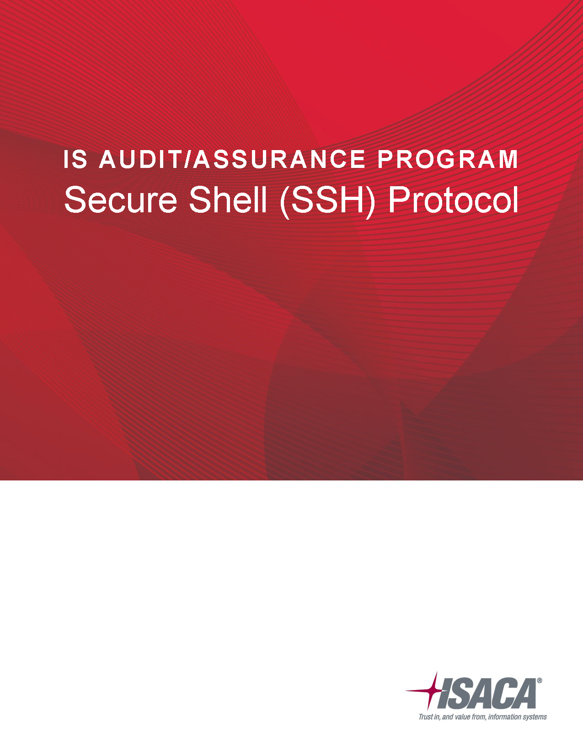
Table of Contents
IS Audit/Assurance Program for Secure Shell (SSH) Protocol 3
Audit Subject: Secure Shell (SSH) Protocol 3
Audit Objectives 3
Audit Scope 3
Business Impact and Risk 4
Minimum Audit Skills 4
Testing Steps 4
Acknowledgments 6

Note: The audit program worksheet is provided in a separate file.

IS Audit/Assurance Program for Secure Shell (SSH) Protocol

Audit Subject: Secure Shell (SSH) Protocol
When early network protocols were designed, most users were part of private networks in industries like government research or academia. In these environments, network protocols like Telnet could transmit in plain text without raising significant security concerns because transmission was over private networks.
As the use of public networks increased, so did concerns over privacy and security, because transmission in plain text was not practical. The Secure Shell (SSH) protocol was developed to connect remote servers and clients more securely using encryption, authentication and other security mechanisms. While SSH offers strong security that other network protocols do not, it nevertheless requires continuous monitoring and periodic review. IT auditors may want to review the following areas, among others:
- Policies and procedures
- Configuration
- Access management
- Key management

Audit Objectives
This audit program is designed to assess the following objectives.
- Configuration of SSH aligns with the enterprise’s SSH strategy and protocols.
- Policies and practices have been drafted and implemented to ensure strong controls that:
  - prohibit users from sharing private keys,
  - require key rotation and
  - require continuous monitoring.
- Access to production environments, backup servers and high availability (HA) clusters is available only to appropriately authorized users.
- Users have the minimum level of access necessary to meet stated business needs.
- Processes exist to disable access when users transfer within the enterprise or leave the enterprise.
- Authentication and key management procedures are sufficient to detect unauthorized access, misconfigured keys and other vulnerabilities.

Audit Scope
This audit program applies to all servers and clients running SSH as well as any compliance initiatives that rely on SSH. For example, the Payment Card Industry Data Security Standard (PCI DSS) mandates that only authorized users can access cardholder-data environments. Therefore, if an enterprise relies on SSH to comply with PCI DSS, the enterprise’s SSH audit should cover user and server authentication for all environments in scope for PCI DSS.

Business Impact and Risk
SSH provides a secure means of connecting remote servers to clients, but it is not without challenges. For example, both IT administrators and developers use SSH keys. Administrators may need to configure sensitive network devices; developers often need to promote code from test environments to production environments. If duties are appropriately segregated, the fact that both IT administrators and developers authenticate via SSH keys should not constitute significant risk.
The possibility that SSH keys may be mismanaged, however, can introduce risk. For example, enterprises may fail to identify appropriate resources for managing SSH keys and/or fail to monitor the propagation of keys. If a malicious party gains access to the keys, that party may be able to perform the same functions as IT administrators and/or developers. The enterprise’s risk profile then expands to include misappropriation of data and/or compromise of data integrity.

Minimum Audit Skills
The Secure Shell (SSH) protocol audit program assumes that auditors exercise due professional care and possess professional competencies culminating in the proficiency to conduct an audit. ITAF Standard 1005 and ITAC Guideline 2005 (Due Professional Care) require the auditor to exercise professional skepticism and maintain effective communication throughout the course of an audit. ITAF Standard 1006 and ITAF Guideline 2006 (Proficiency) require the auditor to have technical skill, knowledge and/or experience in the areas under assessment (which in this case includes implementation and management of the SSH protocol). This expectation is particularly relevant to auditors who do not hold the CISA or other appropriate designation.

Testing Steps
Refer to the accompanying spreadsheet file.

About ISACA
ISACA® (isaca.org) helps professionals around the globe realize the positive potential of technology in an evolving digital world. By offering industry-leading knowledge, standards, credentialing and education, ISACA enables professionals to apply technology in ways that instill confidence, address threats, drive innovation and create positive momentum for their organizations. Established in 1969, ISACA is a global association serving more than 500,000 engaged professionals in 188 countries. ISACA is the creator of the COBIT® framework, which helps organizations effectively govern and manage their information and technology. Through its Cybersecurity Nexus™ (CSX), ISACA helps organizations develop skilled cyber workforces and enables individuals to grow and advance their cyber careers.
Disclaimer
ISACA has designed and created the IS Audit/Assurance Program for Secure Shell (SSH) Protocol (the “Work”) primarily as an educational resource for IS audit professionals. ISACA makes no claim that use of any of the Work will assure a successful outcome. The Work should not be considered inclusive of all proper information, procedures and tests or exclusive of other information, procedures and tests that are reasonably directed to obtaining the same results. In determining the propriety of any specific information, procedure or test, IS audit professionals should apply their own professional judgment to the specific circumstances presented by the systems or information technology environment.
Reservation of Rights
© 2017 ISACA. All rights reserved. No part of this publication may be used, copied, reproduced, modified, distributed, displayed, stored in a retrieval system or transmitted in any form by any means (electronic, mechanical, photocopying, recording or otherwise) without the prior written authorization of ISACA.

Acknowledgments
Lead Developer
Justin Leapline, CISA, CEH, CISSP, USA
Expert Reviewers
Cory Missimore, CISM, CISSP, USA
Mayank Garg, CISA, CISM, CSX, USA
Narasimha Raju Chakravaram, CEH, India
Board of Directors
Theresa Grafenstine, CISA, CRISC, CGEIT, CGAP, CGMA, CIA, CISSP, CPA, U.S. House of Representatives, USA, Chair
Robert Clyde, CISM, Clyde Consulting LLC, USA, Vice-Chair
Brennan Baybeck, CISA, CRISC, CISM, CISSP, Oracle Corporation, USA, Director
Zubin Hagar, CISA, CISM, PMP, Amazon Web Services, UK, Director
Peter Christiaans, CISA, CRISC, CISM, PMP, Deloitte Consulting LLP, USA, Director
Hironori Goth, CISA, CRISC, CISM, CGEIT, ABCP, Five-I, LLC, Japan, Director
Mike Hughes, CISA, CRISC, CGEIT, Haines Watts, UK, Director
Leonard Ong, CISA, CRISC, CISM, CGEIT, CPP, CFE, PMP, CIPM, CIPT, CISSP ISSMP-ISSAP, CSSLP, CITBCM, GCIA, GCIH, GSNA, GCFA, Merck & Co., Inc., Singapore, Director
R.V. Raghu, CISA, CRISC, Versatilist Consulting India Pvt. Ltd., India, Director
Jo Stewart-Rattray, CISA, CRISC, CISM, CGEIT, FACS CP, BRM Huldah, Australia, Director
Ted Wolff, CISA, Vanguard, Inc., USA, Director
Tichaona Zororo, CISA, CRISC, CISM, CGEIT, COBIT 5 Certified Assessor, CIA, CRMA, EGIT | Enterprise Governance of IT (Pty) Ltd, South Africa, Director
Christos K. Dimitriadis, Ph.D., CISA, CRISC, CISM, Intralot, S.A., Greece, Past Chair
Robert E Stroud, CRISC, CGEIT, Forrester Research, Inc., USA, Past Chair
Tony Hayes, CGEIT, AFCHSE, CHE, FACS, FCPA, FIIA, Queensland Government, Australia, Past Chair
Matt Loeb, CGEIT, FASAE, CAE, ISACA, USA, Director

