Open HYSPLIT program
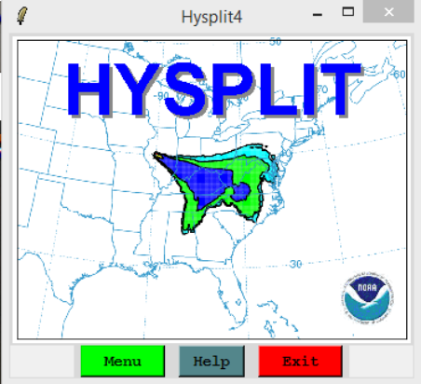
Go to menu

Go to Trajectory – trajectory setup
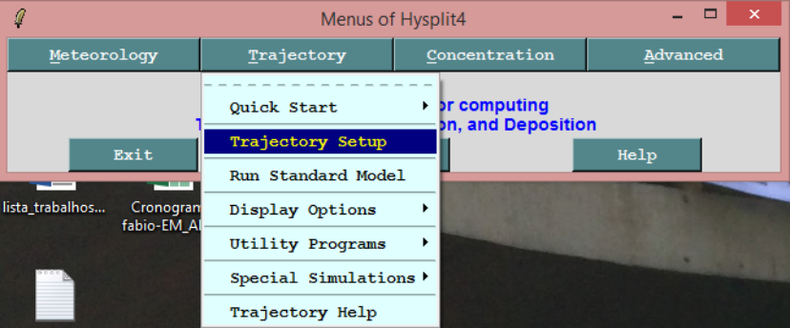

Set starting location with Lat, Long and altitude of interest
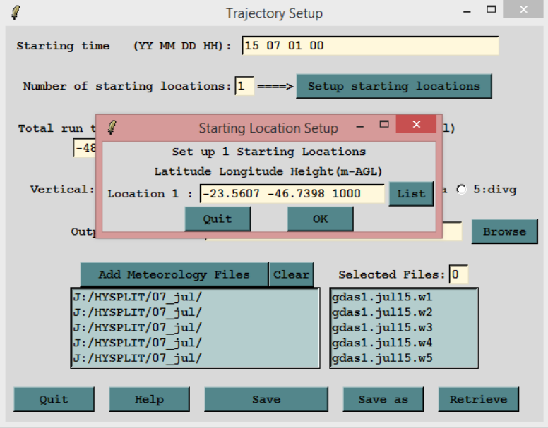

Also setup the Date and time, number of starting location (just one), Direction of trajectories (backward or forward), total run time, and add the files of one month, and on month back or ahead (it depends of the direction of the trajectories.

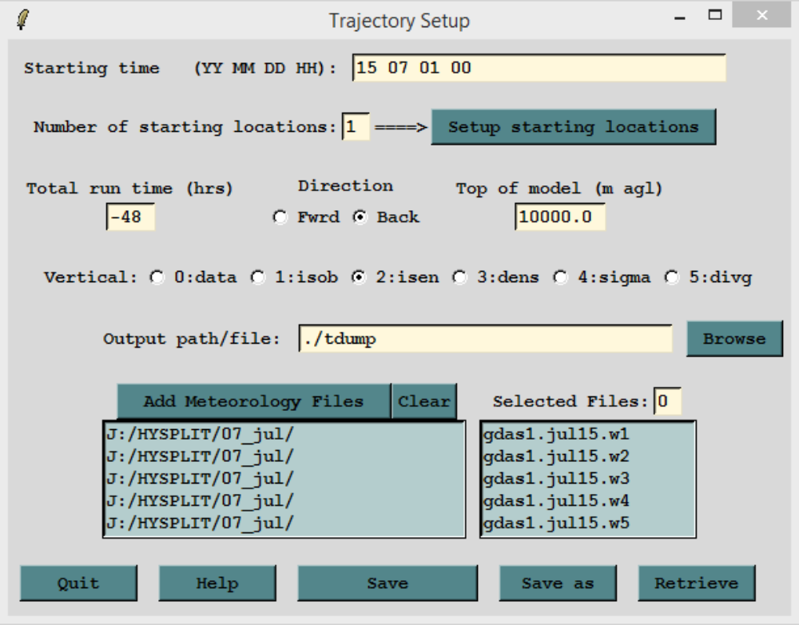
Example: if you want to analyze the backward trajectories cluster for the whole month of July of 2015, include the all the July-2015 data and June-2015 data also.

Click save and go to Run Standard Model just to check if the program is running properly
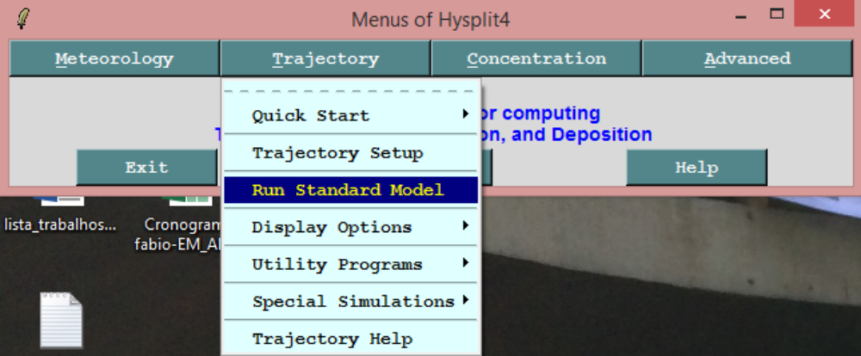

Go to Display Options – Trajectories e click em execute display
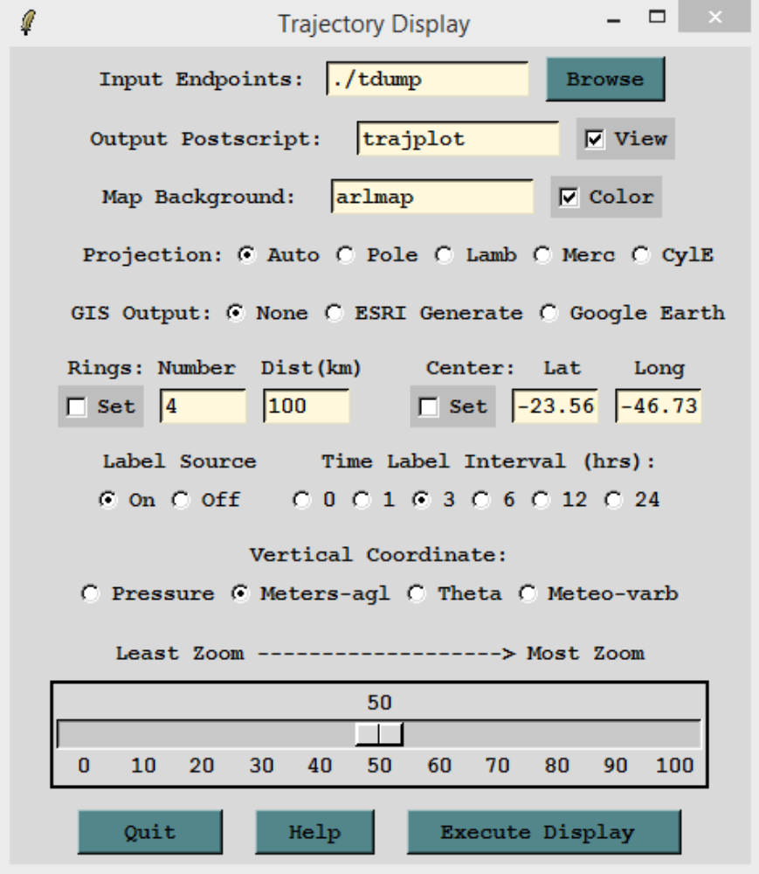

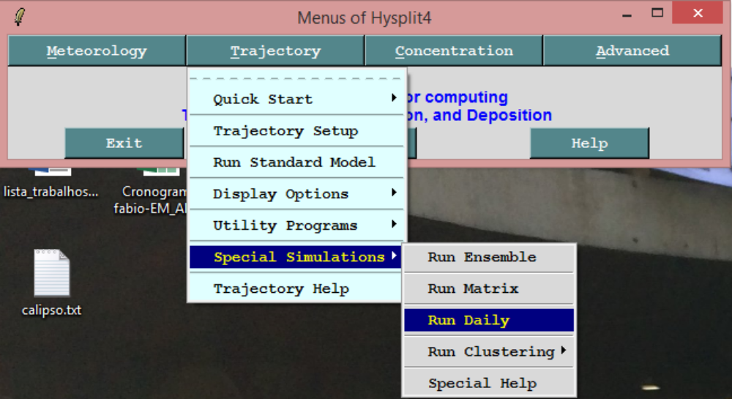
Once it was tested and generated the graphics go to Trajectory – special simulations – Run daily
Put date interval to execute script and the Delta of hours (0, 6, 12 and 18) and execute script

Files will be saved at folder working with name tdumpYYMMDDHH

Move these files to folder hysplit4\cluster\endpts

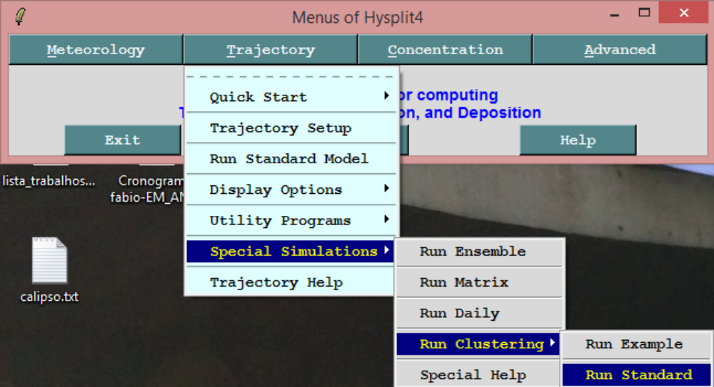
Go to Trajectory -> Special Simulations -> Run Clustering -> and Run standard

STEP 1
Put the hours to cluster as choose before (in this example it was 24 hours)
Time interval and Trajectory skip (I use 1 for both)

STEP 2
Run the cluster program
- Make infile
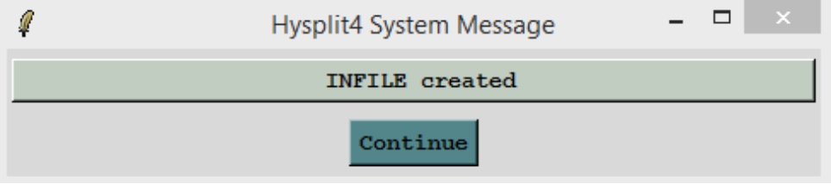

- Run cluster
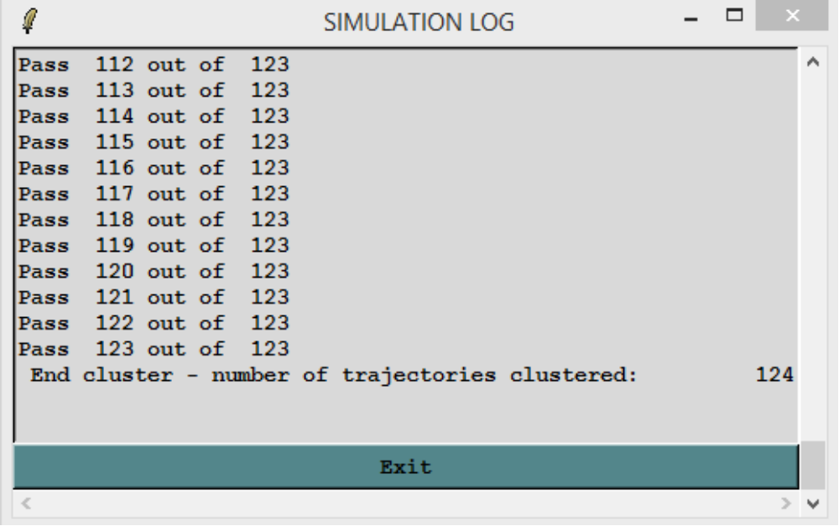

- Click in display plot
- In this graphic, choose number before the different clusters are combined. Before large increase in TSV shows up.
- Use this number on the filed Number of Clusters
  - In this example we use 8 as number of clusters
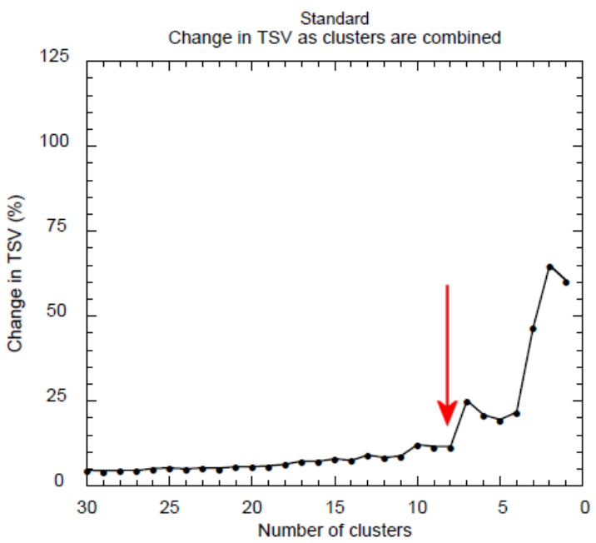

- We also use in the example
  - 24 hours backward trajectories
  - 1 as time interval
  - 1 as trajectory skip
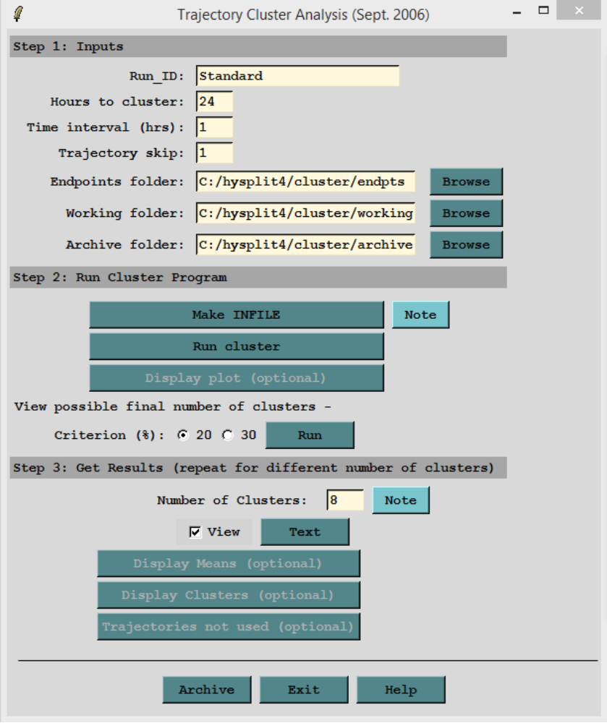

After put the number of clusters click in Text buton
Click in Display means button and it will be open a window Trajectory Cluster Display

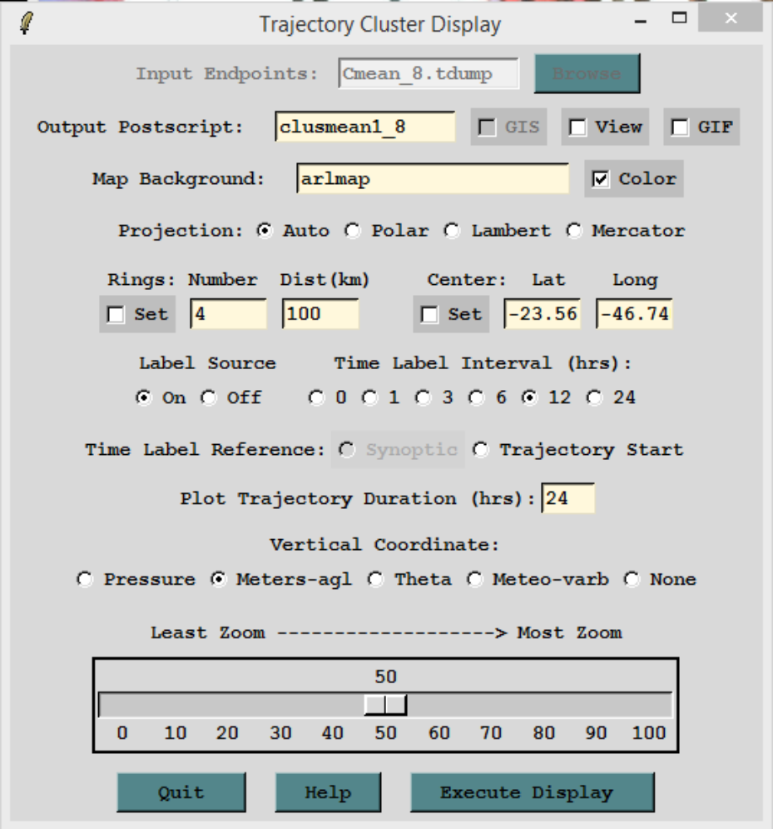

Click in Execute Display button – it will be create the mean clusters trajectories
Close the window and click in the button Display Clusters
Click in Execute Display in the window that will be open – it will be create all the 8 clusters trajectories
After all click in Archive for all files to be archive in the following folder hysplit4\cluster\archive

