Contents

Authentication 2

Menu 3

Homescreen 3

Roles 4

Users 6

Machines 7

Authorizations 9

Maintenance 11

Interventions 12

Usage history 13

Machine types 14

System page 15

Excel export 16

Technical details 16

TODO/MISSING 16

# Authentication

The default page is a login page and all other site pages requires a logged-on user.

Only users with email address and rôle « Can Admin backend » flag can log on.

Default user at install is :

* Login : [admin@fablab.org](mailto:admin@fablab.org)
* Password : admin

In case an admin forgets the email, the forgot password will send an email with a unique link valid for 20 minutes to reset the password.

# Menu

This is the view for logged users :



By clicking on FABLAB you reach the homescreen.

# Homescreen

The homescreen presents a real-time view of the various machines.

Status description :

* IN USE = there is an opened use record (manual or automatic) on this machine
* BLOCKED = the machine has been flagged « BLOCKED FOR ALL »
* OFFLINE = the RFID has not contacted the backend for more than 3 minutes
* MAINTENANCE = the machine is free but requires maintenance intervention based on the plan
* FREE = the machine is idle and waiting for users

# Roles

This is to configure user priviledge levels.

## View

Maintenance = The user can perform maintenance by tapping the card on machine board

Authorize all = User can use any machine in any state. This also bypasses the authorization. This can be useful in an initial phase where all fablab users can use any machine in any state.

Backend admin = User can logon to the backend web interface with its email address. On first access, he needs to receive first a new password by an admin with the Users page.

Reserved = Roles that cannot be deleted.

## Add new role

See Roles page for flag description.

## Edit existing role

# Users

Users are identified by their RFID card ID. There is no strong authentication of RFID cards in the Arduino board, only chip ID read.

## View

This page shows the users and unrecognized RFID tags, and allows several actions:

* Adding new users, editing/disabling them. A disabled user cannot perform any action on the machines, but can still logon to the interface
* Deleting users. In this case the user cannot logon to the webbackend.
* Convert a badge to a new user: this is mainly to simplify the initial database creation where the fablab users may not be registered. Once the user is created, the corresponding rejected RFID card records will be purged.

## Edit existing user

This allows to change user rôle, name, email or card UUID.

## Add new user

This page is reached by « Add User » button or « Convert to new user » button on the main page.

Please note :

* Card UUID is displayed on the arduino LCD when tapping an unknown card.
* When converting a unknown card, the Card UUID field is automatically filled

# Machines

This is the list of machines. Every machine has a unique ID. The Arduino Board is uniquely linked to a machine thanks to the ID field.

## View machines

Description :

* Cumulated usage : hours of power on by users. This is not reset.
* Maintenance plan : list of maintenance procedures to be applied to the machine
* Last seen : when an arduino board has last trasmitted the status of the machine.

View History button : view the latest uses of the machine

## Edit machine

Allows to change machine attributes. The machine name is acquired by the arduino board every minute in case of changes.

Blocked for all : this blocks any user to log on the machine except for user having « authorize all » rôle priviledge.

## Add machine

Same as Edit Screen.

# Authorizations

Authorizations maps users to machines. If a user belongs to a rôle with «Authorize all », the authorizations list is ignored. This can be useful if the FabLab does not want to implement authorization for fab users.

## View authorizations

The list of authorization by machine and users can be filtered.

Description :

* Add Authorization : to add a record for a single user on a single machine
* Add in buil : to quickly add authorizations for many users on a single machine

## Add authorization

## Edit authorization

Add in bulk

Use this screen to add permissions. To remove permissions, you have to use the main screen Delete button.

First select the machine, then the users or the « Add all users.. » button.

# Maintenance

This is for regular maintenance which shall be triggered every X hours of use.

## View

## Edit

## Add new maintenance

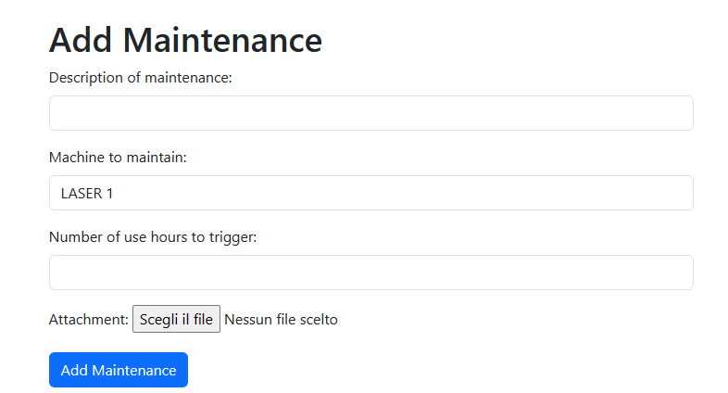

# Interventions

## View

## Add manually

Interventions will be created automatically by tapping the card on the machine board, but can be added manually if the maintenance was done ofline.

## Edit interventions

# Usage history

## View

This page shows the latest uses of all machines (up to 500 records).

If a machine is in use, row is highlighted :

Manual registration

This allows to register a specific use of a machine by one user, e.g. for machine hours tracking.

# Machine types

## View

Description :

* Auto logoff delay : if a user remains active more than X minutes on the machine, the arduino board will log him off. When set to 0, there is no log-off.
* Power-off : when no user is connected, the machine will be powered off after this grace period. If 0, the command relay is closed immediately at logoff. The goal of this feature is to reduce power cycles on the target equipment.

## Add/Edit page

# System page

This page provides an overview of the host backend server, maintenance helpers, and lists the boards which have announced themselves on MQTT brocker.

Database :

* This allows to download SQLite3 database for backups.

System info

* Displays system nature (in this example, a Raspberry Pi Zero)

Application info

* Checks the latest version on pypi repository (requires internet access)
* Update application button runs pip –upgrade
* Restart application runs systemctl restart

Board list :

* ID : unique ID set by the system, meaningless
* Machine ID : the board announces the MachineID it wants to handle.
* IP Address : IP of the board connected to the machine. Useful for OTA upgrades
* FW version : git version of the firmware announced by the board
* Last seen : when did the board announced itself for the last time. Announcements are indipendent of other boards messages.

# Excel export

On most pages, an Excel export button is available, which exports the underlying SQLite tables.

# Technical details

* <https://github.com/fablab-bergamo/rfid-backend>
* Flask python application + MQTT client

# TODO/MISSING

* PDF upload for maintenance procedures