https://circuitjournal.com/50kg-load-cells-with-HX711

Using Two Load Cells in a Single Circuit.
2 x 50kg (100 kg / 220 lbs).
You can connect two cells side-by-side to forms a single scale unit:
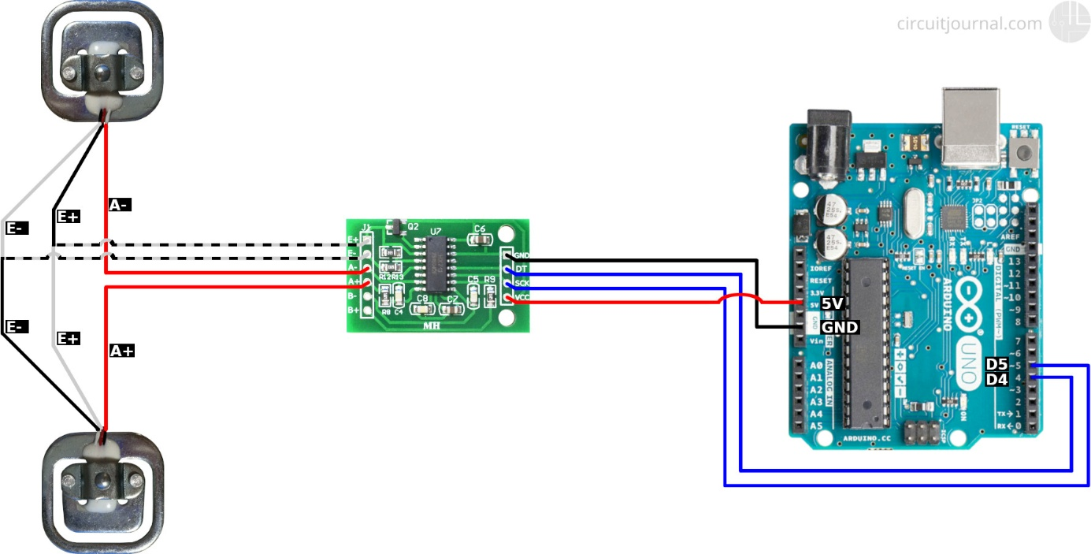
1. Connect the opposite sides of the outer wires (white and black) of the two load cells.
Validate your wiring by measuring the resistance between the two connection points of the white-back wires pairs. It should be about 1k ohm.
Then measure the resistance between the two red wires. It should also be about 1k ohm
2. Connect the outer wire pairs to E+ and E- output of the HX711 module.
One white-black pair goes to the E+ and the other black-white pair to the E-.
E+ and E- are the power wires for the cells. The polarity doesn't matter. Switching will only invert the calibration parameter in the software.
3. Connect the middle wires (red) of the load cells to the A+ and A- inputs of the HX711 module.
A+ and A- are the measurement inputs from the cells. Like with the power wires, the polarity is not important.
4. Connect the GND of the HX711 module to the Arduino GND and VCC to the Arduino 5V pin.
HX711 also works with 3.3V. So if you have some other microcontroller that runs on 3.3V, then you can use 3.3V instead of 5V.
6. Connect the DT and SCK of the HX711 module to any of the Arduino digital IO pins.
In the schematic, I used pins 4 and 5, since those are the default pins for the examples of the "HX711_ADC" library.
If you want to use interrupts to update scale data, then you should connect the DT output to an interrupt enabled pin of the Arduino. For Uno/Nano, those are pins 2 and 3.

Arduino Code to Read Weight Value from the HX711 Module.
1. Download the "HX711_ADC" library:
https://github.com/olkal/HX711_ADC
Click on the green "Clone or download" button and then "Download ZIP."
Extract the downloaded ZIP file and move it into your Arduino "libraries" folder.
On Windows:
C:\Users\<username>\Documents\Arduino\libraries
On Mac:
/Users/<username>/Documents/Arduino/libraries
2. Open the Calibration example that came with the "HX711_ADC" library.
Open Arduino IDE and then from the menu:
File->Examples->HX711_ADC->Calibration
3. Load the example code to your Arduino.
It should work without any modifications if you connected the DT output of the HX711 module to the Arduino pin 4, and SCK to the Arduino pin 5.
3. Open the Arduino Serial Monitor.
Follow the directions in the terminal window. It asks you to put a known mass onto the load cells and then enter the weight of that item. This process calibrates your scale.
Then it starts outputting the current weight value on the scale.

