Seeeduino Test Plan

- Product Profile
The SeeedProduct v4 is a micro-controller board based on the ATmega328, and it's an Arduino compatible board. It has a ATMEL 16U2 USB-to-serial driver chip which can be regarded as a bridge, let your computer can communicate with the board. It has 14 digit pins (which include 6 PWM pins and UART port) and 8 analog pins, a 16 MHz ceramic resonator, a USB connection, a reset button, an ICSP header and a DC power jack. It has A toggle switches for input voltage change of ATmega328. It also has two white Grove connectors, and make it convenient for using Grove products with the board.
- General test procedure
- Flash bootloader to verify IC and solder
- Flash firmware forAtmel 16u2
- Upload test program to verify IO, USB interface, 5v/3v3 voltage and LED
- Press reset button to verify reset function

- Tools
items | Device and tools | Qty | Comment
1 | Computer | 1 | Running Windows system
2 | Mini USB Cable | 1
3 | test fixture | 1
4 | 12v DC power | 1
5 | AVRISP MKII | 1

items | Software tools | description
1 | Xloader | Uploading Arduino HEX files
2 | zadig | install generic USB drivers

- Program files
- Seeeduino_328_bootloader.bat
- Seeeduino _16u2_firmware.bat
- Seeeduino _4_0_test_code_v1_0.hex
- Procedure
  - Flashing procedure
- Connect flash Programmer (AVRISP MKII) to PC.
- Run zadig, Device to AVRISP MKII
- Replace Driver to libusb-win32
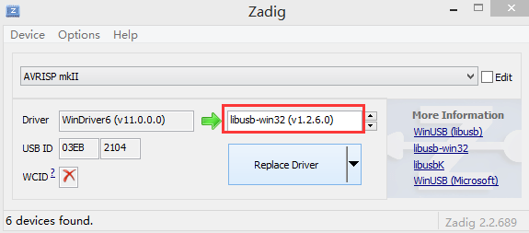

- Power on Seeeduino and Connect it to AVRISP MKII through 6pin ICSP interface， the two green led will be turn on.
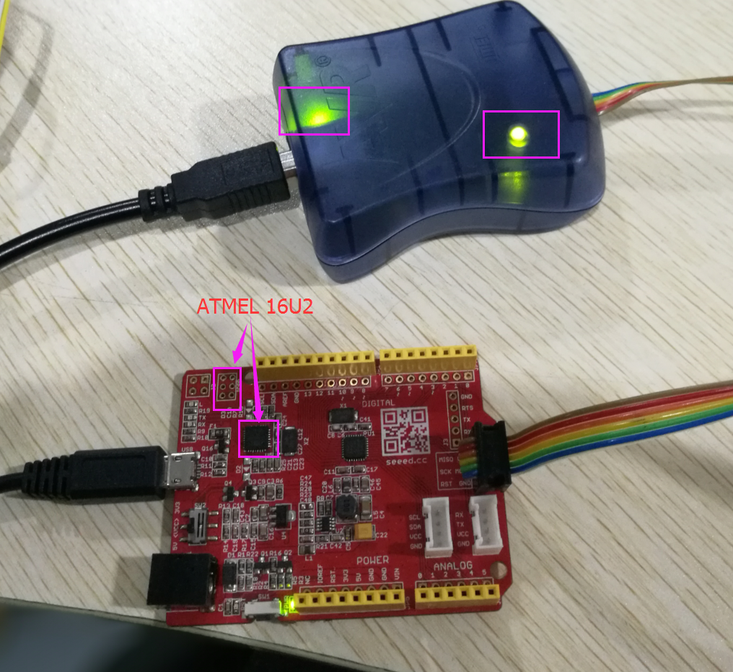
- Run Seeeduino_328_bootloader.bat , if the computer show like this , it means program ok.
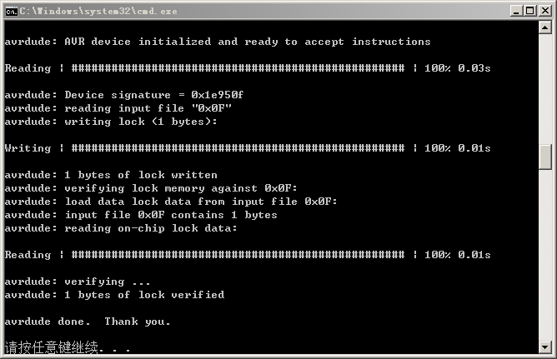
- Connect AVRISP MKII to the ICSP connecter beside the Atmel 16U2
- run Seeeduino_16u2_firmware.bat，if the computer show like this , it means program ok.
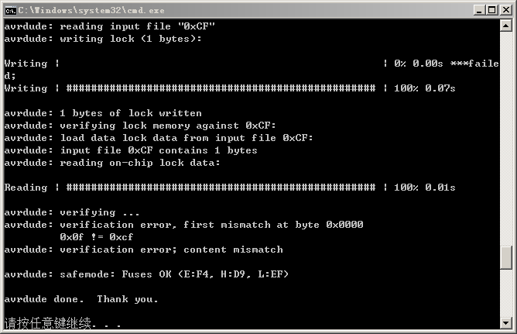

- Toggle switch to 5V. And connect Seeeduino to PC using a micro USB cable.
- Run Xloader and upload test code
Seeeduino_4_0_test_code_v1_0.hex.You can see below picture after upload, the RX/TX LED blink faster than before and make sure instructions window show”5890 bytes upload”
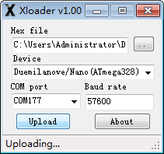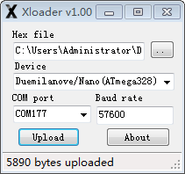
- Connect 12v DC power to the power interface of fixture.
- Toggle switch to 3V3, place Seeeduino to test fixture and depressed wrench.
- Press RESET button repeatedly. The red RST LED should turn off and then turn back on and blink every time.
- The green LED of test fixture light up indicates test passed.

