External Design Document (EDD)
Project: Pastel Planner – Sprint 1 Release
Student: Francesca Mpolomena (301419292)
Student: Surya Anthode Sreekumar
Instructor: Blessing Ajiboye
Course: COMP229 – Web Application Development

1. Project Overview
Pastel Planner is a React + Node.js planning app prototype with a pastel-themed UI.
Sprint 1 focuses on UI development, Express server setup, automated testing (Jest & Cypress),
performance auditing (Lighthouse), and Agile project tracking.

2. System Architecture
Frontend:
- React (Vite)
- Material UI
- Jest + React Testing Library
Backend:
- Node.js
- Express
- No database functionality is implemented in this release.
Testing Tools:
- Jest (unit & snapshot)
- Cypress (E2E automated testing)
- Lighthouse (performance audit)

3. UI Design Description
The Home Page uses pastel colors including navy, pink, lavender, and mint.
Material UI components create a soft, clean interface.
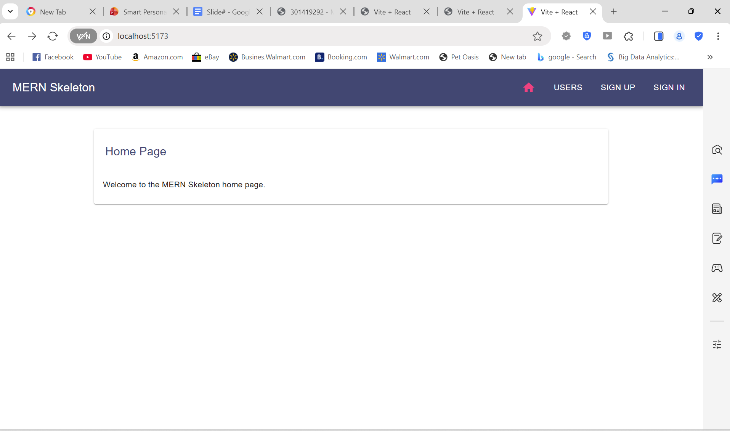

4. Testing Summary
Jest Testing
- Verifies component rendering
- Snapshot test ensures UI consistency
- All tests passed
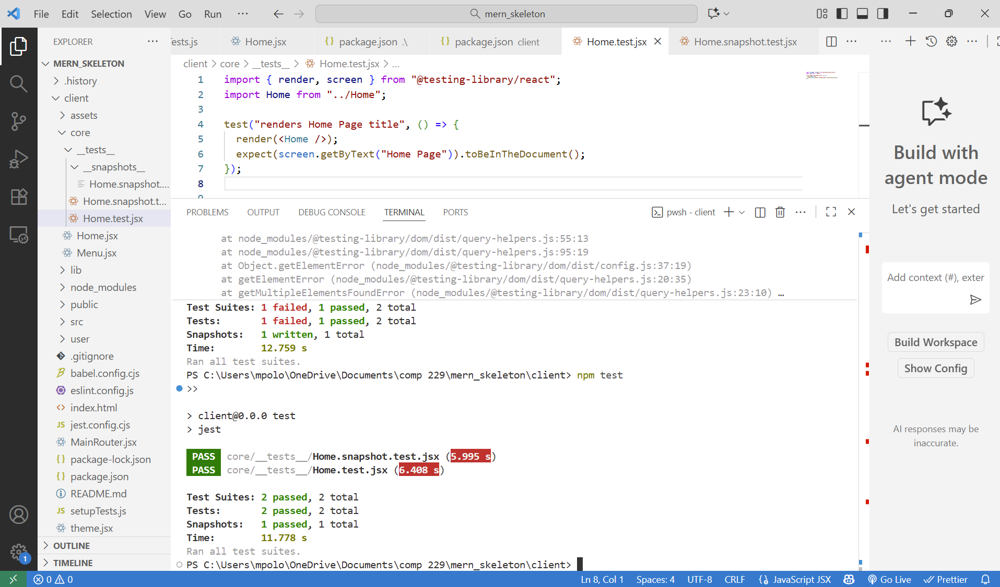
Cypress Testing
- Confirms Home Page loads and displays title text
- E2E test passed successfully
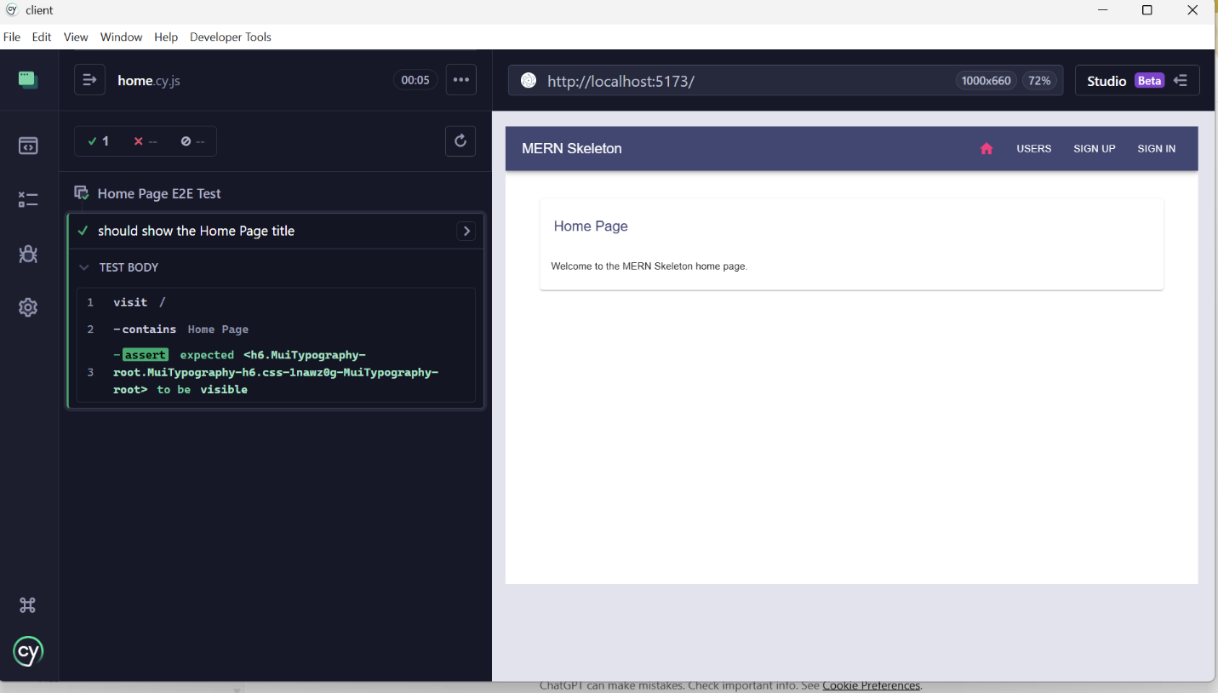
Lighthouse Performance Audit
- Evaluates performance, accessibility, SEO, best practices
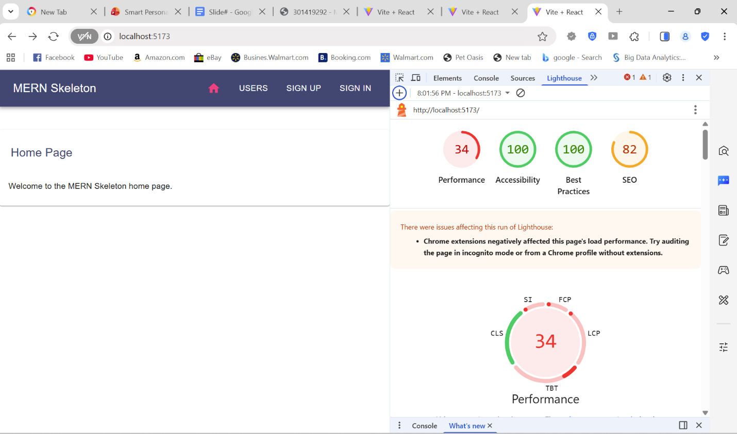
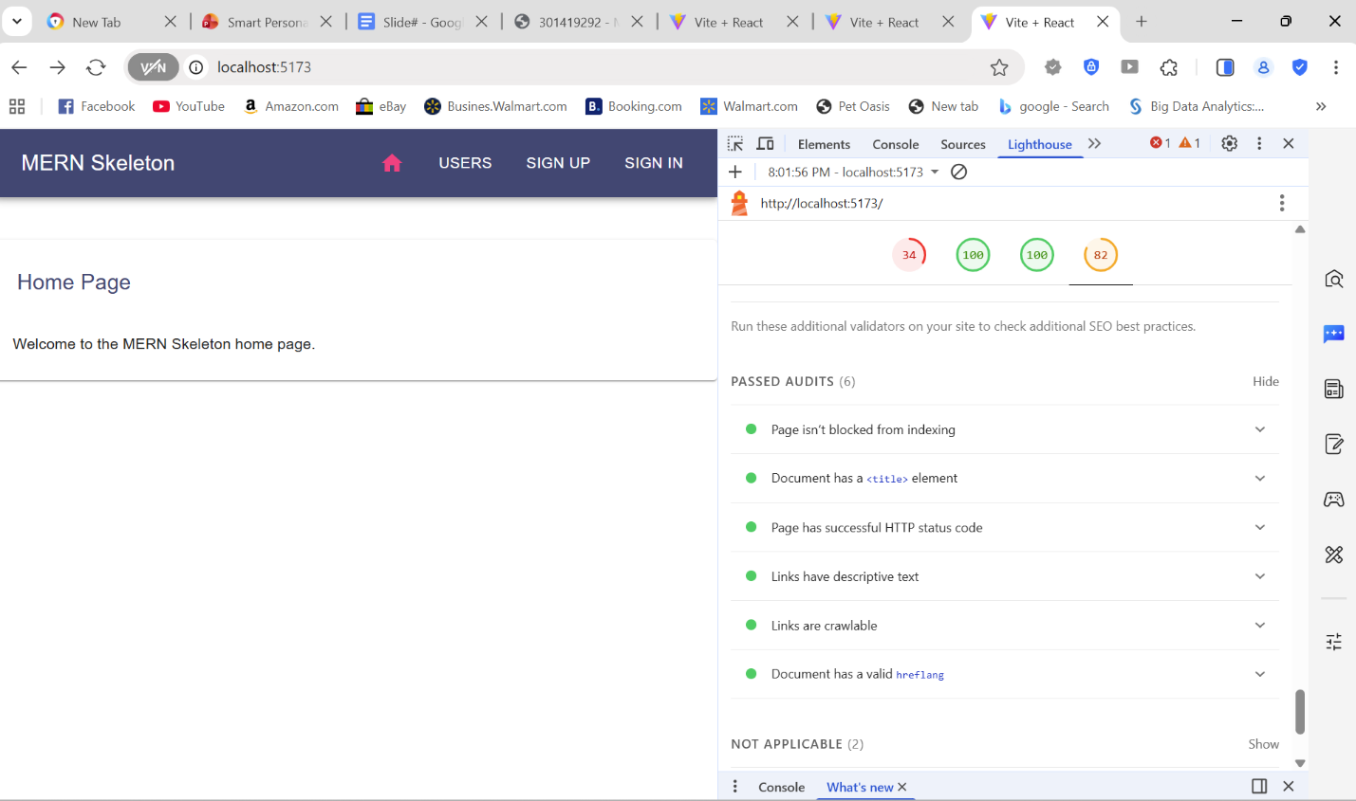
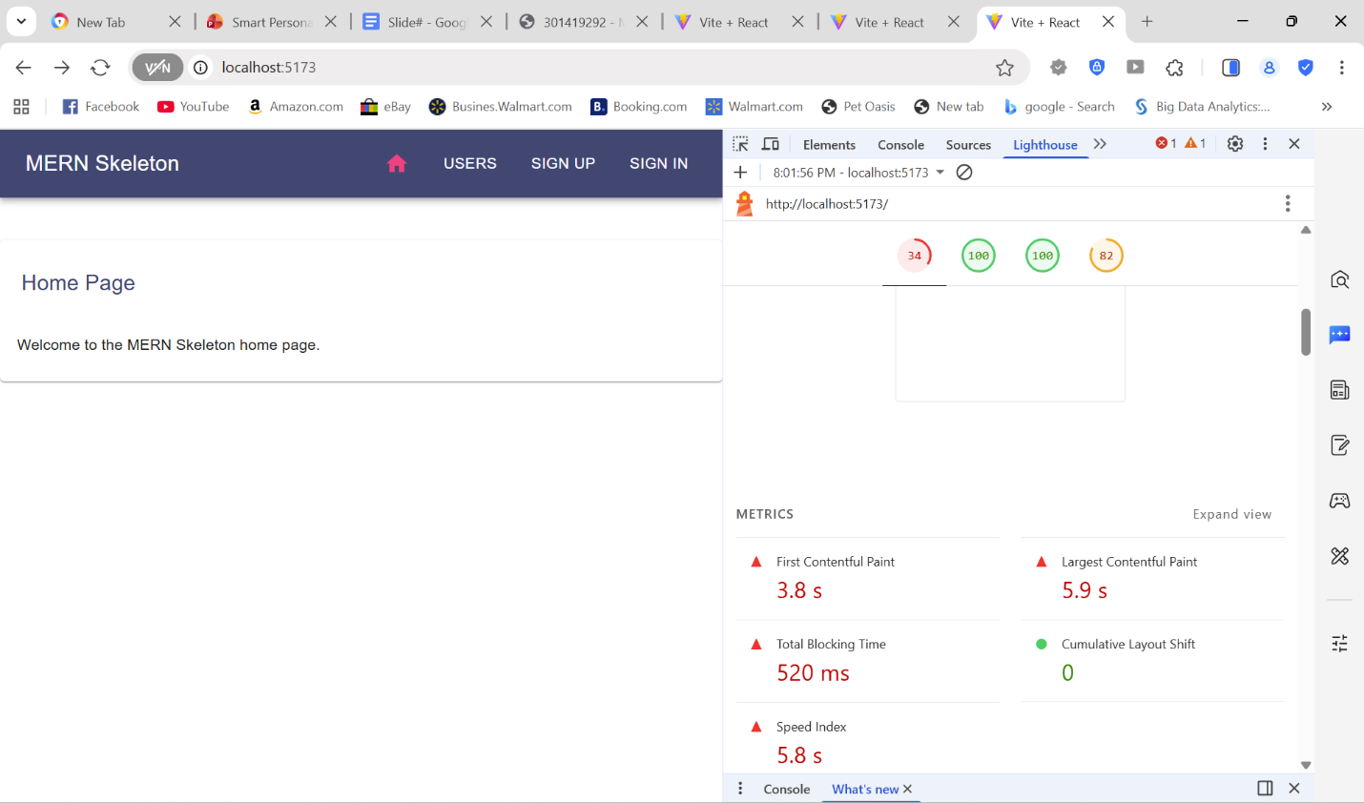
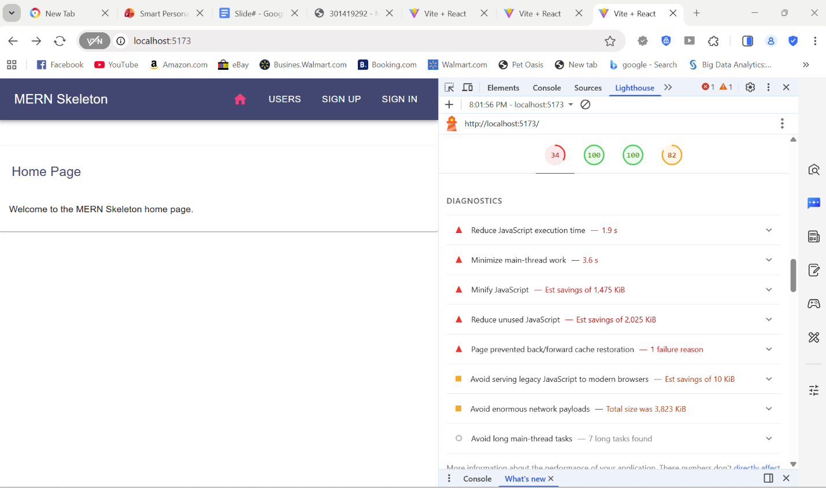

5. Agile Project Management (Trello)
Sprint 1 tasks were tracked across the following lists:
- To Do
- Sprint 1 – To Do
- In Progress
- Doing
- Testing
- Done
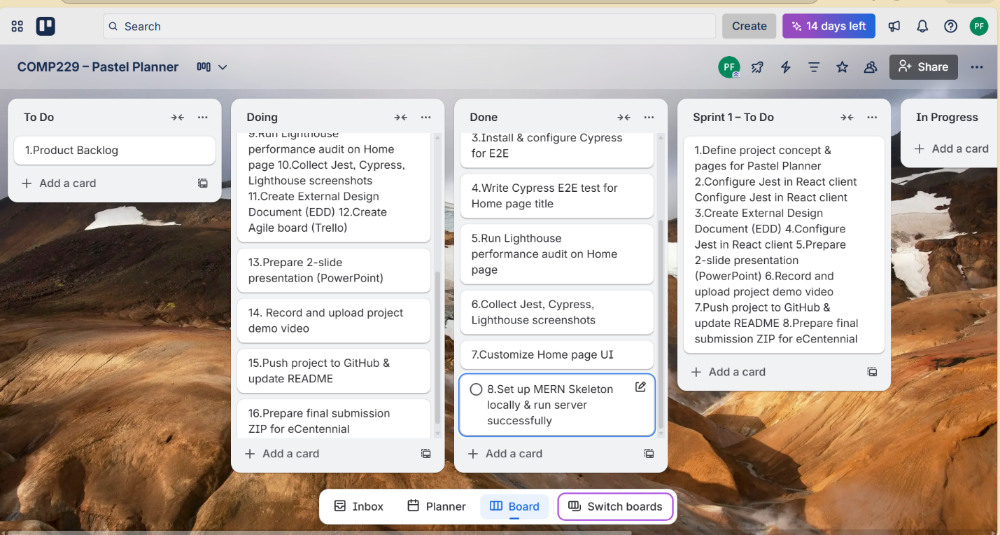
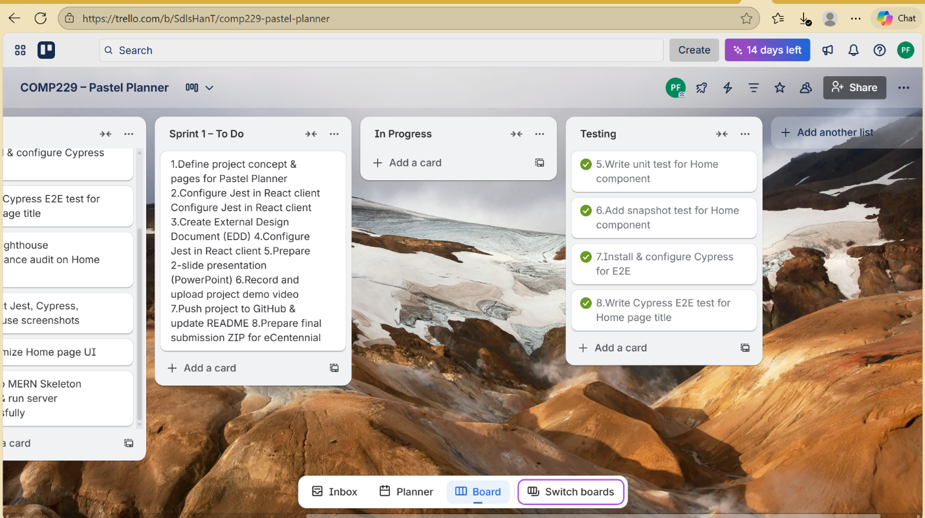

6. Completed Deliverables
- React UI prototype
- Express backend running locally
- Jest unit & snapshot tests
- Cypress E2E test
- Lighthouse audit
- Trello Agile board
- GitHub repository
- Presentation slides

7. Future Work
Upcoming improvements include:
- Adding MongoDB functionality
- CRUD planner items
- User authentication
- Deployment to the cloud
- CI/CD pipeline
- Enhanced UI styling

