# FABO X ACADEMY: WINTER BOOTCAMP

# Fablab O Shanghai’s “Fabo X Academy China”, is a modular course about digital manufacturing and rapid prototyping. The course is based on MIT’s “How to Make (Almost) Anything” course and the Fab Academy global seminar. Fablab O has been iterating its Fabo X Academy for many years through experience teaching collaborations with schools and universities, cooperating with institutions implementing fab labs, its Fabo X Academy three weeks seminar, hosting digital fabrication competitions, and numerous symposiums. The Winter Bootcamp is geared toward educators desiring to understand, experience and improve their implementation of STEAM related activities in teaching practices. Additionally, the Winter Bootcamp will introduce and extend an invitation to Fablab O’s concept of a regional collaborative network of fab labs and STEAM educators within China.

# WHY A BOOTCAMP FOR EDUCATORS?

# By understanding the basic concepts upon which Fablab O built its practice, educators will experience how Fablab O create and organize its courses at a regional level and they will be able to run them in their own site as local instructors.

# KEY CONCEPTS

# Fablabs enable STEAM education worldwide More than 1500+ fablabs in the world, connected on a global network, are creating STEAM contents and bringing them to schools and students.

# Fablab O created a STEAM education platform in China Fablab O is the first fablab established in a university in China to focus on education and it is developing a Fablab regional network with chinese characteristic that will be able to bring the global experience into the chinese system.

# Fablab O shares contents and practices to run a fablab Over the years and with the involvement of leaders from the global network, Fablab O acquired an extended experience on opening, running and managing a fablab, and all this material is shared among the new and old members of the regional network of China.

# More educators need to be trained to be leaders in the regional network Machines, courses and experience are not enough to make the regional network of China bigger and stronger: more trained professionals are needed. The Fablab O’s bootcamp objective is to give educators the skills needed to be a leader in one of the future fablabs in the regional network of China.

# Contents are generated locally and shared regionally As part of the regional network of China, educators will have access to the education contents created in Fablab O headquarter with videoconference classes, and when they create contents locally in their own site, they will be able to share them with the regional network and also with the global network.

# BACKGROUND

# The germ of fab labs started as a collaborative platform for exploring how the content of information relates to its physical representation. Leveraged by an open-source, share everything ethos, fab labs have quickly spread throughout the world. As of December 2017, there total 1205 official fab labs, worldwide. A fab lab (fabrication laboratory) is a small-scale workshop offering (personal) digital fabrication. A fab lab is typically equipped with an array of flexible computer-controlled tools that cover several different length scales and various materials, with the aim to make "almost anything”. Recognizing the unique challenges within China and the profound advantages of open-source collaboration, Fablab O, China’s first fab, has established a platform to install and manage new fab labs and a modular curriculum of STEAM related contents. Fablab O is raising a regional collaborative network of fab labs in China in which every school or institution with a fab lab will be connected, receive educational content from the global and regional network, and in turn share their local discoveries and content creation.

# In October 2017, Fablab O organized the STEAM Education Symposium, hosted at Tongji University’s College of Design & Innovation, to spread and promote innovation in the traditional education system. Throughout three intensive days, the event held a number of lectures, workshops and demonstrations helping hundreds of Chinese educators to deepen their understanding of how fab labs are helping their peers understand and implement STEAM education worldwide. Further, Fablab O fielded countless questions and challenges from the participating educators in regards to their experience with STEAM education. The FABO X Academy Winter Bootcamp has been formulated in direct response to these inquiries.

# OBJECTIVES

# Fablab O’s Winter Bootcamp will offer educators the opportunity to extend their understanding and experience with fab labs as an ecosystem for education through intensive seminars and technology-specific training workshops. The bootcamp is further intended to challenge the participants to take an active role in the definition and future development of the regional network in China, through discussion tables with local and global mentors and collaborative design sessions. The bootcamp culminates in participants creating new workshops generated through the training they received in digital fabrication, electronics and coding exercises across the week. These new workshops will be shared with all attendants and may be used for future education in their classrooms!

# BOOTCAMP SCHEDULE & DETAILED CONTENTS

* **29 Jan, Monday**: Lecture and discussion
* **30 Jan, Tuesday**: Hands-on training
* **31 Jan, Wednesday**: Hands-on training
* **1 Feb, Thursday**: Hands-on training
* **2 Feb, Friday**: Workshop development
* **3 Feb, Saturday**: Workshop finalization and presentation

**GENERAL CLASS STRUCTURE**

The principal for teaching is hands-on learning: keeping the theory short but dense before continuing on practical applications. The participant will be required to bring his/her own laptop, in good working order, with a mouse and basic softwares installed.

**BOOTCAMP GENERAL DAILY SCHEDULE**

Daily activities begin at 9:00AM, with coffee brake at 10:30AM. Lunch brake from 12:00AM to 1:30AM. Afternoon activities from 1:30PM to 16:30PM with coffee brake at 15:00PM. Schedule is subject to changes.

**FABLAB INFORMATION**

|  |  |
| --- | --- |
| **Wifi**  Network: FablabO  Password: fablabshanghai | **People**  Director: 丁峻峰 Jeff - 18621832152  Manager: 薛喜荣 Rio Xue - 18621284185  Instructor: Saverio Silli - 13524015379‬‬  Instructor: Jtravis Russett  ‬‬Instructor: 林世國 Kirk  Instructor: 吕翰林 Lü Hanlin |
| **Address**  281 Fuxin Rd, Tongji University, College of Design and Innovation (D&I), Yangpu, 200092 Shanghai |

### **DAY ONE, MORNING: LECTURES AND DISCUSSIONS**

The morning will be dedicated to lectures and discussion from leaders in the global fab lab network and professional STEAM educators from China and abroad. The main focus will be the development of the regional fab lab ecosystem established by Fablab O in China.

* **How does the fab lab education system work? What we do and how we do it.**

*A videoconference lecture by Fiore Basile*

What is the global fablab network? Fiore Basile, one of the leaders of the Fab Foundation will talk about how it started and spread, how the local labs are connected and contribute and benefit from the global network. He will show notable examples, success stories and how he is kickstarting new labs around the world. Fiore will also explain how we use online resources to coordinate the Academany and he will introduce the Fab Academy X program that was developed in India and other future plans.

* **The future of the Chinese Fabo Network and how local educators and institutions can be a part of the movement.**

*By Jeff Ding*

Jeff Ding will talk about the business model of FABO and how it will impact the future of education in China, how to open a new lab and be connected in the regional network of China. It will be easy to open a new lab thanks to the large amount of information, resources and contents the FABO network will provide and each new lab will be able to contribute with their own locally generated contents.

* **How to: run a successful fab lab! The fab lab philosophy and core values.**

*By Saverio Silli*

The lecture will show examples of fablabs around the world, how they are managed and what activities they run locally. It will show the fundamentals of running a lab and how they can be adapted to the local needs. It will explain the basic values of working in a fablab such as documenting, using and applying the open-source model, organizing the space, understanding and sourcing an inventory of materials and machines shared by every lab.

* **How to use the fab lab tools and processes to teach STEAM education.**

*By Jtravis Russett, Lü Hanlin吕翰林 and Kirk林世國*

In this talk Travis, Harry and Kirk will show their personal experience teaching STEAM education contents created in the fablab, especially showing how they used the machines and material available, how they used the fablab environment to research and test and then to prepare a workshop or class for primary, middle and high schools.

### **DAY ONE, AFTERNOON: COLLABORATIVE DISCUSSION TABLES**

In the afternoon, the lecturers and the participants will join tables focused on the morning subjects and participants will be encouraged to share their points of view and ideas, make questions, propose new arguments, define and prepare the contents for the coming activities in a collaborative way.

### **DAY TWO, THREE AND FOUR: HANDS-ON TRAINING**

Three days of intensive workshops, trainings and hands-on sessions to experience how the processes and tools within the fab lab can be used in the creation of STEAM education contents. The focus of the sessions is to experience the “learning-by-doing” approach and, in reflection, “teaching-by-doing”.

Each day the participants will experience a complete workshop about a different subject. They will learn specific techniques like laser cutting and 3D scanning, but at the same time the mentors will show them how a STEAM workshop is designed, prototyped and created. Special attention will be given to the definition of the inventory list, learning outcome and scheduling.

**WORKSHOP ONE – DESIGN AND LASERCUT A CUSTOM SEAL with KIRK**

Make a seal with the laser cutter: the workshop begins with a design thinking session and will then move on to training on the laser cutter and on 2D design software. The participants will make a customized seal and will design a case to carry it.

**WORKSHOP TWO - FROM ATOMS TO BITS AND BACK with TRAVIS**

From Atoms to Bits and Back introduces the core concept of fab labs: our physical world (atoms) is nearly as malleable as our digital world (bits), in an engaging fun workshop using 3-D printing and 3-D scanning technologies. Participants will make something with modeling clay, 3-D scan it, modify it using Meshmixer, and print their modification. And again and again! Optimally, there are myriad methodologies to resolve making any thing!

**WORKSHOP THREE – MAKE A MOOD INDICATOR with SAVERIO**

Make a Shanghaino, program it and make an input+output device to indicate your daily mood.

Shanghaino is a simplified Arduino clone, developed in Fablab O Shanghai. In the workshop the participant will assemble their own device with simple components, solder and program it with the Arduino environment, developing basic soldering skills and learning the fundamental programming workflow.

### **DAY FIVE AND SIX: DESIGN AND PROTOTYPE A STEAM WORKSHOP**

Over the final two days, the participants will be divided into teams and, supported by mentors, will design, develop, test and prototype a STEAM workshop that can be made in the fab lab.

Special attention will be given to the brainstorming session and the definition of all the components of a workshop. The group must provide powerpoint introduction/slides, a bill of materials, the list of software/hardware. Optionally they can make a simple one-page html website that could be used to share their work with the network.

Designing a workshop will let the participant experience the fablab approach, apply the fablab philosophy and create exceptional STEAM contents that can be shared in the network.

**Day schedule:**

* Groups formation.
* Brainstorming moderated by the mentors: Find a problem. Find a solution. Formulate proposal.
* At the end of the first day each group explain what they did so far to the others, mentors can give their suggestions.
* They can work overnight if they want.
* On the morning of day six, the groups must deliver their project before 12.30AM.

**Proposal requirements:**

* Must use at least one of the techniques from the workshops.
* Must be easily replicated in any fablab (i.e.: use the general fablab inventory)
* Must use materials found in the fablab with fewest exceptions
* Group must provide powerpoint introduction (at least one slide), bill of materials, list of software/hardware, schedule and learning outcomes.
* Extra-credit: make a one-page html website.

### **DAY SIX, AFTERNOON: PRESENTATION AND CLOSING CEREMONY**

Each team will present its workshop prototype to the audience. The results and the materials will be shared among all the participants and be open to use in the future. The best workshop, elected by consensus of the mentors, will be awarded in the closing ceremony.

**MENTORS**

Throughout the Winter Bootcamp, like the October STEAM Education Symposium, there will be numerous experienced mentors speaking, teaching workshops, and hands-on coaching participants. The mentors will be nationally and globally based experts offering a wide-range of perspective and experience teaching and developing STEAM programmes, starting fab labs, working alongside local and national institutions, and fostering thriving communities.

丁峻峰 Junfeng(Jeff)Ding

同济大学设计创意学院，副教授；环境设计专业，副主任；

同济大学Fablab O |中国“数制”工坊， FABO Playground｜中国“数制”乐园创始人；

美国哈佛大学设计学，爱荷华州立大学建筑学双硕士；

美国Atelier-iformI上海形成建筑设计事务所合伙人，设计总监；

美国注册建筑师 AIA

美国绿色资质认证会员LEED AP

Associate Professor, Vice-Director, Environmental Design Program,

College of Design and Innovation, Tongji University;

Founder of Fablab O ( the first Fablab in China) , FABO Playground

Master in Design Study, Harvard University;

Master of Architecture, Iowa State University

Partner and Design Director of Atelier-iform /

American Registered Architects in Illinois (AIA)

LEED AP

本科毕业于东南大学建筑学，并获得哈佛大学设计学和爱荷华建筑学双硕士，任上海形成建筑规划有限公司/美国Atelier-iform创意设计总监， 身为美国注册建筑设计师和绿色资质设计师的他，先后在国内外大型跨国设计事务所担任资深设计师，拥有操作海内外项目的丰富实践经验，在计算机辅助设计和绿色环保设计等方面拥有卓越成就。

Graduated from South-East University majored in Architecture, Junfeng Jeff Ding achieved the Master degree of Design in Harvard as well as the Master degree of Architecture in Iowa State University. Now he is the creative design director of Atelier-iform Design Firm.

自2013年开始，担任同济大学设计创意学院 Fablab 主任（中国第一个“开放创造”实验室）,创办了 Fablab O品牌。FABO承担社区建造（FABO C）、教育(FABO U)、创业(FABO I)三大使命。FABO Academy X China｜“智造学术X” 课程是基于麻省理工学院的如何创制（几乎）万物How To Make （Almost ）Anything课程衍生出来的一个为期3周的精简版课程。它将带您深入学习数字化制造、快速成型技术、电路设计、编程并建立网页记录整体过程。在FABOX基础上，丁老师和团队开发的FABOHUB|“数制天地”品牌，专门针对中学开展模块化实验室建设及课程内容开发。FABO Playground|“数制乐园”品牌，专门针对青少年K12的创客教育系统。

As director of Fablab in College of Design and Innovation, Tongji University (the first Fablab in Mainland China) in 2013, Junfeng Ding founded the Fablab O brand. FABO undertakes three missions: community construction (FABO C), education (FABO U) and entrepreneurship (FABO I).

同时，丁老师也在最近几年活跃在艺术创作的跨界领域，被多次邀请在国内外重要艺术节、双年展展示自己数字化作品，包括上海桃浦当代艺术展，卡莎布兰卡当代艺术双年展，比利时当代艺术双年展和刚果国际艺术双年展等。2016年策展《阳澄湖地景艺术及》及《阳澄湖家庭创客嘉年华》。

Meanwhile, in recent years, Mr. Ding has been active in the field of cross-border artistic creation as well. He has been invited to show his digitized works at important festivals home and abroad and Biennial shows several times。

**Shih-Kuo Lin**

Shih-Kuo Lin, nickname is Kirk.

Graduated from the Fab Academy 2017. His major is electrical engineering, and he is a senior high school teacher. He teach about making some interesting things such as go-kart, standbeast bicycle, record & play device, etc.

**Fiore Basile（意大利）**

FabAcademy｜全球数制学术课程项目负责人，意大利卡希纳Fablab负责人，数制工厂（FabFactory）联合创始人。

**Saverio Silli**

Graduated in architecture in Roma Tre University, Saverio Silli worked as an architect, while pursuing the academic career as a lecturer in Roma Tre’s School of Architecture, for the classes “Visual Communication Design” and “Graphic Representation Methods”.

He has been an active member of Italian’s maker community since 2012, giving birth to the first two Fablabs in Rome. In 2015 he moved to Milan to enroll in the Fab Academy course directed by Neil Gershenfeld, director of MIT’s Center for Bits and Atoms.

After graduation as a Digital Fabrication Specialist he became the local instructor for Fab Academy in Fablab WOMA in Paris, France, and since December 2016 he is the Director of Courses at Fablab O Shanghai and Assistant Research Fellow in Tongji University’s College of Design and Innovation in Shanghai, working as an instructor and developing new classes for the STEAM education.

He has organized digital fabrication workshops in Rome, Milan, Paris, Seoul, Shenzhen, Xian, Boston and he is an active member of the international fablab network.

Saverio Silli毕业于罗马第三大学建筑学院，曾担任建筑师，同时在Roma Tre建筑学院担任讲师，担任“视觉沟通设计”和“图像表达法”课程。  
自2012年以来，他一直是意大利创客社区的积极成员，在罗马创造了前两个Fablabs。在2015年，他搬到米兰参加了麻省理工学院位和原子中心主任Neil Gershenfeld领导的Fab学院课程。  
毕业后作为数字制造专员，他在法国巴黎的Fablab WOMA成为Fab学院的本地讲师，自二零零六年十二月起，他是上海市Fablab O课程主任，同济大学设计与创新学院助理研究员上海作为讲师，为STEAM教育开设新课程。  
他在罗马，米兰，巴黎，首尔，深圳，西安，波士顿等地组织了数字制造工作坊，他是国际fablab网络的积极成员。

**J.travis Russett**

J.travis Russett, founder of *bēstia—a laboratory for symbiotic life-machine exploration,* imbues his works with *an erotics of wildness,* the spirit of *humanity*, *nature* and intelligent *machines*. Since 2016, J.travis has lead *bēstia* to embody a culture of interdisciplinary fabrication and rapid prototyping, evident in developing works: *dìshūBot*, a self-learning robot that paints Chinese calligraphy in water (featured in the 2017 Bay Area Maker Faire) and *Pure Imagination*, plant fed microbial fuel cells that will power our homes and much more. J.travis holds a Master degree in Architecture from UCLA and a Fab Diploma of the 2017 Fab Academy. Further, he is a researcher at Tongji University of Shanghai, developing STEAM education and outreach in a number schools and universities throughout Eastern China.

J.travis Russett，是致力于探索生命与机器共生模式的bēstia实验室创始人。其作品充分彰显他的研究兴趣：以人文精神、自然精神和机器精神三者，来共同展现不羁野性的原始魅力。自2016年以来，J.travis引领bēstia实验室创作了体现“跨学科数字智造”和“快速成形技术”精髓的作品：*dìshūBot* 地书机器人*——* 能以水性涂料书写中国书法的自我学习型智能机器人（2017年旧金山湾区Maker Faire特别精选作品）；以及 *Pure Imagination* 纯粹的想象力*——* 能为人类家园提供电力的纯植物喂养型微生物燃料电池。J.travis拥有加利福尼亚大学洛杉矶分校建筑学硕士学位，并且毕业于2017年度Fab Academy课程。同时

**LASER CUTTING STAMP INDICATOR**

**Tuesday 30th - Kirk**

**ABSTRACT**

Design and make your own stamp with laser cutters and small saws machine to indicate what you want people to feel about you.

The stamp is an expression of Chinese culture and a traditional way of presenting personal style. In the workshop the participant will use 2D design software to design their own stamp and case. Using laser engraving and cutting to make their stamp. Finally, use a small saw machine to hand make the body of the stamp.

**DESCRIPTION**

當別人見到你的印章，會如何想像你這個人?是熱情?還是嚴謹?

如何利用印章讓陌生人能迅速了解你?拉近彼此的距離?

透過設計思考的過程讓參與者了解印章的意義，並設計專屬於個人的印章，同時利用數位工具，例如雷射切割機，實現腦中的設計。

過程中可以讓參與者學習到2D繪圖軟體、雷射切割機操作、小型線鋸機使用等技術。

How do people imagine you when they see your seal? Passionate? Rigorous?

How to use a seal so strangers can quickly understand you? Close to each other's distance?

Through the process of design thinking, participants can understand the significance of the seal and design their personal seal while using the digital tools such as laser cutting machine to realize the design in the brain.

The process allows participants to learn 2D drawing software, laser cutting machine operation, the use of small wire saws and other technologies.

**MATERIALS FOR ONE STUDENT**

* 1 MDF(Medium Density Fiberboard) 600x450x3 mm
* 1 wood block 50x50x80 mm
* 1 Odorless rubber 148x210 mm
* 1 Sandpaper 210x297mm 300p

**TECHNOLOGIES**

* 2D design software(Corel Draw、Inkscape)
* Laser cutter
* Small saw machine
* Computers

**LEARNING OUTCOMES**

* Learn to design a stamp and case with 2D design software.
* Learn to operator the laser cutting machine.
* Learn to use small saw machine to make the body of stamp.

**From Atoms to Bits and Back**

**Wednesday 31st – Jtravis Russett**

**ABSTRACT**

*From Atoms to Bits and Back* introduces the core conceit of fab labs: our physical *world (atoms)* is nearly as malleable as our digital world *(bits)*, in an engaging fun workshop using 3-D printing and 3-D scanning technologies. Participants will make something with modeling clay, 3-D scan it, modify it using *Meshmixer,* andprint their modification. And again and again! Optimally, there are myriad methodologies to resolve making any thing!

**DESCRIPTION**

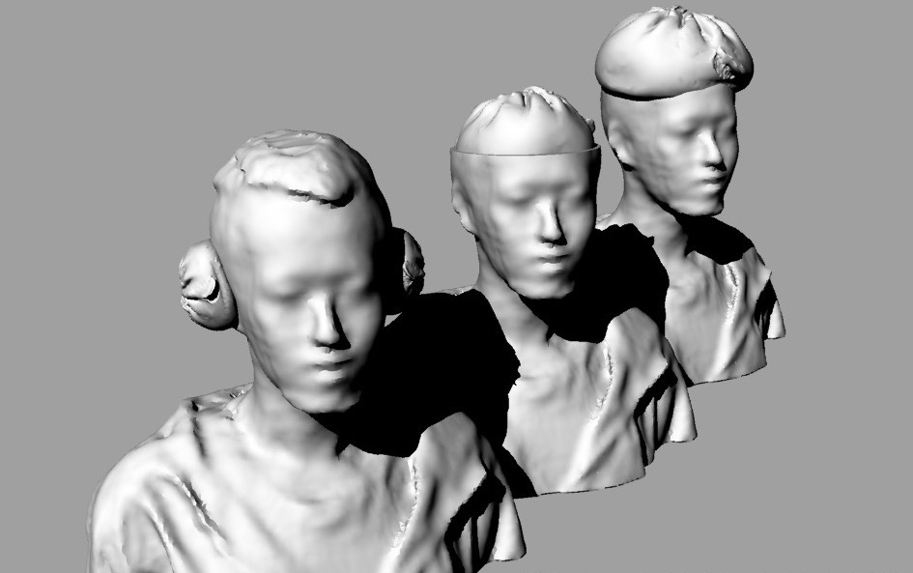Critical to learning digital manufacturing is an understanding of the interaction between the computer’s digital world of bits and the physical world of atoms. Tools common to fab labs make atoms as malleable as computer files. *From Atoms to Bits and Back* introduces this concept in an engaging fun workshop using 3-D printing and scanning technologies. The workshop begins with a demonstration of the capabilities and limitations of PLA 3-D printers. 3-D printing, a process of additive manufacturing, is beginning to disrupt portions of the $10 trillion dollar global manufacturing industry *(McKinsey Global Institute, “Manufacturing the future: The next era of global growth and innovation)* as a tool for rapid prototyping and custom manufacturing and is often the first machine people ask to learn within fab labs. Next, everyone will make something from modeling clay (atoms) which they will in turn 3-D scan. A 3-D scanner is a device that generates digital models (bits) from the shape, textures and often colors of physical things. This technology is common to many industries including medical sciences, industrial design, virtual and augmented realities, video-game design and filmmaking. Next, using Meshmixer, a simple, free 3D modeling application, participants will learn to modify their models digitally and they will 3-D print (atoms) the new digital versions of their things. Although, having a new physical iteration of their things in hand is the official finish of the workshop, is it really the end? Each person could modify their prints with clay and 3-D scan them again or directly adjust aspects digitally before making another 3-D print. And again!

**MATERIALS**

* Modeling Clay
* Small clay modeling tools
* Calipers
* Polylactic Acid (PLA) is a biodegradable thermoplastic, made from renewable resources like corn starch or sugarcane. Outside of 3D printing, it’s typically used in medical implants, food packaging, and disposable tableware. The main benefit of PLA is that it’s easy to print.

**TECHNOLOGIES**

* 3-D Printer
* 3-D Scanner
* Computers (Preferably people have their own for 3-D modeling)

**LEARNING OUTCOMES**

* Learn to use a 3-D printer
* Learn to use a 3-D scanner
* Learn basic digital 3-D modeling
* Understand the malleability and interchangeability of atoms and bits

**This workshop will use the freely available applications linked below. In order to hit the ground running, please download, install, and confirm their operation prior to the workshop. You will need to create no-strings-attached accounts online.**

Makerbot Print: <https://www.makerbot.com/download-print/>

Meshmixer : <http://meshmixer.com/download.html>

**SHANGHAINO MOOD INDICATOR**

**Thursday 1st – Saverio Silli**

**ABSTRACT**

Assemble a Shanghaino board, program it and make an input+output device to indicate how you feel today!

Shanghaino is a simplified Arduino clone, developed in Fablab O Shanghai. In the workshop the participant will assemble their own device with simple components, solder and program it with the Arduino environment, developing basic soldering skills and learning the fundamental programming workflow.

**DESCRIPTION**“ Shanghaino | 小上海”是FablabO中国“数制”工坊实验室基于Arduino开源单片机基础上，开发的简化的上海地图版本的开源单片机。可以让K12到大学生学习电子制作，PCB焊接，编程和原型设计，以有趣的方式组装自己的设备！该套件具有几个简单的组件，并且在短时间内可以焊接并连接到计算机以开始使用它。 它与Arduino环境完全兼容，可以用以开源编程。

Shanghaino is a simplified Arduino clone, developed in Fablab OShanghai. It allows students from K12 to university to learn electronic production, PCB soldering, programming and prototyping a circuit in a fun and engaging way: they have to assemble their own device! The kit has few and simple components, and in a short time it can be soldered and connected to the computer to start using it. It is fully compatible with the Arduino environment and it is perfect to teach programming.

In the first part of the workshop we will understand how the board is made and what is the function of each component. Then we will connect it to a computer and we will use Arduino IDE to write a simple code. The code will show how each component can be programmed with its specific functions. We will connect the input and the output devices such as a potentiometer, a servo motor and an LCD screen using cables and a breadboard. In the end we will create a simple enclosure with carboard, tape and markers to understand how easy it is to make a simple product out of some bare electronic components and wires.

**Materials for one student**

* Shanghaino Kit
* 1 small servo motor
* 1 potentiometer 10k
* 1 trimmer 10k
* 1 330 Ohm resistor
* 2 Capacitor 100uF (electrolytic)
* 1 LCD Screen 1602
* 20 jumper cables male to male
* 20 jumper cables male to female
* 1 small breadboard

**Technologies**

* Soldering Iron, solder tin
* Arduino IDE (https://www.arduino.cc/en/Main/Software)
* Computers

**Learning Outcomes**

* Learn to use a soldering iron and to manage electronic components
* Learn basic programming skills with Arduino IDE
* Understand how to associate electronic parts with programming language blocks
* 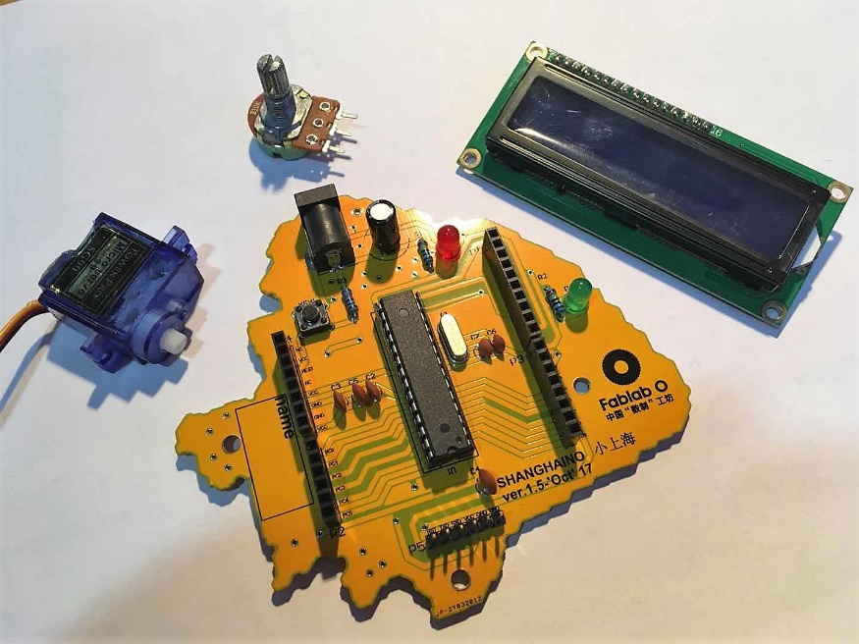Experience creating an integrated system from bare electronics and cardboard.