TRAVEL MEMORY
AWS Deployment and Validation Report
EC2 | Nginx | Node.js | React | MongoDB Atlas | Application Load Balancers

Candidate | Pardeep Singh
Assignment | Travel Memory Application Deployment
AWS Region | US East (N. Virginia) - us-east-1
Frontend | Two EC2 instances behind an Application Load Balancer
Backend | Two EC2 instances behind an Application Load Balancer
Database | MongoDB Atlas
Submission date | 17 October 2026

Submission scope This report provides screenshot-backed evidence of the complete deployment. Cloudflare DNS and HTTPS were treated as optional and were not implemented. The application was validated through the AWS frontend and backend Application Load Balancer DNS names.

Executive Summary
The TravelMemory MERN application was deployed in AWS us-east-1 using separate frontend and backend tiers. Each tier consists of two Ubuntu EC2 instances distributed across two Availability Zones and registered behind a dedicated internet-facing Application Load Balancer. Nginx serves the React production build on the frontend tier and reverse-proxies backend requests to the Node.js service on localhost port 3000. The backend uses MongoDB Atlas for persistent data storage.
The deployment was validated through service-status checks, HTTP health checks, database-backed API tests, target health, Application Load Balancer tests, browser network evidence, and a functional create/read operation. Runtime secrets and private keys are intentionally excluded from this report and from version control.

Deployment Process and Communication Overview

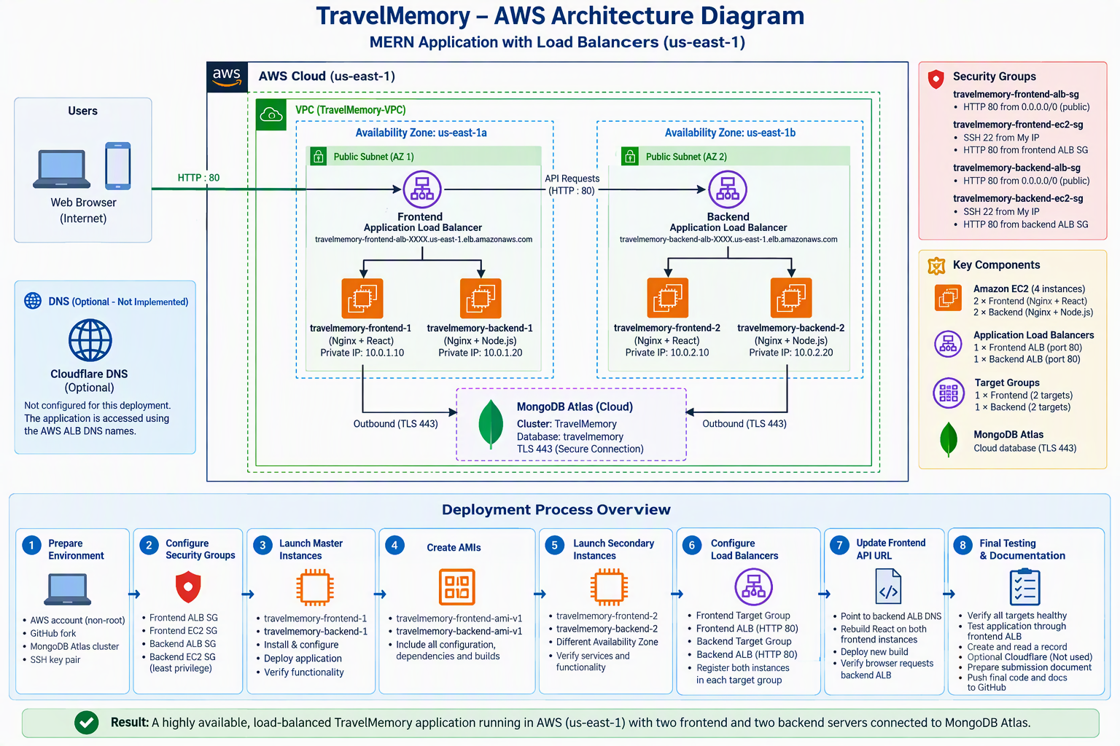
Figure 1. End-to-end TravelMemory architecture and deployment process. The visual shows user traffic through the frontend and backend load balancers, EC2 tiers, MongoDB Atlas connectivity, security controls and the ten-stage deployment workflow.

Implementation Summary

Layer | Implementation | Validation
Frontend | React build served by Nginx on two EC2 instances | Root path HTTP 200; two healthy targets
Backend | Node.js/Express managed by systemd; Nginx reverse proxy | /hello and /trip HTTP 200; two healthy targets
Database | MongoDB Atlas | Database-backed /trip and functional record test
Traffic distribution | Separate frontend and backend ALBs across two AZs | ALB DNS tests and browser Network evidence
Resilience | AMI-created second instance for each tier | Four instances and automatic service startup

Security and Evidence Handling
AWS root credentials were not used for routine deployment.
SSH access was restricted to the administrator public IP.
Node.js port 3000 was not exposed publicly; Nginx receives target traffic on port 80.
The operational MongoDB URI is stored only in backend/.env and is excluded from Git.
Private key files, environment files and editor swap files are excluded through .gitignore.
Screenshots are intended to show configuration and validation without revealing credentials.

Contents

Assessment Acceptance Criteria
Criterion | Evidence section | Expected result | Status
Atlas configured | 1 | Cluster, user and network access recorded | PASS
Two-tier EC2 deployment | 2-4 | Frontend and backend master instances operational | PASS
Restart-ready baseline | 5 | Services enabled and successful local tests | PASS
Reusable images | 6 | Backend and frontend AMIs and snapshots created | PASS
Multi-AZ scaling | 7 | Four EC2 instances across two AZs | PASS
Backend load balancing | 8 | Two healthy backend targets and ALB HTTP 200 | PASS
Frontend load balancing | 9 | Two healthy frontend targets and ALB HTTP 200 | PASS
End-to-end communication | 10 | Browser uses backend ALB; functional record created | PASS

1. MongoDB Atlas Setup
Process summary: A MongoDB Atlas project and cluster were created to provide managed persistent storage. A dedicated application database user was configured, Atlas Network Access was enabled for the deployment, and the resulting connection string was stored securely in the backend environment file rather than in source control.

1.1 Project Name: TravelMemory
Evidence statement: The Atlas project groups the database deployment and its security settings.

1.2 Cluster Name: TravelMemoryCluster
Evidence statement: The managed Atlas cluster provides the application database service.
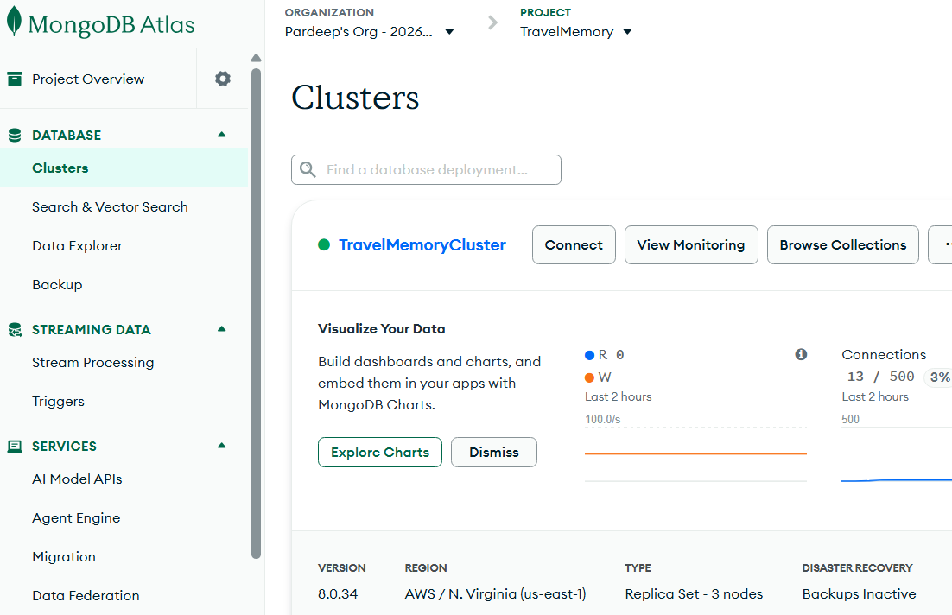

1.3 Database username: travelmemory_app
Evidence statement: A dedicated database user authenticates the backend application.
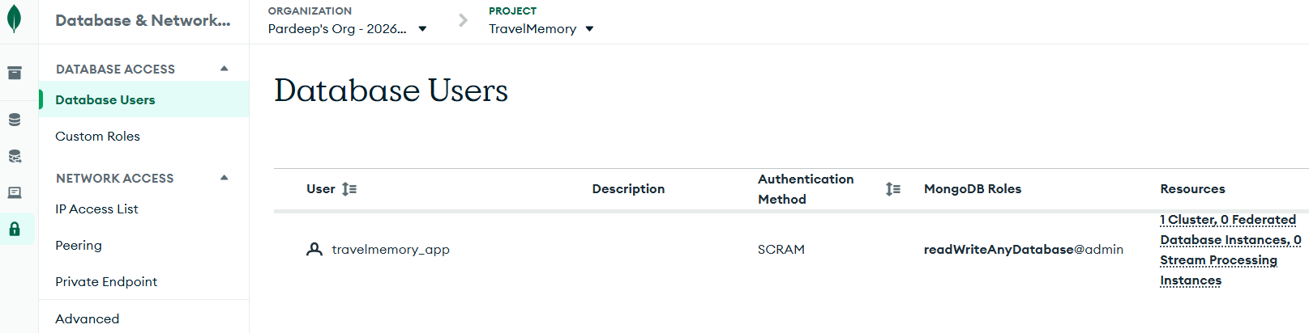

1.4 Network Access
Evidence statement: The Atlas IP access list controls which sources may attempt database connections.
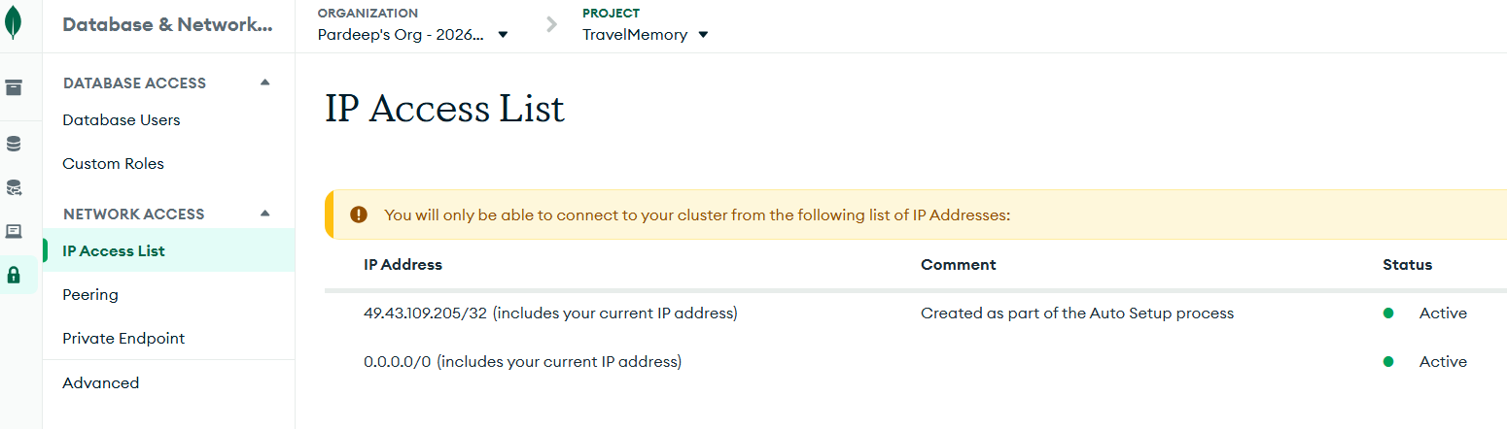

1.5 Connection String

Sanitized connection-string pattern:
mongodb+srv://<DATABASE_USER>:<PASSWORD>@<ATLAS_HOST>/travelmemory?retryWrites=true&w=majority
Security note: The operational connection string is stored only in backend/.env on the EC2 instances and is intentionally excluded from this report and GitHub.

2. Launch the Two Master Instances
Process summary: Two Ubuntu EC2 master instances were launched in the us-east-1 Region: one for the React frontend and one for the Node.js backend. The instances were placed in the selected VPC and subnet, associated with tier-specific security groups, and configured with the same SSH key pair for controlled administration.

2.1 Default VPC ID: vpc-09e93388ac8b8fe06

2.2 Availability Zone 1 : use1-az1 (us-east-1a)
Subnet 1 ID: subnet-01a403c3b13514d8b
Availability Zone 2: use1-az2 (us-east-1b)
Subnet 2 ID: subnet-056adad50a41484b5

2.3 Security Group 1: travelmemory-backend-ec2-sg

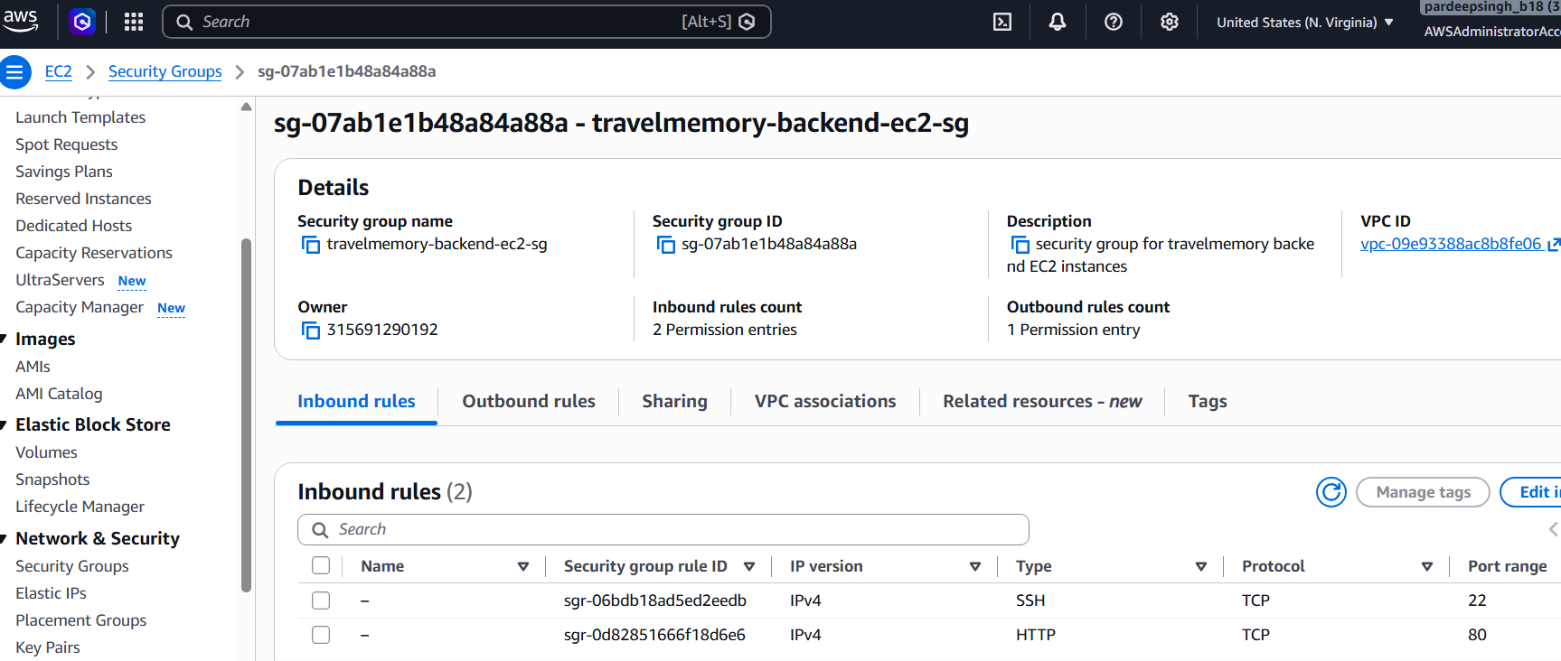

Security Group 2: travelmemory-frontend-ec2-sg
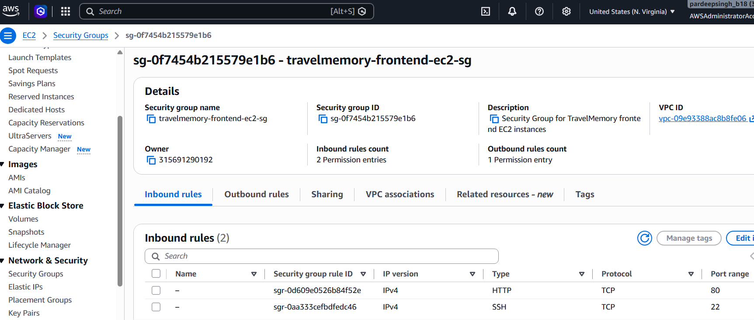

2.4 Backend instance
Name: travelmemory-backend-1
Instance ID: i-0033c90dd8f7fd3c3
Availability Zone: us-east-1a

2.5 Frontend instance
Name: travelmemory-frontend-1
Instance ID: i-0914a423db30fe878
Availability Zone: us-east-1a

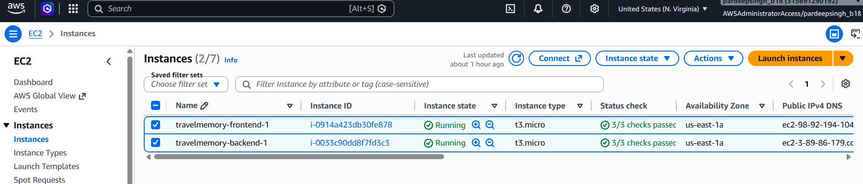

3. Backend setup
Process summary: The backend master was updated and equipped with Git, Node.js, npm and Nginx. The TravelMemory source was cloned, dependencies were installed, MongoDB settings were supplied through backend/.env, Node.js was managed by systemd, and Nginx reverse-proxied port 80 traffic to the application on localhost port 3000.

3.1 Node.js and npm versions
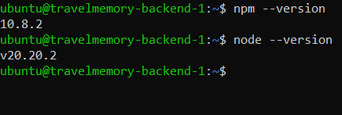

3.2 Backend system service
Evidence statement: The systemd service keeps the Node.js backend running and enables boot-time startup.

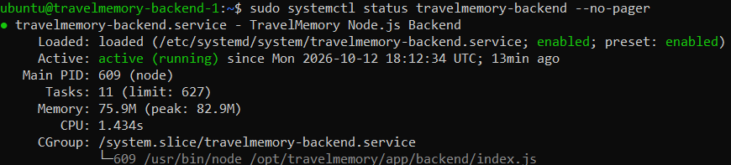

3.3 Nginx configuration test
Evidence statement: A successful syntax test confirms the reverse-proxy configuration is valid.

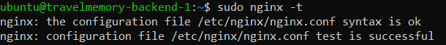

3.4 Local backend test through Nginx
Evidence statement: The local test validates Nginx port 80 to Node.js port 3000 routing.

3.5 Public backend test

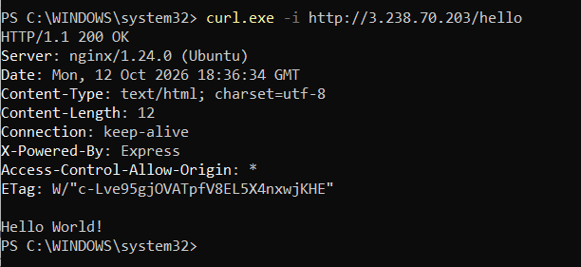

4. Frontend setup
Process summary: The frontend master was updated and equipped with Git, Node.js, npm and Nginx. A production React build was generated using the backend endpoint, copied to /var/www/travelmemory, and served by Nginx with single-page-application routing enabled.

4.1 Nginx configuration validation

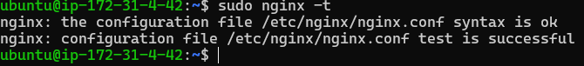

4.2 Nginx running status

4.3 Local frontend HTTP test
Evidence statement: HTTP 200 confirms Nginx is serving the React production build.

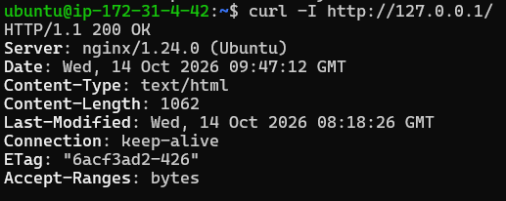

4.4 Public frontend test in PowerShell

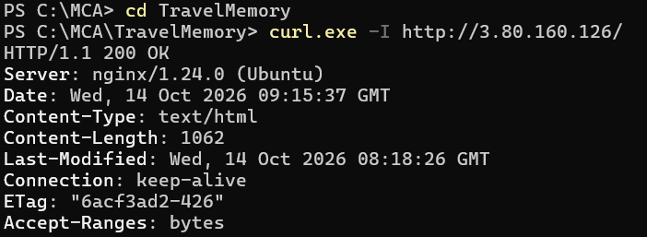

4.5 TravelMemory application in the browser

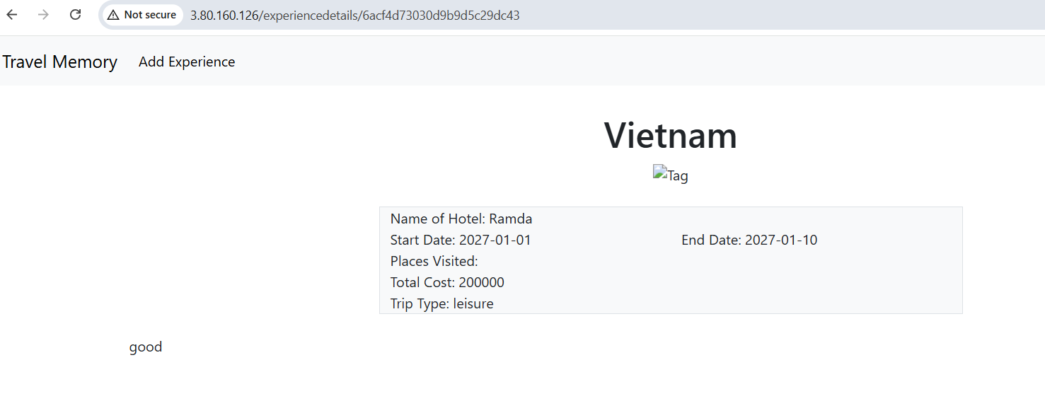

5 Verify the Baseline Before Imaging
Process summary: Both master instances were validated before imaging. Service status, boot-time enablement, local HTTP responses, backend health and database routes, listening ports and the browser application were checked to ensure that the master systems were stable and reproducible.

5.1 Backend services after reboot

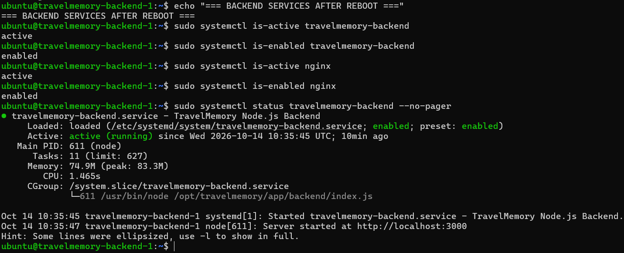

5.2 Backend health and database tests
Evidence statement: The health endpoint and database-backed route validate the complete backend path.

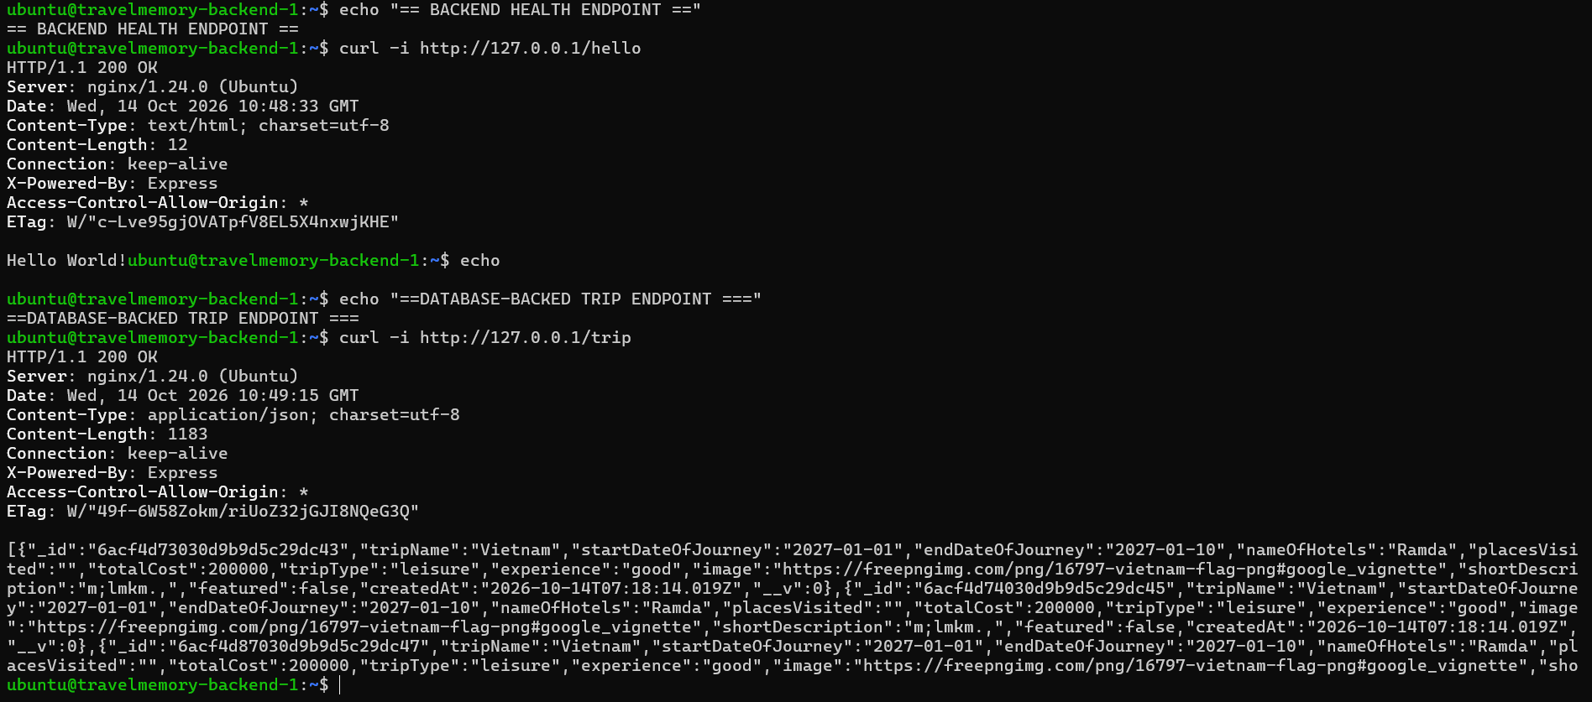

5.3 Backend listening ports

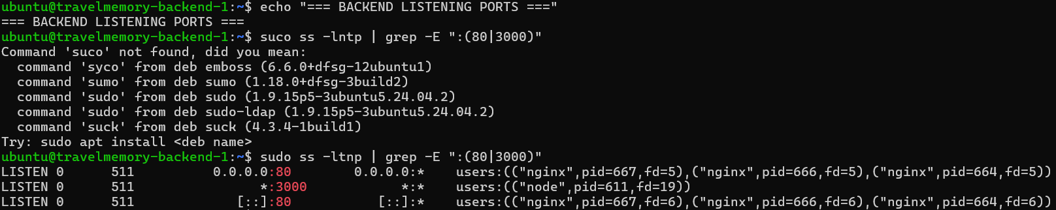

5.4 Frontend Nginx after reboot

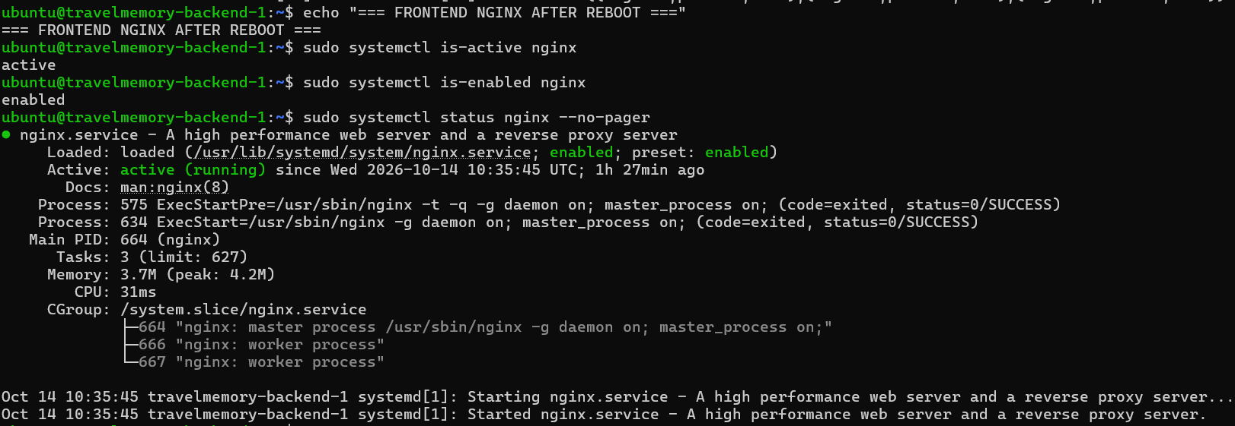

5.5 Frontend local test

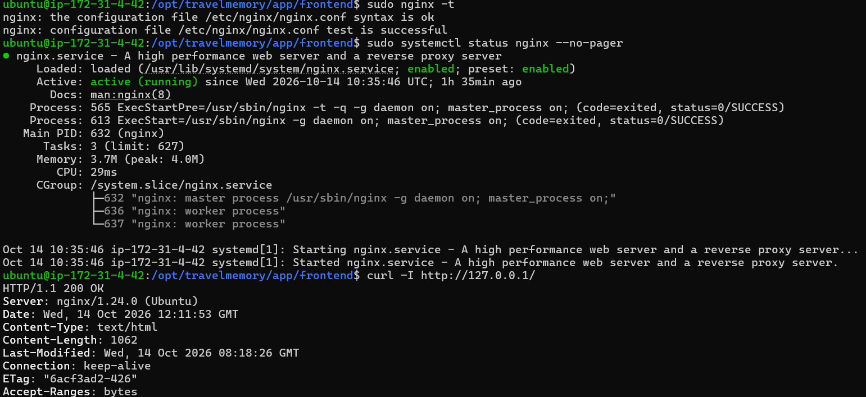

5.6 EC2 master instance overview

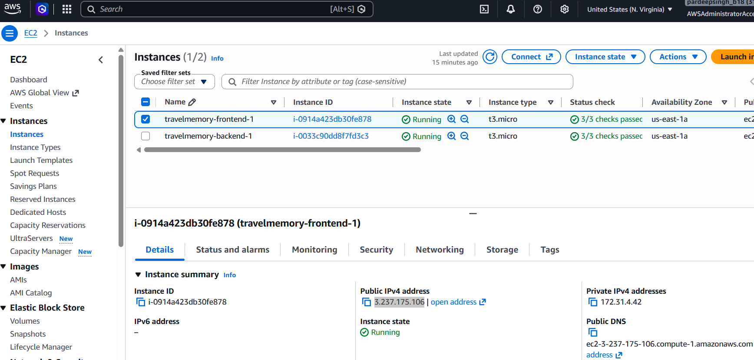

6. Create AMIs
Process summary: Custom frontend and backend Amazon Machine Images were created from the validated master instances. The associated EBS snapshots were allowed to complete, producing reusable machine images that contain the installed software, application files and service configuration.

6.1 Backend AMI
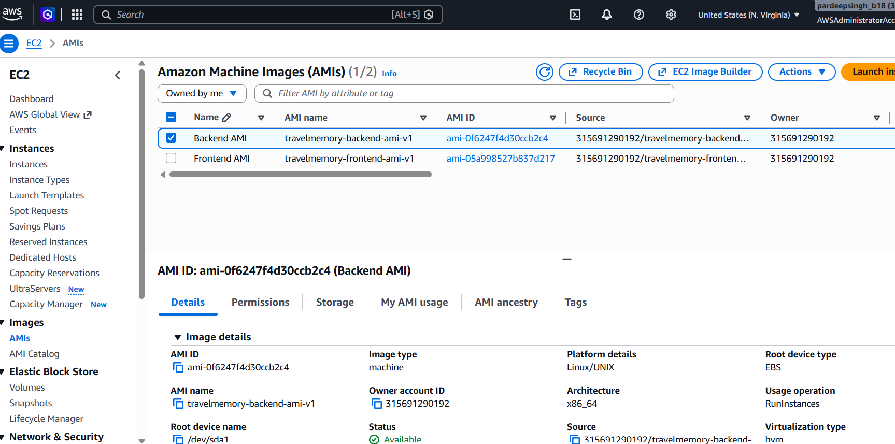

6.2 Frontend AMI
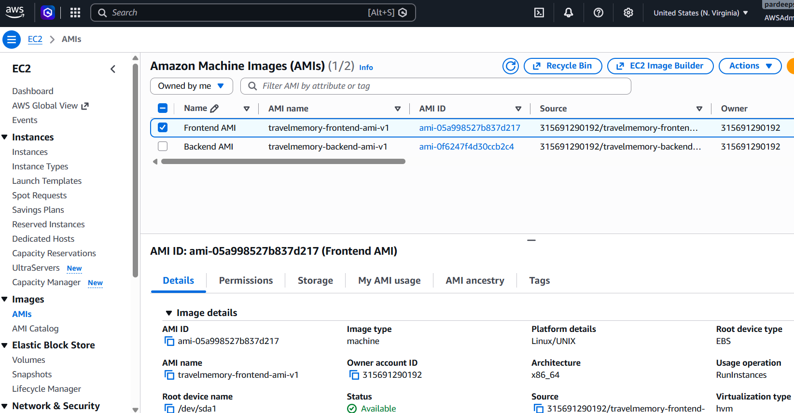

6.3 Snapshot

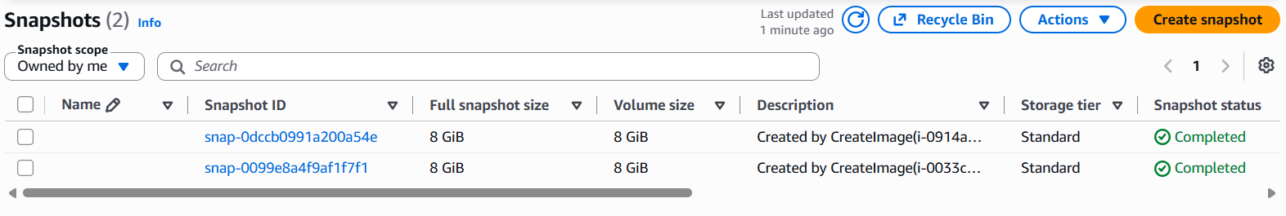

7 Launch Instance #2 from each AMI
Process summary: A second frontend and backend instance were launched from the custom AMIs in another Availability Zone. The cloned instances inherited the required software and configurations, and service, health and HTTP checks confirmed that each secondary instance started correctly.

Travelmemory-backend-1
Availability Zone: us-east-1a
Subnt ID: subnet-01a403c3b13514d8b

Travelmemory-frontend-1
Availability Zone: us-east-1a
Subnt ID: subnet-01a403c3b13514d8b

7.1 Four EC2 instances
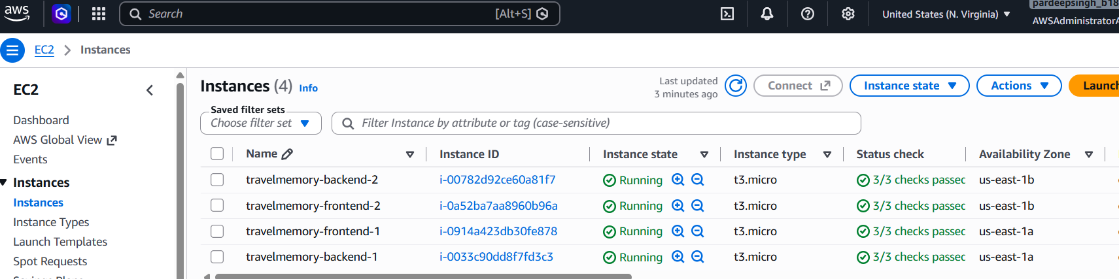

7.2 backend-2 verification
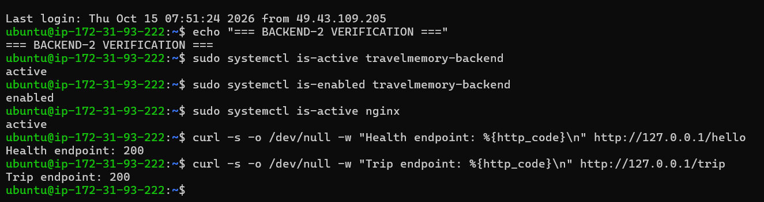

7.3 frontend-2 verification
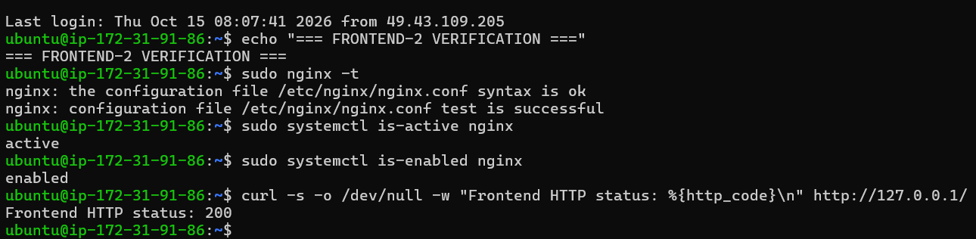

8 Backend Target Group + Load Balancer
Process summary: A backend target group was created on HTTP port 80 with the /hello health-check path. Both backend instances were registered, a dedicated internet-facing backend Application Load Balancer was created across two Availability Zones, and listener traffic was forwarded to the healthy backend targets.

8.1 Backend target group configuration
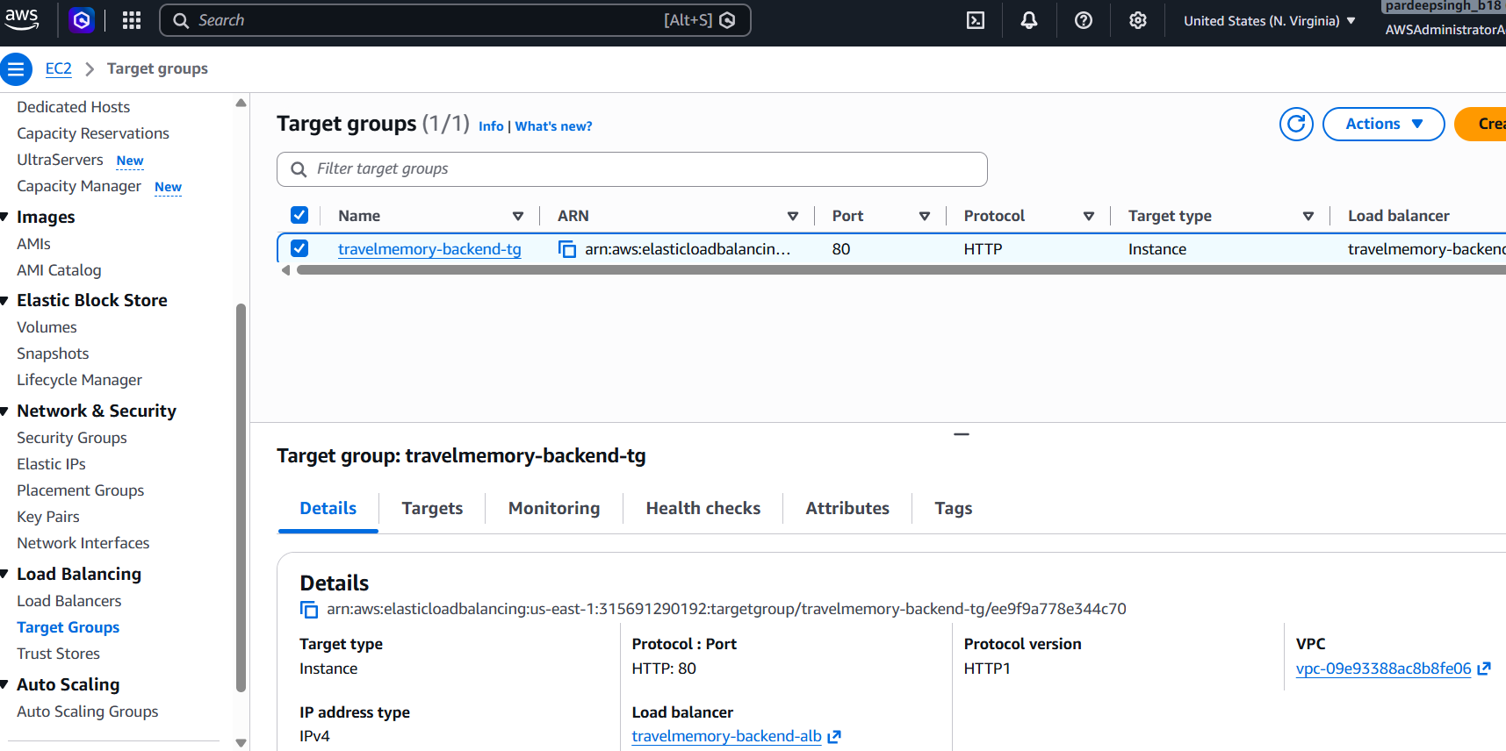

8.2 Both backend targets healthy
Evidence statement: Both backend instances passed the /hello health check on port 80.
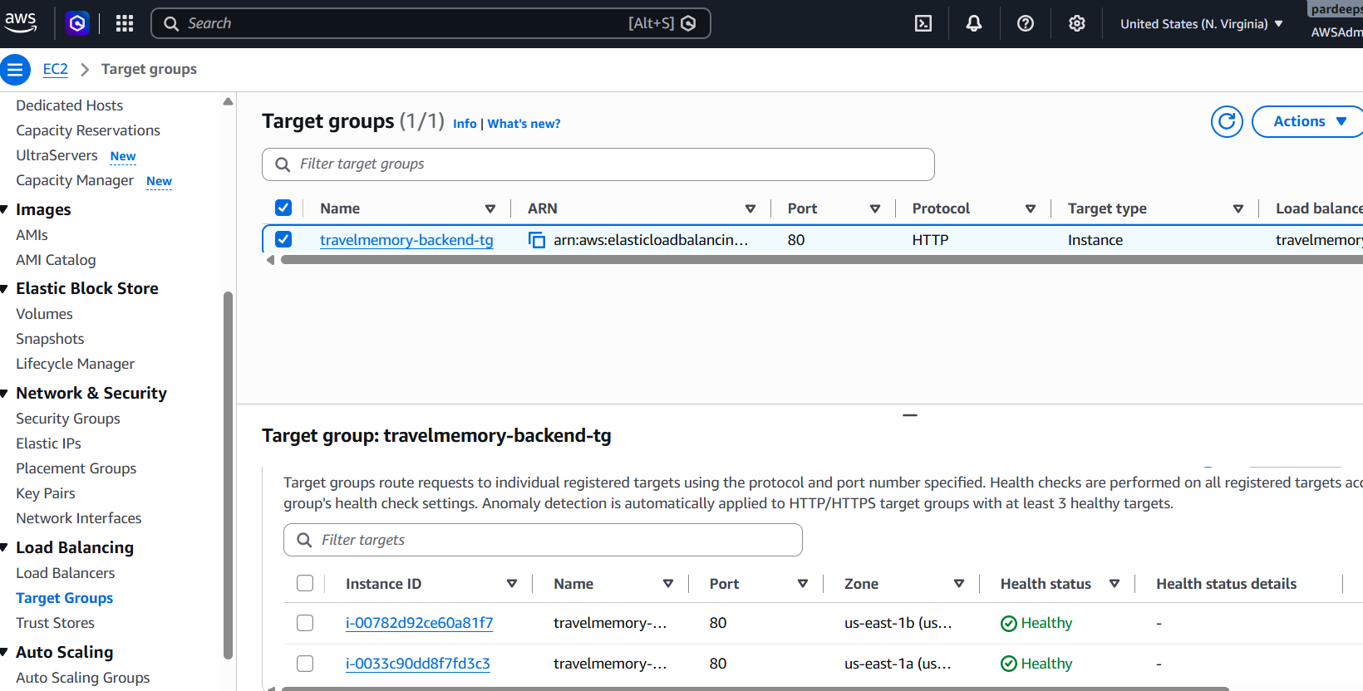

8.3 Backend ALB details

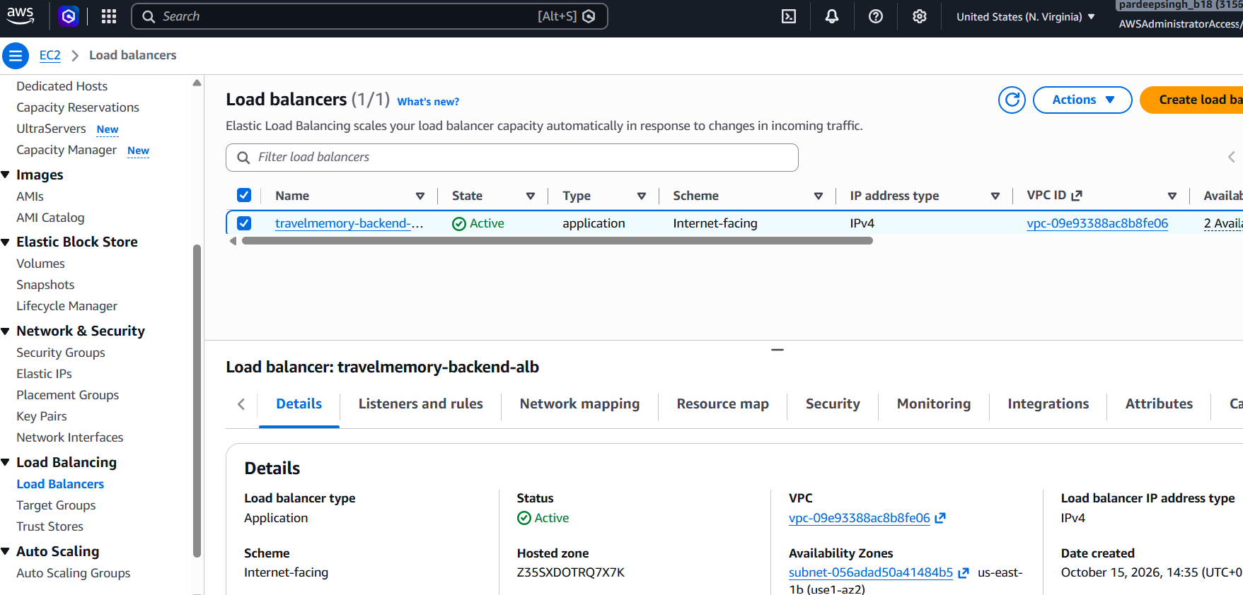

8.4 Listener configuration
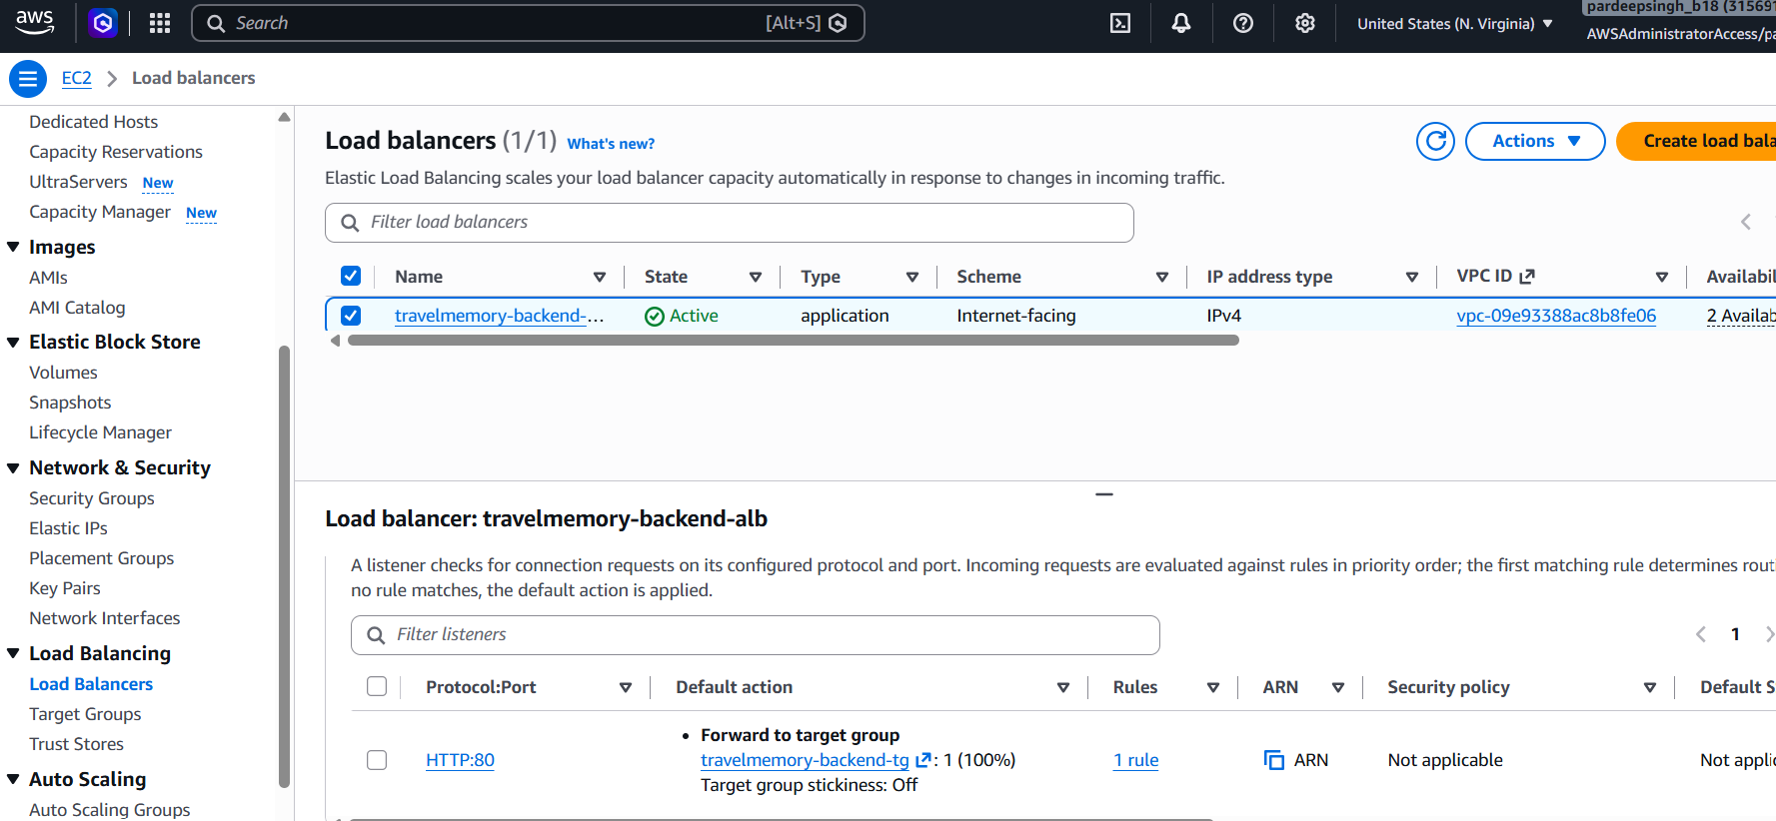

8.5 Successful ALB test

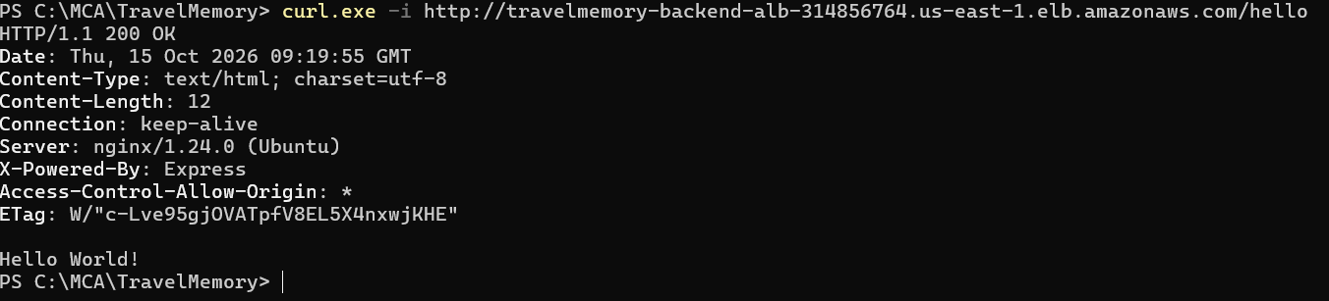

9 Frontend target Group + Load Balancer
Process summary: A frontend target group was created on HTTP port 80 with the root path as its health check. Both frontend instances were registered, a separate internet-facing frontend Application Load Balancer was created across two Availability Zones, and its listener distributed browser traffic to the healthy React/Nginx targets.

9.1 Frontend target-group configuration
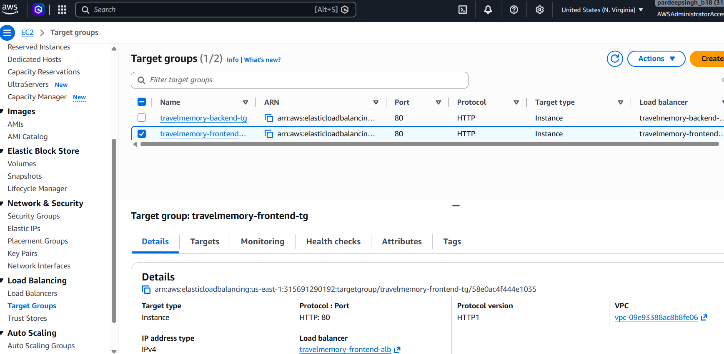

9.2 Both frontend targets healthy
Evidence statement: Both frontend instances passed the root-path health check on port 80.
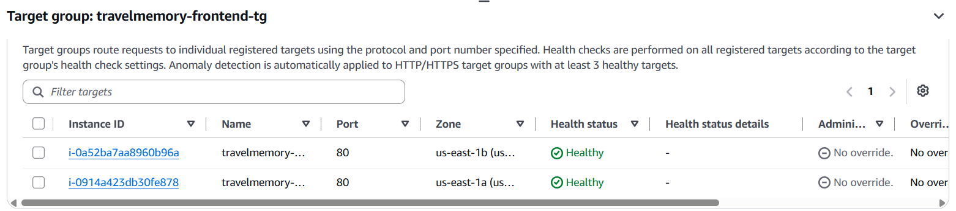

9.3 Frontend ALB details

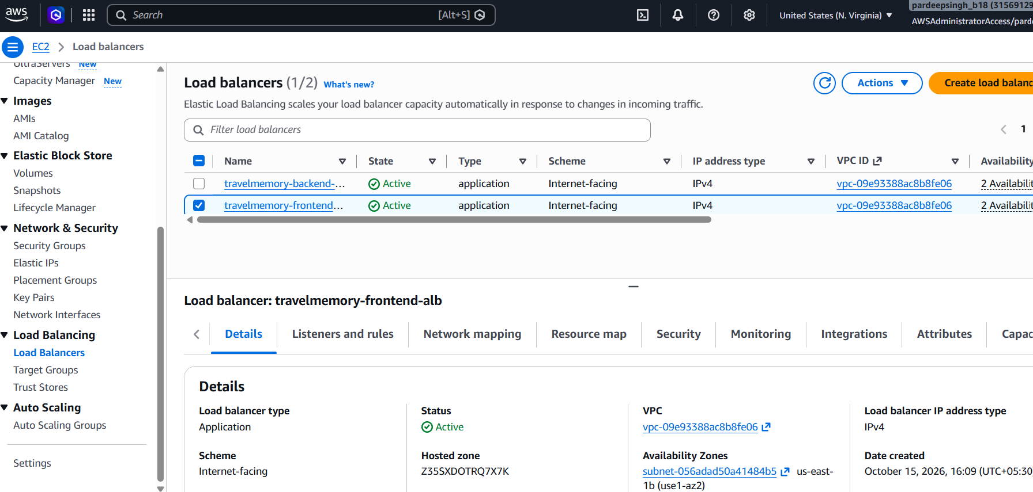

9.4 Frontend listener

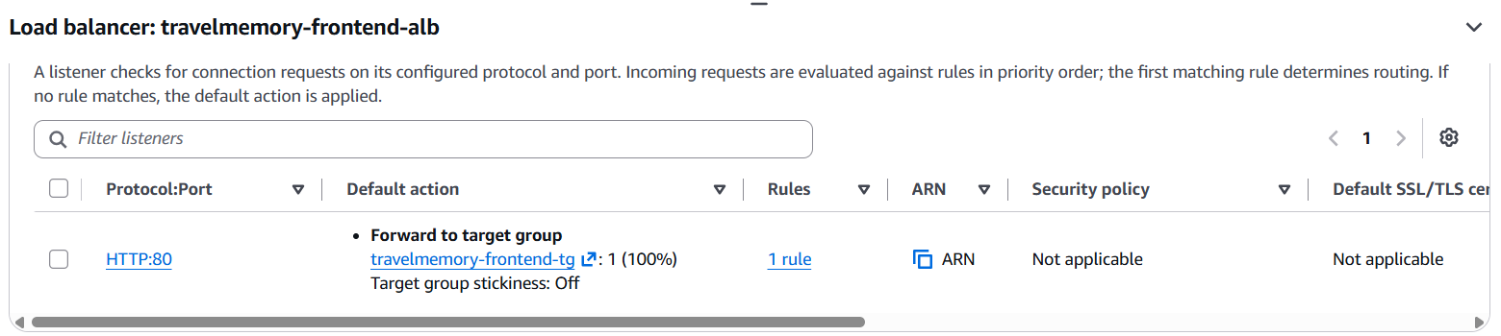

9.5 Frontend ALB HTTP test
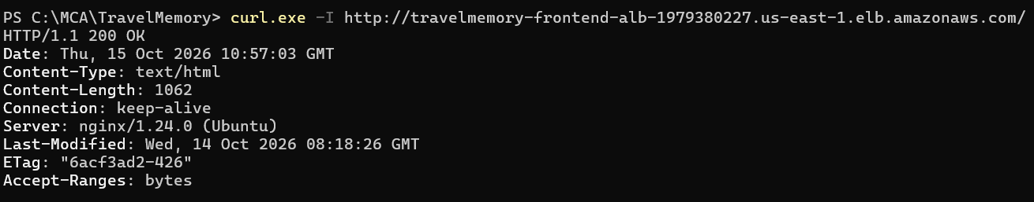

9.6 Application through frontend ALB
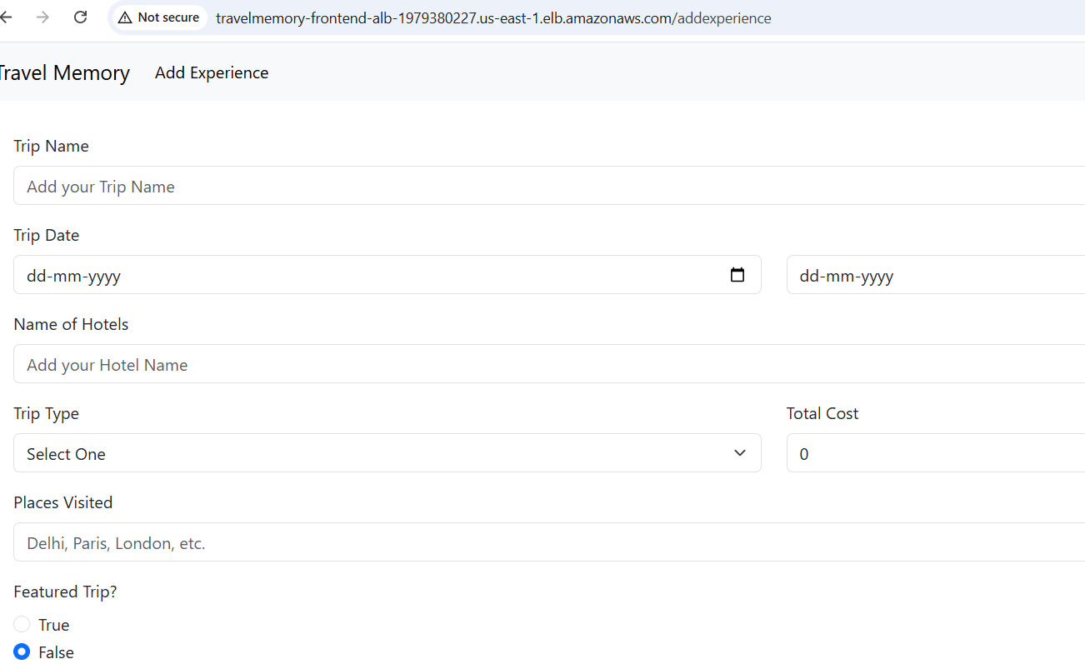

10 Point Frontend at the Backend Load Balancer
Process summary: Both frontend instances were updated so REACT_APP_BACKEND_URL referenced the backend load balancer DNS name. New production builds were generated and redeployed to Nginx, after which browser Network evidence and a functional record test confirmed end-to-end communication through both load balancers and MongoDB Atlas.

10.1 Backend ALB endpoint tests
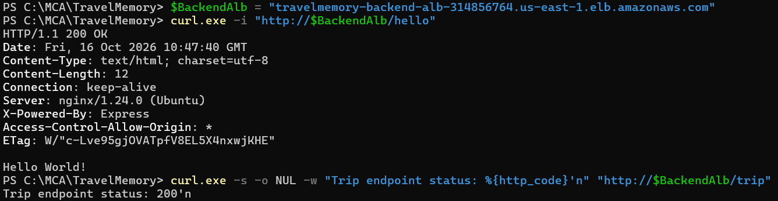

10.2 Browser Network request
Evidence statement: The browser request confirms the frontend uses the backend Application Load Balancer.
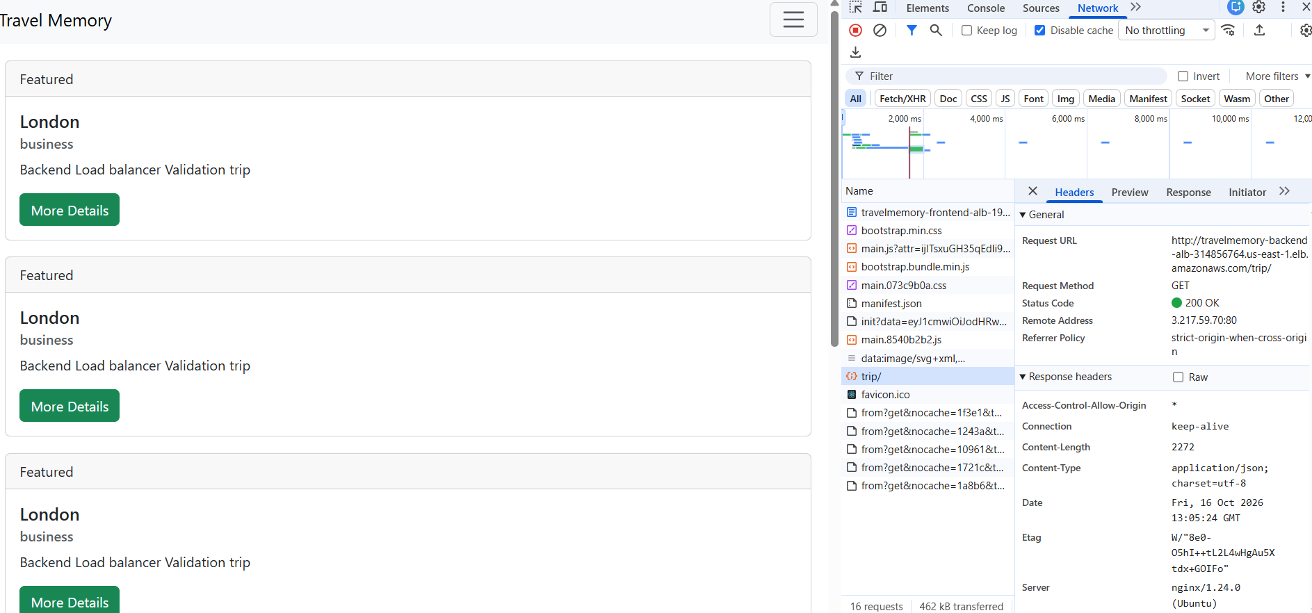

10.3 Functional record
Evidence statement: The persisted record demonstrates end-to-end create and read functionality.
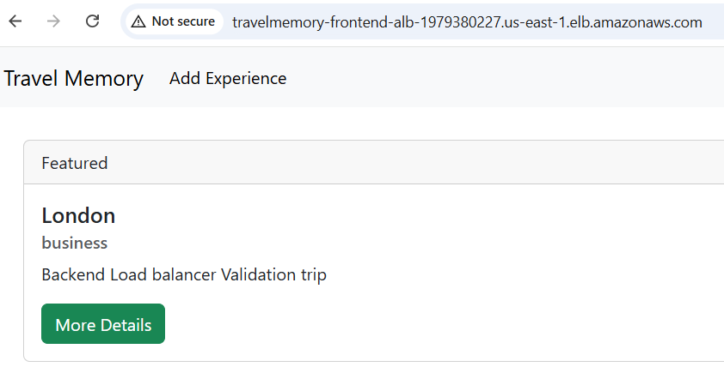

11. Final Verification and Submission

Final outcome
The collected evidence demonstrates a functioning load-balanced deployment with two frontend and two backend EC2 instances, persistent data in MongoDB Atlas, service recovery through systemd/Nginx, and successful frontend-to-backend communication through separate Application Load Balancers.

Optional component declaration Cloudflare DNS and HTTPS were not implemented because they were treated as optional. The final application was validated through the AWS frontend Application Load Balancer DNS name, and backend connectivity was validated through the backend Application Load Balancer DNS name.

Final submission checklist
☐ All four EC2 instances are running and show 2/2 status checks.
☐ Backend target group shows two healthy targets.
☐ Frontend target group shows two healthy targets.
☐ Backend ALB /hello and /trip endpoints return successful HTTP responses.
☐ Frontend ALB loads the TravelMemory application.
☐ Browser Network evidence shows the frontend calling the backend ALB.
☐ A functional TravelMemory record can be created and remains after refresh.
☐ No passwords, complete connection strings, private keys or tokens appear in the report.
☐ GitHub repository excludes .env, .env.production and .pem files.
☐ GitHub repository URL and live ALB URLs are added before portal submission.

Submission links
Deliverable | Value
GitHub repository | https://github.com/fabpardeep/TravelMemory
Live application | http://travelmemory-frontend-alb-1979380227.us-east-1.elb.amazonaws.com/
Backend health endpoint | http://travelmemory-backend-alb-314856764.us-east-1.elb.amazonaws.com /hello
Editable architecture diagram | TravelMemory_AWS_Architecture.drawio
Final report | Pardeep_Singh_TravelMemory_Deployment_Documentation.docx

