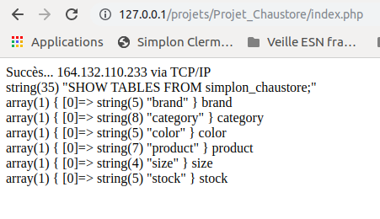

Toutes les tables de la base [simplon_chaustore]

Table PRODUCT

describe product;

Field | Type | Null | Key | Default | Extra
id | int(11) unsigned | NO | PRI | NULL | auto_increment
name | varchar(255) | NO | MUL
category_id | int(11) unsigned | NO | MUL
brand_id | int(11) unsigned | NO | MUL
color_id | int(11) unsigned | NO | MUL
image | varchar(255) | YES
price | decimal(5,2) unsigned | NO |  | 0.00
gender | char(1) | NO |  | M

show create table product ;

CREATE TABLE `product` (
`id` int(11) unsigned NOT NULL AUTO_INCREMENT,
`name` varchar(255) COLLATE utf8mb4_unicode_ci NOT NULL DEFAULT '',
`category_id` int(11) unsigned NOT NULL,
`brand_id` int(11) unsigned NOT NULL,
`color_id` int(11) unsigned NOT NULL,
`image` varchar(255) COLLATE utf8mb4_unicode_ci DEFAULT '',
`price` decimal(5,2) unsigned NOT NULL DEFAULT '0.00',
`gender` char(1) COLLATE utf8mb4_unicode_ci NOT NULL DEFAULT 'M',
PRIMARY KEY (`id`), KEY `name` (`name`(191)), KEY `product_brand` (`brand_id`), KEY `product_color` (`color_id`), KEY `product_category` (`category_id`),
CONSTRAINT `product_brand` FOREIGN KEY (`brand_id`) REFERENCES `brand` (`id`), CONSTRAINT `product_category` FOREIGN KEY (`category_id`) REFERENCES `category` (`id`), CONSTRAINT `product_color` FOREIGN KEY (`color_id`) REFERENCES `color` (`id`) ) ENGINE=InnoDB AUTO_INCREMENT=30 DEFAULT CHARSET=utf8mb4 COLLATE=utf8mb4_unicode_ci" }

Type requête | Requête SQL | Description requête
Sélection | Select * from <nom Table> ; | Sélection de tous les enregistrements d’une table donnée
Ajout brand | INSERT INTO brand VALUES ('','Napapijri',null);
Modification

Suppression

Select * from <nom Table> ;

