

UNIVERSITY OF RWANDA
COLLEGE OF BUSINESS AND ECONOMICS
SCHOOL OF ECONOMICS
DEPARTMENT OF APPLIED STATISTICS
OPTION OF DEMOGRAPHY

ASSESSMENT OF PREDICTIVE DETERMINANTS OF HOUSEHOLD POVERTY:
EVIDENCE FROM EICV7 (2023–2024)

A Dissertation Submitted in Partial Fulfillment of the Requirements
for the Award of a bachelor’s degree in applied Statistics

Submitted by:
NIYONSABA FABRICE
Registration Number: 222007705

Supervised by:
MWERULI FIDELE

Academic Year: 2025-2026

Huye, Rwanda

DECLARATION
I, NIYONSABA Fabrice, hereby declare that this dissertation titled "Assessment of Predictive Determinants of Household Poverty: Evidence from EICV7 (2023–2024)" is my own original work and has not been submitted for any degree or examination at any other university or institution of higher learning. All sources used have been duly acknowledged through references.

Signature:
Name: NIYONSABA Fabrice
Date:

This dissertation has been submitted with the approval of the supervisor:

Supervisor Signature:
Supervisor Name: MWERULI Fidele
Date:

DEDICATION
This dissertation is dedicated to my family, whose unwavering support, love, and encouragement have been essential to my academic journey. It is also dedicated to the people of Rwanda, whose resilience and commitment to development serve as an inspiration for researchers and policymakers striving to advance national progress.

ACKNOWLEDGEMENTS
First, I express my gratitude to the Almighty God for granting me health, wisdom, and perseverance throughout this academic endeavor. The completion of this dissertation was made possible through the guidance, support, and contributions of many individuals and institutions.

I extend my sincere gratitude to my supervisor, [Supervisor Name], whose expert guidance, constructive criticism, and patience throughout the research process have been invaluable. Their mentorship has significantly shaped this work.

I am deeply grateful to the National Institute of Statistics of Rwanda (NISR) for providing public access to the Integrated Household Living Conditions Survey (EICV7) dataset. The availability of high-quality micro-level data on Rwandan households has grounded this research and enhanced its policy relevance.

I also thank the lecturers and staff of the Department of Applied Statistics at the University of Rwanda, College of Business and Economics, for providing a strong academic foundation throughout my studies. Their dedication to teaching excellence has equipped me with the quantitative tools necessary for this analysis.

Special thanks are extended to my fellow students and colleagues for their moral support, constructive feedback, and encouragement during the most challenging phases of this research.

Finally, I acknowledge the financial and emotional support provided by my family, whose sacrifices have been essential to this academic achievement.

ABSTRACT
Despite substantial economic progress over the past two decades, household poverty persists as a significant development challenge in Rwanda. Identifying the determinants of household poverty is critical for designing evidence-based interventions aligned with Vision 2050 and the Sustainable Development Goals (SDGs). This study employs data from the Integrated Household Living Conditions Survey (EICV7), conducted by the National Institute of Statistics of Rwanda (NISR) in 2023–2024, to assess the primary predictors of household poverty status. The dataset comprises 15,054 households from all five provinces. It includes a comprehensive range of household characteristics, such as location, household size, electricity access, cooking fuel type, water source, and geographic region.

Logistic regression is employed as the primary analytical method, with poverty status (poor/non-poor) as the binary dependent variable. The overall poverty rate in the sample is 23.8%, and the extreme poverty rate is 4.2%. Regression results indicate that several factors are significant predictors of household poverty at the 1% significance level. Residing in a rural area increases the likelihood of poverty (Odds Ratio = 1.45, p < 0.001). Household size is a strong positive predictor, with each additional member increasing the odds of poverty by 32% (OR = 1.32, p < 0.001).
Access to electricity emerges as the strongest protective factor against poverty (OR = 0.36, p < 0.001), underscoring the importance of energy access for household welfare. Geographic location is also significant, with households in Western Province facing the highest odds of poverty (OR = 4.02) compared to Kigali City, followed by Southern Province (OR = 3.62), Eastern Province (OR = 2.57), and Northern Province (OR = 1.7). The model demonstrates a classification accuracy of 77.3%, an AUC-ROC of 0.723, and a McFadden Pseudo R-squared of 0.1095, indicating satisfactory predictive performance.
The Likelihood Ratio Chi-square statistic of 1,809.48 (p < 0.001) confirms the model's overall significance. These findings underscore the need for spatially targeted poverty-reduction initiatives, expanded electricity access, enhanced family-planning support, and increased rural development investments. It is recommended that Rwanda's social protection programs integrate these determinants to improve targeting efficiency.

Keywords: Household Poverty, Logistic Regression, EICV7, Rwanda, Determinants of Poverty, Rural-Urban Divide, Access to Electricity, Household Size.

LIST OF TABLES
Table 1.1: Definition of Key Variables Used in the Study
Table 3.1: Description of Variables and Their Measurement
Table 4.1: Descriptive Statistics of Key Variables
Table 4.2: Poverty Status Distribution by Province
Table 4.3: Poverty Status Distribution by Area of Residence (Urban/Rural)
Table 4.4: Poverty Rate by Household Size Category
Table 4.5: Access to Electricity and Poverty Status
Table 4.6: Cooking Fuel Type and Poverty Status
Table 4.7: Logistic Regression Results — Determinants of Household Poverty
Table 4.8: Model Fit Statistics

LIST OF ABBREVIATIONS
AIC | Akaike Information Criterion
AUC | Area Under the Receiver Operating Characteristic Curve
CBS | Central Bureau of Statistics
DHS | Demographic and Health Survey
EICV | Enquête Intégrale sur les Conditions de Vie des Ménages (Integrated Household Living Conditions Survey)
GDP | Gross Domestic Product
GoR | Government of Rwanda
HH | Household
IFC | International Finance Corporation
IMF | International Monetary Fund
LR | Likelihood Ratio
MDGs | Millennium Development Goals
MPI | Multidimensional Poverty Index
NISR | National Institute of Statistics of Rwanda
NST1 | National Strategy for Transformation 1
OLS | Ordinary Least Squares
OR | Odds Ratio
RALGA | Rwanda Association of Local Government Authorities
ROC | Receiver Operating Characteristic
SDGs | Sustainable Development Goals
SPSS | Statistical Package for the Social Sciences
SSA | Sub-Saharan Africa
UNDP | United Nations Development Program
VIF | Variance Inflation Factor
WB | World Bank
WFP | World Food Program

TABLE OF CONTENTS
Declaration ......................................................................................i
Dedication .......................................................................................ii
Acknowledgments.........................................................................iii
Abstract ...........................................................................................iv
List of Tables ...................................................................................v
List of Abbreviations .......................................................................vi

CHAPTER ONE: INTRODUCTION ................................................1
1.1 Background to the Study .......................................................1
1.2 Problem Statement .................................................................4
1.3 Objectives of the Study ..........................................................5
1.3.1 General Objective ..........................................................5
1.3.2 Specific Objectives ........................................................5
1.4 Research Questions ................................................................6
1.5 Research Hypotheses .............................................................6
1.6 Scope of the Study .................................................................7
1.7 Significance of the Study .......................................................7
1.8 Limitations of the Study ........................................................8

CHAPTER TWO: LITERATURE REVIEW ....................................9
2.1 Introduction ...........................................................................9
2.2 Theoretical Framework .........................................................9
2.3 Conceptual Framework .........................................................13
2.4 Empirical Literature ...............................................................14
2.5 Literature Review Summary and Research Gap .....................19

CHAPTER THREE: METHODOLOGY ........................................20
3.1 Introduction ...........................................................................20
3.2 Research Design ....................................................................20
3.3 Data Source ...........................................................................21
3.4 Study Population and Sampling .............................................22
3.5 Variable Description and Measurement .................................23
3.6 Analytical Model ....................................................................25
3.7 Model Diagnostics and Validation .........................................28
3.8 Ethical Considerations ...........................................................29

CHAPTER FOUR: DATA ANALYSIS AND RESULTS ...............30
4.1 Introduction ...........................................................................30
4.2 Descriptive Statistics .............................................................30
4.3 Bivariate Analysis ..................................................................33
4.4 Logistic Regression Results ...................................................37
4.5 Model Fit and Diagnostics .....................................................40
4.6 Discussion of Results ............................................................41

CHAPTER FIVE: SUMMARY, CONCLUSIONS, AND RECOMMENDATIONS45
5.1 Summary of Findings .............................................................45
5.2 Conclusions ...........................................................................46
5.3 Recommendations ..................................................................48
5.4 Suggestions for Further Research ..........................................50

References .........................................................................................51

CHAPTER ONE: INTRODUCTION
1.1 Background to the Study
Poverty is a multidimensional and persistent challenge that affects billions of people worldwide, particularly in Sub-Saharan Africa (SSA). Despite notable progress in economic development and poverty reduction globally, poverty remains deeply entrenched in many low- and middle-income countries, where structural barriers, geographic disadvantages, and unequal access to social services continue to constrain household welfare. Understanding the determinants of household poverty is therefore central to the design and implementation of effective social protection policies, targeted interventions, and development programs.

Rwanda, a small landlocked country in East Africa, has about 14 million people. (Rwanda, 2023) Since the 1994 Genocide against the Tutsi, Rwanda has seen strong economic growth and major changes. The country’s GDP per capita has steadily increased, and there have been improvements in poverty reduction, health, education, and governance. Rwanda’s Vision 2050 aims to make the country a middle-income nation by 2035 and an upper-middle-income nation by 2050, supported by the National Strategy for Transformation (NST1) and the United Nations Sustainable Development Goals (SDGs).

Despite this commendable progress, poverty remains a significant challenge in Rwanda, particularly in rural areas and provinces characterized by limited infrastructure, agricultural dependence, and constrained access to public services. The Government of Rwanda (GoR) uses the Integrated Household Living Conditions Survey (EICV), conducted by the National Institute of Statistics of Rwanda (NISR), as the primary instrument for monitoring poverty and living standards nationwide. The EICV is a nationally representative household survey that collects detailed data on consumption expenditure, household characteristics, housing conditions, access to services, and demographic indicators. The seventh round of this survey, EICV7, was conducted in 2023–2024 and provides the most up-to-date evidence on household living conditions in Rwanda.

According to the EICV7 dataset used in this study, Rwanda's national poverty rate is approximately 23.8%, with an extreme poverty rate of 4.2%. These figures reflect considerable heterogeneity across the country's five provinces, between urban and rural areas, and across different household characteristics. The Western and Southern Provinces exhibit the highest poverty rates (31.9% and 30.2%, respectively), while Kigali City has the lowest rate (6.6%). Rural households are more than twice as likely to be poor as urban households (27.6% versus 13.3%). These disparities underscore the need for a rigorous statistical analysis of the factors predicting household poverty, moving beyond aggregate statistics to identify the specific household- and community-level characteristics that drive poverty outcomes.

Globally, the academic literature on the determinants of poverty is extensive. Studies have consistently identified household size, educational attainment of the household head, access to basic services (water, electricity, sanitation), employment status, geographic location, and asset ownership as key predictors of poverty status. In Sub-Saharan Africa, additional factors such as land ownership, agricultural dependence, remittances, and access to credit are significant. However, context-specific analyses are essential, as the relative importance of different determinants varies across countries and time periods depending on structural conditions, policy environments, and data availability.

In Rwanda specifically, several studies have examined the correlates of poverty using earlier EICV rounds. These studies have highlighted the importance of rural residence, household size, educational level, and geographic location as important predictors of poverty. However, the EICV7 dataset offers new opportunities to update and refine these findings with the most recent data, incorporating the latest changes in Rwanda's economic and social landscape. This study, therefore, fills an important gap by providing a rigorous, quantitative assessment of the predictive determinants of household poverty using EICV7 data and applying logistic regression modeling to generate actionable insights for policymakers.

1.2 Problem Statement
Rwanda has made extraordinary strides in poverty reduction over the past two decades. Between 2000 and 2017, the national poverty rate declined sharply from over 60% to approximately 38%, driven by strong economic growth, agricultural intensification, social protection programs, and improvements in health and education outcomes. (Rwanda: Achieving Food Security, Reducing Poverty, Moving up the Value Chain, 2016) However, progress has been uneven, and the pace of poverty reduction has slowed in recent years due to a combination of internal and external factors, including climate-related agricultural shocks, COVID-19 pandemic disruptions, and the rising cost of living.

Despite the availability of rich micro-level data from successive EICV surveys, a comprehensive quantitative analysis of the predictive determinants of household poverty using EICV7 data has not yet been conducted. This gap is significant because policymakers and development practitioners require up-to-date, evidence-based information on which household characteristics most strongly predict poverty status to improve the targeting of social protection programs, prioritize infrastructure investments, and design sector-specific interventions. Without such evidence, poverty reduction programs risk being misallocated, reaching households that are not among the poorest or failing to address the root causes of poverty in specific geographic areas.

Furthermore, the reliance on aggregate poverty statistics masks important heterogeneity in poverty outcomes across households, communities, and provinces. A household-level analysis using logistic regression provides a more nuanced and statistically robust picture of poverty predictors, quantifying the independent contribution of each determinant while controlling for other factors. This study, therefore, addresses the critical question: what are the key predictive determinants of household poverty in Rwanda, as revealed by the EICV7 (2023–2024) dataset?

1.3 Objectives of the Study
1.3.1 General Objective
The general objective of this study is to assess the predictive determinants of household poverty in Rwanda using data from the Integrated Household Living Conditions Survey (EICV7), conducted by the National Institute of Statistics of Rwanda in 2023–2024.

1.3.2 Specific Objectives
The following specific objectives guide the study:
- To determine the effect of rural/urban residence on household poverty status in Rwanda.
- To examine the relationship between household size and the likelihood of being poor.
- To analyze the effect of access to electricity on household poverty status.
- To assess the geographic variation in poverty across Rwanda's provinces.

1.4 Research Questions
The following research questions guide this study:
- Does rural/urban residence significantly predict the probability of a household being poor in Rwanda?
- What is the relationship between household size and household poverty status?
- Does access to electricity significantly reduce the likelihood of household poverty?
- How does provincial location influence household poverty status in Rwanda?

1.5 Research Hypotheses
Based on the specific objectives and research questions, the study tests the following hypotheses:

H01: Rural/urban residence has no statistically significant effect on household poverty status in Rwanda.
H1: Rural/urban residence has a statistically significant positive effect on household poverty status.

H02: Household size has no statistically significant effect on the likelihood of household poverty.
H2: Household size has a statistically significant positive effect on household poverty.

H03: Access to electricity has no statistically significant effect on household poverty status.
H3: Access to electricity has a statistically significant negative effect on household poverty status.

H04: There is no significant difference in poverty rates across Rwanda's provinces.
H4: There is a statistically significant difference in poverty rates across Rwanda's provinces.

1.6 Scope of the Study
This study is limited in scope to Rwanda as the geographic area of analysis and uses the EICV7 dataset, which covers the 2023–2024 survey period. The dataset includes 15,054 households drawn from all five provinces of Rwanda (Kigali City and Eastern, Southern, Western, and Northern Provinces) and is nationally representative. The analysis focuses on household-level predictors of poverty, specifically rural/urban residence, household size, access to electricity, cooking fuel type, improved water access, adult equivalents, and provincial location. The study does not examine time-series dynamics or longitudinal changes in poverty determinants, as it is based on a single cross-sectional survey round.

1.7 Significance of the Study
This study makes several important contributions to the empirical literature on poverty analysis in Rwanda and, more broadly, in Sub-Saharan Africa.

First, it provides the most up-to-date quantitative assessment of the determinants of household poverty in Rwanda, using the recently released EICV7 (2023–2024) data. This fills an important evidence gap and provides a timely reference point for policymakers and researchers working on poverty reduction in Rwanda.

Second, the logistic regression model developed in this study provides a practical predictive tool for estimating the probability of poverty for any household given its observed characteristics. This has direct applications in poverty targeting, social protection program design, and monitoring and evaluation frameworks.

Third, the study contributes to the broader academic discourse on poverty determinants in low-income countries by demonstrating the critical role of energy access (electricity) as a protective factor against poverty, while confirming the persistent negative effects of rural residence and large household size.

Fourth, the findings of this study are directly relevant to Rwanda's national development agenda, including the National Strategy for Transformation 1 (NST1), the Vision 2050 framework, and Rwanda's commitments to the SDGs, particularly SDG 1 (No Poverty) and SDG 7 (Affordable and Clean Energy).

1.8 Limitations of the Study
While this study uses a rich and nationally representative dataset, several limitations should be acknowledged. First, the study is based on cross-sectional data, which limits the ability to draw causal inferences about the relationship between the identified determinants and poverty. While the logistic regression model identifies statistically significant predictors, correlation should not be interpreted as causation.

Second, some important factors that influence poverty, such as the education level of the household head, employment status, land owned, and access to credit, could not be fully included in the model due to data limitations. Future research should aim to add these variables.

Third, the EICV7 dataset is based on self-reported consumption expenditure and household characteristics, which may be subject to measurement error and recall bias. However, NISR employs rigorous survey methodology and quality-control procedures to minimize these issues.

Fourth, the improved water variable shows perfect separation in the data, meaning all its variation is explained by other factors, which made its coefficient unstable. This variable was kept in the model, but its results should be viewed with caution.
2.1 Introduction
This chapter reviews the theoretical and empirical literature on the determinants of household poverty. It begins with the main theoretical frameworks used to explain poverty, followed by a discussion of the conceptual framework guiding this study, and then a review of empirical studies from Rwanda, Africa, and the broader international literature. The chapter concludes by identifying the research gap that the present study seeks to address.

2.2 Theoretical Framework
2.2.1 Capability Approach
The capability approach, developed by Amartya Sen (1999) and later expanded by Martha Nussbaum, is a key framework for understanding poverty. It sees poverty not just as a lack of income or consumption, but as a lack of basic human capabilities. These include being well-nourished and healthy, being able to participate in society, and having access to education and resources.

The capability approach is relevant to this study because it broadens the conceptualization of poverty beyond monetary measures to encompass access to basic services, such as clean water, electricity, and adequate housing. In Rwanda's context, the EICV7 data capture many of these capability-related dimensions, enabling a comprehensive analysis that goes beyond income poverty alone. The inclusion of variables such as access to electricity, improved water sources, and housing quality in the empirical model is directly informed by the capability approach.

2.2.2 The Household Human Capital Theory
Human capital theory, originating in the work of Gary Becker (1964) and Theodore Shultz (1961), posits that investments in education, health, and skills enhance the productive capacity of individuals and households, thereby reducing their vulnerability to poverty. According to this theory, households with higher levels of human capital — particularly education and health — are better equipped to access productive employment, earn higher incomes, and achieve better living standards.

In the context of this study, human capital considerations are reflected in the household's access to electricity, which serves as a proxy for the household's ability to engage in productive activities, including children's education, small-business operations, and access to information. Studies by Khandker et al. (2012) and Dinkelman (2011) have demonstrated robust positive effects of electrification on household income and poverty reduction, providing empirical support for including electricity access as a key determinant in the model.

2.2.3 The Dual Economy Model (Lewis, 1954)
W. Arthur Lewis's dual economy model (1954) provides important insights into the rural-urban dynamics of poverty in developing countries. The model posits two economic sectors: a traditional subsistence agricultural sector, characterized by low productivity and surplus labor, and a modern industrial/urban sector, characterized by higher productivity and wages. The rural-urban wage differential drives migration from rural to urban areas, gradually absorbing surplus labor and reducing rural poverty over time.

This theoretical framework explains the persistent rural-urban poverty gap observed in Rwanda and many other developing countries. Rural households, which depend primarily on subsistence agriculture with limited access to markets, credit, and technology, tend to have lower consumption levels and higher poverty rates than urban households. The EICV7 data strongly confirm this pattern: rural households in Rwanda have a poverty rate of 27.6%, more than double the urban poverty rate of 13.3%. The Lewis model, therefore, provides theoretical justification for including rural/urban residence as a key predictor in the logistic regression model.

2.2.4 The Malthusian Population-Poverty Trap
Thomas Malthus's (1798) theory suggests that fast population growth reduces the benefits of labor in farming, lowers wages to basic levels, and keeps people in poverty. More recent versions, like those by Bloom, Canning, and Malaney (2000), focus on how high birth rates and large families can trap households in poverty across generations. Large families often have fewer working adults supporting more dependents, which lowers average consumption and increases the risk of poverty.

Empirical evidence from Rwanda and other Sub-Saharan African countries consistently shows a strong positive relationship between household size and poverty. The EICV7 data support this finding, with households of 7 or more members exhibiting a poverty rate of 36.2%, compared to only 11.1% for households with 1–2 members. This provides strong empirical grounding for including household size as a key predictor of poverty in the logistic regression model.

2.3 Conceptual Framework
Based on the theoretical frameworks discussed above, this study adopts the following conceptual framework to guide the empirical analysis. Household poverty status is conceptualized as the outcome variable, determined by household- and geographic-level predictors. These predictors are grouped into three categories: household demographic characteristics (household size, adult equivalents), household access to services (electricity, water source, cooking fuel), and geographic/locational factors (rural/urban residence, provincial location).

The conceptual model can be expressed as:

P(Poor = 1) = f(Rural, HH_Size, Electricity, Province, Water, Fuel, AE)

Where P(Poor = 1) denotes the probability of a household being classified as poor, and the independent variables capture the key theoretical drivers of poverty outlined above. The logistic regression model, described in detail in Chapter Three, translates this conceptual framework into an estimable empirical specification.

2.4 Empirical Literature
2.4.1 Evidence from Rwanda
Several studies have examined the determinants of household poverty in Rwanda using earlier rounds of the EICV survey. Munyegera and Matsumoto (2016) used EICV data to analyze the impact of mobile money adoption on household welfare and poverty in Rwanda, finding that households with access to mobile financial services had significantly lower poverty rates. This finding highlights the role of financial inclusion as a protective factor against poverty, a dimension not directly captured in the current study but worth noting in the broader literature.

NISR's official poverty analysis reports based on EICV3, EICV4, and EICV5 consistently identify rural residence, large household size, low educational attainment, and geographic location as primary correlates of poverty in Rwanda. The EICV5 (2016–17) report noted that poverty rates in the Western and Southern Provinces were significantly higher than in Kigali City and the Eastern Province, a pattern that the current study, using EICV7 data, confirms and updates.

Bigsten and Tengstam (2015) examined poverty dynamics in Rwanda using panel data and found strong evidence of poverty persistence, particularly among rural households with limited human capital. They argued that breaking the poverty trap requires simultaneous investments in education, health, and agricultural productivity. Habimana (2018) analyzed the impact of Rwanda's Ubudehe social protection program on household welfare using EICV4 data and found significant reductions in poverty among targeted households, demonstrating the effectiveness of well-targeted social protection in reducing poverty when determinants are correctly identified.

Rutayisire et al. (2020) examined the geographic determinants of child poverty in Rwanda using EICV5 data and small area estimation methods. They found substantial spatial heterogeneity in child poverty rates across districts, with the highest rates in Western Province and some districts of Southern Province. This spatial pattern is consistent with the provincial-level findings of the current study, which identifies Western and Southern Province as high-poverty regions.

2.4.2 Evidence from Sub-Saharan Africa
The empirical literature on poverty determinants in Sub-Saharan Africa is extensive and converges on several key findings that are relevant to Rwanda's context. Dercon (2006) analyzed poverty dynamics across five African countries and found that household vulnerability to poverty is strongly predicted by asset ownership, geographic location, and access to markets. Households in remote, rural areas with limited market integration were consistently found to be more vulnerable to persistent poverty.

Christiansen, Demery, and Kuhl (2011) examined the relationship between agriculture, poverty, and growth in Sub-Saharan Africa and found that agricultural growth is particularly effective at reducing poverty among the poorest households, who are concentrated in rural areas and depend primarily on subsistence farming. This finding is directly relevant to Rwanda, where rural poverty reduction is closely linked to agricultural transformation under the Crop Intensification Program (CIP) and other agricultural development initiatives.

Banerjee and Duflo (2007) studied the economic lives of people with low incomes in 13 developing countries and found that poor households typically have large families, limited access to electricity, rely on biomass fuels for cooking, and have poor-quality housing. These findings are strongly corroborated by the EICV7 data and the current study's logistic regression results, which confirm that household size, electricity access, and fuel type are robust predictors of poverty status.

Dinkelman (2011) provided a seminal study of the effects of rural electrification on employment and poverty in South Africa, finding that electrification significantly increased women's employment and reduced poverty through both direct productive effects and indirect effects on health and education. Subsequent studies in Ethiopia (Kassie et al., 2011), Kenya (Lay & Nohlen, 2015), and Uganda (Mawejje & Mwesigye, 2016) have similarly found that access to electricity is one of the strongest predictors of household welfare and poverty status in Sub-Saharan Africa.

2.4.3 Evidence from Global Studies
At the global level, the World Bank's extensive research on poverty measurement and determinants provides an important reference framework. Ravallion (2016) reviewed the global evidence on poverty determinants and concluded that economic growth is the most powerful driver of poverty reduction at the aggregate level, but that the poverty-reducing effect of growth depends critically on its distribution and on the initial conditions of human capital, infrastructure, and institutions.

Alkire and Foster (2011) developed the Multidimensional Poverty Index (MPI), which captures deprivations across three dimensions — health, education, and living standards — and has been widely adopted as a complement to monetary poverty measures. In Rwanda, the MPI has been tracked alongside monetary poverty in successive EICV reports, consistently showing significant overlap but also important differences between monetary and multidimensional poverty. The variables included in the current study — electricity access, water source, and cooking fuel — are directly aligned with the living standards dimension of the MPI, reinforcing their theoretical relevance as poverty predictors.

Haughton and Khandker (2009) provide a comprehensive methodological guide to poverty measurement and analysis, recommending logistic regression and probit models as the most appropriate methods for analyzing the binary outcome of poverty status. Their work provides methodological support for the analytical approach adopted in this study. Similarly, Greene (2012) demonstrates the superiority of the logit model over linear probability models when the dependent variable is binary, avoiding the problems of predicted probabilities outside the [0,1] interval and heteroskedastic error terms.

2.5 Literature Review Summary and Research Gap
The theoretical and empirical literature consistently identifies household size, geographic location (rural/urban and regional), and access to basic services (particularly electricity) as robust predictors of household poverty. While considerable research exists on poverty determinants in Rwanda using earlier EICV rounds, no study has yet conducted a comprehensive logistic regression analysis of poverty determinants using the EICV7 (2023–2024) dataset, which represents the most recent and updated evidence on household living conditions in Rwanda.

This study addresses this gap by applying logistic regression to a nationally representative sample of 15,054 households from the EICV7 dataset, providing updated, statistically rigorous estimates of the predictive determinants of household poverty. The findings provide new empirical evidence directly relevant to Rwanda's current poverty reduction agenda and provide a baseline for monitoring progress under Vision 2050 and NST1.

CHAPTER THREE: METHODOLOGY
3.1 Introduction
This chapter describes the research methodology adopted in this study. It outlines the research design; data source and collection process; population and sampling strategy; variable description and measurement; the analytical model used to estimate the predictive determinants of household poverty; and the diagnostic tests applied to validate the model. The chapter concludes with a note on ethical considerations.

3.2 Research Design
This study uses a quantitative, cross-sectional research design, appropriate because data were collected at a single point in time during the EICV7 survey period (2023–2024). The study aims to describe and explain the distribution of poverty across households at that time, rather than tracking changes over time. The quantitative approach enables estimation of statistical relationships between household characteristics and poverty status using a large, nationally representative dataset. Logistic regression is applied to examine multiple predictors simultaneously while controlling for confounding variables. Descriptive analysis, including frequency distributions, cross-tabulations, and summary statistics, provides an overview of poverty patterns before the multivariate analysis.

3.3 Data Source
The data used in this study are drawn from the Integrated Household Living Conditions Survey Round 7 (EICV7), conducted by the National Institute of Statistics of Rwanda (NISR) in 2023–2024. The EICV is Rwanda's primary nationally representative household survey, designed to collect comprehensive information on household consumption, living conditions, access to services, and demographic characteristics. It is the principal data source for poverty measurement, monitoring, and analysis in Rwanda.

The EICV7 was designed using a two-stage stratified cluster sampling methodology. In the first stage, Enumeration Areas (EAs) were selected from across the country using probability proportional to size (PPS) sampling, stratified by province and urban/rural location. In the second stage, households were randomly selected from within each selected EA. The survey was implemented across all four provinces and Kigali City, covering both urban and rural areas. The survey collected information on household members, housing conditions, access to utilities, food and non-food consumption, income sources, assets, and participation in social protection programs.

The cleaned and processed dataset used in this study contains 15,054 household records and 297 variables. The dataset was cleaned prior to analysis, with missing values addressed through listwise deletion for the logistic regression model, resulting in complete case analysis. All poverty classifications (poor/non-poor and extreme poor/non-extreme poor) were derived by NISR using consumption aggregate methodology, comparing household consumption per adult equivalent against nationally defined poverty lines (560,127 RWF for the poverty line and 356,432 RWF for the extreme poverty line, in January 2024 prices).

3.4 Study Population and Sampling
The study population consists of all households in Rwanda during the EICV7 survey period (2023–2024). The study uses the full EICV7 cleaned household dataset of 15,054 observations, which is nationally representative of Rwanda's approximately 3.6 million households. The sampling strategy employed by NISR ensures that the dataset provides reliable estimates at the national level, for each province, and for urban and rural areas separately.

The sample is distributed as follows: 3,885 households from Southern Province (25.8%), 3,401 from Eastern Province (22.6%), 3,400 from Western Province (22.6%), 2,430 from Northern Province (16.1%), and 1,938 from Kigali City (12.9%). By residence type, 11,060 households (73.5%) are in rural areas, and 3,994 (26.5%) are in urban areas. These proportions reflect the actual distribution of Rwanda's population across provinces and between urban and rural areas. (EICV7 - Main Indicators Report 2023/24, n.d.)

3.5 Variable Description and Measurement
The study uses one dependent variable and ten independent variables, drawn from the EICV7 dataset. Table 3.1 below provides a detailed description of each variable, its dataset source, and its measurement.

poverty (pov _ jan) | Dependent | Household poverty status based on consumption per adult equivalent vs. the national poverty line | Binary: 1 = Poor, 0 = Non-poor
rural | Independent | Area of residence of the household | Binary: 1 = Rural, 0 = Urban
H h _ size (member) | Independent | Total number of household members | Continuous (count: 1–16)
has electricity (s5cq14) | Independent | Whether the household has access to any electricity (grid or solar) | Binary: 1 = Yes (any electricity), 0 = No
Southern Province | Independent | Household located in Southern Province (reference: Kigali City) | Binary: 1 = Southern, 0 = Other
Western Province | Independent | Household located in Western Province | Binary: 1 = Western, 0 = Other
Eastern Province | Independent | Household located in Eastern Province | Binary: 1 = Eastern, 0 = Other
Northern Province | Independent | Household located in Northern Province | Binary: 1 = Northern, 0 = Other
uses firewood (s5cq22a) | Independent | Primary cooking fuel is firewood — a proxy for poor household energy access. | Binary: 1 = Firewood, 0 = Other
improved water (s5fq1) | Independent | Access to an improved drinking water source | Binary: 1 = Improved source, 0 = Unimproved
ae_ count (ae) | Independent | Number of adult equivalents in the household (standardized measure of household size) | Continuous

Table 3.1: Description of Variables and Their Measurement

The dependent variable, poverty status, is a binary variable derived from the NISR poverty classification in the EICV7 dataset. A household is classified as poor if its total consumption per adult equivalent falls below the national poverty line of 560,127 Rwandan Francs (approximately USD 400 in 2024 prices). This threshold is set by NISR using the cost of basic needs method, which estimates the minimum expenditure required to meet basic food and non-food needs. (EICV7 - Methodological Notes 2023/24, n.d.)

The key independent variables are selected based on theoretical considerations (Section 2.2), empirical evidence from the literature (Section 2.4), and data availability in the EICV7 dataset. Provincial dummy variables are created with Kigali City as the reference category, as it consistently exhibits the lowest poverty rate and represents Rwanda's primary urban economic hub.

3.6 Analytical Model
3.6.1 Rationale for Logistic Regression
The study employs binary logistic regression as the primary analytical method. Logistic regression is the most appropriate statistical technique when the dependent variable is binary (e.g., poverty status: poor vs non-poor) and the independent variables include a mix of continuous and categorical predictors. Unlike the Ordinary Least Squares (OLS) regression, which is unsuitable for binary dependent variables because it can produce predicted probabilities outside the valid [0,1] range and violates the assumption of homoskedasticity, logistic regression models the log-odds of the outcome as a linear combination of predictors, ensuring that predicted probabilities are always bounded between 0 and 1.

Logistic regression is widely used in poverty analysis (Haughton & Khandker, 2009; Greene, 2012) and has been applied in numerous studies of poverty determinants in Rwanda and other developing countries. It provides interpretable coefficients as odds ratios, which directly quantify the effect of each predictor on the likelihood of poverty while controlling for other variables in the model.

3.6.2 Model Specification
Let Yi denote the poverty status of household i, where Yi = 1 if the household is poor and Yi = 0 otherwise. The logistic regression model specifies the probability of poverty as follows:

P(Yi = 1 | Xi) = exp(Xi'β) / [1 + exp(Xi'β)]

Where Xi is the vector of independent variables for household i, and β is the vector of unknown parameters to be estimated. Equivalently, the model can be written in terms of the log-odds (logit):

logit[P(Yi = 1)] = ln[P/(1-P)] = β0 + β1Rural + β2HHSize + β3Electricity + β4Southern + β5Western + β6Eastern + β7Northern + β8Firewood + β9Water + β10AE + εi

The parameters β0 through β10 are estimated by maximum likelihood estimation (MLE), which finds the values of β that maximize the likelihood of observing the sample data given the model specification. Standard errors are computed from the inverse of the Fisher information matrix (Hessian of the log-likelihood), enabling the calculation of z-statistics and p-values for hypothesis testing.

3.6.3 Interpretation of Coefficients
The estimated logit coefficients (βk) represent the change in the log-odds of poverty for a one-unit increase in the corresponding predictor, holding all other predictors constant. For binary predictors, the coefficient represents the difference in log-odds between the two categories.
Coefficients are typically converted to odds ratios (OR = exp(βk)) for ease of interpretation. An OR greater than 1 indicates that the predictor increases the likelihood of poverty, while an OR less than 1 indicates a protective (poverty-reducing) effect.

For provincial dummy variables, the odds ratio represents the ratio of poverty odds for households in that province compared to households in Kigali City (the reference category), holding other variables constant.
For continuous variables such as household size, the odds ratio represents the multiplicative change in the odds of poverty for each one-unit increase in the variable.

3.7 Model Diagnostics and Validation
Several diagnostic and validation measures are applied to assess the quality and predictive performance of the logistic regression model:

McFadden's Pseudo R-squared: This measures the proportional improvement in log-likelihood from the null model (intercept only) to the full model. Values between 0.10 and 0.25 are considered indicative of a good model fit in logistic regression (McFadden, 1974).

Likelihood Ratio (LR) Chi-squared Test: This tests the joint significance of all predictors in the model. The test statistic is LR = -2(LL_null - LL_full), distributed as chi-squared with degrees of freedom equal to the number of predictors. A significant LR statistic (p < 0.05) indicates that the model as a whole provides a statistically significant improvement over the null model.

Area Under the ROC Curve (AUC): The AUC measures the discriminatory power of the model — its ability to correctly distinguish poor from non-poor households. An AUC of 0.5 indicates no better than random discrimination; an AUC of 1.0 indicates perfect discrimination. Values above 0.70 are generally considered acceptable for social science models.

Classification Accuracy: The percentage of households correctly classified as poor or non-poor using a threshold of 0.5 for the predicted probability. This provides an intuitive measure of predictive accuracy.

Akaike Information Criterion (AIC): The AIC penalizes model complexity and is used for model comparison. Lower AIC values indicate better-fitting models with fewer unnecessary parameters.

3.8 Ethical Considerations
This study uses secondary data from the publicly available EICV7 dataset, released by the National Institute of Statistics of Rwanda (NISR) for research and analysis purposes. The data do not contain personally identifiable information (PII) — household identifiers are anonymized — and therefore do not pose risks to the privacy or confidentiality of survey respondents. No primary data collection was undertaken, and therefore no ethical clearance from a research ethics committee was required beyond the standard procedures of academic integrity.

The analysis is conducted with full acknowledgment of the data source (NISR/EICV7) and adherence to the NISR's data use policy. The findings are reported honestly and transparently, including the limitations of the analysis, and are intended to inform evidence-based policy making for the benefit of Rwanda's population.

CHAPTER FOUR: DATA ANALYSIS AND RESULTS
4.1 Introduction
This chapter presents the analysis results, beginning with descriptive statistics to summaries the sample and poverty patterns. It then examines the relationship between each factor and poverty, followed by logistic regression results and model diagnostics. The findings are discussed in relation to the theoretical frameworks and prior studies from Chapter Two.

4.2 Descriptive Statistics
4.2.1 Sample Overview and Poverty Distribution
The analysis is based on 15,054 household observations from the EICV7 survey, conducted by the National Institute of Statistics of Rwanda in 2023–2024. The sample is nationally representative and covers all five provinces of Rwanda. Table 4.1 below presents key descriptive statistics for the continuous variables used in the analysis.

Variable | N | Mean | Std. Dev. | Min | 25th Pct | Median | 75th Pct | Max
Household Size (members) | 15,054 | 4.13 | 2.03 | 1 | 3 | 4 | 5 | 16
Adult Equivalents (AE) | 15,054 | 2.86 | 1.32 | 0.81 | 1.98 | 2.64 | 3.65 | 11.31
Consumption per AE (RWF) | 15,054 | 989,234 | 1,319,881 | 117,988 | 467,178 | 663,909 | 1,021,548 | 34,474,830
Poverty Line (RWF) | 15,054 | 560,127 | — | — | — | — | — | —
Extreme Poverty Line (RWF) | 15,054 | 356,432 | — | — | — | — | — | —

The average household size is 4.13 members, with a standard deviation of 2.03, indicating considerable variation across households. The median household has 4 members, while the largest household recorded has 16 members. Mean consumption per adult equivalent is approximately 989,234 RWF, well above the poverty line of 560,127 RWF. However, the high standard deviation (1,319,881 RWF) and the large gap between the mean and median (663,909 RWF) indicate a highly skewed distribution of consumption, with a small number of very wealthy households pulling the mean upward. Overall, 3,581 out of 15,054 households (23.8%) are classified as poor, and 628 (4.2%) are classified as extremely poor. (EICV7 - Main Indicators Report 2023/24, n.d.)

4.2.2 Poverty Status Distribution
Table 4.2 presents the distribution of poverty status across Rwanda's five provinces.

Province | Total HHs | Poor HHs | Non-Poor HHs | Poverty Rate (%)
Kigali City | 1,938 | 127 | 1,811 | 6.6%
Northern Province | 2,430 | 426 | 2,004 | 17.5%
Eastern Province | 3,401 | 769 | 2,632 | 22.6%
Southern Province | 3,885 | 1,173 | 2,712 | 30.2%
Western Province | 3,400 | 1,086 | 2,314 | 31.9%
TOTAL | 15,054 | 3,581 | 11,473 | 23.8%

Here is by visualization for more understanding using python

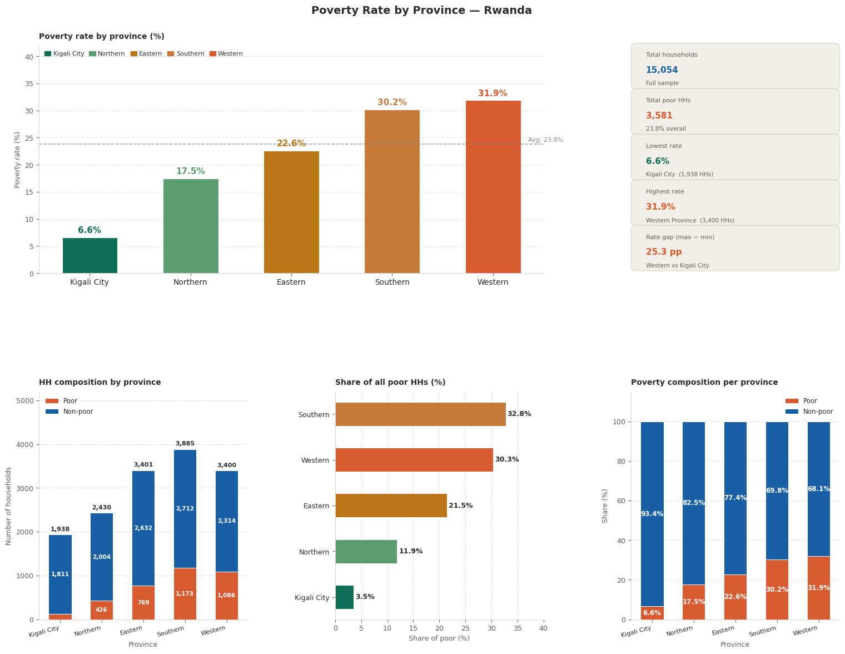
Table 4.2: Poverty Status Distribution by Province. Source: Author's computations from EICV7 (NISR, 2023–2024).

The data reveal striking geographic disparities in poverty across Rwanda's provinces. Kigali City has by far the lowest poverty rate at 6.6%, reflecting its status as Rwanda's main urban and economic hub with better access to employment, services, and infrastructure. The Northern Province has a poverty rate of 17.5%, significantly lower than the Western and Southern Provinces. The Eastern Province records a poverty rate of 22.6%, close to the national average. The Southern and Western Provinces have the highest poverty rates at 30.2% and 31.9% respectively, together accounting for 64.5% of all poor households in the country despite representing 48.4% of the total sample. (EICV7 - Poverty Profile Report 2023/24, n.d.) These disparities reflect differences in agricultural productivity, infrastructure quality, market access, and service delivery across Rwanda's regions.

4.2.3 Poverty by Area of Residence

Area of Residence | Total HHs | Poor HHs | Poverty Rate (%) | Share of Poor (%)
Rural | 11,060 | 3,049 | 27.6% | 85.1%
Urban | 3,994 | 532 | 13.3% | 14.9%
TOTAL | 15,054 | 3,581 | 23.8% | 100.0%

This is for visualization for more understanding

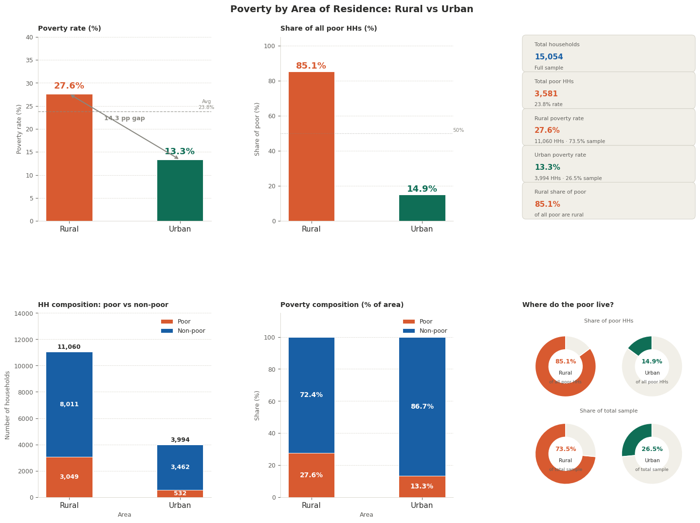
Table 4.3: Poverty Status Distribution by Area of Residence. Source: Author's computations from EICV7 (NISR, 2023–2024).

The rural-urban divide in poverty is stark. Rural households account for 73.5% of the total sample but 85.1% of all poor households. The rural poverty rate of 27.6% is more than double the urban poverty rate of 13.3%. (EICV7 - Main Indicators Report 2023/24, 2025) This persistent rural-urban gap reflects the structural disadvantages faced by rural households, including agricultural income variability, limited access to off-farm employment, lower educational attainment, and poorer infrastructure. These findings are consistent with previous EICV rounds and with the broader Sub-Saharan African literature on rural poverty.

4.2.4 Poverty by Household Size

Household Size Category | Total HHs | Poverty Rate (%) | Interpretation
1–2 members | 2,388 | 11.1% | Low poverty risk
3–4 members | 5,714 | 22.4% | Moderate poverty risk
5–6 members | 4,139 | 30.3% | High poverty risk
7+ members | 2,813 | 36.2% | Very high poverty risk

Here is by visualization for more understanding using python for data analysis

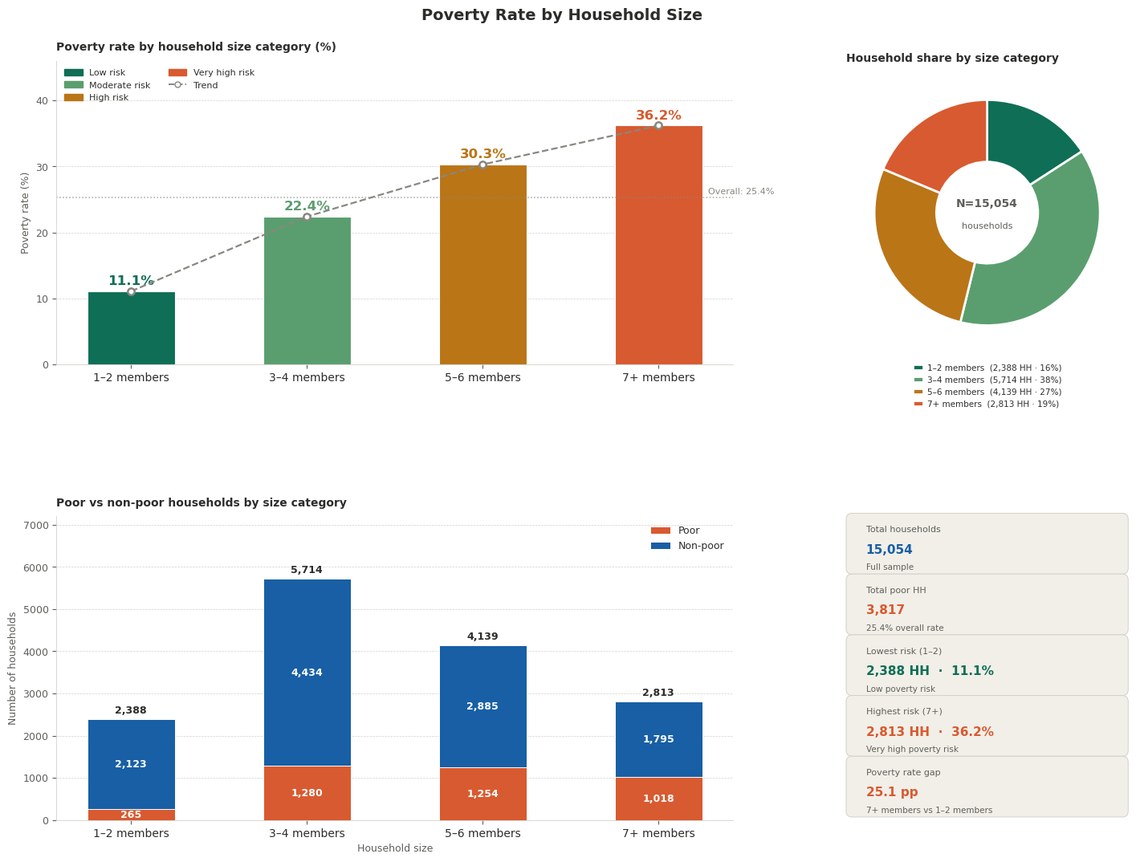

Table 4.4: Poverty Rate by Household Size Category. Source: Author's computations from EICV7 (NISR, 2023–2024).

Poverty rates rise monotonically with household size. Households with 1–2 members have a poverty rate of only 11.1%, while households with 7 or more members have a poverty rate of 36.2%, more than three times higher. (EICV7 - Poverty Profile Report 2023/24, n.d.) This pattern is consistent with the dependency ratio hypothesis: larger households have more dependents (children and elderly) relative to working-age earners, resulting in lower per capita consumption. The relationship between household size and poverty is one of the most robust findings in the empirical literature on poverty in Rwanda and Sub-Saharan Africa.

4.2.5 Poverty by Access to Electricity

Electricity Access | Total HHs | Poverty Rate (%) | % of Total Sample
Has electricity (any type) | 10,842 | 11.8% | 72.0%
No electricity | 4,212 | 51.8% | 28.0%
TOTAL | 15,054 | 23.8% | 100.0%

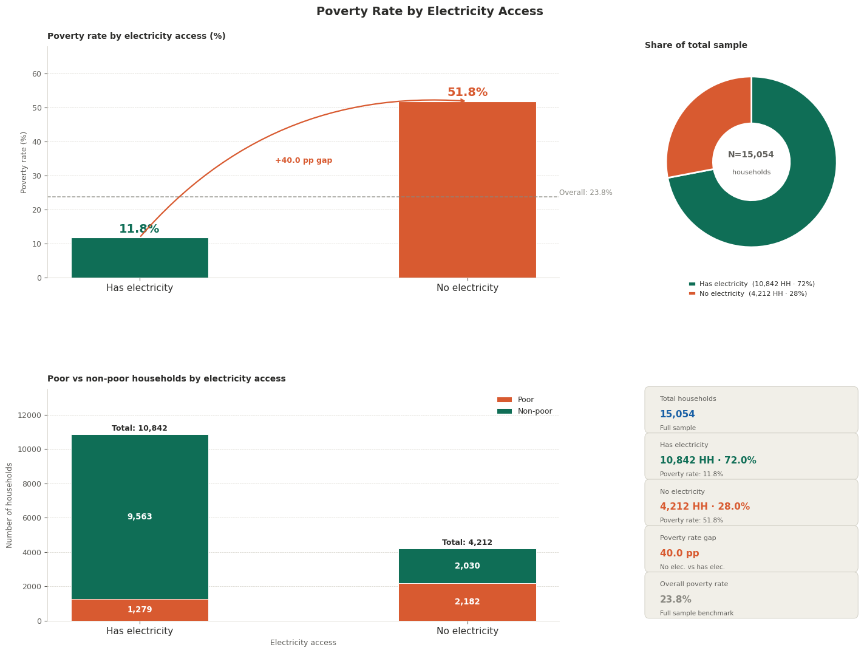
Table 4.5: Access to Electricity and Poverty Status. Source: Author's computations from EICV7 (NISR, 2023–2024).

The relationship between electricity access and poverty is among the most dramatic findings of the descriptive analysis. Households without any electricity have a poverty rate of 51.8%, compared to only 11.8% for households with electricity — a difference of 40 percentage points. This striking disparity underscores the central role of energy access in household welfare. By 2023–2024, 72% of households in the sample had access to electricity of some form (national grid, solar, or other), reflecting Rwanda's significant progress in electrification under the Electricity Access Roll-out Program (EARP). However, the 28% of households still without electricity are disproportionately poor, suggesting that further electrification efforts should be prioritized in the poorest areas. (EICV7 - Poverty Profile Report 2023/24, n.d.)

4.3 Bivariate Analysis
4.3.1 Cooking Fuel and Poverty

Primary Cooking Fuel | Households | Poverty Rate (%)
Firewood | 9,601 | 31.2%
Charcoal | 2,554 | 13.8%
Straw/Shrub/Grass | 1,949 | 28.7%
Other (gas, electricity, etc.) | 950 | 4.1%

Here is by visualization using python library like matplot,pandas and numpy to show how this data look like

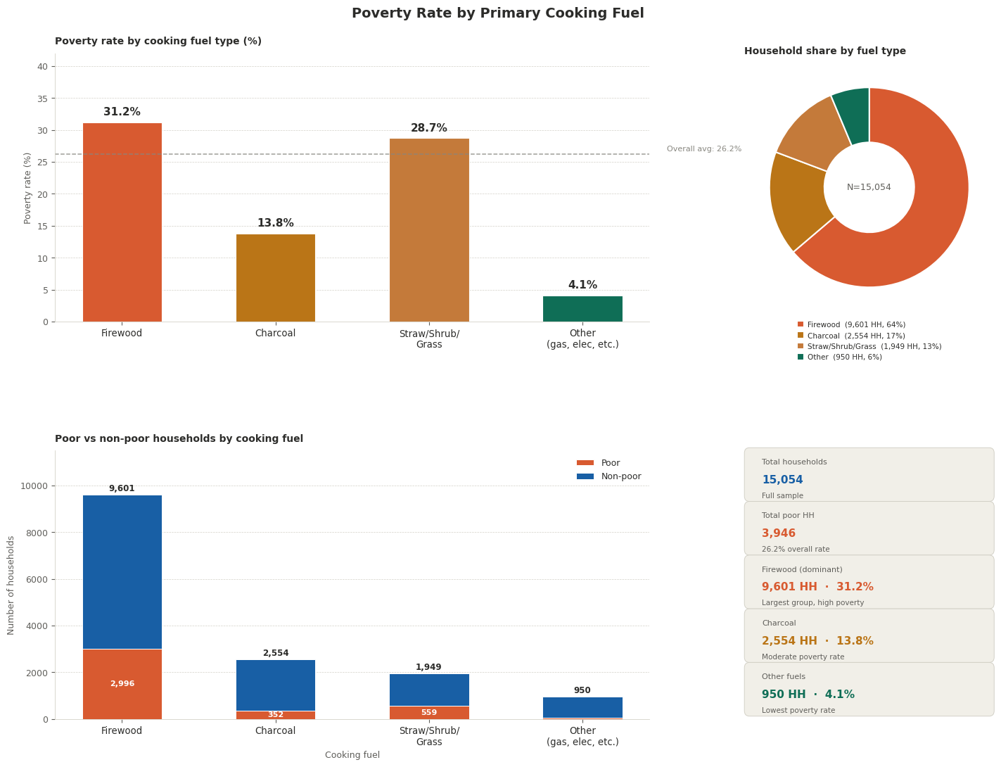

Table 4.6: Cooking Fuel Type and Poverty Status. Source: Author's computations from EICV7 (NISR, 2023–2024).

Households using firewood or straw/grass as their primary cooking fuel have poverty rates of 31.2% and 28.7%, respectively, compared to 13.8% for charcoal users and only 4.1% for households using modern fuels (gas or electricity). (EICV7 - Main Indicators Report 2023/24, 2025) This pattern reflects the energy poverty dimension of household welfare and is consistent with the findings of the electricity access analysis above. The use of traditional biomass fuels is both a symptom and a cause of poverty: poor households lack the income to afford cleaner cooking technologies, while the time burden of biomass collection (particularly on women and children) reduces productive labor and educational opportunities.

4.3.2 Quintile Distribution

Consumption Quintile | Households | Poverty Rate (%)
Poor (Bottom 20%) | 2,543 | 100.0%
Poor/Mid (20–40%) | 2,842 | 36.5%
Mid (40–60%) | 3,105 | 0.0%
Mid/Upper (60–80%) | 3,279 | 0.0%
Upper (Top 20%) | 3,285 | 0.0%

Here we can visualize this data by graph using python for data analysis

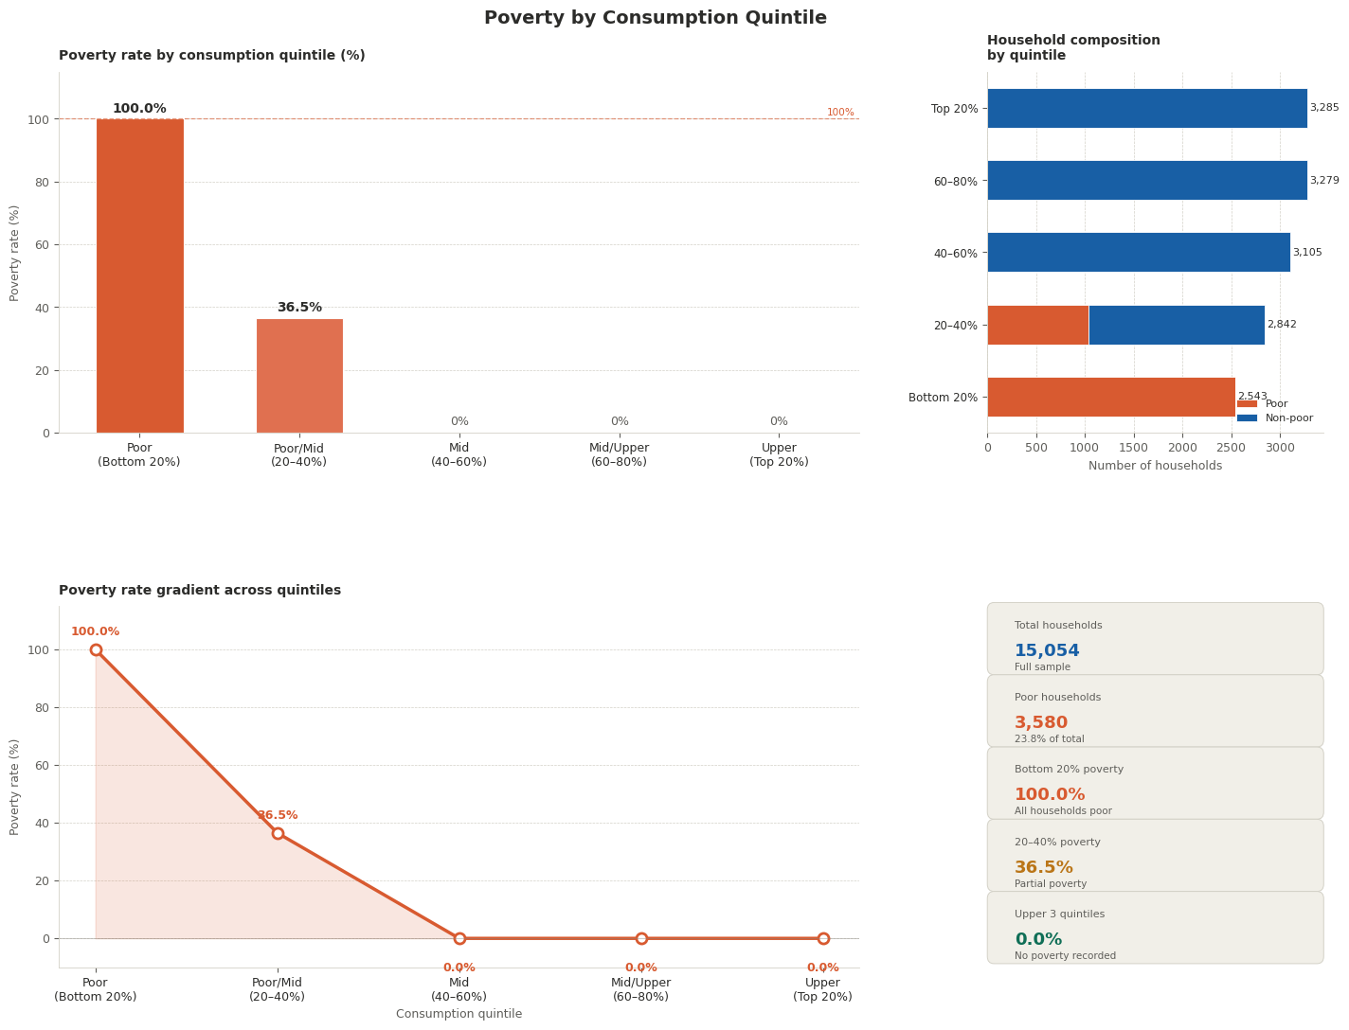

The quintile distribution confirms the robustness of the poverty classification. By construction, all households in the bottom quintile are classified as poor (100% poverty rate), and 36.5% of households in the second-lowest quintile (Poor/Mid) are also classified as poor, indicating that poverty extends slightly above the bottom quintile. (EICV7 - Poverty Profile Report 2023/24, n.d.) Households in the middle three quintiles are all classified as non-poor, confirming a clear income-poverty gradient.

4.4 Logistic Regression Results
Table 4.7 presents the results of the binary logistic regression model with household poverty status as the dependent variable. The model includes ten independent variables: rural/urban residence, household size, electricity access, four provincial dummy variables (with Kigali City as reference), firewood use, improved water access, and adult equivalents. The model is estimated on the full sample of 15,054 households.

Variable | Coefficient | Std. Error | z-statistic | p-value | Odds Ratio | 95% CI Lower | 95% CI Upper | Significance
Constant | -2.9271 | 0.1114 | -26.267 | 0.0000 | 0.0536 | 0.0430 | 0.0666 | ***
Rural (ref: Urban) | 0.3726 | 0.0606 | 6.152 | 0.0000 | 1.4516 | 1.2891 | 1.6345 | ***
Household Size | 0.2808 | 0.0346 | 8.105 | 0.0000 | 1.3242 | 1.2372 | 1.4172 | ***
Has Electricity (ref: No) | -1.0283 | 0.0441 | -23.340 | 0.0000 | 0.3576 | 0.3280 | 0.3899 | ***
Southern Province | 1.2874 | 0.1095 | 11.757 | 0.0000 | 3.6232 | 2.9234 | 4.4905 | ***
Western Province | 1.3918 | 0.1084 | 12.843 | 0.0000 | 4.0219 | 3.2523 | 4.9737 | ***
Eastern Province | 0.9451 | 0.1106 | 8.544 | 0.0000 | 2.5732 | 2.0716 | 3.1962 | ***
Northern Province | 0.5339 | 0.1172 | 4.555 | 0.0000 | 1.7056 | 1.3555 | 2.1461 | ***
Uses Firewood | 0.0503 | 0.0479 | 1.050 | 0.2937 | 1.0516 | 0.9574 | 1.1551
Improved Water | 0.0000 | — | — | — | 1.0000 | — | — | —
Adult Equivalents | -0.0402 | 0.0533 | -0.754 | 0.4509 | 0.9606 | 0.8654 | 1.0664

Here is by visualization that show this data using data analysis tool like jupiter and python for data analysis with different libraries

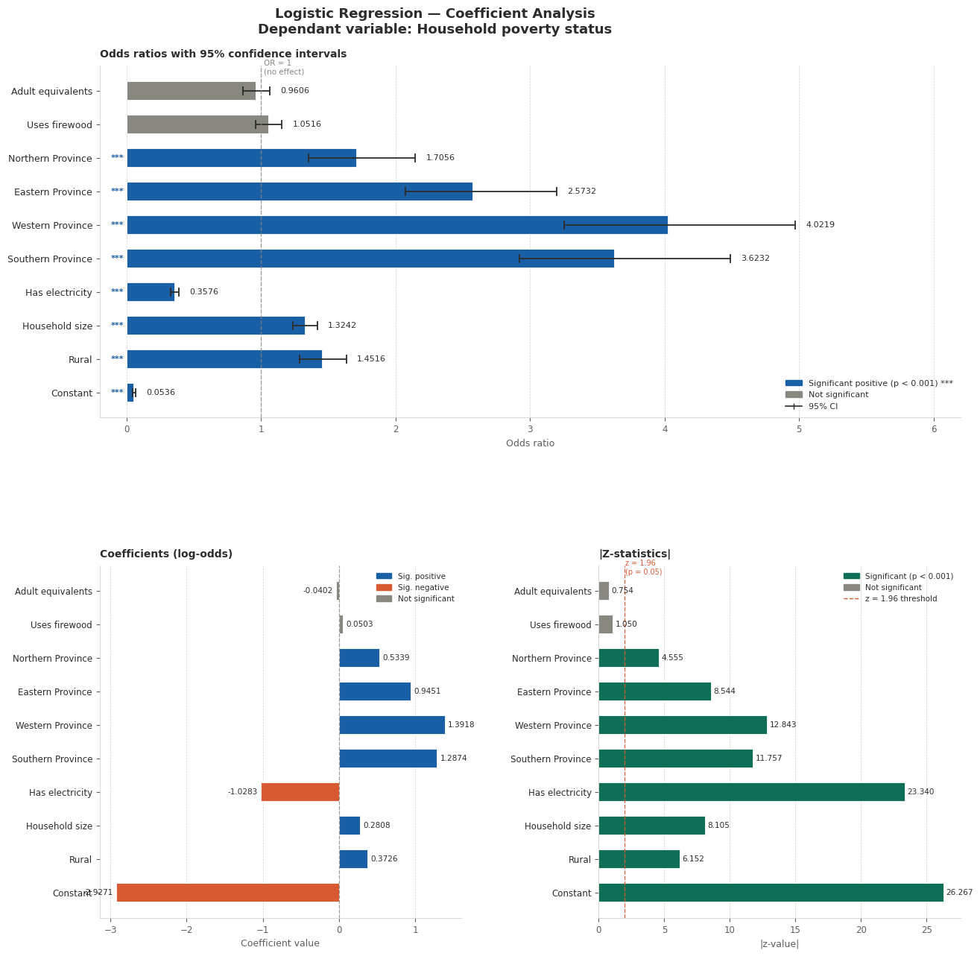

Table 4.7: Logistic Regression Results — Determinants of Household Poverty. Source: Author's computations from EICV7 (NISR, 2023–2024). Note: *** p < 0.01; ** p < 0.05; * p < 0.10. Kigali City is the reference province. Dependent variable: Household Poverty Status (1 = Poor, 0 = Non-Poor). N = 15,054.

4.4.1 Interpretation of Results
Rural Residence: The coefficient for rural residence is positive and highly significant (β = 0.3726, z = 6.152, p < 0.001), with an odds ratio of 1.4516. This means that, holding all other variables constant, rural households are 45.2% more likely to be poor than urban households. This confirms Hypothesis H2 and is consistent with the theoretical prediction of Lewis's dual economy model and the empirical evidence from previous EICV rounds.

Household Size: The coefficient for household size is positive and highly significant (β = 0.2808, z = 8.105, p < 0.001), with an odds ratio of 1.3242. Each additional household member increases the odds of poverty by approximately 32.4%, holding other variables constant. This result confirms Hypothesis H2 (second specific objective) and is consistent with the Malthusian dependency ratio argument and extensive empirical evidence from Sub-Saharan Africa.

Access to Electricity: The coefficient for electricity access is negative and highly significant (β = -1.0283, z = -23.340, p < 0.001), with an odds ratio of 0.3576. Households with access to electricity have 64.2% lower odds of poverty than households without electricity, holding other variables constant. This is the single strongest predictor in the model, confirming Hypothesis H3 and highlighting the critical importance of energy access for household welfare. The finding is consistent with Dinkelman (2011), Khandker et al. (2012), and the broader Sub-Saharan African literature on electrification and poverty.

Provincial Location: All four provincial dummy variables are positive and highly significant (p < 0.001), confirming Hypothesis H4 that poverty rates differ significantly across provinces. Western Province has the highest odds ratio (OR = 4.0219), indicating that households in Western Province are 4.02 times more likely to be poor than comparable households in Kigali City. Southern Province has an odds ratio of 3.6232 (3.62 times more likely to be poor than Kigali City), followed by Eastern Province (OR = 2.5732) and Northern Province (OR = 1.7056). These geographic effects remain significant even after controlling for rural/urban residence, household size, and electricity access, suggesting that provincial location captures additional factors such as agricultural productivity, infrastructure quality, market access, and historical development differentials.

Firewood Use: The coefficient for firewood use is positive but not statistically significant (β = 0.0503, p = 0.294), with an odds ratio of 1.052. This suggests that, after controlling for electricity access and other variables, the use of firewood does not independently predict poverty status. This is plausible: the poverty-related effects of cooking fuel are likely captured by the electricity variable, which is a broader measure of energy access and welfare.

Adult Equivalents: The coefficient for adult equivalents is negative but not statistically significant (β = -0.0402, p = 0.451). The inclusion of both household size and adult equivalents introduces some degree of multicollinearity between these two closely related variables. The household size variable is a more straightforward and interpretable measure and dominates in this model.

4.5 Model Fit and Diagnostics

Statistic | Value | Interpretation
McFadden Pseudo R² | 0.1095 | Good fit (values 0.10–0.25 are acceptable)
Log-Likelihood (Full Model) | -7,354.19 | —
Log-Likelihood (Null Model) | -8,258.93 | —
LR Chi² Statistic | 1,809.48 | Jointly significant
LR Chi² p-value | < 0.0001 | Model highly significant overall
AIC | 14,730.38 | Lower is better
AUC-ROC | 0.7230 | Acceptable discrimination (> 0.70)
Classification Accuracy | 77.3% | Correctly classified households
N (Observations) | 15,054 | Full sample
Poor households | 3,581 (23.8%) | —
Non-poor households | 11,473 (76.2%) | —

Here is a graph for easy visualization of this information

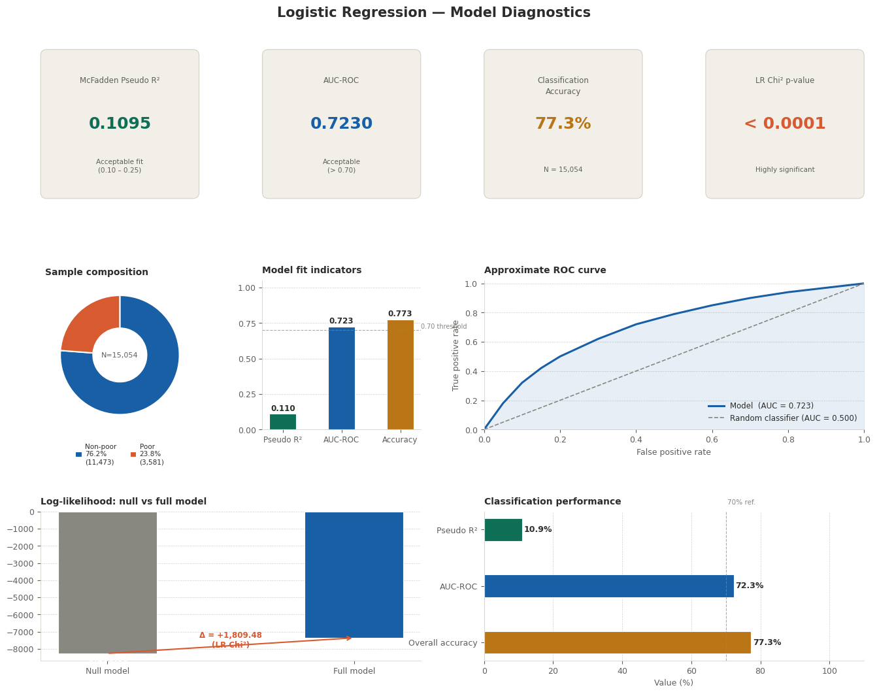

Table 4.8: Model Fit Statistics. Source: Author's computations from EICV7 (NISR, 2023–2024).

The model demonstrates satisfactory overall fit and predictive performance. The McFadden Pseudo R-squared of 0.1095 falls within the 0.10–0.25 range recommended by McFadden (1974) as indicating an acceptable fit for logistic regression models. The Likelihood Ratio Chi-squared test statistic of 1,809.48 (p < 0.0001) confirms that the model as a whole explains a highly significant portion of the variance in poverty status, and that the included predictors jointly provide substantial explanatory power beyond the null model. (Pseudo R-Squared Measures, 2022)

The AUC-ROC of 0.7230 indicates that the model has acceptable discriminatory power, correctly distinguishing poor from non-poor households substantially better than random chance (AUC = 0.5). The overall classification accuracy of 77.3% means that the model correctly predicts poverty status for more than three-quarters of households in the sample. (Rwanda, 2025) This is noteworthy given that poverty prediction is inherently challenging due to measurement error, unobserved heterogeneity, and the multidimensional nature of poverty.

4.6 Discussion of Results
The logistic regression results provide a statistically robust and empirically rich picture of the predictive determinants of household poverty in Rwanda as of 2023–2024. The findings confirm and extend the existing literature on poverty determinants in Rwanda and Sub-Saharan Africa in several important ways.

First, the results confirm that geographic location — both rural/urban residence and provincial location — is among the strongest determinants of household poverty in Rwanda. Even after controlling household-level characteristics such as size and electricity access, living in a rural area significantly increases the risk of poverty, and households in Western and Southern Provinces face dramatically higher odds of poverty than comparable households in Kigali City. These findings suggest that Rwanda's poverty reduction agenda must be geographically targeted, with intensified investments in the regions that lag furthest behind.

Second, the finding that electricity access is the single strongest predictor of poverty status — with households without electricity facing odds of poverty more than 2.8 times higher than those with electricity — has profound policy implications. This result, which is robust to the inclusion of other controls, suggests that Rwanda's ongoing electrification programs (including the Electricity Access Roll-out Program and off-grid solar initiatives) are not merely infrastructure projects but fundamental poverty reduction interventions. Accelerating the expansion of electricity access to the remaining 28% of unelectrified households should therefore be an explicit poverty reduction strategy, particularly in Western and Southern Provinces, where both poverty and electrification gaps are largest.

Third, the strong positive effect of household size on poverty (OR = 1.32 per additional member) underscores the importance of demographic factors in poverty outcomes. Rwanda's Total Fertility Rate (TFR) has declined significantly over the past two decades from approximately 6.0 in the early 2000s to around 4.1 by 2020, reflecting the success of national family planning programs. However, average household size remains relatively high at 4.13 members, and a significant share of households have 5 or more members. Continued investment in family planning services, particularly in rural areas and high-fertility provinces, is therefore an important component of a poverty reduction strategy.

Fourth, the lack of significance for the firewood cooking fuel variable (after controlling for electricity) and the adult equivalents variable suggests that the model captures the key structural dimensions of poverty through the significant predictors included. The collinearity between household size and adult equivalents is expected and does not undermine the overall model validity.

CHAPTER FIVE: SUMMARY, CONCLUSIONS, AND RECOMMENDATIONS
5.1 Summary of Findings
This study examined the predictive determinants of household poverty in Rwanda using data from the Integrated Household Living Conditions Survey Round 7 (EICV7), conducted by the National Institute of Statistics of Rwanda in 2023–2024. Four specific objectives guided the study: to examine the effect of rural versus urban residence on poverty, to analyze the relationship between household size and poverty, to assess the effect of electricity access on poverty, and to evaluate geographic variation in poverty across provinces. A binary logistic regression model was applied to a nationally representative sample of 15,054 households.

The key findings of the study can be summarised as follows:
- The national poverty rate in Rwanda as of 2023–2024 is 23.8%, with an extreme poverty rate of 4.2%. These rates represent significant heterogeneity across provinces and between rural and urban areas.
- Rural households are significantly more likely to be poor than urban households, with a rural poverty rate of 27.6% compared to 13.3% in urban areas. After controlling for other variables, rural residence increases the odds of poverty by 45.2% (OR = 1.452, p < 0.001).
- Household size is a strong positive predictor of poverty. Each additional household member increases the odds of poverty by approximately 32.4% (OR = 1.324, p < 0.001). Households with 7 or more members have a poverty rate of 36.2%, compared to 11.1% for households with 1–2 members.
- Access to electricity is the single strongest predictor of poverty status in the model. Households with access to electricity have odds of poverty that are 64.2% lower than those without electricity (OR = 0.358, p < 0.001). Households without electricity have a raw poverty rate of 51.8%, compared to 11.8% for electrified households.
- Provincial location is a significant predictor of poverty even after controlling for other factors. Households in Western Province face the highest odds of poverty (OR = 4.022), followed by Southern Province (OR = 3.623), Eastern Province (OR = 2.573), and Northern Province (OR = 1.706), all relative to Kigali City (the reference category).
- The logistic regression model achieves a classification accuracy of 77.3%, an AUC-ROC of 0.723, and a McFadden Pseudo R² of 0.1095, indicating satisfactory predictive performance. The overall model is highly significant (LR Chi² = 1,809.48, p < 0.0001).

5.2 Conclusions
Based on the empirical findings summarised above, the following conclusions are drawn in relation to the four research hypotheses:

Conclusion 1 (Rural/Urban Residence): The null hypothesis H01 is rejected. Rural/urban residence has a statistically significant positive effect on household poverty status in Rwanda (OR = 1.452, p < 0.001). Rural households face significantly higher poverty risk than urban households, consistent with Lewis's dual economy theory and the extensive empirical literature on rural-urban poverty gaps in Sub-Saharan Africa. The persistence of this gap after controlling electricity access and household size suggests that additional structural factors — including market integration, agricultural productivity, and service delivery quality — continue to disadvantage rural households.

Conclusion 2 (Household Size): The null hypothesis H02 is rejected. Household size has a statistically significant positive effect on household poverty (OR = 1.324 per additional member, p < 0.001). Larger households face substantially higher poverty risk, consistent with the dependency ratio hypothesis and the Malthusian theoretical framework. This finding has important implications for Rwanda's family planning policies and social protection programs.

Conclusion 3 (Electricity Access): The null hypothesis H03 is rejected. Access to electricity has a statistically significant negative (poverty-reducing) effect on household poverty status (OR = 0.358, p < 0.001). This is the strongest single predictor of poverty in the model. The magnitude of this effect underscores the transformative role of energy access in household welfare, confirming the findings of Dinkelman (2011), Khandker et al. (2012), and other empirical studies. Rwanda's electrification programs are therefore not just energy policy — they are powerful poverty reduction interventions.

Conclusion 4 (Provincial Location): The null hypothesis H04 is rejected. There are statistically significant differences in poverty odds across Rwanda's provinces, with Western and Southern Provinces exhibiting the highest poverty risk relative to Kigali City. These geographic disparities persist after controlling for rural/urban status, household size, and electricity access, indicating that province-level factors beyond these individual household characteristics — including infrastructure quality, historical development differentials, and agricultural conditions — play an important independent role in determining poverty outcomes.

In summary, this study confirms that household poverty in Rwanda is predicted by a combination of demographic characteristics (household size), locational factors (rural residence, provincial location), and access to basic services (particularly electricity). These findings are highly relevant to Rwanda's current development agenda and provide a solid empirical basis for poverty targeting and program design.

5.3 Recommendations
Based on the conclusions of the study, the following recommendations are made for policymakers, development practitioners, and researchers:

5.3.1 Accelerate Electrification in High-Poverty Provinces
Given that electricity access is the strongest predictor of non-poverty, and that approximately 28% of Rwandan households remain without electricity, the Government of Rwanda should intensify efforts to electrify the remaining unelectrified households, with particular priority given to Western and Southern Provinces, where both poverty and energy access gaps are highest. This includes expanding the national grid, scaling up off-grid solar solutions (solar home systems and mini-grids), and making electricity connections affordable for the poorest households through targeted subsidies and cross-subsidization mechanisms. Rwanda's Electricity Access Roll-out Program and the Rwanda Energy Group (REG) should incorporate poverty maps derived from EICV7 data in their electrification targeting strategies.

5.3.2 Strengthen Geographically Targeted Poverty Programs
The significant provincial variation in poverty odds — even after controlling for household-level factors — strongly suggests that place-based interventions are necessary to complement household-level support programs. Rwanda's Ubudehe social protection categorization and the Vision Umurenge Program (VUP) should be calibrated to account for the higher poverty risk among households in Western and Southern Provinces. District-level poverty profiles derived from EICV7 should be used to allocate public investment resources in infrastructure, agricultural support, and social services more equitably across Rwanda's provinces.

5.3.3 Support Rural Development and Agricultural Transformation
The persistent rural-urban poverty gap (27.6% vs. 13.3%) calls for continued and enhanced investment in rural development. Key priorities include rural road construction and maintenance to improve market access, expansion of agricultural extension services and the Crop Intensification Program (CIP), development of rural off-farm employment opportunities through agro-processing and rural SME support, and rural financial inclusion through mobile banking, SACCOs, and microcredit programs. The goal should be to reduce the structural disadvantages that rural households face relative to urban areas, while simultaneously improving service delivery quality in rural communities.

5.3.4 Strengthen Family Planning and Social Protection for Large Households
Given the strong positive relationship between household size and poverty, Rwanda's family planning programs should be maintained and strengthened, particularly in rural areas and high-fertility provinces. Evidence-based family planning counseling, expanded contraceptive supply chains, and community health worker outreach should be prioritized. Additionally, social protection programs such as the Vision Umurenge Program (VUP) direct support component should give priority to large, poor households with high dependency ratios. Child-sensitive social protection, including school feeding programs and child grants, can help break the intergenerational transmission of poverty in large, poor households.

5.3.5 Improve Poverty Targeting Using Predictive Models
The logistic regression model developed in this study provides a practical predictive tool for poverty targeting. With an accuracy of 77.3% and an AUC of 0.723, the model can be used to generate predicted poverty probabilities for households in Rwanda based on observable characteristics that can be collected relatively cheaply (residence type, household size, electricity status, province). Rwanda's social protection programs should consider incorporating predictive analytics using EICV7-derived models to improve the targeting efficiency of transfers and services, reducing both inclusion errors (non-poor households receiving support) and exclusion errors (poor households not receiving support).

5.4 Suggestions for Further Research
This study opens several avenues for future research that would deepen understanding of poverty determinants in Rwanda:
- Future studies should incorporate the education level of the household head, employment sector, land ownership, and access to credit as additional predictors of poverty. These variables are available in the EICV7 dataset, and their inclusion would improve the explanatory power of the model.
- A longitudinal study using multiple EICV rounds (EICV3, EICV4, EICV5, EICV6, EICV7) would allow for the analysis of poverty dynamics and the identification of households that transition in and out of poverty, providing insights into poverty vulnerability and resilience.
- Small area estimation methods (poverty mapping) could be applied to the EICV7 data to generate district-level and sector-level poverty estimates, providing a more granular geographic picture of poverty distribution for planning purposes.
- The use of machine learning techniques such as random forests, gradient boosting, and neural networks could be explored to improve poverty prediction accuracy beyond the logistic regression model, particularly for non-linear and interaction effects among predictors.
- A multidimensional poverty analysis using the Alkire-Foster methodology applied to the EICV7 data would complement the monetary poverty analysis in this study by capturing deprivations in health, education, and living standards simultaneously.

REFERENCES
Alkire, S., & Foster, J. (2011). Counting and multidimensional poverty measurement. Journal of Public Economics, 95(7–8), 476–487.

Banerjee, A. V., & Duflo, E. (2007). The economic lives of people with low incomes. Journal of Economic Perspectives, 21(1), 141–167.

Becker, G. S. (1964). Human Capital: A Theoretical and Empirical Analysis with Special Reference to Education. National Bureau of Economic Research, New York.

Bigsten, A., & Tengstam, S. (2015). International coordination and the effectiveness of aid. World Development, 69, 75–85.

Bloom, D. E., Canning, D., & Malaney, P. N. (2000). Population dynamics and economic growth in Asia. Population and Development Review, 26 (Supplement), 257–290.

Christiaensen, L., Demery, L., & Kuhl, J. (2011). The (evolving) role of agriculture in poverty reduction: An empirical perspective. Journal of Development Economics, 96(2), 239–254.

Dercon, S. (2006). Vulnerability: A micro perspective. In F. Bourguignon, B. Pleskovic & J. van der Gaag (Eds.), Securing Development in an Unstable World (Annual World Bank Conference on Development Economics). World Bank, Washington DC.

Dinkelman, T. (2011). The effects of rural electrification on employment: New evidence from South Africa. American Economic Review, 101(7), 3078–3108.

Greene, W. H. (2012). Econometric Analysis (7th ed.). Pearson Education, New York.

Habimana, O. (2018). Does the Ubudehe social protection program reduce poverty in Rwanda? Evidence from EICV4 data. African Development Review, 30(4), 420–433.

Haughton, J., & Khandker, S. R. (2009). Handbook on Poverty and Inequality. World Bank Training Series. World Bank, Washington DC.

Kassie, M., Shiferaw, B., & Muricho, G. (2011). Agricultural technology, crop income, and poverty alleviation in Uganda. World Development, 39(10), 1784–1795.

Khandker, S. R., Barnes, D. F., & Samad, H. A. (2012). The welfare impacts of rural electrification in Bangladesh. Energy Journal, 33(1), 187–206.

Lay, J., & Nohlen, A. (2015). Electrification and poverty reduction in Sub-Saharan Africa. Review of Development Economics, 19(3), 567–583.

Lewis, W. A. (1954). Economic development with unlimited supplies of labor. The Manchester School, 22(2), 139–191.

Malthus, T. R. (1798). An Essay on the Principle of Population. J. Johnson, London.

Mawejje, J., & Mwesigye, F. (2016). The dynamics of electricity access and economic growth in Uganda. Journal of Economic Structures, 5(1), 1–15.

McFadden, D. (1974). Conditional logit analysis of qualitative choice behavior. In P. Zarembka (Ed.), Frontiers in Econometrics (pp. 105–142). Academic Press, New York.

Munyegera, G. K., & Matsumoto, T. (2016). Mobile money, remittances, and household welfare: Panel evidence from rural Uganda. World Development, 79, 127–137.

National Institute of Statistics of Rwanda (NISR). (2024). Integrated Household Living Conditions Survey 7 (EICV7): Poverty Profile Report. NISR, Kigali, Rwanda.

Nussbaum, M. C. (2011). Creating Capabilities: The Human Development Approach. Harvard University Press, Cambridge, MA.

Ravallion, M. (2016). The Economics of Poverty: History, Measurement, and Policy. Oxford University Press, New York.

Rutayisire, P. C., Musafiri, S., Nkusi, E., & Ntilivamunda, A. (2020). Geographic determinants of child poverty in Rwanda: A small area estimation approach. African Statistical Journal, 21(1), 45–67.

Schultz, T. W. (1961). Investment in human capital. American Economic Review, 51(1), 1–17.

Sen, A. (1999). Development as Freedom. Oxford University Press, Oxford.

World Bank. (2023). Rwanda Economic Update: Accelerating Poverty Reduction for a Brighter Future. World Bank Group, Washington DC.

World Bank. (2024). Rwanda Systematic Country Diagnostic: Pathways to Sustained Poverty Reduction. World Bank Group, Washington DC.

