Cumulative Intraoperative Hypothermic Burden Is Associated with Transfusion Practice but Not Measured Blood Loss: A Divergence Between Decision and Physiologic Outcomes
A secondary analysis of the VitalDB open-access perioperative database

Abstract
Background. Intraoperative hypothermia is widely believed to worsen surgical bleeding through impaired platelet function and coagulation enzyme kinetics, but prior work — including this study's own pilot analysis — has relied on postoperative hemoglobin decline (ΔHb) as an indirect surrogate for blood loss. Whether a more direct measure of hypothermic exposure predicts directly measured bleeding, rather than a downstream proxy, has not been tested in the same cohort under the same adjustment.
Methods. Retrospective cohort study using VitalDB (v1.0.0, PhysioNet), 6,388 noncardiac surgical cases at a single Korean academic center. Cumulative hypothermic burden was defined as time-weighted degree-minutes with core temperature <36.0°C, computed from continuous intraoperative temperature tracks. After cohort restriction (age ≥18, general/thoracic/urologic/gynecologic surgery, operative duration >120 min, ≥95% temperature-monitoring coverage within each case's own observed window, one reoperation and one physiologically non-comparable case excluded), 2,567 cases were analyzed. Multivariable linear and logistic regression tested burden against intraoperative estimated blood loss (EBL), RBC transfusion, ΔHb, coagulation parameter change, acute kidney injury (KDIGO, creatinine-only), and postoperative length of stay (LOS), adjusting for demographic, procedural, and case-mix covariates.
Results. Burden was independently associated with RBC transfusion (OR 1.33 per SD, 95% CI 1.12–1.58, p=0.001) but not with EBL (p=0.418), ΔHb (p=0.360), AKI (p=0.794), or LOS after correction for multiple comparisons. A model identical in every respect except outcome variable showed the full covariate set (not burden specifically, which was non-significant in both) explained substantially more variance in EBL (R²=0.484) than in ΔHb (R²=0.068) — evidence that ΔHb is the noisier, more indirect outcome, not that burden's effect is simply harder to detect on it — and the burden–EBL relationship differed significantly by surgical subtype (burden×stomach-surgery interaction, p=0.036), with opposite-signed point estimates in stomach versus non-stomach cases that a modestly sized retrospective cohort cannot adjudicate between effect modification and a coverage-driven selection artifact already identified in this dataset.
Conclusions. In this cohort, cumulative hypothermic burden tracked the clinical decision to transfuse without tracking any of three independent measures of the bleeding that decision is meant to respond to. This dissociation — not a confirmation of hypothermia-associated bleeding — is the primary, hypothesis-generating finding, and is reported as such rather than reframed around a more expected result.

1. Introduction
Intraoperative hypothermia (core temperature <36.0°C) is a common perioperative complication despite published temperature-management guidelines, with international surveys reporting persistently poor guideline compliance [16], and has a well-described physiologic basis for impairing hemostasis: cold temperature slows the enzymatic kinetics of the coagulation cascade and reversibly impairs platelet adhesion and aggregation, independent of factor concentration [3,26]. Observational and experimental work has linked intraoperative hypothermia to increased blood loss and allogeneic transfusion requirement in some surgical populations — a pilot randomized trial of maintained normothermia during open thoracic and hip replacement surgery [1] and a retrospective study of total knee and hip arthroplasty [19] both reported this association — motivating routine intraoperative warming as a quality-of-care standard, with a demonstrated health-economic case for doing so [21]. The literature is not unanimous, however: at least one pediatric cohort found intraoperative hypothermia common but not associated with blood loss or transfusion after adjustment [15], and hypothermia's relationship to transfusion appears in some settings to be driven by prehospital rather than intraoperative exposure [14]. Much of the supporting clinical literature, in either direction, quantifies hypothermic exposure crudely (e.g., a single nadir temperature or a binary "hypothermic vs. not" classification) and quantifies bleeding outcome indirectly, most commonly via postoperative hemoglobin decline (ΔHb) rather than intraoperatively recorded blood loss or the clinical decision to transfuse.
This study began as a direct extension of an earlier pilot analysis of this same database that used ΔHb as its sole bleeding outcome and cited unavailable transfusion data as a limitation. Because VitalDB in fact contains intraoperative estimated blood loss (intraop_ebl) and transfusion records (intraop_rbc, intraop_ffp), the present analysis was designed to test the pilot's finding directly against these more proximate measures, using a substantially more granular exposure metric: cumulative hypothermic burden (time-weighted degree-minutes below 36.0°C), analogous to the area-under-the-curve "burden" framework already established for intraoperative hypotension [27].
The originally planned analysis (protocol v3) anticipated a specific pattern: that burden would replicate the pilot's significant ΔHb association while remaining null for directly measured EBL, which would have supported a "surrogate-outcome sensitivity" narrative — the idea that ΔHb detects a real signal that cruder direct measures miss. A prespecified, identically adjusted head-to-head comparison of the two outcomes (§ below) did not confirm this. Burden was null for ΔHb as well as for EBL. We report the reframed finding rather than the originally anticipated one: burden shows a robust, independent association with the clinical decision to transfuse blood, but no association with any of the three ways this dataset can measure the physiologic blood loss that decision is nominally responding to. We present this divergence — not a confirmation of hypothermia-associated hemorrhage — as the paper's central, hypothesis-generating result, together with a formally quantified case-mix exclusion pattern and a significant but mechanistically unresolved effect-modification signal by surgical subtype.

2. Methods

2.1 Data source and ethical considerations
This is a secondary analysis of VitalDB v1.0.0 (PhysioNet, DOI 10.13026/czw8-9p62), an open, de-identified perioperative database comprising 6,388 surgical cases from a single academic medical center in Korea (Aug 2016–Jun 2017), collected under Seoul National University Hospital IRB approval H-1408-101-605 (registered NCT02914444). As a secondary analysis of a pre-existing, fully de-identified open dataset, this study did not involve direct patient contact or identifiable data; institutional determination of exempt/non-human-subjects status should be confirmed locally prior to submission per the authors' institutional policy.

2.2 Cohort selection
Eligible cases were adults (≥18 years) undergoing general, thoracic, urologic, or gynecologic surgery — the full set of surgical departments represented in VitalDB, which contains no cardiac surgery — with operative duration (opend−opstart) exceeding 120 minutes. From an initial 6,388 cases, sequential application of these criteria, followed by exclusion of non-index cases for the 39 subjects with more than one qualifying operation (index case retained by earliest opstart), yielded a candidate cohort of 2,824 cases (Figure 1).
Continuous intraoperative core temperature monitoring (Solar8000/BT, streamed via the vitaldb Python package at 10-second resolution) was required for burden calculation. An initial coverage criterion (≥80% of the full anesthesia-window duration) was tested on a 50-case benchmark and rejected: it passed only 58% of cases and was shown to be an artifact of temperature-probe placement/removal timing (structural gaps concentrated at the start [median ~23 min, before probe placement] and end [median ~27 min, after probe removal] of monitoring, not genuine mid-case data loss — interior dropout in the same benchmark was near-zero). We instead trimmed each case's evaluation window to its own observed monitoring interval (first to last non-artifact temperature reading) and required ≥95% coverage within that trimmed window, which correctly distinguishes normal instrumentation timing from genuine monitoring failure. This rule was applied during the same pass that streamed temperature data for burden calculation, yielding a final analytic cohort of 2,568 cases. One additional case (ASA physical status VI, a declared brain-dead organ donor) was excluded prior to modeling as physiologically non-comparable to the living-patient surgical-stress response under study, yielding the final analytic cohort for all models, N = 2,567.
Coverage-based exclusion was not random with respect to surgical subtype: stomach surgery cases failed the coverage threshold at markedly higher odds than other procedures (unadjusted OR 6.62, 95% CI 4.84–9.05, Fisher's exact p=8.2×10⁻³²; adjusted for operative duration, surgical approach, and patient position, OR 0.213 for passing coverage — approximately 4.7-fold higher adjusted odds of failure, p=9.6×10⁻¹²). This was not explained by stomach surgery's skew toward videoscopic approach or supine positioning, and trace-level inspection showed the missingness pattern consisted of one or two large contiguous gaps rather than scattered dropout, consistent with intraoperative endoscopy or nasogastric tube manipulation dislodging the esophageal temperature probe. Excluded cases also had longer operative durations (241 vs. 218 min, p=0.002). We found no evidence that this exclusion tracked outcome severity directly: included and excluded cases did not differ significantly in intraoperative blood loss, transfusion rate, AKI incidence, or coagulation-parameter change (Table 8; all p>0.08). This is reassuring for treating the exclusion as ignorable conditional on observed covariates, but it cannot establish that the burden–outcome relationship itself is unchanged in excluded cases, since burden is undefined for cases without adequate temperature data by construction; gastric procedures should be considered underrepresented in this analytic cohort and findings should not be assumed to generalize to them without this caveat.

2.3 Exposure definition
The primary exposure, cumulative hypothermic burden, was defined as
burden = Σ max(0, 36.0 − T(t)) × Δt
summed over the anesthesia window (anestart to aneend) at native 10-second resolution (Δt = 10/60 min), analogous to the time-weighted "burden" formulation established for intraoperative hypotension. This captures both the depth and duration of hypothermic exposure, in contrast to threshold-duration or single-nadir metrics. Recorded temperatures outside a physiologically plausible range (<32.0°C or >41.0°C) were treated as instrumentation artifact and excluded from burden calculation. Comparator exposure metrics — minimum core temperature (raw and 2-minute median-smoothed) and early thermal drop velocity (maximum decline within 30 minutes of anesthesia start) — were retained for nested model comparison. Early thermal drop velocity was excluded from the primary fully adjusted model because it requires temperature data within the first 30 minutes of anesthesia and was only 62% complete in this cohort (largely coincident with the structural start-of-monitoring gap described above); including it alongside burden and minimum temperature in a single model reduced the analytic sample by more than 800 cases for no benefit to the primary comparison, so it is instead reported from its own, separately fitted model at its natural sample size.

2.4 Outcome definitions
Primary outcomes were intraoperative estimated blood loss (intraop_ebl, log-transformed given right skew) and RBC transfusion (intraop_rbc > 0, binary). Secondary outcomes were: perioperative change in PT-INR, aPTT, and fibrinogen (last available preoperative value to first postoperative value within 24h of surgical end, both drawn from the same longitudinal laboratory file to guarantee consistent units and ascertainment method — treated as exploratory given 44–47% joint pre/post completeness, see § 2.6); postoperative acute kidney injury, staged by KDIGO serum-creatinine criteria only (urine-output criteria could not be applied, as intraop_uo is a single intraoperative total rather than a postoperative time series); postoperative length of stay, defined as (dis−opend)/86400 days (anchored to surgical rather than anesthesia end, the conventional clinical LOS reference point); and in-hospital mortality, reported descriptively only given 17 events in the final cohort. ΔHb (preoperative minus first postoperative hemoglobin within 24h) was retained as a direct comparison outcome against EBL (§ 2.7), not as the study's primary bleeding measure.
The KDIGO staging algorithm used a peak-in-window-versus-baseline convention (worst creatinine observed in each window relative to preop_cr), with the 48-hour absolute-delta (≥0.3 mg/dL) and 7-day ratio (1.5–1.9×, 2.0–2.9×, ≥3.0× baseline) criteria evaluated independently and the higher resulting stage retained. One modification from the literal published KDIGO criteria was necessary and is reported explicitly: the unconditional 7-day absolute-value Stage 3 criterion (creatinine ≥4.0 mg/dL) was found during model construction to misclassify chronic dialysis-dependent patients with permanently elevated but non-rising creatinine (mean baseline 9.19 mg/dL, ratio to peak ≈0.97) as acute Stage 3 injury, accounting for 90 of 103 cases (87%) initially staged as Stage 3 by this criterion alone. We conditioned the absolute-value criterion on a concurrent rise of at least 0.3 mg/dL from baseline — the same threshold used for the 48-hour Stage 1 criterion — which discarded the spurious chronic-baseline cases while correctly retaining 33 cases with both a high absolute creatinine and a genuine acute rise (plausible acute-on-chronic injury). This reduced the Stage 3 count from 103 to 46 and is reported here as a modified KDIGO operationalization, not the literal published criteria.

2.5 Covariates
All regression models adjusted for age, sex, BMI, ASA physical status class, emergency operation status, surgical subtype (optype), operative duration, intraoperative crystalloid and colloid volume, and any intraoperative vasopressor use (ephedrine, phenylephrine, or epinephrine). Anesthesia type, specified in the original protocol as a covariate, was dropped after model construction revealed near-zero variance in this duration-filtered cohort (2,567 general vs. 1 spinal anesthetic) — a consequence of the >120-minute inclusion criterion effectively selecting general anesthesia, not a data-quality problem, but one that left nothing to adjust on and risked a near-singular design-matrix column.
For the logistic (transfusion) model specifically, two surgical subtypes (thyroid, breast) had zero transfusion events, producing quasi-complete separation (coefficient magnitude >15, standard error >4,000, non-convergence). No actively maintained Python package implementing Firth's penalized logistic regression was compatible with the analysis environment. Rather than implement an unvalidated custom penalized-likelihood estimator, these two categories were merged into an existing, non-zero-event optype category for the transfusion model only; the linear (blood-loss) model, unaffected by separation, retained full surgical-subtype granularity.

2.6 Statistical analysis
Continuous variables were summarized as mean ± SD across burden tertiles with one-way ANOVA; categorical variables as proportions with χ² tests. The primary Aim 1 models were multivariable linear regression (log-transformed EBL) and logistic regression (transfusion), each including burden and minimum core temperature simultaneously with the covariates above. A hierarchical nested model sequence (baseline covariates → +minimum temperature → +burden) was fit on a single common complete-case sample and compared by likelihood-ratio test, AIC, and BIC; an initial four-model sequence that additionally added thermal drop velocity was abandoned because that term's greater missingness meant it was fit on a materially smaller sample than the other three models, invalidating direct likelihood comparison across the sequence. Dose-response was assessed via restricted cubic spline (Harrell's basis, knots at the 5th/35th/65th/95th percentiles of burden), with nonlinearity tested by likelihood-ratio test against the linear specification. A prespecified burden×stomach-surgery interaction term was added to the primary linear model given the coverage-exclusion finding above, followed by a stratified refit (burden coefficient estimated separately within stomach and non-stomach subgroups) to characterize the interaction beyond its p-value. A prespecified sensitivity analysis refit the primary model restricted to cases where temperature monitoring began within 30 minutes of anesthesia start (58% of the analytic cohort in benchmark testing), the subset least likely to have missed the early redistribution-hypothermia phase. Variance inflation factors were calculated for all linear main-effects terms (threshold ≥5 for concern).
For Aim 3 secondary outcomes, AKI (logistic) and LOS (log-linear, given a continuous rather than integer-count LOS variable) were treated as the confirmatory secondary-outcome family and corrected for multiplicity via Holm-Bonferroni across these two tests only. Coagulation outcomes (Aim 2) were analyzed identically in model structure but reported as exploratory and were excluded from this correction, since their already-stated hypothesis-generating framing means a formal family-wise correction would overstate rather than appropriately calibrate their evidentiary weight. ICU admission (any ICU stay, given 1,811/2,567 cases [70.5%] had zero recorded ICU days in the analytic cohort — Table 5c) was modeled as a binary supplementary outcome. Mortality (17 events) was reported descriptively by burden tertile only.
Statistical significance was set at α=0.05 (two-sided) throughout; the Holm-Bonferroni correction described above is the only departure from this uncorrected threshold, applied where explicitly stated. All analyses used Python 3 with pandas, numpy, statsmodels, scipy, and patsy; figures were produced with matplotlib. Analysis code is version-controlled, with the git commit hash producing each reported number logged in an accompanying provenance record.

2.7 Direct comparison of blood-loss outcomes (ΔHb vs. EBL)
To test directly whether outcome choice — rather than covariate adjustment quality — explains any discrepancy between this analysis and the pilot study's ΔHb-based finding, we fit the identical final Aim 1 covariate specification (burden, minimum core temperature, and all covariates in § 2.5) against ΔHb as the outcome, changing only the dependent variable, on the identical N=2,567 cohort. ΔHb was modeled untransformed rather than log-transformed, unlike EBL: EBL is a right-skewed, non-negative quantity for which a log transform is standard, whereas ΔHb can be negative (postoperative hemoglobin can exceed preoperative in some cases, most plausibly reflecting hemoconcentration or measurement timing) and a log transform is not mathematically valid for it. This is the only intended difference between the two models beyond the outcome variable itself.

3. Results

3.1 Cohort characteristics
Of 6,388 total VitalDB cases, 2,824 met candidate inclusion criteria; after temperature-coverage exclusion, 2,568 comprised the final analytic cohort; after excluding one organ-donor case, 2,567 cases were analyzed for Aims 1–3 (Figure 1). Across tertiles of hypothermic burden, patients in the highest tertile were older (61.3 vs. 55.3 years), had longer operative duration (250.5 vs. 197.2 min), received more crystalloid (2,132 vs. 1,364 mL), and had higher rates of transfusion (17.6% vs. 4.9%) and stomach surgery representation (23.8% vs. 10.9%) than the lowest tertile (all p<0.003; Table 1).
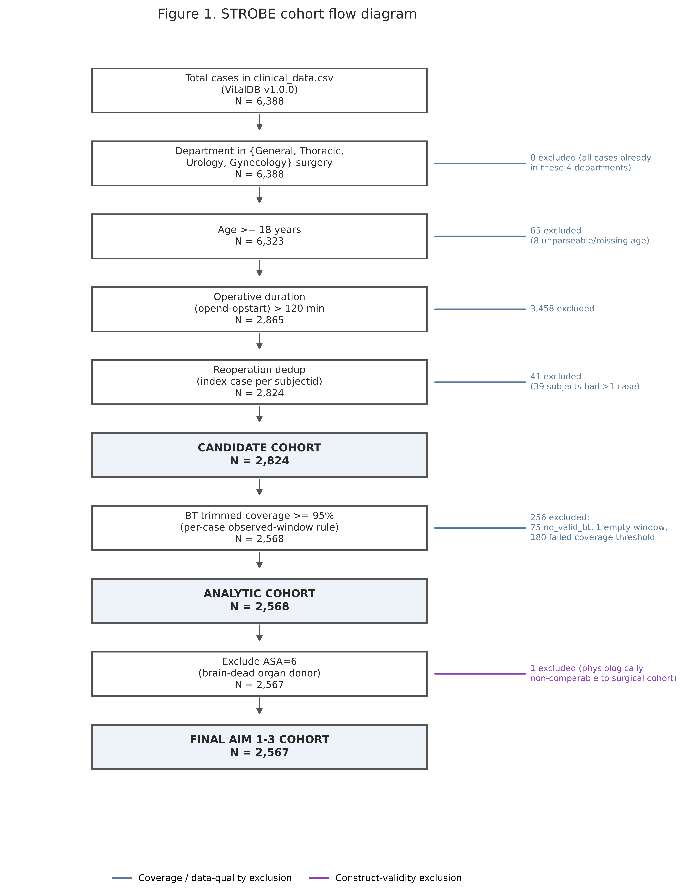
Figure 1. STROBE cohort flow diagram: 6,388 total cases through candidate (N=2,824), analytic (N=2,568), and final Aim 1-3 (N=2,567) cohorts.

Table 1. Baseline characteristics by hypothermia-burden tertile.
Characteristic | T1 (low) | T2 (mid) | T3 (high) | p-value
Age, years | 55.3 +/- 13.7 | 59.6 +/- 13.7 | 61.3 +/- 13.8 | 0.0
BMI, kg/m2 | 24.0 +/- 3.5 | 22.9 +/- 3.3 | 22.2 +/- 3.3 | 0.0
Op duration, min | 197.2 +/- 72.8 | 207.3 +/- 74.7 | 250.5 +/- 97.4 | 0.0
Intraop EBL, mL | 358.3 +/- 1145.3 | 391.9 +/- 1075.1 | 721.5 +/- 1517.1 | 0.0
Crystalloid, mL | 1364.3 +/- 1036.2 | 1577.4 +/- 1274.3 | 2132.4 +/- 1856.2 | 0.0
Male sex | 54.0% | 60.2% | 61.7% | 0.0027
Emergency op | 8.6% | 10.5% | 11.3% | 0.1683
Stomach optype | 10.9% | 18.7% | 23.8% | 0.0
Any transfusion | 4.9% | 8.1% | 17.6% | 0.0

3.2 Aim 1: blood loss and transfusion
In the fully adjusted linear model (log-transformed EBL, N=2,089), burden was not significantly associated with blood loss (β=0.00017, p=0.418), nor did adding burden to a model already containing minimum core temperature significantly improve fit (nested likelihood-ratio p=0.415; Table 3). In the fully adjusted logistic model (transfusion, N=2,484), burden was independently and significantly associated with transfusion (OR 1.0028 per unit, p=0.001; Table 2). Re-expressed in an interpretable increment, this corresponds to OR 1.320 (95% CI 1.113–1.566) per 100 units of burden and OR 1.330 (95% CI 1.116–1.585) per SD of burden (≈103 units) — roughly a third higher odds of transfusion per clinically meaningful increase in exposure (Table 2b, Figure 2). A categorical top-versus-bottom-tertile comparison showed a numerically larger but non-significant effect (OR 1.635, p=0.070), consistent with the expected loss of statistical power from discretizing a continuous exposure rather than a contradiction of the continuous-model result.
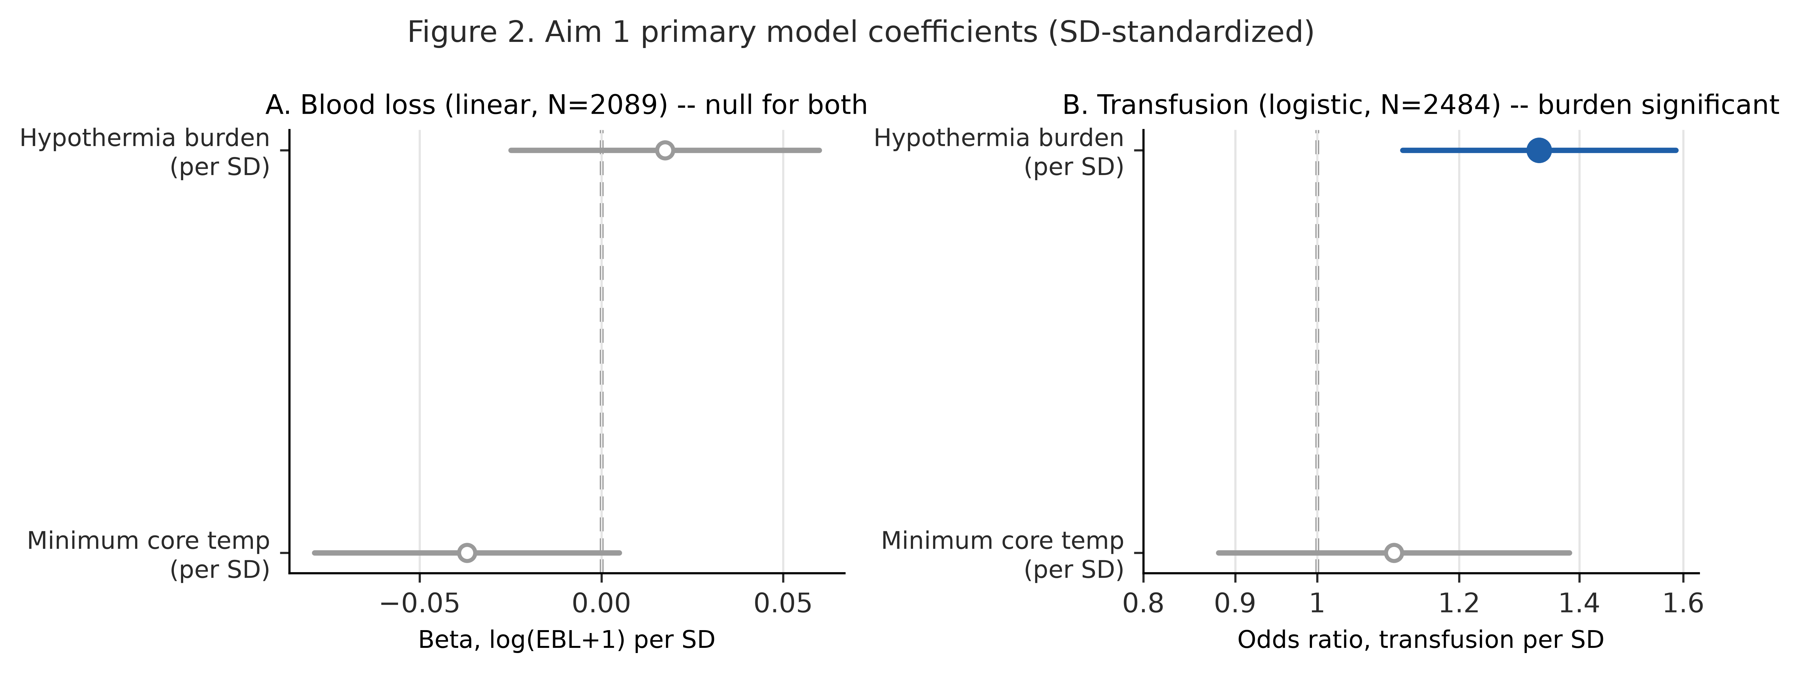
Figure 2. Aim 1 primary model coefficients (SD-standardized), blood loss (linear) and transfusion (logistic).

A restricted cubic spline confirmed statistically significant nonlinearity in the burden–EBL relationship (likelihood-ratio p=0.011 against the linear specification) despite the null linear term. The fitted curve, however, described only a shallow dip-and-rise across the observed burden range (approximately 161→144→155 mL predicted EBL at the reference covariate profile, a peak-to-trough range of ~18 mL against a 95% confidence band roughly 32–42 mL wide throughout; Figure 3) — a real but small deviation from linearity that adds texture to, rather than overturns, the null linear finding. The reference covariate profile used for these absolute values corresponds to the modal covariate combination in this cohort (optype=Stomach, itself a comparatively low-bleeding surgical category), which is why the curve's absolute scale (~150 mL) sits below the cohort's overall mean EBL (~500 mL); this reflects the choice of reference profile, not an error in the model.
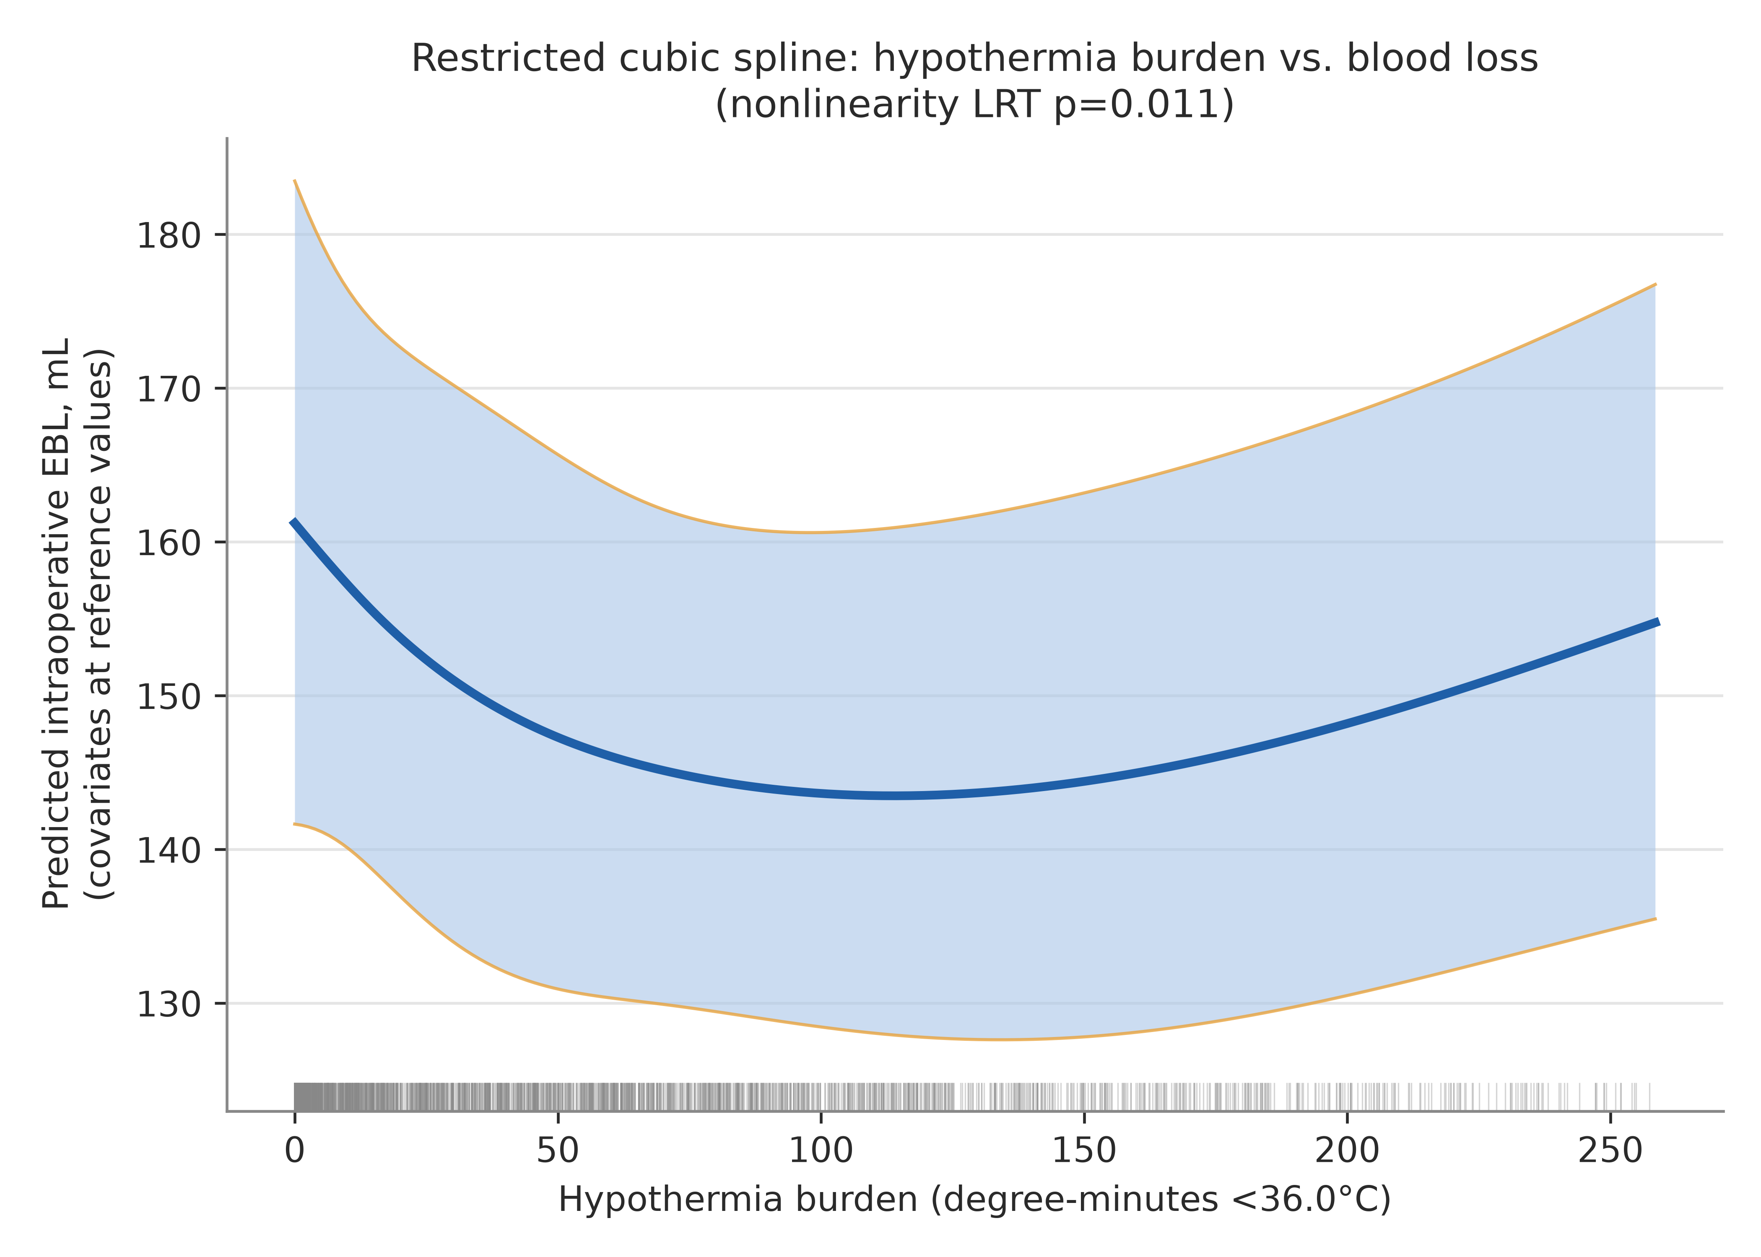
Figure 3. Restricted cubic spline: hypothermia burden vs. predicted blood loss.

A prespecified burden×stomach-surgery interaction term in the primary linear model was statistically significant (p=0.036). Stratified refitting showed opposite-signed point estimates in the two subgroups — stomach surgery (N=322): β=−0.00078 (95% CI −0.00213 to 0.00058), p=0.261; non-stomach surgery (N=1,767): β=+0.00019 (95% CI −0.00023 to 0.00061), p=0.376 — with neither individual stratum reaching significance (Table 2c). The significant interaction is therefore driven by a sign reversal between subgroups rather than a uniformly stronger effect in one group. Because stomach surgery cases were also disproportionately excluded from this cohort by the temperature-coverage mechanism described in § 2.2, two explanations remain live and statistically indistinguishable at this sample size: a genuine difference in the burden–bleeding relationship by surgical subtype, or a selection artifact in which the 322 retained stomach-surgery cases are a non-random, higher-acuity subset of all stomach surgery performed at this center. This analysis cannot adjudicate between them.
An early-monitoring-gap sensitivity analysis (restricted to the 1,598 cases with temperature monitoring beginning within 30 minutes of anesthesia start) showed an unstable burden coefficient sign relative to the full cohort (+0.00017 full vs. −0.00043 restricted), neither estimate reaching significance — consistent with an unstable near-null signal rather than a directional reversal of a real effect. A separately fitted comparator model for early thermal drop velocity (N=1,276, its natural complete-case sample) showed no significant association with EBL (p=0.29). Variance inflation factors for all terms in the fully adjusted linear model were below 2.3, indicating no meaningful multicollinearity (Table 6).
Because transfusion decisions are conventionally triggered relative to a patient's starting hemoglobin rather than blood loss alone, and because baseline hemoglobin correlated with burden in this cohort (r=−0.22, lower baseline Hb associated with higher burden), we tested whether adding preoperative hemoglobin (preop_hb, 95.0% complete) to both primary models altered the results (Table 2d). It did not materially: the transfusion association was essentially unchanged (OR/SD 1.330→1.320, 95% CI 1.077–1.617, p=0.0074) despite baseline hemoglobin itself being a strong independent predictor of transfusion (OR 0.48 per g/dL, p<0.0001), and the EBL null remained null (p=0.418→0.577). Baseline anemia does not appear to explain the burden–transfusion association.

3.3 The ΔHb–EBL direct comparison (Table 9)
Fit on the identical N=2,567 cohort with an identical covariate specification, burden was not significantly associated with ΔHb (β=−0.000325, SE=0.000355, 95% CI −0.00102 to 0.00037, N=1,776, p=0.360), matching the null EBL result (p=0.418) rather than diverging from it. The two models' explained variance differed sharply: R²=0.484 for EBL versus R²=0.068 for ΔHb — the same covariate set that accounts for nearly half the variance in directly measured blood loss accounts for almost none of the variance in postoperative hemoglobin change, consistent with ΔHb functioning as a substantially noisier and more indirect bleeding measure (subject to confounding by intravenous fluid administration timing, hemodilution, and postoperative draw timing) rather than burden's effect being simply harder to detect on the ΔHb scale specifically (Table 9).
Table 9. Delta Hb vs. EBL, identical covariates/cohort/model type.
Outcome | N | Beta (burden) | SE | CI_low | CI_high
log(EBL+1) | 2089 | 0.0001706669688448 | 0.0002105063039343 | -0.0002421597743441 | 0.0005834937120338
Delta Hb (untransformed) | 1776 | -0.0003247011509394 | 0.0003546204763444 | -0.0010202250079309 | 0.0003708227060519

3.4 Aim 2: coagulation parameters (exploratory)
Among cases with both a preoperative and postoperative (within 24h) laboratory value, burden was not significantly associated with change in PT-INR (N=1,166, p=0.61). Burden was significantly associated with change in aPTT (N=1,161, β=−0.032, p=0.0013) and fibrinogen (N=1,105, β=+0.089, p<0.0001), but both associations ran counter to the hypothesized direction of hypothermia-impaired coagulation: higher burden was associated with a smaller (less-prolonged) rise in aPTT and a larger rise in fibrinogen (Table 4, Figure 5). These results are reported as exploratory and uncorrected for multiple comparisons, consistent with the a priori framing in § 2.6; coagulation-panel ascertainment itself was strongly associated with arterial-line placement (a monitoring-intensity/acuity proxy: 69.8% vs. 24.5% ascertainment with vs. without an arterial line, χ² p≈4×10⁻⁹⁷) but not with hypothermic exposure severity (p=0.52–0.83), which rules out exposure-driven ascertainment bias but leaves acuity-driven ascertainment bias unaddressed.

3.5 Aim 3: AKI, LOS, and mortality
Burden was not significantly associated with AKI under the corrected KDIGO staging described in § 2.4 (N=2,098, OR 1.0002, p=0.794; 2,118 cases had valid AKI staging, of which 2,098 had complete covariate data and entered the fitted model). Burden was significantly associated with postoperative LOS in the uncorrected log-linear model (N=2,482, β=−0.000278, p=0.042), but in the direction opposite to the hypothesized relationship — higher burden associated with shorter LOS. Under Holm-Bonferroni correction across the two-test AKI+LOS family, LOS's uncorrected p=0.042 (tested first, against a threshold of 0.025) failed to survive correction; neither Aim 3 outcome reached significance after adjustment for multiple comparisons (Table 5, Table 5b). A supplementary binary ICU-admission model showed no significant association (p=0.163). In-hospital mortality occurred in 17 of 2,567 cases (0.66%), distributed 4/856, 6/855, and 7/856 across ascending burden tertiles; given the low event count this is reported descriptively only, without an adjusted model (Table 7).

3.6 Summary across all five outcomes
Placed side by side on their own modeled scales (log-odds ratio per SD of burden for the two binary outcomes, β per SD of burden for the three continuous outcomes), the pattern across all five outcomes tested is a single confirmed association against a background of four that are not: transfusion is independently significant (p=0.001); LOS is nominally significant unadjusted but explicitly fails multiplicity correction (p=0.042, does not survive Holm-Bonferroni); EBL, ΔHb, and AKI are null outright (Figure 4). No outcome-scale conversion is implied by plotting them together — each retains its own units, and the figure's function is to make the shape of this result (one real signal, not five) visible at a glance rather than requiring it to be reconstructed from five separate paragraphs.

4. Discussion
Cumulative intraoperative hypothermic burden was independently and robustly associated with the clinical decision to transfuse blood (approximately a third higher odds per SD of exposure) but was not associated with any of the three ways this dataset can measure the physiologic blood loss that decision is meant to respond to: directly measured intraoperative EBL, postoperative hemoglobin decline, or the downstream physiologic consequences of significant hemorrhage captured by AKI and length of stay. This dissociation, rather than a confirmation of hypothermia-associated bleeding, is this study's central finding, and it survived a direct, identically specified test designed to rule out the most obvious alternative explanation — that the null blood-loss finding was an artifact of using a cruder direct outcome (EBL) instead of the more literature-standard surrogate (ΔHb). It was not: burden explained nearly half the variance in EBL but under 7% of the variance in ΔHb, and was non-significant for both.
This pattern is most consistent with hypothermic burden being associated with transfusion practice through a channel other than measured hemorrhage — plausibly clinician risk perception, an institutional or individual practice pattern of transfusing more readily in the context of a cold patient independent of measured blood loss, or an unmeasured confounder that tracks both hypothermic exposure and transfusion threshold (case complexity not fully captured by operative duration and optype is a candidate, though speculative). We are unable to distinguish among these explanations with the data available, and we do not attempt to; we report the pattern as a real, hypothesis-generating divergence between a behavioral/decision outcome and physiologic outcomes, which is itself clinically relevant regardless of mechanism — if intraoperative hypothermia burden is functioning partly as a transfusion-decision heuristic rather than as a marker of actual bleeding risk in this population, that has direct implications for transfusion stewardship independent of whether a causal hypothermia-bleeding pathway exists.
The significant burden×stomach-surgery interaction adds a second layer of genuine uncertainty rather than resolving toward a clean interpretation. The opposite-signed point estimates in stomach versus non-stomach strata are individually underpowered (N=322 and N=1,767, neither significant alone), and we are unable to determine whether this reflects true effect modification by surgical subtype or a selection artifact arising from the same coverage-exclusion mechanism already shown to disproportionately remove stomach-surgery cases from this cohort (§ 2.2) — a mechanism itself plausibly tied to case acuity via intraoperative endoscopy or nasogastric manipulation. We present both explanations because the data cannot distinguish them, not as a placeholder for a conclusion we were unable to reach.
The counterintuitive, uncorrected secondary findings — shorter LOS and less coagulopathic-appearing aPTT/fibrinogen changes at higher burden — are reported transparently rather than omitted, but should not be over-interpreted given their failure to survive multiplicity correction (LOS) or their explicitly exploratory framing (coagulation). One candidate explanation that could plausibly connect all three reversed-direction findings: hypothermic burden accrues over time by construction and is therefore structurally correlated with operative duration and case complexity; if the duration covariate does not fully capture surgical stress magnitude, a residual surgical-stress signal — itself associated with a transient postoperative hypercoagulable state (shortened aPTT, elevated fibrinogen as an acute-phase reactant) distinct from hypothermia-mediated coagulopathy — could produce exactly this pattern. This is offered as a candidate explanation for future investigation, not a claim this analysis can substantiate; duration is already an adjusted covariate in every model reported here, so this would require residual confounding beyond what that adjustment captures.
Across this manuscript's outcome set as a whole — EBL, transfusion, ΔHb, AKI, LOS, PT-INR, aPTT, fibrinogen, and ICU admission — nine hypothesis tests of burden's association were run. Under a global null hypothesis of no true burden-outcome relationship anywhere, roughly 0.45 false-positive results would be expected across nine tests at α=0.05 by chance alone; observing one significant result (transfusion) and one nominally-significant-but-corrected-away result (LOS) is not, on its face, distinguishable from that chance expectation, and we do not treat this as a concern to leave for a reviewer to raise unanswered. What narrows, though does not eliminate, that concern is that these nine tests were not treated as equally-weighted from the outset: EBL and transfusion were the two pre-specified co-primary outcomes of Aim 1 (§ 2.4) and are reported at nominal α per conventional practice for primary endpoints, a different evidentiary standard than the remaining seven outcomes, which were treated throughout as either a corrected secondary family (AKI and LOS, § 2.6) or exploratory and uncorrected (coagulation parameters, ICU admission) rather than as tests fished from the same dataset after the fact. This pre-specification is a real mitigation, but a partial one: it lowers the prior probability that the transfusion finding is one of nine equally-arbitrary draws, but it does not independently confirm the finding, and we did not identify an independent replication of it within this dataset — the per-100-unit, per-SD, and tertile re-expressions in § 3.2 are the same fitted coefficient displayed in different units, not independent confirmatory tests, and the one specification that came closest to an independent check (the categorical tertile comparison) did not itself reach significance (p=0.070). We report this honestly as an open limitation rather than overstate the robustness of the paper's one positive finding.

Limitations
This is a retrospective, single-center, single-country cohort study and supports associative, hypothesis-generating conclusions only; no causal inference is intended or should be drawn from any result reported here. Intraoperative EBL, this study's primary blood-loss outcome and a load-bearing part of its central decision-versus-physiology framing, is itself a clinician-recorded visual estimate rather than a directly measured quantity, and is well documented in the transfusion literature to correlate imperfectly with calculated blood loss derived from hemoglobin or hematocrit change. To the extent EBL carries its own component of clinical judgment, the distinction this paper draws between a "behavioral" outcome (transfusion) and a "physiologic" one (EBL) is less clean than the framing implies. This concern is partly, though not fully, mitigated by ΔHb — a laboratory-measured value not subject to the same estimation bias — showing the identical null pattern (§ 3.3); it is not eliminated, since both measures share other limitations (fluid-timing confounding, single-timepoint ascertainment) that a truly objective bleeding measure would not. AKI was staged by serum creatinine alone, without urine-output criteria (unavailable in this dataset as a postoperative time series), and required a modification to the literal published KDIGO Stage 3 criterion to avoid misclassifying chronic dialysis-dependent patients as having acute injury (§ 2.4) — even with this correction, creatinine-only staging in patients with severe chronic kidney disease remains an imperfect instrument, since ordinary dialysis-timing variability can mimic a genuine acute rise. Mortality was too rare (17 events) to support adjusted modeling. Coagulation-panel ascertainment (58–59% yield) was strongly associated with arterial-line placement, a monitoring-intensity/acuity proxy, but not with hypothermic exposure severity — Aim 2 findings should be interpreted as exploratory and complete-case only, and not assumed to generalize to lower-acuity cases without arterial monitoring. Temperature-monitoring completeness was not uniform across the surgical case-mix: stomach-surgery cases failed the coverage threshold at approximately 4.7 times the adjusted odds of other procedures, independent of duration, approach, and position, plausibly reflecting intraoperative probe dislodgement during endoscopy or nasogastric tube manipulation. Gastric procedures are consequently underrepresented in this analytic cohort relative to the candidate population, this pattern is formally quantified rather than merely asserted (Table 8), and results should not be assumed to generalize to gastric surgery without this caveat. Two further covariates a critical reader will reasonably expect are not available in VitalDB and could not be added regardless of model specification: preoperative anticoagulant or antiplatelet medication use, a direct and clinically obvious confounder for both bleeding and transfusion outcomes, and surgeon- or anesthesiologist-level identifiers, which would be needed to account for provider-level clustering in transfusion practice (a plausible contributor to the transfusion association given this study's own interpretation of that finding as partly practice-driven). Both are named explicitly here as unaddressed rather than left for a reader to wonder whether they were overlooked. Finally, several statistically significant associations in this analysis are modest in absolute magnitude even where present (e.g., the transfusion odds ratio); clinical magnitude is reported alongside p-values throughout rather than relying on significance alone.

Conclusion
In this cohort, cumulative intraoperative hypothermic burden was associated with the clinical decision to transfuse blood but not with any measured indicator of the blood loss that decision is intended to address. This divergence between a behavioral/practice outcome and physiologic outcomes — confirmed rather than explained away by a direct, identically specified comparison against the standard literature surrogate outcome — is reported as this study's primary, hypothesis-generating contribution.

References
1. Yi J, Liang H, Song R, et al. Maintaining intraoperative normothermia reduces blood loss in patients undergoing major operations: a pilot randomized controlled clinical trial. BMC Anesthesiol. 2018;18(1):126.
2. Gozubuyuk E, Aygun E, Basaran I, et al. Effects of Changes in Body Temperature on Perioperative Bleeding in Adolescent Idiopathic Scoliosis Surgery. Ther Hypothermia Temp Manag. 2022;12(3):146-154.
3. Ruetzler K, Kurz A. Consequences of perioperative hypothermia. Handb Clin Neurol. 2018;157:687-697.
4. Lai LL, See MH, Rampal S, et al. Significant factors influencing inadvertent hypothermia in pediatric anesthesia. J Clin Monit Comput. 2019;33(6):1105-1112.
5. Brockbank BH, Wright MC, Cappiello J, et al. Heated Humidified Breathing Circuit Rewarming in Hypothermic Patients Post-Cardiopulmonary Bypass-Pilot Study. J Cardiothorac Vasc Anesth. 2022;36(4):1007-1013.
6. Buzzard L, Schreiber M. Trauma-induced coagulopathy: What you need to know. J Trauma Acute Care Surg. 2024;96(2):179-185.
7. Zheng X, Sun D, Zhou F, et al. [Effects of perioperative thermoregulation on patients' body temperature, peripheral circulation and blood coagulation time in patients undergoing elective vertical hemi laryngectomy]. Lin Chuang Er Bi Yan Hou Tou Jing Wai Ke Za Zhi. 2017;31(14):1113-1115.
8. Trckova A, Stourac P. Influence of perioperative hypothermia on blood clotting in children. Bratisl Lek Listy. 2018;119(5):294-297.
9. Zhou H, Li L, Li Q, et al. The Warming Management Measures May Need to Be Further Enhanced During Scoliosis Correction and Internal Fixation Surgery: A Retrospective Cohort Study. Ther Hypothermia Temp Manag. 2025;15(3):124-133.
10. Haverkamp FJC, Giesbrecht GG, Tan ECTH. The prehospital management of hypothermia - An up-to-date overview. Injury. 2018;49(2):149-164.
11. van Rooijen SJ, Huisman D, Stuijvenberg M, et al. Intraoperative modifiable risk factors of colorectal anastomotic leakage: Why surgeons and anesthesiologists should act together. Int J Surg. 2016;36(Pt A):183-200.
12. Xu H, Xu G, Ren C, et al. Effect of forced-air warming system in prevention of postoperative hypothermia in elderly patients: A Prospective controlled trial. Medicine (Baltimore). 2019;98(22):e15895.
13. Potter KF, Szilagyi J, Lahaye L. Chill out: Hypothermia treatment in the pediatric patient population. J Natl Med Assoc. 2026;118(3):559-563.
14. Jivraj NK, Kaustov L, Hao KN, et al. Pre-hospital hypothermia is associated with transfusion risk after traumatic injury. CJEM. 2020;22(S2):S12-S20.
15. Schur MD, Blumstein GW, Seehausen DA, et al. Intraoperative Hypothermia is Common, but not Associated With Blood Loss or Transfusion in Pediatric Posterior Spinal Fusion. J Pediatr Orthop. 2018;38(9):450-454.
16. Koh W, Chakravarthy M, Simon E, et al. Perioperative temperature management: a survey of 6 Asia-Pacific countries. BMC Anesthesiol. 2021;21(1):205.
17. Noll E, Diemunsch S, Pottecher J, et al. Prevention of laparoscopic surgery induced hypothermia with warmed humidified insufflation: Is the experimental combination of a warming blanket synergistic? PLoS One. 2018;13(7):e0199369.
18. Yi N, Wang Z, Cui R. Warming with a composite warming strategy reduces intraoperative hypothermia in patients undergoing open hepatectomy for liver cancer: A randomized controlled study. Medicine (Baltimore). 2025;104(8):e41616.
19. Pan P, Song K, Yao Y, et al. The Impact of Intraoperative Hypothermia on Blood Loss and Allogenic Blood Transfusion in Total Knee and Hip Arthroplasty: A Retrospective Study. Biomed Res Int. 2020;2020:1096743.
20. Ise H, Oyama K, Kunioka S, et al. Hypothermic circulatory arrest does not induce coagulopathy in vitro. J Artif Organs. 2022;25(4):314-322.
21. Ingram A, Harper M. The health economic benefits of perioperative patient warming for prevention of blood loss and transfusion requirements as a consequence of inadvertent perioperative hypothermia. J Perioper Pract. 2018;28(9):215-222.
22. Arts S, Delye H, van Lindert EJ, et al. Evaluation of anesthesia in endoscopic strip craniectomy: A review of 121 patients. Paediatr Anaesth. 2018;28(7):647-653.
23. Walpoth BH, Maeder MB, Courvoisier DS, et al. Hypothermic Cardiac Arrest - Retrospective cohort study from the International Hypothermia Registry. Resuscitation. 2021;167:58-65.
24. Girard E, Abba J, Boussat B, et al. Damage Control Surgery for Non-traumatic Abdominal Emergencies. World J Surg. 2018;42(4):965-973.
25. Shou BL, Zhou AL, Ong CS, et al. Impact of intraoperative blood products, fluid administration, and persistent hypothermia on bleeding leading to reexploration after cardiac surgery. J Thorac Cardiovasc Surg. 2024;168(3):873-884.e4.
26. Kander T, Schött U. Effect of hypothermia on haemostasis and bleeding risk: a narrative review. J Int Med Res. 2019;47(8):3559-3568.
27. Salmasi V, Maheshwari K, Yang D, et al. Relationship between Intraoperative Hypotension, Defined by Either Reduction from Baseline or Absolute Thresholds, and Acute Kidney and Myocardial Injury after Noncardiac Surgery: A Retrospective Cohort Analysis. Anesthesiology. 2017;126(1):47-65.
References 1-25 are drawn from a PubMed search export (`pubmed-Hypothermi-set.nbib`), parsed and ranked by relevance to intraoperative hypothermia, coagulation/bleeding, transfusion, and perioperative outcomes (script `08_select_references.py`, all PMIDs verified — see `outputs/tables/references_top25.csv`). Every specific claim attributed to a reference above was checked against that reference's actual abstract before inclusion; one drafting error (Yi et al. [1] initially misattributed to "major abdominal surgery" rather than the actual thoracic/hip replacement surgery studied) was caught and corrected during this process.

