Treatment Limitation Documentation and Risk Adjusted Mortality Benchmarking in 190 US Intensive Care Units
Fabrice T. Nyambod, MD, MPH¹
¹ Department of International Health, Johns Hopkins Bloomberg School of Public Health, Baltimore, Maryland, USA
Corresponding author.
Fabrice T. Nyambod, Department of International Health, Johns Hopkins Bloomberg School of Public Health, Baltimore, Maryland, USA. Email tikufabrice@gmail.com
ORCID. 0009-0006-6592-2673

Running head. Treatment limitation and ICU benchmarking
Word count, body. 2704
Tables. 5
Figures. 4
Keywords. intensive care, benchmarking, standardized mortality ratio, treatment limitation, code status, risk adjustment

Abstract
Rationale. Standardized mortality ratios from severity of illness scores are used to compare intensive care unit performance. These scores estimate the probability of death under full treatment and contain no term for treatment limitation.
Objective. To determine whether between unit variation in treatment limitation reflects patient case mix or local practice, and to quantify its effect on risk adjusted mortality benchmarking.
Methods. Retrospective analysis of 136,236 adult admissions to 190 US intensive care units in the eICU Collaborative Research Database, 2014 to 2015. Limitation documented within 24 hours was classified from full therapy to comfort measures only. We assessed APACHE IVa calibration within strata, compared the highest and lowest limitation quintiles before and after inverse probability weighting, and ranked units with and without limitation in the risk model.
Measurements and Main Results. Code status was documented in 96.1 percent of admissions and 9.9 percent carried a limitation. The standardized mortality ratio rose from 0.62 under full therapy to 1.87 under comfort measures, and the integrated calibration index from 0.037 to 0.342. After weighting balanced all 13 covariates, units in the highest quintile still documented limitation 2.89 times as often as the lowest, against 3.58 unweighted. Adding limitation to the risk model changed quartile assignment for 23.5 percent of units and reversed outlier classification for 8.0 percent, with movement predicted by unit limitation rate (rho negative 0.689). Excluding the 878 comfort measures admissions, 0.6 percent, reclassified 11.1 percent of units.
Conclusions. Units differ severalfold in documenting treatment limitation and case mix does not account for it. Benchmarking that ignores these decisions disadvantages units documenting limitations more often.

Introduction
End of life practice varies widely between intensive care units. Withdrawal of life sustaining treatment among patients who die ranges from 0 to 84 percent across published cohorts (31). The Ethicus-2 investigators found comparable variation across 199 units in 36 countries (32). Variation has been documented between countries, between regions and between units within a single country (31, 36, 37). Two academic centres at opposite extremes of treatment intensity differed in decision making norms rather than in patients (34). Hospital level measures of end of life treatment intensity have been developed and validated for precisely this reason (33). Hart and colleagues studied 277,693 admissions to 141 US units and found the proportion admitted with existing treatment limitations ranged from under 1 percent to 20.9 percent after risk adjustment (30). Measurable centre characteristics did not explain that variation (30).
Treatment limitation is common in critical illness. Do not resuscitate orders were recorded in 13 percent of 24,790 admissions to one tertiary unit over 19 years (24), and in 36.6 percent of a medical intensive care cohort when orders for life sustaining treatment were included (22). Timing varies, with roughly a quarter of orders written within 48 hours of admission and the remainder later (25). These orders carry substantial prognostic weight. Mortality among patients with such orders is several times that of patients without them (22, 26), and the association persists after propensity matching (29). Placing an order also changes subsequent care, including the intensity of interventions delivered (23).
Severity of illness scores estimate the probability of death under full treatment. The APACHE method was introduced in 1985 and validated on 5,815 admissions from 13 hospitals (2). The APACHE IVa model was derived from 110,558 admissions to 104 units during 2002 and 2003 (1). Its covariates describe physiology, age, comorbidity and admission diagnosis (1). Comparable models including SAPS 3 and the Simplified Acute Physiology Score share this structure (10, 11). No covariate in any of them represents a decision to withhold resuscitation. An order not to resuscitate alters the probability of death without altering any variable the model observes.
The performance of these models is known to be unstable. Discrimination and calibration deteriorate as practice changes, which is why successive versions have been required (6, 7). Performance also differs across ethnic groups within the same health system (9). Calibration is generally the first property to fail while discrimination is preserved (6).
Standardised mortality ratios derived from these scores are the accepted currency of intensive care benchmarking (12). Units are compared and ranked on observed deaths divided by predicted deaths, and in some systems reimbursed on that basis (12). The ratio is assumed to isolate quality of care once case mix is accounted for (12). Several lines of evidence suggest the assumption is fragile. Glance and colleagues showed that the choice of scoring system determines which units are labelled outliers (12). Kramer and colleagues compared APACHE IVa against a National Quality Forum model across 89,353 admissions and found the two agreed on the direction and significance of the standardised mortality ratio in only 45 percent of units (13). Admission patterns alone alter mortality based performance measures (14). Risk adjusted mortality carries conceptual limits that constrain its use as a quality signal, since a statistically unexpected death is not the same as a preventable one (15). Model misspecification introduces bias into the resulting quality measures (19), and alternative modelling strategies produce materially different unit level estimates (16, 17).
Whether treatment limitation practice distorts these comparisons has not been tested. Hart and colleagues proposed that advance care planning norms contribute to variation in intensive care use and demonstrated the mechanism by simulation (35). Feng and Dubin identified variables associated with incorrect APACHE IVa predictions in a multicentre database and included the frequency of care limitation change among them, but examined classification error rather than calibration (47). No study has measured the consequence for risk adjusted mortality benchmarking in observed data.
We examined 136,236 admissions to 190 US intensive care units. We asked whether APACHE IVa calibration depends on documented treatment limitation, whether between unit variation in limitation survives balancing of patient case mix, and whether accounting for limitation changes how units are ranked.
Methods
Data source
We analyzed the eICU Collaborative Research Database version 2.0, which contains 200,859 unit stays at 208 US hospitals participating in a tele critical care programme during 2014 and 2015 (46). The database carries vital signs, laboratory values, care plan documentation, severity scores and outcomes (46), and has been characterized in detail elsewhere (49). It is deidentified and was accessed under a data use agreement following completion of human subjects research training (46). Institutional review board approval was waived for analysis of this deidentified resource. Reporting follows the TRIPOD recommendations for studies evaluating prediction models (44, 45).
Cohort
We included adult unit stays with a valid APACHE IVa predicted hospital mortality linked to the APACHE predictor table, yielding 136,236 stays at 190 units. Unit level analyses were restricted to the 162 units contributing 100 or more stays, comprising 135,325 admissions. Figure 1 shows the derivation.
Exposure
Treatment limitation was taken from structured care plan documentation. For each stay we recorded the most restrictive value documented within 24 hours of unit admission on an ordered scale. Full therapy formed the reference. Limitation of resuscitation type comprised do not resuscitate, no cardiopulmonary resuscitation, no intubation and no cardioversion. Partial withdrawal comprised no vasopressors or inotropes, no augmentation of care, no blood products and no blood draws. Comfort measures only formed the most restrictive category. Stays with no entry were retained as an undocumented category and reported but not interpreted.
The 24 hour window follows prior work distinguishing early from late limitation orders (25) and limits the degree to which the exposure reflects deterioration occurring later in the stay.
Outcome
In hospital mortality was compared against APACHE IVa predicted hospital mortality.
Statistical analysis
Calibration was assessed by logistic recalibration, regressing observed mortality on the logit of predicted mortality. A slope of 1 and an intercept of 0 indicate perfect calibration. Within strata we report the standardised mortality ratio and the integrated calibration index, the mean absolute difference between a smoothed observed risk and the predicted risk (39, 40). Standard errors were clustered on unit throughout.
The independent contribution of limitation status was estimated by adding it to a recalibration model containing the APACHE linear predictor. Malignancy was included to test whether an established source of miscalibration behaves similarly (48). Discrimination was assessed on a random 30 percent holdout of 40,871 admissions by area under the receiver operating characteristic curve with DeLong's test and by Brier score.
To distinguish practice from case mix we compared units in the highest and lowest quintile of limitation rate. Patient characteristics were balanced by inverse probability of treatment weighting estimated by logistic regression, following recommended practice (56). Balance was assessed by standardised mean differences against a threshold of 0.1 (56). We then compared limitation rates between quintiles before and after weighting. If case mix accounted for the difference, balancing case mix should remove it. Between unit variation was additionally summarised by the intraclass correlation coefficient and the median odds ratio from mixed effects models with a unit random intercept (42, 43).
To quantify the benchmarking consequence, expected deaths per unit were computed twice. The first used a recalibrated APACHE IVa model representing current practice. The second added limitation status. Units were ranked by standardised mortality ratio under each and compared on rank shift, quartile change and outlier status using exact Poisson 95 percent limits following Spiegelhalter (41). We additionally evaluated two simpler strategies, excluding admissions under comfort measures orders and excluding all admissions with any limitation.
Analyses used R version 4.6.0.
Results
Cohort
Among 136,236 admissions, mean APACHE IVa predicted mortality was 11.8 percent against observed mortality of 8.85 percent, giving an overall standardised mortality ratio of 0.75. Code status was documented within 24 hours in 96.1 percent of admissions. A limitation beyond full therapy was present in 13,496 admissions, or 9.9 percent.
Table 1 shows cohort characteristics by limitation status. Patients with any limitation were older, with a median age of 77 years in the resuscitation limitation group against 63 years under full therapy. They were more severely ill, with a median APACHE IVa score of 66 against 49. Patients under comfort measures orders had a median APACHE IVa score of 85 and a median unit stay of 18.2 hours.
APACHE IVa calibration depends on treatment limitation
The overall calibration slope was 1.005 with an intercept of negative 0.425. The model ranks patients almost perfectly and is uniformly displaced, over predicting death across the entire risk range. This pattern of preserved discrimination with failed calibration matches that described for severity scores in contemporary cohorts (6).
Calibration differed sharply by limitation status (Figure 2A). The standardised mortality ratio was 0.62 under full therapy, 1.17 with resuscitation limitation, 1.22 with partial withdrawal and 1.87 under comfort measures only. The integrated calibration index was 0.039, 0.037 and 0.054 in the first three strata and 0.34 under comfort measures. In that stratum the model is not miscalibrated but uninformative.
In a recalibration model with full therapy as reference, the adjusted odds of death were 2.63 with resuscitation limitation, 2.97 with partial withdrawal and 15.30 under comfort measures only (Figure 2B). Metastatic or haematologic malignancy carried an adjusted odds ratio of 1.15. Adding limitation status reduced model deviance by 3.6 percent against 0.0 percent for malignancy, and the likelihood ratio statistic was 2,136 against 17.
On held out data, adding limitation status improved the area under the curve from 0.8657 to 0.8760, significant by DeLong's test at p less than 0.001, and reduced the Brier score from 0.0621 to 0.0579. Adding malignancy changed the area under the curve by 0.0001, which was not significant.
Variation between units is not explained by case mix
Across 162 units, limitation rates ranged from 0 to 27.5 percent with a median of 10.5 percent (Figure 3A). One unit documented no limitation across more than 100 admissions.
Units in the highest limitation quintile differed from those in the lowest on two of 13 measured characteristics before weighting. Patients were older, with a standardised mean difference of 0.197, and more often admitted from the emergency department, at 0.149. Severity was near identical, at negative 0.006 for the APACHE IVa score and 0.008 for predicted mortality.
After inverse probability weighting all 13 covariates balanced within the 0.1 threshold (Figure 3B). Age fell to negative 0.004 and admission from the emergency department to 0.004. Despite complete balance on measured characteristics, units in the highest quintile documented limitation in 16.5 percent of admissions against 5.7 percent in the lowest, a ratio of 2.89. The unweighted ratio was 3.58. Approximately four fifths of the difference in practice survived balancing of patient case mix.
Mixed effects models gave the same answer. The intraclass correlation was 0.084 before adjustment and 0.104 after adjustment for case mix. The median odds ratio rose from 1.69 to 1.80, indicating that moving a patient between randomly chosen units changes the odds of documented limitation by close to twofold (43).
Consequences for benchmarking
Adding limitation status to the risk model preserved the overall ordering of units, with a Spearman correlation of 0.949, while moving individual units substantially. The median absolute rank shift was 7.5 positions of 162. Sixty two units moved more than 10 positions and 24 moved more than 20.
Thirty eight units, or 23.5 percent, changed quartile. Thirteen units, or 8.0 percent, changed outlier classification against exact Poisson limits (41). Four units previously flagged as high mortality became unremarkable and three previously unremarkable units became outliers (Figure 4B).
Movement was systematic. The signed rank shift correlated with a unit's limitation rate at a Spearman coefficient of negative 0.689 (Figure 4A). Units in the lowest limitation quintile moved from a standardised mortality ratio of 0.984 to 1.027. Units in the highest quintile moved from 1.013 to 0.876. Under current benchmarking these quintiles appear equivalent. After accounting for limitation they do not.
A simpler remedy
Excluding the 878 admissions under comfort measures orders, 0.6 percent of the cohort, reclassified 18 units across quartiles, or 11.1 percent. Full adjustment for the ordered limitation scale reclassified 38 units, or 23.5 percent. Excluding all 13,496 admissions with any limitation reclassified 46 units, or 28.4 percent. Excluding the smallest group recovered roughly half the effect of full adjustment.
Discussion
APACHE IVa calibration depends on a decision the model does not observe. The standardised mortality ratio was 0.62 among patients receiving full therapy and 1.87 among patients under comfort measures. The integrated calibration index in that stratum was nine times larger than elsewhere (39). The model is not merely displaced in these patients. It is uninformative.
Documentation of limitation varied severalfold between units and patient case mix did not account for it. This extends Hart and colleagues, who reported comparable variation after regression adjustment in a different database a decade earlier (30). Our design equalised the covariate distributions rather than adjusting for them (56), and roughly four fifths of the practice difference persisted. Limitation rates were higher in our cohort than in theirs, 10.5 percent against 4.0 percent, consistent with the expansion of palliative care services over the intervening period. Palliative care consultation more than doubles transition to limitation orders in randomised comparison, from 23.4 to 50.5 percent (53), and integration of palliative care into critical care alters both process and outcome measures (54, 55). Units therefore differ in limitation rate partly because they differ in service configuration, which is a property of the unit rather than of its patients (34).
The consequence for benchmarking is substantial. Accounting for limitation moved 23.5 percent of units across quartiles and reversed outlier classification for 8.0 percent. Kramer and colleagues found that substituting an entirely different risk model changed the direction and significance of the standardised mortality ratio in 55 percent of units (13). Glance and colleagues reached a similar conclusion comparing scoring systems (12), and admission patterns alone have been shown to shift these measures (14). We find that a single variable already recorded in 96 percent of charts moves a quarter of quartile assignments. The intervention is far smaller and the effect is of comparable order.
Whether to adjust for limitation status is a genuine question and we do not resolve it. Adjustment treats limitation as patient preference and therefore as case mix. Withholding adjustment treats it as modifiable unit behaviour. Both positions are defensible. Nerenz and colleagues framed the identical dilemma for social risk factors, where adjustment may conceal real differences in care while omission penalises institutions serving different populations (21). The parallel is exact. Misspecification of the adjustment model is itself a recognised source of bias in quality measurement (19). Our contribution is not to settle the question but to show that the answer changes the rank of one unit in four, and that the choice is currently made by default.
A simpler remedy exists. Excluding admissions under comfort measures orders affects six patients in every thousand and recovers half the effect. Benchmarking programmes already exclude categories of patient from severity scoring, and the National Quality Forum model excludes 27.9 percent of admissions against 10.6 percent for APACHE IVa (13). Adding one narrow exclusion is feasible within existing practice.
This study has limitations. We observed documentation and not practice. Code status documentation in electronic records is frequently incomplete, difficult to locate or internally contradictory (50). Units may limit treatment without recording it, which would understate true variation. The data describe 2014 and 2015 and derive from units participating in a single tele critical care programme (46). Limitation status is partly a consequence of prognosis. Clinicians write these orders because they expect death, so limitation encodes information the score lacks and no causal interpretation is available. This same dependency has been shown to bias mortality based effect estimates in trauma (27). Adjusting for a variable partly under unit control carries the hazards of mediator adjustment. Weighting balanced measured characteristics only and unmeasured differences between units may remain (56). Cancer ascertainment relied on APACHE comorbidity flags and captured metastatic solid tumour and haematologic malignancy only (48).
Intensive care units are ranked on mortality. Mortality depends on whether treatment is given. Whether treatment is given depends on a decision that varies severalfold between units for reasons unrelated to patients. Benchmarking that ignores this decision measures end of life practice alongside quality of care.
Declarations
Funding. No funding was received for conducting this study.
Conflicts of interest. The author declares no competing interests.
Ethics approval. Not required. This study analysed only de-identified data from the eICU Collaborative Research Database, for which the original collection and release were approved with a waiver of informed consent. No human participants were involved and no identifiable data were accessed. Access was granted following completion of the CITI human subjects research training required by PhysioNet and execution of the PhysioNet Credentialed Health Data Use Agreement.
Consent to participate. Not applicable.
Consent for publication. Not applicable.
Protocol registration. This analysis was not prospectively registered. The exposure definition, the ordered limitation scale, the 24 hour window and the decision thresholds used to judge feasibility were fixed before the corresponding analyses were run and are recorded in the project repository. The research question was, however, refined during exploratory work. An initial framing around malignancy was abandoned when malignancy proved to contribute nothing to prediction, and the benchmarking framing was adopted after preliminary calibration results had been seen. Readers should weigh the findings accordingly. The confirmatory analyses reported here, namely the weighted comparison of limitation quintiles and the ranking comparison, were specified before they were run.
Availability of data and material. The eICU Collaborative Research Database version 2.0 is available to credentialed investigators from PhysioNet at https://physionet.org/content/eicu-crd/2.0/. Access requires completion of human subjects research training and execution of a data use agreement that prohibits redistribution, so patient level data cannot be shared by the author. Investigators who complete credentialing can reproduce the analytic dataset exactly using the extraction query in the repository. Unit level aggregate results, including the per unit limitation rates, standardised mortality ratios and ranking data underlying Figures 3 and 4, are provided as supplementary files and contain no patient level information.
Code availability. The full analysis pipeline is publicly available at [repository URL to be inserted at submission], released under the MIT Licence. It covers cohort extraction, the ordered limitation classification, calibration assessment, inverse probability weighting, the unit ranking comparison, and all table and figure generation. Analyses used R 4.6.0. The repository records the decision thresholds that were fixed in advance, together with a record of the deviations described under protocol registration.
Author contributions. F.T.N. conceived the study, designed the analysis, performed the data extraction and statistical analysis, generated the figures and tables, and wrote the manuscript.
Acknowledgements. The author thanks the MIT Laboratory for Computational Physiology and Philips Healthcare for developing and maintaining the eICU Collaborative Research Database, and PhysioNet for hosting it.

Tables
Table 1. Characteristics of 136,236 intensive care admissions by treatment limitation status within 24 hours.
Characteristic | Full therapy | DNR type | Partial withdrawal | Comfort measures | Undocumented
Stays, n | 117,377.00 | 11,929.00 | 689.00 | 878.00 | 5,363.00
Percent of cohort | 86.20 | 8.80 | 0.50 | 0.60 | 3.90
Age, median years | 63.00 | 77.00 | 76.00 | 74.00 | 64.00
Age over 89, % | 2.20 | 15.60 | 19.00 | 13.80 | 3.90
Female, % | 45.10 | 54.10 | 55.90 | 50.50 | 45.00
APACHE IVa score, median | 49.00 | 66.00 | 69.00 | 85.00 | 50.00
Predicted mortality, % | 10.50 | 22.30 | 26.20 | 39.60 | 11.20
Observed mortality, % | 6.50 | 26.10 | 31.90 | 74.10 | 8.80
Standardised mortality ratio | 0.62 | 1.17 | 1.22 | 1.87 | 0.78
Malignancy, % | 2.90 | 6.10 | 7.00 | 6.80 | 1.90
Immunosuppression, % | 2.50 | 4.30 | 2.80 | 6.00 | 1.60
Ventilated day 1, % | 23.60 | 29.30 | 32.50 | 45.80 | 19.30
ICU stay, median hours | 43.20 | 43.10 | 36.30 | 18.20 | 43.10
APACHE denotes Acute Physiology and Chronic Health Evaluation. Malignancy denotes metastatic solid tumour or haematologic malignancy.

Table 2. APACHE IVa calibration by treatment limitation status.
Code status | n | Predicted, % | Observed, % | SMR | ICI | Emax
Full therapy | 117,377 | 10.5 | 6.5 | 0.62 | 0.039 | 0.241
DNR type | 11,929 | 22.3 | 26.1 | 1.17 | 0.037 | 0.048
Partial withdrawal | 689 | 26.2 | 31.9 | 1.22 | 0.057 | 0.078
Comfort measures | 878 | 39.6 | 74.1 | 1.87 | 0.342 | 0.487
Undocumented | 5,363 | 11.2 | 8.8 | 0.78 | 0.022 | 0.125
SMR denotes standardised mortality ratio. ICI denotes integrated calibration index. Emax denotes maximum absolute calibration error.

Table 3. Discrimination and accuracy on held out data.
model | AUC | AUC_lo | AUC_hi | Brier
APACHE IVa (raw) | 0.8657 | 0.8597 | 0.8717 | 0.06210
APACHE recalibrated | 0.8657 | 0.8597 | 0.8717 | 0.06049
+ cancer | 0.8658 | 0.8599 | 0.8718 | 0.06048
+ code status | 0.8760 | 0.8701 | 0.8818 | 0.05785
+ code status + cancer | 0.8761 | 0.8702 | 0.8819 | 0.05785
Held out sample n = 40,871. AUC denotes area under the receiver operating characteristic curve.

Table 4. Effect of modelling treatment limitation on unit ranking.
Measure | Value
Spearman correlation of ranks | 0.949
Median absolute rank shift | 7.5 of 162
Units moving more than 10 positions | 62 (38.3%)
Units moving more than 20 positions | 24 (14.8%)
Units changing quartile | 38 (23.5%)
Units changing outlier classification | 13 (8.0%)
High mortality outlier to as expected | 4
As expected to high mortality outlier | 3
Based on 162 units with 100 or more admissions. Outlier status from exact Poisson 95 percent limits.

Table 5. Comparison of remediation strategies.
Strategy | Admissions affected | Units changing quartile | Correlation with current
Current practice, APACHE IVa alone | 0 | reference | 1.000
Adjust for limitation status | 0 | 38 (23.5%) | 0.949
Exclude comfort measures only | 878 (0.6%) | 18 (11.1%) | 0.986
Exclude any limitation | 13,496 (9.9%) | 46 (28.4%) | 0.878
Correlation is the Spearman rank correlation of standardised mortality ratios against current practice.

Figures
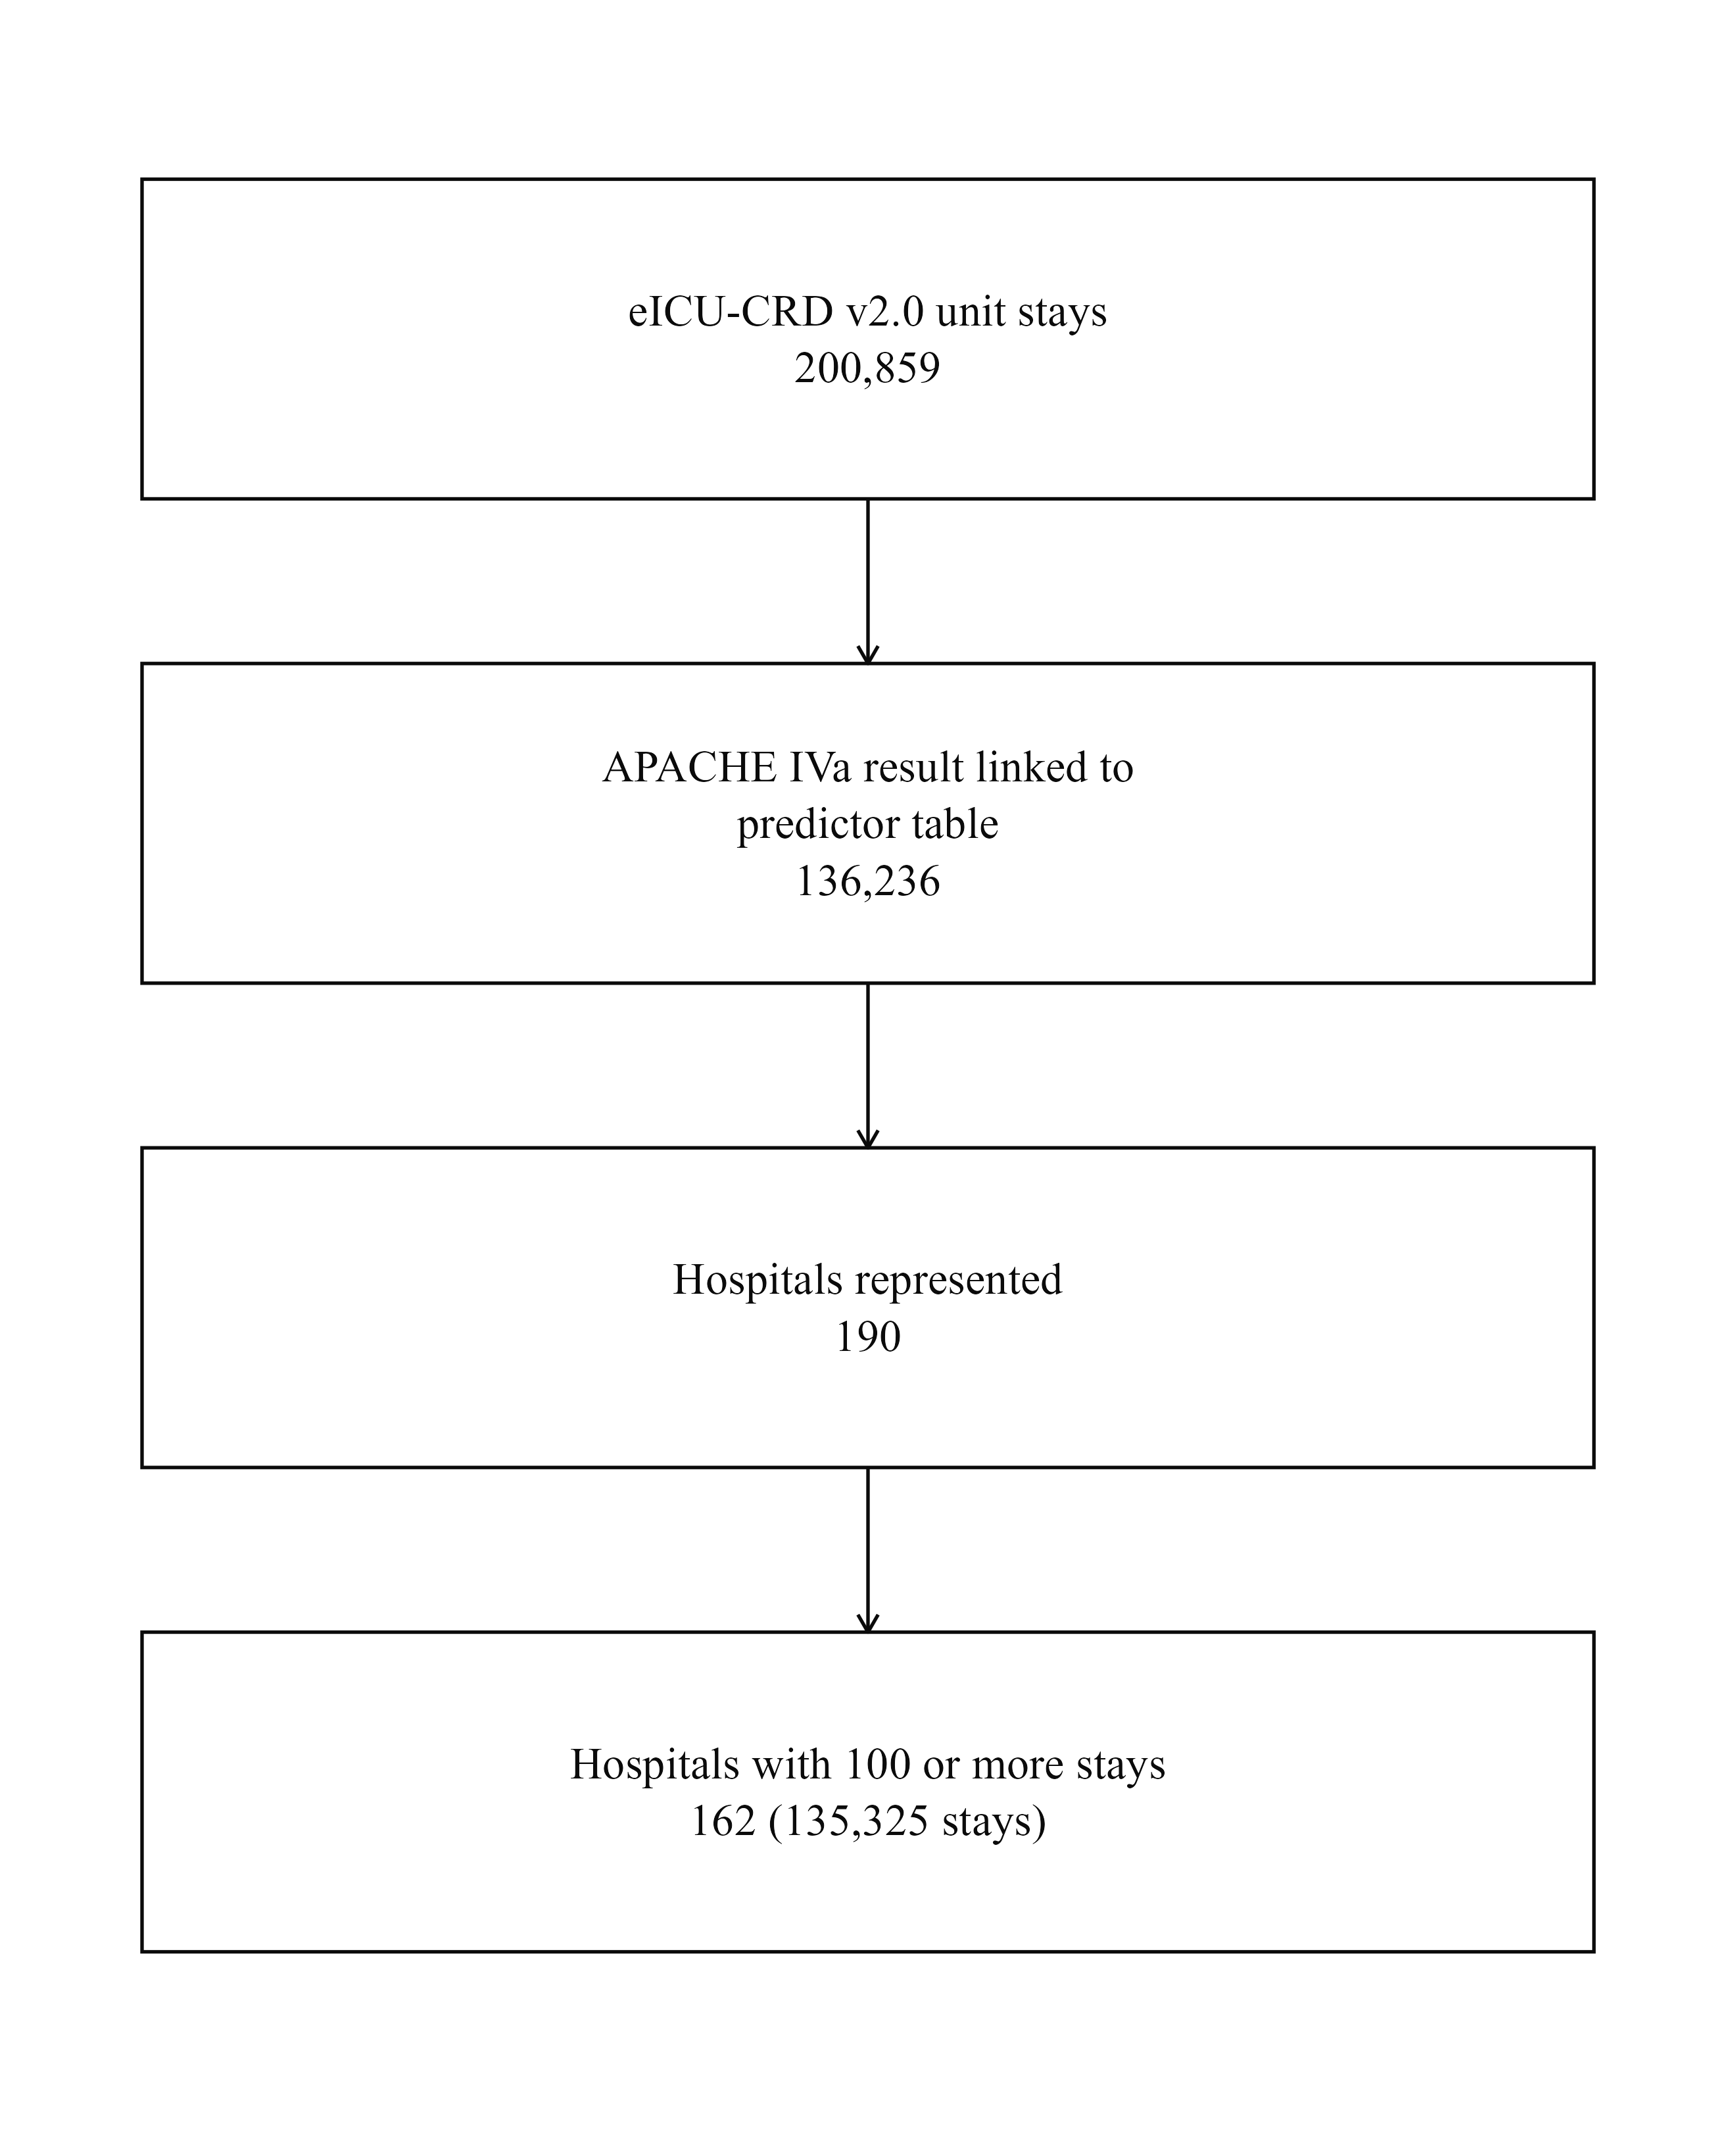
Figure 1. Derivation of the study cohort from the eICU Collaborative Research Database version 2.0.

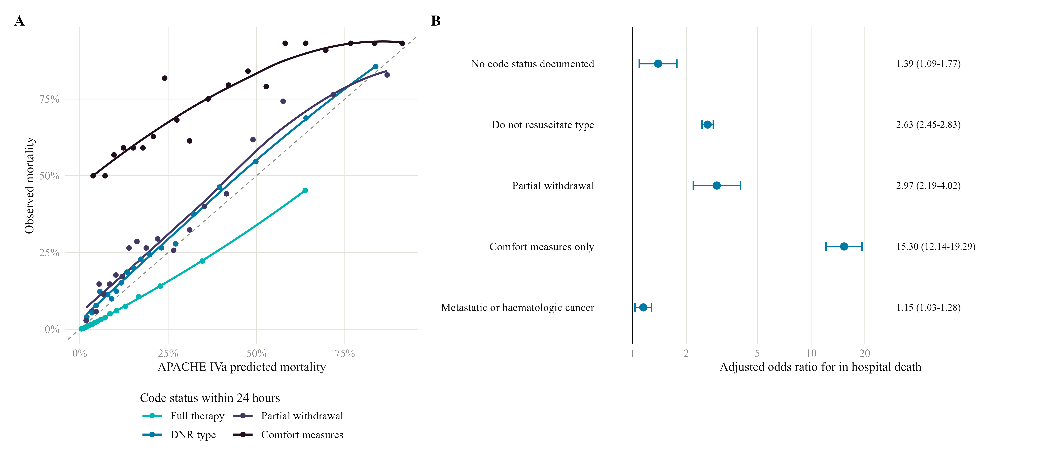
Figure 2. APACHE IVa performance by treatment limitation status. (A) Calibration curves. Points are 5 percent risk bins and the dashed line indicates perfect calibration. (B) Adjusted odds ratios for in hospital death from a logistic recalibration model, with full therapy as reference and standard errors clustered on unit.

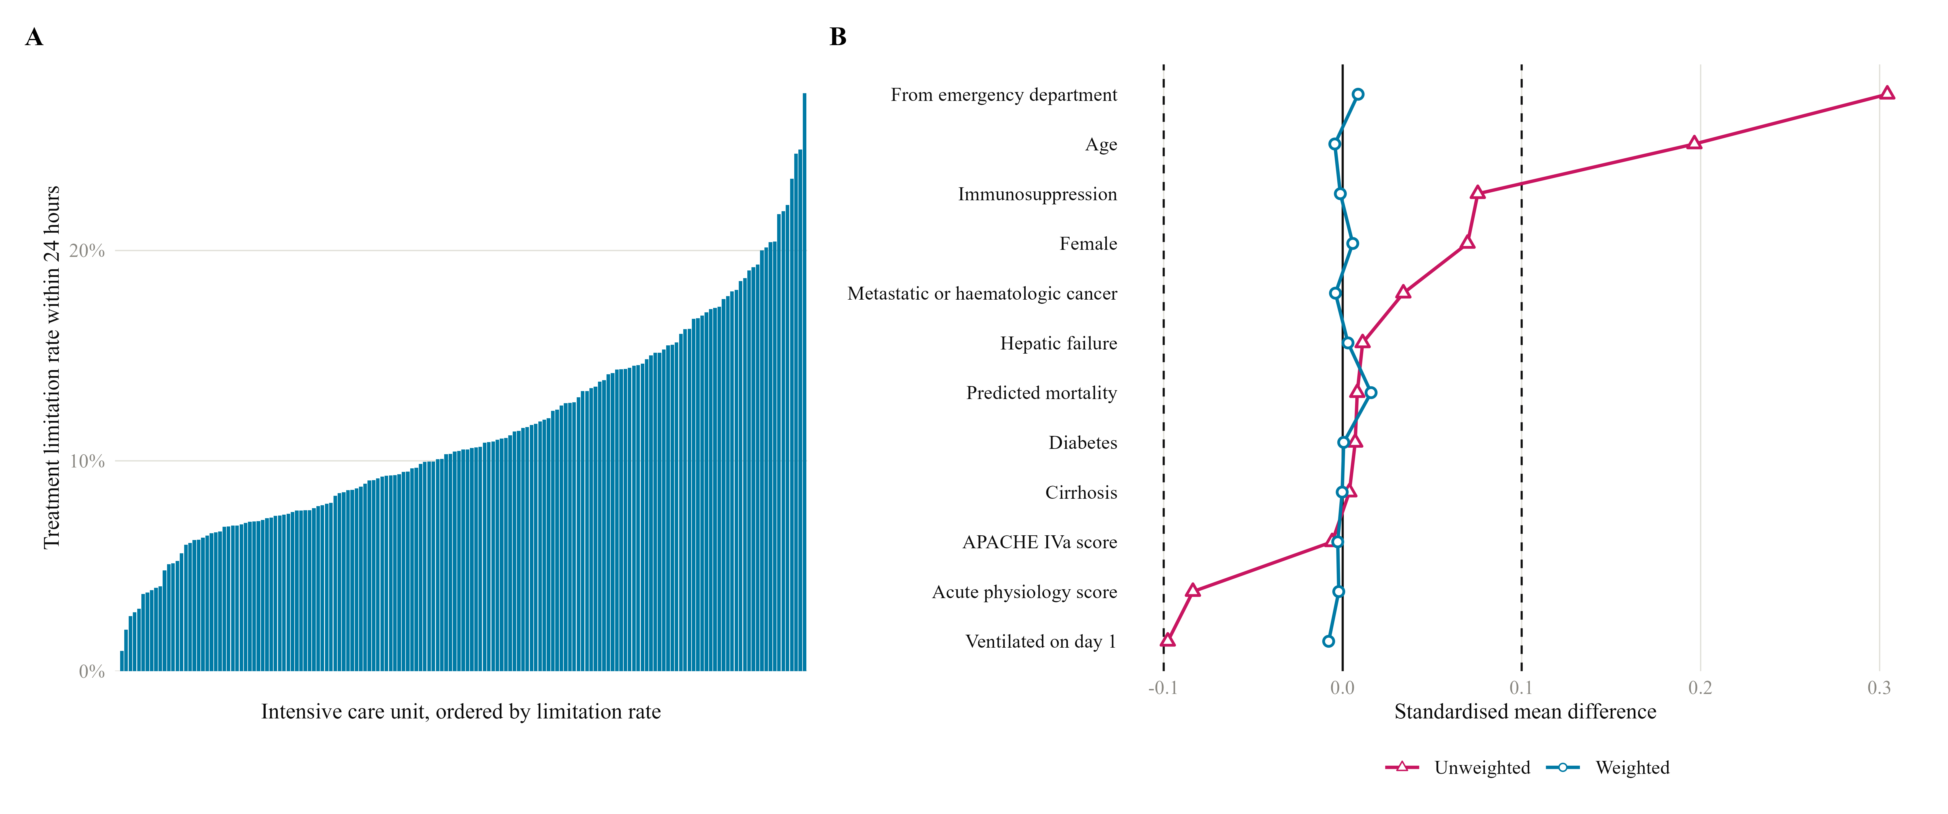
Figure 3. Between unit variation in treatment limitation. (A) Limitation rate within 24 hours across 162 units with 100 or more admissions, ordered. (B) Standardised mean differences in patient characteristics between units in the highest and lowest limitation quintile, before and after inverse probability weighting.

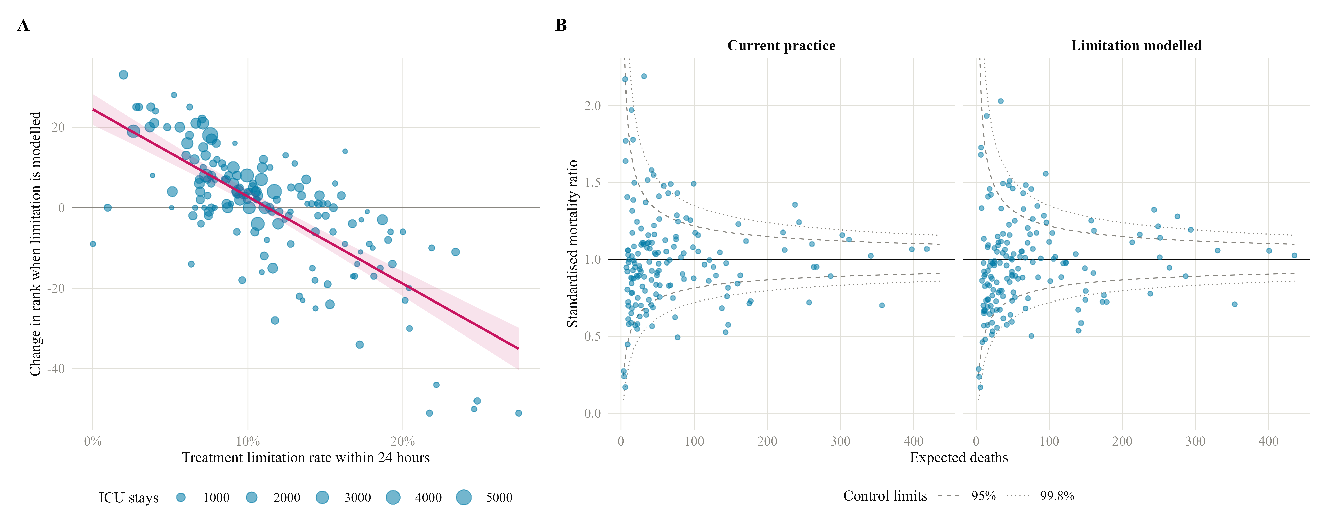
Figure 4. Effect of modelling treatment limitation on unit benchmarking. (A) Change in unit rank against limitation rate. Negative values indicate improvement. (B) Funnel plots of standardised mortality ratio against expected deaths under current practice and with limitation modelled, with 95 and 99.8 percent exact Poisson control limits.

References
1. Zimmerman JE, Kramer AA, McNair DS, Malila FM. Acute Physiology and Chronic Health Evaluation (APACHE) IV: hospital mortality assessment for today's critically ill patients. Crit Care Med. 2006;34(5):1297-310.
2. Knaus, William A, Draper, Elizabeth A, Wagner, Douglas P, Zimmerman, Jack E. APACHE II: a severity of disease classification system. Critical Care Medicine. 1985;13(10):818-829.
6. Soares M, Dongelmans DA. Why should we not use APACHE II for performance measurement and benchmarking?. Rev Bras Ter Intensiva. 2017;29(3):268-270.
7. Bennett CE, Wright RS, Jentzer J, Gajic O, Murphree DH, Murphy JG, Mankad SV, Wiley BM, Bell MR, Barsness GW. Severity of illness assessment with application of the APACHE IV predicted mortality and outcome trends analysis in an academic cardiac intensive care unit. J Crit Care. 2019;50:242-246.
9. Sarkar R, Martin C, Mattie H, Gichoya JW, Stone DJ, Celi LA. Performance of intensive care unit severity scoring systems across different ethnicities in the USA: a retrospective observational study. Lancet Digit Health. 2021;3(4):e241-e249.
10. Falcão ALE, Barros AGA, Bezerra AAM, Ferreira NL, Logato CM, Silva FP, do Monte ABFO, Tonella RM, de Figueiredo LC, Moreno R, Dragosavac D, Andreollo NA. The prognostic accuracy evaluation of SAPS 3, SOFA and APACHE II scores for mortality prediction in the surgical ICU: an external validation study and decision-making analysis. Ann Intensive Care. 2019;9(1):18.
11. Moralez GM, Rabello LSCF, Lisboa TC, Lima MDFA, Hatum RM, De Marco FVC, Alves A, Pinto JEDSS, de Araújo HBN, Ramos GV, Silva AR, Fernandes GC, Faria GBA, Mendes CL, Ramos Filho RÁ, de Souza VP, do Brasil PEAA, Bozza FA, Salluh JIF, Soares M, ORCHESTRA Study Investigators. External validation of SAPS 3 and MPM(0)-III scores in 48,816 patients from 72 Brazilian ICUs. Ann Intensive Care. 2017;7(1):53.
12. Glance LG, Osler TM, Dick A. Rating the quality of intensive care units: is it a function of the intensive care unit scoring system?. Crit Care Med. 2002;30(9):1976-82.
13. Kramer AA, Higgins TL, Zimmerman JE. Comparing observed and predicted mortality among ICUs using different prognostic systems: why do performance assessments differ?. Crit Care Med. 2015;43(2):261-9.
14. Barbash IJ, Le TQ, Pike F, Barnato AE, Angus DC, Kahn JM. The Effect of Intensive Care Unit Admission Patterns on Mortality-based Critical Care Performance Measures. Ann Am Thorac Soc. 2016;13(6):877-86.
15. Dijkema LM, Dieperink W, van Meurs M, Zijlstra JG. Preventable mortality evaluation in the ICU. Crit Care. 2012;16(2):309.
16. Liang Y, Jiang X, Zhang B. Evaluating Risk-Adjusted Hospital Performance Using Large-Scale Data on Mortality Rates of Patients in Intensive Care Units: A Flexible Semi-Nonparametric Modeling Approach. IEEE J Transl Eng Health Med. 2023;11:232-246.
17. Prescott HC, Kadel RP, Eyman JR, Freyberg R, Quarrick M, Brewer D, Hasselbeck R. Risk-Adjusting Mortality in the Nationwide Veterans Affairs Healthcare System. J Gen Intern Med. 2022;37(15):3877-3884.
19. Ray M, Zhao S, Wang S, Bohl A, Romano PS. Improving hospital quality risk-adjustment models using interactions identified by hierarchical group lasso regularisation. BMC Health Serv Res. 2023;23(1):1419.
21. Nerenz DR, Austin JM, Deutscher D, Maddox KEJ, Nuccio EJ, Teigland C, Weinhandl E, Glance LG. Adjusting Quality Measures For Social Risk Factors Can Promote Equity In Health Care. Health Aff (Millwood). 2021;40(4):637-644.
22. Lee SI, Ju YR, Kang DH, Lee JE. Characteristics and outcomes of patients with do-not-resuscitate and physician orders for life-sustaining treatment in a medical intensive care unit: a retrospective cohort study. BMC Palliat Care. 2024;23(1):42.
23. Driggers KE, Keenan LM, Alcover KC, Atkin M, Irby K, Kovacs M, McLawhorn MM, Mir-Kasimov M, Sabbahi WZ, Sellman J, Johnson LS. Unintended Consequences of Code Status in the Intensive Care Unit: What Happens After a Do-Not-Resuscitate Order Is Placed? A Retrospective Cohort Study. J Palliat Med. 2024;27(4):508-514.
24. Asiri A, Alenezi FZ, Tamim H, Sadat M, Bin Humaid F, AlWehaibi W, Al-Dorzi HM, Alzoubi YA, Alanazi SA, Naidu B, Arabi YM. Practice and Predictors of Do-Not-Resuscitate Orders in a Tertiary-Care Intensive Care Unit in Saudi Arabia. Crit Care Res Pract. 2024;2024:5516516.
25. Ouyang DJ, Lief L, Russell D, Xu J, Berlin DA, Gentzler E, Su A, Cooper ZR, Senglaub SS, Maciejewski PK, Prigerson HG. Timing is everything: Early do-not-resuscitate orders in the intensive care unit and patient outcomes. PLoS One. 2020;15(2):e0227971.
26. Fuchs L, Anstey M, Feng M, Toledano R, Kogan S, Howell MD, Clardy P, Celi L, Talmor D, Novack V. Quantifying the Mortality Impact of Do-Not-Resuscitate Orders in the ICU. Crit Care Med. 2017;45(6):1019-1027.
27. Wade CE, del Junco DJ, Fox EE, Cotton BA, Cohen MJ, Muskat P, Schreiber MA, Rahbar MH, Sauer RM, Brasel KJ, Bulger EM, Myers JG, Phelan HA, Alarcon LH, Holcomb JB, PROMMTT Study Group. Do-not-resuscitate orders in trauma patients may bias mortality-based effect estimates: an evaluation using the PROMMTT study. J Trauma Acute Care Surg. 2013;75(1 Suppl 1):S89-96.
29. Patel K, Sinvani L, Patel V, Kozikowski A, Smilios C, Akerman M, Kiszko K, Maiti S, Hajizadeh N, Wolf-Klein G, Pekmezaris R. Do-Not-Resuscitate Orders in Older Adults During Hospitalization: A Propensity Score-Matched Analysis. J Am Geriatr Soc. 2018;66(5):924-929.
30. Hart JL, Harhay MO, Gabler NB, Ratcliffe SJ, Quill CM, Halpern SD. Variability Among US Intensive Care Units in Managing the Care of Patients Admitted With Preexisting Limits on Life-Sustaining Therapies. JAMA Intern Med. 2015;175(6):1019-26.
31. Mark NM, Rayner SG, Lee NJ, Curtis JR. Global variability in withholding and withdrawal of life-sustaining treatment in the intensive care unit: a systematic review. Intensive Care Med. 2015;41(9):1572-85.
32. Avidan A, Sprung CL, Schefold JC, Ricou B, Hartog CS, Nates JL, Jaschinski U, Lobo SM, Joynt GM, Lesieur O, Weiss M, Antonelli M, Bülow HH, Bocci MG, Robertsen A, Anstey MH, Estébanez-Montiel B, Lautrette A, Gruber A, Estella A, Mullick S, Sreedharan R, Michalsen A, Feldman C, Tisljar K, Posch M, Ovu S, Tamowicz B, Demoule A, DeKeyser Ganz F, Pargger H, Noto A, Metnitz P, Zubek L, de la Guardia V, Danbury CM, Szűcs O, Protti A, Filipe M, Simpson SQ, Green C, Giannini AM, Soliman IW, Piras C, Caser EB, Hache-Marliere M, Mentzelopoulos SD, ETHICUS-2 Study Group. Variations in end-of-life practices in intensive care units worldwide (Ethicus-2): a prospective observational study. Lancet Respir Med. 2021;9(10):1101-1110.
33. Barnato AE, Farrell MH, Chang CC, Lave JR, Roberts MS, Angus DC. Development and validation of hospital "end-of-life" treatment intensity measures. Med Care. 2009;47(10):1098-105.
34. Barnato AE, Tate JA, Rodriguez KL, Zickmund SL, Arnold RM. Norms of decision making in the ICU: a case study of two academic medical centers at the extremes of end-of-life treatment intensity. Intensive Care Med. 2012;38(11):1886-96.
35. Barnato AE, Mohan D, Lane RK, Huang YM, Angus DC, Farris C, Arnold RM. Advance care planning norms may contribute to hospital variation in end-of-life ICU use: a simulation study. Med Decis Making. 2014;34(4):473-84.
36. Curtis JR, Engelberg RA, Teno JM. Understanding variability of end-of-life care in the ICU for the elderly. Intensive Care Med. 2017;43(1):94-96.
37. Fong C, Kueh WL, Lew SJW, Ho BCH, Wong YL, Lau YH, Chia YW, Tan HL, Seet YHC, Siow WT, MacLaren G, Agrawal R, Lim TJ, Lim SL, Lim TW, Ho VK, Soh CR, Sewa DW, Loo CM, Khan FA, Tan CK, Gokhale RS, Siau C, Lim NLSH, Yim CF, Venkatachalam J, Venkatesan K, Chia NCH, Liew MF, Li G, Li L, Myat SM, Zena Z, Zhuo S, Yueh LL, Tan CSF, Ma J, Yeo SL, Chan YH, Phua J, for SICM-NICER group. Predictors and outcomes of withholding and withdrawal of life-sustaining treatments in intensive care units in Singapore: a multicentre observational study. J Intensive Care. 2024;12(1):13.
39. Austin PC, Steyerberg EW. The Integrated Calibration Index (ICI) and related metrics for quantifying the calibration of logistic regression models. Stat Med. 2019;38(21):4051-4065.
40. Austin PC, Harrell FE Jr, van Klaveren D. Graphical calibration curves and the integrated calibration index (ICI) for survival models. Stat Med. 2020;39(21):2714-2742.
41. Spiegelhalter DJ. Funnel plots for comparing institutional performance. Stat Med. 2005;24(8):1185-202.
42. Austin PC, Merlo J. Intermediate and advanced topics in multilevel logistic regression analysis. Stat Med. 2017;36(20):3257-3277.
43. Merlo J, Chaix B, Ohlsson H, Beckman A, Johnell K, Hjerpe P, Råstam L, Larsen K. A brief conceptual tutorial of multilevel analysis in social epidemiology: using measures of clustering in multilevel logistic regression to investigate contextual phenomena. J Epidemiol Community Health. 2006;60(4):290-7.
44. Collins GS, Reitsma JB, Altman DG, Moons KG. Transparent Reporting of a multivariable prediction model for Individual Prognosis or Diagnosis (TRIPOD): the TRIPOD statement. Ann Intern Med. 2015;162(1):55-63.
45. Collins GS, Moons KGM, Dhiman P, Riley RD, Beam AL, Van Calster B, Ghassemi M, Liu X, Reitsma JB, van Smeden M, Boulesteix AL, Camaradou JC, Celi LA, Denaxas S, Denniston AK, Glocker B, Golub RM, Harvey H, Heinze G, Hoffman MM, Kengne AP, Lam E, Lee N, Loder EW, Maier-Hein L, Mateen BA, McCradden MD, Oakden-Rayner L, Ordish J, Parnell R, Rose S, Singh K, Wynants L, Logullo P. TRIPOD+AI statement: updated guidance for reporting clinical prediction models that use regression or machine learning methods. BMJ. 2024;385:e078378.
46. Pollard TJ, Johnson AEW, Raffa JD, Celi LA, Mark RG, Badawi O. The eICU Collaborative Research Database, a freely available multi-center database for critical care research. Sci Data. 2018;5:180178.
47. Feng S, Dubin JA. Identifying early-measured variables associated with APACHE IVa providing incorrect in-hospital mortality predictions for critical care patients. Sci Rep. 2021;11(1):22203.
48. Gao S, Wang Y, Yang L, Wang Z, Huang W. Characteristics and clinical subtypes of cancer patients in the intensive care unit: a retrospective observational study for two large databases. Ann Transl Med. 2021;9(1):13.
49. Essay P, Shahin TB, Balkan B, Mosier J, Subbian V. The Connected Intensive Care Unit Patient: Exploratory Analyses and Cohort Discovery From a Critical Care Telemedicine Database. JMIR Med Inform. 2019;7(1):e13006.
50. Russell E, Hall AK, McKaigney C, Goldie C, Harle I, Sivilotti MLA. Code Status Documentation Availability and Accuracy Among Emergency Patients with End-stage Disease. West J Emerg Med. 2021;22(3):628-635.
53. Ma J, Chi S, Buettner B, Pollard K, Muir M, Kolekar C, Al-Hammadi N, Chen L, Kollef M, Dans M. Early Palliative Care Consultation in the Medical ICU: A Cluster Randomized Crossover Trial. Crit Care Med. 2019;47(12):1707-1715.
54. Martins BDCPCC, Oliveira RA, Cataneo AJM. Palliative care for terminally ill patients in the intensive care unit: Systematic review and metaanalysis. Palliat Support Care. 2017;15(3):376-383.
55. Hsu-Kim C, Friedman T, Gracely E, Gasperino J. Integrating Palliative Care into Critical Care: A Quality Improvement Study. J Intensive Care Med. 2015;30(6):358-64.
56. Austin PC, Stuart EA. Moving towards best practice when using inverse probability of treatment weighting (IPTW) using the propensity score to estimate causal treatment effects in observational studies. Stat Med. 2015;34(28):3661-79.

