**CERTIFICATE**

I, **MUNYANEZA Alphonse** hereby certify that this project report entitled “**TECH-SHOP ONLINE ORDERING SYSTEM**”is the original work of **RUKUNDO Fabrice** who carried out the research under my supervision. I certify further that, to the best of my knowledge, the work reported herein does not form part of any other project or dissertation.

**SUPERVISOR:**

**MUNYANEZA Alphonse**

**-----------------------------**

**Signature: …………………………** Date: …… /…. /…….

**DECLARATION**

I hereby declare that project named “**TECH-SHOP ONLINE ORDERING SYSTEM**” was implemented from my own effort and is submitted in the fulfilment of requirement of the award of A2 in “COMPUTER SCIENCE” and it has never presented or submitted in any institution.

**SUPERVISOR:**

**MUNYANEZA Alphonse**

**Signature: …………………………** Date: ……. /….. /……..

**DEDICATION**

I dedicate this project to:

My above highest GOD,

My lovely parents,

My family,

My beloved colleagues,

My teachers and authorities,

My supervisor,

My friends

I dedicate this project to all persons who will read it and your support is important to me.

My God bless you all

# 

# ACKNOWLEDGEMENT

This work has been archived by the help and support of many different people. First of all, I would like to thank GOD for his unlimited protection to me, my family and my school I thank my lovely parents for different kind of support.

I thank so much my teachers of Computer Science at MIPCfor high education and facilities offered to me for my studies.

I would like to offer my sincere thanks to my colleagues and teachers who gave me suggestion for lot of helpful advices especially my supervisor **MUNYANEZA Alphonse** for full of ideas in my work.

And I’m thanking everyone who helped me in this work.

# 

# ABSTRACT

According to the evolution and the technology of the world, I have studied the system which can help me to computerize **“TECH-SHOP ONLINE ORDERING SYSTEM’’**. This system will reduce the difficulties met by them during writing down on papers the number of orders that they received each day and also managing the number of clients they receive.

# 

# LIST OF ABBREVIATION

**WWW**: World Wide Web

**CSS:** Cascading Style Sheet

**PHP:** Hypertext Preprocessor

**HTML:** Hypertext Markup Language

**CSS:** Cascading Style Sheet

**HTTP**: Hypertext Transfer Protocol

**SQL:** Structure Query Language

**DBMS: Database Management System**

**URL:** Uniform Resource Locator

**XAMPP:** Extensible Apache MySQL PHP Perl

# CHAPTER I. GENERAL INTRODUCTION

## **Introduction**

All over the world for many countries, we want to improve or promoting information technology using new technology which uses capacity an multi capacity tools such as computer and its devices but it is used by human to realize and to do many functions in various domain of his life.

Rwanda is stilled in those countries and in the world general has not remained insensible to the opportunisms provided by that technology. It has tried to computerize some domains according to computers functionalities.

Our country Rwanda has a long way to attain success in this area. Website development and the use of automated system network system development, the need to share resources within the country and with the outside world, is what among other things that hold largely the certificate of measure of development in the Rwanda society.

Given the typical nature of information technology evolving day by day, there are wide rangers of activities that must be executed to implement ICT strategic activities presented as interactive and online information.

Therefore, as research, I committed to study information technology applications in Tech-Shop Online Ordering System. It is crucial issue; we have dedicated to orient our project research in developing system that will help clients and the administrator for managing various activities in the shop and it will be used to manage information, it will also manage products details, client details of the shop, it will keep the track of the number of the customers and orders they make.

This project will help people about what we have said above.

## **1.2. Problem statement**

The existing system uses sheet paper to store data and consumed time. Due to the limitations of this system faces a lot of problems which include:

* Information of client or customers can be loose.
* It takes time to find record of ordered product and other information because it is in paper.
* The work is done slowly.
* It increases the work of the employees of the shop.

## **1.3 Objectives of the study**

The objectives of this system are consisting: the general objectives, specific objectives and significance objectives.

## **1.3.1 General objectives of the study**

The general objective of this system is to analyze and help the administrator to organize from the manual work from which is difficult to find the records of the clients or customers and ordered products.

## **1.3.2. Specific objectives of the study**

* Time saving
* It helps to manage the manual work from which it is very difficult to find the record of ordered products and other information.
* Secured way for electronic device management system.
* It reduces the works performed by the employee.

## **1.3.3. Significance objectives**

This subject has been chosen because I found those different problems as explained above that were include in electronic device management system.

## **1.4 Project interest and Choice**

## **1.4.1 Personal interest**

I’m glad to implement my own web-based application.

Also, it is very important to me because it will improve my skills in programming.

**1.4.2 Social interest**

Socially, this project is very important for the shop that will use it, so that it can help administration to get information of the products that have been ordered and to keep them safely in database.

**1.4.3 Scientific interest**

Scientifically, my project has been taken to improve my knowledge in programing languages and database management system that I had learned in class.

## **1.5 Scope of project**

In this project we will focus on the following functions services:

* Creating an interface with a way in which the user can enter information form.
* A way in which the user can view reports.
* The system that help administrator to manage or control our products

Project is limited to what I have said above.

## **1.6 Data collection method**

In the scientific research domain, the concept “techniques” means the entire process used by the research to find information.

## **1.7.1 Interview**

An interview is a technique used when we have made observation to collect a variety of information from electronic devices shop related to Tech-shop Online Ordering System from the beginning up to the of Tech-shop Online Ordering System.

## **1.7.2 Documentation**

It is another technique used to collect data, and we usually know that for getting the facts information we must read the books and visiting the internet web sites in order to order to do effective and efficiency research study we have read the different books and visited many internet web sites for having this output which is the final product of our research study.

## **1.7.3 Observation**

Observation is visual study of something or someone in order to gain information. This allows us to make informed decisions and to get the facts information and also allowance based on what we have been studied. Observation is a basic and important method used to collect the real data in our research methodology of making a web-based application of Tech-Shop Online Ordering System. We did it by collecting data about Tech-Shop Online Ordering System.

# CHAP II: LITERATURE REVIEW

## **2.1. Introduction**

This chapter explains the technical terms I have used, and some tools that I have used when designing this system. Those definitions I have read them in different locations, some from different websites, and others from the notes from my different teachers.

## **2.2. Concepts of dissertation**

Tech-Shop Online Ordering System: Consists of the set of rules which must be followed for a managing and control to be considered valid.

## **2.3. Database concepts**

## **2.3.1. Database**

The term database is a system of collecting, organizing, modifying and updating related data. By related we mean that in table describes a domain of interest to a group of users that the users can use the data to answer questions concerning that domain. By organized we mean that the data are structured so as to be easily restored, manipulated by the user.

## **2.3.2. Data**

Data defined as the collection of facts stored in database.

Because data are the raw materials from which information is generated, the determination of which data are to be entered into database and how such data are to be organized is a vital of database designer’s job.

Information is the processed and organized data. when data is processed, organized, structured in a given context so to make it useful it is what we call information. Databases are used to provide meaningful information.

## **2.3.3. Relationship**

Relationship, in the context of database, is a situation that exists between two relational tables when one table has a foreign key that references the primary key of the other table.

One-to-one relation: is when each instance of a given entity relates exactly to one instance of another entity.

One-to-many relation: is when each instance of a given entity relates exactly to one or more instance of another entity.

Many-to-many relation: is when many instance of a given entity relates exactly to many instance of another entity.

## **2.3.4. Entity or table**

Entity is conceptual or physical thing that can be identified in the user’s work environment, something about which the organization wants to hold information. In the case of the project, entity may be physical thing such as student, or conceptual like save.

## **2.3.5. A primary key**

A table typically has a column or combination of columns that contain values that uniquely identify columns that contain values that uniquely identify each row in a table. There can only be one primary key per table. When you define a primary key for a table, you create a constraint on data in the table where a primary key should be unique and should not contain null values.

## **2.3.6. A foreign key**

A foreign key consists of one or more columns in a table whose value in one now uniquely identifies another row in the same or another table.

Also, foreign key is a primary key of one relation that migrates to another relation to create relationship.

Relationship describes how entities interact.

## **2.3.7. MYSQL**

MYSQL is a database. The data in MYSQL is stored in database objects called tables.

A table is a collection of related data entries and it consists of columns and rows.

Databases are useful when storing information categorically. A company may have a database with the following table: “Employees”,” Products”, “customers” and “Orders”.

## **2.3.8. SQL**

SQL stands for Structure Query Language, and is a standard language for accessing and manipulating databases.

## **2.3.9. DBMS**

**DBMS:** To access information in database you need Database Management System which is a collection of programs that enable users to enter, organize access and select data in a database.

## **2.3.10. Local host**

**Local host:** is a powerful computer which is responsible to answer all request of client computer.

## **2.4. Web concepts**

## **2.4.1. Web page**

A web page is a block of data available on the word-wide, identified by an URL.

Also, is a simple text written in description of language called HTML permitting to describe the page setup of the document the page setup.

## **2.4.2. Website**

A website is a set of web pages linked between them (together).

## **2.4.3. Static website**

A static website is a web page that is delivered to the exactly as stored, in contrast to dynamic webpage which are generated by a web application. A static web page displays the same information for all users, from all contexts, subjects to modem capabilities of a web server to negotiate content-type or language of the document where such versions are available and the server is configured to do so. Static web pages are often HTML documents stored as files in the file system and made available by the web server over HTTP.

## **2.5. Tools and languages used**

## **2.5.1. CSS**

CSS stands for Cascading Style sheets.

A style sheet: is a numeric document which can specify all characteristics of formatting a document linked with a tag on which it is applied on.

**A style**: This defines how to display HTML elements.

## **2.5.2. HTML**

HTML is a language for describing web pages.HTML stands for Hyper Text Markup Language

It is not a programming, but it is markup language is asset of markup tags, uses markup tags to describe web pages.

HTML tags: are instructions used to format web page content and it is also a cold web page.

## **2.5.3. PHP**

PHP stands for Hypertext Preprocessor.

PHP is a server scripting language that is used to create dynamic websites. There are many server-side scripting language include ASP, CGI cold fusion, and so on.

## **2.5.4. JetBrains Php Storm**

JetBrains Php Storm is an internet –ready 32-bit and 64-bit text, HTML, and code editor for windows. It offers, many features for webpage authors and programmers, including syntax highlighting for HTML, CSS, PHP, JavaScript, XML, ASP…

## **2.5.5. Visual Studio Code**

Visual Studio Code is an Internet-ready 32-bit text, HTML, and code editor for Windows. It offers many features for Web page authors and programmers, including syntax highlighting for HTML, CSS, and PHP

## **2.5.6. Adobe Photoshop**

Adobe Photoshop is a graphic editing program developed and published by adobe system incorporated for creating and modifying Images for the web

## **2.5.7. Browser**

A browser is software that accesses and displays pages and files on the web, browser require Connection to the internet with wire or wirelessly.

The most popular browsers are:

* Mozilla Firefox
* Internet explorer
* Google chrome
* Safari
* Netscape navigators
* Opera mini

# CHAP III. SYSTEM ANALYSIS AND DESIGN

## **3.1. Introduction**

This chapter explain the techniques that I have used for collecting information required for developing this software, analyzing how the system will work, the description of the existing system that is using up today, the new system and how it will help administrator of system to get information everywhere and anytime, also this will help administrator of Tech-Shop to make report of activities in secured way.

This chapter also explains the whole processes of activities and the management of those activities that will be done by administrator.

## **3.2. Use case of Existing system**

The problem cannot be easily solved without analyzing how the system will work after understanding the problem by observation I tried to analyze the problem and try to find out the practical solution of it by also look what will be the necessary tools, so that the problem will be solved and in general theory of how the system will work.

## **3.3. Methodology**

Requirement Analysis Planning

System Design

Testing

Maintenance

Coding

Figure 1: Methodology

## **3.4. Use Case of New System**

After discussing of the old process that they used to manage their products, customers and activities I have found that the process used was not efficient due to development of technology in now days. That’s why this new system can be a good way to manage that in short time and secured way through this system. The following explain the details about the system functionality and different links and how they should be used by both sides.

* Dashboard: This link is the main page of the system and it welcomes users to the system.
* Product category and category list: This link provides the form to administrator, they use to add product category to the system and category list provide list of all product categories of the Tech-Shop.
* Product and product list: This link provide the form used to add new product with its details and product list provide the link which display all products with their details.
* Slider and slider list: This link provide the form used to add new slider of image and slider list provide the link which display all slider images.
* Manage payment: This link displays all payment list that have been done by customers.
* View shipping: This link display list all shipping or orders that have been ordered by customers with their shipping details.
* Blog, blog list and about us: This link provides the form used to add latest news about new products that arrived in Tech-Shop, blog list displays all blogs and about us provide the link to add about us and even to update it.

## **3.5 Database description and structure**

My database is composed of 8 tables.

* Users: This table will contain all users.
* Categories: This table will contain all products categories.
* Products: This table will contain all products.
* Payments: This table stores all payments.
* Shippings: This table will contain all shippings details.
* Sliders: This table contains all sliders.
* Blogs: This table contains all blogs.
* aboutus: This table contains aboutus.

## **3.6 Data Flow Diagram**

A data flow diagram (DFD) is a graphical representation of the flow of data through an information system, model in gets process aspects. A DFD is often used as preliminary step to create an overview of the system, which can later be elaborated. A data flow diagram (DFD) illustrates how data is processed by system in terms of inputs and outputs. As its name indicates its focus is on the flow of information, where data comes from, where it goes and how it gets stored. A data flow diagram shows what kind of information will be input and out put from the system, where the data will come from and go to, and where the data will be stored.

## **3.6.1 Elements of data-flow diagrams**

Four basic elements to construct data-flow diagram: processes, data-flows, data stores and external entities.

**3.6.2 DFD notation**

Data flow diagram has symbolic notation with, each symbol has meaning according to its role.

This table shows symbols of data-flow diagram and their meanings.

**Table 7:** **Data flows and meaning**

**Symbols** **Meaning**

**An entity:** A source of data or a d destination for data. An entity can send or r receive da ta from the system. Entity is also a called source or destination of data.

**A process:** or task that is performed by the s system. A process shows a transformation or m manipulation of data flows within the system

**A data link:** it marks the movement of data.

**3.6.3 DFD of Tech-Shop Online Ordering System**

**Administration**

**Tech-Shop Online Ordering System**

**Customers**

**3.7 Entity Relationship Diagram**

Relationship works by matching data in keys fields- usually field with the same name in both tables. In most cases, these matching fields are the primary key from one table, which provides a unique identifier for each record, and a foreign key in the other table. A foreign key is a column or combination of columns used to establish and enforce a link between the data in two tables.

**One-to-one**

This occurs when exactly one record in the first table that correspond exactly one record in the related table.

**One-to-many**

Occurs when each record in the table may link records in table be may have only one corresponding record in table.

**Many-many**

Occur when each record in the record in the first table corresponds to one or more record in the second table and each record in second table correspond to one or more records in the first table.

## **3.7.1. Entity Relationship Diagram of the system**

## **3.8 Requirements Specifications**

## **3.8.1. The server-side**

* Windows operating system,
* The package must include: Apache 2.2.11, MySQL 5.1.30, PHP version 4 or 5
* Xampp-win32-1.7.4-VC6-installer (3) for database management.

## **3.8.2. The client-side**

* Web client.
* Ethernet card and internet connection.

**3.9 Data dictionary**

**Table 1: Users Table**

This table stores all users accounts

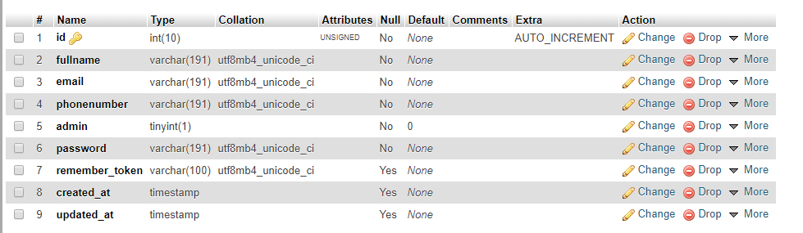

**Table 2: Categories Table**

This table stores all product categories

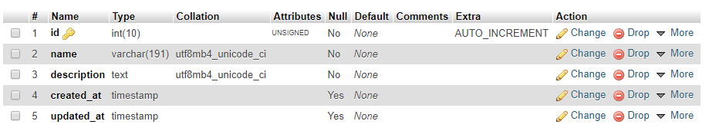

**Table 3: Products Table**

This table stores all products

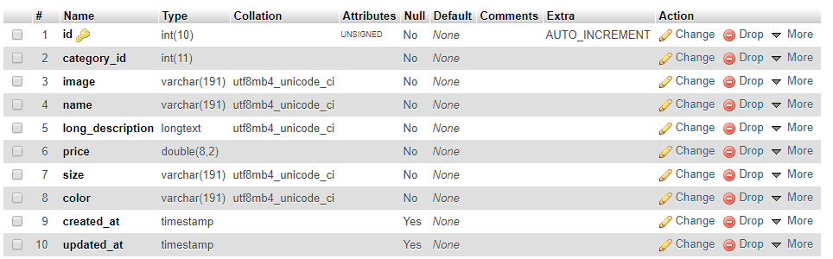

**Table 4: Payment Table**

This table stores all payment  
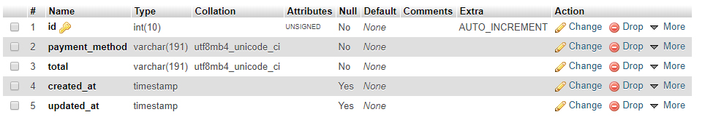

**Table 5: Shipping table**

This table stores all shippings

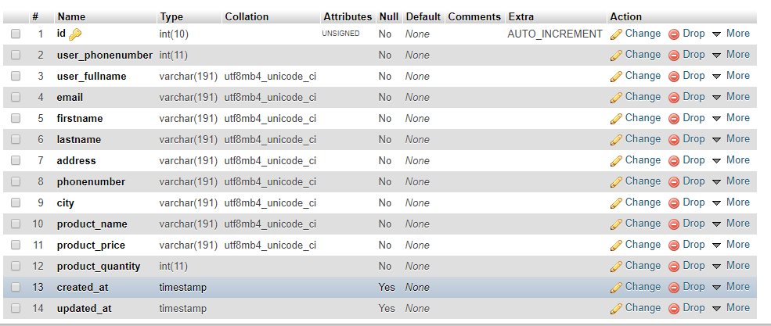

**Table 6: Blog Table**

This table stores all blogs

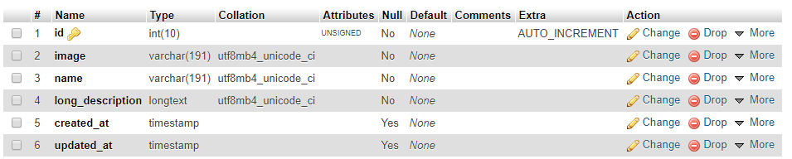

**Table 7: Sliders Table**

This table stores all sliders

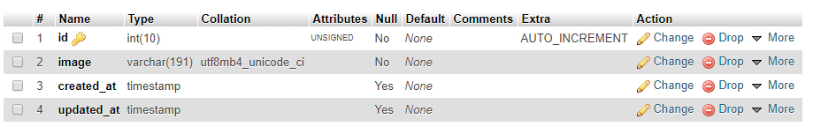

# CHAP IV. IMPLEMENTATION OF THE SOFTWARE

During this part of the process we need to develop our system architecture, to define how all components will fit together and operate; database design. The system has been designed in such a way that the modifications can be made at each step. The advantage of this approach is that it can result better testing. Each increment is likely to be easier than testing the entire system as in management of Tech-Shop Online Ordering System in order to improve good quality of services operation.

**4.2 SOFTWARE AND HARDWARE REQUIREMEMNTS**

**4.2.1 Software requirements**

The software requirements as follows:

* Operating system: Microsoft Windows7, etc……
* Browser: Mozilla Firefox, Internet explore, Google chrome, etc…..
* Web serve: Apache server
* Database package: MySQL
* Front End Tools: HTML, Easy PHP, Edit plus, Visual Studio Code etc……

**4.2.2Hardware requirements**

The hardware requirements as follows:

* CPU: Pentium III processor or Higher processor
* RAM: 125 MB or Plus
* HDD: 20 GB
* Keyboard, Monitor, Mouse, Printer

**Figure: Operation of my project**

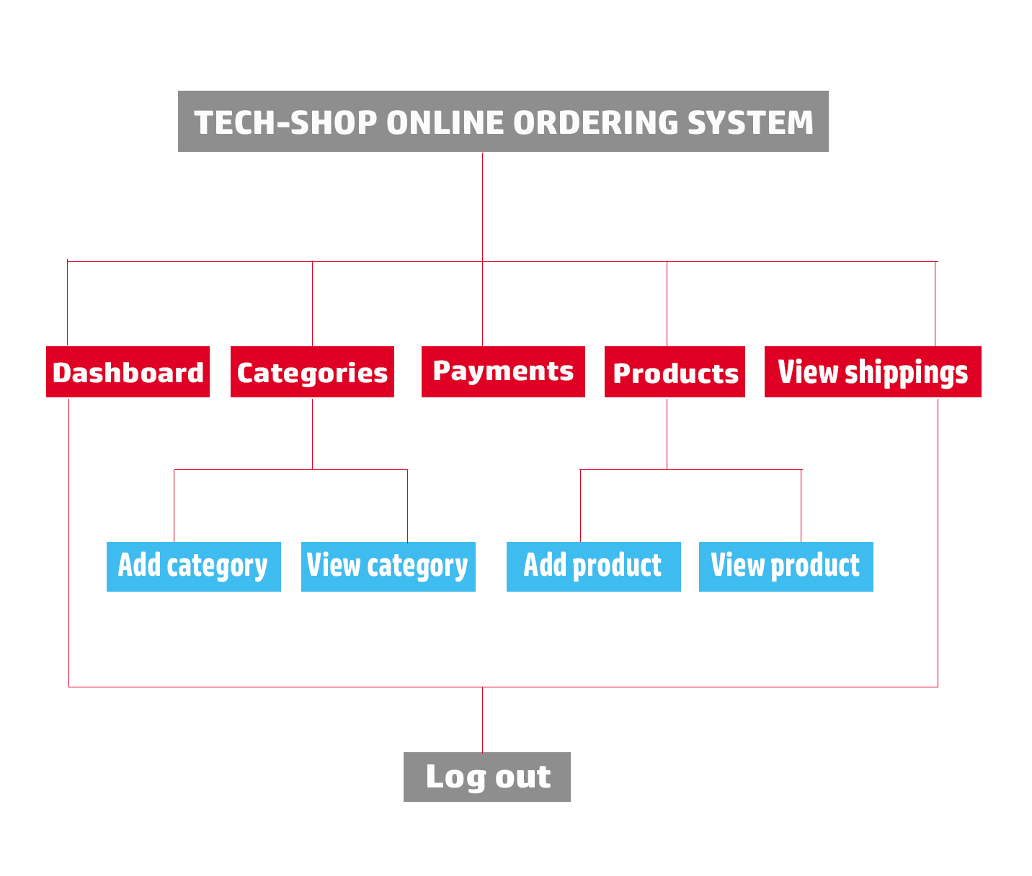

**Figure: Structure of my project**

# CHAPTER V: RECOMMANDATIONS AND CONCLUSION

## **5.1. Conclusion**

After recovering the problems, the old system has, the new system that use computerized was designed to solve all the problems appeared in old system that use papers.

By the time you will be using this system it will not take a long time in order you learn how to use it because its not a big program like other software as you know because it is a simple program which is not hard to use.

A customer who will join Tech-Shop after he/she start to use this system they will be a big different to the old one because you can order any product wherever you are in a very simple way.

## **5.2. Recommendation**

Considering the services that this project will serve in order to overcome those problems found in the existing system I advise that Tech-Shop have to look forward to start using Tech-Shop Online Ordering System.

**5.3. REFERENCES**

**Books:**

**Electronic reference**

1. <https://www.google.rw/search?sclient=psy-ab&site=&source=hp&btnG=Search&q=what+is+Votes%3F#q=PHP+stands+for+Hypertext+Preprocessor>.

<https://www.google.rw/search?sclient=psy-ab&site=&source=hp&btnG=Search&q=what+is+Votes%3F#q=PHP+stands+for+Hypertext+Preprocessor>.

<http://https-en-wikipedia_org.internet.com/wiki/Methodology?!org-service-id-internal>

<https://en.wikipedia.org/wiki/Voting_system>

1. <http://searchsoa.techtarget.com/definition/HTML>