1) explain the image formation in the eye. What are the differences in focusing between the ordinary cameras and the human eyes?
the image formation in the eye : visible range of human eye : 350 nm < λ > 780 nm
for a given λ
f(x,y) denotes images as two-dimensional functions
f intensity value (f ≥ 0) , 0 < f(x,y) < ∞
(x,y) spatial coordinates
f(x,y) = i(x,y) r(x,y)
0 < i(x,y) < ∞ is illumination – the amount of source illumination incident on the scene being viewed
0 < r(x,y) < 1 is reflectance – the amount of illumination reflected by the objects in the scene

Retina contains two types of photoreceptors :
- 100 millions of rods which are distributed over Retina (dark environment)
- 6.5 millions of cones which are mostly packed in Fovea and responsible for color vision . The number of cones in fovea is about 265K
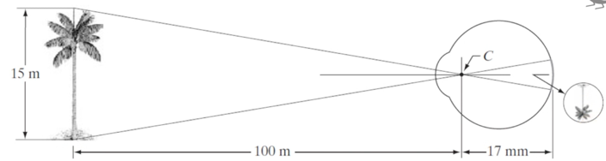

For example suppose that a person is looking at a tree 15 m high at a distance of 100 m.
Letting H denote the height of that object in the retinal image, the geometric yields 15/100 = h/17 $→$ h = 2.55 mm

In other words, how human visual system works as below:
- Light energy is focused by the lens of the eye into sensors and retina.
- The sensors respond to the light by an electrochemical reaction that sends an electrical signal to the brain (through the optic nerve)
- The brain uses the signals to create neurological patterns that we perceive as images.

Different focusing between technical camera system and HVS ?
- First different is the lens. In the HVS lens is flexible but for the most of cameras technique lent is fix, for more expensive cameras we can adapt for focusing but is not flexible like that.

- The density of photo sensitive element in HVS is not uniform But in the camaras The density of pixels distribution of the senser is always uniform and with the largest concertation in the area of Fovea ,It is very tiny area with size 0.15 mm.
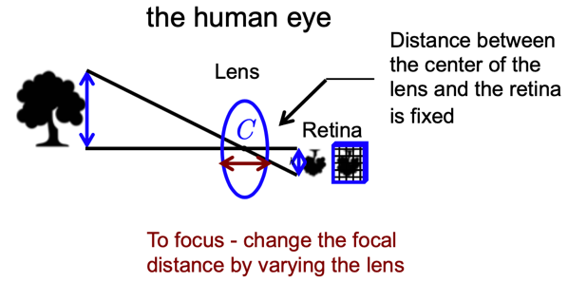
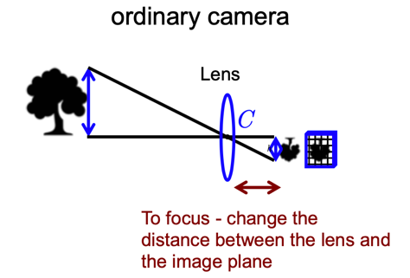

- Another difference of the HVS and ordinary cameras consists in the way how it perceives the light.
- Range of light intensity levels to which HVS can adapt: on the order of 10¹⁰ .
- Intensity as perceived by the HVS(subjective brightness) is a logarithm function of the light intensity incident on the eye.
Slides(18 -24) and slide 33
2. HVS. Explain the fundamentals of color vision. Explain the additive and subtractive color mixings.
Objectively, we can distinguish:
Acromatic light (no color): is characterized by the intensity (or amount) of light. It varies from black (no light) to white (very bright light). The intermediate level is gray.
Chromatic light (color) (in the visible spectrum 380-700nm)
that is characterized by 3 quantities:
- Radiance is a total amount of energy emmited by a source of light (measured in watts (W)).
- Liminace is a measure of the amount of energy that an observer perceives from the light source. We can consider it as filtered by the HVS (lumens) (see previous slides)
- Brightness is a subjective evaluation what is the source of radiation we talk about (see all issues discussed above

Explain the fundamentals of color vision
There are two ways to consider the color vision:
1. we can consider it as a part of a electromagnetic spectrum and from the perspectives of the perception by the human eye and interpretation by the human brain
2. To consider it as a part of how the color as such is created by the prime colors (spectrum) or by mixing colors
Color is the way our eyes and brains perceive light . light is a wave and like any type of wave, every particular wave has a wavelength . Technically speaking, the range of human perception is very narrow compared to the complete electromagnetic spectrum .
The color we see is based on the wavelength of the light. Also the more there is the brighter the color we see. Most colors are combination of multiple wavelengths.
For example white (as a color) contains all rainbow colors. Newton’s prism is used to break up light into its constituent spectral colors because the refractive index depends on frequency
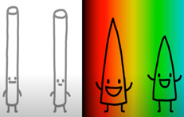
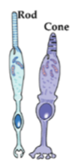
But how do we see these colors? When color enters in our eyes, it hits our retina where there are light-sensitive rod cells and cone cells. Only the cones are used for color vision, so we are just going to focus on them.

There are 3 types of cones(3 different photopsins) and each type is sensitive to different wavelengths in different amounts

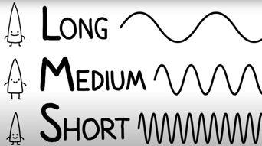

L-cones – sensitive to high-wavelength “Red”(not exact) %65
M-cones – sensitive to medium-wavelength “Green”(not exact) %33
S-cones – sensitive to short-wavelength “Blue” (not exact) 2%
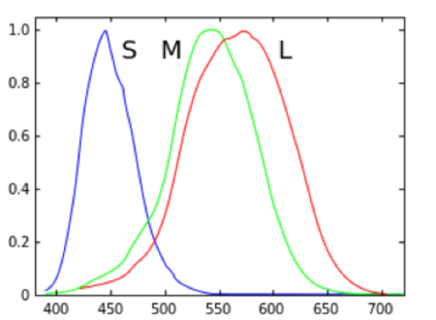
In normal human most of receptors are Red colors(%65)

But in digital camera We have 2 times more greens receptors rather than red and blue . red and blue have the same proportion.

the largest concentration of receptors for normal person is in the Fovea et not everywhere in retina.

remarque : L- and M-cones are coded in X-chromosome (the cause of color-blondeness) Genetic determine what we see .
Colorblind people might not have all types of cones or have some issues with them .
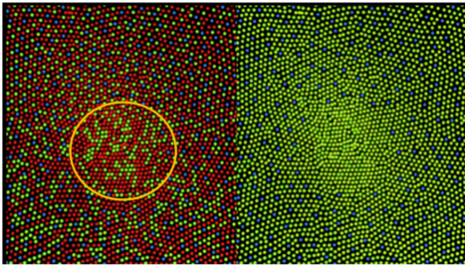
The distribution of cone cells in the fovea of a person with normal color vision (left) and a colorblind (protanopic) retina.
Conclusion:
- there are no S cones or rods in the fovea.
- Colorblind people not have L-cones.

Also different animals have different types of cones: Some birds - for 4 or even 5 colors....

Slide 50

Explain the additive and subtractive color mixings.
Additive color mixings:

subtractive color mixings:
----------------------------------------------------------------------------------------------------------------
3. HVS. Explain the CMYK model.
Stands for "Cyan Magenta Yellow Black." These are the four basic colors used for printing color images. Unlike RGB (red, green, blue), which is used for creating images on your computer screen, CMYK colors are "subtractive." This means the colors get darker as you blend them together. Since RGB colors are used for light, not pigments, the colors grow brighter as you blend them or increase their intensity.
Exemplify the reflection of colors.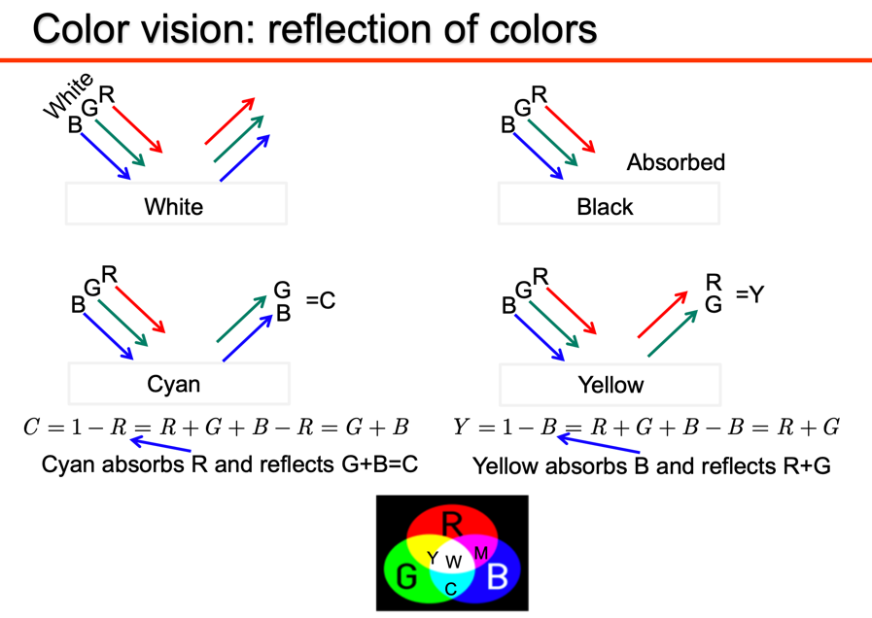
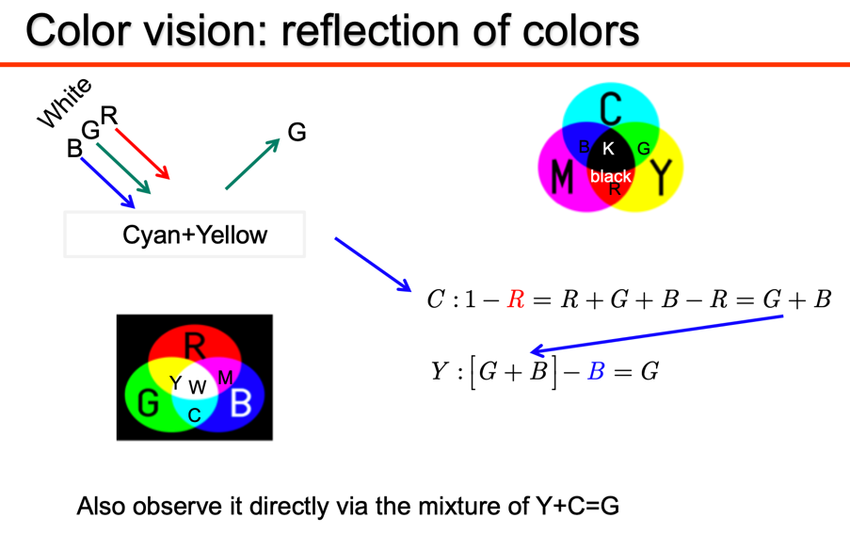

Explain the principles of halftoning.

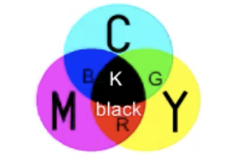
Why “K” is used in CMYK model in practice, while it is enough to have CMY to simulate any color? People just for economy reasons uses black inks because black inks is less expensive to produce and take less time for printing and paper is not so wet and more saturated compared by using 3 component.

----------------------------------------------------------------------------------------------------------------
4. HVS. Explain the chromaticity color diagram.
All physiquly existing colors appeared on this normalized x, y plain.
What is the achievable color gamut?
Which factors determine the achievable color gamut for the screens and printers?
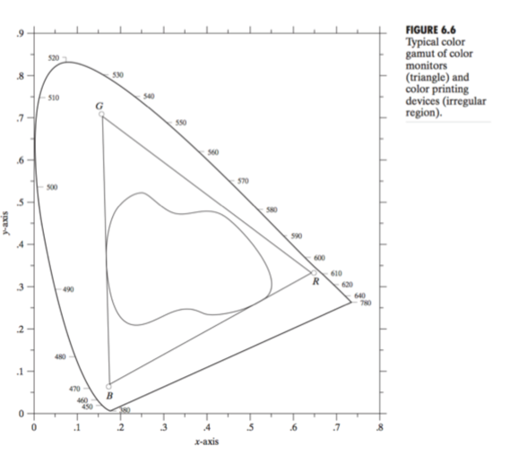
Gamaut of the screen is larger than the gamaut of the printer . printer can reproduce less color

---------------------------------------------------------------------------------------------------------
Chapitre 6
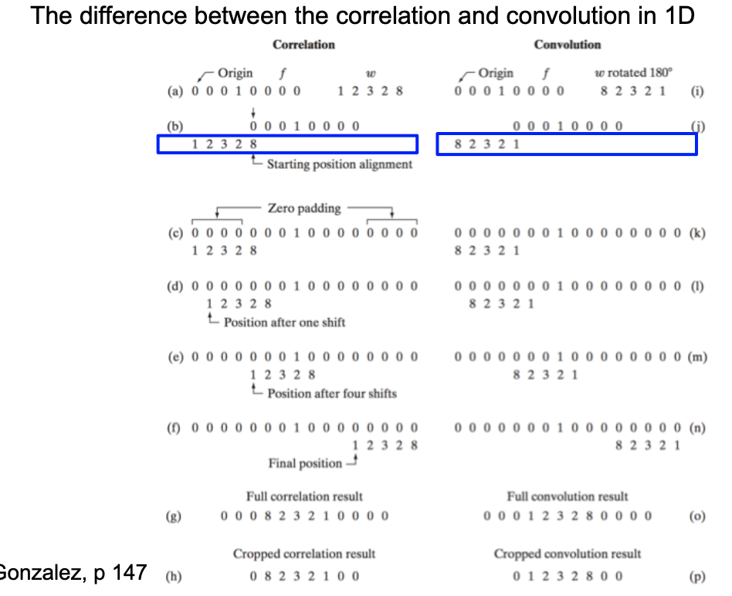
Q15. Explain the difference between the convolution and correlation. Give examples and explain the practical usage of both.

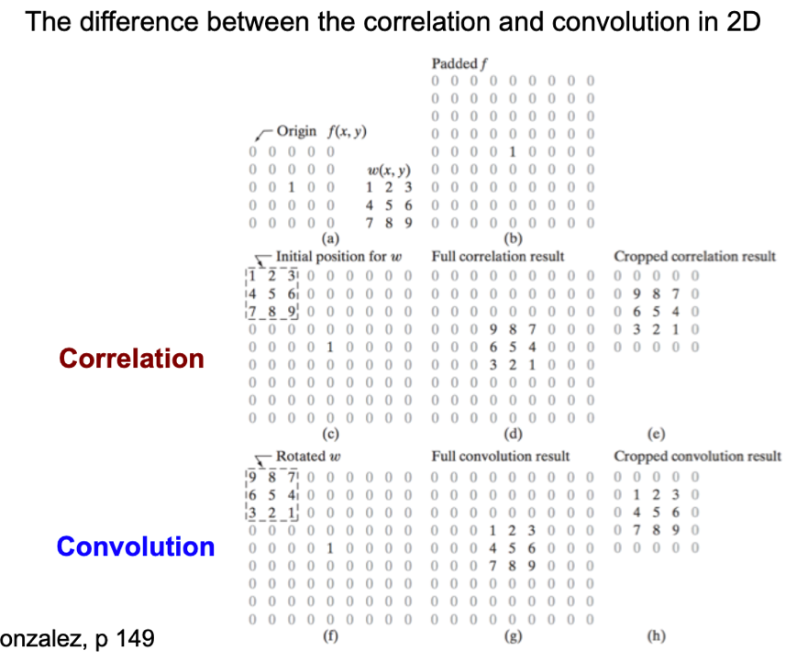

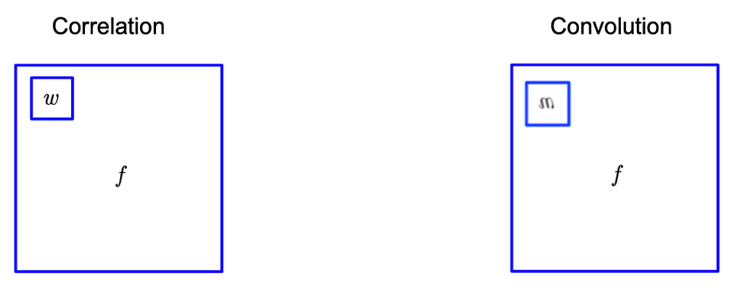
Important : If the filter is symmetric the result of coevolution and correlation will be the same.

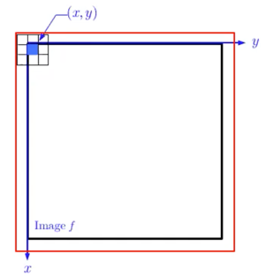
Q16.Explain the border effects during the computation of 2D convolution. Define the total size of filtered images. Give examples.
We don’t know the pixel intensity of the borders so we do some padding operation.
Handling the border effect (for example)
- Zero padding
- Periodic extension
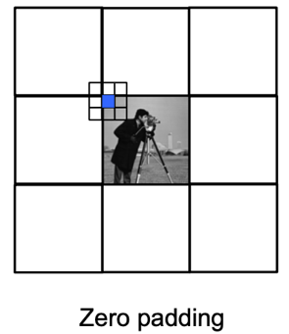
- Symmetrically flip

Zero padding : around the image I create a virtual border( the half of filter-1)
One ligne of image cropped
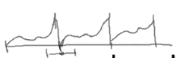
Periodic extension : I can create just image repeat it multiply time .
One ligne of image cropped

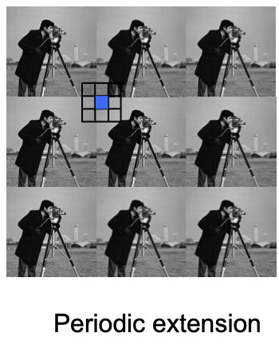
Here we see we take the same signal (line) and we repeat it . we can see our intensity is very small but intensity from the previous period is very high and if I need to multiply all these values on filter coefficients, I will have a jump near de edges so as result we have a border effect near the edges of the image due such kind of the periodical extension . (happens in Fourier transformations )

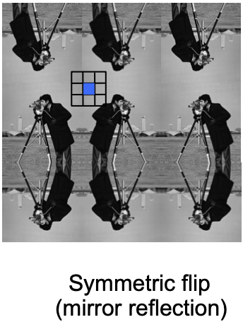
Symmetrically flip :
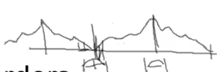

explication….

total size of filtered images : If i compute with all of my border effect
-a a
Filter size $m×n$
Image size $M×N$
Resulting image size $S_{v}×S_{h}$
$S_{v}=m+M-1$
1 |  |  |  |  |  |  |  |  |  |  |  |  |  | N
M
$S_{h}=+N-1$

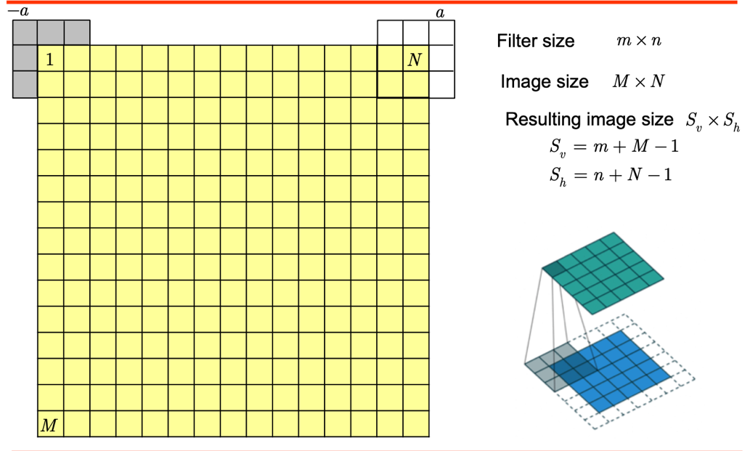
Exemples :

Q17. Explain the main properties of convolution. Complexity of convolution in 2D.
- The Commutative property (general form)
$$g\left(x\right)=f\left(x\right)*h\left(x\right)=\sum_{m=-∞}^{∞}{f\left(m\right)h\left(x-m\right)↔h\left(x\right)*f\left(x\right)=\sum_{x=-∞}^{∞}{f\left(x-k\right)h(k)}}\left|\begin{aligned}k=x-m \\ m=x-k\end{aligned}\right.$$
$f(x)$ $g(x)$ $h(x)$ $g(x)$
$$f(x)$$
$$h(x)$$

- The associative property

$$g\left(x\right)=f\left(x\right)*\left(h_{1}\left(x\right)*h_{2}\left(x\right)\right)↔\left(f\left(x\right)*h_{1}\left(x\right)\right)*h_{2}(x)$$

$f(x)$ $g(x)$ $f(x)$ $g(x)$
$$h_{1}\left(x\right)*h_{2}(x)$$
$$h_{2}(x)$$
$$h_{1}(x)$$

$f(x)$ $g(x)$ $f(x)$ $g(x)$
$$h_{2}\left(x\right)*h_{1}(x)$$
$$h_{1}(x)$$
$$h_{2}(x)$$

- The distributive property

$$g\left(x\right)=f\left(x\right)*\left(h_{1}\left(x\right)+h_{2}\left(x\right)\right)=f\left(x\right)*h_{1}\left(x\right)+f\left(x\right)*h_{2}(x)$$
$$h_{1}(x)$$
$f(x)$ $g(x)$ $f(x)$ $g(x)$
$$h_{1}\left(x\right)+h_{2}(x)$$
$$h_{2}(x)$$

Property 1: Generally if we have the convolution between f(x) and g(x) it means we can interchange the sense what is the signal, what is the filter -- > Filtering the signal by filter and filtering the filter by signal.
Property 2 : we have two filter h1 and h2 and our signal f(x). we can convolve one filter with another filter create a new virtual filter and convolve the signal with h result . otherwise we can convolve our signal with filter h1 then convolve with the second filter or convolve our signal with filter h2 then convolve with the first filter.
Remarque: property 2 is true for convolution but its not true for correlation . for correlation if I replace the order it not the same due to the fact the filter is not flip.
Property 3
In case de correlation For pattern recognition et for classification it is ok but not for edge detection of filtering (property 1 et 2)
Property | Convolution | Correlation
Commutative | $$f*h=h*f$$ | Does not hold
Associative | $$f*\left(h_{1}*h_{2}\right)=\left(f*h_{1}\right)*h_{2}$$ | Does not hold
Distributive | $$f*\left(h_{1}+h_{2}\right)=f*h_{1}+f*h_{2}$$ | $$fo\left(h_{1}+h_{2}\right)=foh_{1}+foh_{2}$$

the Correlation will be a Somme of Correlation here (Distribution), But it’s not generally true if I would just apply the Associative or Commutative property. You can also thank from the inner product point.
The Correlation is the expected value between the signal X and Y (E(XY^{T}]) it’s not will be the same result if I just interchange E[YX^{T}].

Complexity of convolution in 2D :
Q18. Explain the advantages of separable filters for the computation of 2D convolution. Complexity of separate convolution computation in 2D.
Q19. Explain the low-pass filtering. Provide the examples of smoothing filters.
Q20.Explain the high-pass filtering. Provide the examples of sharpening filters. Derivatives.
