Demo Markdown for Converter Testing
This document contains mixed Markdown features to validate DOCX and PDF conversion.

1) Plain Text and Formatting
This paragraph includes bold, italic, and inline code.
This sentence includes a manual line break.
This line should appear directly below it.

2) Lists and Nested Lists
- Item A
- Item B
  - Item B.1
  - Item B.2
    - Item B.2.a
- Item C
- Step one
- Step two
- Step three

3) Table
Column | Type | Notes
id | integer | Primary key
name | text | Display name
active | boolean | Defaults to true in samples

4) Blockquote and Callout Style Content
This is a blockquote. It spans multiple lines.
- It can include list items.
- It can include inline code.

5) Code Blocks

5.1 Python
def summarize(items):
return {
"count": len(items),
"first": items[0] if items else None,
}
print(summarize(["alpha", "beta", "gamma"]))

5.2 JSON
{
"service": "md-converter",
"version": "0.1.0",
"features": ["docx", "pdf", "mermaid"]
}

5.3 Nested Fence Example (Literal Markdown)
Here is a fenced block shown *as content*:
```bash
make convert INPUT=demo/demo.md FORMAT=pdf
```

6) Mermaid Diagrams

6.1 Flowchart
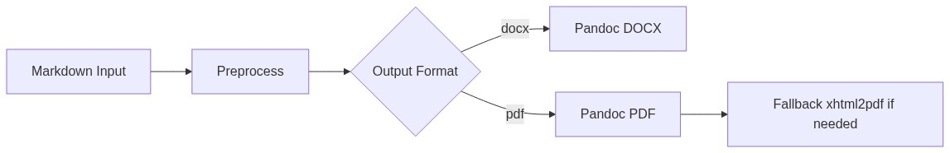
Diagram 1

6.2 Sequence Diagram
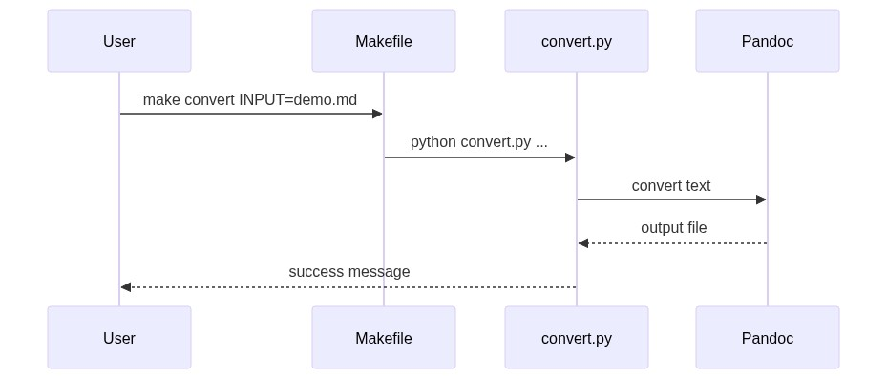
Diagram 2

6.3 Class Diagram
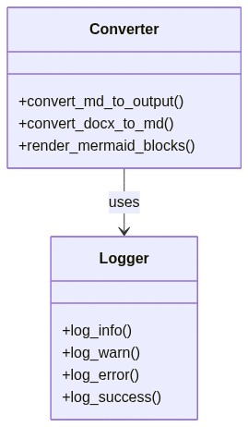
Diagram 3

7) Horizontal Rule

8) Links and Image Placeholder
- Repository docs: https://example.com/docs
- Issue tracker: Sample Issue Board
Image markdown example (path may or may not exist in your environment):

Sample placeholder image

9) Escapes and Special Characters
Characters: *literal asterisks*, _literal underscores_, and backticks: `
Math-like plain text: a^2 + b^2 = c^2

10) Final Checklist
- ☒ Includes YAML front matter
- ☒ Includes multiple Mermaid blocks
- ☒ Includes nested fenced code example
- ☒ Includes tables, lists, quotes, links, and image reference

