Body-weight-convertor.py

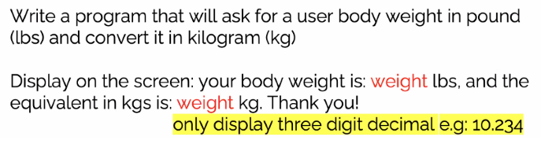

<https://github.com/fabricesoffack/Python-codes.git>

