PANTA ACQUISITION REVIEW
Deterministic fixture for text, table and image extraction
Document ID: PANTA-DOCX-001
Decision date: 2026-08-15
Status: Approved

Investment decision
The investment committee approved Project Aurora on 2026-08-15. Maria Rossi recorded the approval.

Regional operating profile
Region | Revenue (EUR m) | EBITDA (EUR m)
North | 125 | 45
South | 90 | 28

Visual evidence
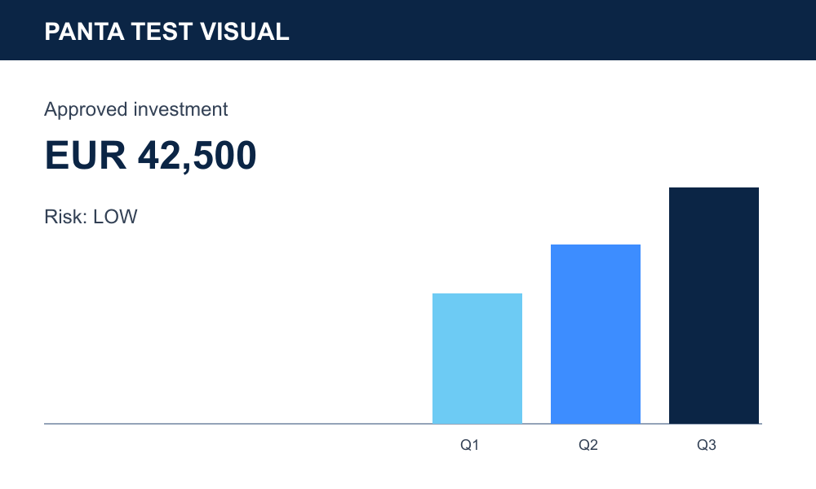
Figure 1. Approved investment indicator.

