WavesDownloader Tutorial

A. Install Page 1
B. Usage and Examples Page 1
C. Summary.log Files Page 4
D. Options List Page 5

A. Install

Requirements: . Obspy-0.1.2 see http://obspy.org
. rdseed-5.0 see http://www.iris.edu/forms/rdseed_request.htm

Install: add the PATH to wavedownloader directory into your $PATH

Eida registration: Fill form at http://webservices.rm.ingv.it/ingv_ws_registration.php for automatic registration. This step is required in order to access to EIDA services.

B. Usage and Example

Usage: type

wavesdownloader1.1.py -h
wavesdownloader1.1.py --help

Example:

A directory examples is included with this release. The directory includes one subdirectory for each one of the following examples with the downloaded data, summary files and figures.

1. Simple data requests to servers

Simple data request using two selection area modes: cicular and rectangular. The requests ask for 10 minutes waveforms from all stations and networks available at both iris and eida servers for the 2011/03/11 eastern Honshu main event. Data are downloaded into ˜/data subdirectory. Paz and Resp files, and waveform in SAC file format are extracted into ˜/data directory.

a. Circular selection: area within 40 and 80 degree from epicenter
wavesdownloader.py --usr user@network.net --pas myPassword --beg 2011-03-11T05:46:00 --end 2011-03-11T05:56:00 --center "38.32 145.35" --radius "40 80"

b. Rectangular selection: area within the two corners C_{inf}(lat=40, lon=-10) and C_{sup}(lat=85, lon=30)
wavesdownloader.py --usr user@network.net --pas myPassword --beg 2011-03-11T05:46:00 --end 2011-03-11T05:56:00 --mode rectangular --infCor "40 -10"
--supCor "85 30"

Notes:
--usr and –pas Eida server requires to be registered. Please fill form at
http://eida.rm.ingv.it/ingv_ws_registration.php for automatic registration
--radius Gives minimum and maximum distance from epicenter in degree

--center Center of the area “lat lon"
--infCor/--supCorner Coordinates of corners “lat lon"

Defaults:
--server "IRIS EIDA"
--net "*"
--cha “BHZ"
--respo 2

2. Complete your dataset stored into your local repository with data from IRIS

Option --server allows to access to your dataset stored into a fseed file stored on your local device. Eida and/or Iris data repository are accessible meanwhile. Here we perform the same data request as in 1.a, adding a fseed file on your local device. Note that --server “LOCAL” will extract the waveforms only from your local fseed file.

wavesdownloader.py --usr user@network.net --pas myPassword --beg 2011-03-11T05:46:00 --end 2011-03-11T05:56:00 --center "38.32 145.35" --radius "40 80" --server "IRIS LOCAL" --fsfile "./my_data_example02.fseed"

3. Simple data requests to servers with selection of server, network and channel

Simple data request for specific networks and channels. Here we perform the same data request as in 1.a, but only for stations of the II and MN networks, and only for the LHN and LHE channel.

wavesdownloader.py --usr user@network.net --pas myPassword --beg 2011-03-11T05:46:00 --end 2011-03-11T05:56:00 --center "38.32 145.35" --radius "40 80" --net "II MN" --cha "LHN LHE"

Multiple channel for single component using wildcard is not allowed. If you want to request only LHZ and BHZ waveforms, you need to use --cha option as follow:

wavesdownloader.py --usr user@network.net --pas myPassword --beg 2011-03-11T05:46:00 --end 2011-03-11T05:56:00 --center "38.32 145.35" --radius "40 80" –net “II MN" --cha “LHZ BHZ"

4. Local earthquake data plot with picking and bandpass filter.

The plot window option is activated using the --pltmode option. This option allows two plot modes:
--pltmode 1 plot the simple list of seismograms;
--pltmode 2 plot seismograms with respect to the distance from epicenter. This mode is not allowed with rectangular data selection.
Horizontal plots are produced with –pltNERT. Two modes are allowed:
--pltNERT NE: plot NS and EW components
--pltNERT RT: plot Radial and transversal components. This moode needs --rot Y option and and --center request mode.
Band pass filter is activated using --bandpass option. Highpass and lowpass filter are also allowed:
--bandpass “nr_of_poles lowerFrequency_corner higherFrequency_corner" (e.g.: --bandpass "4 0.1 1.0")
--lowpass “nr_of_poles highFrequency_corner" (e.g.: --lowpass "4 1.0")
--highpass “nr_of_poles lowerFrequency_corner" (e.g.: --bandpass "4 0.1")
Picking is activated using –slta option (short-term/long-term average), which requires 4 paramenters:
STA: Length of short time average window in samples
LTA: Length of long time average window in samples
ON: Value above which trigger (of characteristic function) is activated (higher threshold)
OFF: Value below which trigger (of characteristic function) is deactivated (lower threshold)
Characteristic functions generated by --stla option are stored in binary sac file format into the ˜/data directory with file name *.stalta.SAC.
Picks and --slta parameters are stored into ˜data/summary3.log file. See Summary section of this tutorial for details.

wavesdownloader.py --usr user@network.net --pas myPassword --beg 2011-07-17T18:30:00 --end 2011-07-17T18:34:00 --center "45.01 11.41" --radius "0 1" --server "EIDA" --net "IV FR CH" --cha "BH*" --pltmode 1 --pltchan "B" --pltNERT "NE" --slta "1 5 4 1" --bandpass "4 0.1 1"

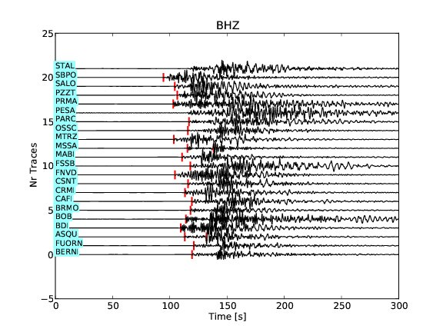
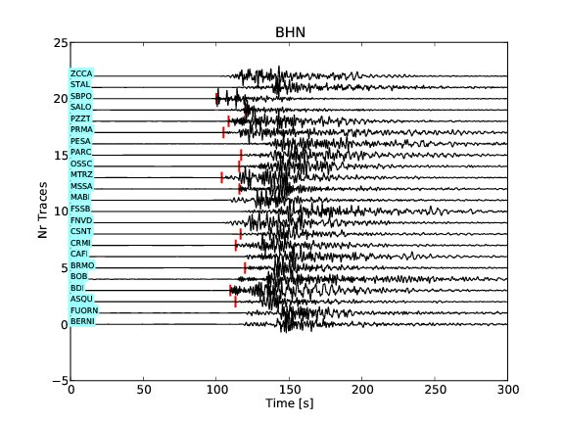
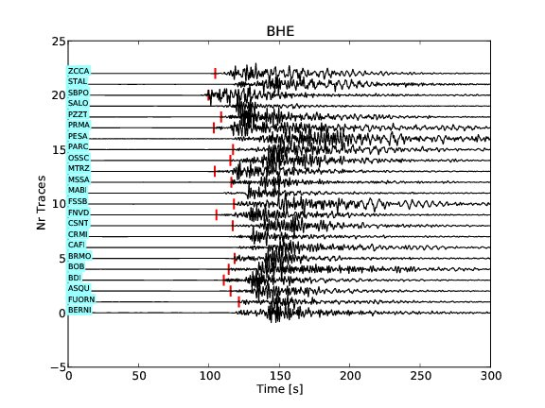

Figure 1
Plots generated using --pltmode 1 option for the 3 requested components. Plots are stored into ˜/data directory in pdf file format with names plotWavesZ.pdf, plotWavesN.pdf, plotWavesE.pdf. Names of the stations are indicated on the light blue box on the left. Picks are indicated by the red vertical bars. The maximal amplitude of the traces are normalized to 1.

5. Azimuthally selected plot of time-distance curves for local earthquake and picking

Option --pltazi allows to plot only stations selected with respect to the azimuth of the epicenter. Default values are –pltazi "0 360". The --pltazi option behaves only on the plot and not on any other parameters. In this example will also store the lowpass filtered seismograms into --wfiltr ˜/filtered_data directory.

wavesdownloader.py --usr user@network.net --pas myPassword --beg 2012-01-25T08:06:40 --end 2012-01-25T08:08:40 --center "44.85 10.54" --radius "0 3" --server EIDA --pltmode 2 --cha "BHZ" --pltchan B --pltazi "340 20" --lowpass "4 1" --slta "1 5 4 1" --wfiltr "filtered_data"

Picks --slta parameters and peak on/off positions (in number of samples after begin of trace) are stored into sub subpath/summary3.log file. See Summary section of this tutorial for details.
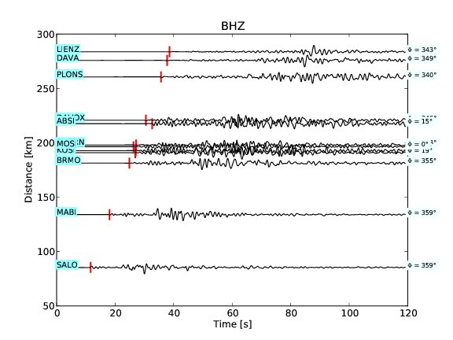

Figure 2
Plot of the vertical component generated using --pltmode 2 and pltazi "340 20". The azimuth of each station is indicated on the right of each trace.

6. Extract data into user-oriented directory with name crete and Plot stations and epicenter on GoogleEarth

Earthquake epicenter and Station names with coordinates are always stored into ˜/data/stations.kml file. With option --outdir “crete" activated, the kml file is stored into ˜/crete subdirectory. To plot stations and epicenter with GoogleEarth, load stations.kml file into your browser.

wavesdownloader.py --usr user@network.net --pas myPassword --beg 2012-01-27T01:33:00 --len 300 --center "35.93 25.02" --radius "0 10" --cha "BH*" --pltmode 2 --pltchan B --rot Y --pltNERT RT --server EIDA --pltazi "300 310" --outdir "Crete"

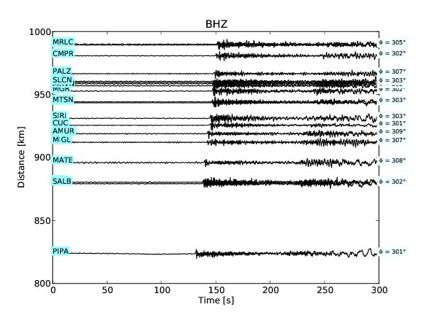

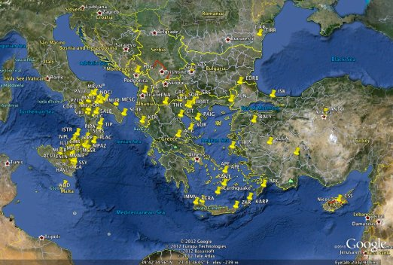

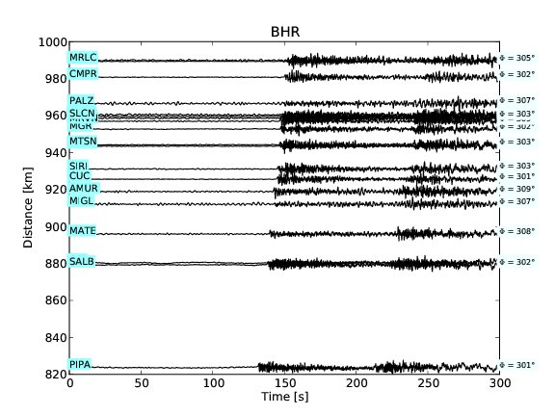
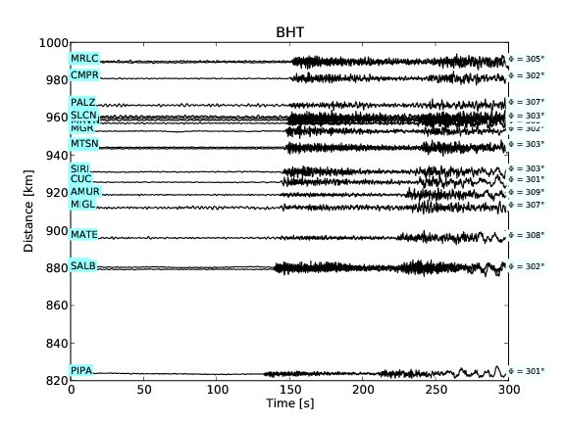

Figure 3
On the top left the map with stations and epicenter markers generated by GoogleEarth using the file ˜/data/stations.kml. On the top right and bottom the plots of the vertical, radial and transversal components azimuthally selected. Note that the --pltazi act only on the waveform plot and not on the stations map.

7. Compute defaults Shakemap PGMs parameters and spectral acceleration responses.

Options --pgm Y and --cfreq Y allows to compute peak ground motion, peak ground velocity, peak ground acceleration, spectral acceleration response and central frequency. Option --pgm Y automatically enable --sa “0.05 0.33 1.00 3.33" option, which compute spectral acceleration responses with damping factor 0.05 and corner frequencies 0.33 1.00 3.33 Hz. Computed values are stored into ˜/data/summary3.log file (see summary section of this tutorial for details).

wavesdownloader.py --usr user@network.net --pas myPassword --beg 2012-01-27T14:53:00 --len 120 --center "44.48 10.033" --radius "0 1.5" --server EIDA --cha "HH*" --pgm Y --cfreq Y --deco Y --net IV --slta "1 7 3 1" --pltmode 2 --pltchan H

To modify the spectral acceleration response default parameters (e.g.: damping=0.1 and corner frequencies 1 Hz), just add --sa option to your request as in the example below.

wavesdownloader.py --usr user@network.net --pas myPassword --beg 2012-01-27T14:53:00 --len 120 --center "44.48 10.033" --radius "0 1.5" --server EIDA --cha "HH*" --pgm Y --cfreq Y --deco Y --net IV --sa "0.1 1" --slta "1 7 3 1"

CODE Net chan loc stlat stlon evlat evlon dist [km] Azimuth Max Dis [m] Max Vel [m/s] Max Acc [m/s^2] Psa [sec]|[m/s^2]: 0.300 1.000 3.030 Cfreq [Hz] Sta Lta t_on t_off picks
BDI IV HHE -- 44.062 10.597 44.480 10.033 64.7 135.664 5.469e-04 5.200e-03 1.292e-01 3.796e-01 3.035e-02 2.297e-03 1.721e-01 1.00 7.00 3.00 1.00 [3883 7377]
BDI IV HHN -- 44.062 10.597 44.480 10.033 64.7 135.664 1.201e-03 5.739e-03 2.030e-01 3.642e-01 3.516e-02 2.760e-03 8.719e-02 1.00 7.00 3.00 1.00
BDI IV HHZ -- 44.062 10.597 44.480 10.033 64.7 135.664 9.666e-04 3.492e-03 1.090e-01 1.086e-01 1.212e-02 1.088e-03 5.320e-02 1.00 7.00 3.00 1.00 [3933 7373]
BOB IV HHE -- 44.768 9.448 44.480 10.033 56.4 304.766 5.290e-04 4.869e-03 6.073e-02 1.280e-01 5.156e-02 3.582e-03 6.843e-01 1.00 7.00 3.00 1.00 [ 700 4026]
BOB IV HHN -- 44.768 9.448 44.480 10.033 56.4 304.766 4.163e-04 2.406e-03 4.170e-02 1.254e-01 3.416e-02 2.020e-03 3.967e-01 1.00 7.00 3.00 1.00
BOB IV HHZ -- 44.768 9.448 44.480 10.033 56.4 304.766 2.873e-04 1.800e-03 3.392e-02 1.026e-01 1.634e-02 1.987e-03 1.032e+00 1.00 7.00 3.00 1.00 [2665 3251][3594 4070]
CRMI IV HHE -- 43.790 10.970 44.480 10.033 107.3 135.311 1.242e-04 8.734e-04 2.029e-02 3.952e-02 5.646e-03 8.484e-04 3.071e-01 1.00 7.00 3.00 1.00 [ 700 4628]
CRMI IV HHN -- 43.790 10.970 44.480 10.033 107.3 135.311 1.292e-04 1.361e-03 2.857e-02 4.629e-02 7.535e-03 5.430e-04 9.962e-01 1.00 7.00 3.00 1.00 [4495 4960]
CRMI IV HHZ -- 43.790 10.970 44.480 10.033 107.3 135.311 8.019e-05 4.034e-04 9.258e-03 2.376e-02 4.619e-03 5.611e-04 5.515e-01 1.00 7.00 3.00 1.00 [4540 5099]

Example of 3 station components extracted from the summarty3.log of 7a request. The first line is the header.
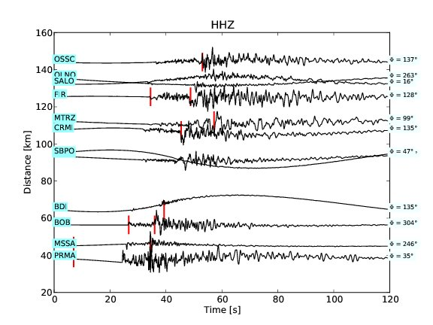

Figure 4
Plots generated using --pltmode 2 option for the vertical component (default if --pltNERT not activated). The picks represented with red vertical bars are listed in the˜/data/ summary3.log file at the last positions. The red bars represents the first value of the [on off] values (see example of summary3.log above). If a -1 is listed instead, no pick is found.

C. Summary.log files

Summary.log files are automatically saved into the --outdir directory (e.g.: ˜/data as using the default).

1. summary1.log :
Includes a summary of all option used to run wavesdownloader

Example of summaty1.log file obtained with example 7 of the previous section
H000 SUMMARY OPTIONS
H001 ---------------
H002 Begin Time 2012-01-27T14:53:00
H003 Begin End 2012-01-27T14:55:00
H004 Station list *
H005 Channel list HH*
H006 Network list IV
H007 Location list *
H008 Server list EIDA
H009 Local fseed file None
H010 Area mode circular
H011 center 44.48 10.033
H012 radius 0 1.5
H013 Rotation N
H014 Response 2
H015 Format SAC
H016 OutDir data
H017 Redo unused
H018 Remove gaps Y
H019 Min Gap 0
H020 Max Gap 0
H021 Reject 100
H022 Remove mean/trt Y
H023 Bandpass 0
H024 Lowpass 0
H025 Highpass 0
H026 Write filtered N
H027 Decimation None
H028 Deconvolution Y
H029 Sta/Lta and pick 1 7 3 1
H030 PGMs Y
H031 Plot Mode 2
H032 Plot Channel H
H033 Plot Component unused
H034 Plot Horizontals None
H035 Plot Azimuth 0 360

2. summary2.log :
List of downloaded stations and metadata.
Format: One line for each station.channel data.
Metadata listed for each line:
StationCode
Network
Channel
LocationCode
BegTime
EndTime
Samp_rate
dT
Station_lat
Station_lon
Event_lat
Event_lon
Epicentral_distance (degree)
Azimuth
Back_azimuth
Epicentral_distance (km)

Example of 3 station lines extracted from the summarty2.log file obtained with example 7 of the previous section:
BDI IV HHE -- 2012-01-27T14:53:00.000000Z 2012-01-27T14:55:00.000000Z 100.00 0.0100 12001 44.062 10.597 44.480 10.033 64.692 0.582 135.664 316.056
BDI IV HHN -- 2012-01-27T14:53:00.000000Z 2012-01-27T14:55:00.000000Z 100.00 0.0100 12001 44.062 10.597 44.480 10.033 64.692 0.582 135.664 316.056
BDI IV HHZ -- 2012-01-27T14:53:00.000000Z 2012-01-27T14:55:00.000000Z 100.00 0.0100 12001 44.062 10.597 44.480 10.033 64.692 0.582 135.664 316.056
BOB IV HHE -- 2012-01-27T14:53:00.000000Z 2012-01-27T14:55:00.000000Z 100.00 0.0100 12001 44.768 9.448 44.480 10.033 56.424 0.507 304.766 124.357
BOB IV HHN -- 2012-01-27T14:53:00.000000Z 2012-01-27T14:55:00.000000Z 100.00 0.0100 12001 44.768 9.448 44.480 10.033 56.424 0.507 304.766 124.357
BOB IV HHZ -- 2012-01-27T14:53:00.000000Z 2012-01-27T14:55:00.000000Z 100.00 0.0100 12001 44.768 9.448 44.480 10.033 56.424 0.507 304.766 124.357
CRMI IV HHE -- 2012-01-27T14:53:00.000000Z 2012-01-27T14:55:00.000000Z 100.00 0.0100 12001 43.790 10.970 44.480 10.033 107.293 0.965 135.311 315.961
CRMI IV HHN -- 2012-01-27T14:53:00.000000Z 2012-01-27T14:55:00.000000Z 100.00 0.0100 12001 43.790 10.970 44.480 10.033 107.293 0.965 135.311 315.961
CRMI IV HHZ -- 2012-01-27T14:53:00.000000Z 2012-01-27T14:55:00.000000Z 100.00 0.0100 12001 43.790 10.970 44.480 10.033 107.293 0.965 135.311 315.961

3. summary3.log :
List downloaded stations, metadata, PGMs, central frequency and picker values. 2 Lines of format explaining header.
Format: 1 lines of format explaining header; 1 line for each station.channel data.
Metadata and values for each line:
StationCode
Network
Channel
LocationCode
Station_lat
Station_lon
Event_lat
Event_lon
Epicentral_distance (km)
Azimuth
PeakGroundDisplacement [m]
PeakGroundVelocity [m/s]
PeakGroundAcceleration [m/s^2]
List of Spectral Acceleration Response at different corner frequencies [m/s^2]
Central Frequencies [Hz] (may be empty if option --cfreq is not activated)
Short-term average window for st/la
Long-term average window for st/la
Picker trigger on value
Picker trigger off value
Picking list (sample after begin trace) [on off][on off]....[on off]

Example of two station components extracted from the summarty3.log file obtained with example 7a of the previous section:

CODE Net chan loc stlat stlon evlat evlon dist [km] Azimuth Max Dis [m] Max Vel [m/s] Max Acc [m/s^2] Psa [sec]|[m/s^2]: 0.300 1.000 3.030 Cfreq [Hz] Sta Lta t_on t_off picks
BDI IV HHE -- 44.062 10.597 44.480 10.033 64.7 135.664 5.469e-04 5.200e-03 1.292e-01 3.796e-01 3.035e-02 2.297e-03 1.721e-01 1.00 7.00 3.00 1.00 [3883 7377]
BDI IV HHN -- 44.062 10.597 44.480 10.033 64.7 135.664 1.201e-03 5.739e-03 2.030e-01 3.642e-01 3.516e-02 2.760e-03 8.719e-02 1.00 7.00 3.00 1.00
BDI IV HHZ -- 44.062 10.597 44.480 10.033 64.7 135.664 9.666e-04 3.492e-03 1.090e-01 1.086e-01 1.212e-02 1.088e-03 5.320e-02 1.00 7.00 3.00 1.00 [3933 7373]
BOB IV HHE -- 44.768 9.448 44.480 10.033 56.4 304.766 5.290e-04 4.869e-03 6.073e-02 1.280e-01 5.156e-02 3.582e-03 6.843e-01 1.00 7.00 3.00 1.00 [ 700 4026]
BOB IV HHN -- 44.768 9.448 44.480 10.033 56.4 304.766 4.163e-04 2.406e-03 4.170e-02 1.254e-01 3.416e-02 2.020e-03 3.967e-01 1.00 7.00 3.00 1.00
BOB IV HHZ -- 44.768 9.448 44.480 10.033 56.4 304.766 2.873e-04 1.800e-03 3.392e-02 1.026e-01 1.634e-02 1.987e-03 1.032e+00 1.00 7.00 3.00 1.00 [2665 3251][3594 4070]
CRMI IV HHE -- 43.790 10.970 44.480 10.033 107.3 135.311 1.242e-04 8.734e-04 2.029e-02 3.952e-02 5.646e-03 8.484e-04 3.071e-01 1.00 7.00 3.00 1.00 [ 700 4628]
CRMI IV HHN -- 43.790 10.970 44.480 10.033 107.3 135.311 1.292e-04 1.361e-03 2.857e-02 4.629e-02 7.535e-03 5.430e-04 9.962e-01 1.00 7.00 3.00 1.00 [4495 4960]
CRMI IV HHZ -- 43.790 10.970 44.480 10.033 107.3 135.311 8.019e-05 4.034e-04 9.258e-03 2.376e-02 4.619e-03 5.611e-04 5.515e-01 1.00 7.00 3.00 1.00 [4540 5099]

Note: -1.00 values means that short/long term average and trigger are off or not found with the current stla values.
D. Options List

optional arguments:

-h, --help show this help message and exit
--beg BEG Begin Time. !! No defaults!! Format YYYY-MM-DDThh:mm:ss
(UTC Time) (e.g.: 2011-07-25T12:30:00)
--end END End Time. !! No defaults!! F\ormat YYYY-MM-DDThh:mm:ss
(UTC Time) (e.g.: 2011-07-25T12:35:00)
--len LEN Length of signal in seconds. !! No defaults!! Mandatory
option if --end not specified
--usr USR User name for eida !! MANDATORY OPTION, No defaults!!
--pas PAS Passwd for eida \!! MANDATORY OPTION, No defaults!!
--sta STA Station list. default=*
--net NET Network list. default=*
--loc LOC Station information location ID. default=*
--cha CHA Channel list. default=BHZ
--rot ROT Rotate horizontal components from North-East -> Radial-
Trasversal. Only with --mode “center”. Default [Y]/N.
--res RES Instrument response extraction: 0=none; 1=RESP; 2=PAZ
(default); 3=RESP&PAZ
--mode MODE Area selection mode: [circular|rectangular]. Default=circular
--center CENTER Lat Lon inner position for circular request. Default ="41.9 12.5"
--radius RADIUS Radius in DEGREE from innerPos to outerPos for --mode
circular. Default="0 10"
--supCor SUPCOR Max latitude and longitude for --mode rectangular. Default="60 60"
--infCor INFCOR Min latitude and longitude for --mode rectangular. Default="10 10"
--format FORMAT File format extraction storage [SAC,SACXY,GSE1,GSE2,SH_ASC,WAV].
If format=None to data extracted. Default=None
--outdir OUTDIR Directory for data extraction. Default=data
--server SERVER Servers [EIDA,IRIS,LOCAL,WEBDC]. LOCAL look for fseed
files stored on your local machine. Only fseed files
are allowed. --server "LOCAL" needs --fsfile to be
specified. LOCAL and external server are allowed within
the same request. Default="EIDA WEBDC IRIS"
--fsfile FSFILE fseed file name inclusive of path if path different
than \. Default None
--rmgaps RMGAPS Remove traces with gaps. default=Y
--mingap MINGAP Minimum gap allowed in seconds. default=0
--maxgap MAXGAP Maximum gap allowed in seconds. default=0
--reject REJECT Minimum length in percent for trace rejection. Default=100
--cfreq CFREQ Get dominant period [N]/Y.
--demean DEMEAN Remove mean and trend. Default=Y
--bandpass BANDPASS Bandpass filter "corners fimn fmax". No Defaults. E.g.:"2 0.01 0.1"
--highpass HIGHPASS Highpass filter "corners freq". No Defaults. E.g.: "2 0.01"
--lowpass LOWPASS Lowpass filter "corners freq". No Defaults. E.g.: "2 0.1"
--wfiltr WFILTR Write new filtered files into --wfiltr path. Default=N
--deci DECI Decimation factor for sampling rate. Only integer
decimation factor allowed. Default=None
--deco DECO Deconvolution from instrument response [N]/Y. Requires
--res=[2|3]. Default=N
--flim FLIM Corner frequency for deconvolution filtering. Defaults “0.002 0.005 0.5 1”
--slta SLTA Make Short-term/long-term average and trigs picks:
--slta "STA LTA ON OFF" (--sta "0.5 5 7 1.5").
Default=”None” STA: Short-term average LTA: Long-term average
ON: level trigger on OFF: level trigger off
--pgm PGM Peaks Ground Motion parameters. max_displacement [m],
max_velocity[m/s], max_acceleration[m/s^2]. Output into
summary3.log file. Automatically enable --sa option
(Spectral acceleration response). Default [N]/Y
--pgmfile PGMFILE Name file for shakemap. User file-name MUST end with
"_dat.xml" in order to be accepted by ShakeMap.
Default=shakeList_dat.xml
--shake SHAKE Write PGMs for ShakeMap. [N]/Y
--sa SA Modify defaults Spectral Acceleration Response
parameters (only if –pgm=”Y”): damping and corner
frequencies in Hz. Example: --sa “0.1 1 10”;
damping factor (0.1) and corner frequencies in Hz.
Spectral Acceleration Response in [m/s^2]. Defaults:
sa=”0.05 3.33 1.00 3.33”.
--pltmode PLTMODE Plot traces. 0=No plot; 1=y_axe regular; 2=y_axe
distance from epicenter. Plots saved in pdf format, see
Notes for details. (Default=0). Plot names:
plotWavesZ.pdf for vertical; plotWavesNS.pdf and
plotWavesEW.pdf with --pltNERT "NE"; plotWavesT.pdf and
plotWavesR.pdf with --pltNERT "RT"
--pltchan PLTCHAN Channel to plot. Default=None
--pltNERT PLTNERT Horizontal components [NE|RT]. Default=None !! ONLY with --rot=Y
--pltazi PLTAZI Plot traces within azimuth. Default="0 360"
--summary SUMMARY Print data request summary on screen. [N]/Y.

EXAMPLES:
---------

1. Circular download.
./wavesdownloader.py --usr user@network.net --pas myPassword --beg 2011-01-29T17:41:00 --end 2011-01-29T17:45:00 --center "47.56 18.34" --radius "0 6"

2. Circular Download with server EIDA selected and plot (y-axe = Distance [km]).
./wavesdownloader.py --usr user@network.net --pas myPassword --beg 2011-05-26T11:35:00 --len 300 --center "42.94 11.05" --radius "0 1.8" --server "EIDA" --res 3 --pltmode 2

3. Rectangular Download with network, channel selectd and plot.
./wavesdownloader.py --usr user@network.net --pas myPassword --beg 2011-01-29T06:55:00 --end 2011-01-29T07:15:00 --mode rectangular --infCor "40 -10" --supCor "85 30" --net "MN II" --cha "BH*" --pltmode 1

4. Rectangular Download with bandpass filter from IRIS, no user and password required.

./wavesdownloader.py --beg 2011-04-01T13:29:00 --end 2011-04-01T13:49:00 --mode rectangular --infCor "20 10" --supCor "50 40" --server "IRIS" --net "MN GE II" --cha "BH*" --pltmode 1 --bandpass "2 0.01 0.02"

5. Circulare Download with rotation to GCP and azimuthal selected plot. Lopass filtered data are stored into "filterd" subdirectory. End timewindow 600 second after begin Time.

./wavesdownloader.py --usr user@network.net --pas myPassword --beg 2011-07-17T18:30:00 --len 600 --center "45.01 11.41" --radius "0 2" --cha "BH*" --pltmode 2 --rot "Y" --pltNERT "RT" --pltazi "0 180" --lowpass "4 0.5" --wfiltr "filtered"

6. Circulare Download with multiple channel list selection.
./wavesdownloader.py --usr user@network.net --pas myPassword --beg 2011-07-17T18:30:00 --len 600 --center "45.01 11.41" --radius "0 2" --server "EIDA" --cha "BHZ BHN BHE HHZ HHN HHE"

7. Circular Download with slta picking and lowpass filter.
./wavesdownloader.py --usr user@network.net --pas myPassword --beg 2011-07-17T18:29:00 --end 2011-07-17T18:34:00 --center "45.01 11.41" --radius "0 1" --server "EIDA" --cha "BHZ" --pltmode 2 --cfreq "Y" --slta "1 5 4 1" --lowpass "4 1"

8. Circular Download from IRIS server including local fseed file as a data source. Instrument response
deconvolution and user specified corner frequencies for deconvolution. No user and Password required.
Default –res 2.
./wavesdownloader.py --beg 2011-07-17T18:29:00 --end 2011-07-17T18:34:00 --center "45.01 11.41" --radius "0 20" --server "IRIS LOCAL" --fsfile "mypath/myfile.fseed" --net "II MN IU" --cha "BHZ" --pltmode 2 --cfreq "Y" --slta "1 5 4 1" --lowpass "4 1" --deco Y --flim "0.01 0.05 0.1 1"

9. ShakeMap configuartion. Corner frequencies limits for deconvolution should be adapted for high
frequencies. Pgm values stored into user specified file "ShakePga_dat.xml".
./wavesdownloader.py --usr user@network.net --pas myPassword --beg 2012-05-29T10:54:00 --len 200 --center "44.89 11.01" --radius "0 4" --server EIDA --cha "HH*" --res 3 --deco Y --pgm Y --shake Y --pgmfile ShakePga_dat.xml --flim "0.05 0.1 20 40"

