Cheaper LLMs as AMR literature screeners
Executive Summary
Hyam Ali · Dr Fabrizio Costa · Dr Shiqiang Wang | University of Exeter · Google DeepMind Research Ready | September 2026
Research question: Can a cheaper language model stand in for Claude Sonnet 5 when screening PubMed abstracts, without changing which WHO GLASS pathogen–antibiotic pairs come out as research priorities?
89  pathogen–antibiotic pairs | 73,857  paper–pair screens | 711,925  LLM decisions | 12  models tried | 2  acceptance rules

1. Key Findings  1. The acceptance rule matters more than which model you use. Under strict-only, any two candidates put 22–52% of pairs in different quadrants, compared with just 11–16% under strict-or-yes. Relaxing the rule helps every model; GPT-3.5, for example, goes from ρ 0.62 to 0.92.  2. With the permissive rule, most of the agreement comes from publication volume. If we skip the LLM entirely and accept every abstract, we still get ρ = 0.95. Gemini 3.5 Flash-Lite (0.97) is the only model that does better, and both GPT models do worse.  3. With the strict rule, the choice of model decides the outcome, and even the best one misses emerging pairs. Gemini 3.5 Flash-Lite reaches ρ 0.87 against 0.67 without an LLM, yet it still moves 38% of pairs into a different quadrant and finds only 2 of the 13 emerging pairs.  4. Agreeing on individual papers is not the same as agreeing on the ranking. Gemini is the only model with moderate per-paper agreement (κ 0.58). Gemma 3 270M is no better than chance (κ = −0.01), and yet it ranks the pairs at ρ = 0.83.  2. Method  Every model screened all 73,857 paper–pair items as strict, yes or no. The accepted counts for each pair and year go into a pooled ridge regression, and the residual from that regression is the Scientific Interest (SI) signal. A damped 5-year forecast then puts each pair into a priority quadrant. We compared each model with Sonnet 5 at the paper level (Cohen's κ) and at the pair level (Spearman ρ and quadrant changes), under the strict-only and strict-or-yes rules and against a no-LLM baseline that accepts every abstract. | 3. Cost versus Fidelity  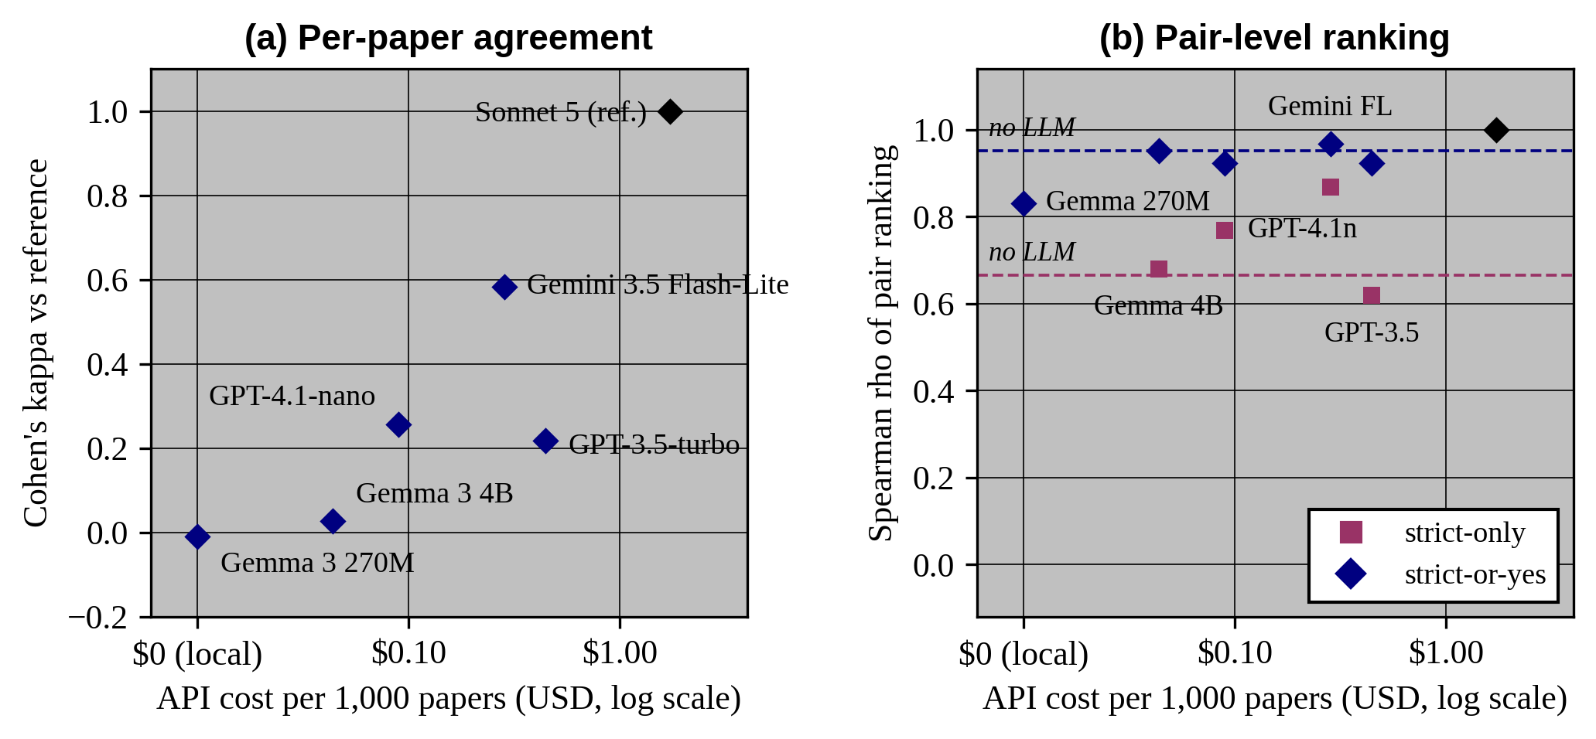  Figure 1. Agreement with the reference against API cost. Dashed lines mark the no-LLM baseline for each rule. Gemma 3 270M has no strict-only value because its SI signal is constant.  Table 1. Screening cost by model.  Prices are list prices from Jul–Aug 2026, with Sonnet 5 on the Batch API (50% off). The full corpus is 73,849 screens. The local model costs $0 in API fees but took ~84 h on one GPU.
  Model | $ per 1,000 papers | Full corpus | vs. ref. | Kappa
  Claude Sonnet 5 (ref.) | $1.72 | $127.22 | 100% | 1.00
  Gemini 3.5 Flash-Lite | $0.28 | $20.97 | 16% | 0.58
  GPT-4.1-nano | $0.09 | $6.62 | 5% | 0.26
  GPT-3.5-turbo | $0.44 | $32.74 | 26% | 0.22
  Gemma 3 4B | $0.04 | $3.23 | 2.5% | 0.03
  Gemma 3 270M | $0.00 | $0.00 | 0% | -0.01
Recommendation. Gemini 3.5 Flash-Lite is the only substitute that beats the no-LLM baseline under both rules, and it costs 16% of the reference ($21 against $127 for the full corpus). The acceptance rule should be reported as a main design choice, and any strict-or-yes result should be compared with the no-LLM baseline.
Before submission: we still have no human ground truth, and 6.6% of the reference screens came back empty (probably because adaptive thinking hit the 60-token cap), so these need re-running. The work also rests on a single prompt, and the size ladder covers only 3 of the 89 pairs.

