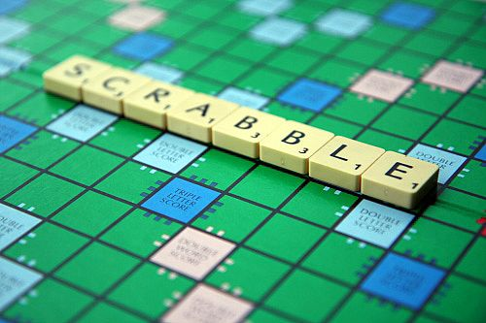
Super Computer

The Goal
In the Computer2000 data center, you are responsible for planning the usage of a supercomputer for scientists. ​Therefore you've decided to organize things a bit by planning everybody’s tasks. The logic is simple: the higher the number of calculations which can be performed, the more people you can satisfy.

Rules
Scientists give you the starting day of their calculation and the number of consecutive days they need to reserve the calculator.
For example:
Calculation | Starting Day | Duration
A | 2 | 5
B | 9 | 7
C | 15 | 6
D | 9 | 3
Calculation A starts on day 2 and ends on day 6
Calculation B starts on day 9 and ends on day 15
Calculation starts on day 15 and ends on day 20
Calculation D starts on day 9 and ends on day 11
In this example, it’s not possible to carry out all the calculations because the periods for B and C overlap. 3 calculations maximum can be carried out: A, D and C.

Game Input
Input
Line 1: The number N of calculations
The N following lines: on each line, the starting day J and the duration D of reservation, separated by a blank space.
Output
The maximum number of calculations that can be carried out.
Constraints
0 < N < 100000
0 < J < 1000000
0 < D < 1000
Examples
Input
4
2 5
9 7
15 6
9 3
Output
3
Input
5
3 5
9 2
24 5
16 9
11 6
Output
4

