# Buongiorno Fabrizio! the best Trade updated 2021-02-02 16:12:20 are ready!!!

## All The best trade

|  |  |  |  |  |  |  |  |
| --- | --- | --- | --- | --- | --- | --- | --- |
| trend3m | trend | gain | stock | slope_x1000 | name_ist | var_10gg | var_1gg |
| 0.0 | RAISING | 6131 | X | 0.00015 | ist154 | -85.5 | -85.28 |
| 1.0 | 0 | -632 | GME | -4e-05 | ist91 | 184.94 | -37.44 |
| 1.0 | 0 | 530 | RFP | -4e-05 | ist149 | -13.69 | -21.06 |
| 0.0 | 0 | 5149 | SCO | -5e-05 | ist131 | -4.02 | -5.05 |
| 1.0 | 0 | -376 | VSTO | -0.00023 | ist62 | 9.66 | -4.77 |
| 1.0 | 0 | 313 | SLV | -0.0 | ist163 | 7.09 | -4.56 |
| 0.0 | 0 | 28594 | NOG.L | -0.00356 | ist156 | 9657.79 | -3.89 |
| 1.0 | RAISING | 1064 | TTM | 1e-05 | ist87 | 21.22 | -3.84 |
| 0.0 | RAISING | 33 | CDW | 0.00049 | ist147 | 6.43 | -3.39 |
| 0.0 | 0 | 230 | GDXJ | -0.00028 | ist168 | 5.02 | -3.08 |
| 1.0 | RAISING | -84 | SAH | 2e-05 | ist61 | 4.25 | -2.85 |
| 1.0 | 0 | 412 | JMP | -1e-05 | ist32 | 6.19 | -2.8 |
| 1.0 | RAISING | 720 | DDS | 0.00012 | ist60 | 17.4 | -2.77 |
| 0.0 | 0 | 1300613 | SQQQ | -0.14321 | ist159 | 1.15 | -2.72 |
| 1.0 | RAISING | 112 | VRTX | 0.00044 | ist107 | -1.0 | -2.57 |
| 1.0 | 0 | 189 | UA | -0.00012 | ist6 | 6.36 | -2.34 |
| 1.0 | RAISING | -166 | NOW | 0.00141 | ist63 | 11.19 | -2.25 |
| 0.0 | 0 | 190 | GDX | -6e-05 | ist167 | 2.9 | -2.24 |
| 1.0 | RAISING | 117 | SYY | 0.0001 | ist200 | -0.3 | -2.19 |
| 1.0 | 0 | 13059 | PBYI | -0.00025 | ist11 | 20.19 | -1.9 |
| 0.0 | 0 | 396 | GOLD | -6e-05 | ist76 | 0.5 | -1.77 |
| 0.0 | RAISING | 27 | V | 0.00047 | ist13 | 4.98 | -1.62 |
| 1.0 | RAISING | -26 | HCA | 0.0004 | ist7 | 7.77 | -1.47 |
| 1.0 | 0 | 3719 | RRD | -6e-05 | ist150 | -5.04 | -1.22 |
| 1.0 | RAISING | 226 | BIDU | 0.00042 | ist79 | 3.71 | -1.05 |
| 1.0 | RAISING | 874 | IBM | 9e-05 | ist44 | 1.0 | -0.98 |
| 1.0 | RAISING | -10 | ORCL | 9e-05 | ist29 | 3.28 | -0.96 |
| 1.0 | RAISING | -314 | AMD | 5e-05 | ist10 | 3.33 | -0.95 |
| 1.0 | RAISING | 34 | WORK | 0.00019 | ist85 | 1.74 | -0.71 |
| 1.0 | RAISING | 813 | COP | 1e-05 | ist17 | 3.92 | -0.69 |
| 1.0 | RAISING | 5369 | BHC | 5e-05 | ist183 | 6.82 | -0.54 |
| 1.0 | 0 | -23 | MIK | -0.0001 | ist59 | -2.51 | -0.46 |
| 0.0 | RAISING | 173 | KO | 7e-05 | ist36 | 1.71 | -0.43 |
| 1.0 | 0 | 201 | APRN | -0.00066 | ist193 | 28.89 | -0.42 |
| 1.0 | 0 | 3028 | TEVA | -6e-05 | ist83 | 4.75 | -0.42 |
| 1.0 | RAISING | -85 | NVR | 0.00703 | ist196 | 5.59 | -0.4 |
| 1.0 | RAISING | 256 | BSX | 6e-05 | ist5 | 2.43 | -0.33 |
| 1.0 | RAISING | 97 | AMGN | 0.00042 | ist15 | -0.82 | -0.18 |
| 1.0 | RAISING | 50 | COUP | 0.00214 | ist173 | 9.11 | -0.07 |
| 0.0 | RAISING | 306 | WEN | 2e-05 | ist57 | 1.67 | -0.05 |
| 0.0 | RAISING | 701 | JUVE.MI | 0.0 | ist80 | 3.71 | -0.03 |
| 1.0 | RAISING | 1127 | GILD | 0.00017 | ist8 | -0.65 | -0.02 |
| 0.0 | 0 | 2478682 | BAYN | -0.0 | ist104 | 0.0 | 0.0 |
| 1.0 | 0 | 1078 | TYO | -0.00013 | ist106 | 1.84 | 0.0 |
| 1.0 | 0 | 273 | KHC | -0.00041 | ist121 | 0.75 | 0.0 |
| 0.0 | RAISING | 162 | AEE | 7e-05 | ist162 | 2.91 | 0.0 |
| 0.0 | RAISING | -1 | PG | 0.00012 | ist38 | 0.99 | 0.02 |
| 1.0 | RAISING | -193 | MDB | 0.00255 | ist53 | 11.27 | 0.03 |
| 0.0 | RAISING | 205 | SNY | 2e-05 | ist100 | 0.89 | 0.04 |
| 1.0 | RAISING | 1003 | BA | 0.00055 | ist16 | 3.23 | 0.08 |
| 1.0 | RAISING | -41 | UNP | 0.00036 | ist9 | 3.76 | 0.11 |
| 1.0 | RAISING | -63 | NIO | 0.00041 | ist178 | -2.33 | 0.12 |
| 1.0 | 0 | 7012 | FOSL | -4e-05 | ist212 | 47.17 | 0.13 |
| 1.0 | RAISING | 153 | BYND | 0.00039 | ist176 | 25.01 | 0.16 |
| 0.0 | 0 | 342 | KZR | -0.00025 | ist206 | -1.13 | 0.19 |
| 1.0 | RAISING | -45 | OKTA | 0.0019 | ist51 | 7.29 | 0.21 |
| 1.0 | 0 | 1187 | MAT | -1e-05 | ist130 | 2.94 | 0.22 |
| 0.0 | 0 | 4884 | ICPT | -0.00037 | ist119 | 29.77 | 0.22 |
| 1.0 | 0 | 354 | JPC | -0.0 | ist92 | 1.64 | 0.22 |
| 1.0 | RAISING | -51 | CIEN | 3e-05 | ist84 | 3.26 | 0.24 |
| 0.0 | RAISING | 71 | AZN | 5e-05 | ist101 | 0.06 | 0.24 |
| 0.0 | RAISING | 43 | MCD | 0.00036 | ist23 | 1.79 | 0.26 |
| 1.0 | RAISING | 176 | CSCO | 6e-05 | ist14 | 2.52 | 0.26 |
| 1.0 | 0 | 32 | RLGY | -0.00017 | ist117 | 7.61 | 0.27 |
| 1.0 | RAISING | 145 | FSLY | 0.00177 | ist54 | 9.92 | 0.28 |
| 1.0 | RAISING | -51 | UNH | 0.00059 | ist22 | 2.5 | 0.31 |
| 0.0 | RAISING | 290 | EVRG | 0.0001 | ist177 | 3.76 | 0.33 |
| 1.0 | RAISING | -160 | ILMN | 0.00074 | ist4 | 10.12 | 0.33 |
| 1.0 | RAISING | -175 | TXN | 0.00023 | ist190 | 5.92 | 0.34 |
| 0.0 | RAISING | 53 | PEP | 0.00018 | ist30 | 1.08 | 0.34 |
| 0.0 | RAISING | 302 | PFE | 5e-05 | ist24 | -2.37 | 0.36 |
| 1.0 | RAISING | -159 | ABG | 0.0002 | ist188 | -0.48 | 0.38 |
| 1.0 | RAISING | 29 | CMCSA | 9e-05 | ist18 | 4.32 | 0.4 |
| 0.0 | RAISING | 258 | RNR | 0.00029 | ist185 | 4.35 | 0.4 |
| 1.0 | RAISING | -133 | EL | 0.00039 | ist64 | 4.61 | 0.41 |
| 1.0 | RAISING | 370 | PLTR | 0.00247 | ist209 | 23.08 | 0.41 |
| 0.0 | RAISING | 3 | HD | 0.00049 | ist31 | 0.91 | 0.43 |
| 0.0 | RAISING | 4186 | PAM | 8e-05 | ist89 | 9.79 | 0.44 |
| 1.0 | 0 | 486 | FE | -6e-05 | ist161 | 3.71 | 0.45 |
| 0.0 | RAISING | 376 | SIRI | 1e-05 | ist208 | 2.27 | 0.48 |
| 1.0 | RAISING | 1095 | WFC | 5e-05 | ist34 | 2.68 | 0.5 |
| 1.0 | RAISING | -235 | OSTK | 4e-05 | ist74 | 26.13 | 0.52 |
| 1.0 | RAISING | -219 | ABT | 0.00014 | ist25 | 8.24 | 0.57 |
| 0.0 | RAISING | 362 | REGN | 0.00125 | ist109 | 1.22 | 0.58 |
| 1.0 | RAISING | -255 | LLY | 0.0002 | ist98 | 0.79 | 0.61 |
| 1.0 | 0 | 713 | HSBC | -0.00011 | ist78 | 1.11 | 0.61 |
| 1.0 | RAISING | -7 | SYNA | 0.00011 | ist158 | 5.54 | 0.62 |
| 0.0 | RAISING | -38 | RPM | 0.00013 | ist189 | 2.74 | 0.62 |
| 1.0 | RAISING | 149 | ABBV | 0.00022 | ist97 | 0.91 | 0.68 |
| 1.0 | RAISING | -207 | MSFT | 0.00029 | ist46 | 7.67 | 0.69 |
| 1.0 | 0 | 4250 | PCG | -3e-05 | ist77 | 7.14 | 0.7 |
| 1.0 | RAISING | 316 | ULTA | 0.00078 | ist81 | 3.18 | 0.71 |
| 1.0 | RAISING | 392 | MMM | 0.00032 | ist28 | 3.69 | 0.73 |
| 1.0 | RAISING | -131 | PYPL | 0.00091 | ist66 | 6.89 | 0.73 |
| 1.0 | RAISING | 80 | PHM | 4e-05 | ist197 | 2.9 | 0.74 |
| 0.0 | RAISING | 3348 | PRGO | 0.00013 | ist112 | 0.98 | 0.74 |
| 1.0 | RAISING | 1072 | MO | 1e-05 | ist43 | -0.16 | 0.76 |
| 1.0 | RAISING | -57 | IAC | 0.00414 | ist169 | 10.94 | 0.76 |
| 0.0 | RAISING | 29 | FB | 0.00084 | ist26 | 3.19 | 0.76 |
| 1.0 | RAISING | 170 | NVS | 0.0001 | ist96 | 0.29 | 0.79 |
| 1.0 | RAISING | 1700 | BAYN.DE | 0.00011 | ist70 | 2.91 | 0.79 |
| 1.0 | 0 | 305 | GSK | -2e-05 | ist102 | 0.7 | 0.8 |
| 1.0 | RAISING | 193 | MRK | 0.0001 | ist35 | 1.51 | 0.81 |
| 1.0 | RAISING | 61 | INTC | 8e-05 | ist33 | 7.22 | 0.88 |
| 1.0 | RAISING | -270 | ROKU | 0.00216 | ist58 | 6.98 | 0.91 |
| 1.0 | RAISING | 579 | BAS.DE | 9e-05 | ist120 | 2.15 | 0.91 |
| 1.0 | RAISING | 76 | NVO | 0.00013 | ist99 | 1.84 | 0.92 |
| 1.0 | 0 | 772 | ACA.PA | -2e-05 | ist125 | 4.43 | 0.92 |
| 1.0 | RAISING | 22 | ROST | 0.00023 | ist199 | 6.4 | 0.94 |
| 1.0 | RAISING | 151 | NTAP | 6e-05 | ist2 | 1.86 | 0.94 |
| 0.0 | RAISING | -115 | CTAS | 0.00052 | ist157 | 4.17 | 0.95 |
| 1.0 | RAISING | 216 | DLTR | 0.00023 | ist52 | 1.32 | 0.98 |
| 1.0 | RAISING | 9572 | ACB | 0.00023 | ist118 | 15.86 | 0.98 |
| 0.0 | RAISING | 734 | SRPT | 0.00024 | ist172 | 2.36 | 0.98 |
| 1.0 | RAISING | -225 | NKE | 0.0002 | ist201 | 5.95 | 0.99 |
| 1.0 | RAISING | 239 | THG | 0.00019 | ist165 | 1.24 | 0.99 |
| 1.0 | RAISING | 525 | T | 1e-05 | ist21 | -0.3 | 1.01 |
| 1.0 | RAISING | -154 | ISRG | 0.00119 | ist1 | 2.13 | 1.01 |
| 1.0 | RAISING | 2245 | SIG | 5e-05 | ist86 | 18.68 | 1.01 |
| 1.0 | RAISING | -209 | GOOGL | 0.00278 | ist39 | 6.39 | 1.06 |
| 1.0 | RAISING | 511 | KRTX | 0.00172 | ist207 | 6.25 | 1.06 |
| 0.0 | 0 | 1009 | VXX | -0.00018 | ist69 | 16.56 | 1.06 |
| 0.0 | 0 | 3405 | TEO | -0.0 | ist68 | 4.14 | 1.08 |
| 1.0 | 0 | 781 | TPR | -1e-05 | ist72 | 6.04 | 1.1 |
| 1.0 | RAISING | -257 | AMZN | 0.00493 | ist3 | 5.95 | 1.11 |
| 1.0 | RAISING | -160 | GPI | 0.00013 | ist166 | 1.44 | 1.12 |
| 0.0 | 0 | 2435 | ZYNE | -7e-05 | ist143 | 1.29 | 1.15 |
| 1.0 | RAISING | -366 | KLAC | 0.00027 | ist160 | 5.38 | 1.16 |
| 1.0 | 0 | 287 | ANF | -0.00012 | ist123 | 1.22 | 1.17 |
| 0.0 | RAISING | -97 | WMT | 0.00016 | ist40 | 1.26 | 1.18 |
| 1.0 | RAISING | -372 | AAPL | 0.00016 | ist47 | 2.43 | 1.19 |
| 1.0 | RAISING | 706 | BMRN | 0.00021 | ist110 | 0.6 | 1.22 |
| 0.0 | RAISING | -378 | NVDA | 0.00062 | ist75 | 3.96 | 1.22 |
| 1.0 | 0 | 5071 | VEON | -4e-05 | ist202 | 3.73 | 1.23 |
| 1.0 | RAISING | 57 | HIBB | 1e-05 | ist204 | 5.41 | 1.24 |
| 1.0 | RAISING | -94 | ZS | 0.00142 | ist90 | 7.11 | 1.27 |
| 1.0 | RAISING | 325 | BMY | 0.0001 | ist19 | 3.84 | 1.27 |
| 1.0 | RAISING | -122 | FIVE | 0.00042 | ist67 | 2.68 | 1.27 |
| 0.0 | RAISING | 225 | CNC | 0.00014 | ist186 | 4.14 | 1.28 |
| 1.0 | RAISING | 676 | INCY | 0.00025 | ist111 | 3.3 | 1.3 |
| 1.0 | 0 | 1251 | GE | -3e-05 | ist45 | 3.0 | 1.3 |
| 1.0 | 0 | -2 | LYFT | -0.00049 | ist187 | 10.28 | 1.3 |
| 1.0 | RAISING | -39 | SYK | 0.00035 | ist105 | 5.67 | 1.32 |
| 1.0 | RAISING | 356 | CGC | 0.00016 | ist194 | 26.95 | 1.32 |
| 1.0 | 0 | 2734 | AKBA | -5e-05 | ist205 | 10.63 | 1.32 |
| 1.0 | RAISING | 115 | IPGP | 0.00043 | ist88 | 2.45 | 1.33 |
| 1.0 | RAISING | 42 | SCHW | 7e-05 | ist181 | 6.4 | 1.42 |
| 1.0 | 0 | 1028 | XOM | -1e-05 | ist48 | 2.17 | 1.47 |
| 1.0 | 0 | 609 | CRON | -5e-05 | ist175 | 8.58 | 1.47 |
| 1.0 | 0 | 2656 | SLB | -6e-05 | ist49 | 3.42 | 1.53 |
| 1.0 | RAISING | 1510 | ANDE | 2e-05 | ist65 | 1.87 | 1.53 |
| 1.0 | RAISING | 56 | CHWY | 0.00123 | ist146 | -1.53 | 1.54 |
| 1.0 | RAISING | 1 | JNJ | 0.00022 | ist42 | 0.72 | 1.6 |
| 1.0 | RAISING | 18 | FTCH | 0.00025 | ist174 | 6.61 | 1.63 |
| 1.0 | RAISING | -99 | DIS | 0.00027 | ist27 | 7.37 | 1.64 |
| 1.0 | RAISING | 49 | ADS.DE | 0.00051 | ist126 | 5.73 | 1.66 |
| 1.0 | RAISING | 88 | NET | 0.0015 | ist184 | 7.66 | 1.67 |
| 1.0 | RAISING | 218 | CUB | 8e-05 | ist210 | 2.13 | 1.67 |
| 1.0 | RAISING | 237 | PLUS | 0.0002 | ist71 | 1.06 | 1.67 |
| 1.0 | RAISING | -12 | JBL | 3e-05 | ist152 | 3.13 | 1.69 |
| 1.0 | RAISING | 753 | BIIB | 0.00073 | ist103 | 6.03 | 1.7 |
| 1.0 | RAISING | -47 | GH | 0.00101 | ist153 | 6.7 | 1.76 |
| 1.0 | 0 | 2387 | CYH | -6e-05 | ist122 | 3.11 | 1.79 |
| 1.0 | RAISING | -11 | JPM | 0.00018 | ist50 | 3.24 | 1.79 |
| 1.0 | RAISING | 635 | NEWR | 0.00028 | ist135 | 1.78 | 1.81 |
| 0.0 | RAISING | 231 | VZ | 7e-05 | ist20 | 0.23 | 1.82 |
| 1.0 | 0 | 2304 | AKSO.OL | -7e-05 | ist179 | 3.51 | 1.86 |
| 1.0 | RAISING | -61 | SHOP | 0.00494 | ist129 | 9.09 | 1.88 |
| 1.0 | RAISING | 51 | THC | 2e-05 | ist124 | 7.47 | 1.89 |
| 1.0 | RAISING | -119 | BX | 9e-05 | ist94 | 8.2 | 1.95 |
| 1.0 | RAISING | 104 | IBKR | 0.0001 | ist195 | 7.89 | 2.03 |
| 1.0 | 0 | 137 | OIL | -0.00012 | ist73 | 4.85 | 2.07 |
| 1.0 | RAISING | -40 | SPOT | 0.00139 | ist128 | 8.64 | 2.11 |
| 1.0 | RAISING | 52 | ROG | 0.00023 | ist95 | 5.93 | 2.14 |
| 1.0 | RAISING | -75 | CVNA | 0.00165 | ist148 | 14.67 | 2.18 |
| 1.0 | RAISING | -374 | LRCX | 0.00052 | ist164 | 5.25 | 2.2 |
| 1.0 | RAISING | -443 | MTCH | 0.00015 | ist170 | 11.91 | 2.23 |
| 1.0 | 0 | 3715 | PBF | -3e-05 | ist140 | 4.47 | 2.23 |
| 1.0 | RAISING | 846 | MPC | 0.00011 | ist151 | 4.77 | 2.28 |
| 1.0 | RAISING | 4096 | ADS | 0.00033 | ist127 | 2.01 | 2.29 |
| 1.0 | 0 | 2679 | USO | -0.0011 | ist136 | 4.93 | 2.35 |
| 1.0 | 0 | 72281 | PDL.L | -0.00012 | ist82 | 2.96 | 2.4 |
| 1.0 | 0 | 688 | UGA | -6e-05 | ist138 | 5.47 | 2.48 |
| 1.0 | 0 | 8234 | WLL | -0.00026 | ist132 | 9.39 | 2.51 |
| 1.0 | 0 | 5203 | SWN | -7e-05 | ist115 | 20.91 | 2.53 |
| 1.0 | RAISING | -279 | AVAV | 0.00011 | ist155 | 2.17 | 2.64 |
| 0.0 | 0 | 2540 | TA | -0.00011 | ist145 | 3.39 | 2.64 |
| 1.0 | 0 | 3500 | GSAT | -1e-05 | ist93 | 3.43 | 2.83 |
| 0.0 | RAISING | 103 | FDX | 0.00031 | ist144 | 4.51 | 2.99 |
| 0.0 | 0 | -72 | JFU | -0.00029 | ist56 | 11.79 | 3.23 |
| 1.0 | RAISING | 2577 | CLR | 5e-05 | ist134 | 7.49 | 3.25 |
| 1.0 | 0 | 2572 | MUR | -8e-05 | ist133 | 2.31 | 3.31 |
| 1.0 | 0 | 585 | HES | -2e-05 | ist142 | 3.89 | 3.38 |
| 1.0 | 0 | -115 | CLLS | -8e-05 | ist180 | 8.45 | 3.52 |
| 1.0 | 0 | 5375 | RIG | -0.00029 | ist137 | 25.19 | 3.6 |
| 1.0 | RAISING | 2598 | DXC | 7e-05 | ist113 | -0.43 | 3.69 |
| 1.0 | 0 | 2725 | MRO | -3e-05 | ist141 | 4.01 | 4.22 |
| 1.0 | 0 | -230 | ASLN | -8e-05 | ist203 | 36.25 | 4.26 |
| 1.0 | RAISING | -52 | UBER | 0.00014 | ist191 | 19.68 | 4.45 |
| 1.0 | 0 | 3332 | APA | -0.00016 | ist139 | 11.13 | 4.5 |
| 1.0 | 0 | 761 | GPRO | -0.00025 | ist198 | 15.78 | 4.78 |
| 0.0 | RAISING | 409 | CODX | 0.0001 | ist211 | 23.72 | 4.91 |
| 1.0 | RAISING | 120 | BIG | 5e-05 | ist116 | 8.46 | 8.46 |
| 1.0 | 0 | 2724 | VXRT | -0.00091 | ist192 | 135.2 | 9.83 |
| 1.0 | 0 | 6317 | RAD | -2e-05 | ist55 | 11.52 | 14.61 |
| 1.0 | RAISING | -638 | ZTS | 6e-05 | ist108 | 220.22 | 211.36 |
| 1.0 | RAISING | -706 | MKC | 3e-05 | ist182 | 242.38 | 228.09 |
| 1.0 | RAISING | -978 | HPQ | 0.0 | ist12 | 2679.21 | 2423.71 |
| 1.0 | 0 | -971 | Y | -3e-05 | ist171 | 4648.41 | 4635.85 |
| 1.0 | 0 | -988 | OMI | -0.0 | ist114 | 6900.0 | 6876.74 |
| 1.0 | RAISING | -992 | CVX | 0.0 | ist41 | 12705.88 | 12123.61 |

## The best trade

|  |  |  |  |  |  |  |  |
| --- | --- | --- | --- | --- | --- | --- | --- |
| trend3m | trend | gain | stock | slope_x1000 | name_ist | var_10gg | var_1gg |
| 1.0 | RAISING | 4096 | ADS | 0.00033 | ist127 | 2.01 | 2.29 |
| 1.0 | RAISING | 579 | BAS.DE | 9e-05 | ist120 | 2.15 | 0.91 |
| 1.0 | RAISING | 1700 | BAYN.DE | 0.00011 | ist70 | 2.91 | 0.79 |
| 1.0 | RAISING | 706 | BMRN | 0.00021 | ist110 | 0.6 | 1.22 |
| 0.0 | RAISING | 290 | EVRG | 0.0001 | ist177 | 3.76 | 0.33 |
| 0.0 | RAISING | 173 | KO | 7e-05 | ist36 | 1.71 | -0.43 |
| 1.0 | RAISING | 392 | MMM | 0.00032 | ist28 | 3.69 | 0.73 |
| 0.0 | RAISING | 231 | VZ | 7e-05 | ist20 | 0.23 | 1.82 |
| 1.0 | RAISING | 1095 | WFC | 5e-05 | ist34 | 2.68 | 0.5 |
| 0.0 | RAISING | 6131 | X | 0.00015 | ist154 | -85.5 | -85.28 |

## The best trade at 1gg

|  |  |  |  |  |  |  |  |
| --- | --- | --- | --- | --- | --- | --- | --- |
| trend3m | trend | gain | stock | slope_x1000 | name_ist | var_10gg | var_1gg |
| 0.0 | RAISING | 6131 | X | 0.00015 | ist154 | -85.5 | -85.28 |

## The best trade at 10gg

|  |  |  |  |  |  |  |  |
| --- | --- | --- | --- | --- | --- | --- | --- |
| trend3m | trend | gain | stock | slope_x1000 | name_ist | var_10gg | var_1gg |
| 0.0 | RAISING | 6131 | X | 0.00015 | ist154 | -85.5 | -85.28 |

## Today highest drop start

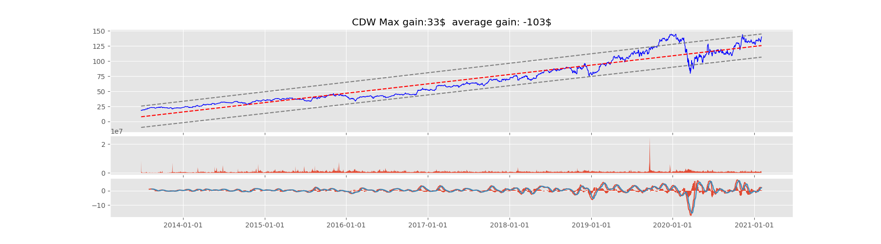

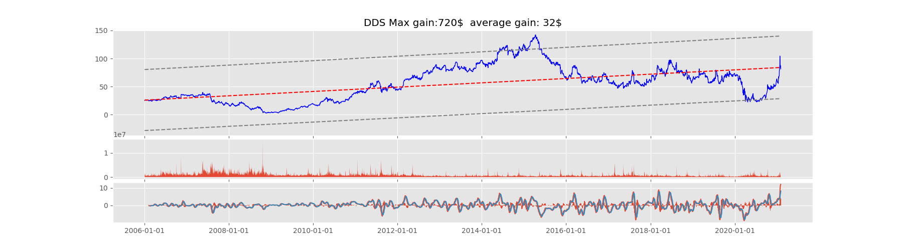

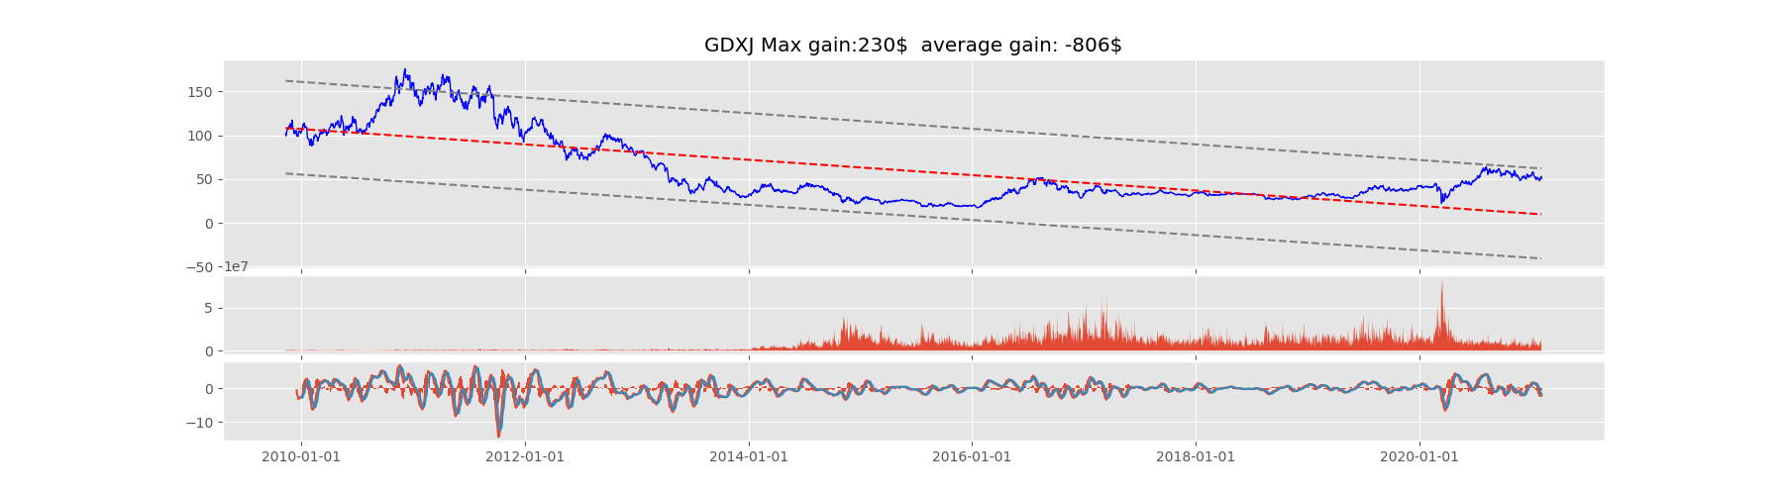

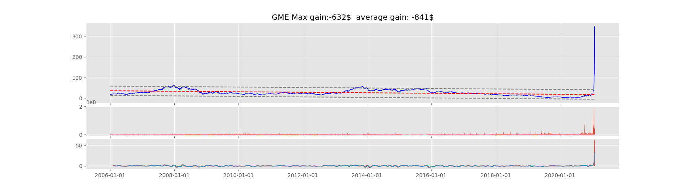

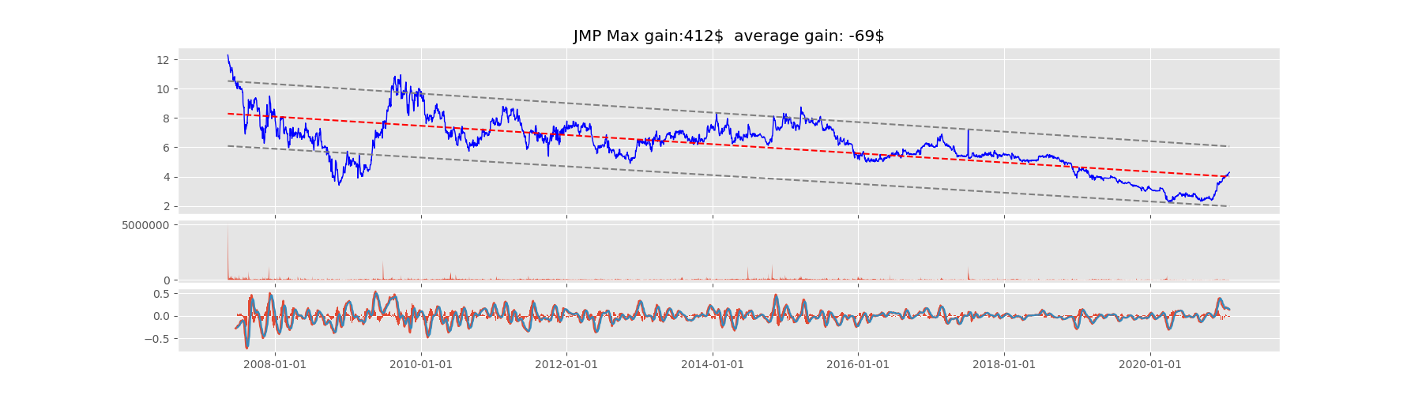

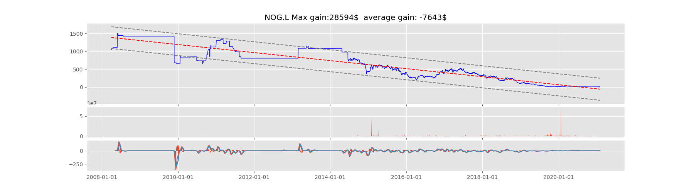

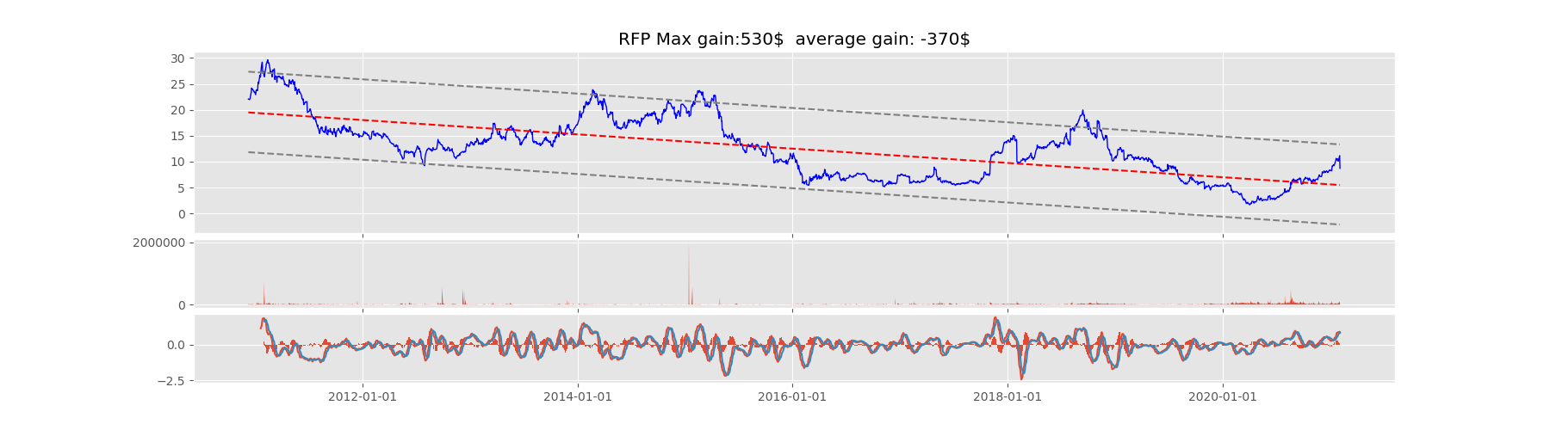

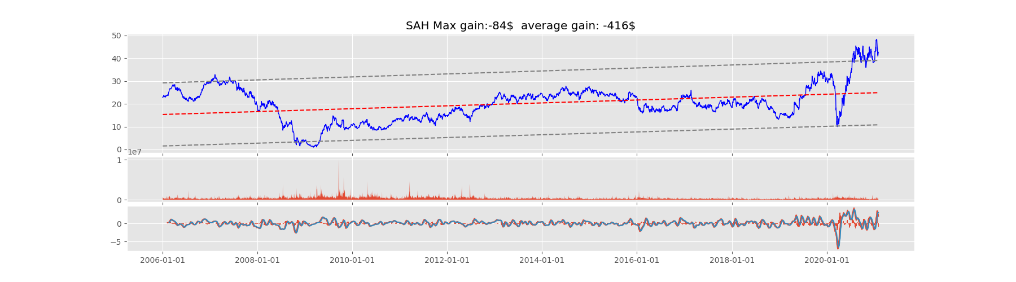

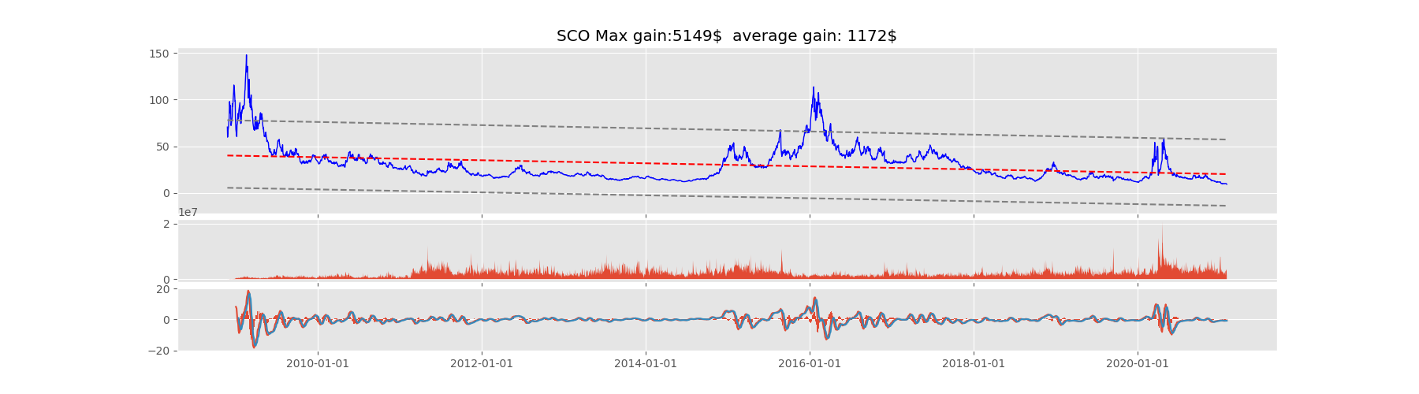

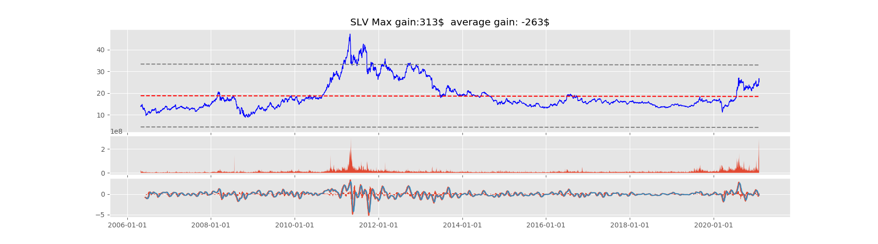

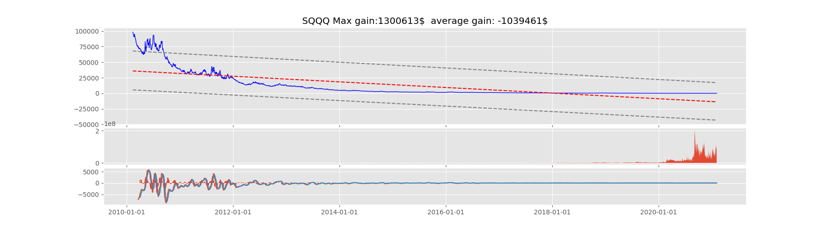

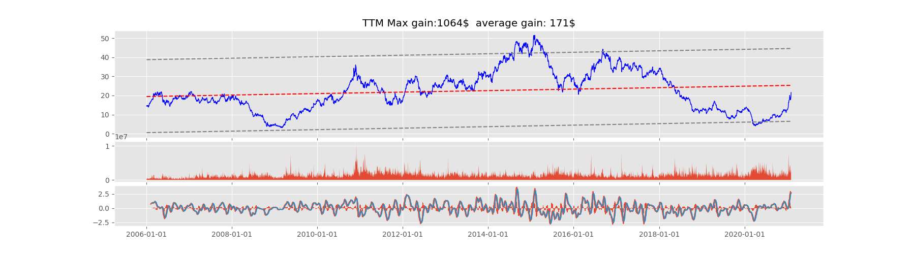

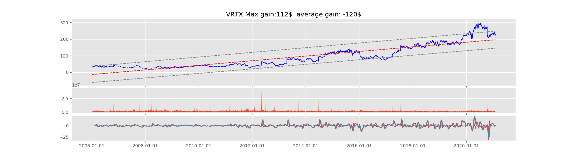

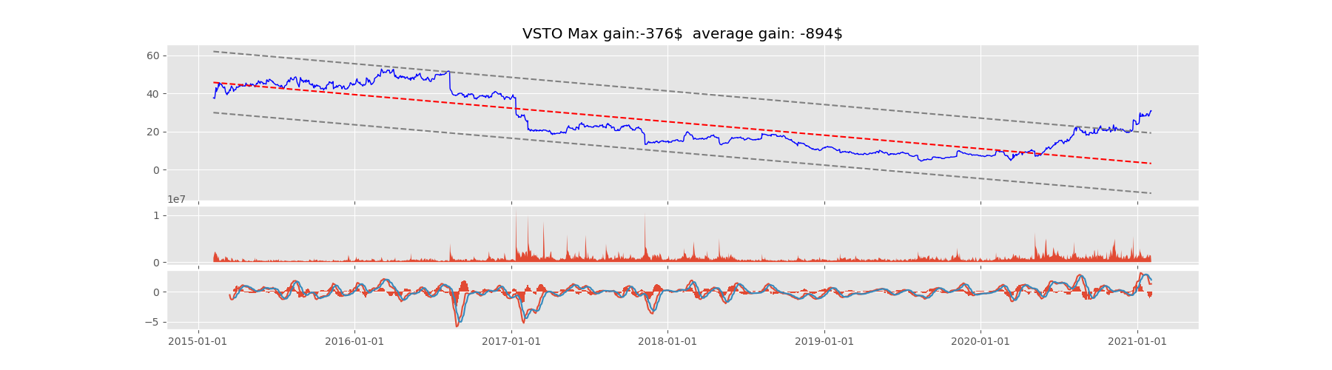

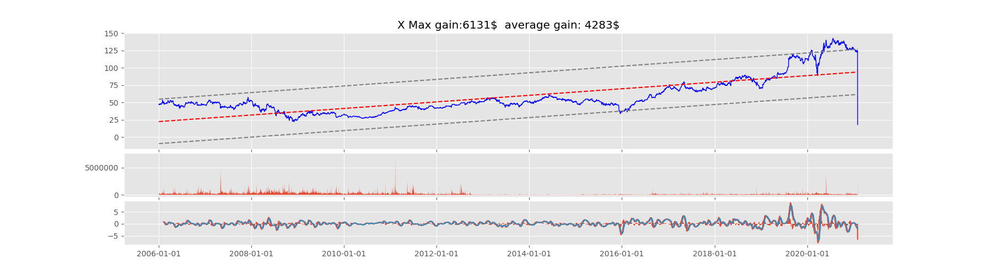

## The best trade graphs

