

MESI_ISC Specification
Draft

Author: Yair Amitay
yair.amitay@yahoo.com
www.linkedin.com/in/yairamitay

Rev. 0.11
January 2013

This page has been intentionally left blank.
Revision History
Rev. | Date | Author | Description
0.10 | 1/3/2013 | Yair Amitay | Draft, Under Construction
0.11 | 8/3/2012 | Yair Amitay | Stabilized the Coherency Systems chapter.  Stabilized the MESI_ISC Coherency Concept chapter.  Add and improve the Examples Diagrams.  Start stabilized the Architecture chapter.

Contents
Introduction 1
Coherency Systems 2
MESI Coherency Protocol 6
Project Purpose 7
MESI_ISC Coherency Concept 8
MESI_ISC Coherency Protocol 8
Coherency operation for a write miss 10
Coherency operation for a read miss 11
Coherency operation for a write to a Shared line 12
Examples Diagrams for Coherency Scenarios 13
A write miss to a an Invalid location 13
A write miss to a Modified location in other master's cache 14
Two parallel write misses to the same location which is Invalid 15
A write miss and a parallel read miss to two different addresses 16
Architecture 17
Coherency System Architecture 17
Coherency Operations 18
System Performance and Memory Mapping 18
Masters Definition and Requirements (Under Construction) 19
Integration MESI_ISC to Existing Systems (Under Construction) 19
MESI_ISC Configuration (Under Construction) 19
Clock and Reset (Under Construction) 19
Micro Architecture 20
Verification 21
Verification Environment (Under Construction) 21
Validation of Data Consistency 22
Validation of MESI Protocol 22
Random Stimulus 22
Timing, Power and Area 23
Design Environment 24
(Under Construction) 24
Tools 24
Synthesis 24
Simulation 24
Lint 24
IO Ports 25
Waveforms 27
Open Issues 28

Introduction
The MESI InterSection Controller (ISC) is a coherence system controller. It supports the MESI coherence protocol. It synchronizes the memory requests of the system masters. It enables to keep the consistency of the data in the memory and in the local caches.
This project provides a synthesizable controller core and it defines the requirements of the system masters.

Coherency Systems
A coherency system is a system in which all the different copies of the same memory address are consistency. It means that if a master writes a certain data to a memory address then any other master that access this address read the update data. One of the cases that an inconsistency can occur is when the system masters have memory caches. If a data copy in the cache is not update according to the least written data the master that own this cache may read the wrong data.
A system is coherent if it obeys the all following rules:
Rule 1
Time | Master | Address | Write Data | Read Data
T1 | M1 | A1 | D1
T2 | M1 | A1 |  | D1
T2 > T1
Rule 2
Time | Master | Address | Write Data | Read Data
T1 | M1 | A1 | D1
T2 | M2 | A1 |  | D1
T2 > T1
Rule 3
Time | Master | Address | Write Data | Read Data | Comment
T1 | M1 | A1 | D1
T2 | M2 | A1 | D2
T3 | M3 | A1 |  | D2
T4 | M3 | A1 |  | D2 | It is not allowed to read D1 at this point
T4 > T3 > T2 > T1

Figure 1 describes an example of a basic system. It contains a main memory and three masters. The masters are connected to the main memory and all of them can access the memory through the arbiter. A write action of a master has three stages. First the master performs a read access to the main memory and the requested memory data is copied to the master`s cache. Then the local copy of the data in the cache is updated with the write data. Later, the master may evict the cache line that contains the update data and write it back to the memory. Data inconsistent can occur in several cases. The following scenario describes an example of data inconsistent:
- Master 1 write data D1 to address A1
  - Master 1 performs a read access to A1 in the main memory.
  - The data of A1 in the main memory, D0, is copied to the local cache of master 1.
  - The data of A1 in the local cache is overwritten with the written data, D1.
- Master 2 read from address A1
  - Master 2 performs a read access to A1 in the main memory.
  - The data of A1 in the main memory, D0, is copied to the local cache of master 2.
The data of A1 in the memory in not update and Master 2 read the wrong data.
In a basic system data inconsistent can be prevented by software synchronization between the masters.

Figure 1: Basic System
Figure 2 describes an example of a hardware coherency system. It is similar to the basic system with some changes. Each master monitors (snoops) the actions of all other master. A master can postpones main memory accesses of the other masters. A master postpones a memory access of other master when it has a data copy of a certain memory address in its cache and the other master tries to access this memory location. It evicts the cache line that contains the certain data and writes it back to the memory. Then it enables the other master to continue and access the memory. The following scenario describes an example which preventing data inconsistent:
- Master 1 write data D1 to address A1
  - Master 1 performs a read access to A1 in the main memory.
  - The data of A1 in the main memory, D0, is copied to the local cache of master 1.
  - The data of A1 in the local cache is overwritten with the written data, D1.
- Master 2 read from address A1
  - Master 2 starts to perform a read access to A1 in the main memory.
  - Master 1 detects this access and holds it.
  - Master 1 evicts the cache line that contains the data copy of A1. This line contains data D1.
  - Data D1 is written to the main memory to address A1.
  - Master 1 releases the memory access of master 2 and lets it continue.
  - Master 2 finishes performing the read access from A1 in the main memory and read the data D1.
In a coherency system data inconsistent is prevented by the hardware.

Figure 2: Schematic Coherence System

MESI Coherency Protocol
MESI_ISC supports the MESI protocol. There are several types of system architectures and cache structures. The coherency of any combination of them can be done by some coherency protocols. The MESI protocol is used for system with multi masters and local caches. The cache policy is write-back. In the MESI protocol any cache line has one four states: Modified, Exclusive, Shared, and Invalid. A cache line in Modified state is a line that owned only by the current cache and it is modified (dirty) by a write data of the local master. A cache line in Exclusive state is a line that owned only by the current cache and it is not dirty. A cache line in Shared state is a line that owned by the current and also by other caches and it is not dirty. Invalid state means that the cache line in invalid and does not contains a valid data. The next table describes, for any given pair of caches, the permitted states of a two cache line that contains the same address location:
 | Cache A
Cache B | M | E | S | I
M | X | X | X | V
E | X | X | X | V
S | X | X | V | V
I | V | V | V | V

Figure 3 describes the MESI state machine.
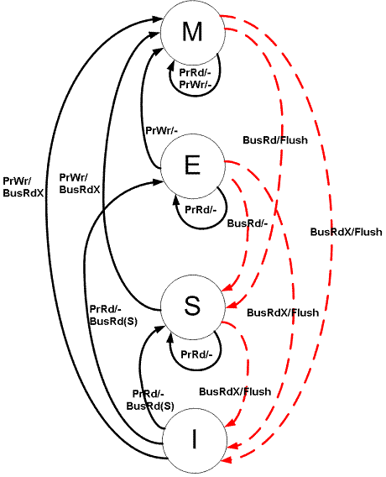
Figure 3: MESI State Machine (Wikipedia)

Project Purpose
A coherence system contains several elements that together enable the data consistency. The major elements of the coherency mechanism are:
- Coherency controller.
- Coherency masters.
- Coherency buses.
This project provides a synthesizable coherency controller block. This block can be combined to exist system with some additional changes. In addition this project defines the masters' behavior and requirements that enable a correct coherency operation.

MESI_ISC Coherency Concept

MESI_ISC Coherency Protocol
The MESI_ISC coherency protocol is based on the MESI protocol. This protocol is defined by the order and types of event for each coherency action.
In a basic system any master has a port of a main bus for performing the memory read accesses and writes accesses. In coherency system the masters have to accept information and messages from the coherency controller. The masters of a system that adopts the MESI_ISC contain additional port of coherency bus. The main bus is used as in a basic system for performs memory accesses. In addition the main bus and the coherency bus are used for the coherence protocol. The transactions of the main bus are initiated and drive by the masters. They respond by the main memory, the system matrix or the coherency controller. The transactions that are done in the main bus are:
- Write access – A write access to the memory (legacy bus transaction).
- Read access – A read access to the memory (legacy bus transaction).
- Write broadcast – A write broadcast request. Asks for all other master to evict and invalidate data of the requested address. This transaction type is unique for coherency systems.
- Read broadcast – A read broadcast request. Asks for all other master to evict modified data of the requested address. This transaction type is unique for coherency systems.

The coherency bus is unique for coherency systems. Its transactions are initiated and drive by the coherency controller. They respond by the masters. The transactions that are done in the coherency bus are:
- Write snoop – Another master request to write to a requested memory location.
- Read snoop – Another master request to read to a requested memory location.
- Enable write – A respond to a write broadcast (which was performed in the main bus). It means that the write to the requested memory location can be done.
- Enable read – A respond to a read broadcast (which was performed in the main bus). It means that the read to the requested memory location can be done.
In general, a coherency operation starts when a master (initiator) starts generating an access the memory. Prior to any memory access the master sends a broadcast request in the main memory. The coherency controller spreads the request to all the other masters and collects the responds. Then it enables the initiator to perform the memory access. All operations of the coherency controller are done in the coherency bus.
A coherency operation occurs when one of the caches in the system performs a read miss, a write miss, or a write to a Shared cache line. Write hit, read hit, line eviction, and line invalidate do not cause to a coherency operations.
The following tables define in details all the stages for the coherency operations. In the tables the meanings of some expression are:
Source/destination: Initiator – A master which requests to perform one of the following memory accesses: (1) A read access to a memory location that is not present in its cache (read miss), or (2) a write access to a memory location that is not present in its cache (write miss) or present and has a Shared state (write to a Shared cache line).
Source/destination: Coherency Controller – The element that responsible for the broadcast management. In this project is the MESI_ISC.
Source/destination: Snooper – A master that receives a write or read snoop request.
Bus: Internal – An internal operation in a block.

Coherency operation for a write miss
The following table defines the stages that are done for a write miss.
Stage | Source | Destination | Bus | Operation | Comments
1 | Initiator | Coherency Controller | Main | Send write broadcast
2 | Coherency Controller | Initiator | Main | Acknowledge write broadcast request | When it receive the request
3 | Coherency Controller | Snooper | Coherency | Write snoop | Done to all masters except the initiator
4 | Snooper |  | Internal | Evicts a dirty line | In case the line is M state
 |  |  |  | Cache state: E/S->I | In case the line is E or S states
 |  |  |  | Do nothing | In case there is no a valid line
5 | Snooper | Memory | Main | Write back line to memory  Cache state: M->I | In case of eviction
6 | Snooper | Coherency Controller | Coherency | Acknowledge write snoop
7 | Coherency Controller | Initiator | Coherency | Enable write | After all masters acknowledged the write snoop broadcast
8 | Initiator | Memory | Main | Read line | Fill line
 | Initiator |  | Internal | Cache state: I->S | For the cache line that contains the read data
9 | Initiator |  | Internal | Write to the cache  Cache state: S->M | For the cache line that contains the read data

Coherency operation for a read miss
The following table defines the stages that are done for a read miss.
Stage | Source | Destination | Bus | Operation | Comments
1 | Initiator | Coherency Controller | Main | Send read broadcast
2 | Coherency Controller | Initiator | Main | Acknowledge read broadcast request | When it receive the request
3 | Coherency Controller | Snooper | Coherency | Read snoop | Done to all masters except the initiator
4 | Snooper |  | Internal | Evicts a dirty line | In case the line is M
 |  |  |  | Cache state: E->S | In case the line is E
 |  |  |  | Do nothing | In case the line is S or there is no a valid line
5 | Snooper |  | Main | Write back line to memory  Cache state: M->I | In case of eviction
6 | Snooper | Coherency Controller | Coherency | Acknowledge read snoop
7 | Coherency Controller | Initiator | Coherency | Enable read | After all masters acknowledged the read snoop
8 | Initiator | Memory | Main | Read line | Fill line
9 | Initiator |  | Internal | Cache state: I->S | For the cache line that contains the read data

Coherency operation for a write to a Shared line
The following table defines the stages that are done for a write hit to a line in Shared state.
Stage | Source | Destination | Bus | Operation | Comments
1 | Initiator | Coherency Controller | Main | Send write broadcast
2 | Coherency Controller | Initiator | Main | Acknowledge write broadcast request
3 | Coherency Controller | Snooper | Coherency | Write snoop | Done to all masters except the initiator
5 | Snooper |  | Internal | Invalidates the valid line:  Cache state: S->I
6 | Snooper | Coherency Controller | Coherency | Acknowledge write snoop
7 | Coherency Controller | Initiator | Coherency | Enable write | After all masters acknowledged the write snoop
8 | Snooper |  | Internal | Write to the cache  Cache state: S->M | For the cache line that contains the read data

Examples Diagrams for Coherency Scenarios
The diagrams in this section describe the development of events in different coherency scenarios. They do not show the detailed timing behavior. The diagrams help to understand the coherency operation and the MESI_ISC coherency protocol.

A write miss to a an Invalid location
The following diagram describes a write miss of M0 (master 0) to an address that is invalid in all masters. M0 sends write-broadcast on the main bus. M1 and M2 receive write-snoop on the coherency busses and return immediately acknowledge. M0 receives write-enable on the coherency bus and performs a writes access (read A1 from memory on the main bus and write to its cache).
Figure 4: Write miss to an Invalid location

A write miss to a Modified location in other master's cache
The following diagram describes a write miss of M0 to an address that is modified in the cache of M1. M0 sends write-broadcast in the main bus. M1 and M2 receive write-snoop in coherency busses. M2 returns immediately acknowledge. As a result of the write snoop, M1 evicts A1 and writes it back to the memory through the main bus. Then M1 returns acknowledge. M0 receives write-enable and performs a writes access (read A1 from memory and write to its cache).
Figure 5: Write miss to a Modified location in other master

Two parallel write misses to the same location which is Invalid
The following diagram describes a write miss of M0 to address A1 in parallel to a write miss of M1 to address A1. A1 is invalid in all masters. M0 and M1 send, separately, write-broadcasts. MESI_ISC responds first to M0 (according to a random priority). M1 and M2 receive write-snoop on the coherency busses and return immediately acknowledge. M0 receives write-enable on the coherency bus and performs a writes access (read A1 from memory and write to its cache). Then MESI_ISC responds the broadcast of M1. M0 and M2 receive write-snoop on the coherency busses. M2 returns immediately acknowledge. As a result of the write snoop, M0 evicts A1 and writes it back to the memory through the main bus. Then M0 returns acknowledge. M1 receives write-enable and performs a writes access (read A1 from memory and write to the cache).
Figure 6: Two parallel write misses to an Invalid location

A write miss and a parallel read miss to two different addresses
The following diagram describes a write miss of M0 to address A1. Address A1 is in an Exclusive state at M1. In parallel to the write miss M1 performs a read miss to address A2. Address A2 is in a Modified state at M1. M0 and M1 send, separately, write-broadcasts and read broadcast, respectively. MESI_ISC responds first to M1 (according to a random priority). M0 and M2 receive read-snoop for A2 on the coherency busses. M2 returns immediately acknowledge. As a result of the read snoop M0 evicts A2 and writes it back the memory through the main bus. Then M0 returns acknowledge. M1 receives read-enable and performs a read access (read A2 from memory and copy it to its cache). Then MESI_ISC responds the broadcast of M0. M1 and M2 receive write-snoop on the coherency busses. Both return immediately acknowledge. M1 also change the line state from Exclusive to Invalid. M0 receives write-enable and performs a writes access (read A1 from memory and write to its cache).
Figure 7: A write misses and a read miss to different addresses

Architecture

Coherency System Architecture
A coherency system contains, in addition to the legacy elements, the MESI_ISC, coherency ports of the masters and the coherency bus. MESI_ISC has two connection types. In one direction it connects to the main bus as a slave and receives the bus' controls and address. In the other direction it connects to the coherency bus as a bus master. MESI_ISC has two ports for each system master, one main bus port and one coherency bus port. The legacy structure of the system that include the memory matrix, the arbitration, and the memory, remains unchanged.
Figure 8 describes a coherence system with MESI_ISC

Figure 8: MESI_ISC Architecture and the Masters system

Coherency Operations
The MESI_ISC receives the broadcast request from the system masters through the main bus. It sends the write snoop, read snoop, write-enable, and read-enable to the system masters through the coherency bus. MESI_ISC separates each broadcast request that a master sends (initiator) to a separated snoop requests for each master, except for the initiator.

System Performance and Memory Mapping
The memory mapping of a coherency system can contain two areas, a private area and a shared area. The private area has several nonoverlapping spaces, each space directed to a specific master. There is no consistency of the data in the private area between the different masters of the system. Therefore a space memory in the private area which is directed to a specific master can be accessed only by that master. The shared area can be used by all masters and its data is consistency between the masters. The shared area is used to synchronize the masters and to transfer data between them. Both the areas are cacheable.
The way masters access the memory depends on the memory mapping. A memory access to an address which is located in the private area is done without prior actions. The master performs a read or a write access directly to the memory. The memory data is copied to the local cache and is used by the regular cache operations.
A master that intends to access a location in the shared area is required to notify the other master about the action. The notification enables the other master to invalidate that location in their caches or to write back the dirty data. The notification is done by sending to the MESI_ISC a broadcast request. Only after the MESI_ISC enables the access the master can perform the intended memory access.
A synchronization system, by nature, requires additional resources such as timing and area. In a coherence systems with MESI_ISC the latency of the MESI protocol (sending a broadcast request and receive acknowledges), in the best case, is seven cycles. This latency can cause to degradation of the system performance.
However it is possible to reduce the performance degradation. This list describes the major field for doing it:
      - System configuration and S/F management
        - The usage of the shared memory is done only for synchronization and for data transfer between the masters. All the other tasks use the private memory.
        - Evict or invalidate dirty cache lines when are unused.
      - MESI_ISC configuration
        - Defining and tuning the MESI_ISC FIFO sizes to achieve the best system performance (see MESI_ISC Configuration (Under Construction))
      - Maters architecture
        - Improving the respond time of the masters for the snoop requests (see Masters Definition and Requirements (Under Construction)).
        - Change the cache configurations. For example increase the line size to reduce the synchronization events.
      - MESI_ISC architecture
        - Changes of the to reduce its latency (remove the snoop FIFOs see Open issues)

Masters Definition and Requirements (Under Construction)

Integration MESI_ISC to Existing Systems (Under Construction)

MESI_ISC Configuration (Under Construction)
FIFO sizes
Number of masters in the system

Clock and Reset (Under Construction)

Micro Architecture
(Under Construction)
Figure 4 describes the micro-architecture of MESI_ISC

Figure 9: MESI_ISC Micro-Architecture

Verification
(Under Construction)

Verification Environment (Under Construction)
Figure 5 describes the MESI_ISC verification environment.

Figure 10: MESU_ISC Verification Environment

Validation of Data Consistency

Validation of MESI Protocol

Random Stimulus

Timing, Power and Area
(Under Construction)

Design Environment

(Under Construction)

Tools

Synthesis

Simulation

Lint

IO Ports
(Under Construction)
This section specifies the MESI_ISC IO ports.
Clock and reset
Port | Direction | Description
clk | Input
rst | Input

Main bus
Port | Direction | Description
mbus_cmd3_i | Input
mbus_cmd2_i | Input
mbus_cmd1_i | Input
mbus_cmd0_i | Input
mbus_addr3_i | Input
mbus_addr2_i | Input
mbus_addr1_i | Input
mbus_addr0_i | Input
mbus_ack3_o | Output
mbus_ack2_o | Output
mbus_ack1_o | Output
mbus_ack0_o | Output

Coherency Bus
Port | Direction | Description
cbus_ack3_i | Input
cbus_ack2_i | Input
cbus_ack1_i | Input
cbus_ack0_i | Input
cbus_addr_o | Output
cbus_cmd3_o | Output
cbus_cmd2_o | Output
cbus_cmd1_o | Output
cbus_cmd0_o | Output

Waveforms
(Under Construction)
The next figure shows a read access to the memory which preceded by a read broadcast. A similar operation is describe in figure A write miss and a parallel read miss to two different addresses
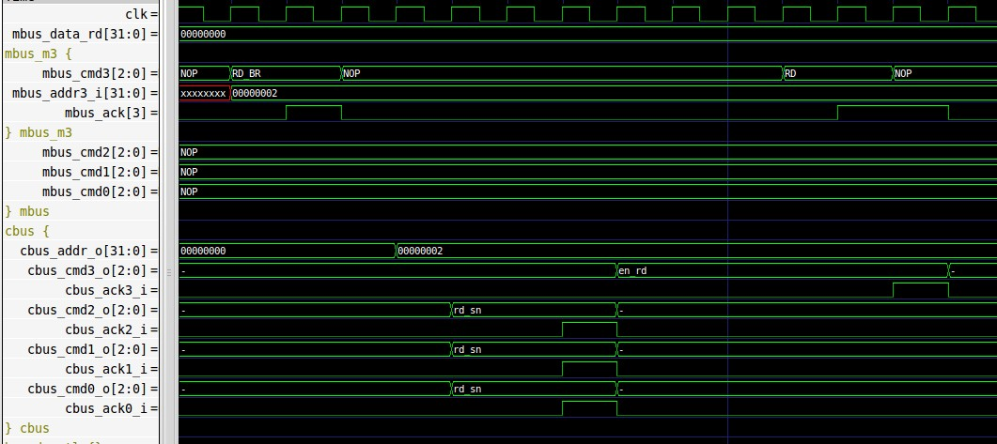

Open Issues
            - Add an option to remove the snoop request FIFOs in the RTL (by Verilog define or by additional MESI_ISC version).

