RAM with Wishbone interface
A configurable implementation of a RAM with wishbone interface
Brought to You By ORSoC / OpenCores

Legal Notices and Disclaimers
Copyright Notice
This ebook is Copyright © 2009 ORSoC
General Disclaimer
The Publisher has strived to be as accurate and complete as possible in the creation of this ebook, notwithstanding the fact that he does not warrant or represent at any time that the contents within are accurate due to the rapidly changing nature of information.
The Publisher will not be responsible for any losses or damages of any kind incurred by the reader whether directly or indirectly arising from the use of the information found in this ebook.
This ebook is not intended for use as a source of legal, business, accounting, financial, or medical advice. All readers are advised to seek services of competent professionals in the legal, business, accounting, finance, and medical fields.
No guarantees of any kind are made. Reader assumes responsibility for use of the information contained herein. The Publisher reserves the right to make changes without notice. The Publisher assumes no responsibility or liability whatsoever on the behalf of the reader of this report.
Distribution Rights
The Publisher grants you the following rights for re-distribution of this ebook.
[YES] Can be given away.
[YES] Can be packaged.
[YES] Can be offered as a bonus.
[NO] Can be edited completely and your name put on it.
[YES] Can be used as web content.
[NO] Can be broken down into smaller articles.
[NO] Can be added to an e-course or auto-responder as content.
[NO] Can be submitted to article directories (even YOURS) IF at least half is rewritten!
[NO] Can be added to paid membership sites.
[NO] Can be added to an ebook/PDF as content.
[NO] Can be offered through auction sites.
[NO] Can sell Resale Rights.
[NO] Can sell Master Resale Rights.
[NO] Can sell Private Label Rights.
Table of Contents
Overview 4
Chapter 2 5
Recommended Resources 6

Overview
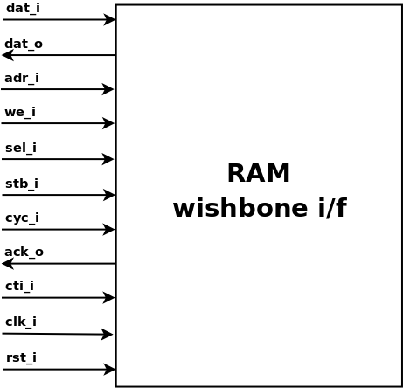
All available FPGA have built-in RAM modules. For a SoC type of implementation all memory not used by peripheral and processor caches, MMU, registers etc can be used as instruction or data memory.
This memory has a 32 bit Wishbone B3 compatible system interface. Burst read and write cycle are supported.
The internal memory do not need byte enable signals to support byte and halfword write cycles.
The internal memory is defined as one memory array with 32 bit width. For simulation purposes the content can be defined at startup.

Configuration parameters
Parameter | Default
RAM_WB_MEM_SIZE | 4096 | Memory size in bytes
RAM_WB_ADR_SIZE | 12 | Number of address lines used
RAM_WB_DAT_SIZE | 32 | Number of bits in data bus

Recommended Resources
ORSoC – http://www.orsoc.se
ORSoC is a fabless ASIC design & manufacturing services company, providing RTL to ASIC design services and silicon fabrication service. ORSoC are specialists building complex system based on the OpenRISC processor platform.
Open Source IP – http://www.opencores.org
Your number one source for open source IP and other FPGA/ASIC related information.

