

IP Core
Specification

Author: Stephen Hawes
[Email Address]

Rev. [0.1]
May 9, 2015

This page has been intentionally left blank.
Revision History
Rev. | Date | Author | Description
0.1 | 02/05/15 | Stephen Hawes | First Draft  Include skeleton specification doc into source control

Contents
Introduction 1
Architecture 2
Operation 3
Registers 4
List of Registers 4
Register 1 – Description 4
Clocks 5
IO Ports 6

Introduction
[This section contains the introduction to the core, describing its use and features.]

Architecture
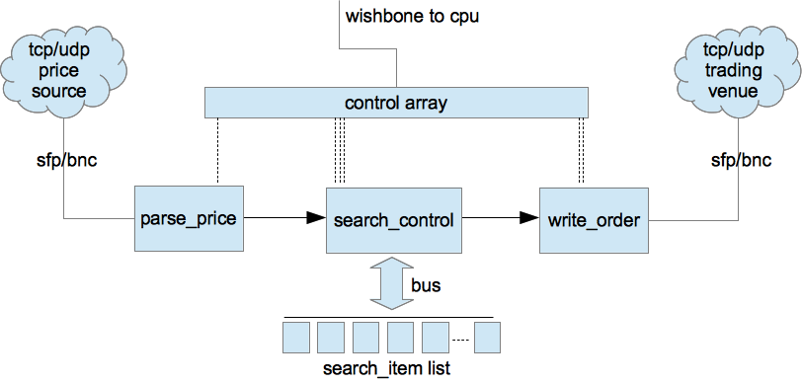

[This section describes the architecture of the block. A block diagram should be included describing the top level of the design.]

Operation
[This section describes the operation of the core. Specific sequences, such as startup sequences, as well as the modes and states of the block should be described.]

Registers
[This section specifies all internal registers. It should completely cover the interface between the core and the host as seen from the software view.]

List of Registers
Name | Address | Width | Access | Description
Table 1: List of registers

Register 1 – Description
[You shall choose the style of register you prefer. Do not use both options in one and the same document.]
Bit # | Access | Description
Reset Value:
Reg_Name: 0000h

31 | 30 | 29 | 28 | ... | 8 | 7 | 6 | 5 | 4 | 3 | 2 | 1 | 0
Table 2: Description of registers
Reset Value:
Reg_Name: 0000h

Clocks
[This section specifies all the clocks. All clocks, clock domain passes and the clock relations should be described.]

Name | Source | Rates (MHz) |  |  | Remarks | Description
Name | Source | Max | Min | Resolution | Remarks | Description
clk_pad_i | Input Pad | 10 | 4 | 0.1 | Duty cycle 70/30. | For external interface.
wb_clk_I | PLL | 200 | - | - | Must be synchronized to sm_clk_i | System clock.
sm_clk_i | Input port | 55 | 40 | 1 | There are multi-clocks paths. | Clock 55MHz for State machine.
Table 3: List of clocks

IO Ports
[This section specifies the core IO ports.]

Port | Width | Direction | Description
wb_clk_i | 1 | Input | Block’s WISHBONE Clock Input
wb_rst_i | 1 | Input | Block’s WISHBONE Reset Input
wb_sel_i | 4 | Input | Block’s WISHBONE Select Inputs
foo_pad_o | 1 | Output | Block’s foo output to output pad
…
Table 4: List of IO ports

Name
[This section may be added to outline different specifications.]

Name
[This section may be added to outline different specifications.]

[This section contains an alphabetical list of helpful document entries with their corresponding page numbers.]

