AES Implementation details
AES is implemented as defined in the FIPS-197 document.
The Algorithm is implemented in ECB mode.

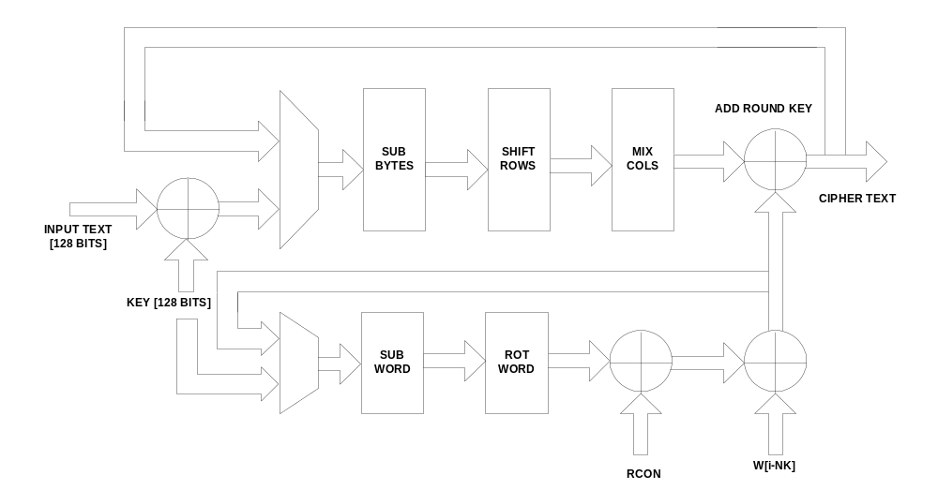
Figure 1-Error! No text of specified style in document.-1 Architectural block diagram

For details about each of the blocks refer the FIPS-197 document.
The decryption process follows virtually the same order as encryption except for another round of mix columns on the generated keys before giving them to the add round key step. This flow is clearly explained in the FIPS-197 document.

The encryption/decryption sequence
Input data and key is fed in two blocks of 64 bits in consequtive clock cycles with the load signal. 64 bits of input and key are read in the posedge after the load signal goes high and another block of 64 bits of input and key are read in the posedge after the load signal goes low. Hence the complete data and key is loaded only when the load signal makes a low-high-low transition(basically a pulse). The process starts once the start signal is pulsed and the output is validated with 'done' signal 13 clock cycles after the 'start' signal goes low . 'done' remains high until the next start cycle.

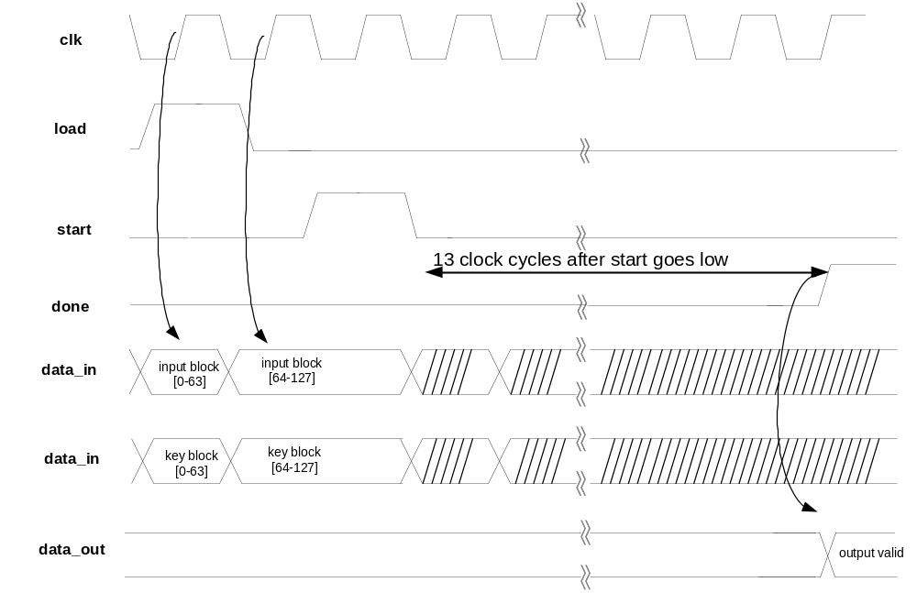
Figure -2 Process sequence for encryption/decryption

The arcitecture isnt pipelined and hence only able to perform multi encryption/decryption serially one after the other. The output is registered and avialable after 'done' signal goes high. Asserting the start signal during an encrytion/decryption process will lead to erroneous output.

