

aoOCS
Specification

Author: Aleksander Osman
alfik@poczta.fm

Rev. 1.0
December 20, 2010

This page has been intentionally left blank.
Revision History

Rev. | Date | Author | Description
1.0 | 20.12.2010 | Aleksander Osman | First Publish

Contents
Introduction 1
Features 1
WISHBONE compatibility 2
Similar projects 3
Limitations 3
TODO 3
Status 4
Requirements 4
Architecture 5
Operation 14
SD card 14
aoOCS_tool 15
On-Screen-Display description 15
Software compatability list 16
Registers 18
Clocks 20
IO Ports 21
aoOCS top-level IO Ports 21
References 23

Introduction

The OpenCores aoOCS SoC is a Wishbone compatible implementation of most of the Amiga Original Chip Set (OCS) and computer functionality.
aoOCS is not related in any way with Minimig - it is a new and independent Amiga OCS implementation.

Features
- The aoOCS SoC contains the following Amiga/OCS components:
  - blitter
  - copper
  - system control (interrupts)
  - video: bitplains, sprites, collision detection
  - audio: 4 channels, low-pass filter
  - user input: PS/2 mouse, PS/2 keyboard and joystick (keyboard arrow keys)
  - floppy: read and write ADF files directly from a SD card. Only the internal floppy drive is implemented
  - 8520 CIA
  - ao68000 OpenCores IP core is used as the aoOCS processor
- All of the above components are WISHBONE revision B.3 compatible
- The aoOCS contains the following additional components:
  - SD card controller written in HDL with DMA. Supports SDHC cards only.
  - 10/100 Mbit Ethernet controller written in HDL to send the current VGA frames (frame grabber)
  - HDL drivers for SSRAM, PS/2 keyboard, PS/2 mouse, audio codec, VGA DAC
- aoOCS uses only one external memory: a SSRAM with 36-bit words and pipelined access. A video buffer with about 250KB is located SSRAM. Another 256KB are used by the ROM. All the rest memory can be used as Chip RAM.
- The On-Screen-Display is implemented in HDL as a finite state machine. No additional controller/processor with firmware required to handle the SoC.
- The following options are available on the On-Screen-Display:
  - select ROM file to load (only Amiga Kickstart v1.2 was tested)
  - enable or disable Joystick (keyboard arrow keys)
  - enable or disable floppy write protection
  - insert a floppy - select one from a list
  - eject an inserted floppy
  - reset the system
- The On-Screen-Display is independent of the running Amiga software. It is enabled and disabled by the Home key and controled by the keyboard arrow keys and the right CTRL key.
- Only PAL timings are implemented.
- The video output is VGA compatible: 640x480 at 70 Hz. A rather simple method is used to extend the 256 PAL horizontal lines to 480 VGA lines: all lines are doubled except for every 8th one.
- The system uses generally a single clock: 30 MHz. There are two more clocks: 12 MHz, 25 MHz generated to interface with external hardware (Audio codec, Ethernet controller). A single altpll is used to generate all three clocks from one 50 MHz external clock. More information about clocks is available at Clocks.
- A VGA frame grabber is implemented that sends captured frames by 100 Mbit Ethernet in IP/UDP packets.
- The system uses about 26.400 LE on Altera Cyclone II and about 267.000 bits of on-chip RAM.
- The blitter functionality was tested against the E-UAE Amiga software emulator.
- Tested only on a Terasic DE2-70 board (www.terasic.com.tw).
- Documentation generated by Doxygen (www.doxygen.org) with doxverilog patch (http://developer.berlios.de/projects/doxverilog/). The specification is automatically extracted from the Doxygen HTML output.

WISHBONE compatibility
- Version: WISHBONE specification Revision B.3,
- General description: 32-bit WISHBONE interface,
- WISHBONE data port size: 32-bit,
- Data port granularity: 8-bits,
- Data port maximum operand size: 32-bits,
- Data transfer ordering: BIG ENDIAN,
- Data transfer sequencing: UNDEFINED,
- Constraints on CLK_I signal: described in Clocks.

Similar projects
Other Open-Source Amiga implementations include:
- Minimig (http://code.google.com/p/minimig/) - FPGA-based re-implementation of the original Amiga 500 hardware. Runs on the Minimig PCB and also on Terasic DE1,2 boards.

Limitations
- No filesystem support on the SD card. Data is read from fixed positions. The contents of the SD card is generated by the aoOCS_tool described at Operation.
- No video external synchronize, lace mode, lightpen, genlock audio enable, color composite (BPLCON0)
- All bitplain data is fetched at once in a burst memory read at the begining of each line. No changes to the bitplain data done after the beginning of a line are visible.
- Currently aoOCS requires an 36-bit word SSRAM to store the video buffer. This way 3 pixels 12-bits each can be stored in one word.
- Serial port not implemented.
- Parallel port not implemented.
- Low-pass filter disable/enable by CIA-A port A bit 1 not implemented.
- Proportional controller and light pen not implemented.
- Some rarely used OCS registers are not implemented: strobe video sync, write beam position, coprocessor instruction fetch identify. For a complete list of not implemented registers look at Registers.
- Only some of the Amiga software was tested and works on the aoOCS. A list of aoOCS software compatability is located at Operation.

TODO
- Fix some of the above limitations.
- Optimize the design.
- Run WISHBONE verification models.
- More documentation of Verilog sources.
- Describe testing and changes done in E-UAE sources.
- Prepare scripts for VATS: run_sim -r -> regresion test.
- Port the aoOCS SoC to a Xilinx FPGA.

Status
- Amiga Workbench v1.2 runs with some minor graphic problems: bottom of screen not displayed correctly.
- Prince of Persia runs perfectly.
- Wings of Fury runs correctly. Some sound glitches in intro.
- Lotus 2 runs correctly. Some sound problems in intro.
- Warzone runs poor. Some major graphic problems.
- More information about aoOCS software compatability is available at Operation.

Requirements
- Altera Quartus II synthesis tool (http://www.altera.com) is required to synthesise the aoOCS System-on-Chip.
- Java SDK (http://java.sun.com) is required to compile the aoOCS_tool (The tool is described in Operation).
- A FPGA board. Currently only the Terasic DE2-70 board was tested.
- Icarus Verilog simulator (http://www.icarus.com/eda/verilog/) is required to compile the and run some tests.
- Access to Altera Quartus II directory (directory eda/sim_lib/) is required to compile and run some tests.
- GCC (http://gcc.gnu.org) is required to compile some testes based on E-UAE sources.

Architecture
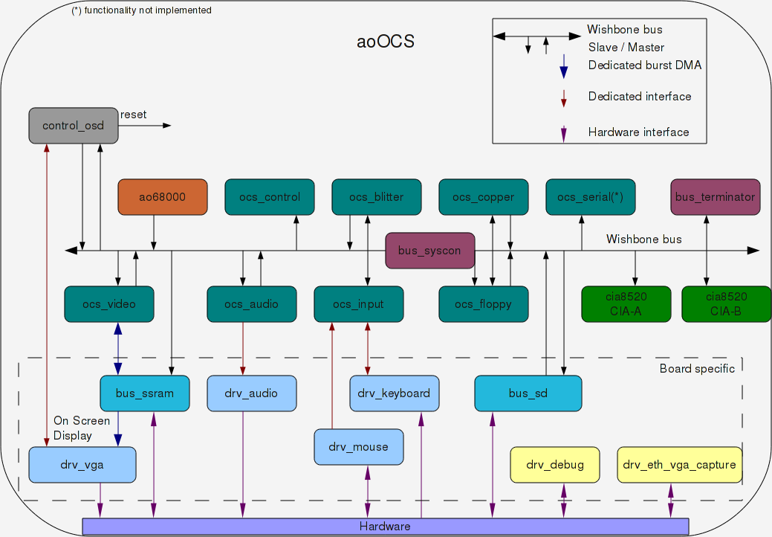

Figure 1: aoOCS structure.
control_osd
On-Screen-Display and overall system management.
ao68000
ao68000 top level module.
This module contains only instantiations of sub-modules and wire declarations.
ocs_control
OCS system control implementation with WISHBONE slave interface.
List of system control registers:
Implemented:
[DDFSTOP 094 W A Display bitplane data fetch stop
(horiz. position) write not implemented here]
DMACON 096 W ADP DMA control write (clear or set) write not implemented here

DMACONR *002 R AP DMA control (and blitter status) read
VPOSR *004 R A( E ) Read vert most signif. bit (and frame flop)
VHPOSR *006 R A Read vert and horiz. position of beam

ADKCON 09E W P Audio, disk, UART control

ADKCONR *010 R P Audio, disk control register read
[POT0DAT *012 R P( E ) Pot counter pair 0 data (vert,horiz) read implemented here]

INTENAR *01C R P Interrupt enable bits read
INTREQR *01E R P Interrupt request bits read

[CLXCON 098 W D Collision control write not implemented here]
INTENA 09A W P Interrupt enable bits (clear or set bits) write not implemented here
INTREQ 09C W P Interrupt request bits (clear or set bits)

Not implemented:
REFPTR & *028 W A Refresh pointer
VPOSW *02A W A Write vert most signif. bit (and frame flop)
VHPOSW *02C W A Write vert and horiz position of beam

STREQU & *038 S D Strobe for horiz sync with VB and EQU
STRVBL & *03A S D Strobe for horiz sync with VB (vert. blank)
STRHOR & *03C S DP Strobe for horiz sync
STRLONG & *03E S D( E ) Strobe for identification of long horiz. line.

RESERVED 1110X
RESERVED 1111X
NO-OP(NULL) 1FE
ocs_blitter
OCS blitter implementation with WISHBONE master and slave interface.
List of blitter registers:
Implemented:
BLTCON0 ~040 W A Blitter control register 0
BLTCON1 ~042 W A( E ) Blitter control register 1
BLTAFWM ~044 W A Blitter first word mask for source A
BLTALWM ~046 W A Blitter last word mask for source A
BLTCPTH + ~048 W A Blitter pointer to source C (high 3 bits)
BLTCPTL + ~04A W A Blitter pointer to source C (low 15 bits)
BLTBPTH + ~04C W A Blitter pointer to source B (high 3 bits)
BLTBPTL + ~04E W A Blitter pointer to source B (low 15 bits)
BLTAPTH + ~050 W A( E ) Blitter pointer to source A (high 3 bits)
BLTAPTL + ~052 W A Blitter pointer to source A (low 15 bits)
BLTDPTH + ~054 W A Blitter pointer to destination D (high 3 bits)
BLTDPTL + ~056 W A Blitter pointer to destination D (low 15 bits)
BLTSIZE ~058 W A Blitter start and size (window width,height)
BLTCMOD ~060 W A Blitter modulo for source C
BLTBMOD ~062 W A Blitter modulo for source B
BLTAMOD ~064 W A Blitter modulo for source A
BLTDMOD ~066 W A Blitter modulo for destination D
BLTCDAT % ~070 W A Blitter source C data register
BLTBDAT % ~072 W A Blitter source B data register
BLTADAT % ~074 W A Blitter source A data register
Not implemented:
BLTDDAT & *000 ER A Blitter destination early read (dummy address)
ocs_copper
OCS copper implementation with WISHBONE master and slave interface.
List of copper registers:
Implemented:
COPCON *02E W A( E ) Coprocessor control register (CDANG)
COP1LCH + 080 W A( E ) Coprocessor first location register (high 3 bits, high 5 bits if ECS)
COP1LCL + 082 W A Coprocessor first location register (low 15 bits)
COP2LCH + 084 W A( E ) Coprocessor second location register (high 3 bits, high 5 bits if ECS)
COP2LCL + 086 W A Coprocessor second location register (low 15 bits)
COPJMP1 088 S A Coprocessor restart at first location
COPJMP2 08A S A Coprocessor restart at second location
Not implemented:
COPINS 08C W A Coprocessor instruction fetch identify
Note:
- COPINS is not implemented.
ocs_serial
OCS serial port implementation with WISHBONE slave interface. [functionality not implemented].
List of serial registers:
Not implemented:
SERDATR *018 R P Serial port data and status read read implemented here
[DSKBYTR *01A R P Disk data byte and status read read implemented here]

SERDAT *030 W P Serial port data and stop bits write
SERPER *032 W P Serial port period and control
bus_terminator
Terminator for not handled WISHBONE bus cycles.
bus_syscon
WISHBONE priority and round-robin SYSCON.
ocs_video
OCS video implementation with WISHBONE master and slave interface.
List of video registers:
Implemented:
DIWSTRT 08E W A Display window start (upper left vert-horiz position)
DIWSTOP 090 W A Display window stop (lower right vert.-horiz. position)
DDFSTRT 092 W A Display bitplane data fetch start (horiz. position)
DDFSTOP 094 W A Display bitplane data fetch stop write implemented here
[DMACON 096 W ADP DMA control write (clear or set) write implemented here]

[JOY1DAT *00C R D Joystick-mouse 1 data (vert,horiz) read not implemented here]
CLXDAT *00E R D Collision data register (read and clear) read not implemented here
CLXCON 098 W D Collision control write implemented here
[INTENA 09A W P Interrupt enable bits (clear or set bits) write implemented here]

BPLCON0 100 W AD( E ) Bitplane control register (misc. control bits)
BPLCON1 102 W D Bitplane control reg. (scroll value PF1, PF2)
BPLCON2 104 W D( E ) Bitplane control reg. (priority control)

BPL1MOD 108 W A Bitplane modulo (odd planes)
BPL2MOD 10A W A Bitplane modulo (even planes)

BPL1PTH + 0E0 W A Bitplane 1 pointer (high 3 bits)
BPL1PTL + 0E2 W A Bitplane 1 pointer (low 15 bits)
BPL2PTH + 0E4 W A Bitplane 2 pointer (high 3 bits)
BPL2PTL + 0E6 W A Bitplane 2 pointer (low 15 bits)
BPL3PTH + 0E8 W A Bitplane 3 pointer (high 3 bits)
BPL3PTL + 0EA W A Bitplane 3 pointer (low 15 bits)
BPL4PTH + 0EC W A Bitplane 4 pointer (high 3 bits)
BPL4PTL + 0EE W A Bitplane 4 pointer (low 15 bits)
BPL5PTH + 0F0 W A Bitplane 5 pointer (high 3 bits)
BPL5PTL + 0F2 W A Bitplane 5 pointer (low 15 bits)
BPL6PTH + 0F4 W A Bitplane 6 pointer (high 3 bits)
BPL6PTL + 0F6 W A Bitplane 6 pointer (low 15 bits)

BPL1DAT & 110 W D Bitplane 1 data (parallel-to-serial convert)
BPL2DAT & 112 W D Bitplane 2 data (parallel-to-serial convert)
BPL3DAT & 114 W D Bitplane 3 data (parallel-to-serial convert)
BPL4DAT & 116 W D Bitplane 4 data (parallel-to-serial convert)
BPL5DAT & 118 W D Bitplane 5 data (parallel-to-serial convert)
BPL6DAT & 11A W D Bitplane 6 data (parallel-to-serial convert)

SPR0PTH + 120 W A Sprite 0 pointer (high 3 bits)
SPR0PTL + 122 W A Sprite 0 pointer (low 15 bits)
SPR0POS % 140 W AD Sprite 0 vert-horiz start position data
SPR0CTL % 142 W AD( E ) Sprite 0 vert stop position and control data
SPR0DATA % 144 W D Sprite 0 image data register A
SPR0DATB % 146 W D Sprite 0 image data register B
SPR1PTH + 124 W A Sprite 1 pointer (high 3 bits)
SPR1PTL + 126 W A Sprite 1 pointer (low 15 bits)
SPR1POS % 148 W AD Sprite 1 vert-horiz start position data
SPR1CTL % 14A W AD Sprite 1 vert stop position and control data
SPR1DATA % 14C W D Sprite 1 image data register A
SPR1DATB % 14E W D Sprite 1 image data register B
SPR2PTH + 128 W A Sprite 2 pointer (high 3 bits)
SPR2PTL + 12A W A Sprite 2 pointer (low 15 bits)
SPR2POS % 150 W AD Sprite 2 vert-horiz start position data
SPR2CTL % 152 W AD Sprite 2 vert stop position and control data
SPR2DATA % 154 W D Sprite 2 image data register A
SPR2DATB % 156 W D Sprite 2 image data register B
SPR3PTH + 12C W A Sprite 3 pointer (high 3 bits)
SPR3PTL + 12E W A Sprite 3 pointer (low 15 bits)
SPR3POS % 158 W AD Sprite 3 vert-horiz start position data
SPR3CTL % 15A W AD Sprite 3 vert stop position and control data
SPR3DATA % 15C W D Sprite 3 image data register A
SPR3DATB % 15E W D Sprite 3 image data register B
SPR4PTH + 130 W A Sprite 4 pointer (high 3 bits)
SPR4PTL + 132 W A Sprite 4 pointer (low 15 bits)
SPR4POS % 160 W AD Sprite 4 vert-horiz start position data
SPR4CTL % 162 W AD Sprite 4 vert stop position and control data
SPR4DATA % 164 W D Sprite 4 image data register A
SPR4DATB % 166 W D Sprite 4 image data register B
SPR5PTH + 134 W A Sprite 5 pointer (high 3 bits)
SPR5PTL + 136 W A Sprite 5 pointer (low 15 bits)
SPR5POS % 168 W AD Sprite 5 vert-horiz start position data
SPR5CTL % 16A W AD Sprite 5 vert stop position and control data
SPR5DATA % 16C W D Sprite 5 image data register A
SPR5DATB % 16E W D Sprite 5 image data register B
SPR6PTH + 138 W A Sprite 6 pointer (high 3 bits)
SPR6PTL + 13A W A Sprite 6 pointer (low 15 bits)
SPR6POS % 170 W AD Sprite 6 vert-horiz start position data
SPR6CTL % 172 W AD Sprite 6 vert stop position and control data
SPR6DATA % 174 W D Sprite 6 image data register A
SPR6DATB % 176 W D Sprite 6 image data register B
SPR7PTH + 13C W A Sprite 7 pointer (high 3 bits)
SPR7PTL + 13E W A Sprite 7 pointer (low 15 bits)
SPR7POS % 178 W AD Sprite 7 vert-horiz start position data
SPR7CTL % 17A W AD Sprite 7 vert stop position and control data
SPR7DATA % 17C W D Sprite 7 image data register A
SPR7DATB % 17E W D Sprite 7 image data register B

COLOR00 180 W D Color table 00
COLOR01 182 W D Color table 01
COLOR02 184 W D Color table 02
COLOR03 186 W D Color table 03
COLOR04 188 W D Color table 04
COLOR05 18A W D Color table 05
COLOR06 18C W D Color table 06
COLOR07 18E W D Color table 07
COLOR08 190 W D Color table 08
COLOR09 192 W D Color table 09
COLOR10 194 W D Color table 10
COLOR11 196 W D Color table 11
COLOR12 198 W D Color table 12
COLOR13 19A W D Color table 13
COLOR14 19C W D Color table 14
COLOR15 19E W D Color table 15
COLOR16 1A0 W D Color table 16
COLOR17 1A2 W D Color table 17
COLOR18 1A4 W D Color table 18
COLOR19 1A6 W D Color table 19
COLOR20 1A8 W D Color table 20
COLOR21 1AA W D Color table 21
COLOR22 1AC W D Color table 22
COLOR23 1AE W D Color table 23
COLOR24 1B0 W D Color table 24
COLOR25 1B2 W D Color table 25
COLOR26 1B4 W D Color table 26
COLOR27 1B6 W D Color table 27
COLOR28 1B8 W D Color table 28
COLOR29 1BA W D Color table 29
COLOR30 1BC W D Color table 30
COLOR31 1BE W D Color table 31
ocs_audio
OCS audio implementation with WISHBONE master and slave interface.
List of audio registers:
Implemented:
AUD0LCH + 0A0 W A( E ) Audio channel 0 location (high 3 bits, 5 if ECS)
AUD0LCL + 0A2 W A Audio channel 0 location (low 15 bits) (horiz. position)
AUD0LEN 0A4 W P Audio channel 0 length
AUD0PER 0A6 W P( E ) Audio channel 0 period
AUD0VOL 0A8 W P Audio channel 0 volume
AUD0DAT & 0AA W P Audio channel 0 data

AUD1LCH + 0B0 W A Audio channel 1 location (high 3 bits)
AUD1LCL + 0B2 W A Audio channel 1 location (low 15 bits)
AUD1LEN 0B4 W P Audio channel 1 length
AUD1PER 0B6 W P Audio channel 1 period
AUD1VOL 0B8 W P Audio channel 1 volume
AUD1DAT & 0BA W P Audio channel 1 data

AUD2LCH + 0C0 W A Audio channel 2 location (high 3 bits)
AUD2LCL + 0C2 W A Audio channel 2 location (low 15 bits)
AUD2LEN 0C4 W P Audio channel 2 length
AUD2PER 0C6 W P Audio channel 2 period
AUD2VOL 0C8 W P Audio channel 2 volume
AUD2DAT & 0CA W P Audio channel 2 data

AUD3LCH + 0D0 W A Audio channel 3 location (high 3 bits)
AUD3LCL + 0D2 W A Audio channel 3 location (low 15 bits)
AUD3LEN 0D4 W P Audio channel 3 length
AUD3PER 0D6 W P Audio channel 3 period
AUD3VOL 0D8 W P Audio channel 3 volume
AUD3DAT & 0DA W P Audio channel 3 data
ocs_input
OCS user input implementation with WISHBONE slave interface.
List of user input registers:
Implemented:
[DSKDATR & *008 ER P Disk data early read (dummy address) not implemented]
JOY0DAT *00A R D Joystick-mouse 0 data (vert,horiz) read implemented here

JOY1DAT *00C R D Joystick-mouse 1 data (vert,horiz) read implemented here
[CLXDAT *00E R D Collision data register (read and clear) read implemented here]

JOYTEST *036 W D Write to all four joystick-mouse counters at once

Not implemented:
[ADKCONR *010 R P Audio, disk control register read read not implemented here]
POT0DAT *012 R P( E ) Pot counter pair 0 data (vert,horiz) read not implemented here

POT1DAT *014 R P( E ) Pot counter pair 1 data (vert,horiz)
POTGOR *016 R P Pot port data read (formerly POTINP)
POTGO *034 W P Pot port data write and start
ocs_floppy
OCS floppy implementation with WISHBONE master and slave interface.
List of floppy registers:
Implemented:
[SERDATR *018 R P Serial port data and status read read not implemented here]
DSKBYTR *01A R P Disk data byte and status read read not implemented here

DSKPTH + *020 W A( E ) Disk pointer (high 3 bits, 5 bits if ECS)
DSKPTL + *022 W A Disk pointer (low 15 bits)
DSKLEN *024 W P Disk length
DSKDAT & *026 W P Disk DMA data write

[not used 07C]
DSKSYNC ~07E W P Disk sync pattern register for disk read

Not implemented:
DSKDATR & *008 ER P Disk data early read (dummy address) not implemented
[JOY0DAT *00A R D Joystick-mouse 0 data (vert,horiz) read not implemented here]
cia8520
Commodore 8520 Complex Interface Adapter implementation.
drv_vga
ADV7123 Video DAC driver for VGA output.
bus_ssram
IS61LPS51236A pipelined SSRAM driver with WISHBONE slave interface.
drv_audio
WM8731 audio codec driver for stereo audio output.
drv_keyboard
PS/2 keyboard driver.
drv_mouse
PS/2 mouse driver.
drv_debug
Switches and hex leds driver for debug purposes.
drv_eth_vga_capture
DM9000A 10/100 Mbit Ethernet driver for a VGA frame grabber.

Operation

SD card
The aoOCS SoC requires a SD card containing a list of available ROMs and floppy images together with images themselves. The aoOCS does not support any filesystem on the card. A binary image file must be prepared and written on the card starting at sector 0. The aoOCS_tool is used to prepare the image in the following way:
- a title screen PNG image must be available. A default image is available at ./sw/aoOCS_tool/title.png
- a directory with ROM files must be created
- a directory with floppy images (ADF files) must be created
- the following make command must be run at the base directory of the project:
make sd_disk AO_INTRO_IMAGE=<path to title screen PNG image> AO_ROMS=<path to ROMs directory> AO_FLOPPIES=<path to floppy images directory>

- The SD disk image is generated and saved to ./tmp/sd_disk.img. That image must be written directly on a SD disk bypassing and most probably destroying the filesystem on the disk. The easiest way to write the image is to run the dd command as a super-user on a Linux system:
dd if=<path to image file> of=<path to SD device>

aoOCS_tool
The aoOCS_tool is used to:
- Create the contents of the SD card. A image containing: a title screen, ROMs and floppy disk ADF files is created. This image has to be written to the SD card starting from sector 0.
- Extract vga frames from the drv_eth_vga_capture module as PNG images.
- Generate ./rtl/control_osd.mif memory initialization file with On-Screen-Display text strings.
- Extract the specification contents from Doxygen HTML output, to generate the specification ODT file.
The source code for the tool is located at: ./sw/aoOCS_tool/.

On-Screen-Display description
- After powerup or reset, the SoC tries to initialize the SD card and read the title screen, list of ROM files and list of floppy files. If all goes well, the following screen is displayed:
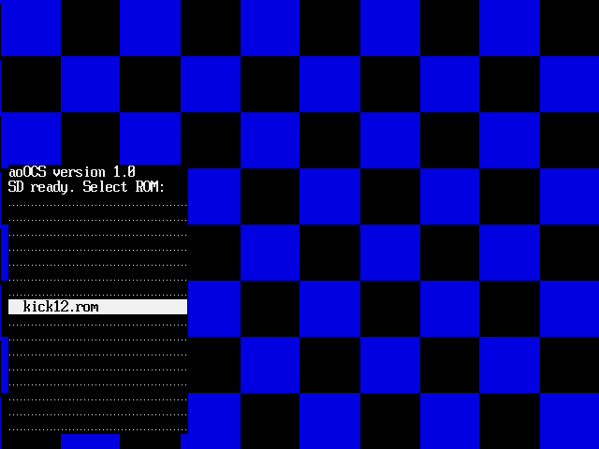
aoOCS title screen with ROM selection menu
- The On-Screen-Display is controlled by the keyboard arrow Up and Down keys. To select an item use the right Control key:
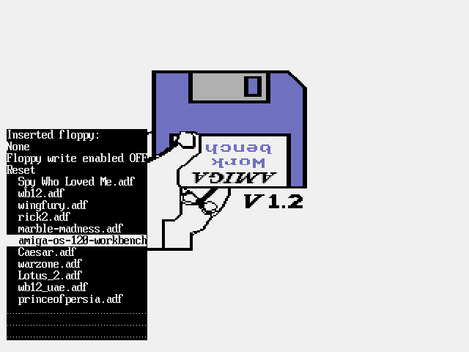
aoOCS floppy selection menu with Amiga Workbench 1.2 floppy highlighted
- After selecting the ROM file, the menu disappears and the Amiga boots from the ROM:
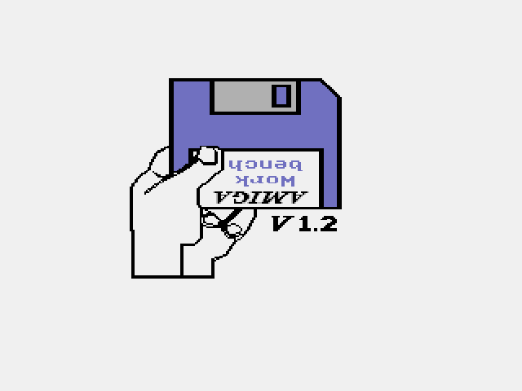
Amiga Kickstart v1.2 bootstrap screen
- To select a floppy disk to insert into the internal disk drive, the On-Screen-Display is used. To display the menu press the Home key. The Home key is also used to hide the menu. The menu when no floppy is inserted looks like this:
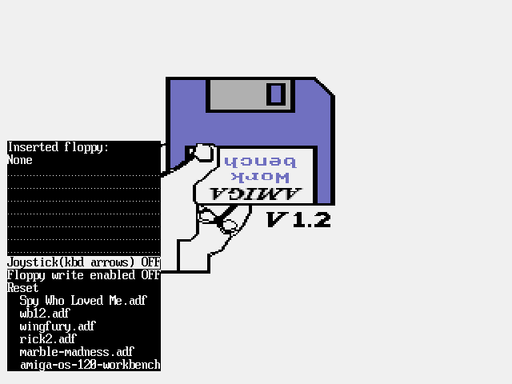
aoOCS floppy selection menu
- The following options are available:
  - Joystick (kbd arrows): enable or disable the joystick on Amiga port 1. The joystick is controlled by the keyboard arrow keys and the right Control key. When enabled, the arrow keys are unavailable to the Amiga keyboard - the key strokes are redirected to the joystick.
  - Floppy write enabled: enable or disable floppy writes. The floppy changes are made directly on the SD disk.
  - Reset: reset the aoOCS SoC
  - Below is a list of available floppy disks to insert. After selecting a floppy the display changes to the following:
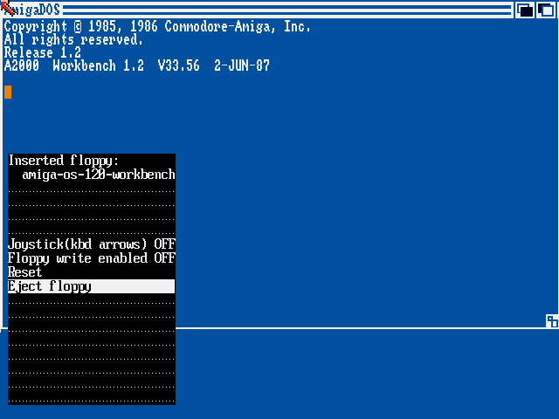
aoOCS menu after floppy selection
- In this menu it is possible to eject the floppy disk. After ejecting the floppy the previous menu is dispayed.

Software compatability list
The state of software can be:
PERFECT | no visible and no audible distortions
GOOD | some minor distortions
FAIR | software starts but has major distortions
FAILED | software does not start

- Amiga Workbench version 1.2
 | 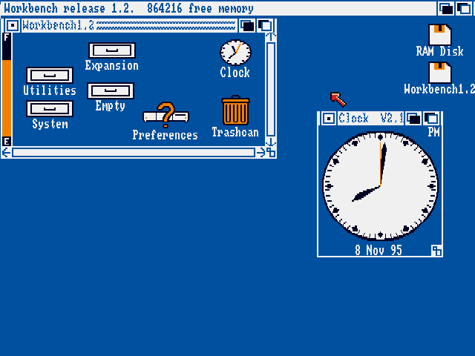  Amiga Workbench v1.2 screen
  aoOCS version: | 1.0
  State: | GOOD
  Description: | Some minor graphic problems: bottom of screen not displayed correctly. Most probably problem with Copper and vertical beam position.
- Prince of Persia
 | 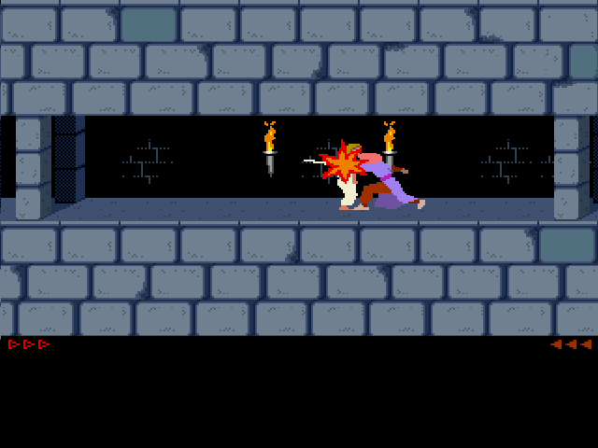  Prince of Persia
  aoOCS version: | 1.0
  State: | PERFECT
  Description: | No problems.
- Wings of Fury
 | 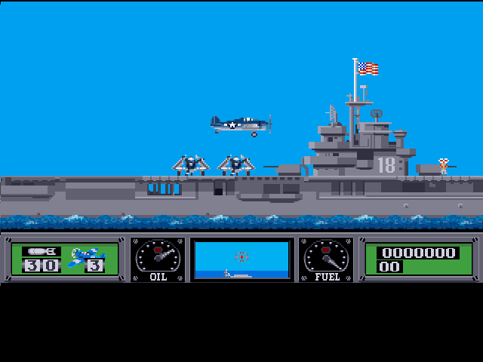  Wing of Fury
  aoOCS version: | 1.0
  State: | GOOD
  Description: | Some sound gliches in introduction. The game itself works perfect.
- Lotus 2
 | 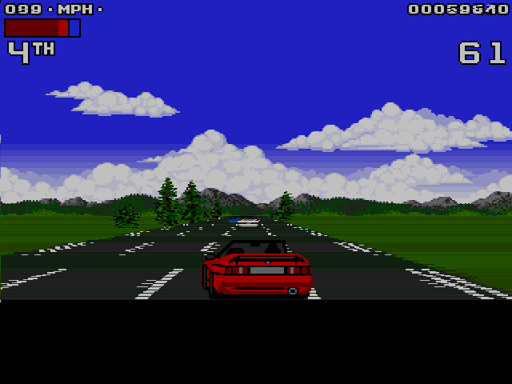  Lotus 2
  aoOCS version: | 1.0
  State: | GOOD
  Description: | Some minor sound problems in introduction - most probably some bug in the low-pass filter or channel modulation. The VGA frame was captured in the middle of screen update so there are some distortions. In real-time in looks OK.
- Warzone
 | 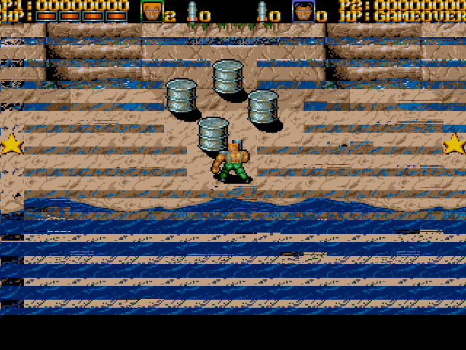  Warzone
  aoOCS version: | 1.0
  State: | FAIR
  Description: | Major graphic problems - as seen on captured VGA frame.

Registers

List of not implemented OCS registers:
ocs_control
STREQU & *038 S D Strobe for horiz sync with VB and EQU
STRVBL & *03A S D Strobe for horiz sync with VB (vert. blank)
STRHOR & *03C S DP Strobe for horiz sync
STRLONG & *03E S D( E ) Strobe for identification of long horiz. line.
VHPOSW *02C W A Write vert and horiz position of beam
ocs_input
POT0DAT *012 R P( E ) Pot counter pair 0 data (vert,horiz)
POT1DAT *014 R P( E ) Pot counter pair 1 data (vert,horiz)
POTGOR *016 R P Pot port data read (formerly POTINP)
POTGO *034 W P Pot port data write and start
ocs_copper
COPINS 08C W A Coprocessor instruction fetch identify
ocs_serial
SERDATR *018 R P Serial port data and status read
SERDAT *030 W P Serial port data and stop bits write
SERPER *032 W P Serial port period and control
ocs_floppy
DSKDATR & *008 ER P Disk data early read (dummy address)
ocs_blitter
BLTDDAT & *000 ER A Blitter destination early read (dummy address)

Clocks

Name | Source | Rates (MHz) |  |  | Remarks | Description
Name | Source | Max | Min | Resolution | Remarks | Description
clk_50 | Input Port | 50 | 50 | - | - | External input clock. Used only as input to altpll.
clk_30 | altpll output | 30 | 30 | - | - | Main system clock.
clk_12 | altpll output | 12 | 12 | - | - | Used only in drv_audio to clock the WM8731 audio codec hardware.
clk_25 | altpll output | 25 | 25 | - | - | Used only in drv_eth_vga_capture to clock the DM9000A Ethernet hardware.
Table 1: List of clocks.

IO Ports

aoOCS top-level IO Ports
Inputs
Clock and reset
clk_50
reset_ext_n
DM9000A Ethernet hardware interface
enet_irq
Switches and hex leds hardware interface from drv_debug
debug_sw1_pc
debug_sw2_adr
debug_sw3_halt
Inouts
IS61LPS51236A pipelined SSRAM hardware interface
ssram_data [35:0]
SD bus 1-bit hardware interface
sd_cmd_io
sd_dat_io
PS/2 keyboard hardware interface
ps2_kbclk
ps2_kbdat
PS/2 mouse hardware interface
ps2_mouseclk
ps2_mousedat
WM8731 audio codec hardware interface
ac_sdat
DM9000A Ethernet hardware interface
enet_data [15:0]
Outputs
IS61LPS51236A pipelined SSRAM hardware interface
ssram_address [18:0]
ssram_oe_n
ssram_writeen_n
ssram_byteen_n [3:0]
ssram_clk
ssram_globalw_n
ssram_advance_n
ssram_adsp_n
ssram_adsc_n
ssram_ce1_n
ssram_ce2
ssram_ce3_n
SD bus 1-bit hardware interface
sd_clk_o
ADV7123 Video DAC hardware interface
vga_r [9:0]
vga_g [9:0]
vga_b [9:0]
vga_blank_n
vga_sync_n
vga_clock
vga_hsync
vga_vsync
WM8731 audio codec hardware interface
ac_sclk
ac_xclk
ac_bclk
ac_dat
ac_lr
DM9000A Ethernet hardware interface
enet_clk_25
enet_reset_n
enet_cs_n
enet_ior_n
enet_iow_n
enet_cmd
Switches and hex leds hardware interface from drv_debug
hex0 [7:0]
hex1 [7:0]
hex2 [7:0]
hex3 [7:0]
hex4 [7:0]
hex5 [7:0]
hex6 [7:0]
hex7 [7:0]
Leds hardware interface for debug purposes
debug_sd [7:0]
debug_68k_state [7:0]
debug_floppy [7:0]

References

- Specification for the: WISHBONE System-on-Chip (SoC) Interconnection Architecture for Portable IP Cores.
Revision: B.3.
Released: September 7, 2002.
Available from: http://www.opencores.org
- AmigaÂ® Hardware Reference Manual.
Revised edition (March 15, 1990)
Addison Wesley Longman Publishing Co.
- E-UAE Amiga software emulator sources.
Source archive: e-uae-0.8.29-WIP4.tar.bz2
Available from: http://http://www.rcdrummond.net/uae/
- aoOCS Doxygen(Design) Documentation.
- ao68000 Doxygen(Design) Documentation.
Available from: http://www.opencores.org

