PWM/Timer/Counter

IP Core

Specification

Author: Damjan Lampret
lampret@opencores.org

Rev. 0.1
February 28, 2001

Preliminary Draft
Revision History

Rev. | Date | Author | Description
0.1 | 28/2/01 | Damjan Lampret | First Draft

Table Of Contents

Introduction 6
Features 6
Architecture 7
Clocks 7
WISHBONE Interface 8
PTC Registers 8
PTC Circuitry 8
Interface to External I/O Cells and Pads 8
Operation 9
Hardware Reset 10
PWM Mode 10
Timer/Counter Mode 10
Gate Feature 11
Interrupt Feature 11
Capture Feature 11
Registers 12
Registers list 12
Register RPTC_CNTR description 12
Register RPTC_HRC description 12
Register RPTC_LRC description 13
Register RPTC_CTRL description 13
IO ports 15
WISHBONE host interface 15
Interface to external I/O cells and pads 16
Core HW Configuration 17

Table Of Figures

Figure 1. Core’s Architecture 7
Figure 2. Block Diagram of PTC Logic 9
Figure 3. Core’s Interfaces 15

Table Of Tables

Table 1. List of All Software Accessible Registers 12
Table 2. Main PTC Counter 12
Table 3. RPTC_HRC Register 13
Table 4. RPTC_LRC Register 13
Table 5. Control Register 14
Table 6. WISHBONE Interface’ Signals 16
Table 7. External interface 16

1
Introduction

The PWM/Timer/Counter (PTC) IP core is a user-programmable PWM, Timer and Counter controller. Its use is to implement functions like Pulse Width Modulation (PWM), timer and counter facilities.

Features

The following lists the main features of PTC IP core:
- 32-bit counter/timer facility
- single-run or continues run of PTC counter
- Programmable PWM mode
- System clock and external clock sources for timer functionality
- HI/LO Reference and Capture registers
- Three-state control for PWM output driver
- PWM/Timer/Counter functionalities can cause an interrupt to the CPU
- WISHBONE SoC Interconnection Rev. B compliant interface

2
Architecture

Figure 1 below shows general architecture of PTC IP core. It consists of four main building blocks:
- WISHBONE host interface
- PTC registers
- PTC circuitry
- Interface to external I/O cells and pads

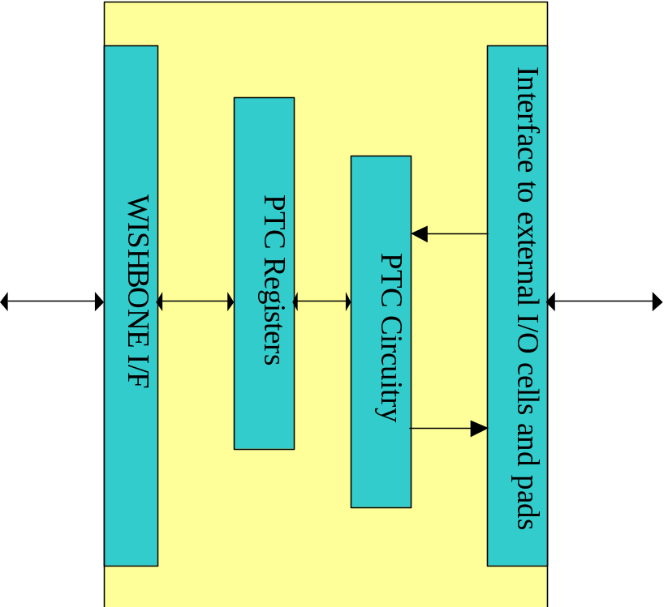

Figure 1. Core’s Architecture

Clocks

The PTC core has two clock domains. All registers except RPTC_CNTR are in system clock domain.
RPTC_CNTR register can be clocked by either system clock or by external clock reference.

WISHBONE Interface

WISHBONE slave interface connects PTC core to the host system. It is WISHBONE SoC Interconnection specification Rev. B compliant. The implementation implements a 32-bit bus width and does not support other bus widths.


PTC Registers

The PTC IP Core has several software accessible registers. The host through these registers programs type and operation of the PTC core.

PTC Circuitry

The PTC core circuitry consists of clock dividers and reference comparators for PWM and counter/timer. It also includes an interrupt generator.

Interface to External I/O Cells and Pads

External interface connects PTC core to external I/O ring cells and pads. External interface is made of eclk/gate input, capture input, PWM output and PWM output driver enable. PWM output can be three-stated with the provided enable signal for the output driver.

3
Operation

This section describes the operation of the PTC core. The PTC core provides PWM, timer and counter facilities. Selection between modes is done implicitly with configuration of the control bits.
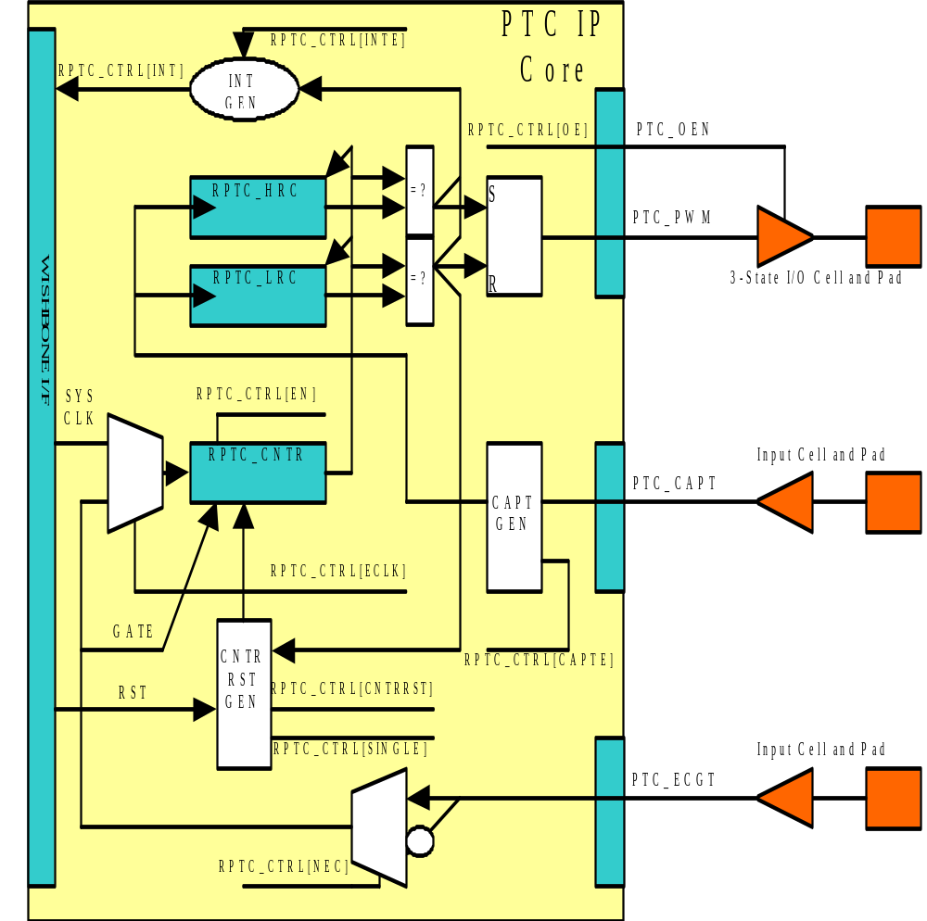
Figure 2. Block Diagram of PTC Logic

When operating in PWM mode, the PTC core generates binary signal with user-programmable low and high periods. Clock source for the PWM can be either system clock or external clock on ptc_ecgt pin. Input signal ptc_capt can be used to capture value of the RPTC_CNTR register into low and high capture registers.
When operating from system clock, ptc_ecgt can be used to gate internal PWM counter circuitry.

When operating in timer/counter mode, the PTC core counts number of clock cycles of system clock or external clock reference on ptc_ecgt pin. After reaching low and/or high reference, the PTC core can generate an interrupt. Input signal ptc_capt can be used to capture value of the RPTC_CNTR register into low and high capture registers.
When operating from the system clock, ptc_ecgt can be used to gate internal timer/counter circuitry.

In both PWM and timer/counter modes, RPTC_CNTR can run for a single cycle and it can automatically restart after each complete cycle. Cycle completes after reaching value in the RPTC_LRC register. These two modes are called single-run and continues run.

Hardware Reset

Following hardware reset PWM output driver is disabled. Interrupt request signal is masked. Ptc_ecgt signal is not used for incrementing the RPTC_CNTR register; instead system clock is used.

PWM Mode

To operate in PWM mode, RPTC_HRC and RPTC_LRC should be set with the value of low and high periods of the PWM output signal. RPTC_HRC is number of clock cycles after reset of the RPTC_CNTR when PWM output should go high. And RPTC_LRC is number of clock cycles after reset of the RPTC_CNTR when PWM output should go low. RPTC_CNTR can be reset with the hardware reset, bit RPTC_CTRL[CNTRRST] or periodically when RPTC_CTRL[SINGLE] bit is cleared.
To enable PWM output driver, RPTC_CTRL[OE] should be set.
To enable continues operation, RPTC_CTRL[SINGLE] should be cleared and RPTC_CTRL[EN] should be set.
If gate function is enabled, PWM periods can be automatically adjusted with the capture input. PWM output signal is controlled with the RPTC_HRC and RPTC_LRC, and these two registers can be set without software control with the ptc_capt signal.

Timer/Counter Mode

To operate in timer/counter mode, only RPTC_LRC or even neither of capture/reference registers is required. In this mode system clock or external clock reference increments RPTC_CNTR register. When RPTC_CNTR equals to the RPTC_LRC, RPTC_CNTR can be reset if this is selected with the RPTC_CTRL[SINGLE].
Usually interrupts are enabled in timer/counter mode. This is done with the RPTC_CTRL[INTE].

Gate Feature

If system clock is used to increment RPTC_CNTR, ptc_ecgt input signal can be used to gate the system clock and not increment the RPTC_CNTR register. Which level of the ptc_ecgt has gating capability depends on value of the RPTC_CTRL[NEC].

Interrupt Feature

Whenever RPTC_CNTR equals to the value of the RPTC_HRC or RPTC_LRC, an interrupt request can be asserted. This depends if RPTC_CTRL[INTE] bit is set.

Capture Feature

Input signal ptc_capt can be used to capture value of the current RPTC_CNTR into RPTC_HRC or LPTC_LRC registers. Into which reference/capture register value is captured, depends on edge of the ptc_capt signal. On positive edge value is captured into RPTC_HRC register and on negative edge value is captured into RPTC_LRC register.
In order to enable capture feature, RPTC_CTRL[CAPTE] must be set.

4
Registers

This section describes all control and status register inside the PTC core. The Address field indicates address in hexadecimal. Width specifies the number of bits in the register, and Access specifies the valid access types for that register. R/W stands for read and write access and R stands for read only access.

Registers list

Name | Address | Width | Access | Description
RPTC_CNTR | Base + 0x0 | 32 | R/W | Main PTC counter
RPTC_HRC | Base + 0x4 | 32 | R/W | PTC HI Reference/Capture register
RPTC_LRC | Base + 0x8 | 32 | R/W | PTC LO Reference/Capture register
RPTC_CTRL | Base + 0xC | 9 | R/W | Control register
Table 1. List of All Software Accessible Registers

Register RPTC_CNTR description

RPTC_CNTR register is the actual counter register. It is incremented at every counter/timer clock cycle. Source clock is either system clock or ptc_ecgt eclk/gate input. Selection between both clocks is performed with the RPTC_CTRL[ECLK]. Active edge of external clock is selected with the RPTC_CTRL[NEC].
In order to count, RPTC_CNTR must first be enabled with the RPTC_CTRL[EN].
RPTC_CNTR can be reset with the RPTC_CTRL[RST].
RPTC_CNTR can operate in either single-run mode or continues mode. Mode is selected with the RPTC_CTRL[SINGLE].

Bit # | Access | Reset | Description
32 | R/W | 0x0 | Main PTC Counter
Table 2. Main PTC Counter

Register RPTC_HRC description

RPTC_HRC register is a 2nd out of two reference/capture registers. It has two functions:
- In reference mode it is used to assert high PWM output or to generate an interrupt
- In capture mode it captures RPTC_CNTR value on high value of ptc_capt signal

Bit # | Access | Reset | Description
32 | R/W | 0x0 | HI Reference/Capture register
Table 3. RPTC_HRC Register

The RPTC_HRC should have lower value than RPTC_LRC. This is because PWM output goes first high and later low.

Register RPTC_LRC description

RPTC_LRC register is a 1st out of two reference/capture registers. It has two functions:
- In reference mode it is used to assert low PWM output or to generate an interrupt
- In capture mode it captures RPTC_CNTR value on low value of ptc_capt signal

Bit # | Access | Reset | Description
32 | R/W | 0x0 | LO Reference/Capture register
Table 4. RPTC_LRC Register

The RPTC_LRC should have higher value than RPTC_HRC. This is because PWM output goes first high and later low.

Register RPTC_CTRL description

Control bits in RPTC_CTRL register control operation of PTC core.

Bit # | Access | Reset | Description
0 | R/W | 0 | EN  When set, RPTC_CNTR can be incremented.
1 | R/W | 0 | ECLK  When set, ptc_ecgt signal is used to increment RPTC_CNTR.  When cleared, system clock is used instead.
2 | R/W | 0 | NEC  When set, ptc_ecgt increments on negative edge and gates on low period.  When cleared, ptc_ecgt increments on positive edge and gates on high period.  This bit has effect only on ‘gating’ function of ptc_ecgt when RPTC_CTRL[ECLK] bit is cleared.
3 | R/W | 0 | OE  Inverted value of this bit is reflected on the ptc_oen signal. It is used to enable PWM output driver.
4 | R/W | 0 | SINGLE  When set, RPTC_CNTR is not incremented anymore after it reaches value equal to the RPTC_LRC value.  When cleared, RPTC_CNTR is restarted after it reaches value in the RPTC_LCR register.
5 | R/W | 0 | INTE  When set, PTC asserts an interrupt when RPTC_CNTR value is equal to the value of RPTC_LRC or RPTC_HRC.  When cleared, interrupts are masked.
6 | R/W | 0 | INT  When read, this bit represents pending interrupt. When it is set, an interrupt is pending.  When this bit is written with ‘1’, interrupt request is cleared.
7 | R/W | 0 | CNTRRST  When set, RPTC_CNTR is under reset.  When cleared, normal operation of the counter is allowed.
8 | R/W | 0 | CAPTE  When set, ptc_capt signal can be used to capture RPTC_CNTR into RPTC_LRC or RPTC_HRC registers. Into which reference/capture register capture occurs depends on edge of the ptc_capt signal.  When cleared, capture function is masked.
Table 5. Control Register

5
IO ports

PTC IP core has two interfaces. Figure 3 below shows both interfaces:
- WISHBONE host interface
- Interface to external I/O cells and pads

PTC
IP
Core
WISHBONE I/F
I/F
WISHBONE
BUS

ptc_pwm
ptc_oen

ptc_capt

ptc_ecgt

Figure 3. Core’s Interfaces

WISHBONE host interface

The host interface is a WISHBONE Rev B compliant interface. PTC IP core works as a slave device only. When it needs the intervention of the local microcontroller, it will assert INTA_O.

Port | Width | Direction | Description
CLK_I | 1 | Input | Clock inputs
RST_I | 1 | Input | Reset input
CYC_I | 1 | Inputs | Indicates valid bus cycle (core select)
ADR_I | 15 | Inputs | Address inputs
DAT_I | 32 | Inputs | Data inputs
DAT_O | 32 | Outputs | Data outputs
SEL_I | 4 | Inputs | Indicates valid bytes on data bus (during valid cycle it must be 0xf)
ACK_O | 1 | Output | Acknowledgment output (indicates normal transaction termination)
ERR_O | 1 | Output | Error acknowledgment output (indicates an abnormal transaction termination)
RTY_O | 1 | Output | Not used
WE_I | 1 | Input | Write transaction when asserted high
STB_I | 1 | Input | Indicates valid data transfer cycle
INTA_O | 1 | Output | Interrupt output
Table 6. WISHBONE Interface’ Signals

Interface to external I/O cells and pads

External interface connects PTC core to external I/O ring cells and pads. Interface consists out of three signals: eclk/gate signal, capture signal, PWM output and PWM output driver enable.

Port | Width | Direction | Description
ptc_ecgt | 1 | Input | EClk/Gate input
Ptc_capt | 1 | Input | Capture input
ptc_pwm | 1 | Output | PWM output
ptc_oen | 1 | Output | PWM output driver enable (for three-state or open-drain driver)
Table 7. External interface

A
Core HW Configuration

This section describes parameters that are set by the user of the core and define configuration of the core. Parameters must be set by the user before actual use of the core in simulation or synthesis.

The PTC IP core has no user settable parameters.

