SMII - Serial MII Ethernet interface
Gives and ordinary Ethernet MAC the possibility to use low pin count serial interface towards Ethernet PHY
Brought to You By ORSoC / OpenCores

Legal Notices and Disclaimers
Copyright Notice
This ebook is Copyright © 2009 ORSoC
General Disclaimer
The Publisher has strived to be as accurate and complete as possible in the creation of this ebook, notwithstanding the fact that he does not warrant or represent at any time that the contents within are accurate due to the rapidly changing nature of information.
The Publisher will not be responsible for any losses or damages of any kind incurred by the reader whether directly or indirectly arising from the use of the information found in this ebook.
This ebook is not intended for use as a source of legal, business, accounting, financial, or medical advice. All readers are advised to seek services of competent professionals in the legal, business, accounting, finance, and medical fields.
No guarantees of any kind are made. Reader assumes responsibility for use of the information contained herein. The Publisher reserves the right to make changes without notice. The Publisher assumes no responsibility or liability whatsoever on the behalf of the reader of this report.
Distribution Rights
The Publisher grants you the following rights for re-distribution of this ebook.
[YES] Can be given away.
[YES] Can be packaged.
[YES] Can be offered as a bonus.
[NO] Can be edited completely and your name put on it.
[YES] Can be used as web content.
[NO] Can be broken down into smaller articles.
[NO] Can be added to an e-course or auto-responder as content.
[NO] Can be submitted to article directories (even YOURS) IF at least half is rewritten!
[NO] Can be added to paid membership sites.
[NO] Can be added to an ebook/PDF as content.
[NO] Can be offered through auction sites.
[NO] Can sell Resale Rights.
[NO] Can sell Master Resale Rights.
[NO] Can sell Private Label Rights.
Table of Contents
Chapter 1 Overview 4
Chapter 1 Internal structure 5
Chapter 2 Interconnect signals 6
Top level signals 6
Optional signals 6
Chapter 3 SMII specification 7
Receive path 7
Transmit path 8
Chapter 4 Implementation 9
Module SYNC 9
Module RXTX 9
Chapter 5 Build environment 10
Chapter 6 Resource usage 11
Recommended Resources 12

Chapter 1 Overview
The Serial Media Independent Interface (SMII) is designed to satisfy the following requirements:
- Convey complete MII information between a 10/100 PHY and MAC with two pins per port
- allow multi port MAC/PHY communications with one system clock
- Operate in both half and full duplex
- per packet switching between 10 Mbit and 100 Mbit data rates
- allow direct MAC to MAC communication
SMII is composed of two signals per port, global synchronization signal, and a global 125 MHz reference clock. All signals are synchronous to the clock.
Name | From | To | Use
RX | PHY | MAC | Receive data and control
TX | MAC | PHY | Transmit data and control
SYNC | MAC | PHY | Synchronization
CLOCK | System | MAC & PHY | Synchronization

Typical SMII application:

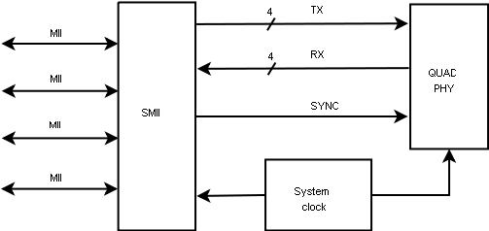
This design is written in Verilog HDL.

Intended use for this IP is to interface Ethernet PHY devices however possible usage includes general purpose IO over SMII. An example is as an interface to an AD converter + FPGA acting as a PHY.

Chapter 1 Internal structure
To be able to support one or multiple SMII channels a structure with one common synchronization module and one transceiver per channel.
To achieve optimal timing IO resources are instantiated at top level.
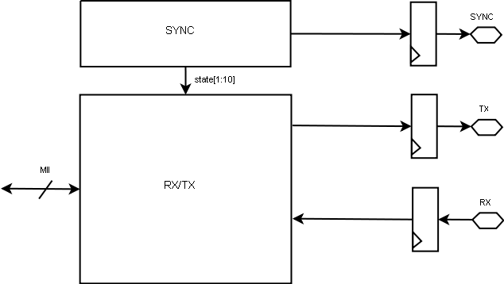

Instance SYNC can be used to multiple RX/TX modules. Use one RX/TX module per SMII channel. To ensure that DFFs on IO signals are placed in IO block a specific target module can be used. The exact module to use is target dependant. For target independent design there are two modules that can be used, OBUFDFF and IBUFDFF.
If multiple SYNC outputs are to be used use one OBUFDFF instance per output.
Module declaration OBUFDFF
Signal | Type | Comment
PAD | Output | Connect to device pad
D | Input | Connect to internal signal; sync, tx
CLK | Input | Connect to 125 MHz clock source
RST | Input | Asynchronous reset active high

Module declaration IBUFDFF
Signal | Type | Comment
PAD | Input | Connect to device pad
Q | Output | Connect to internal signal; rx
CLK | Input | Connect to 125 MHz clock source
RST | Input | Asynchronous reset active high

Chapter 2 Interconnect signals

Top level signals
Group | Name | From | To | Use
SMII | RX | PHY | SMII | Receive data and control
SMII | TX | SMII | PHY | Transmit data and control
SMII | SYNC | System | SMII | Synchronization  optionally one per PHY
SMII | CLOCK | System | SMII | Reference clock
MII  one per PHY | TXD[3:0] | MII | SMII | Transmit nibble
MII  one per PHY | TXEN | MII | SMII | Transmit enable
MII  one per PHY | TXERR | MII | SMII | Transmit error
MII  one per PHY | TX_CLK | SMII | MII | Transmit clock
MII  one per PHY | RXD[3:0] | SMII | MII | Receive nibble
MII  one per PHY | RXDV | SMII | MII | Receive data valid
MII  one per PHY | RXERR | SMII | SMII | Receive error
MII  one per PHY | RX_CLK | SMII | MII | Receive clock
MII  one per PHY | COLL | SMII | MII | Collision detect
MII  one per PHY | CRS | SMII | MII | Carrier sense
MII  one per PHY | SPEED | SMII | MII | Speed, optional  0 – 10Mbit  1 – 100MBit
MII  one per PHY | DUPLEX | SMII | MII | Duplex, optional  0 – half  1 – full
MII  one per PHY | LINK | SMII | MII | Link, optional  0 – down  1 - up

Optional signals
Some signals are implementation dependent. To tailor design edit “smii_defines.v”.
Function | Define | Use
SYNC | SMII_SYNC_PER_PHY | If defined enables one sync signal per PHY
SPEED | SMII_SPEED | If defined enables status signal SPEED
DUPLEX | SMII_DUPLEX | If defined enables status signal DUPLEX
LINK | SMII_LINK | If defined enables status signal LINK

Chapter 3 SMII specification
SMII is composed of two signals per port, a global synchronization signal, and a global 125 MHz reference clock. All signals are synchronous to the clock.

Receive path
Receive data and control information are signaled in ten bit segments. In 100 Mbit mode each segment represents a new byte if data. In 10 mbit mode each segment is repeated ten times.
Segment boundaries are delimited by SYNC. This IP continuously generates a pulse on SYNC every 10 clocks.
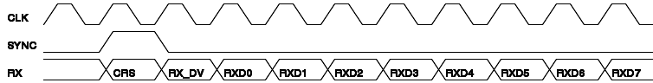
RX contains all of the information found on the receive path of the standard MII.
Bit | Purpose
CRS | Carrier Sense – identical to MII, except that it is not an asynchronous signal
RX_DV | Receive Data Valid – identical to MII
RXD7-0 | Encoded Data

RXD7-0 are used to convey packet data, RX_ER. And PHY status.
CRS | RX_DV | RXD0 | RXD1 | RXD2 | RXD3 | RXD4 | RXD5 | RXD6 | RXD7
X | 0 | RX_ER | Speed | Duplex | Link | Jabber | Upper nibble | False carrier | 1
X | 1 | One data byte (two MII data nibbles)

Transmit path
Transmit data and control information are signaled in ten bit segments just like the receive path.
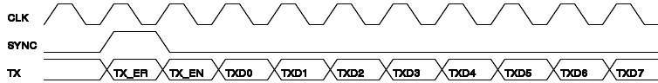
TX contains all of the information found on the transmit path of the standard MII.

Bit | Purpose
TX_EN | Transmit enable – identical to MII
TX_ER | Transmit error – identical to MII
TXD7-0 | Encoded Data

TXD7-0 are used to convey packet data, RX_ER. And PHY status.
TX_ER | TX_EN | TXD0 | TXD1 | TXD2 | TXD3 | TXD4 | TXD5 | TXD6 | TXD7
X | 0 | Use to force an error in a direct MAC-MAC connection | 1  100 mbit | 1  Duplex | 1  Link | 0  no Jabber | 1 | 1 | 1
X | 1 | One data byte (two MII data nibbles)

Chapter 4 Implementation

Module SYNC
The SMII signal should get high once per frame. This signal is generated from this module. Multiple SMII can share the same SYNC module.
Implemented as a ten bit rotate register. Register content distributed as signal state.

Module RXTX
MII clocks, mrx_clk and mtx_clk, are being generated phase locked to signal state. In 10 mbps mode this clock is generated every 10:th segment. This signals might need global buffers, target dependant. These signals will be used as clock sources within the MAC. For ACTEL proASIC3 set define ACTEL to automatically insert global clock buffers.
A 4-bit counter is incremented for each segment modulo 10 when speed is 10 mbps. In 100 mbps counter is equal to zero. Clock pulses are only generated when counter equals zero.
Receive path is implemented with a local shift register to hold received data. Prior to driving mrx_clk high data is output at mrxd.
When signal rx_dv is active status signals is clocked into registers with state bits used as clock enable.
Transmit path involves a complication since transmit data is received from MAC as nibbles and shifted over SMII as bytes. The first segment with data must contains two nibbles of valid data. Signal state synchronize transmit with sync. A register, tx_data_reg is used as temporary storage. Signal a0 keeps track of LSB and MSB nibbles and store them tx_data_reg. A signal, tx_data_reg_valid, goes high when to nibbles have been written. This enable us to start sending to the PHY.
Signal MII collosion mcoll is asserted when carrier sense is active simultaneously with tx_en.

Chapter 5 Build environment
This IP can be used with the following ethernet MAC from OpenCores
Ethernet MAC 10/100 Mbps
There is a Makefile in the RTL directory which can build a file where both the Ethernet MAC and the SMII are included. This Makefile support 1, 2, 3, 4 or 8 Ethernet channels. The user can easily modify the source file smii_module_inst.v. This is a verilog file with preprocessor directive. To build the user must install to standalone Verilog preprocessors.
- Vpp – verilog preprocessor
In debian/Ubuntu install with apt-get install vbpp
Is included in ACTEL libero
- vppp – verilog PERL preprocessor
follow install instructions:
http://search.cpan.org/~wsnyder/Verilog-Perl-3.045/vppp
To build
make all
This generates Verilog files to be included in your SoC top HDL file.
`include “smii_module_inst_4.v”

Chapter 6 Resource usage
Resource usage for different target technologies.
Target | smii_sync | smii_txrx
ACTEL ProASIC3 | 10 slices | 117 slices
ALTERA Cyclone III | comb functions 2  DFFs 10 | comb functions 52  DFFs 36

Recommended Resources
ORSoC – http://www.orsoc.se
ORSoC is a fabless ASIC design & manufacturing services company, providing RTL to ASIC design services and silicon fabrication service. ORSoC are specialists building complex system based on the OpenRISC processor platform.
Open Source IP – http://www.opencores.org
Your number one source for open source IP and other FPGA/ASIC related information.

