BaudGen IP Core
Specification

Author: Andrew Mulcock
amulcock@opencores.org

Rev. 0.1
December 16, 2007

This page has been intentionally left blank

Revision History

Rev. | Date | Author | Description
0.1 | 26-Nov-07 | Andrew Mulcock | First Draft

Contents

Introduction ……………………………………………… 1

IO ports ……………………………………………… 2

Operation ……………………………………………… 3

1
Introduction

The BaudGen is typically used with a UART (Universal Asynchronous Receiver/Transmitter) core to provide timing for serial communication capabilities.

Further uses are for generating timing 'enables' for such items as SPI, I2C and OneWire peripherals.

Features:

- Stand alone, pure VHDL
- Generates an enable pulse and an n times enable pulse
- 'Programed' by generics at 'compile' time.
- Ease of use, Generics to specify the baud ( bit rate ) required and the input clock frequency

2
IO ports & generics

2.1 Ports

Port | Width | Direction | Description
clk | 1 | Input
rst | 1 | Input | Active High synchronous reset
baud_x_en | 1 | Output | Active High one clk wide enable at x times baud rate
baud_en | 1 | Output | Active High one clk wide enable at baud rate

2.2 Generics

Generic | Type | Default | Description
baudrate | int | 115200 | Baud rate required ( in Hz )
clock_freq_mhz | real | 200.0 | Frequency of the clock in ( in MHz )
over_sample | int | 4 | Number of over sample pulses per 'Bit'

3
Operation

This BaudGen core is simple, consisting of two programmable counters. Programing is performed by the use of generics, so it's a fixed frequency Baud-rate generator.

The 'clever' bit, and the reason for writing the core, is the user does not have to 'think' about divider ration's or programming the baud rate up using a bus interface, it's just there in the design. Great for debug UART ports, as you know what the UART speed is going to be.

A baud is another way of saying Bit per second, so the BaudGen can also be used to provide any other timing pulses needed in a design. Apart form baud Rate in a UART, uses so far have included a 1 us period pulse used in a OneWire interface, a 64.5 ns period pulse used in a SPI peripheral, and a 2.5 us period pulse used in a I2C interface.

3.1 Initialization

The core has been used in FPGAs and as such does not require a reset, but for the aid of simulation and for customers that require a reset, a synchronous reset has been included. This active high to reset input sets the counters to a known position.

3.2 Generics

Generics are used to define the required baud rate and the frequency of the clock to divide down from.

If no x times output is required, set over_sample to 2, and do not use the baud_x_en output.

3.3 Timing Diagram

Illustration 1 shows the relationship between the two outputs. In this case, over_sample is set at 4, and 4 evenly spaced pulses are generated on baud_x_en for every baud_en.
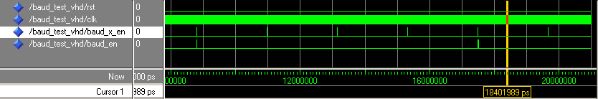Illustration 1: over_sample set at 4

Illustration 2 shows the one clock width of the enable pulses and the fact that the baud_x_en is one clock ahead of the baud_x output. If both are required to 'line up' then register externally baud_x_en to the clock to align.

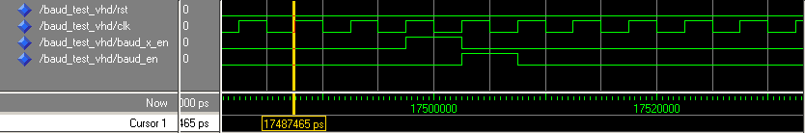Illustration 2: width of enable pulses and the relative timing

