
SPI Core
Specifications

Author: Richard Herveille
rherveille@opencores.org

Document rev. 0.1
This page left intentionally blank

Revision History

Rev. | Date | Author | Description
0.1 | 07/01/02 | Richard Herveille | First Draft

Table of contents
Introduction 1
IO ports 2
Registers 4
Operation 8
Architecture 10

1
Introduction

The OpenCores simple Serial Peripheral Interface core is an enhanced version of the Serial Peripheral Interface found on Motorola's M68HC11 family of CPUs. The Serial Peripheral Interface is a serial, synchronous communication protocol that requires a minimum of 3 wires. Enhancements to the original interface include a wider supported operating frequency range, 4 entries deep read and write FIFOs, and programmable transfer count dependent interrupt generation. The high compatibility with the M68HC11 SPI port ensures that existing software can use this core without major modifications. New software can use existing examples as a starting point.
The core features an 8 bit wishbone interface.

FEATURES:

- Compatible with Motorola’s SPI specifications
- Enhanced M68HC11 Serial Peripheral Interface
- 4 entries deep read FIFO
- 4 entries deep write FIFO
- Interrupt generation after 1, 2, 3, or 4 transferred bytes
- 8 bit WISHBONE RevB.3 Classic interface
- Operates from a wide range of input clock frequencies
- Static synchronous design
- Fully synthesizable

2
IO ports

2.1 WISHBONE Interface Connections
Port | Width | Direction | Description
clk_i | 1 | Input | Master clock input
rst_i | 1 | Input | Asynchronous active low reset
inta_o | 1 | Output | Interrupt request signal
cyc_i | 1 | Input | Valid bus cycle
stb_i | 1 | Input | Strobe/Core select
adr_i | 2 | Input | Lower address bus bits
we_i | 1 | Input | Write enable
dat_i | 8 | Input | Data input
dat_o | 8 | Output | Data output
ack_o | 1 | Output | Normal bus termination

2.1.1 clk_i
All internal WISHBONE logic is registered to the rising edge of the [clk_i] clock input.

2.1.2 rst_i
The active low asynchronous reset input [rst_i] forces the core to restart. All internal registers are preset and all state-machines are set to an initial state.

2.1.3 inta_o
The interrupt request output is asserted when the core needs service from the host system.

2.1.4 cyc_i
When asserted, the cycle input [cyc_i] indicates that a valid bus cycle is in progress. The logical AND function of [cyc_i] and [stb_i] indicates a valid transfer cycle to/from the core.

2.1.5 stb_i
The strobe input [stb_i] is asserted when the core is being addressed. The core only responds to WISHBONE cycles when [stb_i] is asserted, except for the [rst_i], which always receive a response.

2.1.6 adr_i
The address array input [adr_i] is used to pass a binary coded address to the core. The most significant bit is at the higher number of the array.

2.1.7 we_i
When asserted, the write enable input [we_i] indicates that the current bus cycle is a write cycle. When negated, it indicates that the current bus cycle is a read cycle.

2.1.8 dat_i
The data array input [dat_i] is used to pass binary data from the current WISHBONE Master to the core. All data transfers are 8 bit wide.

2.1.9 dat_o
The data array output [dat_o] is used to pass binary data from the core to the current WISHBONE Master. All data transfers are 8 bit wide.

2.1.10 ack_o
When asserted, the acknowledge output [ack_o] indicates the normal termination of a valid bus cycle.

2.2 External (SPI Port) Connections
Port | Width | Direction | Description
sck_o | 1 | Output | SPI clock
mosi_o | 1 | Output | Master Out Slave In
miso_i | 1 | Input | Master In Slave Out

2.2.1 sck_o
SCK [sck_o] is generated by the master device and synchronizes data movement in and out of the device through the MOSI [mosi_o] and MISO [miso_o] lines. The SPI clock is generated by dividing the WISHBONE clock [clk_i]. The division factor is software programmable.

2.2.2 mosi_o
The Master Out Slave In line is a unidirectional serial data signal. It is an output from a master device and an input to a slave device.

2.5.3 miso_i
The Master In Slave Out line is a unidirectional serial data signal. It is an output from a slave device and an input to a master device.

M68HC11 compatibility

The M68HC11 features a Slave Select signal. To reduce resource usage, this core does not. Use a GPIO core, like the OpenCores simple_gpio core, to generate the Slave Select signal(s), if this functionality is required.

3
Registers

3.1 Registers List
Name | adr_i[1:0] | Width | Access | Description
SPCR | 0x00 | 8 | R/W | Control Register
SPSR | 0x01 | 8 | R/W | Status Register
SPDR | 0x02 | 8 | R/W | Data Register
SPER | 0x03 | 8 | R/W | Extensions Register

3.2 Serial Peripheral Control Register [SPCR]
Bit # | Access | Description
7 | R/W | SPIE
6 | R/W | SPE
5 | R/W | Reserved
4 | R/W | MSTR
3 | R/W | CPOL
2 | R/W | CPHA
1:0 | R/W | SPR
Reset Value: 0x10

3.2.1 SPIE – Serial Peripheral Interrupt Enable
When the Serial Peripheral Interrupt Enable is set (‘1’) and the Serial Peripheral Interrupt Flag in the status register is set, the host is interrupted. Setting this bit while the SPIF flag is set generates an interrupt.
‘0’ = SPI interrupts disabled
‘1’ = SPI interrupts enabled

3.2.2 SPE – Serial Peripheral Enable
When the Serial Peripheral Enable bit is set (‘1’), the core is enabled. When it is cleared (‘0’), the core is disabled. The core only transfers data when the core is enabled.
‘0’ = SPI core disabled
‘1’ = SPI core enabled

3.2.3 MSTR – Master Mode Select
When the Master Mode Select bit is set (‘1’), the core is a master device. When it is cleared (‘0’), it is a slave device. Currently only master mode is supported. This bit is set, and can not be cleared.
‘0’ = Slave mode
‘1’ = Master mode

3.2.4 CPOL – Clock Polarity
The Clock Polarity bit, together with the Clock Phase bit, determines the transfer mode. Refer to the SPI Transfers section for more information

3.2.5 CPHA – Clock Phase
The Clock Phase bit, together with the Clock Polarity bit, determines the transfer mode. Refer to the SPI Transfers section for more information.

3.2.6 SPR – SPI Clock Rate Select
These bits select the SPI clock [sck_o] rate. Refer to the ESPR bits in the Extension Register for more information.

3.3 Serial Peripheral Status Register [SPSR]
Bit # | Access | Description
7 | R/W | SPIF
6 | R/W | WCOL
5:4 | R | Reserved
3 | R | WFFULL
2 | R | WFEMPTY
1 | R | RFFULL
0 | R | RFEMPTY
Reset Value: 0x05

3.3.1 SPIF – Serial Peripheral Interrupt Flag
The Serial Peripheral Interrupt Flag is set upon completion of a transfer block. If SPIF is asserted (‘1’) and SPIE is set, an interrupt is generated. To clear the interrupt write the status register with the SPIF bit set (‘1’).

3.3.2 WCOL – Write Collision
The Write Collision flag is set when the Serial Peripheral Data register is written to, while the Write FIFO is full. To clear the Write Collision flag write the status register with the WCOL bit set (‘1’).

3.3.3 WFFULL – Write FIFO Full
The Write FIFO Full and Write FIFO empty bits show the status of the write FIFO.

3.3.4 WFEMPTY – Write FIFO Empty
The Write FIFO Full and Write FIFO empty bits show the status of the write FIFO.

3.3.5 RFFULL – Read FIFO Full
The Read FIFO Full and Read FIFO empty bits show the status of the read FIFO.

3.3.6 RFEMPTY – Read FIFO Empty
The Read FIFO Full and Read FIFO empty bits show the status of the read FIFO.

3.4 Serial Peripheral Data Register [SPDR]
Bit # | Access | Description
7:0 | W | Write Buffer
7:0 | R | Read Buffer
Reset Value: undefined

3.4.1 Write Buffer
The Write Buffer is a 4 entries deep FIFO. Writing to the Write Buffer adds the data to the FIFO. Writing to the Write Buffer while the FIFO is full sets the Write Collision [WCOL] bit. When the Serial Peripheral Enable [SPE] bit is cleared (‘0’), the Write Buffer is reset. When the [SPE] bit is set (‘1’) and the write buffer is not empty, the core initiates SPI transfers. When the transfer is initiated, the data byte is removed from the FIFO.

3.4.2 Read Buffer
The Read Buffer is a 4 entries deep FIFO. When the Serial Peripheral Enable [SPE] bit is cleared (‘0’), the Read Buffer is reset. When an SPI transfer is finished, the received data byte is added to the Read Buffer. There is no overrun detection; it is possible to overwrite the oldest data. This is done to maintain the highest level of compatibility with the M68HC11 type SPI port, and to minimize overhead for systems where the SPI bus is used to transfer data only (e.g. when accessing a DAC).

3.5 Serial Peripheral Extensions Register [SPER]
Bit # | Access | Description
7:6 | R/W | ICNT
5:2 | R/W | Reserved
1:0 | R/W | ESPR
Reset Value: 0x00

3.5.1 ICNT – Interrupt Count
The Interrupt Count bits determine the transfer block size. The SPIF bit is set after ICNT transfers. Thus it is possible to reduce kernel overhead due to reduced interrupt service calls.

ICNT | Description
00 | SPIF is set after every completed transfer
01 | SPIF is set after every two completed transfers
10 | SPIF is set after every three completed transfers
11 | SPIF is set after every four completed transfers

3.5.2 ESPR – Extended SPI Clock Rate Select
The Extended SPI Clock Rate Select bits add two bits to the SPI Clock Rate Select bits. When ESPR = ‘00’ the original M68HC11 coding is used.

ESPR | SPR | Divide WISHBONE clock by
00 | 00 | 2
00 | 01 | 4
00 | 10 | 16
00 | 11 | 32
01 | 00 | 8
01 | 01 | 64
01 | 10 | 128
01 | 11 | 256
10 | 00 | 512
10 | 01 | 1024
10 | 10 | 2048
10 | 11 | 4096
11 | xx | Reserved

NOTE

Do not use the reserved ‘11xx’ values; using those leads to unpredictable results.

4
Operation

4.1 SPI Transfers
During an SPI transfer, data is simultaneously transmitted and received. The serial clock line [SCK] synchronizes shifting and sampling of the information on the two serial data lines. The master places the information onto the MOSI line a half-cycle before the clock edge that the slave device uses to latch the data.
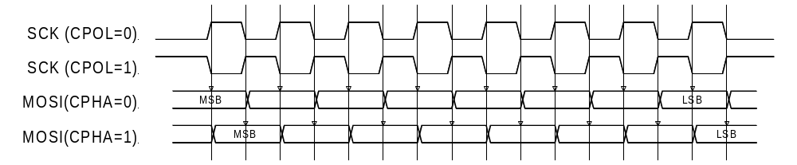Four possible timing relationships can be chosen by using the Clock Polarity [CPOL] and Clock Phase [CPHA] bits in the Serial Peripheral Control Register [SPCR]. Both master and slave devices must operate with the same timing.

4.2 Initiating transfers

4.2.1 Transmitting data bytes
After programming the core’s control register SPI transfers can be initiated. A transfer is initiated by writing to the Serial Peripheral Data Register [SPDR]. Writing to the Serial Peripheral Data Register is actually writing to a 4 entries deep FIFO called the Write Buffer. Each write access adds a data byte to the Write Buffer. When the core is enabled – SPE is set (‘1’) – and the Write Buffer is not empty, the core automatically transfers the oldest data byte.

4.2.2 Receiving data bytes
Receiving data is done simultaneously with transmitting data; whenever a data byte is transmitted a data byte is received. For each byte that needs to be read from a device, a dummy byte needs to be written to the Write Buffer. This instructs the core to initiate an SPI transfer, simultaneously transmitting the dummy byte and receiving the desired data. Whenever a transfer is finished, the received data byte is added to the Read Buffer. The Read Buffer is the counterpart of the Write Buffer. It is an independent 4 entries deep FIFO. The FIFO contents can be read by reading from the Serial Peripheral Data Register [SPDR].

4.2.3 FIFO Overrun
Both the Write Buffer and the Read Buffer are FIFOs that use circular memories to simulate the infinite big memory needed for FIFOs. Because of this writing to a FIFO while it is full overwrites the oldest data byte. Writing to the Serial Peripheral Data Register [SPDR] while the Write Buffer if full sets the WCOL bit, however the damage is already done; the next byte to be transferred is not the oldest data byte, but the latest (newest).

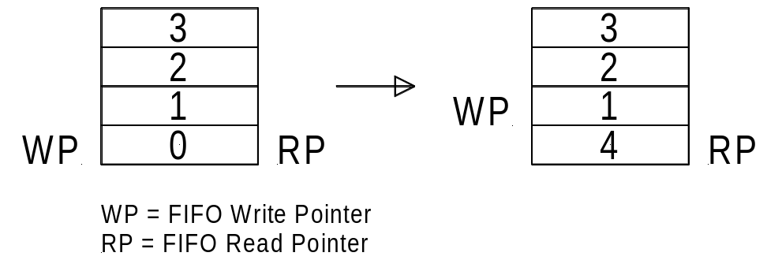
The only way to recover from this situation is to reset the Write Buffer. Both the Read Buffer and the Write Buffer are reset when the Serial Peripheral Enable [SPE] bit is cleared (‘0’).

Read Buffer overruns might be less destructive. Especially when the SPI bus is used to transmit data only; e.g. when sending data to a DAC. The received data is simply ignored. The fact that the Read Buffer overruns is irrelevant. If the SPI bus is used to transmit and receive data, it is important to keep the Read Buffer aligned. The easiest way to do this is to perform a number of dummy reads equal to the amount of bytes transmitted modulo 4.

Note that a maximum sequence of 4 bytes can be stored in the Read Buffer before the oldest data byte gets overwritten. It is therefore necessary to empty (read) the Read Buffer every 4 received bytes.

5
Architecture

