
Pattern Generator

Author: Luis Munoz
Lfmunoz4@gmail.com

Rev. 1.0

This page has been intentionally left blank.
Revision History
Rev. | Date | Author | Description
1.0 | 09/20/11 | Luis Munoz | Specification, first version

Contents
1 Introduction 1
2 Architecture 2
3 Operation 3
4 Generics 5
5 Clocks 6
6 IO Ports 7

Introduction
This VHDL module generates video patterns which can be used for testing video displays. It currently supports four patterns; horizontal lines, vertical lines, moving horizontal lines and moving vertical lines. It sends out one pixel out at a time forming a video pattern on the fly. This module has been successfully used for testing a Camera Link serializer and SDXC Card video streamer.

Architecture
The Pattern Generator is currently implemented using counters and the pixels are generated dynamically based on the current counter values. (In a future version, if there is enough interest, there will be a version using block rams).

Operation
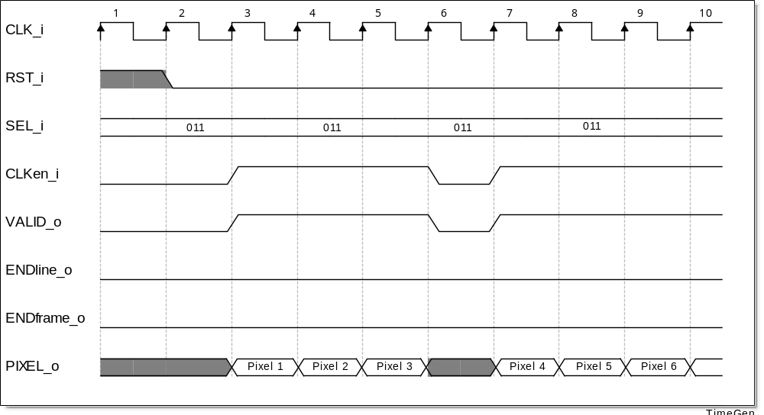
Figure 1: Timing diagram of typical use

Name | SEL_i
Vertical Lines | 001
Horizontal Lines | 010
Moving Vertical Lines | 010
Moving Horizontal Lines | 100
Table 1: Generics for transmitter and receiver

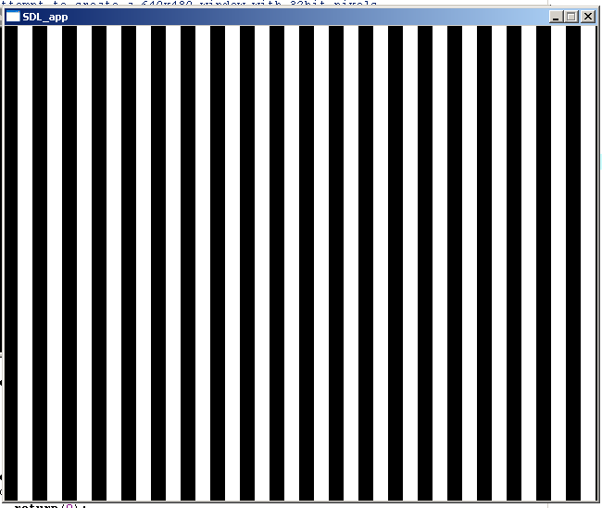
Figure 2: Pattern result of vertical lines

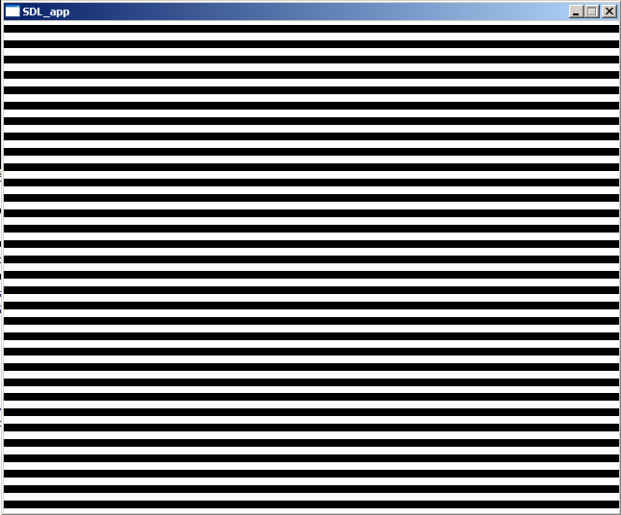
Figure 2: Pattern result of horizontal lines

Generics
Name | Type | Range | Description
FrameWidth | Integer | 4-32bits | The number of pixels per line
FrameHeight | Integer | 4-32bits | The number of lines
PIXEL_SIZE | Integer | 4-32bits | Size of a pixel
REG_SIZE | Integer | 4-32bits
Table 2: Generics for transmitter and receiver

Clocks
Name | Source | Rates (MHz) |  |  | Remarks | Description
Name | Source | Max | Min | Resolution | Remarks | Description
CLK_i | - | - |  | - |  | This clock is used by all the logic, limited by the device.
Table 3: List of clocks

IO Ports
Port | Width | Direction | Description
RST_i | 1 | Input | Puts the module in a known state
SEL_i | 1 | Input | Selects the pattern to output, either horizontal lines, vertical lines, moving horizontal lines, or moving vertical lines
CLKen_i | 1 | Input | Enables the pixels to change, it effectively just prevents the clock from having an effect
PIXEL_o | PIXEL_SIZE | Input | The actual pixels
VALID_o | 1 | Output | High when a pixel is valid
ENDline_o | 1 | Output | High for 1 cycle on the last pixel of each line
ENDframe_o | 1 | Output | High for 1 cycle on the last pixel of each frame
Table 4: Module Signals

