

10GE MAC Core Specification

Author: A. Tanguay
antanguay@opencores.org

Rev. 0.8
01/19/13

This page has been intentionally left blank.
Revision History
Rev. | Date | Author | Description
0.1 | 5/30/2008 | A.Tanguay | Draft
0.2 | 6/6/2008 | A.Tanguay | Added block diagram. Added mod[2:0] signals.
0.6 | 05/23/2009 | A. Tanguay | Added details of operation.
0.7 | 12/13/2009 | A. Tanguay | Added big endian mode for packet interface.
0.8 | 11/25/2012 | A. Tanguay | Added basic packet statistics. Added application example. Reduced FIFO size from 1024 to 512 bytes.
0.9 | 01/19/2013 | A. Tanguay | Added testbench information. Documented synthesis options.

Contents
Introduction 1
Architecture 2
Operation 4
TX Enqueue Engine 4
TX FIFO 4
TX Dequeue Engine 5
RX Enqueue Engine 6
RX FIFO 7
RX Dequeue Engine 8
Fault State-Machine 8
Stats Engine 8
Registers 9
Register List 9
Configuration Register 0 – 0x00 9
Interrupt Pending Register – 0x08 10
Interrupt Status Register – 0x0C 10
Interrupt Mask Register – 0x10 11
Transmit Octets Count Register – 0x80 11
Transmit Packet Count Register – 0x84 11
Receive Octets Count Register – 0x90 11
Receive Packet Count Register – 0x94 12
Clocks 13
Resets 14
IO Ports 15
Wishbone Interface 15
Packet Receive Interface 15
Packet Transmit Interface 17
XGMII Receive Interface 18
XGMII Transmit Interface 18
Waveforms 20
Wishbone Interface 20
Packet Receive Interface 20
Packet Transmit Interface 20
XGMII Receive Interface 21
XGMII Transmit Interface 21
Testbench 22
Verilog Testbench 22
SystemC Testbench 23

Table 1: Configuration Register 0 9
Table 2: Interrupt Pending Register 10
Table 3: Interrupt Status Register 10
Table 4: Interrupt Mask Register 11
Table 5: Transmit Octets Count Register 11
Table 6: Transmit Packet Count Register 11
Table 7: Transmit Octets Count Register 11
Table 8: Transmit Packet Count Register 12
Table 9: 10GE MAC Clocks 13
Table 10: 10GE MAC Resets 14
Table 11: List of IO ports 15
Table 12: List of IO ports 17
Table 13: List of IO ports 18
Table 14: List of IO ports 18
Table 15: List of IO ports 19

Introduction
The 10GE MAC core is designed for easy integration with proprietary custom logic. It features a POS-L3 like interface for the datapath and a Wishbone compliant interface for management. The core was intentionally designed with a limited feature set for a small gate footprint.

Architecture
A block diagram of the core is presented in the figure below with clock domains indicated with green dotted lines.
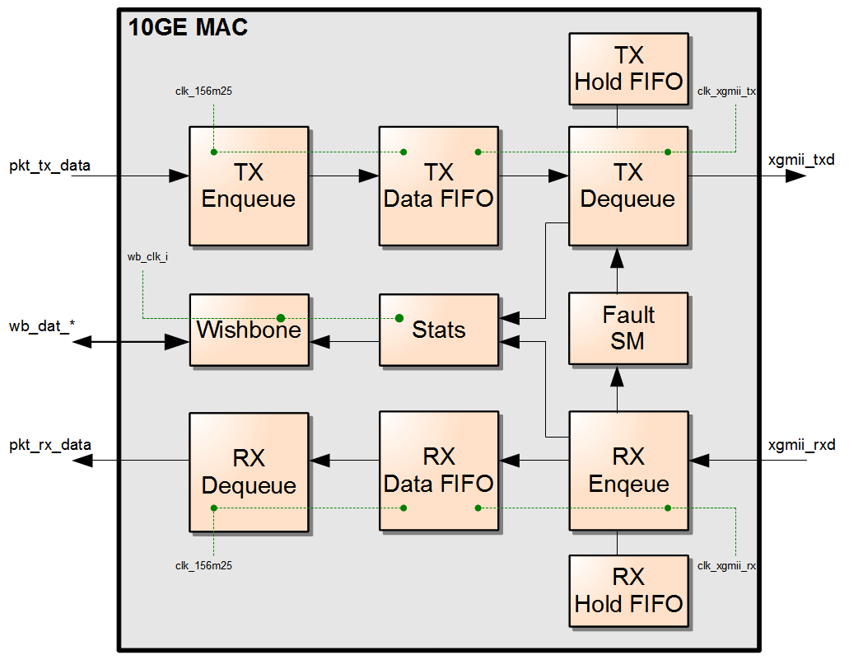Figure 1: Block Diagram

A design example is shown below where the MAC interfaces to a XAUI macro built into the FPGA. In this example, an external PHY is used to convert from XAUI to a 10.3125Gbps signal suitable XFP and SFP+ modules.
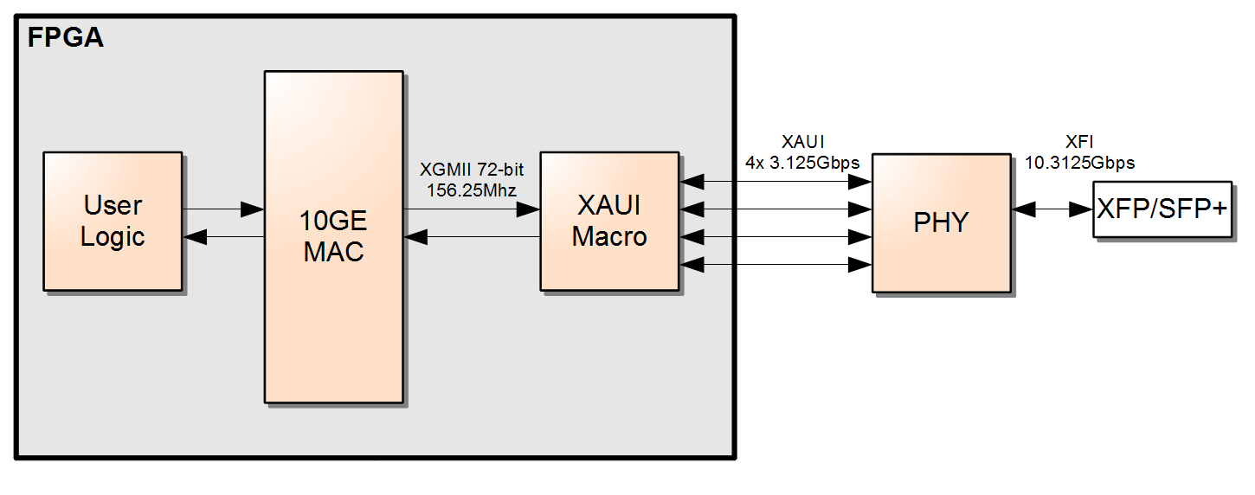Figure 2: Design Example

Operation

TX Enqueue Engine
The TX Enqueue Engine receives frames from the user's core logic and stores them in the transmit FIFO along with some additional flags such as SOP and EOP indicators. It also provides FIFO fill status (available signal) to the core.

TX FIFO
The TX FIFO is 128-entry deep by default with 64-bit of data and 8-bit of status per entry. Since the FIFO can only store 512 bytes of data (64 x 64-bit), the MAC must operate in flow-through mode, meaning that the transmission of a frame on the XGMII interface can (and must) start while the frame is still being written to the FIFO on the enqueue side.
The upper bits of the FIFO, bits 71:64, contains status information used by the TX Dequeue Engine to maintain frame alignment. The format of the FIFO is shown in the next figure:

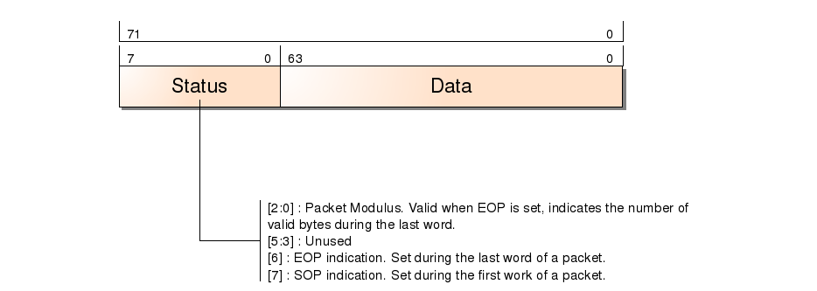Figure 3: Transmit FIFO Format

TX Dequeue Engine
The TX Dequeue Engine contains two state-machines. The first state-machine reads data from the data FIFO and pads small packets to the minimum 64-byte required for Ethernet. The state-machine writes data to the holding FIFO and the CRC calculation logic. The purpose of the holding FIFO is to compensate for latency in the CRC calculation. The CRC logic operates in 64-bit data at the exception of the last word of the frame. Since the last word may contain 1 to 8 valid bytes, the CRC logic transitions to 8-bit mode at the end of the frame. Up to 8 cycles may be required to complete the calculation, hence the 8-word delay in the Holding FIFO.
The Encoding State-Machine reads data from the Holding FIFO after inserting the Ethernet preamble. To minimize the logic, this state-machine aligns all data on 64-bit boundary and generates flags indicating when 32-bit alignment is necessary to meet the required IFG. The IFG is calculated based on the accumulated Deficit Idle Count (DIC) and modulus of the current frame. Resulting flags are passed to the Barrel Shifter which performs the final 32-bit alignment.
The RC Layer monitors link status signals from the Fault State-Machine and inserts remote fault messages when a local fault was detected. The fault signal is also passed to the Encoding State-Machine which stops transmitting packets during faults.

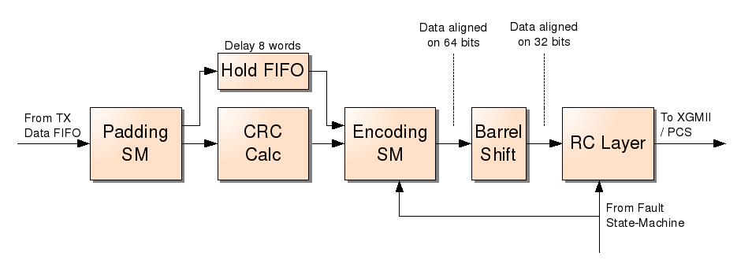Figure 4: TX Dequeue Engine

RX Enqueue Engine
In the RX Enqueue Engine, the RC layer monitors the XGMII interface for fault conditions and pass the status to the Fault State-Machine. The Barrel Shifter looks for the start of frame delimiters on 32-bit boundary and re-aligns the data on 64-bit boundary. This method reduces the complexity of the next stages.
The Decoding State-Machine has the complex task of delimiting frames and detecting invalid frames such as fragments and runts. As it decodes the data, it write a copy to the Holding FIFO and CRC logic. The purpose of the holding FIFO is to compensate for latency in the CRC calculation. The CRC logic operates in 64-bit data at the exception of the last word of the frame. Since the last word may contain 1 to 8 valid bytes, the CRC logic transitions to 8-bit mode at the end of the frame. Up to 8 cycles may be required to complete the calculation, hence the 8-word delay in the Holding FIFO.
As data emerges from the Holding FIFO, it is written to the RX Data FIFO along with SOP, EOP and other flags. If the CRC logic reports an error during that time, an error flag is set in the next FIFO entry.

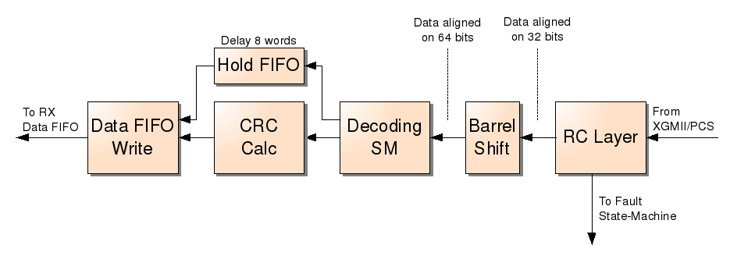Figure 5: RX Enqueue Engine

RX FIFO
The RX FIFO is 128-entry deep by default with 64-bit of data and 8-bit of status per entry. Since the FIFO can only store 512 bytes of data (64 x 64-bit), the MAC must operate in flow-through mode, meaning that the transmission of a frame on the packet interface can (and must) start while the frame is still being written to the FIFO on the enqueue side.
The upper bits of the FIFO, bits 71:64, contains status information used by the TX Dequeue Engine to maintain frame alignment. Also includes is an error flag used to propagate CRC errors or any other error conditions to the Dequeue Engine. The format of the FIFO is shown in the next figure:

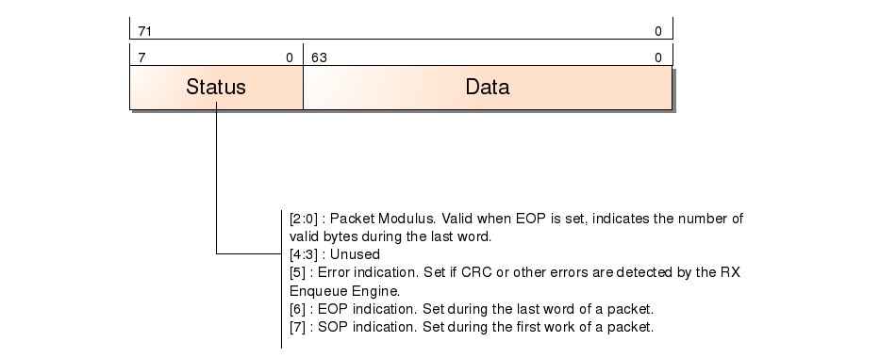Figure 6: RX FIFO Format

RX Dequeue Engine
The RX Dequeue Engine interfaces with the user logic. Its primary function is to convert the internal status from the RX FIFO into meaninful signals on the pkt_rx interface.

Fault State-Machine
The Fault State-Machine monitors fault messages captured by the RX Enqeue Engine. It's role is to debounced fault indications and transition the fault state according to the 802.3ae speciifcation. The state-machine can declare two types of faults: a local fault or a remote fault. Both fault types can be monitored by reading the interrupt status register.
A local fault is usually the result of the PHY's inability to detect valid 64B/66B sequences on the incoming 10.3125Gbps signal.
A remote fault is asserted by the far-end PHY and typically means that it failed to detect valid 64B/66B sequences.

Stats Engine
The Stats Engines monitors frame indication signals from the TX Dequeue and RX Enqeue Engines and accumulates various packet and byte counters. It also is used to traverse from the high-speed clock domains to the lower-speed processor interface clock domain.

Registers

Register List
Name | Address | Width | Access | Description
Configuration  Register 0 | 0x00 | 32 | R/W
Interrupt Pending  Register | 0x08 | 32 | COR
Interrupt Status  Register | 0x0c | 32 | RO
Interrupt Mask  Register | 0x10 | 32 | R/W
Transmit Octets Count | 0x80 | 32 | RO
Transmit Packet Count | 0x84 | 32 | RO
Receive Octets Counts | 0x90 | 32 | RO
Receive Packet Count | 0x94 | 32 | RO

Configuration Register 0 – 0x00
The registers of the WISHBONE slave unit start at offset 0x180.
RESET VALUE: 0x00000001
Bit # | Name | Description
31 - 1 | Reserved | Reserved field. Reading returns zeros.
0 | TX Enable | When set, transmission of frames is enabled. This bit is set by default.
Table 1: Configuration Register 0

Interrupt Pending Register – 0x08
This register is clear-on-read and provides an indication of pending interrupts.
RESET VALUE: 0x00000000
Bit # | Name | Description
31 - 9 | Reserved | Reserved field. Reading returns zeros.
8 | RX Fragment Error | When set, indicates that a fragment was received. A fragment is a frame that has a start of frame delimiter but no end of frame. Typically it is immediately followed by a new start of frame.
7 | RX CRC Error | When set, indicates that a frame was received with invalid CRC.
6 | RX Pause Frame | When set, indicates that a pause frame was received. Pause frames are discarded.
5 | Remote Fault | When set, indicates that the fault state-machine has transitioned in or out of remote fault condition.
4 | Local Fault | When set, indicates that the fault state-machine has transitioned in or out of local fault condition.
3 | RX Data Fifo Underflow | When set, indicates that the receive data FIFO has experienced underflow. This may occur if “pkt_rx_ren” is asserted when no data is available in the receive FIFO.
2 | RX Data Fifo Overflow | When set, indicates that the receive data FIFO has experienced overflow. This may occur if “pkt_rx_ren” remains de-asserted for a too long period while data is present in the receive FIFO.
1 | TX Data Fifo Underflow | When set, indicates that the transmit data FIFO has experienced underflow. This situation should never occur.
0 | TX Data Fifo Overflow | When set, indicates that the transmit data FIFO has experienced overflow. This may occur if “pkt_tx_val”is asserted and no room is left in the transmit FIFO.
Table 2: Interrupt Pending Register

Interrupt Status Register – 0x0C
This register is read-only and provides a direct status of interrupt lines used to set bits in the Interrupt Pending Register.
RESET VALUE: 0x00000000
Bit # | Name | Description
31 - 0 | Interrupt Status | Each bit corresponds to an interrupt in the Interrupt Pending Register.
Table 3: Interrupt Status Register

Interrupt Mask Register – 0x10
This register is read/write and can be used to enable individual interrupts. By default all interrupts are disabled.
RESET VALUE: 0x00000000
Bit # | Name | Description
31 - 0 | Interrupt Mask | Each bit corresponds to an interrupt in the Interrupt Pending Register. Setting a bit enables the interrupt.
Table 4: Interrupt Mask Register

Transmit Octets Count Register – 0x80
This register is read only and cleared only during reset.
RESET VALUE: 0x00000000
Bit # | Name | Description
31 - 0 | Transmit Octets Count | Counter for all transmited octets. Counter will wrap when limit is reached.
Table 5: Transmit Octets Count Register

Transmit Packet Count Register – 0x84
This register is read only and cleared only during reset.
RESET VALUE: 0x00000000
Bit # | Name | Description
31 - 0 | Transmit Packet Count | Counter for all transmited packets. Counter will wrap when limit is reached.
Table 6: Transmit Packet Count Register

Receive Octets Count Register – 0x90
This register is read only and cleared only during reset.
RESET VALUE: 0x00000000
Bit # | Name | Description
31 - 0 | Receive Octets Count | Counter for all valid received octets. Counter will wrap when limit is reached.
Table 7: Transmit Octets Count Register

Receive Packet Count Register – 0x94
This register is read only and cleared only during reset.
RESET VALUE: 0x00000000
Bit # | Name | Description
31 - 0 | Receive Packet Count | Counter for all valid received packets. Counter will wrap when limit is reached.
Table 8: Transmit Packet Count Register

Clocks
This section describes the various clocks required by the 10GE MAC core.

Name | Frequency | Description
wb_clk_i | 30 - 156Mhz | Wishbone interface clock.
clk_156m25 | 156.25Mhz | Clock for transmit and receive packet interfaces towards user's core logic. “pkt_tx_*” and “pkt_rx_*” signal are timed to this clock.
clk_xgmii_rx | 156.25Mhz | Clock for XGMII receive interface between 10GE MAC core and XAUI/PCS macro.
clk_xgmii_tx | 156.25Mhz | Clock for XGMII transmit interface between 10GE MAC core and XAUI/PCS macro.
Table 9: 10GE MAC Clocks

Resets
This section describes the various resets required by the 10GE MAC core. The user must ensure that each reset is synchronously de-asserted with it's corresponding clock. To ensure that transmit and receive FIFO's are initialized correctly, “reset_156m25_n”, “reset_xgmii_rx_n” and “reset_xgmii_tx_n” must be de-asserted within 2-cycles of each other.

Name | Description
wb_rst_i | Wishbone interface reset. Active high. Must be de-asserted synchronous to wb_clk_i.
reset_156m25_n | Core packet interfaces clock domain reset. Active low. Must be de-asserted synchronous to clk_156m25.
reset_xgmii_rx_n | XGMII receive clock domain reset. Active low. Must be de-asserted synchronous to clk_xgmii_rx.
reset_xgmii_tx_n | XGMII transmit clock domain reset. Active low. Must be de-asserted synchronous to clk_xgmii_tx.
Table 10: 10GE MAC Resets

IO Ports
This section specifies the 10GE MAC core IO ports.

Wishbone Interface
Refer to Wishbone interface specification for more details on these signals.
Port | Direction | Description
wb_adr_i [7:0] | Input | Address input. All accesses to core must be 32-bit. Bits 0 and 1 are not used.
wb_cyc_i | Input | Wishbone cycle.
wb_dat_i [31:0] | Input | Wishbone data input.
wb_stb_i | Input | Wishbone strobe.
wb_we_i | Input | Wishbone write enanle.
wb_ack_o | Output | Wishbone acknowledge.
wb_dat_o [31:0] | Output | Wishbone data output.
wb_int_o | Output | Wishbone interrupt signal. Active high.
Table 11: List of IO ports

Packet Receive Interface
This interface is used to transfer received packets to the FPGA/ASIC core logic.
Port | Direction | Description
pkt_rx_ren | Input | Receive Read Enable: This signal should only be asserted when a packet is available in the receive FIFO. When asserted, the 10GE MAC core will begin packet transfer on next cycle. Signal should remain asserted until EOP becomes valid.
pkt_rx_avail | Output | Receive Available: Indicates that a packet is available for reading in receive FIFO.
pkt_rx_data [63:0] | Output | Receive Data: Little-endian format. First byte of packet will appear on pkt_rx_data[7:0].
pkt_rx_eop | Output | Receive End of Packet: Asserted when the last word of a packet is read from receive FIFO.
pkt_rx_val | Output | Receive Valid: Indicates that valid data is present on the bus. This signal is typically asserted one cycle after pkt_rx_ren was asserted unless FIFO underflow occurs.
pkt_rx_sop | Output | Receive Start of Packet: Indicates that the first word of a frame is present on the bus.
pkt_rx_mod [2:0] | Output | Receive Packet Length Modulus: Valid during EOP. Indicates valid bytes during last word:  Little Endian mode:  0: pkt_rx_data[63:0] is valid  1: pkt_rx_data[7:0] is valid  2: pkt_rx_data[15:0] is valid  3: pkt_rx_data[23:0] is valid  4: pkt_rx_data[31:0] is valid  5: pkt_rx_data[39:0] is valid  6: pkt_rx_data[47:0] is valid  7: pkt_rx_data[55:0] is valid  Big Endian mode:  0: pkt_rx_data[63:0] is valid  1: pkt_rx_data[63:56] is valid  2: pkt_rx_data[63:48] is valid  3: pkt_rx_data[63:40] is valid  4: pkt_rx_data[63:32] is valid  5: pkt_rx_data[63:24] is valid  6: pkt_rx_data[63:16] is valid  7: pkt_rx_data[63:8] is valid
pkt_rx_err | Output | Receive Error: When asserted during a transfer, indicates that current packet is bad and should be discarded by user's logic. This signal is most likely asserted as the result of a CRC error. A frame of invalid size will also cause this signal to be asserted.
Table 12: List of IO ports

Packet Transmit Interface
This interface accepts packets from the FPGA/ASIC core logic.
Port | Direction | Description
pkt_tx_data [63:0] | Input | Transmit Data: Little-endian format. First byte of packet must appear on pkt_rx_data[7:0].
pkt_tx_val | Input | Transmit Valid: This signal must be asserted for each valid data transfer to the 10GE MAC.
pkt_tx_sop | Input | Transmit Start of Packer: This signal must be asserted during the first word of a packet.
pkt_tx_eop | Input | Transmit End of Packet: This line must be asserted during the last word of a packet.
pkt_tx_mod [2:0] | Input | Transmit Packet Length Modulus: Valid during EOP. Indicates valid bytes during last word:  Little Endian mode:  0: pkt_tx_data[63:0] is valid  1: pkt_tx_data[7:0] is valid  2: pkt_tx_data[15:0] is valid  3: pkt_tx_data[23:0] is valid  4: pkt_tx_data[31:0] is valid  5: pkt_tx_data[39:0] is valid  6: pkt_tx_data[47:0] is valid  7: pkt_tx_data[55:0] is valid  Big Endian mode:  0: pkt_rx_data[63:0] is valid  1: pkt_rx_data[63:56] is valid  2: pkt_rx_data[63:48] is valid  3: pkt_rx_data[63:40] is valid  4: pkt_rx_data[63:32] is valid  5: pkt_rx_data[63:24] is valid  6: pkt_rx_data[63:16] is valid  7: pkt_rx_data[63:8] is valid
pkt_tx_full | Output | Transmit Full: This signal indicates that transmit FIFO is nearing full and transfers should be suspended at the end of the current packet. Transfer of next packet can begin as soon as this signal is de-asserted.
Table 13: List of IO ports

XGMII Receive Interface
This interface accepts data or control character from XAUI/PCS macro. A normal XGMII interface is made of a 32-bit data bus clocked on rising and falling edges of the clock. For simplicity the 10GE MAC uses a 64-bit interface clocked on the rising edge only.
Port | Direction | Description
xgmii_rxc [7:0] | Input | XGMII Receive Control: Each bit corresponds to a byte on the 64-bit interface. When high, indicates that the byte is a control character. When low, indicates that the byte carries data.
xgmii_rxd [63:0] | Input | XGMII Receive Data: When interfacing with 32-bit devices, xgmii_rxd[31:0] should be mapped to the rising edge of the clock and xgmii_rxd[63:32] should be mapped to the falling edge.
Table 14: List of IO ports

XGMII Transmit Interface
This interface transmits data and control character towards the XAUI/PCS macro. A normal XGMII interface is made of a 32-bit data bus clocked on rising and falling edges of the clock. For simplicity the 10GE MAC uses a 64-bit interface clocked on the rising edge only.
Port | Direction | Description
xgmii_txc [7:0] | Output | XGMII Transmit Control: Each bit corresponds to a byte on the 64-bit interface. When high, indicates that the byte is a control character. When low, indicates that the byte carries data.
xgmii_txd [63:0] | Output | XGMII Transmit Data: When interfacing with 32-bit devices, xgmii_txd[31:0] should be mapped to the rising edge of the clock and xgmii_txd[63:32] should be mapped to the falling edge.
Table 15: List of IO ports

Waveforms

Wishbone Interface
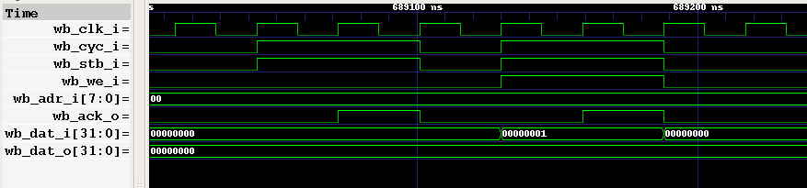Figure 7: Wishbone Waveforms

Packet Receive Interface
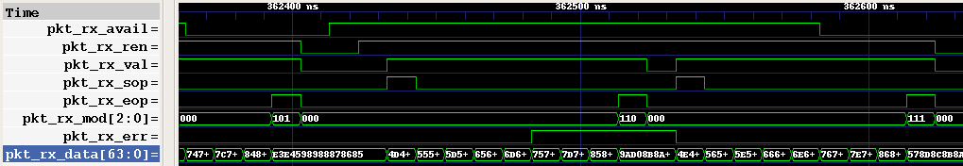Figure 8: Packet Receive Interface Waveforms

Packet Transmit Interface
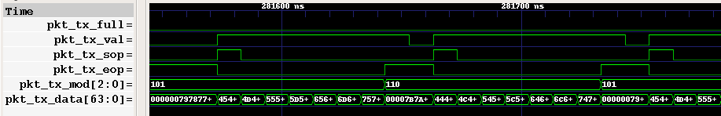Figure 9: Packet Transmit Interface Waveforms

XGMII Receive Interface
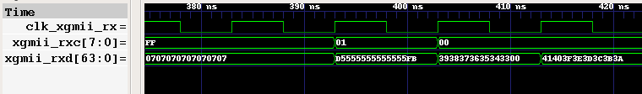Figure 10: XGMII Receive Interface Waveforms

XGMII Transmit Interface
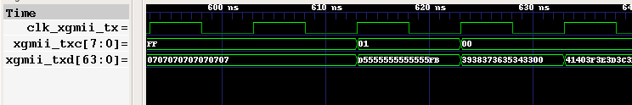Figure 11: XGMII Transmit Interface Waveforms

.
Testbench
There are two testbenches available for simulation and both are maintained up-to-date as additons are made to the project. The Verilog testbench is light and easy to setup and can be use to quickly evaluate the core and look at interface signals. The SystemC testbench is more comprehensive and acheives a high level of code coverage but requires more work to setup. For more information on how to run each testbench, refer to the “README.TXT” file under:
xge_mac/trunk/README.TXT

Verilog Testbench
A high level view of the Verilog testbench is shown below:
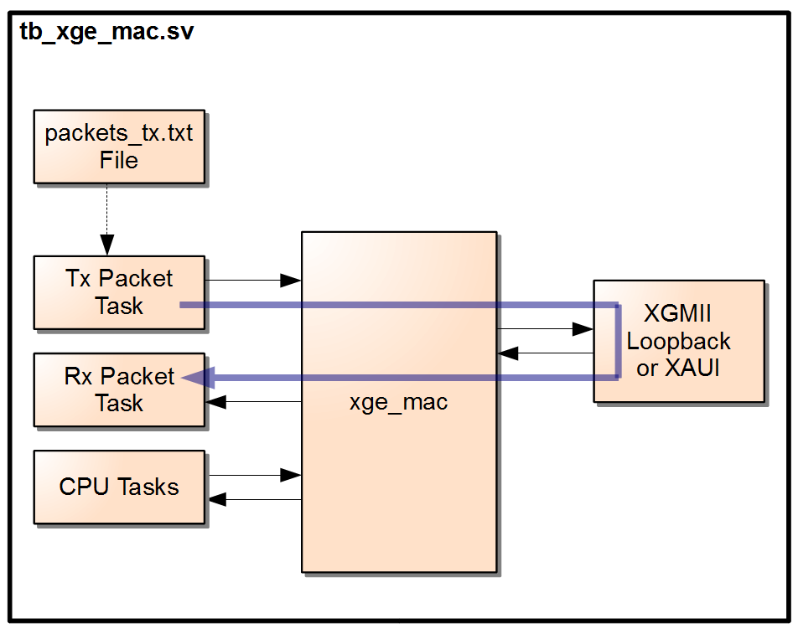Figure 12: Verilog Testbench

SystemC Testbench
A high level view of the SystemC testbench is shown below. For a list of tests available for execution, refer to file “sc_testcases.cpp”.

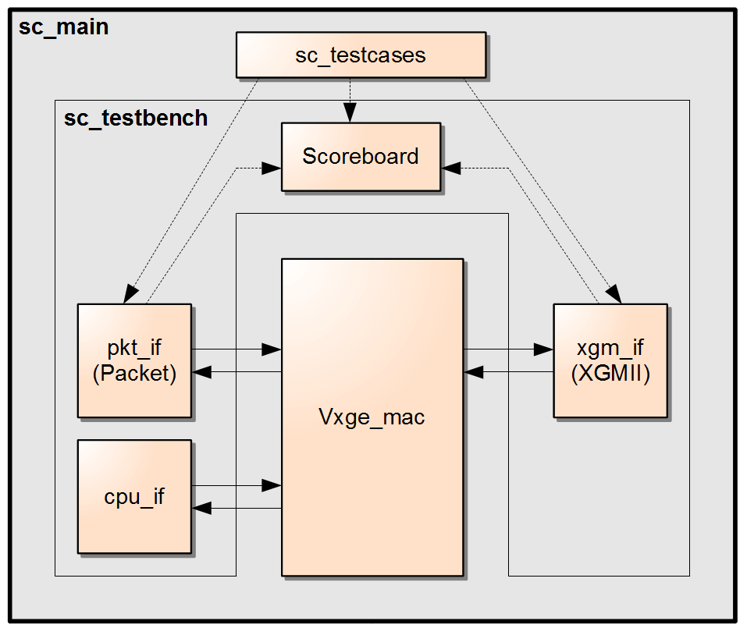Figure 13: SystemC Testbench

.
Synthesis Options
The core allows for a few configurable settings. These settings can be found in file “define.v” and are explained below.

'define XIL
This option is disabled by default but can be enabled by uncommenting the line in “define.v”. This may be required with certain synthesis tools if issues are seen when synthesizing FIFO's. Enabling this option changes the way memories are coded.

`define TX_DATA_FIFO_AWIDTH 6
This option controls the size of the transmit FIFO. The default value of 6 generates a 512-bytes FIFO. Refer to “defines.v” for more details.

`define RX_DATA_FIFO_AWIDTH 6
This option controls the size of the receive FIFO. The default value of 6 generates a 512-bytes FIFO. Refer to “defines.v” for more details.

`define MAX_FRAME_SIZE 14'd16000
This option controls the maximum frame size accepted by the receiver. Any frame exceeding this size will be marked as errored and the “pkt_rx_err” signal asserted during the transfer of the frame.

