Wishbone B3 compatible SDRAM controller
A high performance SDRAM controller supporting SDR, DDR and DDR2 memories
Brought to You By ORSoC / OpenCores

Legal Notices and Disclaimers
Copyright Notice
This ebook is Copyright © 2009 ORSoC
General Disclaimer
The Publisher has strived to be as accurate and complete as possible in the creation of this ebook, notwithstanding the fact that he does not warrant or represent at any time that the contents within are accurate due to the rapidly changing nature of information.
The Publisher will not be responsible for any losses or damages of any kind incurred by the reader whether directly or indirectly arising from the use of the information found in this ebook.
This ebook is not intended for use as a source of legal, business, accounting, financial, or medical advice. All readers are advised to seek services of competent professionals in the legal, business, accounting, finance, and medical fields.
No guarantees of any kind are made. Reader assumes responsibility for use of the information contained herein. The Publisher reserves the right to make changes without notice. The Publisher assumes no responsibility or liability whatsoever on the behalf of the reader of this report.
Distribution Rights
The Publisher grants you the following rights for re-distribution of this ebook.
[YES] Can be given away.
[YES] Can be packaged.
[YES] Can be offered as a bonus.
[NO] Can be edited completely and your name put on it.
[YES] Can be used as web content.
[NO] Can be broken down into smaller articles.
[NO] Can be added to an e-course or auto-responder as content.
[NO] Can be submitted to article directories (even YOURS) IF at least half is rewritten!
[NO] Can be added to paid membership sites.
[NO] Can be added to an ebook/PDF as content.
[NO] Can be offered through auction sites.
[NO] Can sell Resale Rights.
[NO] Can sell Master Resale Rights.
[NO] Can sell Private Label Rights.
Table of Contents
Overall description 4
Wishbone cycles 5
Supported wishbone bus cycles 5
Block diagram 6
Top level 7
Wishbone interface 10
FIFO queues 10
Queue priorities 10
Egress and ingress queue handling 11
Control logic 11
FSM 11
SDR 16 bit state machine 12
FIFO control 12
Refresh timer 12
FSM 13
Recommended Resources 15

Overall description
Overall goal of memory controller:
- easily adaption to new memory types
- multiple wishbone clock domains
- multiple wishbone ports per clock domain
- FIFO interface towards memory controller
- balanced performance/area footprint
This a modular generic design. With parameter settings the number of ports, clock domains and SDRAM geometry configurations can be defined.
A module act as a interface towards the Wishbone system bus. This module has two clock domains
- wishbone clock domain
- memory clock domain
The memory clock domain is shared between all interface modules and the SDRAM memory. The wishbone clock domain could be unique for each interface.
Each module can support up to 16 wishbone ports.
Each wishbone port supports different cycles.
To lower area usage each wishbone channel within one interface module share the same memory resources.

Wishbone cycles

Supported wishbone bus cycles
This SDRAM controller uses two tag fields to effectively support burst transfer
CTI_I[2:0] | Description
000 | Classic cycle
001 | Constant address burst
010 | Incrementing burst cycle
011 | Reserved
100 | Reserved
101 | Reserved
110 | Reserved
111 | End-of-Burst

BTE_I[1:0] | Description
00 | Linear burst
01 | 4-beat wrap burst
10 | 8-beat wrap burst
11 | 16-beat wrap burst

Block diagram
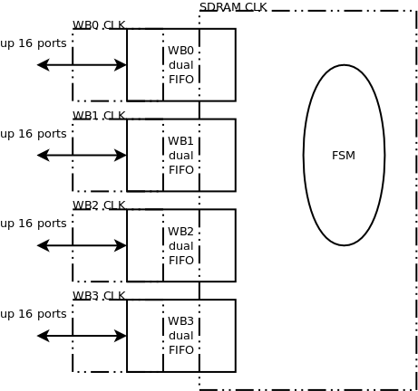

The design is built with the following components
- Top level with IO signals and parameters for configuration
- Wishbone interface
  - ingress and egress async FIFOs shared between wishbone ports
  - logic and FSM to share FIFO resources and handle wishbone control signals
- SDRAM controller
  - state machine generating SDRAM commands
  - versatile LFSR counter generating refresh request
  - logic to handle FIFO signals, including priorities between queues
  - delay line to correctly handle ingress FIFO in respect to SDRAM latency

Top level
Wishbone interface signals:
Signal | direction | comment
wb_adr_i_0 | Input | Address input signals including cycle type as a concatenated vector
wb_dat_i_0 | Input | Data and data strobe signals concatenated as a vector
wb_dat_o_0 | Output | Data signals concatenated as a vector
wb_stb_i_0 | Input | Wishbone strobe signals concatenated as a vector
wb_cyc_i_0 | Input | Wishbone active cycle signals concatenated as a vector
wb_ack_o_0 | Output | Wishbone acknowledge signals concatenated as a vector
wb_adr_i_1 | Input | Address input signals including cycle type as a concatenated vector
wb_dat_i_1 | Input | Data and data strobe signals concatenated as a vector
wb_dat_o_1 | Output | Data signals concatenated as a vector
wb_stb_i_1 | Input | Wishbone strobe signals concatenated as a vector
wb_cyc_i_1 | Input | Wishbone active cycle signals concatenated as a vector
wb_ack_o_1 | Output | Wishbone acknowledge signals concatenated as a vector
wb_adr_i_2 | Input | Address input signals including cycle type as a concatenated vector
wb_dat_i_2 | Input | Data and data strobe signals concatenated as a vector
wb_dat_o_2 | Output | Data signals concatenated as a vector
wb_stb_i_2 | Input | Wishbone strobe signals concatenated as a vector
wb_cyc_i_2 | Input | Wishbone active cycle signals concatenated as a vector
wb_ack_o_2 | Output | Wishbone acknowledge signals concatenated as a vector
wb_adr_i_3 | Input | Address input signals including cycle type as a concatenated vector
wb_dat_i_3 | Input | Data and data strobe signals concatenated as a vector
wb_dat_o_3 | Output | Data signals concatenated as a vector
wb_stb_i_3 | Input | Wishbone strobe signals concatenated as a vector
wb_cyc_i_3 | Input | Wishbone active cycle signals concatenated as a vector
wb_ack_o_3 | Output | Wishbone acknowledge signals concatenated as a vector
wb_clk | Input | Wishbone clock signals concatenated as a vector
wb_rst | Input | Wishbone reset signals concatenated as a vector

Independent of configuration all signals are always present.
Dependent on configuration the vector length will vary.
Note also that “wb_adr_i_n” also contains cycle type information.
The “wb_adr_i_n” is defined as follows
{ adr_i[31:2], we_i, bte_i, cti_i }
Data vector going to SDRAM is defined as:
{ dat_i[31:0], sel_i[3:0] }
For data fetched from memory the following applies:
{ dat_o[31:0]}
The wishbone interface can be configured to suit the actual needs. This is done with a number parameters affecting the number of clock domains and the number of ports for each domain.
Parameter | Default value | Usage
nr_of_wb_clk_domains | 1 | Defines the actual number of clock domains used in the design
nr_of_wb_ports_clk0 | 1 | Defines the number of ports for wishbone clock domain 0
nr_of_wb_ports_clk1 | 0 | Defines the number of ports for wishbone clock domain 1
nr_of_wb_ports_clk2 | 0 | Defines the number of ports for wishbone clock domain 2
nr_of_wb_ports_clk3 | 0 | Defines the number of ports for wishbone clock domain 3

Non used clock domains could be set to any value but it will affect the length of the vector. Unused input signals should be connected to static signals. A defined value equal to zero will case a vector length of 2, any other value will lead to vector length equal to nr_of_wb_ports_clk_n times 36.
Additional parameters is used to configure the geometry of the SDRAM memories used.

Parameter | Default value | Usage
ba_size | 2 | For SDR type memories this should be set to 2
row_size | 13 | Depends on SDRAM
col_size | 9 | Depends on SDRAM
cl | 3'b010 | CAS latency. Valid values for SDR type memories is 3'b010 or 3'b011. This value affect both working mode of SDRAM and delay chains used in SDRAM controller.

Preprocessor defines can be used to chose type of SDRAM.
Current design support the following defines.
Parameter | Usage
SDR_16 | SDR SDRAM with 16 bit databus
DDR_16 | DDR SDRAM with 16 bit databus (work in progress)

For SDR_16 the following signals interfaces the SDRAM:

Signal | Width | Direction | Comment
ba_pad_o | 1:0 | Output | Bank address
a_pad_o | 12:0 | Output | Row/col address
ras_pad_o | 1 | Output | Row address strobe
cas_pad_o | 1 | Output | Column address strobe
we_pad_o | 1 | Output | Write enable
dqm_pad_o | 1:0 | Output | Data bus mask signals
dq_o | 15:0 | Output | Data bus output
dq_i | 15:0 | Input | Data bus input signals
dq_oe | 1 | Output | Data bus output enable
cke_pad_o | 1 | Output | Clock enable, in this design set to static 1
cs_n_pad_o | 1 | Output | Chip select, in this design set to static 0

Independent of memory type the following signals all always present:

Signal | Width | Direction | Comment
sdram_clk | 1 | Input | SDRAM clock domain clock signal
sdram_rst | 1 | Input | SDRAM clock domain reset signal

The sdram_clk signal should also be connected to the external SDRAM. For optimal IO timing an internal PLL should be used to ensure an internal and external sdram_clk with identical phase.

Wishbone interface
The wishbone interface module is built with three major parts
- Egress FIFO queues
  - 9 kbit asynchronous dual port memories configured as 256x36
  - register for egress read address
  - FIFO gray address counters
  - asynchronous address compare for FIFO status
- Egress FIFO queues
  - 8 kbit asynchronous dual port memories configured as 256x32
  - FIFO gray address counters
  - asynchronous address compare for FIFO status
- logic to prioritize among queues
- logic to generate wishbone acknowledges signals

FIFO queues
The FIFO implementation is based on the versatile_fifo IP available from
http://www.opencores.org/project,versatile_fifo
which uses counter implementation from
http://www.opencores.org/project,versatile_counter
The FIFO address counter is defined in the spreadsheet versatile_counter.xls, sheet fifo_adr_counter

The depth of each FIFO is 16 words and the maximum numbers of FIFO queues is 16. Egress FIFO width is 36 and ingress 32.
Memory usage
egress queue : 16 queues x 16 words x 36 bits = 9216 bits
ingress queue : 16 queues x 16 words x 32 bits = 8192 bits

Queue priorities
Wishbone ports with lower port number have priority over ports with higher number.
Clock domains with higher number have priority over domains with lower values.
Within one clock domain all ports are sharing one common egress memory. Only one wishbone port channel can write to this FIFO at any clock cycle.
Within one clock domain all ports are sharing one common ingress memory. Only one wishbone port can read out data at any clock cycle.

Egress and ingress queue handling
The wishbone side communicates with the SDRAM over two FIFO queues. An egress FIFO moves address + control and data signals to the SDRAM side. An ingress FIFO moves data back to wishbone side from SDRAM for read accesses.
Dependent on wishbone cycle type different sequences are generated.
The following table outline the usage:
Cycle type  bte_i | RW  we_i | Egress FIFO | Ingress FIFO | comment
Linear burst | 0 | adr+ctrl | data | For classic cycles once  For linear burst repeated for each word, wishbone master increments address
Linear burst | 1 | adr+ctrl |  | For classic cycles once  For linear burst repeated for each word, wishbone master increments address
Linear burst | 1 | Data
n-beat wrap burst | 0 | adr+ctrl | Data1 | n = 4, 8, 16  For interrupted sequences FSM should empty ingress FIFO
n-beat wrap burst | 0 | adr+ctrl | Data2  ..  datan
n-beat wrap burst | 1 | adr+ctrl |  | n = 4, 8, 16  Interrupted sequences not supported.  Support could be added in FSM by adding a state where FIFO is filled with data+”0000” effectively masking the write on the SDRAM side
n-beat wrap burst | 1 | data1
n-beat wrap burst | 1 | Data2  ..  datan

Control logic
The following signals are used to control egress FIFO write and ingress FIFO read
- wb_wr_ack is a vector of write signals to the egress FIFO
Note: wb_wr_ack is also used for generation of wishbone ack_o
- wb_rd_ack is a vector of read signals to the ingress FIFO

FSM
For each wishbone port a small state machine is used to handle FIFO accesses and to control generation of wishbone ack_o signal. The FSM are daisy chained with the use of the acknowledge signals. Only FSM with active ack signals in will propagate.

Egress FIFO

Refresh timer
A versatile counter configured as LFSR is used to generate refresh request.
Example:
A memory (MT48LC16M16) requires 8192 refresh cycles every 64 ms. Providing an auto refresh command every 7.81 us ensures that each row is refreshed. For a sdram clock frequency of 125 MHz a refresh should be initiated every 976 cycle.
A cycle count of 976 requires a 10 bit counter. To get wrapping pattern:
./VersatileCounter.php 10 975
0110100001

This counter generates a request signal to the SDRAM state machine and a acknowledge signal clears the request.

SDR 16 bit state machine
A controller for 16 bit wide SDR SDRAM memories is available.
The controller is made with the following resources
- logic to handle FIFO read and write
- FSM to generate control signals and SDRAM command and address
- delay chain to handle ingress FIFO

FIFO control
The egress FIFOs has a number of status and control signals.
The egress FIFOs have one FIFO empty flag for each FIFO. The total number of empty flags is 16 queues x 4 clock domains. These flags are contained in a two dimensional array.
wire [0:15] fifo_empty[0:3];
Based on the rules for priorities between the wishbone channels an encoder is used to get a more condensed representation. A two bit field is used to select the clock domain with the non empty FIFO queue with the highest priority. A 16 bit vector is used to represent the queue with highest priority.
wire [0:15] fifo_sel_i;
wire [1:0] fifo_sel_domain_i;
Two modules, encode and decode, is used to changed between these two notations.

FSM
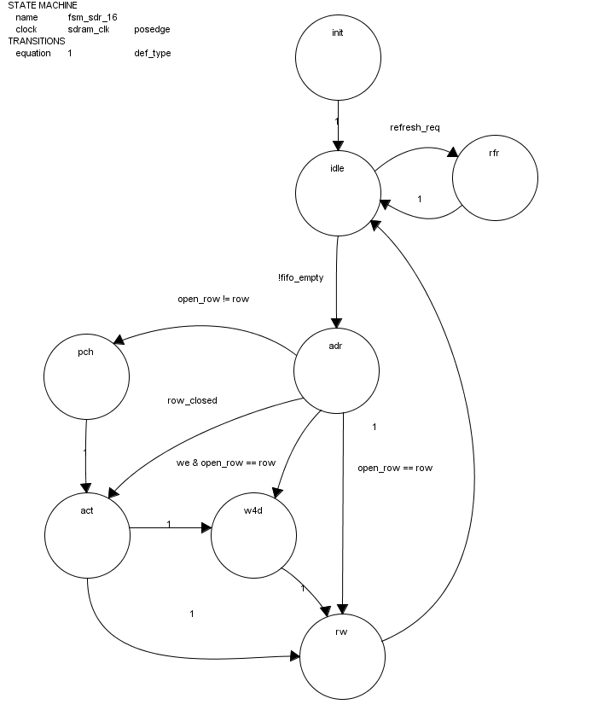
A small state machine in combination with a 5 bit counter is used to generate SDRAM commands and row and column addresses.
State | Encoding | shreg | Functions
init | 3'b000 | 3 | Precharge
init | 3'b000 | 7,19 | Refresh
init | 3'b000 | 31 | Load mode register
init | 3'b000 | default | NOP
idle | 3'b001 |  | Wait for refresh request or not FIFO empty condition  Latch FIFO status signals
rfr | 3'b010 | 0 | precharge (all banks)
rfr | 3'b010 | 2 | Refresh
rfr | 3'b010 | default | NOP
adr | 3'b011 | 0 | FIFO read address active
 |  | 1 | Latch address in egress FIFO
 |  | 2 | Read from egress FIFO
 |  | 3 | Latch row_reg, col_reg, we_reg
 |  | 4
pch | 3'b100 |  | Precharge current bank
act | 3'b101 |  | Activate row in current bank
rw | 3'b111 |  | Emit read, write or NOP (when FIFO is empty)  Increments column address based on cycle type (bte)

Recommended Resources
ORSoC – http://www.orsoc.se
ORSoC is a fabless ASIC design & manufacturing services company, providing RTL to ASIC design services and silicon fabrication service. ORSoC are specialists building complex system based on the OpenRISC processor platform.
Open Source IP – http://www.opencores.org
Your number one source for open source IP and other FPGA/ASIC related information.

