FPGA Development Platform

Hardware Description

Author: Steve Fielding
sfielding@base2designs.com

Rev. 1.0
November 16, 2008

Revision History
Rev. | Date | Author | Description
1.0 | 11/16/08 | Sfielding | Created

Contents
FPGA Main Board 1
FPGA Support Board 2
Operation 4
Connectors 6

FPGA Main Board
+5V Power Input
+3.3V LED

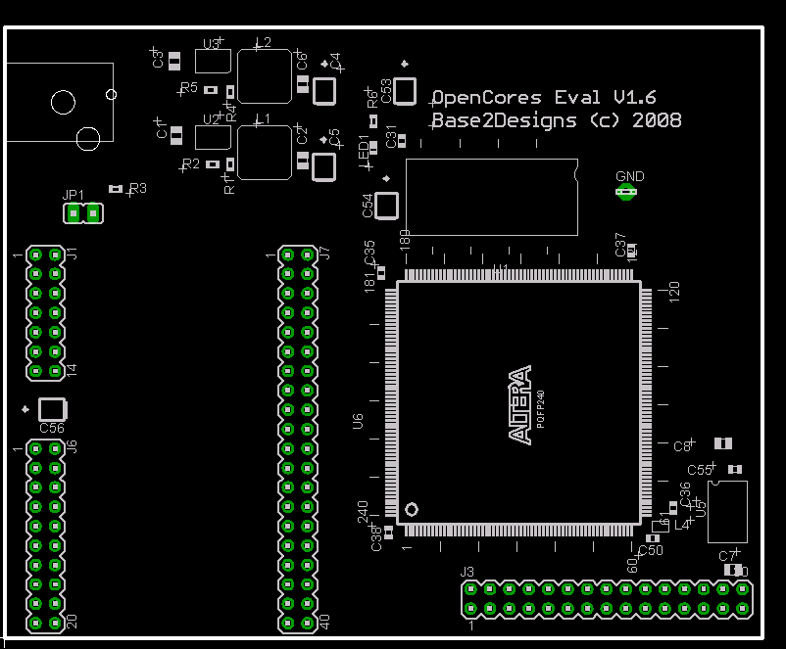
JP1: +3.3V and +1.2V Enable
SDRAM
Altera
EP2C20
Cyclone2
FPGA
+1.2V reg
+3.3V reg
48MHz Osc
FPGA Support Board Connector
Santa Cruz Expansion Connector

FPGA Support Board
J12:
USB2Flash Connector
LED1:
Watchdog Strobe LED

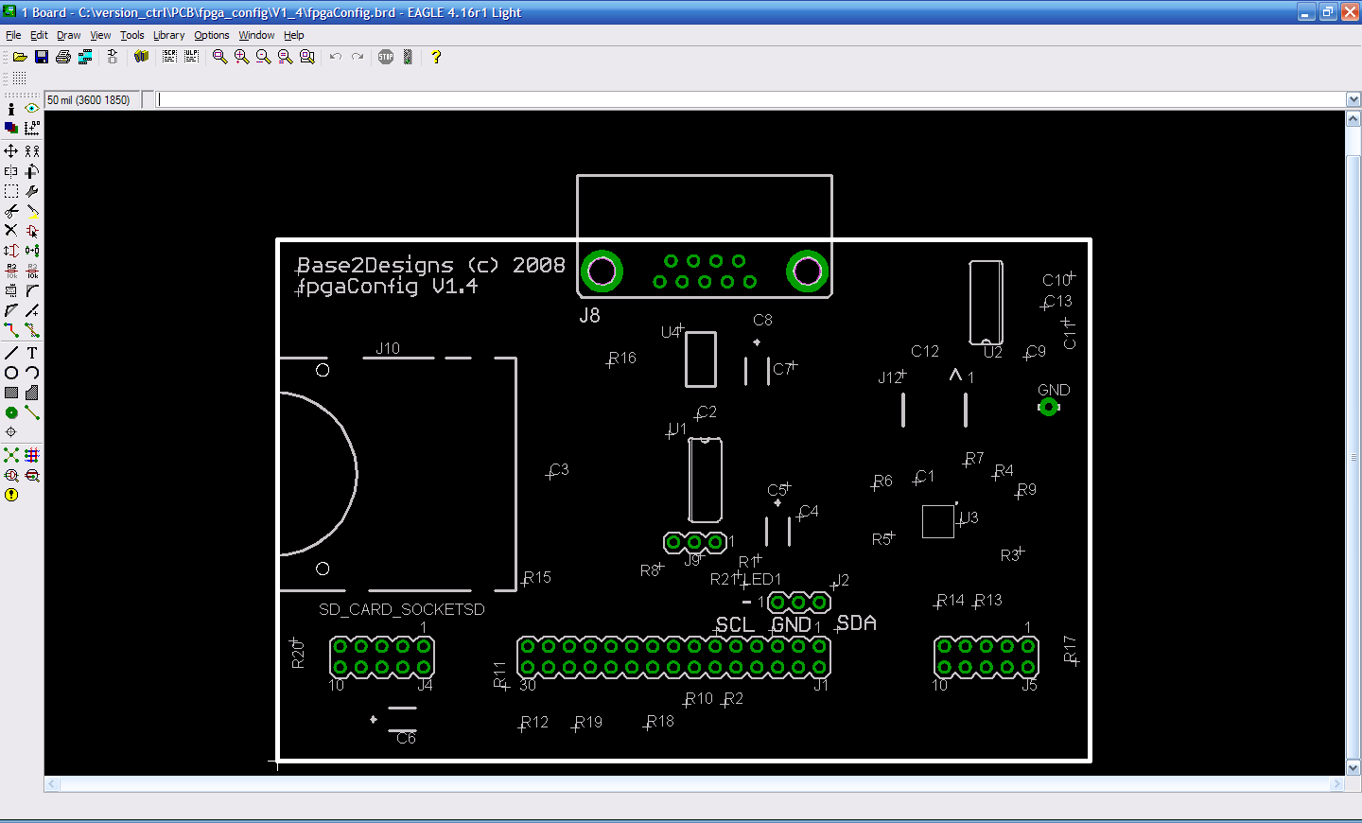
RS-232
Secure
Digital
Card
Socket
SPI flash
+3.3V reg
C8051
J1: FPGA Main Board Connector
J5: FPGA JTAG
J4: RISC JTAG
J9:
SPI Flash or
SD flash
Selector
J2: I2C Bus debug port

Figure 2.1 – Hardwdare block diagram
FPGA
SDRAM
Santa Cruz
Header
Main Board
Connector
Connector
SD/MMC
Connector
RISC JTAG
FPGA JTAG
SPI
Flash
C8051
DB9
RS232
Tx/Rx
Conn
FPGA Support Board
SPI Bus
Conn
USB
8051 Debug
PC
SiLabs
USB
Programming
Adapter
USB
USB
RS-232
USB2Flash Adapter
3.3V & 1.2V
Voltage regulators
5V
Power
Supply

Operation
The Main Board contains a minimal number of components required to support the EP2C20 Cyclone2 FPGA in an OpenRISC application. OpenRISC, is an open source RISC processor, available from OpenCores;
http://www.opencores.org/projects.cgi/web/or1k/overview
A 30-pin ribbon cable connects the Main Board to the FPGA support board. The FPGA Support Board contains all the components required to configure the FPGA using the Base2Designs FPGA configuration scheme. Base2Designs FPGA configuration scheme allows the storage of FPGA configuration files in commodity flash memory, either SPI flash, or SD/MMC flash cards. In addition to storing the FPGA configuration files, the flash memory can be used to store OpenRISC program files. The Support Board also contains a DB9 supporting RS-232 serial communications with the OpenRISC processor, a FPGA JTAG connector useful for running Altera Signal Tap logic analyser, an OpenRISC JTAG connector for OpenRISC software debug, and a USB2Flash connector which supports the Base2Designs USB2Flash Programming adapter.

Selecting SD flash or SPI flash
As a default the FPGA Support Board is configured for using SD flash cards. If you wish to change to using SPI flash, then you will need to load a new image into the C8051 microcontroller, and change the position of jumper J9. Note, that as of this date the OpenRISC boot loader does not support booting from SPI flash. Never the less, if you have applications that will fit inside FPGA flash memory, you can still use SPI flash. Or if you are not using the OpenRISC then you can also use SPI flash. And since everything is open source, you could modify the boot loader to load from SPI flash.
To select between SPI flash and SD flash you need load the C8051 with an appropriate image, and change the position of jumper J9. You will need a SiLabs Programming adapter in order to re-program the C8051, see the “Base2Designs FPGA Configuration Users Guide” for details. Position the J9 jumper on side closest to the SD flash to use SD flash, and the other side to use SPI flash.

Connectors
Table 1: Main Board Connectors
Signal | Pin No. | Dir | Description
Power
+5V |  | input | +5V +/- 5% @ 1A. Current consumption is dependent on FPGA usage, but with a typical OpenRISC project loaded, the board consumes ~100mA
JP1 - Regulator Inhibit
 | 1 and 2 |  | Link the pins to allow the FPGA Support board to control the +1.2V and +3.3V regulator power inhibit pins. Aim is to allow the C8051 to power down the board, thus saving power.  Remove the link to default the regulators to on.  C8051 feature not implemented, so leave unconnected.
J3 – FPGA Support Board Connector
+5V | 29 | output | +5V from main input connector.
+3.3V | 30 | output | +3.3V from regulator.
GND | 3, 7, 17, 27, 28 |  | Ground
MAIN_BRD_PWR_ON | 1 | input | Controls the +1.2V and +3.3V regulator power inhibit pins. High = Power on, low = power off.
WATCH_DOG_STROBE | 13 | output | Watchdog strobe output from FPGA. Toggling of output required to prevent C8051 from reseting the system. Details of toggle rate TBD. Currently unimplemented.
FPGA JTAG debug port
FPGA_TDI | 2 | input | Data in
FPGA_TCK | 4 | input | Clock
FPGA_TDO | 6 | output | Data out
FPGA_TMS | 5 | input | Mode select
RISC JTAG software debug port
RISC_TDI | 22 | input | Data in
RISC_TCK | 18 | input | Clock
RISC_TDO | 19 | output | Data out
RISC_TMS | 20 | input | Mode select
RISC_TRST | 21 | input | Reset
FPGA Serial Configuration port, and SPI bus
FPGA_CONF_CLK | 8 | input | Configuration clock
FPGA_CONF_EN_N | 10 | input | Configuration enable. Active low.
FPGA_STS_N | 26 | output | Configuration status. Configuration cannot start until this signal is high.
FPGA_CONF_DONE | 25 | output | Configuration successfully done. Active high.
SPI_MASTER_DOUT | 9 | inout | Configuration data input during FPGA configuration. After FPGA configuration becomes SPI data output from FPGA.  Connected to two separate pins on FPGA. DATA0 configuration pin and a regular I/O pin.
SPI_MASTER_DIN | 15 | input | SPI data in to FPGA.
FLASH_SPI_CLK | 16 | output | SPI clock from FPGA. Tri-state during FPGA configuration.
SPI_CS_N | 14 | output | SPI chip select from FPGA. Active low. Tri-state during FPGA configuration.
UART
UART_TX | 23 | output | Tx data
UART_RX | 24 | input | Rx data
I2C bus
I2C_SCL | 12 | inout | I2C clock signal. Tri-state capable with pull-up on Support board.
I2C_SDA | 11 | inout | I2C data signal. Tri-state capable with pull-up on Support board.
J1, J6, J7 - Santa Cruz expansion bus
SC_P_CLK | J6-11 | output | Clock.
SC_RST_N | J7-1 | output | Reset
SC_CS_N | J7-38 | output | Chip select
SC_P[39:0] | See schematic | User defined | User defined

Table 2: Support Board Connectors
Signal | Pin No. | Dir | Description
J8 - RS-232
TX | 2 | output | Tx data
RX | 3 | input | Rx data
GND | 5 |  | Ground
J4 - OpenRISC JTAG software debug port
+3.3_SW | 7 | output | +3.3V from the main board regulator. Note that this supply will be switched off when the main board regulators are inhibited.
GND | 1, 9 |  | Ground
RISC_TDI | 2 | input | Data in. 1K pull-up
RISC_TCK | 10 | input | Clock. 1K pull down.
RISC_TDO | 8 | output | Data out
RISC_TMS | 6 | input | Mode select. 1K pull-up
RISC_TRST | 4 | input | Reset
J5 - FPGA JTAG debug port
+3.3_SW | 4 | output | +3.3V from the main board regulator. Note that this supply will be switched off when the main board regulators are inhibited.
GND | 2, 10 |  | Ground
FPGA_TDI | 9 | input | Data in
FPGA_TCK | 1 | input | Clock
FPGA_TDO | 3 | output | Data out
FPGA_TMS | 5 | input | Mode select
J2 – I2C Debug port
I2C_SCL | 1 | inout | Clock
GND | 2 |  | Ground
I2C_SDA | 3 | inout | Data
J12 – USB2Flash connector for C8051 debug and C8051 UART
UART_RX | 2 | input | C8051 serial receive data in. 3.3V LVTTL logic levels.
UART_TX | 4 | output | C8051 serial transmit data out. 3.3V LVTTL logic levels.
C2CK | 6 | input | C8051 debug clock
C2D | 8 | inout | C8051 debug data
NC | 10 |  | No connect
+3.3V | 1 | output | +3.3V supply from local regulator. Always on.
GND | 3, 5, 7, 9 |  | Ground
J9 – Flash selection
FLASH_IC_CS_N | 1 |  | SI flash chip select
SPI_CS_N | 2 |  | SPI chip select from either C8051 during FGPGA configuration, or FPGA after configuration. Place link between 2 and 1 to select SPI flash, or 2 and 3 to select SD flash.
SD_CS_N | 3 |  | Secure Digital chip select
J3 – FPGA Main Board Connector
+5V | 29 | input | +5V from Main board input connector. Supply always present.
+3.3V_SW | 30 | input | +3.3V from Main board regulator. Supply will be switched off when MAIN_BRD_PWR_ON is low.
GND | 3, 7, 17, 27, 28 |  | Ground
MAIN_BRD_PWR_ON | 1 | output | Controls the +1.2V and +3.3V regulator power inhibit pins. High = Power on, low = power off.
WATCH_DOG_STROBE | 13 | input | Watchdog strobe output from FPGA. Toggling of output required to prevent C8051 from reseting the system. Details of toggle rate TBD. Currently unimplemented.
FPGA JTAG debug port
FPGA_TDI | 2 | output | Data in
FPGA_TCK | 4 | output | Clock
FPGA_TDO | 6 | input | Data out
FPGA_TMS | 5 | output | Mode select
RISC JTAG software debug port
RISC_TDI | 22 | output | Data in
RISC_TCK | 18 | output | Clock
RISC_TDO | 19 | input | Data out
RISC_TMS | 20 | output | Mode select
RISC_TRST | 21 | output | Reset
FPGA Serial Configuration port, and SPI bus
FPGA_CONF_CLK | 8 | output | Configuration clock
FPGA_CONF_EN_N | 10 | output | Configuration enable. Active low.
FPGA_STS_N | 26 | input | Configuration status. Configuration cannot start until this signal is high.
FPGA_CONF_DONE | 25 | input | Configuration successfully done. Active high.
SPI_MASTER_DOUT | 9 | inout | Configuration data input during FPGA configuration. After FPGA configuration becomes SPI data output from FPGA.  Connected to two separate pins on FPGA. DATA0 configuration pin and a regular I/O pin.
SPI_MASTER_DIN | 15 | output | SPI data in to FPGA.
FLASH_SPI_CLK | 16 | input | SPI clock from FPGA. Tri-state during FPGA configuration.
SPI_CS_N | 14 | input | SPI chip select from FPGA. Active low. Tri-state during FPGA configuration.
UART
RISC_UART_TX | 23 | input | Tx data
RISC_UART_RX | 24 | output | Rx data
I2C bus
I2C_SCL | 12 | inout | I2C clock signal. Tri-state capable with pull-up on Support board.
I2C_SDA | 11 | inout | I2C data signal. Tri-state capable with pull-up on Support board.

