Fairchild Dual USB PHY Daughter Card Users Guide

Author: Steve Fielding
sfielding@base2designs.com

Rev. 1.0
November 17, 2008

Revision History
Rev. | Date | Author | Description
1.0 | 11/16/08 | Sfielding | Created

Contents
Introduction 1
Getting Started 1
Building the OpenRISC Project 4
Building the usbDevice Project 7
Simulation 9
Connectors 11

Introduction
Typically FPGA development boards have sufficient logic resources to support the development of USB hardware, but they do not have the capability to support the USB electrical specification. DUSB-PHY provides two USB transceivers, each capable of supporting USB full and low speed. One transceiver is connected to a USB type A (Host) connector, and the other transceiver is connected to a USB type B (function or slave) connector. The daughter card connects to FPGA development boards using the Santa Cruz Connector format (three 0.1" pitch connectors), which is supported by Altera, and other development board vendors such as Microtronix.
DUSB-PHY can support any USB hardware IP that has a USB transceiver interface designed for simple USB transceivers such as the Fairchild USB1T11A. However, it is specifically designed to support usbhostslave, which is an Opencores USB 1.1 Host and Function IP core.

Getting Started
Connect all the boards as shown in the photograph
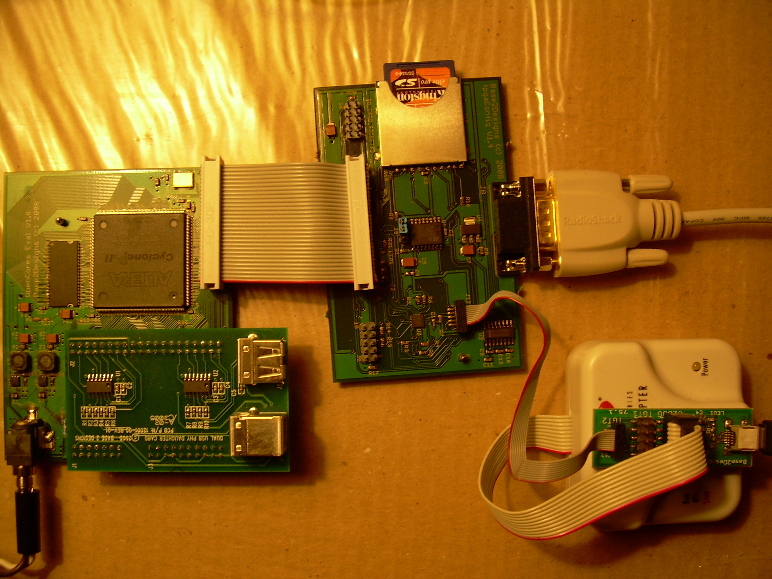

Connect the FPGA Support Board RS-232 port to a PC. You may have to use a RS-232 to USB adapter if your PC does not have a RS-232 serial port. On the PC use a terminal program such as Windows Hyperterminal, and configure the attached serial port for 11520 baud, 8 data bits, 1 stop bit, no parity, no flow control.
Connect the USB2Flash adapter to the PC using a type A to mini B USB cable. On the PC install USB2Flash console application fpgaConfig, either from the Base2Designs install disk or from:
http://www.base2designs.com/downloads/fpgaConfig_v1_1.zip

Load and run USB loop back test
Connect a Type A to type B USB cable (most common USB cable) between the type A and type B USB connectors on the DUSB-PHY board.
From:
cyc2-openrisc\progFiles\2008_11_02\bootLoader
Execute:
downloadFPGAimage.bat
This copies the binary FPGA configuration file cyc_or12_mini_top_memTest.rbf to flash memory at address 0, and forces the FPGA to be reconfigured, thus copying the new file from flash to the FPGA. You should see the following at the terminal screen:
Execute:
downloadSoftware_USBLoopBackTest.bat
The batch file copies the software image file to flash memory at address 0x90000, and then force an FPGA re-configuration. After re-configuration the OpenRISC will run the bootloader program which will then copy the new software image file from flash to DRAM, jump to DRAM, and execute the new program.
At the PC terminal window, monitor the progress of the test. The test is very extensive, and runs for a long period. If there is a problem it will stop and report the error. Try removing the loopback cable, and ensure that the test stops.

Load and run USB mouse test – with OpenRISC
Connect a Type A to type B (most common USB cable) between J4 on DUSB-PHY and a PC.
From:
cyc2-openrisc\progFiles\2008_11_02\bootLoader
Execute:
downloadSoftware_USBMouse.bat
The PC should detect the new USB mouse peripheral, and you should see the Windows mouse pointer move slowly diagonally down and to the right of the screen.

Load and run USB mouse test – no OpenRISC
Connect a Type A to type B (most common USB cable) between J4 on DUSB-PHY and a PC.
From:
usbhostslave\usbDevice\progFiles\2008_11_16
Execute:
download_USB1T11_usbMouse.bat
The PC should detect the new USB mouse peripheral, and you should see the Windows mouse pointer move slowly diagonally down and to the right of the screen.

Building the OpenRISC Project
First you will need to install Quartus. You can download Quartus Web Edition for free:
http://www.altera.com/products/software/quartus-ii/web-edition/qts-we-index.html

Check the project settings
First make sure all the file settings are correct. If you are using an unmodified cyc2-openrisc project then the defaults should be correct.
Using a text editor open :
cyc2-openrisc/syn/cyc_or12_mini_top.qsf
Ensure that onchip_ram_loadRAM is slected:
# set_global_assignment -name VERILOG_FILE ../rtl/mem_if/onchip_ram_loadRAM.v
set_global_assignment -name VERILOG_FILE ../rtl/mem_if/onchip_ram_memTest.v
Next check that cyc_or12_mini_top.v is top level module:
set_global_assignment -name VERILOG_FILE ../rtl/top/cyc_or12_mini_top.v
# set_global_assignment -name VERILOG_FILE ../rtl/top/cyc_or12_mini_top_sdCard.v
Open in a text editor:
cyc2-openrisc /rtl/top/cyc_or12_defines.v
Ensure that
`define PHY_ISP1105
is commented out

Build the project
Now open Quartus, and load the project file:
File >> Open Project
browse to cyc2-openrisc/syn/cyc_or12_mini_top.qpf
Build the project:
Processing >> Start Compilation
Once compilation is complete, create the binary programming file
File >> Convert Programming Files...
In the new window, select
Open Conversion Setup Data...
and browse to syn/cyc_or12_mini_top.cof
Now select:
Generate
This will generate cyc_or12_mini_top.rbf
Execute syn/download.bat , to download the newly created programming file to flash memory.

Build the software
First you will need to load Cygwin. You will need several of the development tools that are available with Cygwin, and also the OpenRisc tool chain.
There are two options for installing Cygwin. One is to install from the internet, and the other is to install from a local directory. If you install from the internet, get Setup from;
http://www.cygwin.com/setup.exe
When you run setup you will be presented with options on the modules that you can install. You will need to install several of the Development tools. Although a large install, the easiest option is simply to install all the Development tools.
Alternatively you can run setup from the Base2Designs installation disk, and select the “install from directory” option.
Next you need to install the Openrisc tool chain:
or32-uclinux-2003-04-13.cygwin.tar.gz
Unzip the files to your Cygwin install directory, c:/cygwin by default.
Add the install path for the new tools to your .bash_profile. C:/cygwin/home/myName by default. Try to use a plain text editor such as vim, as Wordpad can introduce unwanted formating that will confuse Cygwin.
# Set PATH to or32 tools
PATH=$PATH:/opt/or32-uclinux/bin
Start cygwin, and change directory to the install path for cyc2-openrisc/sw. You will need to cd to cygdrive/c to get at your c: drive root. Eg
cd /cygdrive/c/myProjects/cyc2-openrisc/sw/usbLoopBackTest
Now rebuild the project
make clean all
and download to flash memory
./download.bat
Now try re-building the USB mouse project, and downloading to flash.
cd ../usbMouse
make clean all
./download.bat

Building the usbDevice Project
Using a text editor, open:
usbhostslave/usbDevice/RTL/usbDeviceAlteraTop.v
check to ensure that the following line is commented out:
`define PHY_ISP1105
Open Quartus, and load the project file:
File >> Open Project
browse to:
usbhostslave/usbDevice/syn/altera/usbDeviceAlteraTop.qpf
Build the project:
Processing >> Start Compilation
Once compilation is complete, create the binary programming file
File >> Convert Programming Files...
In the new window, select
Open Conversion Setup Data...
and browse to
usbhostslave/usbDevice/syn/altera/syn/usbDeviceAlteraTop.cof
Now select:
Generate
This will generate usbDeviceAlteraTop.rbf
Connect a Type A to type B (most common USB cable) between J4 on DUSB-PHY and a PC.
Execute download.bat , to download the newly created programming file to flash memory.
You should see the PC mouse pointer moving slowly across the screen.

Simulation

Install simulator and waveform viewer
First install Icarus Verilog and GTKwave. You can get the Icarus install file from either Base2Designs install disk, or from:
ftp://icarus.com/pub/eda/verilog/v0.8/Windows
or
http://www.base2designs.com/downloads/iverilog-0.8-setup.exe
You can get GTKWave from the Base2Designs intsall disk, or from:
http://www.base2designs.com/downloads/GTKwave.msi

Build and run the usbhostslave simulation
From the sim directory, build the project. There are two different builds which select different top level modules:
build_icarus_comboHostSlave.bat
or
build_icarus_sepHostSlave.bat
and run the simulation
run_icarus.bat

At the console window you should see the following:
VCD info: dumpfile wave.vcd opened for output.
Host Version number = 0x20
Slave Version number = 0x20
Testing host register read/write --- PASSED
Testing slave register read/write --- PASSED
Testing register reset --- PASSED
Configure host and slave mode. Connect full speed --- PASSED
Cancel interrupts --- PASSED
Disconnect --- PASSED
Connect full speed --- PASSED
Host forcing reset --- PASSED
Connect full speed --- PASSED
Trans test: Device address = 0x00, 2 byte SETUP transaction to Endpoint 0. Checking receive data --- PASSED
Trans test: Device address = 0x5a, 20 byte OUT DATA0 transaction to Endpoint 1. Checking receive data --- PASSED
Trans test: Device address = 0x01, 2 byte IN transaction to Endpoint 2. Checking receive data --- PASSED
Finished all tests

View the waveforms:
viewWave.bat
From the GTKWave application;
Search >> Signal Search Tree
and browse design hierarchy and select the signals you wish to view.

Build and run the usbDevice simulation
From the usbDevice/sim directory, build the project:
build_icarus.bat
and run the simulation:
run_icarus.bat
View the waveforms:
viewWave.bat
From the GTKWave application;
Search >> Signal Search Tree
and browse design hierarchy and select the signals you wish to view.

Connectors
Table 1: USB Connectors
Signal | Pin No. | Dir | Description
J5 – USB Type A
+5V | 1 | output | +5V supply
D- | 2 | inout | Data minus
D+ | 3 | inout | Data plus
GND | 4 |  | Ground
J4 – USB Type B
No connect | 1 | output | USB +5V input. Not used
D- | 2 | inout | Data minus
D+ | 3 | inout | Data plus
GND | 4 |  | Ground

Table 2: Santa Cruz Connector
Signal | Santa Cruz Signal | Pin No. | Dir | Description
 | SC_P_CLK | J3-11
 | SC_RST_N | J2-1
 | SC_CS_N | J2-38
FUNCTION_SPD | SC_P0 | J2-3 | input | Fuction speed. Controls PHY edge transition rate. High = full speed, low = low speed.
 | SC_P1 | J2-4
FUNCTION_RX_VM | SC_P2 | J2-5 | output | Function RX data minus. Gated version of USB D-
 | SC_P3 | J2-6
FUNCTION_RX_VP | SC_P4 | J2-7 | output | Function RX data plus. Gated version of USB D+
 | SC_P5 | J2-8
FUNCTION_OE_N | SC_P6 | J2-9 | input | Function TX data output enable. Low = enable.
 | SC_P7 | J2-10
FUNCTION_TX_VMO | SC_P8 | J2-11 | input | Function TX data minus. When FUNCTION_OE_N is low, this signal drives USB D-
 | SC_P9 | J2-12
FUNCTION_TX_VPO | SC_P10 | J2-13 | input | Function TX data plus. When FUNCTION_OE_N is low, this signal drives USB D+
 | SC_P11 | J2-14
DPLUS_DEF_CTRL | SC_P12 | J2-15 | input | Enable Function D+ 1.5K pull-up resistor. High = enable. D+ pull-up active, and D- pull-up inactive puts USB bus in Full speed mode.
 | SC_P13 | J2-16
DMINUS_DEF_CTRL | SC_P14 | J2-17 | input | Enable Function D- 1.5K pull-up resistor. High = enable. D+ pull-up inactive, and D- pull-up inactive puts USB bus in Full speed mode.
 | SC_P15 | J2-18
 | SC_P16 | J2-21
 | SC_P17 | J2-23
 | SC_P18 | J2-25
 | SC_P19 | J2-27
 | SC_P20 | J2-28
HOST_SPD | SC_P21 | J2-29 | input | Host speed. Controls PHY edge transition rate. High = full speed, low = low speed.
HOST_RX_VM | SC_P22 | J2-31 | output | Host RX data minus. Gated version of USB D-
 | SC_P23 | J2-32
HOST_RX_VP | SC_P24 | J2-33 | output | Host RX data plus. Gated version of USB D+
HOST_OE_N | SC_P25 | J2-35 | input | Host TX data output enable. Low = enable.
 | SC_P26 | J2-36
HOST_TX_VMO | SC_P27 | J2-37 | input | Host TX data minus. When FUNCTION_OE_N is low, this signal drives USB D-.
HOST_TX_VPO | SC_P28 | J2-39 | input | Host TX data plus. When FUNCTION_OE_N is low, this signal drives USB D+
 | SC_P29 | J1-4
 | SC_P30 | J1-5
 | SC_P31 | J1-6
 | SC_P32 | J1-7
 | SC_P33 | J1-8
 | SC_P34 | J1-9
 | SC_P35 | J1-10
 | SC_P36 | J1-11
 | SC_P37 | J1-12
 | SC_P38 | J1-13
 | SC_P39 | J1-14
+5V | +5V | J1-2 | input | +5V supply. Only used for USB +5V supply.
+3.3V | +3.3V | J3-5, 7, 15, 17, 19 | input | +3.3V supply. Main supply for USB PHYs.
GND | GND | J1-1  J2-2, 19, 22, 24, 26, 30, 40  J3-2, 4, 6, 8, 10, 12, 14, 16, 18, 20 |  | Ground

