Design overview

The OFDM technique (Orthogonal Frequency Division Multiplexing) has been used in the last years in applications that require a huge transmission rate like ADSL modem, wireless network (Wi-Fi 802.11), DVB (Digital Video Broadcasting) and DAB (Digital Audio Broadcasting). In all these cases, one needs to implement an integrated circuit (IC) that performs the necessary chip functions. For prototyping circuits FPGA is better choice than using ASIC (application Specific Integrated Circuit), CUSTOM or SEMICUSTOM. FPGA implementations because avoid the:
- Initial costs;
- Great development time and the inherent risks of conventional ASIC.

So, in this way, the development of high advanced techniques of digital data transmission and the actual FPGA stage of integration make possible the building all the circuits that compounds a digital communication systems in an unique chip.

To make use of this modern technologies of data transmission, it is necessary the development efficient techniques of digital modulation. The OFDM is the biggest utilized recently, principally, because of it use the efficient FFT to do the modulation.

This work describes how implement an OFDM modem on FPGA using VHDL for a 31 subcarrier (channels) OFDM system using 64 points radix-4 FFT time decimation, a CORDIC implementation to perform the butterfly calculus, and each channel modulation will use a 4-QAM constellation. The system is divided in a transmission section and a reception section.
Block diagram

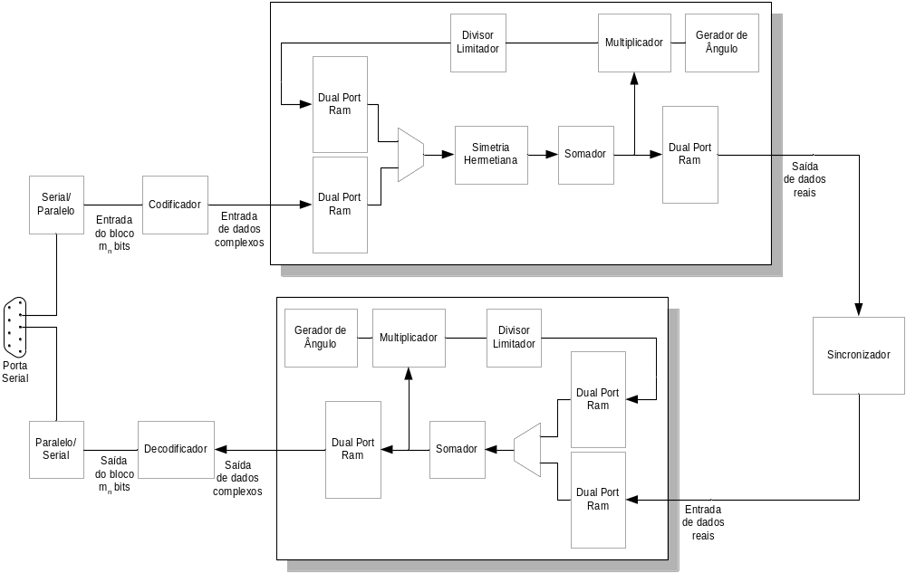
Detailed description

Introduction
Basically, OFDM technique consists of dividing the flow of entrance data over orthogonal channels. In this way, and based on the orthogonality principle, the interference between each transmission channel is minimal. Another advantage that comes from this approach is related to the assumptions about the noise in each channel. Over a large and unique passband channel it is difficult (impossible in fact, in many situations) to assume that the model noise is AWGN (Additive Noise Gaussian Noise). That is important because if the model is know, and it is correct, one can select the best way of frequency equalization. But, in large passband channels (tenths of Mhz) the noise model is unknown and unpredictable. The solution of dividing a unique channel in subchannels simplifies the assumptions of the noise over each subchannel and, of course, one can suppose it approximately AWGN.

In each one of these subchannels, a digital modulation is made, each one with a subcarrier that presents different frequency, in a such form that a channel does not intervene with another one, thus keeping the orthogonallity.

The way of implementation and the orthogonallity property of a system of this type can vary sufficiently: since band pass filters each frequency until sophisticated techniques as the use of the FFT with guard interval, which is the used one for the OFDM.

In literature, this technique has been called for some designations as orthogonally multiplexed QAM (O-QAM), parallel quadrature AM, and so one. However, OFDM for wireless and DMT for systems wired (like DSL) are the most common designations that one can find in literature. As all the above techniques basically use the same principle, it is common to refer to them by means of a generic name: MCM (to Multi-Carrier Modulation). In that way, MCM is the technique in the general direction, and OFDM is related to the implementation of technique MCM using the FFT.

Implementation

Mapping the constellation

The encoder of the constellation maps the m bits of the channel in a point a + jb in the constellation of the modulator. Decoding receives that point and the remap as the m transmitted bits.

Encoder of the constellation

It is important to notice that in that mapping it is just made a conversion of bits for the fasor that acts, however it is not made any modulation, as in the case of QAM, because that as shown, it is done by IFFT.

It is necessary to specify how the constellation will be to be mapped, to implement that block. However, independently of the format of the constellation, the block encoder can be made through a consultation at a conversion table, implemented by LUT that exists in LCs of FPGAs.

For instance, for a 4-QAM constellation in such a way that a and b are binary numbers of 3 bits, and are converted to complement two.

Attempt that the entrance of the encoder a binary number of m bits, and that the exit generates two binary numbers, one in phase, the, and other in quadrature, b, whose size is defined by IFFT.

Decoder of the constellation

In the receiver, the point of the constellation transmitted it can have changed due to the noises of the transmission channel, mistake in the time of sampling of the receiver and several other causes.

Therefore it is necessary to define a threshold so that it can be made the decision on which point in the constellation the received sign is acting. That is the function of the decoder.

For the system exemplified above the bit 0 is converted for 010b and the bit 1 for 110b. In that case, the decoder is implemented in a simple way, sticks to the most significant (that indicates the sign) bit to do the decoding, and generating a binary number of m bits again.

For systems in that the constellation diagram is larger than 4-PSK it will be necessary the implementation of more advanced methods, like a neural network.

The Hemetian symmetry

After having mapped the N channels it is applied the Hermetian symmetry so that the modulation can be made by an IFFT. It is generated 2N+2 channels in symmetry.

In the receiver, to the end of the processing of FFT, they are sent to the decoder only N channels, being eliminated the channels generated due to Hermetian symmetry.

The Hermetian symmetry is implemented in agreement with
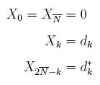

for k = 1, 2..., N - 1, where N = N +1.

For instance, to transmit N = 3 channels (d1, d2, d3) N = 4, 2N = 8 and k = 1, 2, 3. Applying in the above equation it is obtained the result shown in the following table.

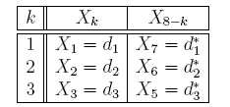
Knowing that X0 = XN=4 = 0 + j0, is obtained in agreement with the Table 2 the result shown in the following equation:
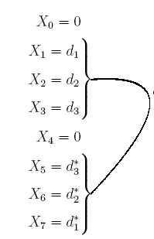

In that way, it can stay X0 and XN always in zero. While it is made XN+1 even X_{2n - i} same to the conjugated of X_{n-1}.

Being it conjugated of Z = a+jb the same of Z* = a- jb, then to do the operation of having conjugated he should move the sign of the imaginary part, in other words, to do a sign inversion. In hardware, the inversion of sign of a binary number in complement two.

The (I)FFT

The modulation OFDM can be made through an IDFT. The fast implementation of IDFT, IFFT, can be used reducing the time of processing and the used hardware. The demodulation, in the same way, can be made by DFT, or better, by FFT, that is it efficient implementation.

FFT calculates DFT with a great reduction in the amount of operations, leaving several existent redundancies in the direct calculation of DFT. That efficiency is gotten at the cost of an additional step to reverse-order the data in order to be determined the final result. That additional step, since implemented efficiently, they won't increase in a significant way the complexity computational of the calculation. As result, FFT is an extremely efficient algorithm that provides a good implementation in hardware.

For great values of N, the computational efficiency is gotten being broken DFT successively in smaller calculations. That can be made so much in the domain of the time, as in the domain of the frequency, as discussed ahead.

Decimation in time and in frequency

As mentioned, it is possible to divide the entrance of FFT successively generating small sequence in the domain of the time, for that the name decimation in the time, TD. It is also possible to become separated the sequence of exit of FFT successively, instead of dividing the entrance. That implementation is called of decimation in the frequency, FD. The decimation can be used so much for FFT as for IFFT.

It is possible to repeat the process until reaching the possible maximum level of division. In that point the basic block decimation is generated so it will be used in the whole FFT (called butterfly). An example of the butterfly of the FFT radix-2 TD is in the following illustration.
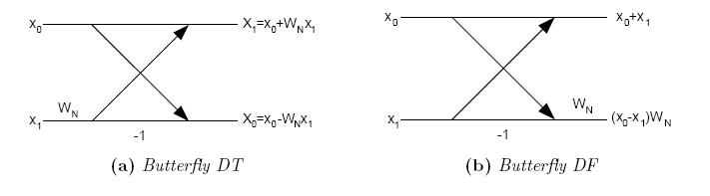

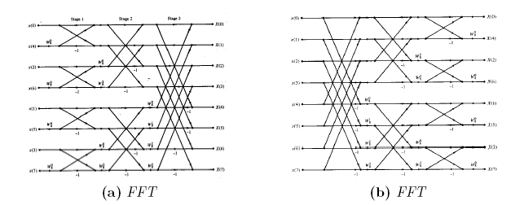
An example of a FFT radix-2 DT, for N = 8 are shown below. It is noticed that is necessary an alteration in the entrance of data, because he/she has to separate the equal part of the odd part.

In the same way that the decimation in the time generates a butterfly, the decimation in the frequency generates a corresponding butterfly.

However the alteration in the flow of data will have to be done in the exit, and no more in the entrance.

Implementation of Butterfly

The sum used in the butterfly possesses the same algorithm, so much for FFT as for IFFT. To avoid overflow danger due to sum in complement two, it is made the extension of the sign in the binary number, repeating the most significant bit, like this to the if it adds 2 binary numbers of 10 bits, we will have of first to do the extension of the sign, obtaining like this, two numbers of 11 bits, to do the sum, where the result will also be of 11 bits. That procedure has to be done every time that will add or to subtract a number.

Already for the multiplication, the exit has to be of the size of the sum of the number of bits of the two multiplicands. In that way, to do the multiplication of two numbers of 10 bits, we will have to an exit of 20 bits. That procedure has to be done to each multiplication.

If there is not impediment, it can be made a rotation for right (divisions for two) in the numbers and to reduce its size, since in the end of the procedure a corresponding multiplier is applied.

The order as it will be made the butterfly is defined by the decimation of the radix. If it goes TD, first it is made multiplication and later the sum. If it goes FD, first it is made the sum and then it is made the multiplication.

The existent multiplication in the butterfly demands a certain attention, because, if it be not implemented efficiently, it will degrade the acting of FFT a lot. Basically, there is two methods to do the multiplication: to store in a table the sine values and cosine or to make calculations in place through CORDIC.

Use of the memory

The algorithm of FFT consists of catching the data of the memory (2 for radix-2 and 4 for radix-4), do the butterfly and to return the data made calculations for the memory. Once the data of entrance of the butterfly were already processed there is no more reason of keeping them. Then we can save the data processed in the same position of memory. With that, the amount of necessary memory will be fixed (look bellow).

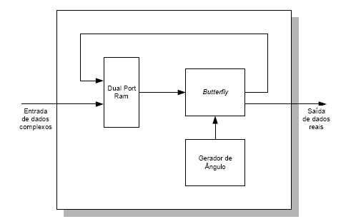

That implementation is not useful for OFDM, because in that system, while FFT is processing, it is not possible to write the data of the entrance in the memory. Another problem is that the exit has to be stored to make the cyclic-prefix.

To solve the problem of the cyclic-prefix, a RAM memory can be put in the exit to store the data. And for the system to work in a continuous way, it is necessary that the entrance memory has double size and separate the content in two parts, so that while FFT is reading of a part, be possible to write in the other and vice-versa. It is also necessary to include another RAM memory so that after the first reading FFT can store and to process the data without interfering in the entrance memory, as can see in the figure bellow.

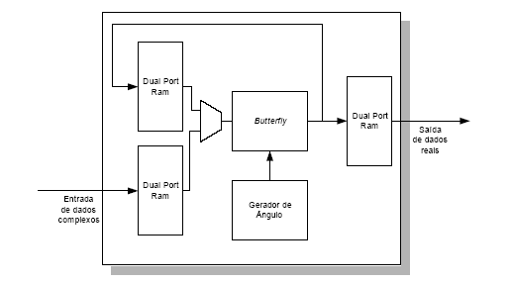

Memory mapping

In the implementation of FFT using the radix, it is noticed that is necessary the remapping of the memory. In the implementation TD that remapping is made starting from the entrance, and in the implementation FD is starting from the exit of FFT. However that remapping can be made in a simple way.

For instance, for the FFT radix-2 TD, the entrance has to be written in the addresses of memory 0, 2, 4, 6, 1 3, 5 and 7. After having processed a scrambling phases, it has to write in 0, 4, 2, 6, 1, 5, 3 and 7. That scrambling follows a much defined order.

The cyclic-prefix

The inclusion of the cyclic-prefix in the transmitter is made in an extremely simple way by the parallel-serial converter. The converter is enough to read the v bits that belong to the cyclic-prefix in the buffer that is the RAM memory of IFFT twice, as explained above.

The exclusion of the cyclic-prefix in the receiver is also made in a simple way, being enough the v bits that it belongs to the cyclic-prefix for FFT not to pass.

Improvements

After analyzing the system with all the components, it is noticed a problem. Some parts were implemented in a parallel way, in other words, it is received all at the same time from the channels, and it is transmitted all at the same time of the channels. However, the used element of main storage is the RAM memory, and the access is in a serial way, it is written and read in one address by time. As the amount of RAM memory in FPGA is limited, it is necessary to adapt the system to this situation.
Therefore, after a careful analysis, some modifications were proposed:
- It is possible to connect the RAM memory direct on the adder;
- It is possible to put the conjugate block between the FFT RAM and the butterfly;
- It is possible to put the coder in series with that memory in such a way that whenever will write a die in the memory, before be made the code because the data will be stored sequentially in the RAM memory of FFT.

Bellow, we can see the final implementation.
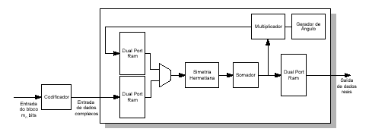

Another important subject is avoids the overflow. For that, it was shown that increasing the number of bits, the amount of bits of the memory it is fixed, it is necessary to be reduced the amount of numbers for that word size. However, it just is not able to rotate the data, because it can happen overrun mistake, in other words, to bursts the capacity of representation of the binary number it returns the zero and it resumes the counting.

To avoid that it is made a rotation with overrun. If rotate some bits, and if even so to remain bits the right of the specified limit, it is limited to the maxim possible representation, so much positive as negative.

Observe that the corresponding block doesn't exist the hermetian symmetry, because the same is made eliminating the channels that leave FFT.

Amount of memory

The amount of memory to be used is a crucial point. Because it is in it that will be stored all the data they be processed. Therefore, we have to specify a FPGA to have the necessary amount of RAM memory.

Being analyzed the memories used by the transmitter, and being known that the encoder generates N complex numbers, that the hermitan symmetry is made in own FFT, and knowing that the memory of entrance of FFT is the double than she needs to store then will be necessary two RAM memories of 2N+2 (two addresses same to zero, for the hermetian) of address capacity.

The processing memory also stores complex numbers and should have the length same to 2N+2. Therefore, it will be necessary more two RAM memories of length 2N+2. Already in the exit memory, that the stored number is real, it will only be necessary a RAM memory of length 2N+2.

The same analysis can be made for the receiver, being arrived the same amount of memory.

In the total it will be necessary then 5 memories of length 2N+2 in the transmitter and in the receiver.

As discussed, it intends to implement the OFDM system using a FPGA. The characteristics of OFDM to be implemented are: encoder and decoder of QAM-4, 64 point IFFT and FFT, 12 bits of precision of entrance, implemented using radix-4 FD for CORDIC.

As base for the implementation, it was acquired a code open of a FFT, in http://www.opencores.org/projects/cfft/. Analyzing acquired FFT, it is noticed that a FFT radix-4 is implemented FD by CORDIC. The number of points and the number of bits for word are configurable. However the use of the memory is wrong, being necessary some adjustments.

The system was developed in VHDL, separating the part of the calculation of the control part. The calculation part was implemented in way totally adjustable, so much in precision of FFT, as in the number of points. The control part, however, it is optimized to operate in 64 points.

As an IFFT of 64 points, the system was drifted will have 2N+2=64, generating 31 available channels for transmission. With that they will be necessary 10 memories of 64 addresses for the modem OFDM. Spartan II is enough for that implementation.

The chosen encoder was the due 4-QAM, mainly, the simplicity of doing the decoder. With that, we can transmit 2 bits for channel, in a total of 31 channel, tends 62 bits for symbol OFDM.

Transmission taxes

For planned OFDM, of 31 channels modulated to 4-QAM by an IFFT of 64 points, it can be made the following analysis.

It is known that will be necessary 3 apprenticeships making 64 calculations, 2 in each for that IFFT, making a total of 192 calculations. As the system is all implemented in pipeline, at the end of 192 clocks it is already begun to have answer. Therefore at least each frame OFDM will have the duration of 192 clocks/frame.

However as it is had to divide the frame for the 31 channels, an exact bill is not gotten, 192/31 = 6.1935 clocks/channel, being rounded upward, each channel will have 7 duration clocks, with that the duration of the frame increases for 7 x 31 = 217 clocks/frame.

Defining like F the frequency of work of FPGA, the duration of the clock will be of 1/F second, therefore the duration of the frame will be of 217/F second/frame, or F/217 frame/second. As a modulator 4-QAM is being used, it is had 2 bits/channel and 31 channels/frame, resulting in 62 bits/frame. Therefore the tax will be of 62F/217 bits a second.

Considering a clock of 50MHz, the transmission tax would be of 14.286Mbit/s. However it was considered for the calculation that guard interval has null value. That tax serves as a reference for the tax of maximum transmission.

That equation can be generalized and to obtain:

bF / n, n > 7

Where b is the number of bits for channel, F is the frequency of operation of FPGA and n is the number entirely of clocks for channel.

Use of the hardware

In that section, an important parameter in the development of the modem, the occupation of the system in FPGA, it is analyzed for used FPGA, SPARTAN II XC2S200.

The use of the hardware of CORDIC will be analyzed, of the part of calculation of FFT, of complete FFT, of the transmission modems and of reception and of the modem it tests.

Conclusions

With the so much development of techniques of digital transmission of data as of current FPGAs possibility to do systems of digital transmission integrated in a single chip. To do use of those modern technologies the complete structure it was developed for the transmitter and for the receiver OFDM, that use FFT (I) to do the modulation. Several forms were analyzed of implementing that modem OFDM in a FPGA, and chosen the most efficient and versatile.

As contribution, the present work, supplies a code in complete and functional VHDL for a modem OFDM with 31 subcarrier, using a 64-points FFT, radix-4 with CORDIC, at a rate of 12.5 Mbps.

For that, it was developed and analyzed several functional blocks of a modem and the chi occupation was compared in hardware of the several parts that compose it.

In that analysis, one of the parts that more highlight is the controller that organizes and manipulates the data in order to perform the modulation in a correct way. This system reveals extremely complex so that to improve better performance (work in a larger frequency) it is necessary to re-analyze all the design.

Getting started (procedure for setting up system)

- Turn on the system.
- Download OFDM.bit to FPGA.
- Plug a serial cable in the DB-9.
- Press BTN1 to reset the system.
- Open Hyperterminal, or similar software, at any baud rate.
- When you press a button in the computer’s keyboard, the system will sample, modulate, demodulate, and regenerating the character transmitted, then you will have an echo at you monitor of what you press.
- You can adjust the baud rate at the maximum (115Kbps) and the system will work fine.

Future ideas or application examples must be in a separated section

Introduction of Error Controls
It can be included several code types for error control, mainly CRC, Reed-Solomon. It can be substituted codifying of the constellation for a TCM (Trellis-Coded Modulation), giving an earnings of up to 7dB to the transmitter. When including TCM, it is necessary to implement the decoder of TCM, where the main of them is Viterbi Decoder. Probably will need two SPARTAN 2, or a bigger, and not so expensive, SPARTAN 3.

MCM applied to Digital TV Modulation
We know that some kinds of interferences like ISI (Intersymbolic Interference) and ICI (Interchannel Interference) can put down a communication link based on multicarrier modulation. Specifically to wireline applications (ex. PLC-Power Line Communications, where data are transmitted over electric wires), ISI interference could reduce considerable the system performance. But, in wireless transmission, the ICI effect is stronger than ISI. So, in wireless applications, that appears in broadcast Digital Television (a topic under studies here in Brazil), it is necessary to evaluate another kind of multicarrier modulation like Cosine Modulated Filter Banks (CMFB), Wavelet Packet Modulation (WPM), and another kind of Multicarrier Modulation that could be represented by Transmultiplex theory. In this case, the hardware considerations like costs of implementation in an IC should be analyzed very deeply; specifically what kind of FPGA will be selected to prototyping the IC.

