DMA Controller(01:016)

Introduction
The DMA controller is an add-on interface to the PCI master. This controller will burst a user-defined amount of data in either direction (PCI write or read bursts). The controller is also an AMBA bus bridge that couples/decouples the PCI master from the primary AHB bus, and connects it to a secondary AHB bus. This secondary bus only has one master (the DMA controller) and one slave (the PCI master), and therefore can occupy this bus at all time during a transfer. Figure 1 below illustrates how the DMA controller is attached between the AHB bus and the PCI master interface.

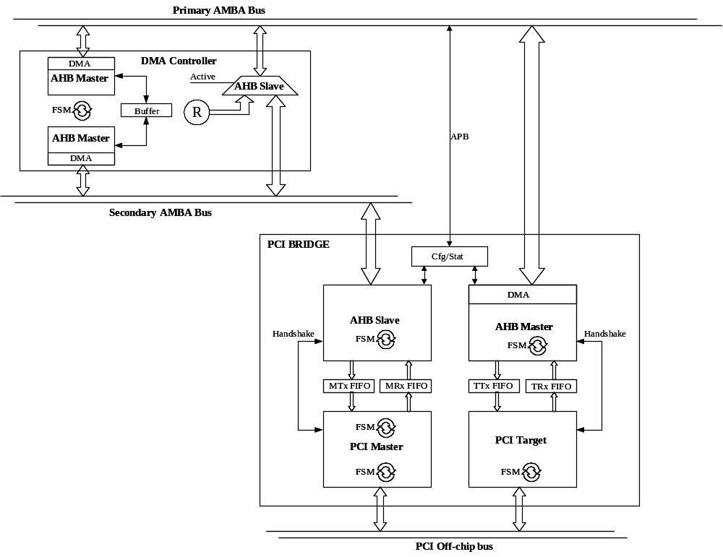

Operation
When disabled, the unit makes no data processing, but bridging accesses between the two AHB buses. During this condition, the PCI master will work just as if it was directly connected to the primary AHB bus, making direct CPU accesses to the PCI master possible. When enabled, the unit decouples the PCI master from the primary AHB bus until the user defined transfer is completed. Any other access from the primary AHB bus to the PCI master will under this condition be replied with a 'retry'-respons. The controller is currently only supporting 32-bit words, not half-words, bytes or other types.
The unit has to be correctly configured prior to start a DMA session. The entire transfer will be controlled by these parameter settings, and shall not be altered during on-going procedure. These parameters are:
- Burst length: Specifies the amount of data to be transferred. It represents the number of 32-bit words.
- PCI address: The start address in the PCI address space. Note that this is a complete 32-bit address, which not is further mapped in the PCI core.
- AHB address: The start address in the AHB address space.
- Direction: Defines the data direction of the transfer. Either read from PCI/write to AHB or counter wise.
- Space type: The target space type on the PCI bus. Either memory- or I/O space. This is in fact the memory bar selects on the AHB bus (hmbsel).
Beside these parameters, one may wants to change the configuration parameters of the PCI master module as well. Note that this must also be done before trigging a new DMA transfer. (ref. PCI Target/Master)
During operation, a transfer is initiated with a synchronization sequence, where a read request on the read side of the transfer is done. When read data is ready, a write request on the write side is done. When ready, the module enters transfer mode, where the data is transferred from one side to the other. The transfer is halted either when a retry response is sampled from any side, or when all data is transferred, according to what was written to the LEN register. Also for an abnormal termination, the transfer is halted, and the error status flag is asserted.
After have initiated a transfer, the 'ready' status bit can be polled to check the transfer status. When set, the 'error' status bit should also be checked to detect errors.

Configuration example
A normal initiation of the DMA controller contains the following APB memory accesses:
- Write the number of words to be transferred to the LEN register.
- Write the start PCI address to the PTA register.
- Write the start AHB address to the ATA register.
- Write the transfer direction among with the correct HMBSEL to the Write and HMBSEL registers.
- Write ‘1’ to the Start, Ready and Err registers (to clear the status registers).

Transfer abort
The DMA transfer is automatically aborted when any error is detected during a transfer. However, the DMA controller will not be able to detect any deadlocks in its communication channels. If the system concludes that a deadlock has occurred in this module, it can manually abort the DMA transfer. While this is an action combined with high risks, this must be a critical action, when there are no other alternatives.
A typical 'deadlock' can occur if the DMA controller receives a 'retry' from the PCI Master, when trying to access it. The DMA controller takes no responsibility for how long time it takes before an okay/error response comes from the PCI Master. If aborted in this condition, the DMA controller is reset, and the responsibility for finishing the transfer is handed over to the aborting master. To prevent deadlock, the aborting AHB master must continue the request to the PCI master (the system must perform the right type of request, 'write' for an aborted DMA write session, and counter wise), until it receives an okay/error response.
In a case where the DMA controller is aborted, but is not locked by retry responses, the system may abort an on-going data transfer on the secondary AHB bus. This is a hazardous condition, and no responsibilities can be taken for the outcome.

Configuration options
The DMA Controller has the following vendor/device id: 01:016
The DMA controller has the following configuration options (VHDL generics):
Generics | Description | Range | Default
mstndx | The AMBA master index on the primary AHB bus. The same index is used on the secondary bus. | 0 – NAHBMST-1 | 0
apbndx | The AMBA APB index for the configuration/status APB interface | 0 - NAPBMAX-1 | 0
apbaddr | The start address location of the APB interface on the AMBA bus. | 0 - 16#FFF# | 0
apbmask | The APB address mask. Defines the size of the APB interface. | 0 - 16#FFF# | 16#FFF#
blength | The number of bits in the burst length register. | 4 - 32 | 4

DMA Ctrl Configuration/Status registers(APB)

Address | Register | Description
0x00 | Start (0)(r/w) | The DMA transfer initiating bit. This shall be set when the DMA controller is correctly configured and ready to start.
0x00 | Write (1)(r/w) | Transfer direction. '1' indicates write to PCI, '0' indicates read from PCI.
0x00 | Ready (2)(r/w) | Indicates that the current transfer is completed. This is a 'sticky bit', and shall be reset by software when detected. Note that the register is cleared by writing '1' to it.
0x00 | Err (3)(r/w) | Indicates that the last transfer was abnormally terminated. This is a 'sticky bit', and shall be reset by software when detected. Note that the register is cleared by writing '1' to it.
0x00 | HMBSEL (7:4)(r/w) | Indicates the memory area to be used in the PCI Master. Only one '1' must be written to this register. For memory accesses on PCI “1000” shall be written to this register, and for I/O accesses “0100”.
0x04 | ATA(31:0)(r/w) | AMBA Target Address. Shall be written by software as the internal AHB start address for any transfer. It also indicates the current transfer address during a transfer. If an error occurred, this address indicates where the error occurred.
0x08 | PTA(31:0)(r/w) | PCI target address. Shall be written by software as the PCI start address for any transfer. This address is a complete 32 bit address and is not further mapped by the PCI Master interface. It also indicates the current transfer address during a transfer. If an error occurred, this address indicates where the error occurred.
0x0C | LEN(blength-1:0)(r/w) | Shall be written by software as the number of 32-bit words that are included in the transfer. Note that this register is not byte based, why a written value of 0x1 indicates one 32-bit word and not one byte.

Signals
The DMA controller has the following signals
Signal | Direction | Description
Clk | Input | Internal clock input
Rst | Input | Internal reset input(active low)
apbi | Input | APB inputs. See APB signal definitions.
apbo | Output | APB outputs. See APB signal definitions
ahbmi | Input | AHB Bus master inputs. See AHB signal definitions.
ahbmo | Output | AHB Bus master outputs. See AHB signal definitions
ahbsi0 | Input | Primary AHB Bus slave inputs. See AHB signal definitions
ahbso0 | Output | Primary AHB Bus slave outputs. See AHB signal definitions
ahbsi1 | Input | Secondary AHB Bus slave inputs. See AHB signal definitions
ahbso1 | Output | Secondary AHB Bus slave inputs. See AHB signal definitions.

