Abstract—LDPC decoding for DVB-S2 is a computationally intensive operation, requiring millions of messages to be passed to achieve acceptable performance. This report describes an implementation of a DVB-S2 LDPC decoder, implemented in Verilog and synthesized in .180μm technology. The implementation uses block-level parallelism to achieve high throughput and error-correcting performance, at the cost of large silicon area. Newer silicon technologies allow for higher frequencies; the architectural implications of this are explored.
DVB-S2 LDPC Decoder, Implemented in 180nm CMOS Technology

INTRODUCTION
Low-Density Parity Check (LDPC) coding is a form of error coding introduced by Gallager [1] that can achieve performance close to the Shannon limit, exceeding the performance of Turbo codes [2]. The coding scheme was introduced in the early 1960’s, but has gained favor recently due to excellent performance and lack of patent rights. Several recent standards include optional or mandatory LDPC coding methods, and among these is the second generation Digital Video Broadcasting standard for satellite applications (DVB-S2) [3]. This application is unencumbered by low latency requirements, so the standard employs strong coding over codewords 64,800 bits long. Although the standard was designed for low complexity in hardware, the length of the codewords makes this the most computationally intensive of LDPC codes described in current standards.

Algorithm
Belief-propagation (BP) is the most commonly used algorithm for decoding LDPC codewords, and is the one used in this project. This algorithm is formed around the idea of iterative message passing along all the edges of a Tanner graph, as illustrated in Figure 1.

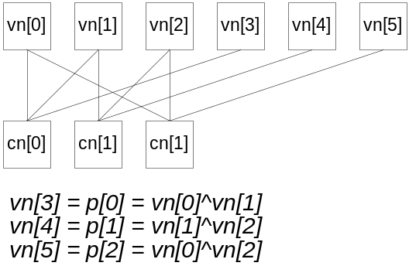
Figure 1: Simple Tanner Graph. A Tanner graph can be formed from the received bits (“variable nodes,” or VN’s) and the parity equations (“check nodes,” or CN’s). The parity equations, shown below the Tanner graph, are used to define the edges in the graph.
In the BP algorithm, parity bits and likelihood values are passed as messages from all variable nodes to all connected check nodes. The initial likelihood values are derived from the channel quality and the Euclidian distance between the received symbols and the nearest constellation points. Messages are passed as log-likelihood ratios (LLR’s), since representing probability ratios in this form allows for simpler arithmetic. The parity equations all evaluate to zero, so the check nodes determine the expected parity bits at each connected VN, based on the signs of each of the other connected nodes. The expected parity bits are passed to each connected variable node, along with likelihood values. The VN’s in turn use these values to update the VN parity bits and likelihood values, and the cycle begins again. In this way, the messages tend to strengthen bits which are in agreement with parity equations and correct bits which are in error.

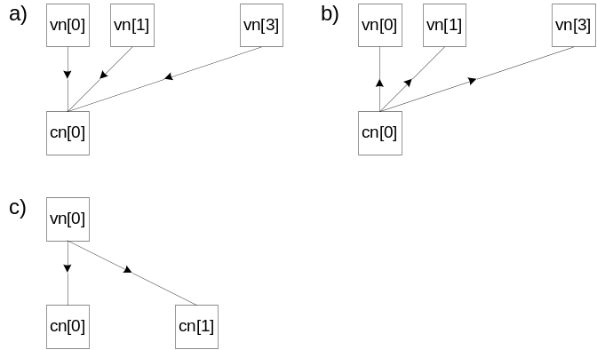
Figure 2: Message Passing. In (a), parity bits and likelihood ratios are passed from the variable nodes to the check nodes. In (b), the received messages are combined to create messages for the variable nodes, containing most likely parity values and the likelihood of that value being correct, based on the messages received from the other VN’s. (c) shows how the variable nodes (in this case, VN[0]) uses the received data to send updated parity values and likelihood ratios in the following iteration.

Trade-offs in the implementation were explored using the IT++ library provided by the Chalmers University of Technology [4]. The DVB generator matrix was imported into the library, and simulations were run at different coding rates and noise levels. Behavioral models of the RTL were created to examine performance differences between the ideal belief-propagation algorithm and a hardware-optimized version.
The ideal BP implementation combines the messages from the variable nodes to create optimal reliability messages. For a parallel implementation, each computation node would have to implement this function. It was shown in [5] that the Min-Sum algorithm can provide similar performance to the ideal implementation with far lower computational complexity. Rather than combining the likelihood values optimally in the check nodes for each edge, the Min-Sum algorithm uses the least likely received message as an approximation of the result for all edges but one. The message created for the edge which transferred the smallest LLR must be calculated separately, since the received result on any edge may not be used in the calculation of the message that will flow back along that same edge. For the edge that transferred the smallest LLR, the next-to-smallest LLR is used as an approximation. The Min-Sum approach allows for simpler arithmetic and reduces storage requirements, since only two LLR values are stored.
For performance comparison, the ideal BP algorithm is simulated over 30 and 500 iterations. In this ideal case, the LLR is represented as a quantized value with very fine granularity of 0.06, and a maximum value of 10⁶. In the hardware implementation, it is necessary to quantize the message values to far fewer bits. The figure below shows the simulated performance for Min-Sum using different word widths, compared with the ideal case. For this code, Min-Sum achieves performance nearly identical to the ideal BP algorithm when messages are quantized to 12 bits, with only a very slight degradation at 8 bits of quantization. Performance degrades more significantly at 4 quantization bits, and 3 or fewer quantization bits achieved unacceptable performance.
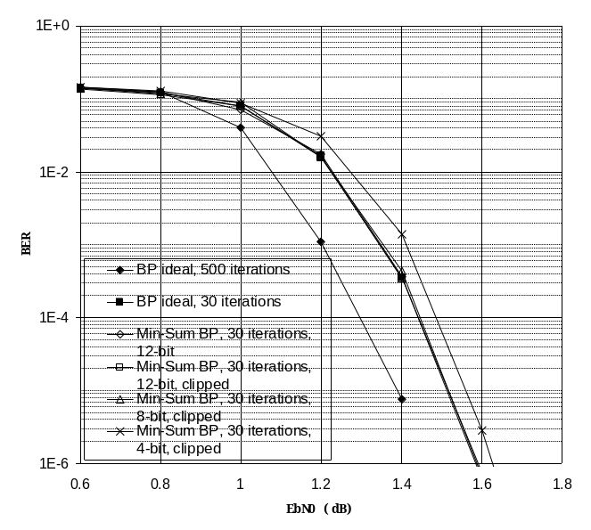
Figure 3: Effects of Min-Sum BP approximation and quantization on error correction performance. Short frames were used in the comparison, at the rate: (n, k)=(16200, 7200).

It was found in [6] that a non-linear message representation improves the compression of messages while retaining the same performance as a linear representation. The simulations carried out for DVB-S2’s LDPC specification could not reproduce this result, with BER results for log-scale messages uniformly inferior to the linear version. Simulations were carried out using logarithmic tables of various lengths, using bases between 1.25 and 2.0, and maximum values the same or twice the magnitude of the linear tables.
Another coding scheme was simulated, with the goal of improving the granularity of the messages by removing a redundant signed zero representation. In this encoding scheme, the coded inputs were offset by positive or negative 1, so that +0 represented 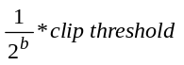 and -0 represented a negative number of the same magnitude. This offset-linear scheme retained symmetry around zero and improved the granularity of the messages. Unfortunately, while offset-linear encoding did have better performance under certain EbN0 values, the performance degraded relative to the linear implementation as EbN0 increased. DVB-S2 is intended to deliver a quasi-noise free stream, so the codeword input to the BCH decoder should have an error rate of at most 10⁻⁴. By that criterion, offset-linear encoding had poorer performance under all usable conditions, compared to direct linear encoding.
It was found in [5] that clipping the received signal at ±1.25 can improve performance under some circumstances, but can also introduce a noise floor. That same paper indicated the optimal BER was achieved using a clipping level of ±2. Simulations carried out on DVB-S2 indicated slightly better performance with the latter clipping value, so that value was chosen. No attempt was made to find the optimal clipping value, as clipping is implemented outside of the LDPC decoder, in the quantization/LLR function.

Architecture
DVB-S2 uses codewords of up to 64,800 bits in length, and with more than 280,000 edges in the Tanner graph. Passing this many messages in parallel would be impractical, and would provide far higher performance than what is required. For this project, a performance level of 135Mbps was targeted, and it was assumed that the synthesized result would run at 200MHz or faster. Single-port RAM’s were used, requiring 2 cycles for each message transmission, but using less silicon and allowing more flexibility in terms of folding logic or multi-cycle paths, compared to dual-port RAM’s. Based on these assumptions, the minimum degree of parallelism was calculated:

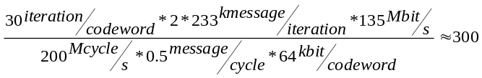

The DVB-S2 standard is written such that bits are arranged in groups of 360 bits, so this is the degree of parallelism that was chosen. Increasing the frequency or using dual-port RAM’s could allow for 180x, 90x or 45x parallelism for reduced area, with some increase in the complexity of the control logic.
Central to the design is a shuffle network, which shifts 360 input messages to 360 outputs through a 3-stage pipeline. The LDPC code described in the DVB-S2 standard is designed such that these connections aren’t random, so the shuffle network is a barrel-rotation, rather than a crossbar. The shuffle network has a multiplexer at each input, to select from the check node and the variable node messages.
The VN’s are each connected to two RAM’s, one holding the LLR values and one holding the sum of the incoming messages from the CN’s. Each VN holds adders to combine incoming messages and create the outgoing message, and registers to hold the I/O data and the messages.
The CN’s are each connected to a single, wide RAM holding the two smallest of the incoming LLR’s during the current iteration, the signs of all incoming messages, the locations of the minimum values, and the parity result of all the incoming messages. The message to the VN’s are produced by reading one of the two min-LLR values, along with the expected sign value for a particular edge.
The control module reads a ROM to fetch a shift value for the shuffle network and a write/read address for the check nodes. In the forward direction, for message passing from VN’s to CN’s, these values are used directly. In the reverse direction, the shift value is negated to allow messages to flow along the same edge in both directions. The control module also needs to compensate for delays in the shuffle network, VN’s and CN’s.

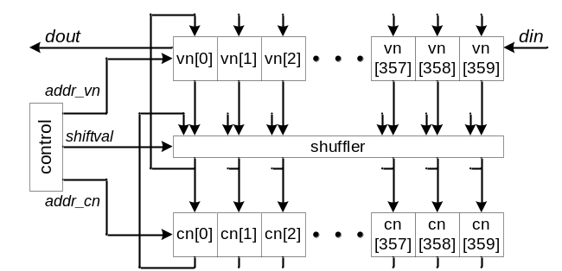
Figure 4: Top-Level Block Diagram

To allow parallel access to all 360 variable nodes in a group, the VN RAM’s are arranged as shown below:

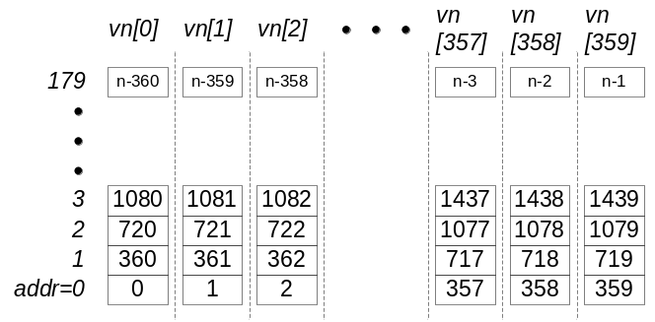
Figure 5: Preliminary VN Memory Organization

The DVB-S2 standard was required to define an LDPC code which could be efficiently implemented in hardware, but a regular edge pattern would have provided poor performance. To create a pseudo-irregular edge pattern, a scrambling factor was introduced, spreading edges throughout the codeword. This scrambling factor, q, is proportional to the number of check nodes, and is defined as 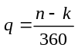. In the standard, the edges are defined in groups of 360 variable nodes, with each edge starting at a vn[m], where m is the relative position within the 360-node group, and ending in check node 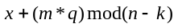, where x is a base parity location, defined in appendices of the standard. For instance, for the 1/4 code rate, the code parameters (n, k) are (64800, 16200), and 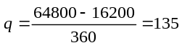. The first edge defined in the standard for vn[0] is 23606. The corresponding edge for vn[1] is . For this example, to allow simultaneous message passing from: {vn[0], vn[1].. vn[359]}, the following CN memory locations must be made available:

{cn[23606], cn[23741].. cn[(23606+135*359)mod(n-k)]}

The need to access {x, x+q, x+2q..} suggests the following memory organization in the CN’s:

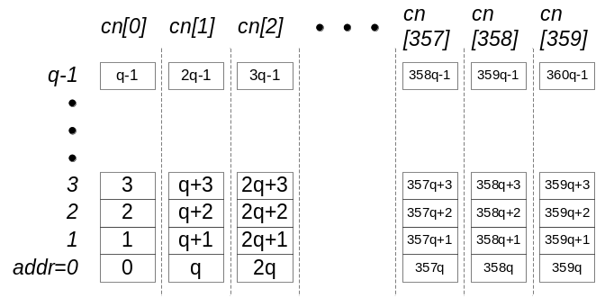
Figure 6: CN Memory Organization

This pattern is used through the parity encoding of all the data bits in the codeword, but in the end the parity bits are combined in a different manner. The first parity bit, vn[k] is encoded into the check equation cn[1], then vn[k+1] is encoded into cn[2], and so on until the end of the codeword. This suggests a different pattern for the check nodes than that used in Figure 6, but the parity VN’s can be reorganized to match the arrangement used in the CN’s, as follows:

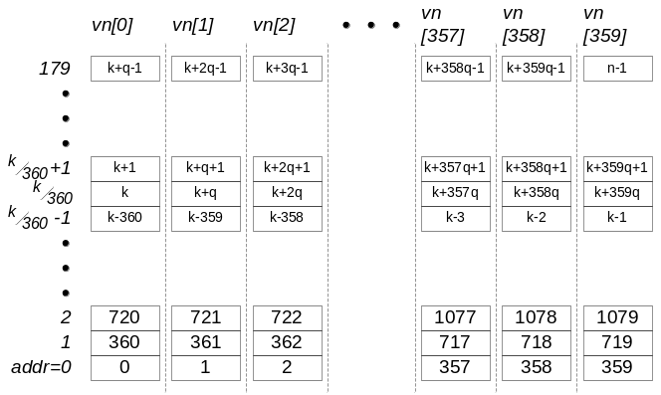
Figure 7: Final VN Memory Organization. Parity VN bits have been scrambled by factor q to align with CN organization. q=(n-k)/360, so the last address of VN[360] contains data for variable node (k+360q-1), or equivalently, (n-1), as illustrated in this figure.
Storing all messages in the VN’s is required for the optimal result by summing the received messages, but excluding the message received on the edge being calculated. Storing all the upstream messages would require a large RAM to store up to 30 messages at each location in each VN. To avoid the use of these large RAM’s, the CN’s store the messages sent in the previous upstream message, and subtract that value from the received downstream message. When neither upstream nor downstream message saturates to the full LLR value, this approach provides identical results to the ideal approach. When one of the messages saturates, some distortion occurs. In particular, for the case when both upstream and downstream messages are saturated, the resulting offset-message received in the CN will be zero, even though the VN sent the maximal LLR. This problem is diminished by limiting the upstream message to one fewer bit than the downstream messages. This approach allows for the use of small RAM’s in the VN’s, but reduces the performance by reducing the number of effective message bits by one.
The use of layered decoding was considered for this project, but was not suitable for the proposed architecture. Layered decoding can reduce the number of required iterations by updating VN outgoing messages during each iteration and using this updated value to provide improved downstream messages to the CN’s. This approach requires shifting the message-passing direction many times during a single iteration to update the VN’s with the latest messages. It also implies that the messages are passed in row-order, (in terms of the parity matrix), so that all messages destined for a single check node are passed around the same time. Switching directions has a significant (at least 5 cycle) penalty in the implemented design, increasing the period of each iteration. For instance, if each check node in the Tanner graph were attached to 4 edges, reversing the direction after each complete check-node update would increase each iteration’s period by more than 60%. Passing messages in parity matrix row-order, rather than column-order, as is currently implemented, would require a very different memory arrangement than the one proposed, and possibly a number of architectural changes.

Detailed Design
LLR data is first loaded serially into the variable nodes through a chain of registers. The signal, llr_access, turns off message passing and connects the chain of registers, with the signal llr_din_we swapping the data in the RAM for the data in the register chain. For instance, if llr_addr were held to zero and the llr_din_we were driven high, the contents of the chain of registers would be written into address zero, and the contents of each of the RAM’s at location zero would be loaded into the chain. In this manner, reads and writes from the module can be accomplished simultaneously. Data should be written in the format described in Figure 7.
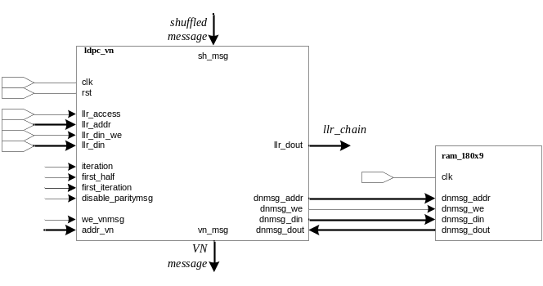
Figure 8: Variable node instance 0
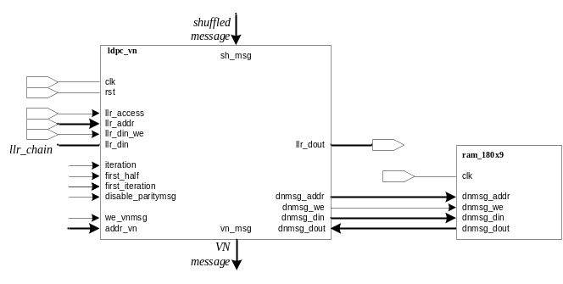
Figure 9: Variable node instance 359
After data has been written into the decoder, the message passing algorithm may begin. This is controlled by the signal “start” which loads parameters, including the mode and the number of iterations, and starts the decoding process. The modes are as follows:

mode number | description | n | k
0 | 1/4 normal | 64800 | 16200
1 | 1/3 normal | 64800 | 21600
2 | 2/5 normal | 64800 | 25920
3 | 1/2 normal | 64800 | 32400
4 | 3/5 normal | 64800 | 38880
5 | 2/3 normal | 64800 | 43200
6 | 3/4 normal | 64800 | 48600
7 | 4/5 normal | 64800 | 51840
8 | 5/6 normal | 64800 | 54000
9 | 8/9 normal | 64800 | 57600
10 | 9/10 normal | 64800 | 58320
11 | 1/5 short | 16200 | 3240
12 | 1/3 short | 16200 | 5400
13 | 2/5 short | 16200 | 6480
14 | 4/9 short | 16200 | 7200
15 | 3/5 short | 16200 | 9720
16 | 2/3 short | 16200 | 10800
17 | 11/15 short | 16200 | 11880
18 | 7/9 short | 16200 | 12600
19 | 37/45 short | 16200 | 13320
20 | 8/9 short | 16200 | 14400
Table 1: Modes
The system controller manages the exchange of messages between the variable and check nodes by controlling the VN and CN write and read addresses and the shift value of the shuffler.

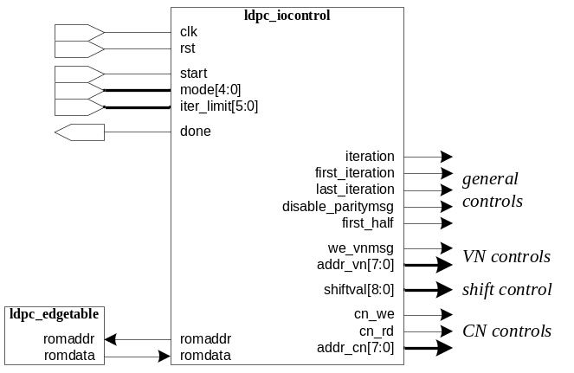
Figure 10: Controller Signals
The controller reads the edge destinations from the ROM and creates addr_cn and addr_vn (the check and variable node addresses), along with the write enable signals based on those edges. The basic state machine operation is as follows:
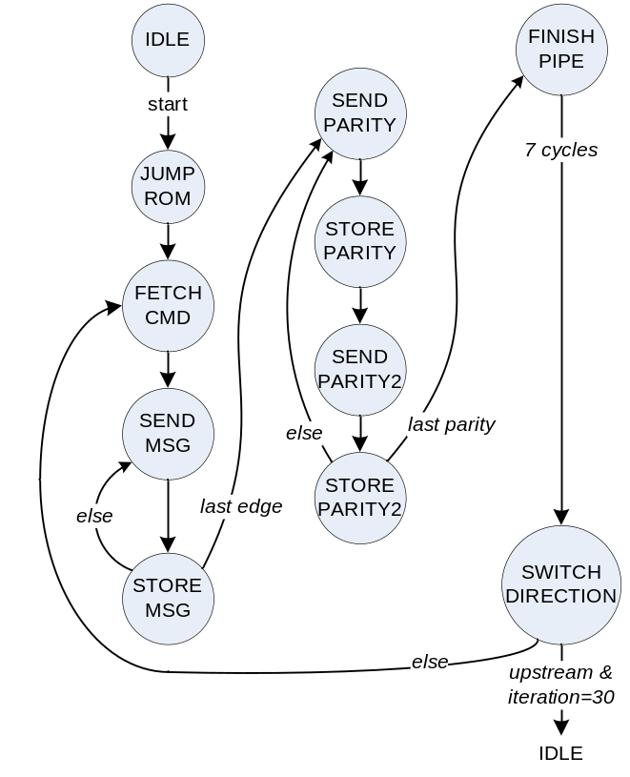
Figure 11: State machine in module iocontrol
The state machine ignores delays in the shuffler, VN’s and CN’s, and relies on delay registers elsewhere in the module “iocontrol” to align the control signals properly.
The shuffler muxes the CN and VN messages into a pipeline of shifters, allowing for any rotation in three cycles. The signal “first_half” controls the multiplexer, using “vn_concat” in the first half of each iteration, and “cn_concat” in the second half.
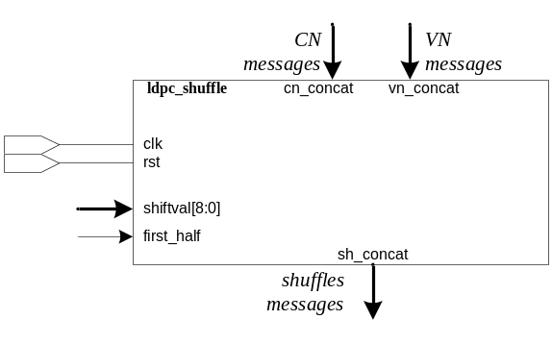
Figure 12: Shuffler Signals

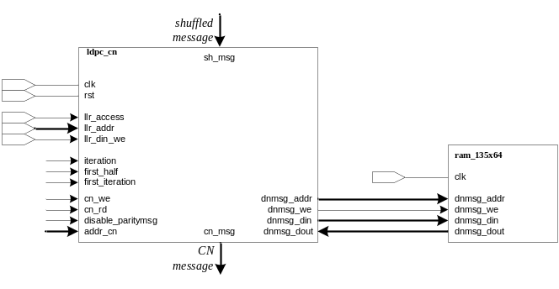
Figure 13: Check node

Verification
Models of the intended behavior of ldpc_vn, ldpc_cn and ldpc_shuffle were written in C, and code was embedded in the top level to detect mismatches between the C and Verilog models. NOTE: I LOST SOME WORK, SO I NO LONGER HAVE THE MODELS OR THE CODE WHICH CALLS THEM. I MAY REPRODUCE THAT LATER. AT THE MOMENT, VERIFICATION RELIES SOLELY ON CHECKING THE ERROR-CORRECTING PERFORMANCE.

Performance – out of date! based on 360 nodes, single-port rams
The error correcting performance of the RTL was tested by adding noise to random frames for each code rate and EbN0 value. Noise values were generated using the IT++ platform, and imported into the RTL testbench. Each normal (64800 bit) code rate was tested at noise levels appropriate to the code rate, at noise levels separated by 0.1dB. The range of noise levels to use in the simulation was extrapolated from [7]. To improve the accuracy of the result, enough codewords were simulated to produce a total of 500 errored bits or more in the decoded results at each EbN0 level, up to 9 codewords in total. Once a noise level was reached which resulted in a BER of lower than 10⁻⁴, simulation was halted, with BER of zero recorded as 10⁻⁶.
The input LLR’s were scaled to a maximum of 24/N0 and quantized. This scale was chosen because 12/N0 was shown to be a good clip value in the IT++ simulation for the 4/9 rate, and the RTL implementation clips messages to half the input LLR level. It is likely that this isn’t the ideal scale, but LLR calculation is outside the scope of this project. It is sufficient to observe that the module corrects errors and that the error correction follows the characteristic curve, with a noisy region at low EbN0 values and a “waterfall region” where increasing EbN0 slightly results in a dramatic improvement in decoder performance. The characteristic curve also includes an “error floor” region, where the resulting BER drops only gradually as EbN0 is increased. Because of the long run-times of the RTL simulation and the number of code lengths to be simulated, it would take a long time to simulate enough frames to show the error floor region, and this wasn’t attempted in this project.

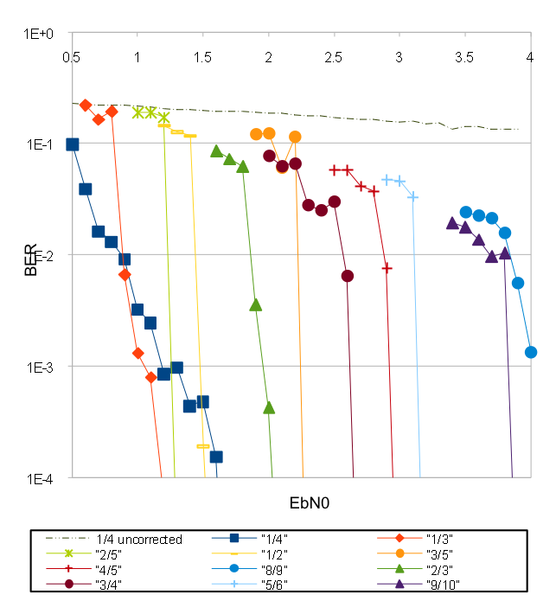
Figure 14: Error correcting performance for various code rates
The results generally follow expectations. There are some irregularities in the transition from the noisy region to the waterfall regions of the curves, but this is to be expected with the small sample size. The number of errors in the waterfall region can vary widely; simulations showed variation of up to an order of magnitude for a single EbN0 value. A simulation of 10 or more frames per EbN0 level would produce smoother curves, but run times would last more than one week for each code rate on the current simulation platform.
Some of the curves, in particular that for 1/4 rate show a gradual decrease in errors as EbN0 increases, rather than the rapid drop-off expected. This likely indicates that the quantization value chosen in the testbench wasn’t optimal, resulting in an early noise floor. Another unexpected result is that the curves for the rates 3/5 and 8/9 are out-of-order in the chart, indicating that the performance for these two rates is poorer than expected. A cursory examination of the simulation at these two code rates did not show any errors in the operation of the circuit, so this remains an open question. A simulation over more frames could shed some light on this problem. It is possible that the clipping level chosen could somehow favor certain rates over others. C simulations indicated that clipping at too low a value could increase performance at high noise levels, but introduce an early noise floor at higher noise levels. Simulation results are generally better than those reported in [7], lending credence to the idea that the clipping level affected performance results.
The desired throughput for this project is 135Mbps, assuming the circuit runs at 200MHz. The actual maximum data rate at 200MHz is approximately 115Mbps. The most serious limiting factor isn’t the decoder itself, which runs at better than 300Mbps, but rather the serial load/unload mechanism. Loading 8 or 16 bits at a time would be a trivial change which would bring performance numbers easily into the desired range.

Code | Cycles to completion | Mbps @200MHz
1/4 normal | 97620 | 132.8
1/3 normal | 101220 | 128.0
2/5 normal | 104100 | 124.5
1/2 normal | 103020 | 125.8
3/5 normal | 112740 | 115.0
2/3 normal | 101220 | 128.0
3/4 normal | 103020 | 125.8
4/5 normal | 104100 | 124.5
5/6 normal | 104820 | 123.6
8/9 normal | 97620 | 132.8
9/10 normal | 97620 | 132.8
Table 2: Throughput

Suggestions for Improvement
The design presented didn’t make optimal use of the RAM’s, since the RAM’s used at the CN’s were wide enough to store information for the highest coding rates, and deep enough to store all messages for the lowest rates. This approach sacrificed area for maximal throughput, even though performance greatly exceeded requirements for most code rates. As demonstrated in the following table, re-organizing memory could save approximately half the memory used:

code | k  /360 | (n-k)  /360 | connections  per varnode | mem. width | RAM  utilization
1/4 | 45 | 135 | 4 | 29 | 45%
1/3 | 60 | 120 | 5 | 33 | 46%
2/5 | 72 | 108 | 6 | 34 | 43%
1/2 | 90 | 90 | 7 | 35 | 36%
3/5 | 108 | 72 | 11 | 42 | 35%
2/3 | 120 | 60 | 10 | 41 | 28%
3/4 | 135 | 45 | 14 | 45 | 23%
4/5 | 144 | 36 | 18 | 52 | 22%
5/6 | 150 | 30 | 22 | 56 | 19%
8/9 | 160 | 20 | 27 | 61 | 14%
9/10 | 162 | 18 | 30 | 64 | 13%
Table 3: CN Message RAM Utilization
Reorganizing the memories in the current architecture is a difficult task, since that implies accessing and writing data at different rates in the VN’s and CN’s. Another solution might be to combine the VN’s and CN’s, and to store data for the two functions in a common RAM. Code rates which require large storage in the CN’s require less storage in the VN’s, and vice-versa, so storing the data together makes better use of RAM. Using the current logic, such a change would require 3-port RAM’s with two simultaneous writes to different addresses.
References
- R. G. Gallager, Low Density Parity Check Codes. Cambridge, MA: MIT Press, 1963
- D. J. C. MacKay and R. M. Neal. “Near Shannon limit performace of low density parity check codes.” Electronics Letters, volume 32, pages 1645-1646, Aug1996
- European Telecommunications Standards Institute. Digital Video Broadcasting (DVB); Second generation framing structure, channel coding and modulation systems for Broadcasting, Interactive Services, News Gathering and other broadband satellite applications; ETSI EN 302 307 V1.1.2 (2006-06)
- Chalmers University of Technology, IT++. htpp://itpp.sourceforge.net
- A. H. Banihashemi, J. Zhao and F. Zarkeshvari, ``On implementation of min-sum algorithm and its modifications for decoding LDPC codes," IEEE Trans. Comm., Nov 2004
- J. K. S. Lee, J. Thorpe, J. Hawkins, “Memory-Efficient Decoding of LDPC Codes,” IEEE Intl. Symposium on Information Theory, Sep 2005
- B. Honary, N. Pandya, “Variable-Rate Low-Density Check Codes for DVB-S2 Applications,” Digital Video Broadcasting Over Satellite: Present and Future, 2006

 

