MiniUART IP Core
Specification

Author: Philippe Carton
Philippe.carton2@libertysurf.fr

Rev. 0.1
November j, 2026

This page has been intentionally left blank

Revision History

Rev. | Date | Author | Description
0.1 | 28/12/01 | Philippe Carton | First Draft
0.2 | 5/3/02 | Philippe Carton | Detailed Baudrate tolerance section

Contents

Introduction ……………………………………………… 1

IO ports ……………………………………………… 2

Clocks ……………………………………………… Error: Reference source not found

Registers ……………………………………………… 4

Operation ……………………………………………… 6

Architecture ……………………………………………… 9

1
Introduction

This UART (Universal Asynchronous Receiver Transmitter) is designed to make an interface between a RS232 line and a wishbone bus, or a microcontroller, or an IP core.
It works fine connected to the serial port of a PC for data exchange with custom electronic.
It was built in the perspective to be very small, but efficient. It had to fit in a small FPGA.
It is not suited to interface a modem as there is no control handshaking (CTS/RTS).
It integrate two separate clocks, one for wishbone bus, the other for bitstream generation. This has the advantage to let the user bring his own desired frequency for the baudrate.

Support:

- WISHBONE interface in 8-bit data bus
- Two clock: one for wishbone interface, one for RS232 bitstream generation
- Baudrate divisor from 1 to 65536 (generic parameter set at integration time)

Does not support:
- FIFO input/output
- Control handshaking

2
IO ports

2.1 WISHBONE interface signals

Port | Width | Direction | Description
WB_CLK_I | 1 | Input | Block’s clock input
WB_RST_I | 1 | Input | Asynchronous Reset
WB_ADDR_I | 2 | Input | Used for register selection
WB_DAT_I | 8 | Input | Data input
WB_DAT_O | 8 | Output | Data output
WB_WE_I | 1 | Input | Write or read cycle selection
WB_STB_I | 1 | Input | Specifies transfer cycle
WB_ACK_O | 1 | Output | Acknowledge of a transfer

2.2 Other internal signals

Port | Width | Direction | Description
IntTx_O | 1 | Output | Transmit Interrupt
IntRx_O | 1 | Output | Receive Interrupt
BR_CLK_I | 1 | Output | Clock for serialisation/unserialisation

2.3 External (off-chip) connections

Port | Width | Direction | Description
TxD_PAD_O | 1 | Output | The serial output signal
RxD_PAD_I | 1 | Input | The serial input signal

3
Clocks
Clocks table:

Name | Source | Rates (MHz) |  |  | Remarks | Description
Name | Source | Max | Min | Resolution | Remarks | Description
WB_CLK_I | Wishbone bus | Limited by target host |  |  | None | Wishbone clock
BR_CLK_I | User | Limited by target host |  |  | None | Baudrate clock

4
Registers

4.1 Registers list

Name | Address | Width | Access | Description
Receive buffer | 0 | 8 | R | Contain byte received
Transmit buffer | 0 | 8 | W | Contain byte to transmit
Status | 1 | 8 | R | Receive buffer full / Transmitter busy
Reserved | 2 | 8
Reserved | 3 | 8

4.2 Status register

Bit # | Access | Description
0 | R | Transmitter buffer state = IntTx_O pin  ‘0’ – Busy. Can’t accept incoming byte  ‘1’ – Accept a byte to transmit
1 | R | Receiver buffer state = IntRx_O pin  ‘0’ – Buffer empty  ‘1’ – Buffer contain a received byte

Reset Value: XXXXXX01b

5
Operation

The UART Operation is very basic :
Upon a write to the data input bus WB_DAT_I, the core will automatically serialise and emit the byte on the TxD_PAD_O. It will hold IntTx_O low as long as it cannot accept an incoming byte. Therefore a rising edge on IntTx_O can trigger the interrupt line of a microcontroller to emit another byte.
Upon reception of a bitstream on RxD_PAD_O, the core will unserialise the information and assert IntRx_O pin. This announce that the received byte can be read on the data output bus WB_DAT_O. As soon as the byte is read, IntRx_O is negated.

Wishbone bus
The core is 8 bit wishbone compatible. It doesn’t use the WB_CYC_I pin as it will never insert wait states.

Initialization
The core doesn’t need to be reset, as it is ready to use upon power on.
However, a synchronous assertion of WB_RST_I will abort any pending transmit / receive and will set the core in idle state.

Baudrate divisor
A generic VHDL parameter allow the user to introduce a divisor between BR_CLK_I clock and the bitstream frequency. In addition, the core insert a 4 divisor for sampling purpose for the receiver.

Thus:
Baudrate = Freq(BR_CLK_I) / BRDIVISOR / 4

Where BRDIVISOR is the generic parameter.

To instanciate the component in a VHDL unit, write:

U1 : MiniUART
generic map (BRDIVISOR => 103)
port map (clk, rst, adr, ...);

for a division of 103.
Below are given some divisor values for common baudrates:
BRDIVISOR | Baudrate
2080 | 1200
1040 | 2400
520 | 4800
260 | 9600
130 | 19200
65 | 38400
BR_CLK_I at 10MHz
BRDIVISOR | Baudrate
192 | 2400
96 | 4800
48 | 9600
32 | 14400
24 | 19200
16 | 28800
8 | 57600
4 | 115200
2 | 230400
1 | 460800
BR_CLK_I at 1.8432MHz

Baudrate tolerance
The receiver will accept a light variation between the expected baudrate and the effective bitstream baudrate that is:

Min freq | Nominal Baudrate -2.60%
Max freq | Nominal Baudrate +5.90%

Equivalent in period :
Min period | Nominal period -5.90%
Max period | Nominal period +2.60%

Going beyond this limits, the receiver will be unable to deserialise correctly.

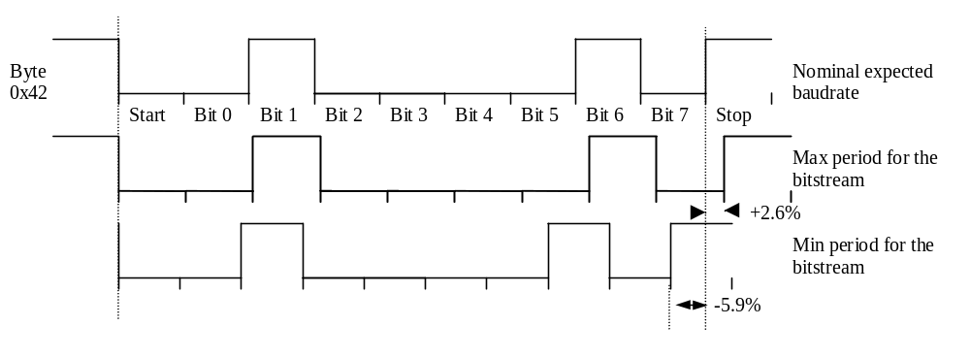

6
Architecture

The block diagram of the core is given:
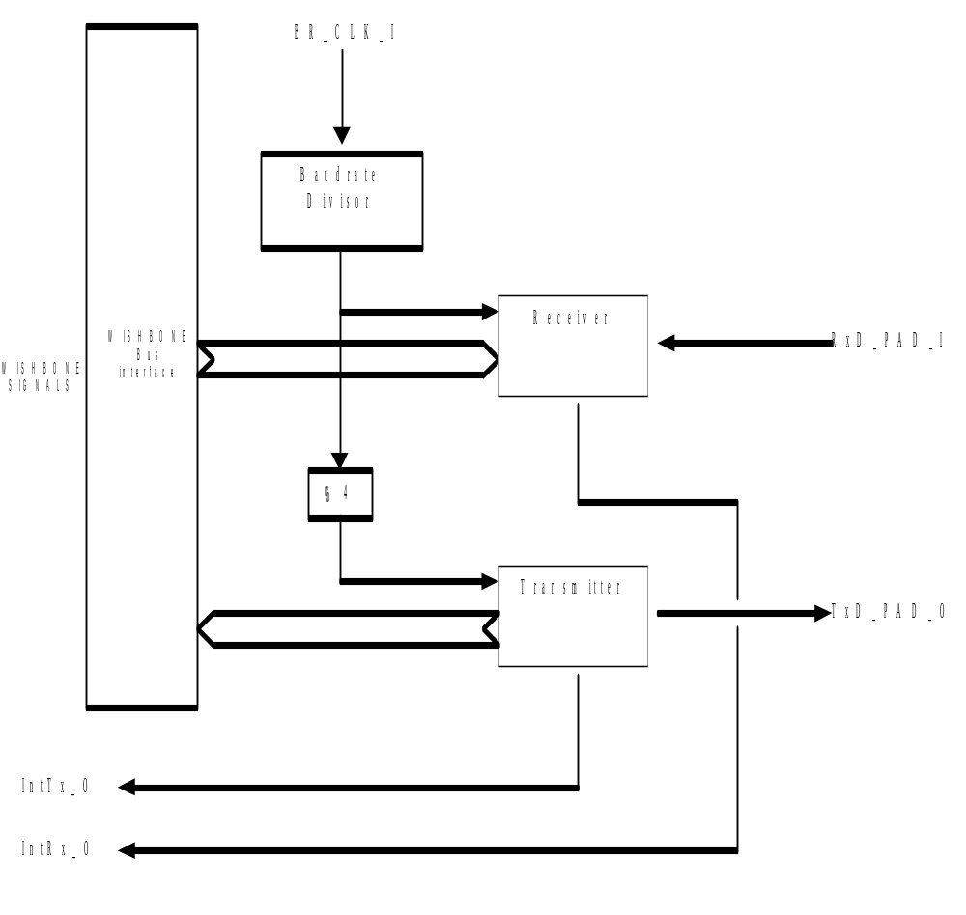
Figure 1 - Block Diagram of the UART core

