OVERVIEW

Light52 is a free, small open-source CPU core compatible to the Intel MCS51 architecture.

While the core is within the performance envelope of other free MCS51 cores, the implementation trades area for speed.
This core is smaller than most free and commercial MCS51 cores and its speed is comparable to that of a 6-clocker -- see sections 8 and 9.

The full original MCS51 instruction set is implemented with the possible exception of the BCD opcodes (DA and XCHD) which are optional.

FEATURES

● | 100% binary compatible to MCS51 (except possibly for optional BCD instructions).
● | Speed comparable to a 6-clocker.
● | Configurable through VHDL generics.
● | Smaller than most other cores.
● | Includes 16-bit timer, UART and I/O ports.
● | Additional peripherals and SFRs can be added easily.
● | 256 bytes of IRAM -- fixed size.
● | Fully synthesizable, static synchronous design with positive edge clocking and no internal tri-states.

Light52 lacks some features usually present in other MCS51 cores and has some important limitations:

SHORTCOMINGS

● | No access to off-chip memory.
● | Strictly Harvard: XDATA and XCODE spaces can't be merged into a Von Neumann architecture.
● | From 2 to 8 clocks per instruction.
● | Far slower than most commercial cores: performance/area ratio is worse even though area is much smaller.
● | No On-Chip Debugging capability.

1.- Pinout

Table 1: Core Signal Pinout
Signal | Direction | Description
clk | input | Clock, active on rising edge.
reset | input | Active high synchronous reset.
rxd | input | RxD input for on-board UART.
txd | output | TxD output from on-board UART.
external_irq[7..0] | input | High-level-sensitive interrupt inputs
p0_out[7..0] | output | Port P0 8-bit output.
p1_out[7..0] | output | Port P1 8-bit output.
p2_in[7..0] | input | Port P2 8-bit input.
p3_in[7..0] | input | Port P3 8-bit input.

2.- Functional Description

Since the MCS51 architecture is already well documented elsewhere, this datasheet will only deal with those aspects of the core which depart from the original.

In this version of the core, there is no support for shared XCODE/XDATA memory spaces (the core performs simultaneous accesses to XCODE and XDATA and there is no wait state or access arbitration logic yet). The MCU memory model is therefore strictly Harvard.

The peripherals included in the MCU core are generally not compatible to the MS51 peripherals and are somewhat less flexible -- the core trades programmability in run-time for configurability in synthesis time. See section 7 below for a detailed description of available peripherals.
Existing MCS51 programs will generally NOT work unmodified on this core -- code needs to be ported to the available peripherals and their SFRs like it needs to be in any other MCS51 derivative.

Interrupt operation is identical to the original, except of course for the unimplemented peripherals whose interrupt request lines have been left unconnected and are available for user designs.

3.- Special Function Registers

Table 2 lists the SFRs implemented in the current version of the core.
Table 2: Light52 Special Function Registers
Symbol | Description | Direct Address | Bit Address and Symbol |  |  |  |  |  |  |  | Reset  Value
ACC | Accumulator | E0H | E7 | E6 | E5 | E4 | E3 | E2 | E1 | E0 | 00H
B | B register | F0H | F7 | F6 | F5 | F4 | F3 | F2 | F1 | F0 | 00H
DPH | DPTR high | 83H |  |  |  |  |  |  |  |  | 00H
DPL | DPTR low | 82H |  |  |  |  |  |  |  |  | 00H
IE | IRQ Enable | A8H | AF | AE | AD | AC | AB | AA | A9 | A8 | 00H
 |  |  | EA | - | - | ES | - | - | ET0 | EX0
IP | IRQ Priority | B8H | BF | BE | BD | BC | BB | BA | B9 | B8 | 00H
 |  |  | - | - | - | PS | - | - | PT0 | PX0
PSW | Program | D0H | D7 | D6 | D5 | D4 | D3 | D2 | D1 | D0 | 00H
 | Status Word |  | CY | AC | F0 | RS1 | RS0 | OV | - | P
SP | Stack Pointer | 81H |  |  |  |  |  |  |  |  | 07H
P0 | Port 0 outp. | 80H | 87 | 86 | 85 | 84 | 83 | 82 | 81 | 80 | 00H
P1 | Port 1 outp. | 90H | 97 | 96 | 95 | 94 | 93 | 92 | 91 | 90 | 00H
P2 | Port 2 inp. | A0H | A7 | A6 | A5 | A4 | A3 | A2 | A1 | A0
P3 | Port 3 inp. | B0H | B7 | B6 | B5 | B4 | B3 | B2 | B1 | B0
T0CON | Timer 0 | 88H | 8F | 8E | 8D | 8C | 8B | 8A | 89 | 88 | 00H
 | Control |  | - | - | T0CEN | T0ARL | - | - | - | T0IRQ
T0L |  | 8CH |  |  |  |  |  |  |  |  | 00H
T0H |  | 8DH |  |  |  |  |  |  |  |  | 00H
T0CL |  | 8EH |  |  |  |  |  |  |  |  | FFH
T0CH |  | 8FH |  |  |  |  |  |  |  |  | FFH
SCON | UART | 98H | 9F | 9E | 9D | 9C | 9B | 9A | 99 | 98 | 00H
 | Control |  | - | - | RxRdy | TxRdy | - | - | RxIrq | TxIrq
SBUF | Data Buffer | 99H
SBPL | Baud Rate L | 9AH | Initialized as per generics UART_BAUD_RATE and UART_CLOCK_RATE |  |  |  |  |  |  |  | (*1)
SBPH | Baud Rate H | 9BH | Initialized as per generics UART_BAUD_RATE and UART_CLOCK_RATE |  |  |  |  |  |  |  | (*1)
EXTINT | External | C0H | C7 | C6 | C5 | C4 | C3 | C2 | C1 | C0 | 00H
 | IRQ Flags |  | EIRQ7 | EIRQ6 | EIRQ5 | EIRQ4 | EIRQ3 | EIRQ2 | EIRQ1 | EIRQ0
Notes
1 | Only if generic UART_HARDWIRED is false, and then write only.

4.- Interrupt Vectors

Interrupt management is identical to the original MCS51. The only difference is that the five available interrupt request inputs are connected to different sources:

Table 3: Interrupt Vectors and Sources
IRQ | Source | Vector | Priority | 8051 equivalent
0 | External IRQ | 0003h | (highest) | IE0
1 | Timer 0 | 000Bh |  | TF0
2 | Unassigned | 0013h |  | IE1
3 | Unassigned | 001Bh |  | TF1
4 | UART | 0023h | (lowest) | RI+TI

Registers IE and IP and the interrupt priority mechanics work exactly as in the original MCS51, and so does instruction RETI.

5.- Object Code Initialization

This core does not have access to external, off-chip memory: the program code is stored internally within the MCU module. And the XCODE memory space cannot be 'merged' with the XDATA space as it can be done in many MCS51 derivatives -- the MCU is strictly Harvard. Thus, the XCODE can only be initialized at synthesis time.
The XCODE ROM is initialized at synthesis time with the contents of VHDL generic OBJ_CODE, which is expected to be defined in a package named obj_code_pkg.
This package must be generated separately for each project and can be considered part of the program application rather than part of the core source -- because it includes the program object code in VHDL format.

The light52 project has adopted the convention that the package obj_code_pkg must be defined in a vhdl file placed within the MCS51 program directories; that is, separate from the rest of the VHDL source files -- for this purpose, the obj_code_pkg package can be considered as just another object code format.
This way, the object code for different projects using this core (or for the different code samples within this project) can be neatly separated from the core sources.

The project includes a Python script (directory /tools/build_rom) which can be used to produce a suitable obj_code_pkg package file from an Intel-HEX object file. The code samples in directory /test contain usage examples for this script (makefiles and/or BAT files build.bat).

While the method chosen for object code initialization is clean and vendor-independent, it has a major drawback: The object code must be available at synthesis time, and every time the code changes the synthesis has to be re-run. This may be a big handicap in certain applications.
Subsequent versions of the core may provide the option to use memory initialization files so that the XCODE memory can be initialized post-synthesis.

Included in the same package as the object code are two constants, XCODE_SIZE and XDATA_SIZE. These constants are set manually in the makefile of each project (only C projects, see the Dhrystone demo for an example) and then are included in the invocation to the Python script. These constants are meant to be assigned to the MCU generics XCODE_ROM_SIZE and XDATA_RAM_SIZE, respectively, which determine the size of the XCODE and XDATA memories.
If you use SDCC, you can make the linker check the object code and XRAM usage against these bounds (again, see the demo makefiles for an example of this).
Thus, you can manually set the ROM and RAM size for your project with the confidence that the final application will work using the smallest amount of FPGA memory.

6.- Configuration Generics

Some of the core features can be configured through VHDL generics:

Table 4: Core Configuration Generics
Generic | Default | Description
CODE_ROM_SIZE | 2048 | Size of XCODE ROM in bytes. Must be >= 512.
XDATA_RAM_SIZE | 0 | Size of XDATA RAM in bytes.
OBJ_CODE | (dummy) | Object code to be placed on ROM. See previous section.
USE_BRAM_FOR_XRAM (*1) | false | Use extra BRAM as XDATA RAM.
IMPLEMENT_BCD_INSTRUCTIONS | false | True to implement DA and XCHD, false to execute them as NOPs.
SEQUENTIAL_MULTIPLIER (*1) | false | Use sequential multiplier instead of combinational.
UART_HARDWIRED | true | True to hardwire UART baud rate, false to make it configurable at run time.
CLOCK_RATE | 5,00E+007 | Clock rate (in Hz) assumed by UART and Timer initialization constants.
UART_BAUD_RATE | 19200 | Default baud rate for UART. Must be <= CLOCK_RATE / 16.
TIMER0_COUNT_RATE | 50000 | Count frequency of Timer0 (configures T0 prescaler).
Notes
1 | Unimplemented, will cause a synthesis assertion failure if given a non-default value.

Object Code and Memory Generics

These generics are meant to be initialized with the constants defined in package obj_code_pkg (see previous section). This will guarantee that the RAM requirements for the application are met without any waste of FPGA resources.
Setting XDATA_RAM_SIZE to 0 will remove the XRAM entirely for those projects that don't need it.
The actual size of the synthesized XDATA RAM will of course be a multiple of the underlying BRAM size for the FPGA architecture, so you are advised to choose the value of the generic accordingly.
The XCODE memory can obviously not be removed (remember this core has no access to external memory) and its minimum size has been arbitrarily set to 512 bytes.
Both XCODE and XDATA are limited to the 'natural' addressing range of 64KB. This core does not support any memory banking scheme.

7.- Peripheral Modules

The MCU core includes a number of peripheral modules. These peripherals have been designed hastily in order to provide a working environment for the CPU -- they do not have their own separate test bench, for example.
The current version of the MCU ships with a simple, hardwired UART, a 16-bit timer and four 8-bit input/output ports. This is enough for a few demos and maybe for some simple applications.
For real projects, though, the MCU is meant to be modified with new peripherals tailored to the application. For this purpose, the SFR bus of the CPU has been made accessible within the MCU entity.

SFR Interface of the CPU Module

Table 5: CPU SFR Interface Signals
Signal | Direction | Description
sfr_addr | output | SFR space address, valid when sfr_vma is high.
sfr_vma | output | Asserted high when a SFR read/write cycle is started.
sfr_rd | input | Read data. Must be valid by the end of the same cycle sfr_vma is asserted.
sfr_wr | output | Write data. Valid when sfr_vma is high AND sfr_we is high.
sfr_we | output | Asserted high (with sfr_vma) for write cycles.

Some of the SFRs are 'internal' cpu SFRs that are, well, internally decoded by the CPU module: ACC, B, DPH, DPL, IE, IP, PSW and SP -- they are grouped together in table 2.
All SFR read and write cycles take a single clock cycle. The SFRs must behave as an asynchronous memory when seen from the CPU; the SFR input multiplexor implemented outside the CPU module must be combinational.

Bit-Addressable SFRs
SFR addresses which are multiple of 8 are bit-addressable. This is exactly the same behavior as the original 8051. There's nothing special to bit-addressable SFRs other than their address.
In order to make a custom SFR bit-addressable, all you have to do is decode it at an address multiple of 8, the core will do the rest.

7.1.- UART

The light52 UART is a simplified version of the original MCS51 serial port.
Some of the operational parameters of the UART are hardwired and non-configurable in the current version, not even at synthesis time:
- Number of stop bits hardwired to 1.
- Parity hardwired to NONE.
- Number of bits per character hardwired to 8.

Besides, the 9-bit mode of the original MCS51, whith its applications in inter-MCU communication, is unimplemented yet.

Serial port interrupts work the same as in the original serial port (same vector IRQ4 and same interrupt enable flag IE.ES).

The UART core has some limited capability to recover from errors, described in the VHDL source file light52_uart and very similar to that of the original UART:
- Error conditions such as bad start and stop bits are detected and cause the UART to discard the received byte and wait for the next start bit.
- Bit sampling mismatches are detected and the bit values are decided by majority.

A follow-up version of this core will include flags for those detected errors, as well as TX and RX overruns.
Since all operational parameters are hardwired except possibly the baud rate, the UART setup is easy: set the baud rate by writing to registers SBPL and SBPH and enable interrupts by setting flag IE.ES -- the UART can be operated in polling mode too if desired.

Register SCON

This register reflects the status of the serial port:

 | 7 | 6 | 5 | 4 | 3 | 2 | 1 | 0
SCON | 0 | 0 | RxRdy | TxRdy | 0 | 0 | RxIrq | TxIrq
reset | 0 | 0 | 0 | 0 | 0 | 0 | 0 | 0
 | h | h | r | r | h | h | w1c | w1c
 | Bits marked 'h' are hardwired and can't be modified.
 | Bits marked 'r' are read only; they are set and reset by the core.
 | Bits marked 'w1c' (write 1 to clear) are set by the core when an interrupt has been triggered and must be cleared by the software by writing a 1.
TxRdy | Ready to transmit. High when there's no transmission in progress.  It is cleared when data is written to SBUF and is raised at the same time a TX interrupt is triggered.
RxRdy | Received data ready. High when there's data in the RX buffer.  Raised at the same time the RX interrupt is triggered, cleared when SBUF is read.
RxIrq | RX interrupt pending service.  Raised when the RX interrupt is triggered, cleared when 1 is written to it.
TxIrq | TX interrupt pending service.  Raised when the TX interrupt is triggered, cleared when 1 is written to it.

When writing to the status/control registers, only flags TxIrq and RxIrq are affected, and only when writing a '1' as explained above. All other flags are read-only.

Interrupt flags are triggered at the following moments:

TxIrq | Last clock cycle of the TX stop bit.
RxIrq | At 11/16ths of the RX stop bit, only if the stop bit is valid.

Register SBUF

This is the read/write buffer of the serial port. It gives the software access to the 1-byte-deep receive and transmit buffers. These buffers work like the original MCS51 serial port.

 | 7 | 6 | 5 | 4 | 3 | 2 | 1 | 0
SBUF | UART Tx/Rx buffer register
reset | x | x | x | x | x | x | x | x
 | r/w | r/w | r/w | r/w | r/w | r/w | r/w | r/w
 | Bits marked 'r/w' can be read and written to by the CPU and can be updated by the core.
SBUF | Writing to this register will trigger a serial port transmission unless SCON.TxRdy=0.  Reading this register will give the last byte received by the UART, if any.

Writing to this register will trigger a transmission unless there is already a transmission going on (flag SCON.TxRdy=0). In which case the last write access will be ignored. there is no overrun flag to signal this event; the user must prevent it from happening.

When a byte is received, the core raises flag SCON.RxRdy=1. If a new byte is received before the last one has been read (i.e. with flag SCON.RxRdy=1), the receive buffer register will be overwritten with the new data. Again, there is no indication that this has happened; the user must make sure to prevent these overruns.

Reading from this register when flag SCON.RxRdy=1 will clear the flag and return the last received byte.
Reading from this register when flag SCON.RxRdy=0 will return undefined data (usually the last received byte but this may change in later versions).

Note that reading SBUF does NOT clear the RxIrq flag. The flag must be cleared explicitly.

Registers SBPH and SBPL

If generic UART_HARDWIRED is set to false, then the UART implements these two write-only registers.
These registers should be loaded with the baud period measured in clock cycles -- no prescaling involved:

BIT_PERIOD = UART_CLOCK_RATE / UART_BAUD_RATE

The bit period register is the 13-bit wide combination of SBPH and SBPL, with the 3 higher bits of SBPH being ignored.

Note that these registers are write only: reading from their addresses will return an indeterminate value (actually, the value of the SCON register). This saves logic and is hardly an inconvenience for the programmer, which will seldom have to read these registers.

These registers are loaded at reset with their default value, defined by generics UART_BAUD_RATE and UART_CLOCK_RATE, according to the same formula above.

When the generic UART_HARDWIRED is set to true, these registers are hardwired to their default value and writing to them has no effect.

Note that the UART is totally independent of the timer and indeed of any other module, unlike the original MCS51.

7.2.- Timer 0

Basic timer, not directly compatible to any of the original MCS51 timers. This timer is totally independent of the UART.
This is essentially a reloadable 16-bit up-counter that optionally triggers an interrupt every time the count reaches a certain value.

Timer Registers

The timer includes 3 registers:
- A configurable prescaler register of up to 31 bits.
- A 16-bit compare register accessible through T0CL and T0CH.
- A 16-bit counter register accessible through T0L and T0H.
Reading T0L or T0H will give the value of the timer register. If the registers are read while the count is enabled, the software has to deal with a possibly inconsistent (T0L,T0H) pair and should apply the usual tricks -- majority vote, etc.
The prescaler is reset to 0 when T0CEN=0.
When T0CEN=1 it counts up to (TIMER0_PRESCALER - 1), then rolls over to 0 and the timer register is incremented.
TIMER0_PRESCALER is a VHDL generic configurable at synthesis time.
The compare register is write-only, in order to save logic. Reading T0CH or T0CL will give the value of T0CON instead.

Timer Operation

The counter register is reset to 0 when T0CEN=0. When flag T0CEN is set to 1, the counter starts counting up at a rate of one count every TIMER0_PRESCALER clock cycles.
When counter register = reload register, the following will happen:

- If flag T0ARL is 0 the core will clear flag T0CEN and and raise flag Irq, triggering an interrupt. The counter will overflow to 0000h and stop.
- If flag T0ARL is 1 then flag T0CEN will remain high and flag Irq will be raised, triggering an interrupt. The counter will overflow to 0000h and continue counting.

Register TSTAT

This register reflects the status of the timer:

 | 7 | 6 | 5 | 4 | 3 | 2 | 1 | 0
TSTAT | 0 | 0 | T0CEN | T0ARL | 0 | 0 | 0 | T0IRQ
reset | 0 | 0 | 0 | 0 | 0 | 0 | 0 | 0
 | h | h | r/w | r/w | h | h | h | w1c
 | Bits marked 'h' are hardwired and can't be modified.
 | Bits marked 'r' are read only; they are set and reset by the core.
 | Bits marked 'r/w' can be read and written to by the CPU and can be reset by the core.
 | Bits marked 'w1c' (write 1 to clear) are set by the core when an interrupt has been triggered and must be cleared by the software by writing a 1.
T0CEN | Count ENable.  Must be set to 1 by the CPU to start the counter.  When T0CEN=0 the prescaler and the counter register are reset to 0.  Writing a 1 to T0CEN will start the count up. The counter will increment until it matches the compare register value (if T0ARL=1) or until it overflows (if T0ARL=0), at which moment the counter register will roll back to zero.
T0ARL | Auto ReLoad. Set to 1 to enable compare/autoreload mode.
T0IRQ | Timer interrupt pending service.  Raised when the timer interrupt is triggered, cleared by writing 1 to it.

Registers T0L,T0H

 | 7 | 6 | 5 | 4 | 3 | 2 | 1 | 0
T0L | Counter register value, bits 7..0
reset | 0 | 0 | 0 | 0 | 0 | 0 | 0 | 0
 | r/w | r/w | r/w | r/w | r/w | r/w | r/w | r/w
 | 7 | 6 | 5 | 4 | 3 | 2 | 1 | 0
T0H | Counter register value, bits 15..8
reset | 0 | 0 | 0 | 0 | 0 | 0 | 0 | 0
 | r/w | r/w | r/w | r/w | r/w | r/w | r/w | r/w
 | Bits marked 'r/w' can be read and written to by the CPU and can be reset by the core.
T0H:T0L | This is the current value of the counter register. Will be reset to zero when T0CEN=0.

Registers TCL,TCH

 | 7 | 6 | 5 | 4 | 3 | 2 | 1 | 0
T0CL | Compare register value, bits 7..0
reset | 1 | 1 | 1 | 1 | 1 | 1 | 1 | 1
 | w | w | w | w | w | w | w | w
 | 7 | 6 | 5 | 4 | 3 | 2 | 1 | 0
T0CH | Compare register value, bits 15..8
reset | 1 | 1 | 1 | 1 | 1 | 1 | 1 | 1
 | w | w | w | w | w | w | w | w
 | Bits marked 'w' can be written to by the CPU but reading them will yield an undefined value.
T0CH:T0CL | This is the current value of the reload register.

7.3.- Input/Output Ports

The MCU includes 4 8-bit I/O ports. In order to save logic, the ports are hardwired to be either input or output, and are not configurable even at synthesis time -- it is simpler and cheaper to just add or modify whatever port setup is needed in each particular application than trying to provide for all possibilities in advance.

The port SFR addresses are the same as the original P0..P3 port addresses. However, since the ports are strictly input or strictly output, the behavior of the ports is different in a very important way:
The 'Read-Modify-Write' behavior of the MCS51 is not implemented:
- All instructions reading an input port read the pin regardless of addressing mode.
- All instructions reading an output port read the register regardless of addressing mode.

In short, writing to an input port will not have any effect. Reading an output port will access the port output registers and NOT the pins, as stated above.

All input ports are registered unconditionally every clock cycle, there's no need to provide registers external to the MCU entity.

7.4.- External Interrupt Inputs

The MCU has 8 external interrupt inputs which, in the current version of the core, are meant mostly for debugging.
The inputs are registered and level sensitive. As long as input external_irq[i] is high, flag EXTINT[i] will be high and the interrupt request line IRQ0 of the CPU will be asserted.

Subsequent versions of the core will use edge triggering and add a mask register.

Register EXTINT

This register contains the external interrupt pending flags:

 | 7 | 6 | 5 | 4 | 3 | 2 | 1 | 0
EXTINT | EIRQ7 | EIRQ6 | EIRQ5 | EIRQ4 | EIRQ3 | EIRQ2 | EIRQ1 | EIRQ0
reset | 0 | 0 | 0 | 0 | 0 | 0 | 0 | 0
 | w1c | w1c | w1c | w1c | w1c | w1c | w1c | w1c
 | Bits marked 'w1c' (write 1 to clear) are set by the core when an interrupt has been triggered and must be cleared by the software by writing a 1.
EIRQ<i> | External interrupt <i> pending service.  Raised when the core input external_irq[i] is high, cleared by writing 1 to it as long as the input has been cleared too.

8.- Opcode Table

Table 6: Instruction Set Summary
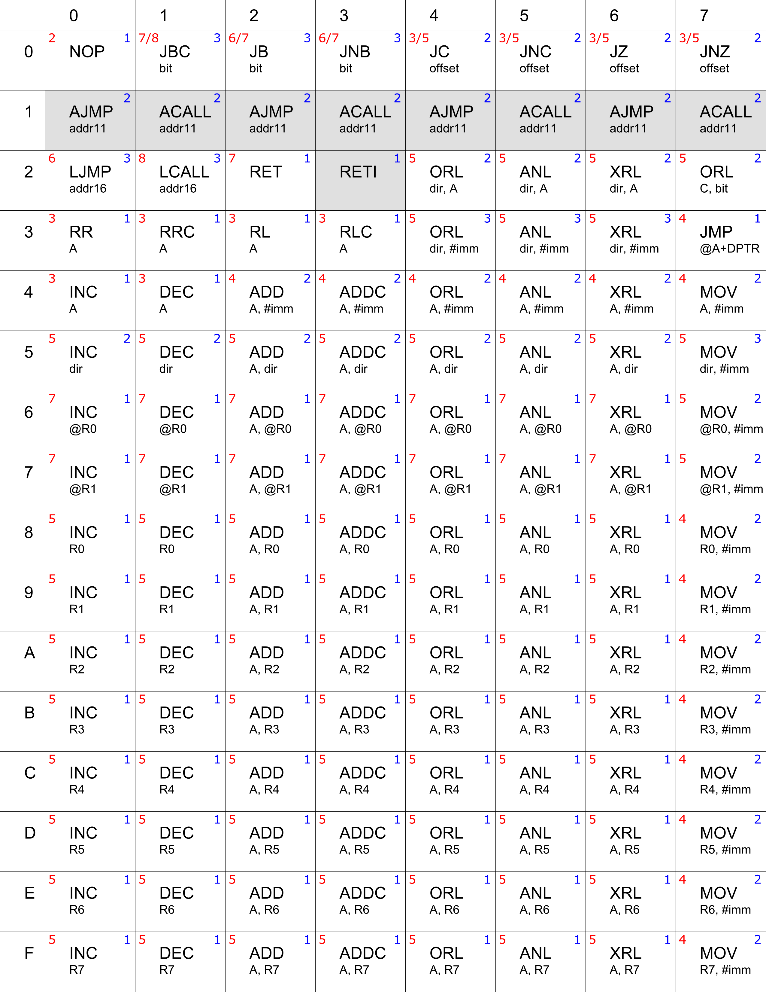
Table 7: Instruction Set Summary (Continued)
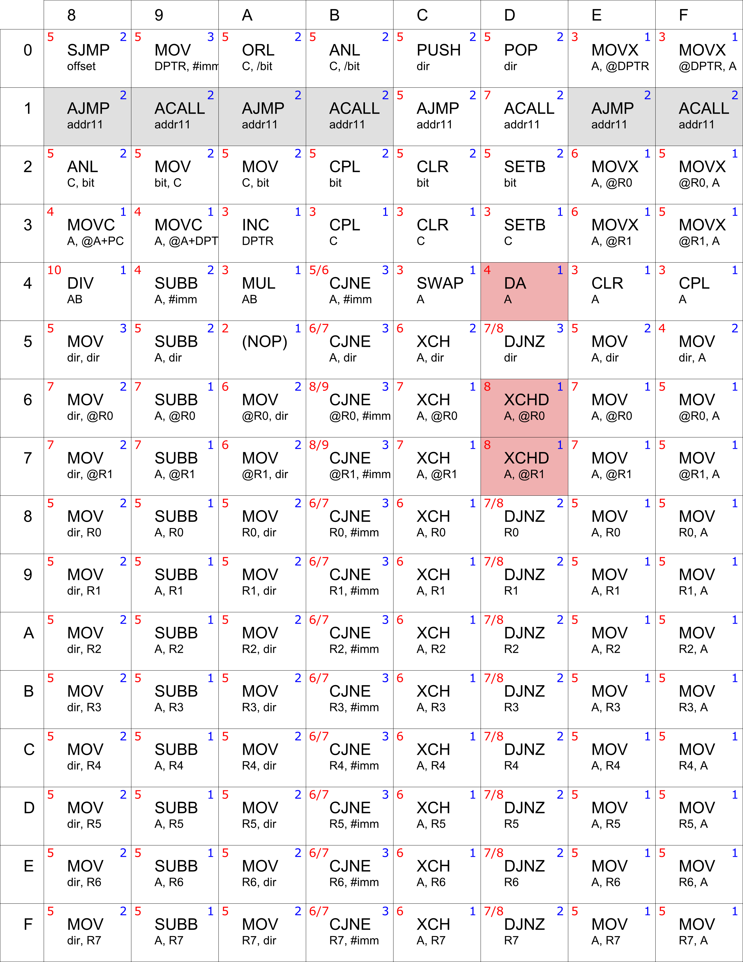

In the opcode tables above, the number of bytes of the instruction is in the right top corner, in blue.
The number in red in the left top corner is the cycle count (min/max for conditional jumps).

The opcode table has been automatically generated from the cycle count log file for the opcode tester program. The cycle count log file (file /sim/cycle_count_log.csv) records the cycle count for all instructions executed by any test bench; but the opcode tester does not execute all opcodes. Those opcodes for which there is no data in the log file are colored in grey, and their cycle count numbers are blank.

Optional instructions (DA and XCHD) are highlighted in red. When not implemented, these opcodes behave as NOP and their cycle count is 2.

Note that all the untested opcodes are part of a wider opcode family for which at least some members have been tested (e.g. ACALL, AJMP instructions).

NOTE: The table generation script is at /tools/build_opcode_table/svg_op_table.py. It will produce SVG files which have to be manually converted to PNG and imported into the ODT datasheet file. It is included in the project repository for completeness, though it is not expected to be of any use.

9.- Performance

9.1.- Synthesis Results
These are the synthesis results for the Dhrystone demo.

Table 8: Synthesis Results for 'Dhrystone' Demo
Target Device | Synthesis | Fmax | Resources
 | Type |  | CPU | Timer | UART | Total for Dhrystone demo
Cyclone-II -C7 | Balanced | 62 MHz | 997 LEs, 29 M4Ks, 1 MUL9 | 85 LEs | 147 LEs | 1339 LEs, 29 M4Ks, 1 MUL9
Spartan-3A -4 | Balanced | 35 MHz | 1162 LUTs, 10BRAM, 1MUL | 66 LUTs | 99 LUTs | 1424 LUTs, 10 BRAMs, 1 MUL18
(*1) The Spartan results include only the MCU and none of the DE-1 on-board glue logic (7-segment decoders, etc.)

The Dhrystone demo includes 12KB of ROM and 2 KB of XRAM, besides the IRAM. On the DE-1 board, it also includes some auxiliary glue logic that is included in the above total count for the Cyclone-II target only. That glue logic accounts for ~66LEs.
Results for Cyclone-II are the the actual synthesis results obtained for the Dhrystone demo on Terasic's DE-1 board (using top file c2sb_demo.vhdl).
Results for the Spartan-3 include about 80 LUTs used as pass-through.
In both cases, the synthesized core implements the BCD opcodes (DA and XCHD). When not implemented, CPU area decreases by about 31 LEs (or 50 to 80 LUTs in the Spartan chip). Clock rate does not change.

The above results have been obtained with Quartus-2 11.1 sp2 and Xilinx ISE Webpack 14.3. The synthesis has been performed with a single clock rate constraint and the results must be considered illustrative only.

The project files for Quartus and ISE are included in the repository.

9.2.- Dhrystone 2.1 Benchmark

The MCU has executed a version of the Dhrystone 2.1 benchmark, adapted for MCUs by ECROS Technology and slightly modified to suit the light52 core. It has been compiled with SDCC with default options.
The benchmark has been executed on a DE-1 development board with a Cyclone-II FPGA clocked at 50 MHz using the top module entity /vhdl/demos/c2sb/c2sb_demo.vhdl. The benchmark executes 25000 iterations over the Dhrystone loop and produces the following results:

Dhrystone 2.1 Benchmark Results
1646 | Dhrystones per second @ 50 MHz
0.9368 | Dhrystone MIPS (*1)
0.0187 | Dhrystone MIPS per MHz
(*1) 1 Dhrystone MIPS = 1757 Dhrystones per second

In order to give some context for this benchmark, the following table compares the results for a few representative cores:

CPU | DMIPS/MHz | Advantage vs. light52 | Fmax
Light52 | 0.0187 |  | 62 MHz
Intel MCS51 | 0.0094 | x0.5 | 12 MHz
CAST R8051XC-2 AF | 0.0883 | x4.7 | 35 MHz
(*1) Fmax on a Cyclone-II FPGA, the same for both cores.

As can be seen below, this core is about twice as fast as a 12-clocker at the same clock rate and therefore can be characterized as a 6-clocker, even if the clock count per instruction is not linearly scalable from the original.

The single-clocker CAST's R8051XC-2 AF has been selected for comparison because its feature set is not far ahead of light52's -- yet it's bigger and not that much faster once the difference in Fmax is accounted for.

