CoreMark
Version 0.2f

Table of contents
CoreMark 1
Background 2
Goals 3
Future Goals 4
Non Goals 4
Methodology 5
Small and easy to understand 5
Portability 5
Code / data size 5
Meaningful work 5
Controlled output 5
Detailed Design Discussion 6
Linked List 6
State Machine 6
Matrix Multiply 8

Background
Current EEMBC benchmarks are aimed at specific embedded market segments and are very successful at approximating real world performance of embedded devices. However, there is also a need for widely available generic benchmarks specifically targeted at the processor core. While some of the EEMBC benchmarks are small, there are many of them, and experienced engineers are needed to use the results. While experienced engineers are of course required to create new products, sometimes they are not available at critical stages of the design and decision cycle.
In addition, EEMBC benchmarks are licensed, and an open source benchmark to serve as initial indicator would be very useful – as indicated by the prevalence of the Dhrystone benchmark.
Dhrystone is currently used as a comparison and evaluation tool for processors because it is:
- Free
- Small
- Easily portable
- Available for practically any processor
- Displays a single number benchmark score
However it has several serious drawbacks which can be summarized into several categories:
- Major portions are susceptible to a smart compiler optimizing the work away, as an upshot this is more a compiler benchmark then a hardware benchmark. This also makes it very difficult to compare results when different compilers / flags are used.
- Library calls are made within the timed portion, and typically those library calls consume the majority of the time consumed by the benchmark. Since the library code is not part of the benchmark, it is difficult to compare results if different libraries are used.
- The code is synthetic and does not mimic any behavior that can be expected in a real application.
- There are no standards on how the code should be run and on how results should be reported. This makes it very difficult to use results for a meaningful comparison.

The plan for CoreMark is to create a simple, open source benchmark, utilizing the experience of EEMBC, and creating a relevant benchmark that will be useful for the industry as a whole.
The perceived benefits to EEMBC:
- Indirectly help proliferate the EEMBC name.
- The base benchmark could be extended and parameterized to create a more comprehensive benchmark.

Any feedback would be appreciated.

Thanks, Shay

Goals
Create a single benchmark that has the following characteristics:
- Small and easy to understand ANSI C code.
- Easily portable to a wide range of microcontrollers and microprocessors
- Demonstrate total binary size of no more then 16K using gcc on x86 machine.
  - For comparison, Dhrystone executable on x86 with gcc 3.4 –O compiles roughly to 16K.
- Demonstrate total object size for benchmark code (timed portion) of no more then 8K using gcc on x86 machine.
  - For comparison, Dhrystone object on x86 with gcc 3.4 –O compiles roughly to 8K.
- Total working set data size for the benchmark should be no more then 2K.
  - Should dynamic memory allocation be used? Heap is commonly used in many applications, but since we want this to run on practically any platform, we must allow for platforms that do not have dynamic memory management.
- While synthetic, the workload is actually useful in real world applications e.g.:
  - Matrix multiply (allow for use of MAC operations, common math use)
  - Linked list search/sort/read (common pointer use)
  - State machine (common use of data dependent branches)
  - CRC (common in embedded)
  - Others? what key functions of a processor should be exercised? AES? DES? MD5?
- While compilers may find more efficient ways of doing the work, the work itself cannot be optimized away. This requires that every computation chain ends in a result that:
  - Is output to a volatile location such as printed to screen. E.g. save all results in a buffer and CRC/print the buffer after ending the test.
  - Any step that is eliminated in the computation or control chain will lead to a different result.
  - Example:
while (cond) { stuff }
    - cond must be initialized, and can be determined only at run time. As a counter example - Dhrystone contains a function where cond is not initialized, and a smart compiler can optimize the loop away since ANSI allows a compiler to choose any value for an uninitialized variable.
    - stuff must end in a result that is output from the memory space of the benchmark e.g. add end result of a computation to a memory location, and output it after the run. As a counter example - Dhrystone contains a function where part of stuff does not modify the output of the benchmark and can therefore be safely optimized away by a smart compiler.
  - Note, it is not the goal or intention to prevent compilers from optimizing the code, but it is a goal to avoid computation chains being computed at compile time instead of run time.
- No library calls are made from within the timed portion.
- Standardize run and reporting rules.
  - Must report compiler version and flags.
  - Must report processor used, speed, cache.
  - Must report OS/kernel version and patches if non-standard.
  - Must report code and data location (SRAM? DRAM? Flash? Disk?)
  - Establish standard result line for data sheet usage.
- The benchmark should verify that the results of all computations are acceptable (Identical to reference for integer operations, SNR of 50dB or better for floating point operations).
- The benchmark should be able to work on an embedded board without an OS – demonstrate on an embedded board.

Future Goals
- Create a floating point version of the benchmark, centered on common uses of FP with the same basic limitations on code/data size and complexity of the code.
- Establish a public forum for results from integer form of CoreMark, and seed it with results for many off-the-shelf devices.
- Standardize procedure for measuring power consumption.
- Create code that can take advantage of parallel computing resources.
- Auto-certify?
  - E.g. auto results submission.

Non Goals
- There is no intention of creating a comprehensive analysis tool.

Methodology

Small and easy to understand
X number of source code lines for timed portion of the benchmark.
Meaningful names for variables and functions.
Comments for each block of code more than 10 lines long.

Portability
A thin abstraction layer will be provided for I/O and timing in a separate file. All I/O and timing of the benchmark will be done through this layer.

Code / data size
Compile with gcc on x86 and make sure all sizes are according to requirements.
If dynamic memory allocation is used, take total memory allocated into account as well.
Avoid recursive functions and keep track of stack usage.
Use the same memory block as data site for all algorithms, and initialize the data before each algorithm – while this means that initialization with data happens during the timed portion, it will only happen once during the timed portion and so have negligible effect on the results.

Meaningful work
 | Required code size | Required data size
Linked list | <2K | Only input data
Matrix multiply | <2K | Only input data
State machine | <2K | 256 bytes (for init)
MD5 | <4K | Only input data
AES | <4K | Only input data
DES | <5K | Only input data
CRC | Used by other algorithms | Only input data
Framework overhead | ~3K | ~1K

Controlled output
This may be the most difficult goal. Compilers are constantly improving and getting better at analyzing code. To create work that cannot be computed at compile time and must be computed at run time, we will rely on two assumptions:
- Some system functions (e.g. time, scanf) and parameters cannot be computed at compile time.
In most cases, marking a variable volatile means the compiler is force to read this variable every time it is read.
This will be used to introduce a factor into the input that cannot be precomputed at compile time. Since the results are input dependent, that will make sure that computation has to happen at run time.
  - Either a system function or I/O (e.g. scanf) or command line parameters or volatile variables will be used before the timed portion to generate data which is not available at compile time. Specific method used is not relevant as long as it can be controlled, and that it cannot be computed or eliminated by the compiler at compile time. E.g. if the clock() functions is a compiler stub, it may not be used. The derived values will be reported on the output so that verification can be done on a different machine.
  - We cannot rely on command line parameters since some embedded systems do not have the capability to provide command line parameters. All 3 methods above will be implemented (time based, scanf and command line parameters) and all 3 are valid if the compiler cannot determine the value at compile time.
  - It is important to note that The actual values that are to be supplied at run time will be standardized. The methodology is not intended to provide random data, but simply to provide controlled data that cannot be precomputed at compile time.
- Printed results must be valid at run time.
This will be used to make sure the computation has been executed.
  - Some embedded systems do not provide “printf” or other I/O functionality. All I/O will be done through a thin abstraction interface to allow execution on such systems (e.g. allow output via JTAG).

Detailed Design Discussion

Linked List
The following linked list structure will be used:
typedef struct list_data_s {
ee_s16 data16;
ee_s16 idx;
} list_data;

typedef struct list_head_s {
struct list_head_s *next;
struct list_data_s *info;
} list_head;

While adding a level of indirection accessing the data, this structure is realistic and used in many embedded applications for small to medium lists.
The list itself will be initialized on a block of memory that will be passed in to the initialization function. While in general linked lists use malloc for new nodes, embedded applications sometime control the memory for small data structures such as arrays and lists directly to avoid the overhead of system calls, so this approach is realistic.
The linked list will be initialized such that ¼ of the list pointers point to sequential areas in memory, and ¾ of the list pointers are distributed in a non sequential manner. This is done to emulate a linked list that had add/remove happen for a while disrupting the neat order, and then a series of adds that are likely to come from sequential memory locations.

For the benchmark itself:
- Multiple find operations are going to be performed. These find operations may result in the whole list being traversed. The result of each find will become part of the output chain.
- The list will be sorted using merge sort based on the data16 value, and then derive CRC of the data16 item in order for part of the list. The CRC will become part of the output chain.
- The list will be sorted again using merge sort based on the idx value. This sort will guarantee that the list is returned to the primary state before leaving the function, so that multiple iterations of the function will have the same result. CRC of the data16 for part of the list will again be calculated and become part of the output chain.

The actual data16 in each cell will be pseudo random based on a single 16b input that cannot be determined at compile time. In addition, the part of the list which is used for CRC will also be passed to the function, and determined based on an input that cannot be determined at run time.

State Machine
This part of the code needs to exercise switch and if statements. As such, we will use a small Moore state machine. In particular, this will be a state machine that identifies string input as numbers and divides them according to format.
The state machine will parse the input string until either a “,” separator or end of input is encountered. An invalid number will cause the state machine to return invalid state and a valid number will cause the state machine to return with type of number format (int/float/scientific).
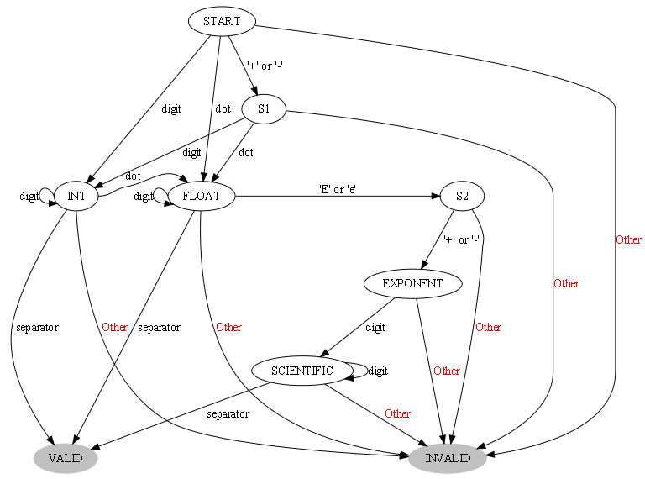

This code will perform a realistic task, be small enough to easily understand, and exercise the required functionality. The other option used in embedded systems is a mealy based state machine, which is driven by a table. The table then determines the number of states and complexity of transitions. This approach, however, tests mainly the load/store and function call mechanisms and less the handling of branches. If analysis of the final results shows that the load/store functionality of the processor is not exercised thoroughly, it may be a good addition to the benchmark (codesize allowing).

For input, the memory block will be initialized with comma separated values of mixed formats, as well as invalid inputs.

For the benchmark itself:
- Invoke the state machine on all of the input and count final states and state transitions. CRC of all final states and transitions will become part of the output chain.
- Modify the input at intervals (inject errors) and repeat the state machine operation.
- Modify the input back to original form.

The actual input must be initialized based on data that cannot be determined at compile time. In addition the intervals for modification of the input and the actual modification must be based on input that cannot be determined at compile time.

Matrix Multiply
This very simple algorithm forms the basis of many more complex algorithms. The tight inner loop is the focus of many optimizations (compiler as well as hardware based) and is thus relevant for embedded processing.
The total available data space will be divided to 3 parts:
- NxN matrix A.
- NxN matrix B.
- NxN matrix C.
E.g. for 2K we will have 3 12x12 matrices (assuming data type of 32b 12(len)*12(wid)*4(size)*3(num) =1728 bytes).

Matrix A will be initialized with small values (upper 3/4 of the bits all zero).
Matrix B will be initialized with medium values (upper half of the bits all zero).
Matrix C will be used for the result.

For the benchmark itself:
- Multiple A by a constant into C, add the upper bits of each of the values in the result matrix. The result will become part of the output chain.
- Multiple A by column X of B into C, add the upper bits of each of the values in the result matrix. The result will become part of the output chain.
- Multiple A by B into C, add the upper bits of each of the values in the result matrix. The result will become part of the output chain.

The actual values for A and B must be derived based on input that is not available at compile time.

Parallel Computing Resources
To accommodate different methods of utilizing parallel computing resources, two functions will be used to create and stop parallel contexts:

core_start_parallel – Start N iterations of the benchmark on a thread/process.
core_stop_parallel – Wait for a specific thread/process to finish, and collect validation data.
Actual implementation of these functions will be left in the portable part of the benchmark, and a target specific part will be sent as parameter to the functions.

The main part of the benchmark will call core_start_parallel N times and then core_stop_parallel N times, with separate and identical parameter space for each call. N will be a compile time constant controlled in the target specific part of the code.

Default implementations with fork()/sockets and pthreads will be created to validate the methodology.

Floating point algorithms for consideration

Vector algorithms
- Values within tolerance – Check all values in array vs. base and tolerance.
- SNR – calculate min/max/avg SNR of signal array vs. processed signal array.
- Array sum/min/max/avg value
- Convert to fixed point and sum.

Matrix algorithms
Use the same algorithms from the integer portion of the benchmark, with floating point data.
Verify using SNR rather then CRC.

Interpolation
- Linear/polynomial – calculate N Bezier points.
- Spline – calculate points along natural cubic spline.
- Non linear least squares for N data points.

Iterative
- Compute square root.
- M-estimation

