

DATA SHEET

PCI Bridge IP Core

Introduction
Today, the PCI bus is the number-one device connectivity standard on the market to integrate modern embedded applications into bigger systems. The PCI Bridge IP Core is built according to PCI specification Rev. 2.2 (or lower) and provides a backend connection that is WISHBONE open-standard compatible. Since standardized backend is rarely seen in common IP cores, the architecture-independent interface, which can be used in a wide variety of applications, is the PCI Bride IP Core’s major benefit.

Features
Figure 1: Core Architecture Overview

PCI Interface
- PCI 2.2 compliant 32bit, 36-MHz Iitiator and Target interface
- Zero wait state burst operation
- Parameterized number of synthesizable, fully programmable images (default one, maximum 6 images) with address translation capability and 4KB to 1GB image size for access from PCI bus to address space on WISHBONE bus
- Programmable image address space mapping (I/O or memory space)
- PCI transaction ordering requirements; use of posted writes and delayed reads in either direction
- Single delayed transaction support in either direction
- Supported initiator functions:
- Memory Read, Memory Read Line, Memory Read Multiple, Memory Write commands
- 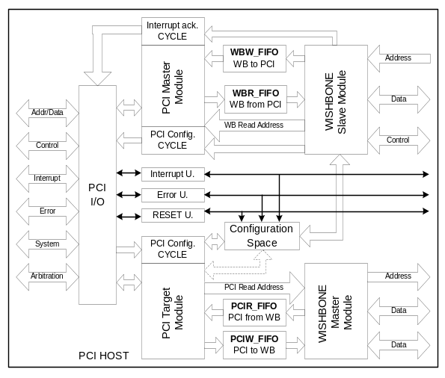IO Read and Write commands
- Configuration Read and Write commands
- Interrupt Acknowledge command
- Support of linear burst ordering
- Supported Target functions:
- Memory Read, Memory Read Line, Memory Read Multiple, Memory Write, Memory Write and Invalidate commands
- IO Read and Write commands
- Configuration Read and Write commands
- Support of linear burst ordering
- Software configurable support for memory access optimizing commands
- Fully transparent WISHBONE interface operation, controllable on image by image basis with proper software settings of configuration registers

WISHBONE Interface
- WISHBONE clock independent of PCI clock
- WISHBONE SoC bus revision B.1 compliant with separate Master and Slave interfaces
- Zero wait state burst operation
- Parameterized number of synthesizable, fully programmable images (default one, maximum 5 images) with address translation capability and 4KB to 1GB image size provided for access from WISHBONE bus to address space on PCI bus
- Fully transparent PCI bus command usage, controllable on image by image basis with proper settings of configuration registers

Core Internals
- Provision of two possible parameterized implementations – HOST (used for host bridging with WISHBONE SoC bus as host bus) and GUEST (used for expansion bus bridging with WISHBONE SoC bus as expansion bus)
- Four synthesizable, dual port FIFOs with parameterized depth
- Extended configuration space, implemented for additional software programmable features of the core

General Description
The PCI Bridge IP Core is PCI specification Rev. 2.2 compliant but can also be used in systems designed according to lower versions, since the PCI is backwards compatible. A set of pre-synthesis parameters is defined in a separate file and offers a wide variety of implementations – from high performance to low cost (in terms of resource utilization). The Core is targeting FPGA as well as ASIC SoC implementations.

Utilization
The following table lists the core’s intended applications.

Technology | FPGA Size | Silicon Area | Speed | Power Consumption
FPGA Xilinx Spartan II -5 | 1300 slices + 6 Block Select+ RAM | TBD | 33 MHz PCI  42 MHz WB | TBD
ASIC .18u VS library | TBD | 1.0965 mm2 (inc. 2KB of MEMORY) | 66 MHz PCI  200 MHz WB | TBD

