**ESCUELA POLITÉCNICA NACIONAL**

**MODELOS LINEALES Y DISEÑO DE EXPERIMENTOS**

**Nombre:** Fabricio Sánchez

**Deber: Regresión sin el intercepto $β_{1}$**

**Código:**

**#Deber Fabricio Sánchez**

dir()

library(readxl)

ls("package:readxl")

excel_sheets("data_rls_uti.xlsx")

data<-read_excel("data_rls_uti.xlsx",sheet =1,col_names = TRUE, na="")

str(data)

Classes ‘tbl_df’, ‘tbl’ and 'data.frame': 40 obs. of 2 variables:

$ Utilidad: num 6017 8049 8551 6720 7391 ...

$ Ventas : num 13270 17127 17814 16000 18026 ...

nrow(data)

[1] 40

regresion<-lm(Utilidad ~ Ventas,data)

summary(regresion)

Residuals:

Min 1Q Median 3Q Max

-676.35 -302.04 42.59 303.67 612.49

Coefficients:

Estimate Std. Error t value Pr(>|t|)

(Intercept) 137.08270 282.69543 0.485 0.631

Ventas 0.43994 0.01859 23.663 <2e-16 ***

---

Signif. codes: 0 ‘***’ 0.001 ‘**’ 0.01 ‘*’ 0.05 ‘.’ 0.1 ‘ ’ 1

Residual standard error: 367.4 on 38 degrees of freedom

Multiple R-squared: 0.9364, Adjusted R-squared: 0.9348

F-statistic: 559.9 on 1 and 38 DF, p-value: < 2.2e-16

anova<-aov(regresion)

summary(anova)

Df Sum Sq Mean Sq F value Pr(>F)

Ventas 1 75578286 75578286 559.9 <2e-16 ***

Residuals 38 5129142 134977

---

Signif. codes: 0 ‘***’ 0.001 ‘**’ 0.01 ‘*’ 0.05 ‘.’ 0.1 ‘ ’ 1

#Fractil de 0.025

qt(0.975,df=38)

[1] 2.024394

#intervalos de confianza

confint(regresion,level=0.95)

2.5 % 97.5 %

(Intercept) -435.2042893 709.3696869

Ventas 0.4022981 0.4775722

(a<-mean(data[,"Utilidad"]))

[1] 6683.725

(b<-mean(data[,"Ventas"]))

[1] 14880.92

names(regresion)

res1<-regresion[["residuals"]]

(predicciones<-regresion[["fitted.values"]])

1 2 3 4 5 6 7 8 9

5975.022 7671.852 7974.088 7176.045 8067.354 8001.804 5950.386 4677.654 5576.881

10 11 12 13 14 15 16 17 18

6839.495 6868.531 8865.836 5760.334 4640.259 6879.529 4970.650 8281.163 4545.233

19 20 21 22 23 24 25 26 27

4992.207 6882.609 8005.323 8257.406 6917.364 6785.383 5972.823 4824.152 8366.510

28 29 30 31 32 33 34 35 36

6879.969 8101.229 8100.789 4800.396 7607.622 5226.253 8809.085 5075.355 4784.558

37 38 39 40

5021.683 8048.877 6781.864 8385.427

data2<-data.frame(data,predicciones,res1)

hist(res1,20)

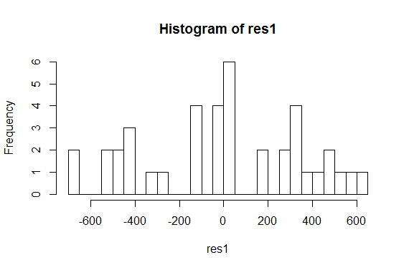

mean(res1)

[1] 1.407208e-15

qqnorm(res1)

qqline(res1,col="blue")

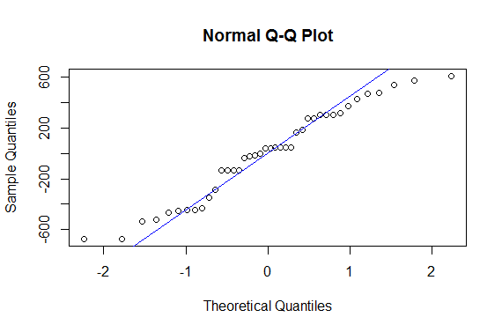

plot(res1,predicciones)

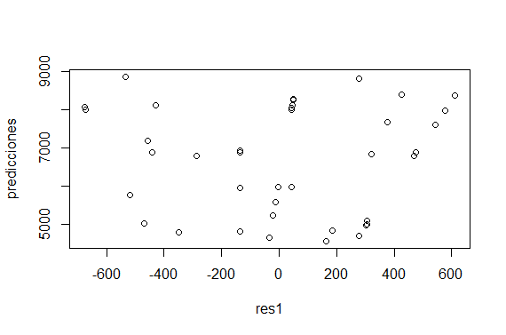

plot(data[,1],data[,2])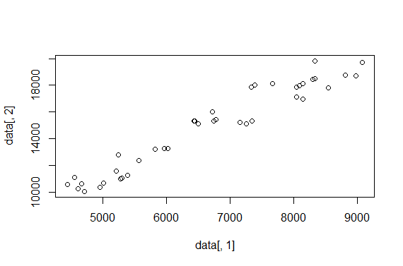

utilidad1<-data[,"Utilidad"]-a

ventas1<-data[,"Ventas"]-b

regresion2<-lm(utilidad1 ~ ventas1)

summary(regresion2)

Residuals:

Min 1Q Median 3Q Max

-676.35 -302.04 42.59 303.67 612.49

Coefficients:

Estimate Std. Error t value Pr(>|t|)

(Intercept) -6.835e-13 5.809e+01 0.00 1

ventas1 4.399e-01 1.859e-02 23.66 <2e-16 ***

---

Signif. codes: 0 ‘***’ 0.001 ‘**’ 0.01 ‘*’ 0.05 ‘.’ 0.1 ‘ ’ 1

Residual standard error: 367.4 on 38 degrees of freedom

Multiple R-squared: 0.9364, Adjusted R-squared: 0.9348

F-statistic: 559.9 on 1 and 38 DF, p-value: < 2.2e-16

anova2<-aov(regresion2)

summary(anova2)

Df Sum Sq Mean Sq F value Pr(>F)

ventas1 1 75578286 75578286 559.9 <2e-16 ***

Residuals 38 5129142 134977

---

Signif. codes: 0 ‘***’ 0.001 ‘**’ 0.01 ‘*’ 0.05 ‘.’ 0.1 ‘ ’ 1

confint(regresion2,level=0.95)

2.5 % 97.5 %

(Intercept) -117.5968432 117.5968432

ventas1 0.4022981 0.4775722

res2<-regresion2[["residuals"]]

(predicciones1<-regresion2[["fitted.values"]])

1 2 3 4 5 6

-708.70257 988.12739 1290.36285 492.32045 1383.62911 1318.07877

7 8 9 10 11 12

-733.33894 -2006.07139 -1106.84390 155.77005 184.80577 2182.11145

13 14 15 16 17 18

-923.39093 -2043.46588 195.80415 -1713.07457 1597.43761 -2138.49188

19 20 21 22 23 24

-1691.51774 198.88369 1321.59825 1573.68111 233.63857 101.65802

25 26 27 28 29 30

-710.90224 -1859.57298 1682.78503 196.24408 1417.50412 1417.06418

31 32 33 34 35 36

-1883.32948 923.89686 -1457.47223 2125.35981 -1608.36999 -1899.16714

37 38 39 40

-1662.04209 1365.15183 98.13854 1701.70224

data4<-data.frame(utilidad1,ventas1,predicciones1,res2)

hist(res2,20)

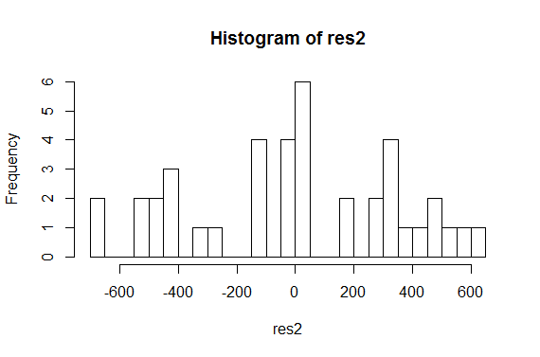

mean(res2)

[1] 7.494005e-17

data5<-data.frame(res2)

qqnorm(res2)

qqline(res2,col="blue")



plot(res2,predicciones1)

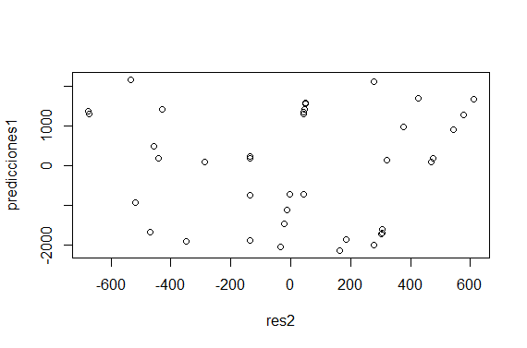

plot(utilidad1,ventas1)

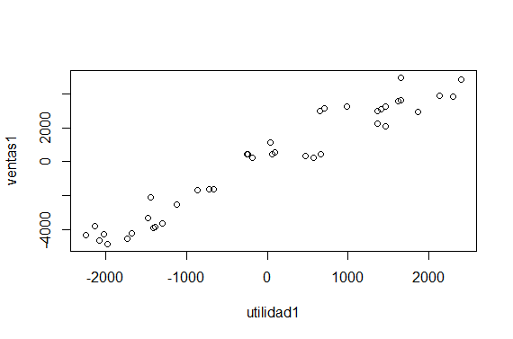

CONCLUSIONES

La regresión es significativa ya que $Pr\left(>\left|t\right|\right)=1$ $>0.05$, además $t tableado=2.024394>t value=0$, por tanto se rechaza $H_{0}: β_{2}=0$ y se comprueba que la regresión es significativa.

Ahora, calculamos el cuartil de Fisher (1,n-2,alpha) $F_{1,n-2}\left(α\right)= F_{1,38}\left(0.05\right)=qf(0.95,df_{1}=1,df_{2}=38= 4.098172$

Es decir; $F value=559,9>F_{1,n-2}\left(α\right)=4,098172$, por tanto se rechaza $H_{0}: β_{2}=0$