

Guide to Github and Github Projects

What is GitHub?
GitHub is a code hosting platform for version control and collaboration. It lets you and others work together on projects from anywhere.

No coding necessary

Issues
Issues are a great way to keep track of tasks, enhancements, and bugs for your projects. They’re kind of like email—except they can be shared and discussed with the rest of your team. Most software projects have a bug tracker of some kind. GitHub’s tracker is called Issues, and has its own section in every repository.
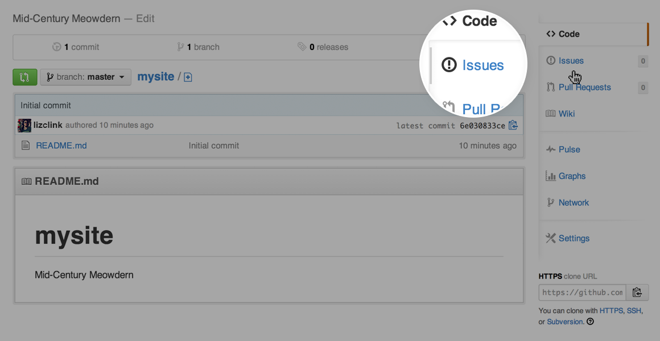

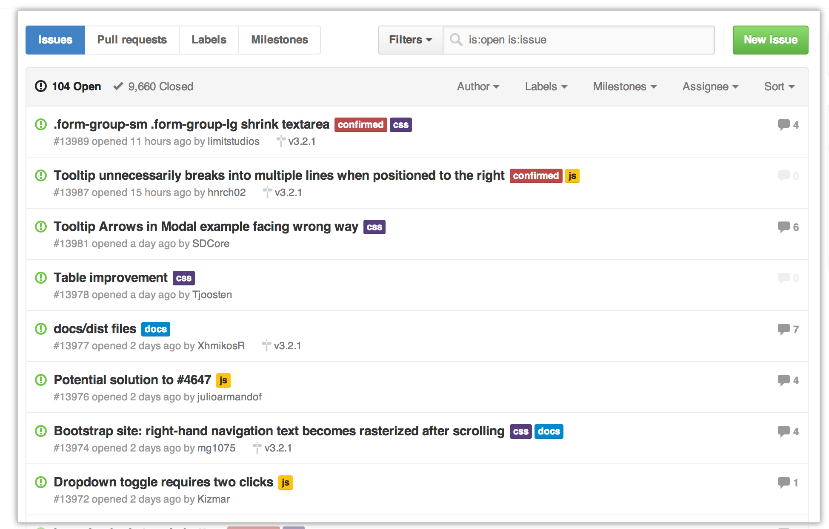

Labels
Labels are a great way to organize different types of issues. Issues can have as many labels as you want, and you can filter by one or many labels at once.

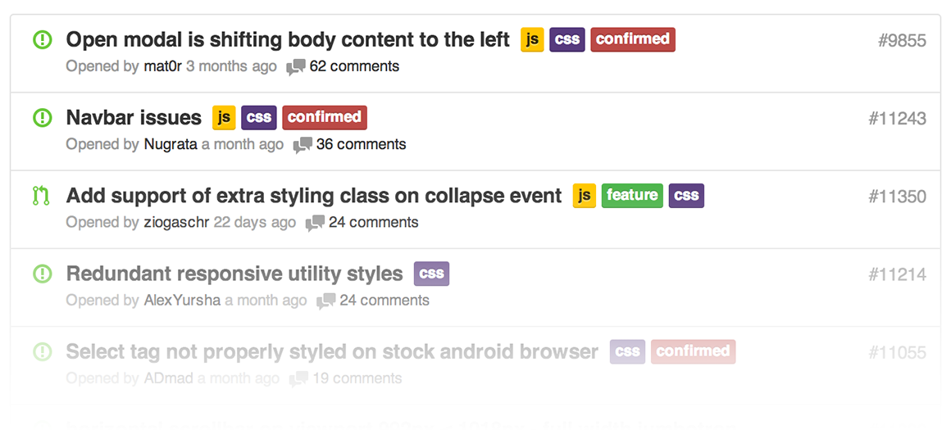
AssigneesEach issue can have an assignee — one or more people, whose
responsible for moving the issue forward. Assignees are selected through the grey bar at the top of the issue.

Github Project Boards

There are a couple of project management tools available today, but we are going to in this article see a very free and popular Project Board by Github. If you are very conversant with open source technology like github, you most likely have seen the project tab on a github repository before. (if you have not, take a few seconds and create a github account here)

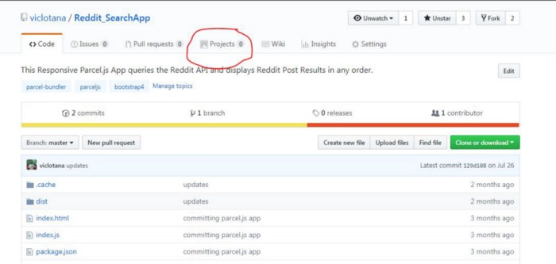

There are project templates, well be using Automated Kanban.

This creates three colums To-do, In-progress and Done and also lets you automate the processes of moving cards from column to column. You can also drag and drop them also.

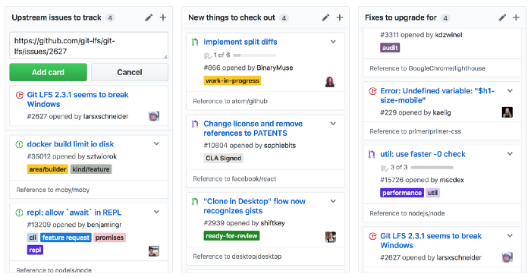

Further information avalible online
If any questions please email and ask. Alternatively, the third workshop has dedicated time for a Github intro.

