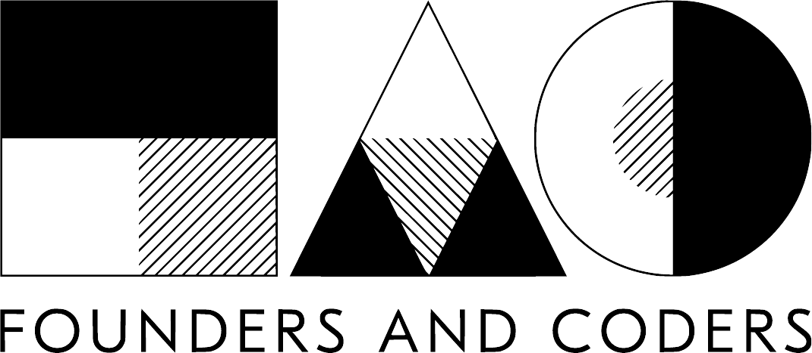

Product Owner Agreement
- Graduate Programme version

Tech for Better is run by Founders & Coders, with funding support from our partner Intersticia.

Applicants to our programme should read through this document and are encouraged to ask questions about anything that is not clear. You will be asked to sign this agreement prior to your first workshop.

What you can expect from this programme?

A working MVP
The deliverable for this project is an MVP (Minimum Viable Product). In the Agile process, this is a term for the first version of a new product. It is the first stage in the “Build, Measure, Learn” cycle. The MVP will have enough features that it can be tested with real users, and useful data can be collected about how people use it, in order to adapt and improve the product further. This allows you to quickly understand what makes your product valuable and adapt accordingly.

To be part of an agile software development team
You will fulfill the Product Owner role in the Agile process. There are more specifics in the file our Agile Process.

We will publish your app under the MIT open source license. See below for more details on this. You will retain rights to any intellectual property belonging to you or your organisation.
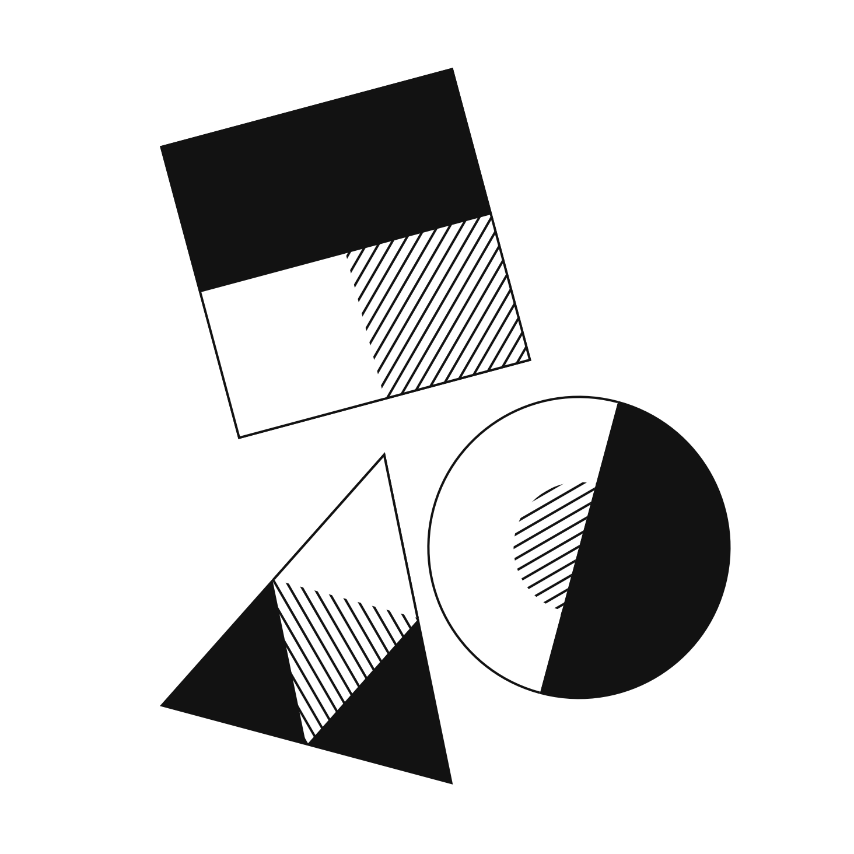

Overview of the project timeline

Workshop 1 (Discovery)
Our team will work with you to think broadly about your problem space. We end by working with you to create a user research survey.

Conduct user research
You conduct user research with between 4-8 users and share your findings with us. Especially if you haven't conducted any before.

Workshop 2 (Exploration)
Our team will work with you to define the specific problem and frame it so that we can build an app to solve it.
Prepare necessary data and/or content. Any copy, data or content for the app should be prepared before the sprint begins.

Workshop 3 (Sprint Planning)
You will work with your team as your role as Product Owner in the Agile/SCRUM process. You will help define user stories that define the functionality of the app. At the end of this together you'll make a map for the build sprints aka a sprint backlog

1 week design sprint
Your team will develop the visual design of the app and make the prototype.
User testing. You will help to plan user testing, with some real potential users

3 weeks build sprints
Your developer team will build the features of the app.

Workshop 4 (Handover)
The product is handed over with documentation, including instructions on how to run the application. This will be a starting point for most projects and we encourage further planning.

Your Responsibilities

Availability
Product Owners must be available for the workshops (2 hours each), to conduct user research (around 4-8 hours), to prepare data and/or content before the build (time varies) and for minimum 8 hours of contact time during the 3-week project sprint. You can expect the handover to take around 1-2 hours.

Enthusiasm and ambition
we have found that these qualities in a Product Owner are desirable for the best project outcome.

Engagement with our process
We expect Product Owners to engage with our team in the workshops, and to work with our team to define and scope a project. We expect you to engage fully with the user research task and to fulfill the Product Owner role in your team.

Flexibility
We ask that you participate in our programme with a flexible attitude. If you have very fixed ideas of the product that you’d like to have built, it may not be possible for us to meet them,

Appropriate scope
It is essential that the project scope is appropriate to the resources available. We must be confident that your project can be completed in a 3-week sprint, and that it is appropriate to the skill level of our developers.

Social impact

For our pro-bono programme, we work with projects that we believe will have a positive social impact. Your project does not necessarily have to be not-for-profit, however, we are looking for projects with a tangible positive contribution to our world and projects that are primarily commercial may not be judged to be suitable.

What happens afterwards?

Product handover

Your finished app will be handed over with documentation, including instructions on how to run the application.

We will publish the code for the app on Github under an open-source MIT license, which means, among other things, that you are not tied-in to working with us. You will have full access to the codebase and you will be able to take the app to any developer or team for further work. We will not publish any of your sensitive or confidential information publicly.

For more information on the MIT license, read here: https://opensource.org/licenses/MIT

For more information about the advantages of open-source software, read about why Google open-sources its software: https://opensource.google.com/docs/why/

Technical support

We do not provide ongoing technical support.

Further development

We intended to build you an MVP that you can use to conduct user testing, and from this learn much more information about what your users need. You may wish to conduct user testing to help inform you about what to do next with your project.

You may wish to use the MVP as a basis for attracting funding - we can offer advice and help with this.

If you do decide you’d like to develop your idea further, whether straight away or after some time, we’d love for you to come back to us. Often the developers who have worked on your app are available to work on a freelance basis

I have read and agree to these terms

Name:_______________________________

Signed: ______________________________

Date: _______________

