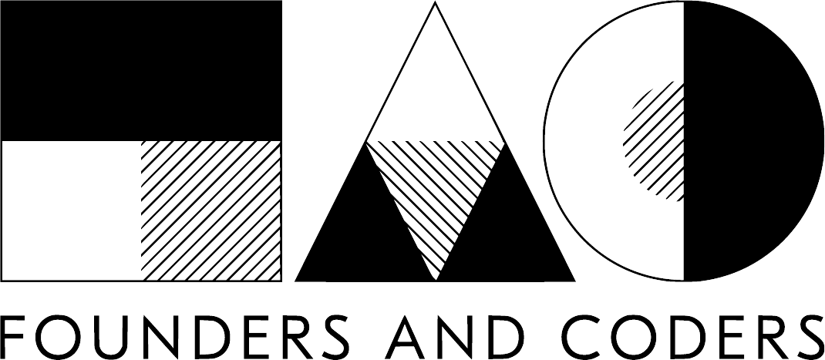

Product Owner Guide
- Graduate Programme version

General

Founders and Coders is UK-based nonprofit
Opening access to the digital economy through sharing our model of peer-led learning and cooperative work

The graduate Programme
A pair of graduates complete three Tech for Better projects. For each project, the London team will be joined remotely by a pair of Palestinian developers.

This programme Is funded by Intersticia. The concept of Intersticia has always been based on dynamism and change, operating within the interstice that exists between technology, culture ,and society. But also between the potential of ideas and the reality of execution. Our goal is to work with people and their ability to the imagination.


Timeline Outline
There are two processes: Design and Build

There will be two workshops in the Design process:
- The Discovery workshop
- The Exploration workshop

There will be two workshops in the Build process:
- Sprint Planning workshop
- The Handover workshop

The Design process

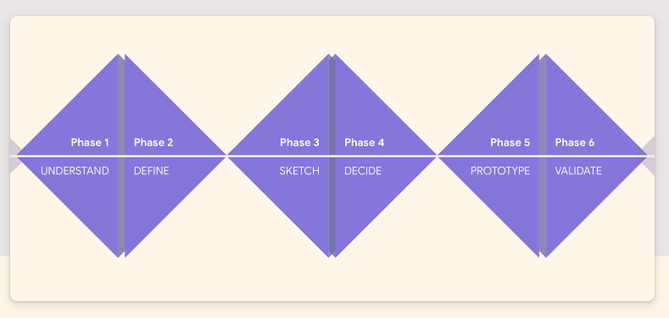

Phase 1 & 2 = The Discovery workshop

Phase 3 & 4 = The Exploration workshop

Phase 5 = Design sprint & User testing of the prototype

Phase 6 = Sprint Planning workshop

What is a prototype?A prototype is a quasi-realistic representation (fancy picture) of
what you are building that can be acted with and tested on users
to help validate your design.

They are useful for several reasons:

- Help identify usability issues before going to code
- Get early user feedback from user research
- Observe how users want to interact with your design
- Faster to create than fully coded solutions (front and back end)

A section on User Research after the build process

The Build process

This section will predominantly be explained in the 3rd workshop as well as an intro to GitHub.

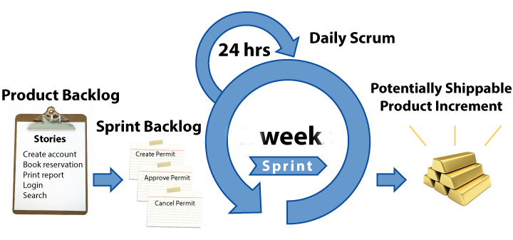

Our agile process

Agile is a way of working that aims to be transparency, inspection, and adaptation.

The roles particularly relevant to the agile process are; your role as product owner and the scrum master. Agile aims to optimize flexibility, creativity, and productivity

The product owner and scrum master share responsibility for maximizing the value of the work of the development team.

The product owner helps the order item’s priority. The Product Owner’s decisions are visible in the content and ordering of the Product Backlog.

The Product Backlog is a map for the development team it will be on GitHub.

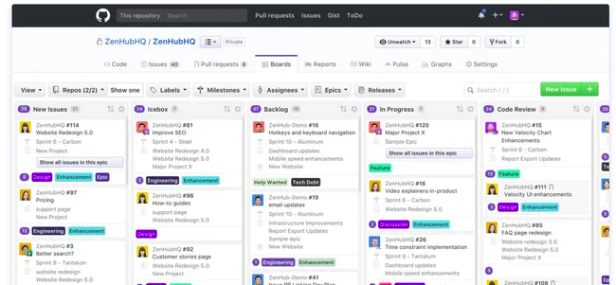

Backlog management includes:
- Each Backlog item has it's minimum requirements and stretch goals
- Ordering the items in the Product Backlog to best achieve goals
- Ensuring that the Product Backlog is visible, transparent, and shows what the Team will work on next

The development team is comprised, four developers. Two from the London Founders and Coders cohort, Kate and Dylan. The remaining two are from [the Gaza Sky Geeks](https://gazaskygeeks.com/about-us/). The application process ongoing currently.

During the Sprint:
- No changes are made that would endanger the Sprint Goal;
- The scope may be clarified and re-negotiated between the product owner and development team as more is learned.

Sprints consist of the Sprint Planning, Daily Scrums, the development work, the Sprint Review, and the Sprint Retrospective. The product owner has predominantly involved the sprint planning.

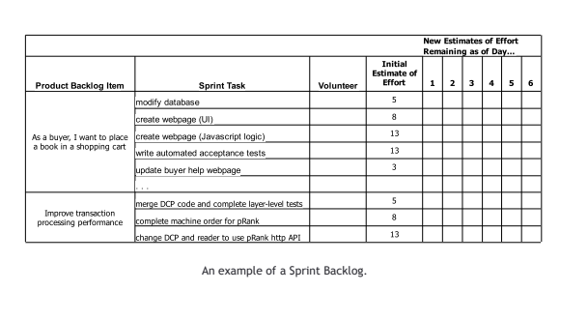

User Research

User research prevents our assumptions from taking over and instead keeps our focus on the actual user.

Possible Methods

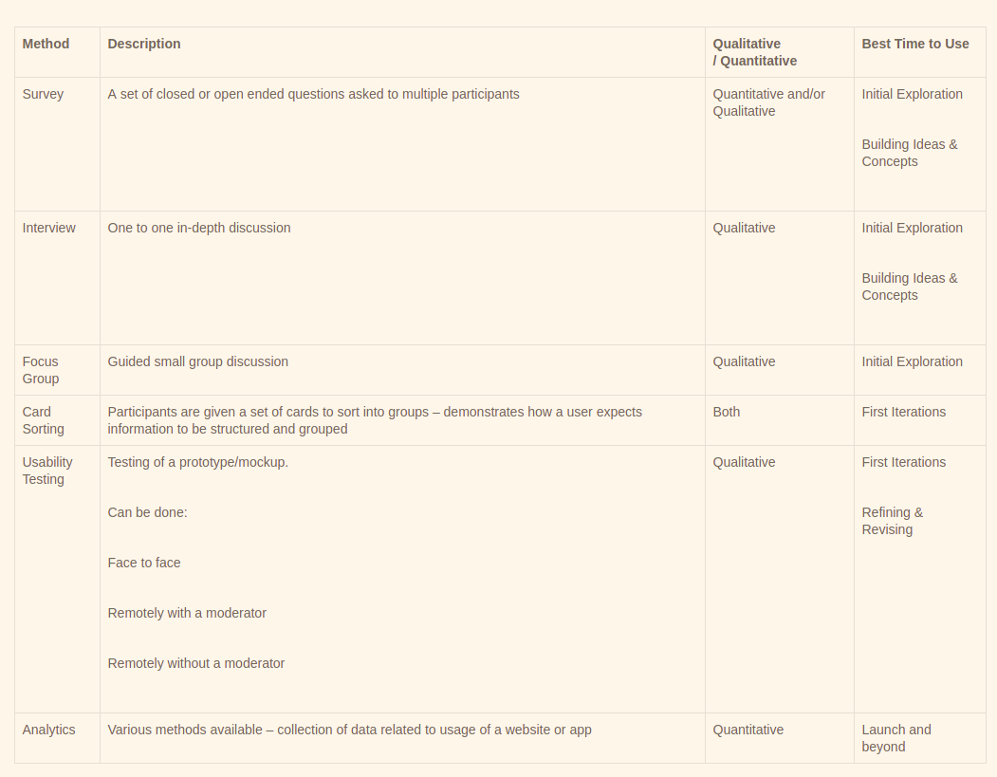

Which methods should I choose?
By using a combination of research methods you are more likely to get a complete picture of who your users are and how you can help them. For example, an online survey may help you to answer a question such as “how many people currently use a fitness app”? But this does not tell you why they use a fitness app. Conducting an in-depth interview could then reveal what motivates people to use a fitness app.

Use a structured approach
Following a structured approach to the user, research ensures consistency, clearly defines objectives and allows for effective use of research findings.

- Set clear objectives for your research
- Devise a hypothesis based on your objectives
- Conduct your research
- Analyse the findings concerning your hypothesis
- Implement changes

Finally, remember to repeat the process. Once you have tested one iteration of the design and made changes to it, test it again to see if you have addressed the issues highlighted by participants during the initial testing.

What is a user interview?
A user interview is a common user research technique used typically to get qualitative information from either existing or potential users.

It typically covers any range of topics from:

The person’s background
Their occupation
Their use of technology
Their goals
Their motivations
Their pain points

These all add vital meat on the bone to any personas you design and help you understand your potential and existing users.

How do you run the user interview?
If you are doing it solo then you have a slightly tougher task in that you need to record your findings as well as run the interview.

Ideally, have another person taking notes - Quotes can be extremely useful.

Let the person know why you are doing the interview – Many people may be wary about a stranger coming and asking them lots of personal questions. Before you jump in to give them an overview of what you are trying to accomplish and most importantly let them know there are no wrong answers. Also, let them know that any feedback will be kept anonymous.

Don’t ask any leading questions – Rather than asking ‘How often do you use Facebook?’, ask ‘Do you use any social networks?’. Not only does this give you opportunities to ask some follow up questions but it can uncover insights that you may have forgotten to ask about.

Use the script as a guide, not a bible – The script should help lead the conversation in the right direction but it should not be stuck too rigidly. Be prepared to go a little off-piste if the conversation is heading in an interesting direction. Just make sure to cover all the areas you need to.

Keep it to under 30 min– 20 min usually is optimum as neither you or the interviewee will feel rushed. A shorter interview can work. Longer ones can be draining for the interviewee and yourself. A fairly simple tip but an important one. Most people will have trouble staying focussed longer than this so if you are running out of time cherry-pick the most important questions.

Leave time between interviews – A whole day of user interviews can be exhausting, particularly towards the end. Give yourself a half-hour buffer between them to allow for any overrun, give you time to finish up your notes and to have a bit of a break.

Some quick tips for during the interview are:

Keep it on track – As previously mentioned, it’s ok to go a little bit off script as long as it’s adding value to your research but if it’s a complete tangent get the interviewee focussed again by saying something like “That’s really interesting, but what I really wanted to ask about was X”

Try not to bury your head in your notes – Easier when there are two of you, but even if it’s you on your own try to maintain eye contact where possible and don’t spend the entire time writing.

Further exercise:

Iceberg exercise of values:

https://designsprintkit.withgoogle.com/methodology/phase1-understand/iceberg-canvas

