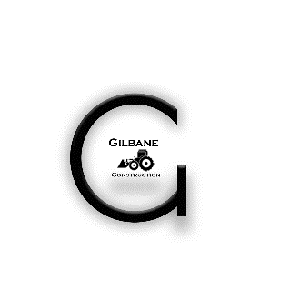

**Gilbane Road Contracting L.L.C**

**Gilbane Technical Services L.L.C**

Since its inception in 2014, Gilbane has been thriving for sustainable growth, maintaining stability in market, to be one of the leaders, contributing in new technology, involving more in managing greater/ bigger projects utilizing our highly skilled resources. We are one of the authorized contractor by the different Government, Semi Government, Private authorize such as RTA, Ministry of public work, Dubai municipality, DEWA, Sharjah RTA, DIP etc.

We provide our services in the continents of Africa, Asia & Europe through our various branches and international partners, with our Central Office located in Dubai, U.A.E.

We have been undertaking prestigious Roads & Infrastructure projects Involving bulk earthworks, demolition works, road works & hiring of all kinds of plants & equipment, Facilities Management, along with providing Project Management Service to our clients.

Having worked with many projects with various clients & contractors, we have established a reputation for quality workmanship, flexibility & timely completion of our projects to the highest standards. The majority of our clients have been with us since our establishment due to our commitment towards Client's satisfaction. Our impartial analysis and advice helps clients stay compliant, efficient and profitable.