Business Proposal: Realms to Riches

Executive Summary
Realms to Riches is a digital business development agency that empowers entrepreneurs to build and scale profitable online brands. Despite strong demand and a robust service offering, the business has faced profitability challenges due to limited access to growth capital. This proposal seeks funding to unlock the company’s full potential through strategic investments in marketing, hiring, technology, and working capital.

Business Model
Realms to Riches offers:
- Branding and design services
- Website and e-commerce development
- Digital marketing and SEO
- Subscription-based growth packages
- Online courses and startup accelerators
- Symbiotic AI Manager: a proprietary AI-powered business assistant that automates and enhances client engagement, content creation, and operational efficiency

Market Opportunity
The demand for digital business services continues to grow, especially among solopreneurs, influencers, and small business owners. Realms to Riches is uniquely positioned to serve this market with tailored, affordable, and scalable solutions. The integration of the Symbiotic AI Manager sets the business apart by offering intelligent automation and strategic insights to clients.

Funding Request
Amount Requested: $100,000 to $250,000
Purpose of Funds:
- Marketing: Paid ads, content creation, lead generation
- Hiring: Freelancers or part-time staff for design, development, and customer support
- Tech Infrastructure: Website upgrades, automation tools, CRM, analytics
- Working Capital: Day-to-day operations, subscriptions, and cash flow buffer

Funding Allocation Plan
The following table and chart illustrate how the requested funds will be allocated:
Category | $100,000 Plan | $250,000 Plan
Marketing | 30000 | 75000
Hiring | 25000 | 60000
Tech Infrastructure | 20000 | 50000
Working Capital | 25000 | 65000
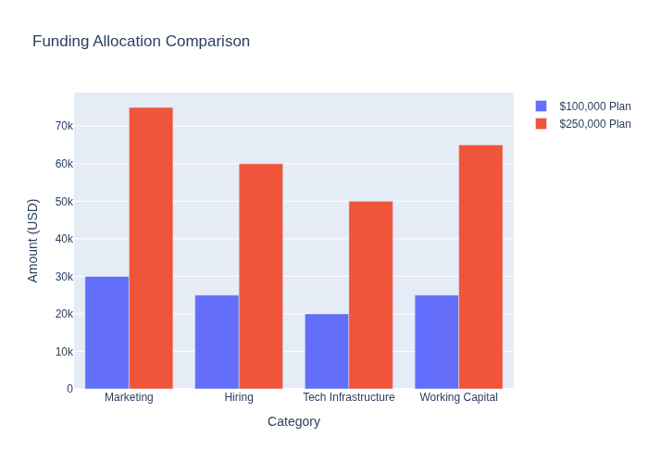

Financial Outlook
While the business is not yet profitable, projections indicate that with proper funding, Realms to Riches can achieve positive cash flow within 12–18 months. Revenue is expected to grow steadily through increased client acquisition and higher-value service offerings.

Repayment or Reporting Strategy
The loan will be repaid through business revenue, with a proposed repayment term of 3–5 years. A detailed cash flow forecast and repayment schedule can be provided upon request.

Conclusion
With two years of groundwork laid and a clear path to profitability, Realms to Riches is ready to scale. This funding will enable the business to reach its target market more effectively, deliver higher-value services, and build a sustainable revenue stream.

