UE-Requested PDU Session Modification with Magma v1.0

[*Authors: ganesh.irrinki@wavelabs.ai*](mailto:Authors:ssanadhya@fb.com)*,* [*prabinak@wavelabs.ai*](mailto:kozat@fb.com) *,* [*suresh@wavelabs.ai*](mailto:obatalla@fb.com)

*Reviewers: Magma Authors*

*Last Updated: July 09, 2021*

**NOTE:** For the table of contents, refer to *View > Show Document Outline*.

# Purpose:

The PDU session modification procedure is used when modifying one or several QoS parameters between the UE and the network.

1) When the UE-requested PDU session modification procedure is used to indicate a change of 3GPP PS data off UE status for a PDU session (see subclause 6.2.10), the UE shall initiate the UE-requested PDU session modification.

2) If the UE needs to revoke the previously indicated support for reflective QoS for a PDU session and timer T3396, T3584, or T3585 is running or is deactivated, the UE shall not initiate the UE-requested PDU session modification procedure and shall instead initiate the UE-requested PDU session release procedure.

3) If the UE needs to initiate the UE-requested PDU session modification procedure to indicate to the network the relevant 5GSM parameters and capabilities (e.g. the UE's 5GSM capabilities, whether the UE supports more than 16 packet filters, the maximum data rate per UE for user-plane integrity protection supported by the UE for uplink, the maximum data rate per UE for user-plane integrity protection supported by the UE for downlink and whether the UE requests the PDU session to be an always-on PDU session in the 5GS) for a PDN connection established when in S1 mode, after the first inter-system change from S1 mode to N1 mode, the UE is operating in single-registration mode in the network supporting N26 interface and timer T3396 is running, the UE shall initiate the UE-requested PDU session modification procedure after expiry of timer T3396.

4) When the UE-requested PDU session modification procedure is used to indicate to request specific QoS handling and segregation of service data flows

# Use Case:

The UE can request the network to modify or release PDU sessions. The network can fulfil such a request from the UE by modifying a PDU session or releasing a PDU session using network-requested procedures (see subclause 6.3).

When a UE establishes a PDU session to a DN, a default non-GBR (non-Guaranteed Bit Rate) QoS Flow without any Packet Filter is also formed to carry the UE’s traffic to the DN and vice versa. The UE or AFs (Application Functions) can create additional QoS Flows with different QoS characteristics using the PDU Session Modification procedures. For example, the UE can initiate a PDU Session Modification to create a new GBR QoS Flow for a video conference session with criteria such as:

* UDP port = 1234
* latency < 10ms
* UL/DL bandwidth = 2 Mbps GBR
* Etc…

# State changes in UE and PDU session:

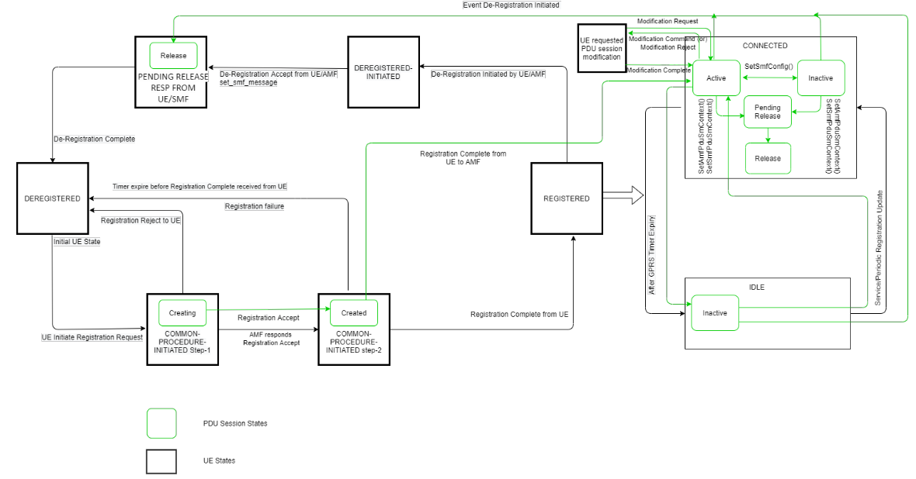

# Call Flows:

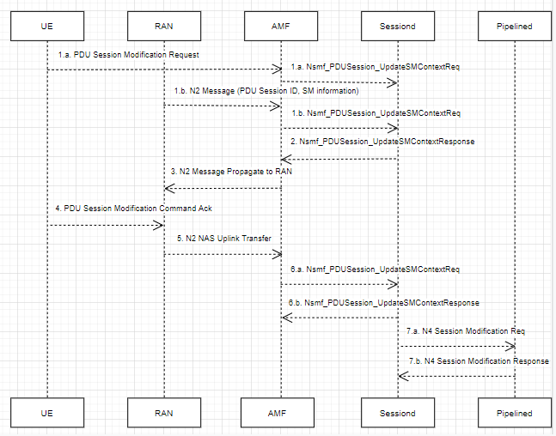

# Detailed Design:

1a. UE initiates the PDU Session Modification procedure by the transmission of a NAS message. The NAS message is forwarded by the RAN to the AMF with an indication of User location Information and AMF invokes API Nsmf_PDUSession_UpdateSMContext to SMF.

1b. RAN shall indicate to the SMF when the AN resource onto which a QoS Flow is mapped are released irrespective of whether notification control is configured. RAN sends the N2 message with SM information includes the QFI, User location Information and an indication that the QoS Flow is released. The AMF invokes Nsmf_PDUSession_UpdateSMContext

Below are the N1 SM container contents:

- N1 SM container

-- PDU Session Modification Request

--- PDU session ID,

--- Packet Filters,

--- Operation,

--- Requested QoS,

--- Segregation,

--- 5GSM Core Network Capability,

--- Number Of Packet Filters,

--- [Always-on PDU Session Requested],

-- UE Integrity Protection Maximum Data Rate

The NAS message is forwarded by (R)AN to AMF with indication of user location information. AMF calls Nsmf_PDUSession_UpdateSMContext (SM context ID, N1 SM container (PDU session modification request)).

2. SMF responds AMF after updating SM_Context and SMF requests to transfer downlink N2 message to the UE and AN through the AMF. i.e. The SMF request to update activation of Data Radio Bearer and N3 tunnel for the PDU session.

# Nsmf_PDUSession_UpdateSMContext Response

- N2 SM information

-- PDU Session ID,

-- QFI(s),

-- QoS Profile(s),

-- Session-AMBR

- N1 SM container

-- PDU Session Modification Command

--- PDU Session ID,

--- QoS rule(s),

--- QoS rule operation,

--- QoS Flow level QoS parameters if needed for the QoS Flow(s) associated with the QoS rule(s),

--- Session-AMBR,

--- [Always-on PDU Session]

For QoS configuration files, QoS rules and QoS flow level QoS parameters, please refer to TS 23.501 [2] Clause 5.7. QoS model

The N2 SM information carries the information that AMF must provide to (R)AN. It can include a QoS configuration file and corresponding QFI to notify (R) AN that one or more QoS flows have been added or modified. It can include only one or more QFIs to notify (R)AN that one or more QoS flows have been deleted. If the UE requests session modification for a PDU session of user plane resources that is not established, the N2 SM information provided to the (R)AN includes information for establishing user plane resources.

The N1 SM container carries the PDU session modification command that AMF must provide to the UE. It may include QoS rules, QoS flow-level QoS parameters required by QoS flows associated with QoS rules, and corresponding QoS rule operations and QoS flow-level QoS parameter operations to notify the UE that one or more QoS rules have been added or deleted or modify.

3. The above N2 message gets propagate to RAN.

4. The UE acknowledges the PDU Session Modification Command by sending a NAS message based on #5 action above.

5. The RAN forwards the NAS message to the AMF.

6.a. The AMF forwards the N1 SM container i.e., PDU Session Modification Command Ack and User Location Information received from the AN to the SMF via Nsmf_PDUSession_UpdateSMContext request.

6.b. The SMF replies with a Nsmf_PDUSession_UpdateSMContext Response.

7.a. The SMF updates N4 session of the UPF that is being affected in the PDU Session Modification procedure, by sending N4 Session Modification Request message to the UPF.

7.b. UPF responds back to SMF, by sending N4 Session Modification Response message.

## N11 GRPC Message definition

#### *M5GSMSessionModificationRequest*

message SetSMSessionContextUpdate {

CommonSessionContext common_context = 1; // Common message for 4g, 5g and WiFi.

RatSpecificContextUpdate rat_specific_context = 2;

}

message RatSpecificContextUpdate {

M5GSMSessionContextUpdate m5gsm_session_context_update = 1;

}

message M5GSMSessionContextUpdate {

required uint32 pdu_session_id = 1;

required bytes procedure_trans_identity = 2;

// Define ENUM 24-501 - 9.11.3.47 . 1 byte. i.e. initial request, existing pdusession, modification request etc...

required RequestType request_type = 3;

//RQoS, MH-IPv6 PDU session

optional M5GSMCapability m5g_sm_capability = 4;

optional M5GSMCause m5gsm_cause = 5;

optional uint32 max_pkt_filter_supported = 6;

optional bool pdu_session_req_always_on = 7;

optional bytes integrity_protection_max_data_rate = 8;

//DQR, seggregation, QFI, no_of_packet_filters, qos_rule_precedence

optional repeated QosRules requested_qos_rules = 9;

optional repeated FlowQos qos_flow_description = 10;

PduSessionType pdu_session_type = 11; // IPv4

optional string user_location_info = 12;

optional repeated LadnServiceArea ladn_service_area = 13;

//5QI, ARP

optional qos_flow_request_list qos_fiveqi = 14;

}

#### *M5GSMSessionModificationReject*

message M5GSMSessionContextUpdateReject {

required uint32 pdu_session_id = 1;

required bytes procedure_trans_identity = 2;

required RequestType request_type = 3;

required M5GSMCause m5gsm_cause = 4;

optional bool M5gsm_congetion_re_attempt_indicator = 5;

}

#### *M5GSMSessionModificationCommand*

message SetSMSessionContextUpdateAccess {

CommonSessionContext common_context = 1; // Common message for 4g, 5g and WiFi.

RatSpecificContextUpdateAccess rat_specific_context = 2;

}

message RatSpecificContextUpdateAccess {

M5GSMSessionContextUpdateAccess m5g_session_context_rsp = 1;

}

message M5GSMSessionContextUpdateAccess {

required uint32 pdu_session_id = 1;

required bytes procedure_trans_identity = 2;

required RequestType request_type = 3;

//session-ambr

optional AmbrUnit downlink_unit_type = 4;

optional AmbrUnit uplink_unit_type = 5;

optional repeated QosRules authorized_qos_rules = 6;

//precedence

optional repeated FlowQos qos_flow_description = 7;

//QCI

optional QoSInformation qos_info = 8;

optional bool M5gsm_congetion_re_attempt_indicator = 9;

//5QI, ARP

optional qos_flow_request_list qos_fiveqi = 10;

optional bool pdu_session_req_always_on = 11;

optional FlowQos qos_flow_description = 12;

//Mapped EPS QoS

//Traffic flow template

}

#### *M5GSMSessionModificationCommandReject*

message M5GSMSessionContextUpdateAccessReject {

required uint32 pdu_session_id = 1;

required bytes procedure_trans_identity = 2;

required RequestType request_type = 3;

required M5GSMCause m5gsm_cause = 4;

}

#### *M5GSMSessionModificationComplete*

message M5GSMSessionContextUpdateComplete {

required uint32 pdu_session_id = 1;

required bytes procedure_trans_identity = 2;

required RequestType request_type = 3;

}

N11 GRPC RPC’s to be added:

//SET API for 3 procedures request from AMF to SMF

service AmfPduSessionSmContext {

rpc SetAmfSessionContext(SetSMSessionContext) returns (SmContextVoid) {}

rpc SetSmfNotification(SetSmNotificationContext) returns (SmContextVoid) {} //AMF to SMF

rpc SetAmfSessionContextUpdate(SetSMSessionContextUpdate) returns (SmContextVoid) {}

}

// RPC service and method

service SmfPduSessionSmContext {

rpc SetAmfNotification(SetSmNotificationContext) returns (SmContextVoid){} // SMF to AMF

rpc SetSmfSessionContext(SetSMSessionContextAccess) returns (SmContextVoid) {}

rpc SetSmfSessionContextUpdate(SetSMSessionContextUpdateAccess) returns (SmContextVoid) {}

}

Exit Criteria:

UE requested session modification should be tested with DSTester and TeraVM.

References:

1) 3GPP TS 24.501 v15.6.0 Release 15 – 5G; Non-Access Stratum (NAS) protocol for 5G System (5GS);

<https://www.etsi.org/deliver/etsi_ts/124500_124599/124501/15.06.00_60/ts_124501v150600p.pdf>

2) 3GPP TS 23.501 version 15.6.0 Release 15 – 5G; System architecture for the 5G System (5GS);

<https://www.etsi.org/deliver/etsi_ts/123500_123599/123501/15.06.00_60/ts_123501v150600p.pdf>