SnapIMS
Operator Guide
Version 0.5.1 - Verification Hardening Patch
Photo-first inventory ingestion for Canada VHS
FastAPI/Jinja browser workstation · SQLite schema 5
Use the final browser UI as the source of truth.
Mock and simulation screenshots do not prove live AI or live Shopify.

Quick start
The routine operator flow is intentionally short.
1. Photograph | 2. Import | 3. Identify | 4. Review | 5. Publish
START, shelf, tape photos, NEXT, repeat, END. | Preview grouping, then preserve/import. | Choose a provider and identify the batch. | Confirm title; optionally adjust Price or Discount; Approve & Next. | Simulate drafts and download the CSV.
- Edit is exception mode, not the routine path.
- Later postpones a tape and leaves it unfinished.
- Never change Item ID; it is permanent across Review, CSV, and Shopify.
- Real operator time per tape must be measured during the live pilot.

QR photography sequence
Card / action | Payload | Meaning
START | CVHS1:BATCH:START | Begins the batch.
LOCATION | CVHS1:LOC:A1 ... J10 or Q1 | Applies shelf to following items.
PRODUCT | ordinary photos | First product photo is Front.
NEXT | CVHS1:ITEM:NEXT | Sole normal item boundary.
FLAGS | CVHS1:FLAG:RARE / REVIEW | Apply to next item, then reset.
END | CVHS1:BATCH:END | Closes final item and batch.
Time gaps never split items. CONT is deprecated compatibility only. Command images are preserved for audit but never attached to products.

Home
Start here. Import a new camera roll or continue the active batch. The summary cards show current workload.
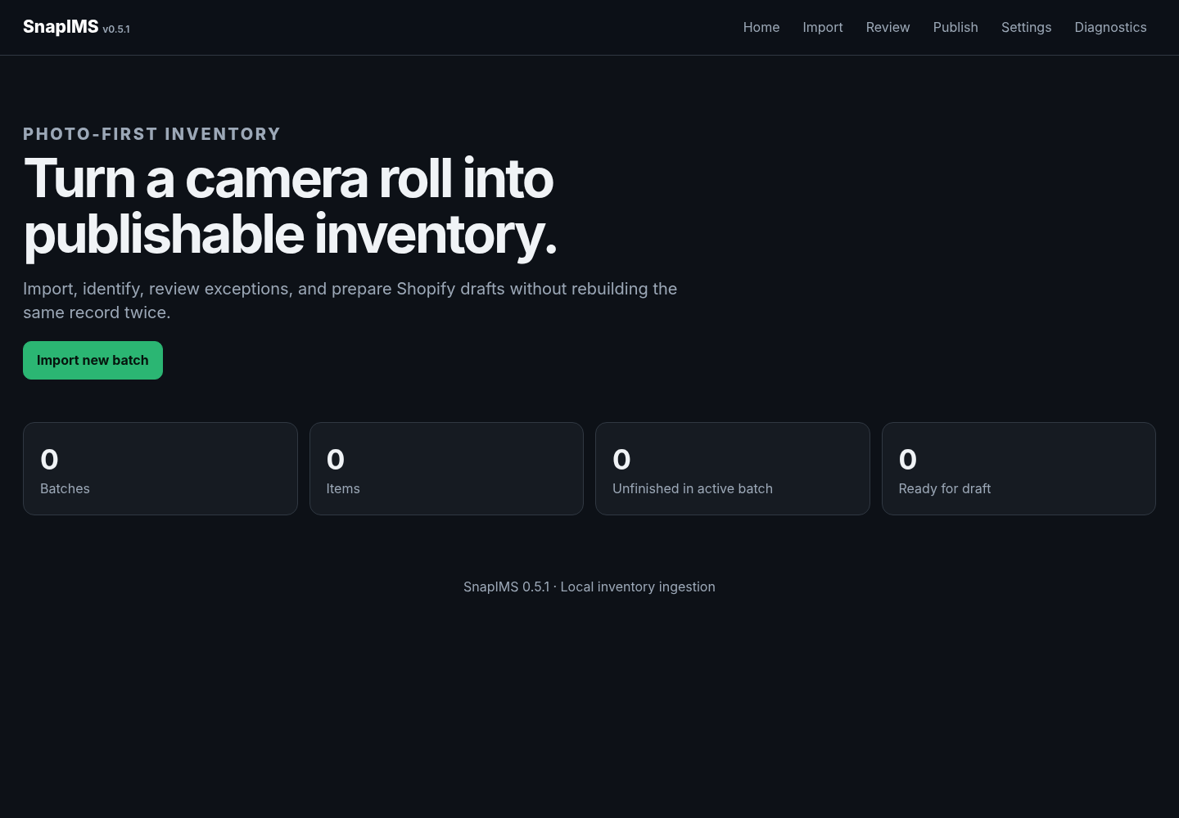
00-home.png

Import - first run
Use Advanced once to choose the camera-roll folder. Save it as the incoming folder so routine later imports use the selector.
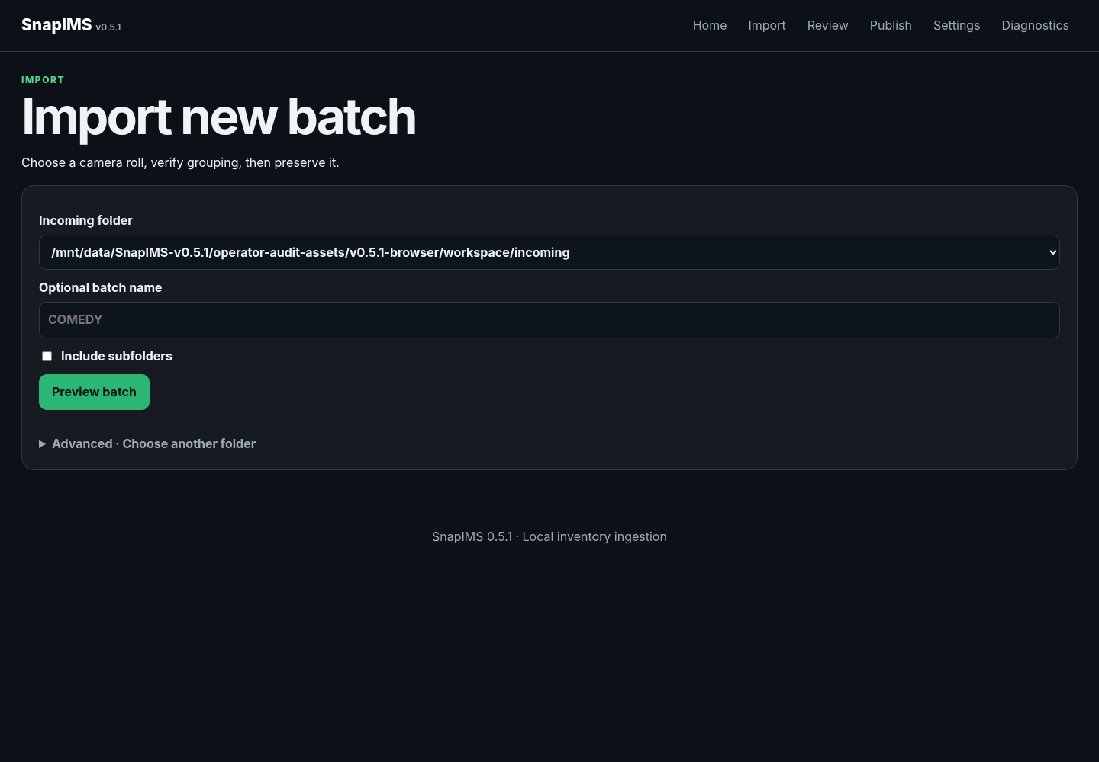
01-first-run-import.png

Preview - not imported yet
Confirm item, product-photo, command, and warning counts. Preview is temporary and does not display a durable Batch ID.
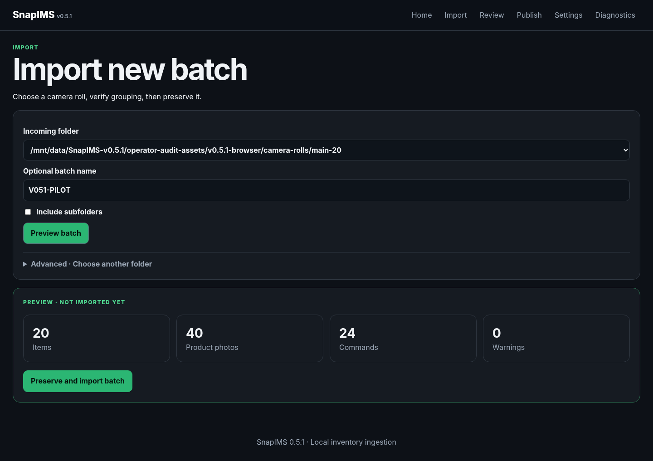
02-preview-not-imported.png

Preserve and import
After grouping is correct, preserve/import. SnapIMS displays exactly one durable Batch ID and leaves source photographs untouched.
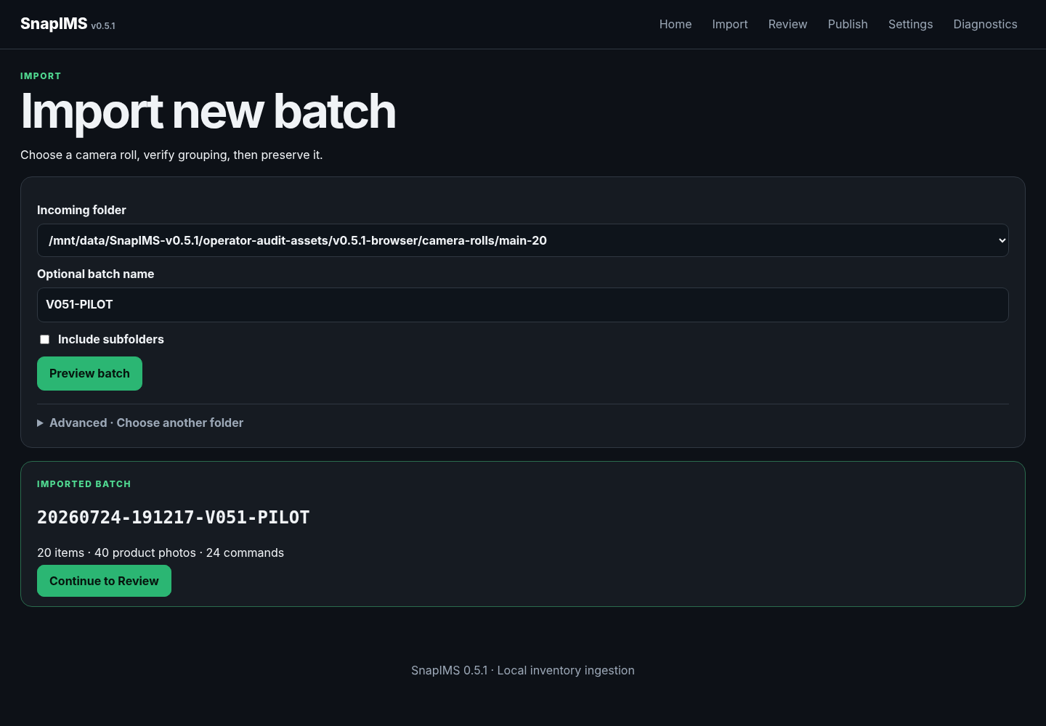
02-imported-durable-id.png

Review before identification
The compact status explains the next action. Select a provider and choose Identify items once.
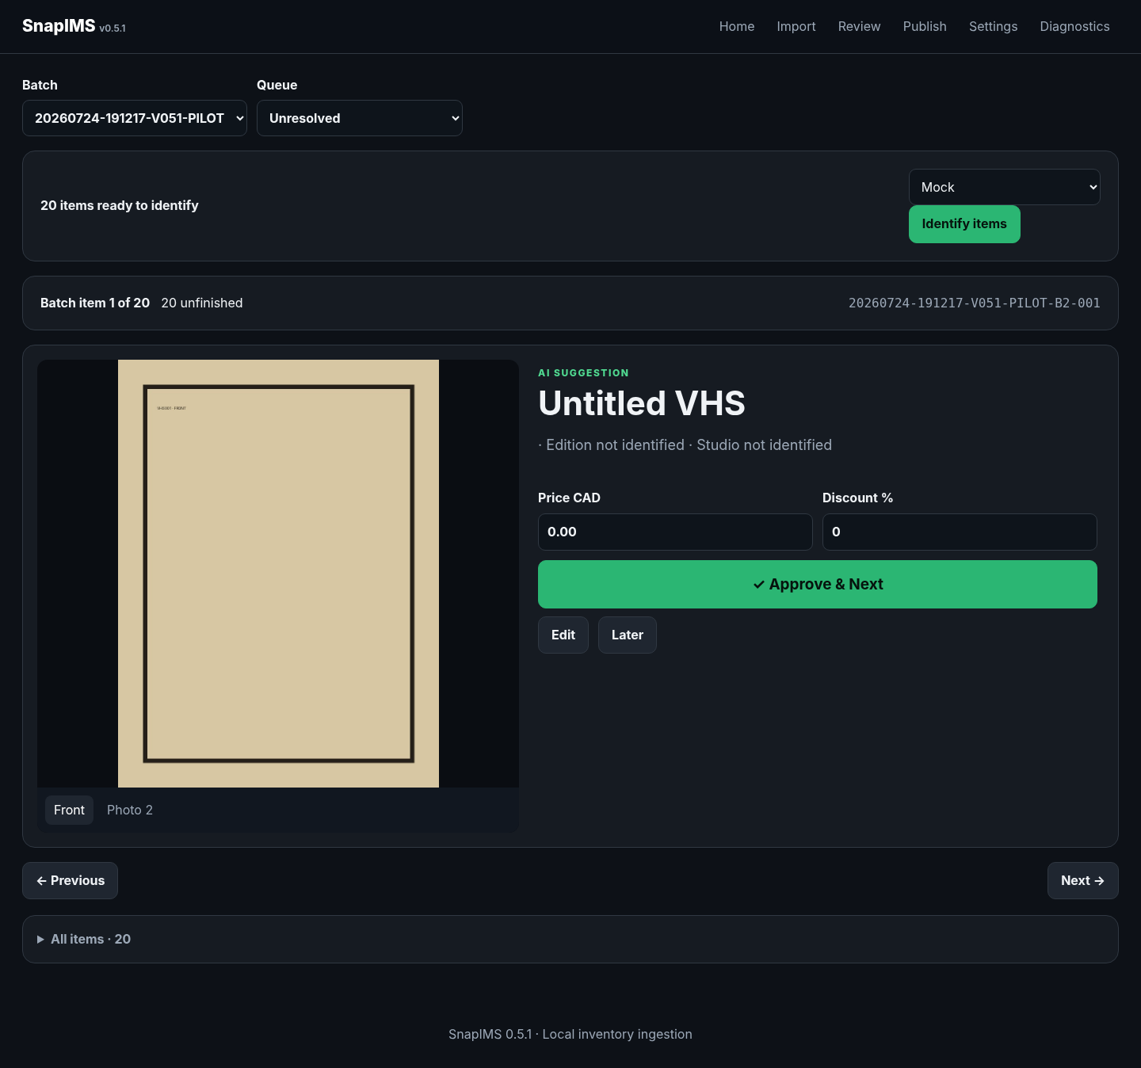
04-review-before-identification.png

Recognition complete
The suggested title, Price, Discount, physical position, and primary action are visible together.
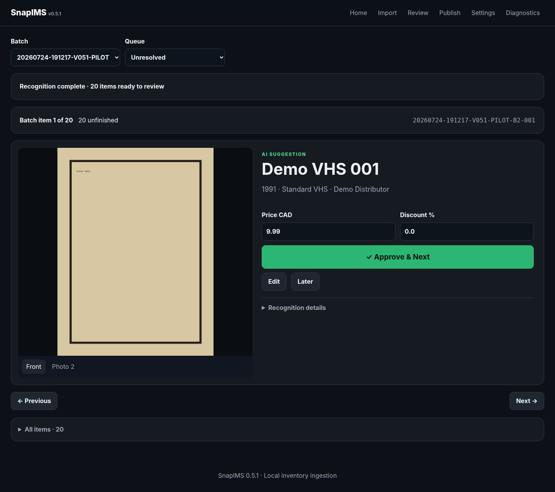
05-recognition-complete.png

Quick edit - Price
Enter a corrected CAD price directly in Review, then choose Approve & Next. No separate Save is required.
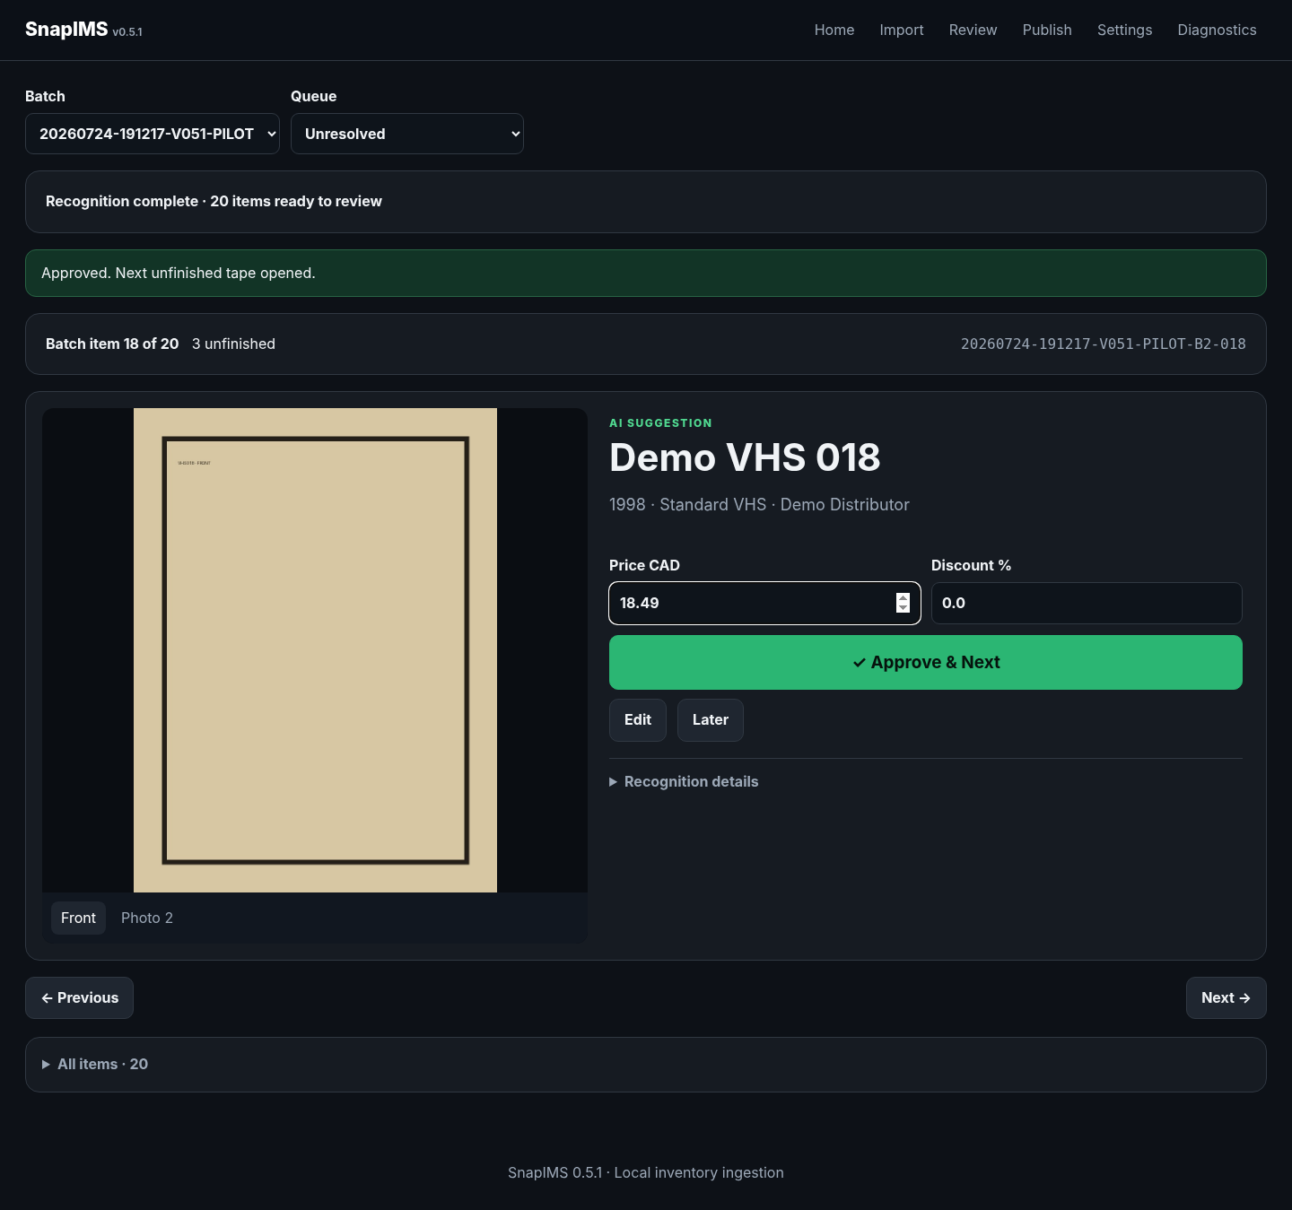
06-price-quick-edit.png

Quick edit - Discount
Enter the percentage directly in Review, then choose Approve & Next once.
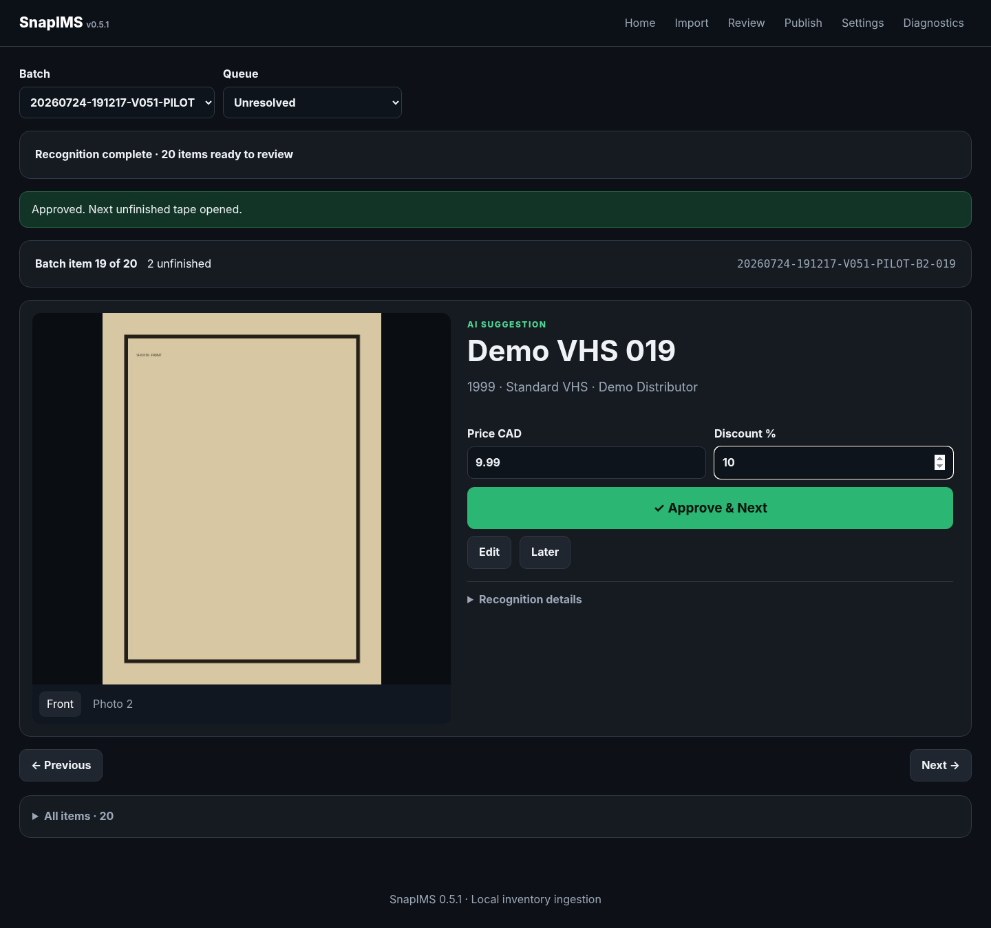
07-discount-quick-edit.png

Quick edit - Price and Discount
Both fields can be changed before the same one-action approval.
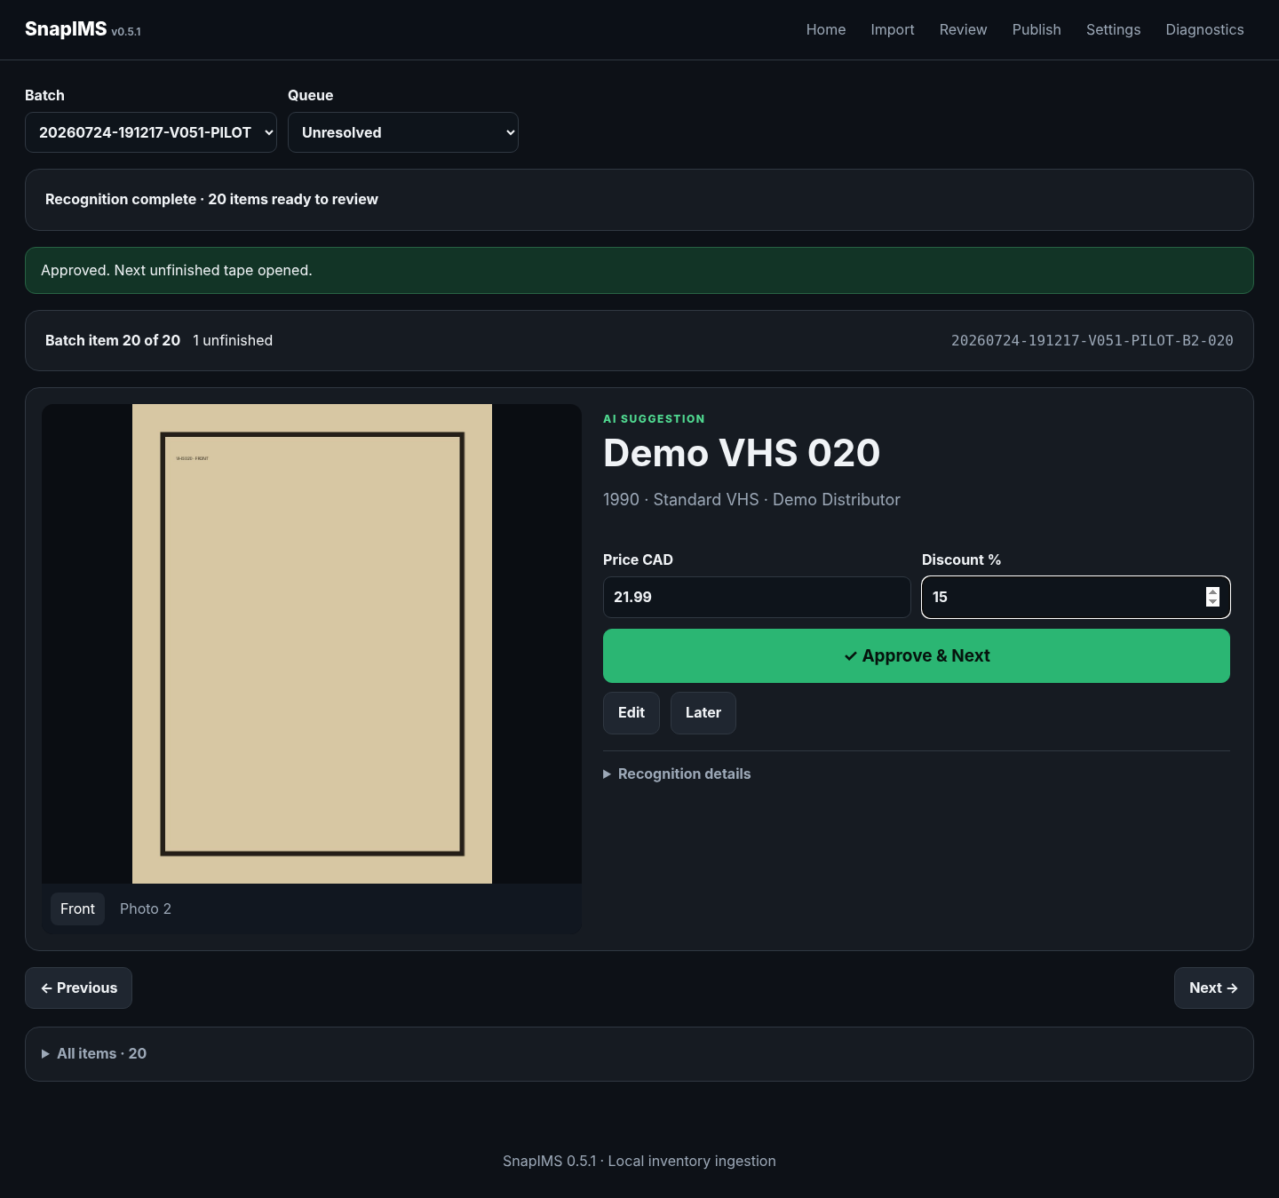
08-price-discount-quick-edit.png

Automatic advancement
Approve & Next marks the current item Done, decrements unfinished count, and opens the next physical item exactly once.
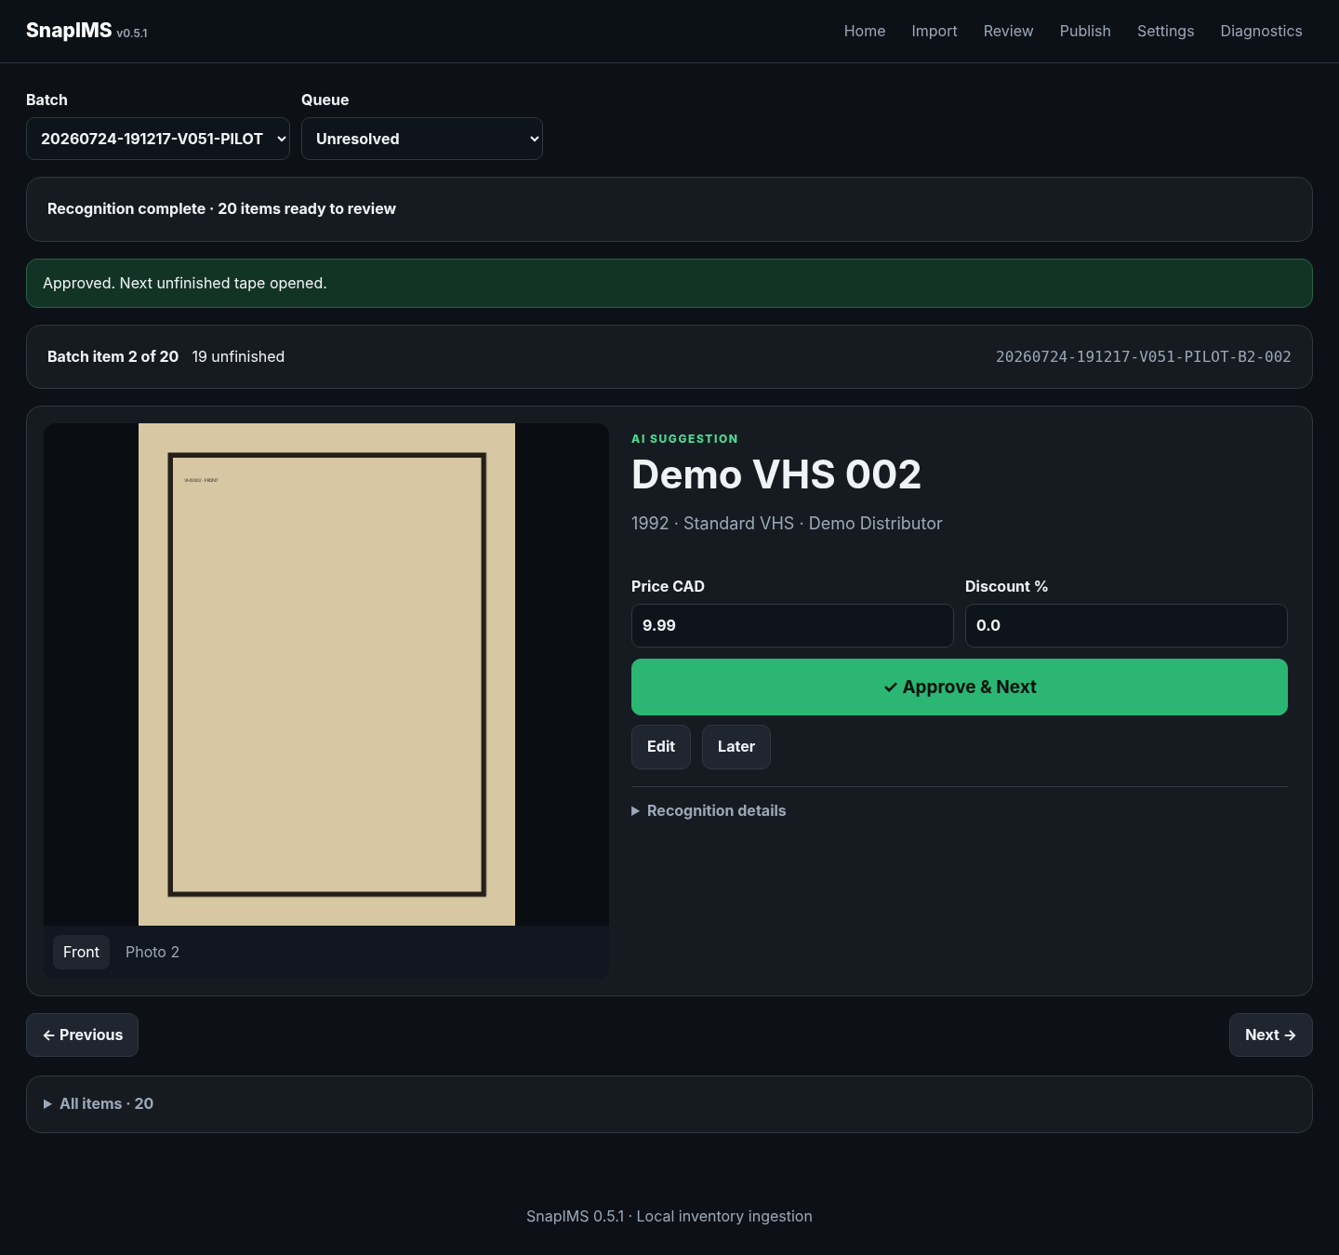
09-next-item-opened.png

Review complete
When unfinished count reaches zero, the Review-complete message replaces normal recognition actions. Use Done to inspect records.
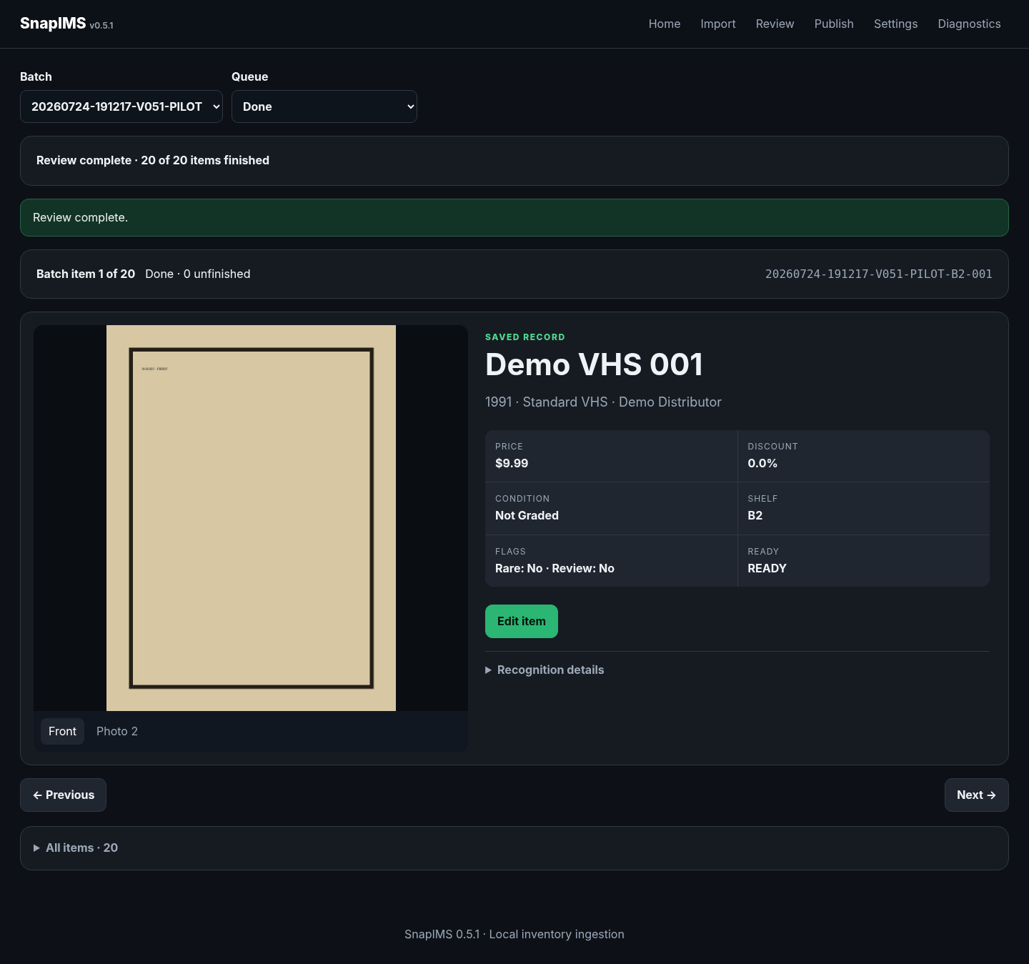
10-review-complete.png

Correct a completed item
Edit item opens saved data. Save changes stays on the same immutable Item ID.
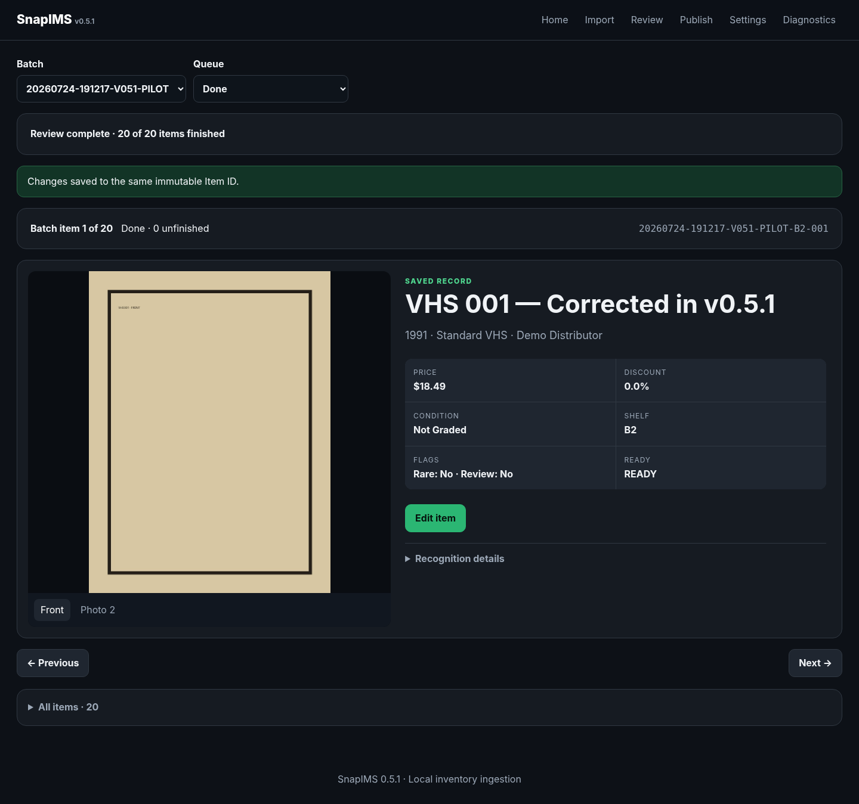
11-completed-item-corrected.png

Validation blocks invalid changes
Blank Title and zero Price are rejected atomically. The editor remains open with exact errors.
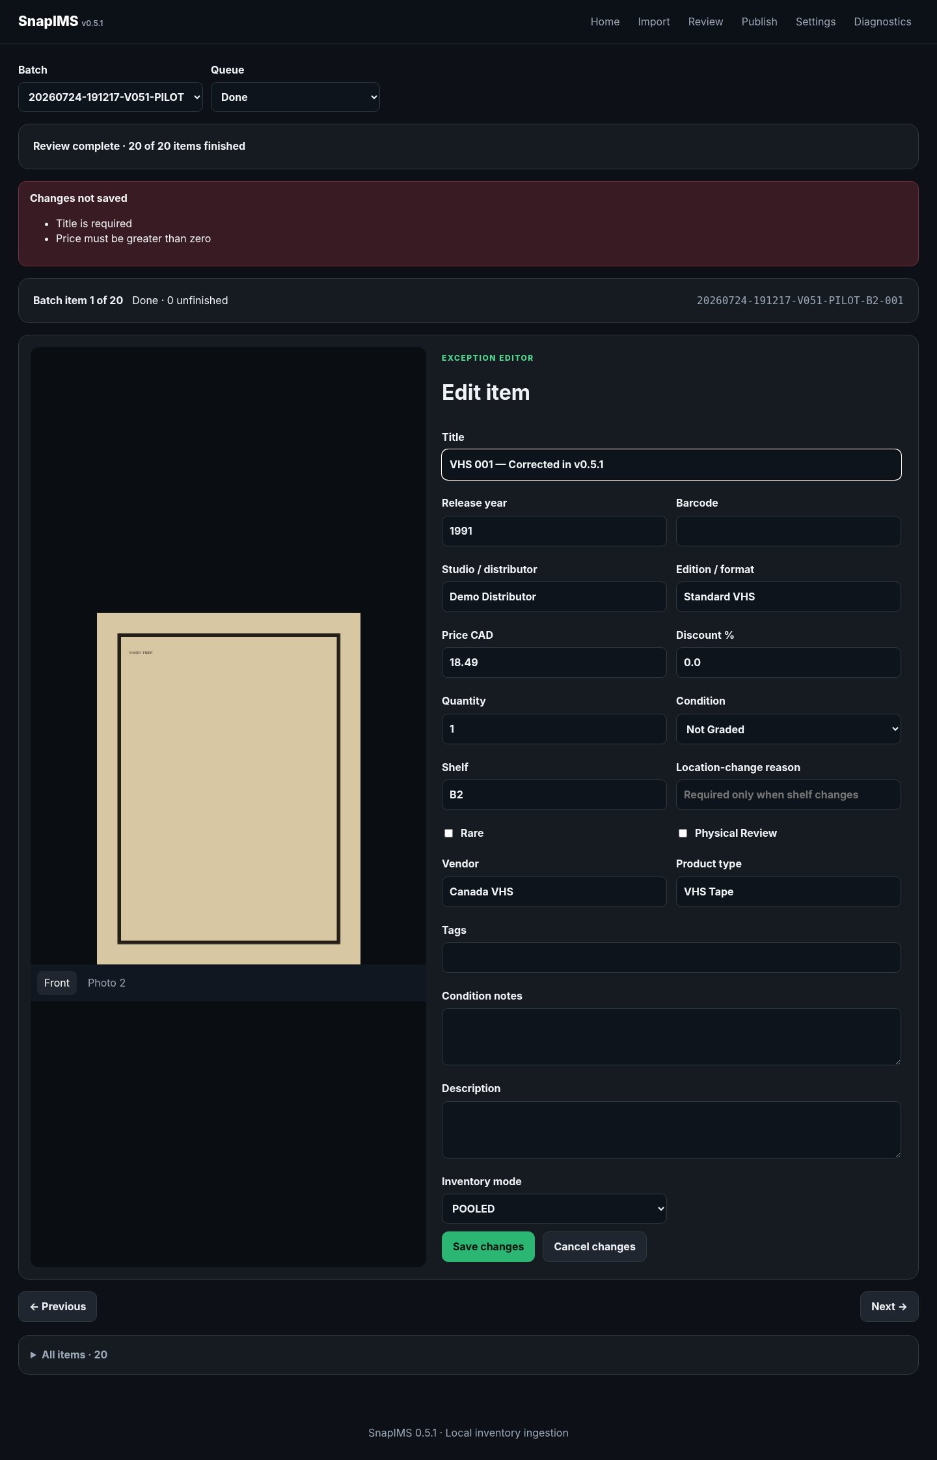
12-invalid-edit-blocked.png

Cancel invalid changes
Cancel changes restores the last valid saved record without altering the Item ID.
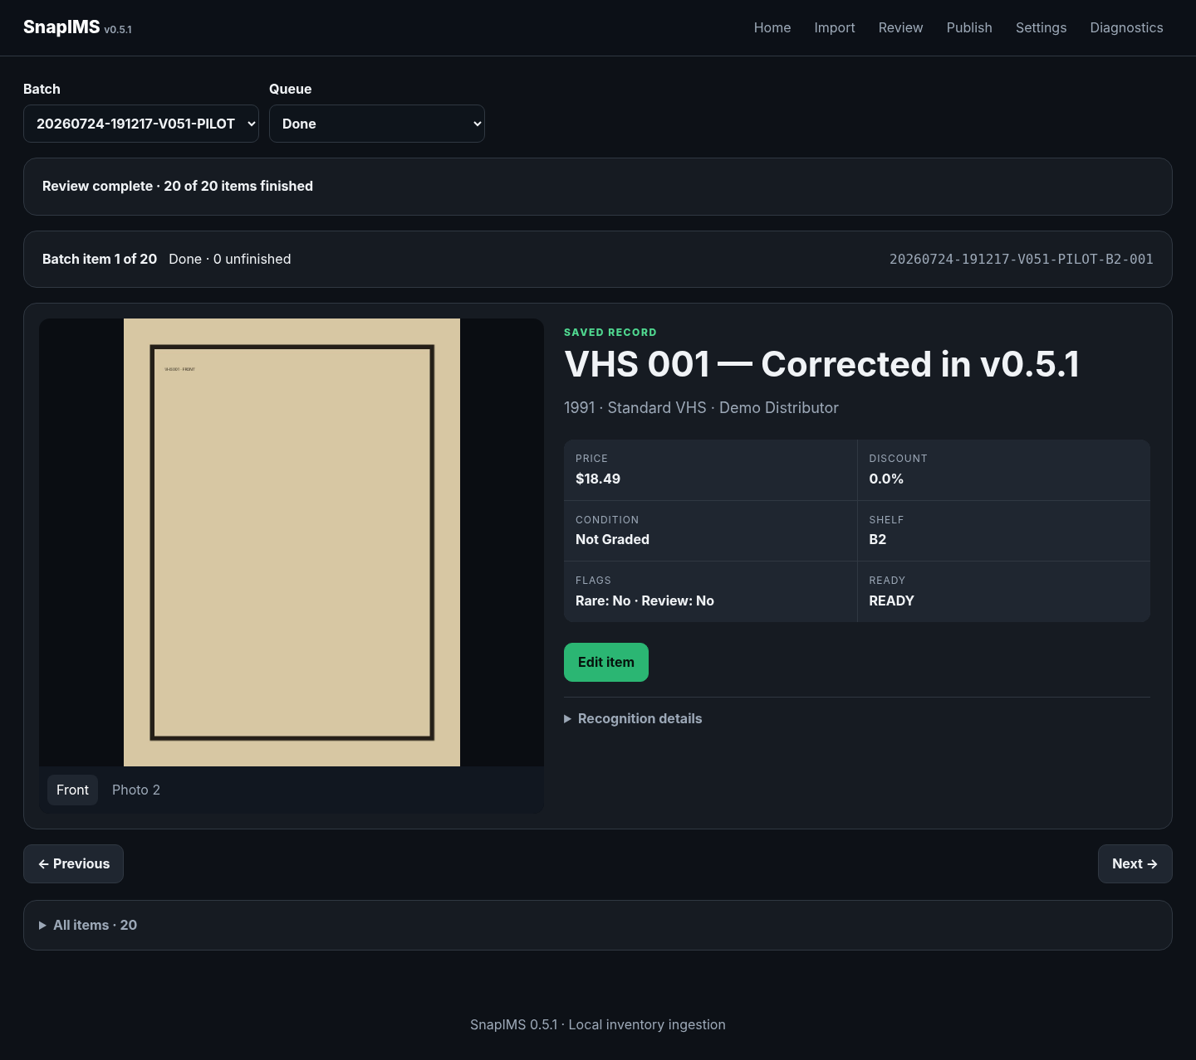
13-invalid-edit-cancelled.png

Restart durability
After a full application-process restart, saved metadata and Item ID remain available from SQLite.

14-restart-durable-correction.png

Publish simulation
Confirm Ready/Blocked counts and payload previews. Download the inventory CSV before any live-draft acceptance test.
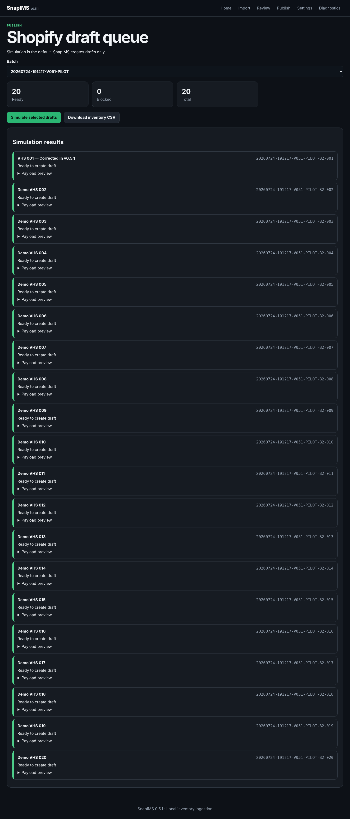
15-publish-simulation.png

Routine second import - Preview
Configured and recent folders avoid routine absolute-path typing.
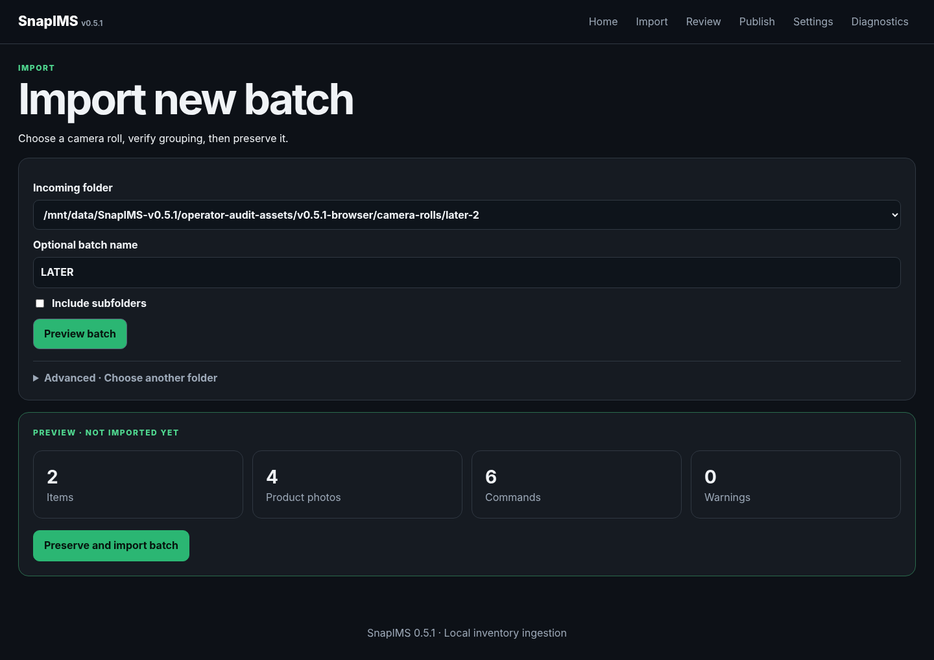
16-preview-not-imported.png

Routine second import - durable ID
A successful import is available immediately through Continue to Review.
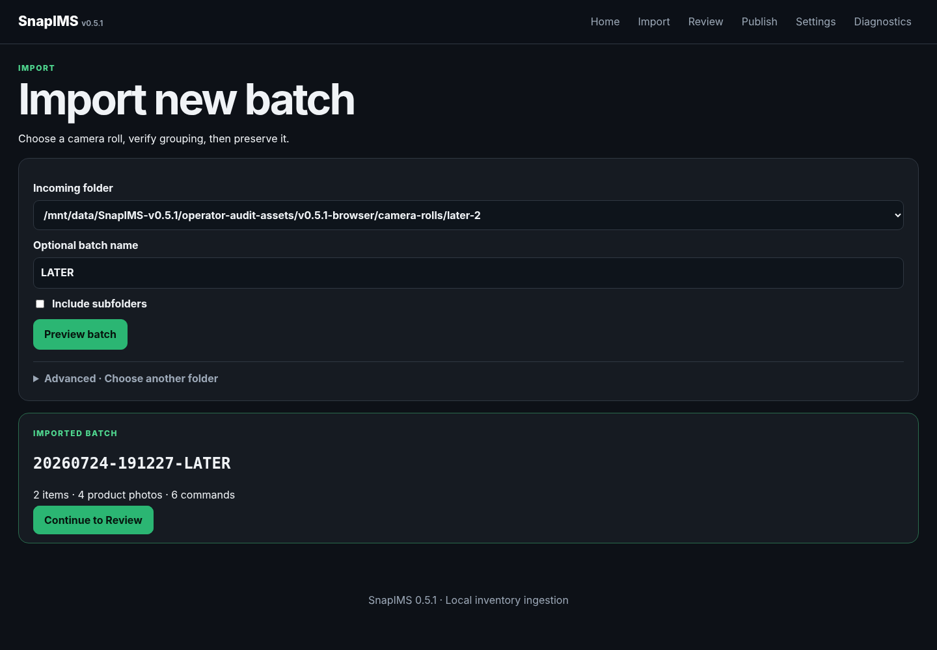
16-imported-durable-id.png

Postpone with Later
Later does not finish the tape. The notice confirms it remains unfinished; return through Unresolved.
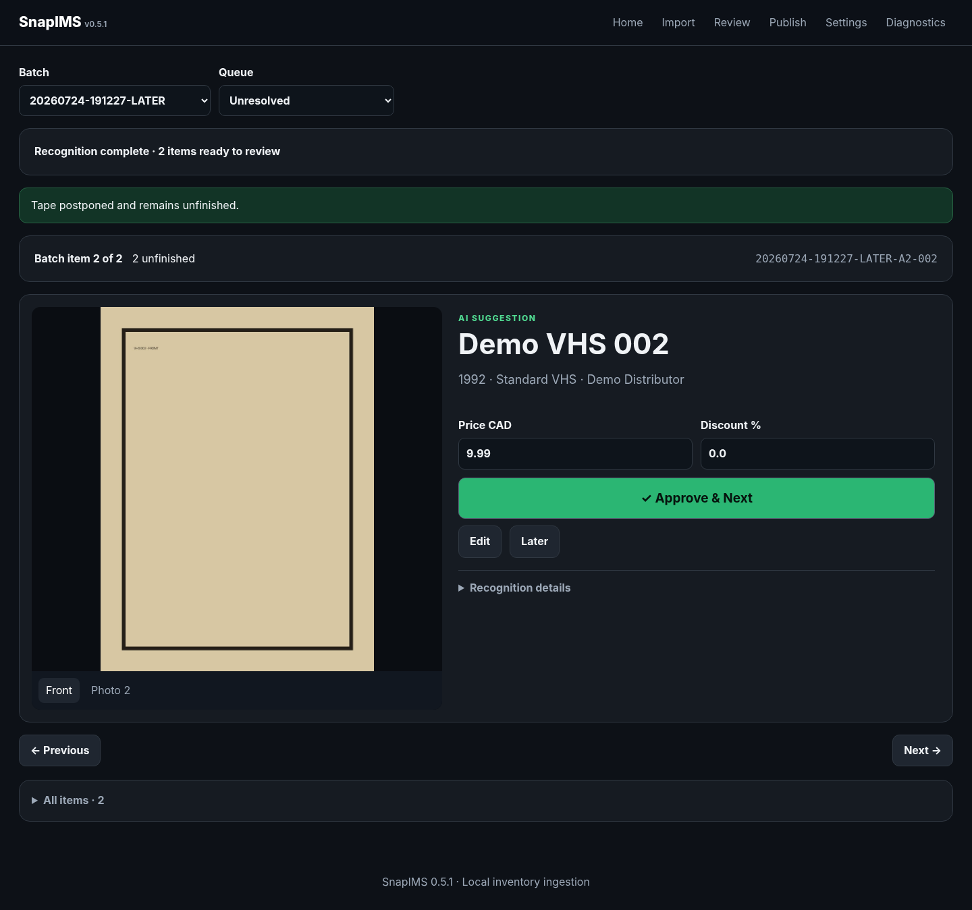
18-later-preserves-unfinished.png

Missing incoming folder
SnapIMS fails closed and does not scan another folder. Reconnect the device or use Advanced recovery.
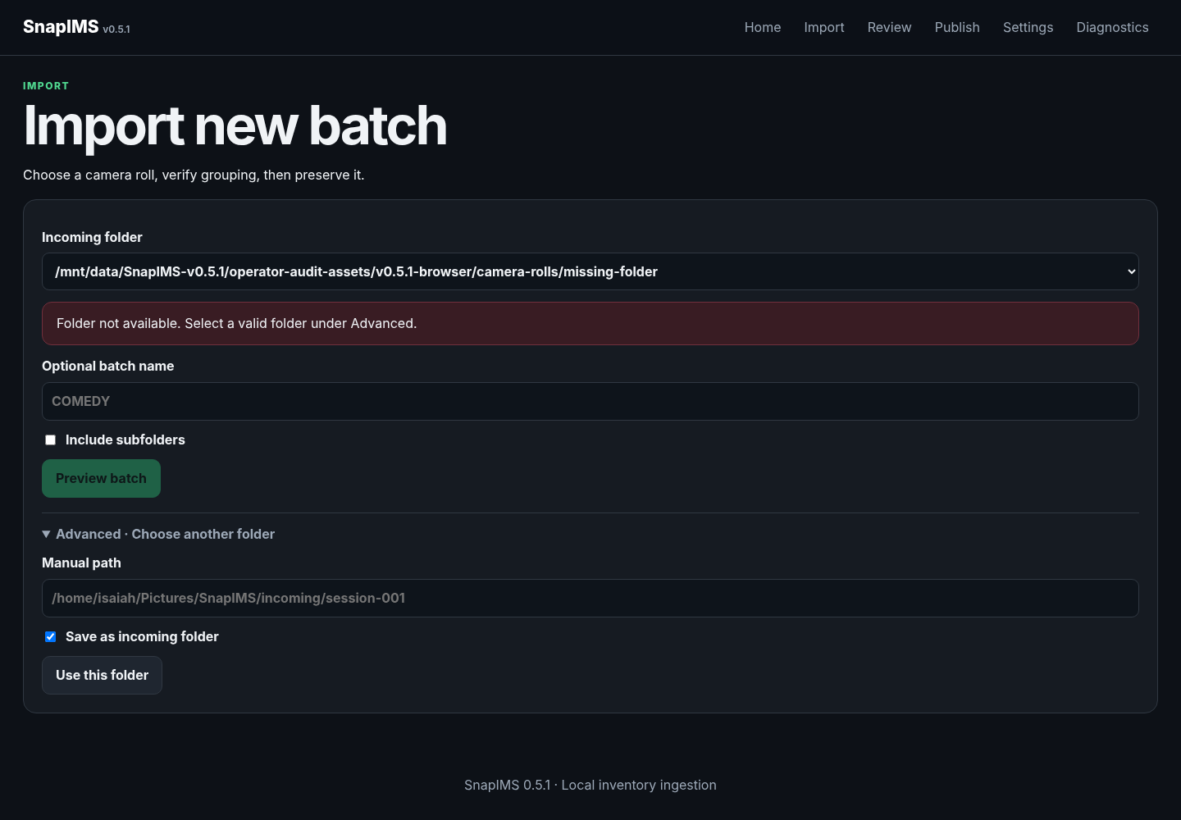
19-missing-folder-recovery.png

Recognition failure fixture - Preview
The normal Preview contract remains unchanged for a one-item failure test.
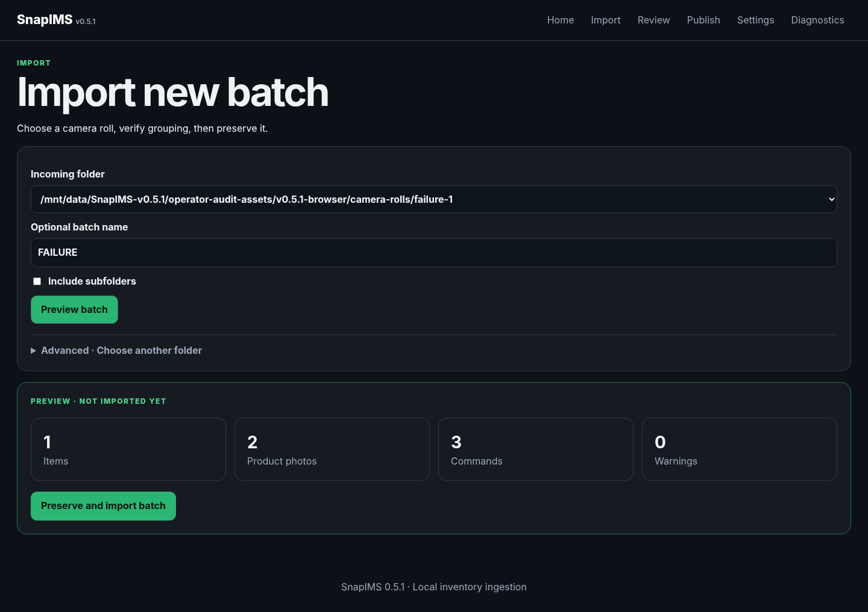
20-preview-not-imported.png

Recognition failure fixture - Import
The failed provider attempt remains attached to this same durable item.
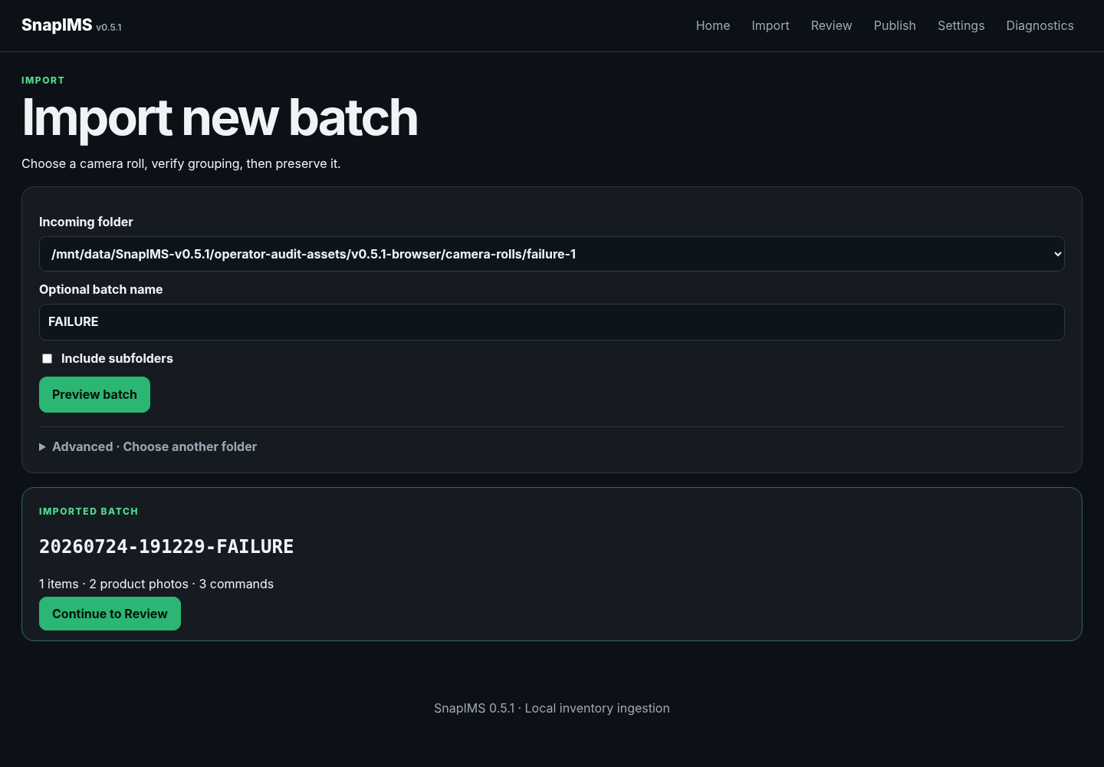
20-imported-durable-id.png

Recognition failure
Open the Failed queue, read the provider error, choose a working provider, and Retry.
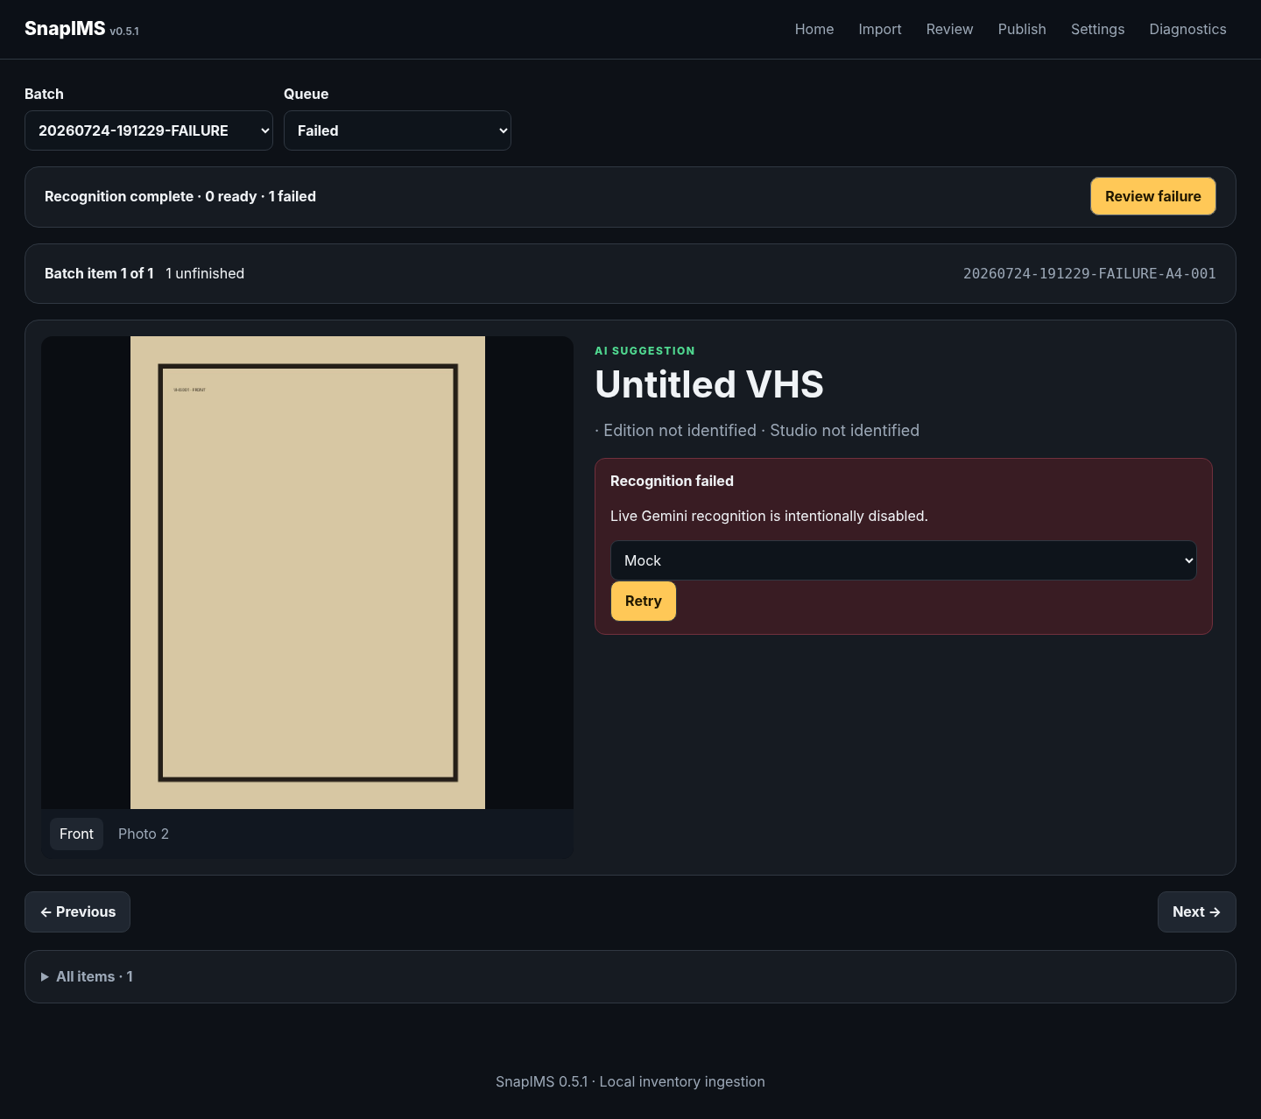
22-recognition-failure.png

Recognition recovered
Retry restores a reviewable suggestion without creating another item or changing physical position.
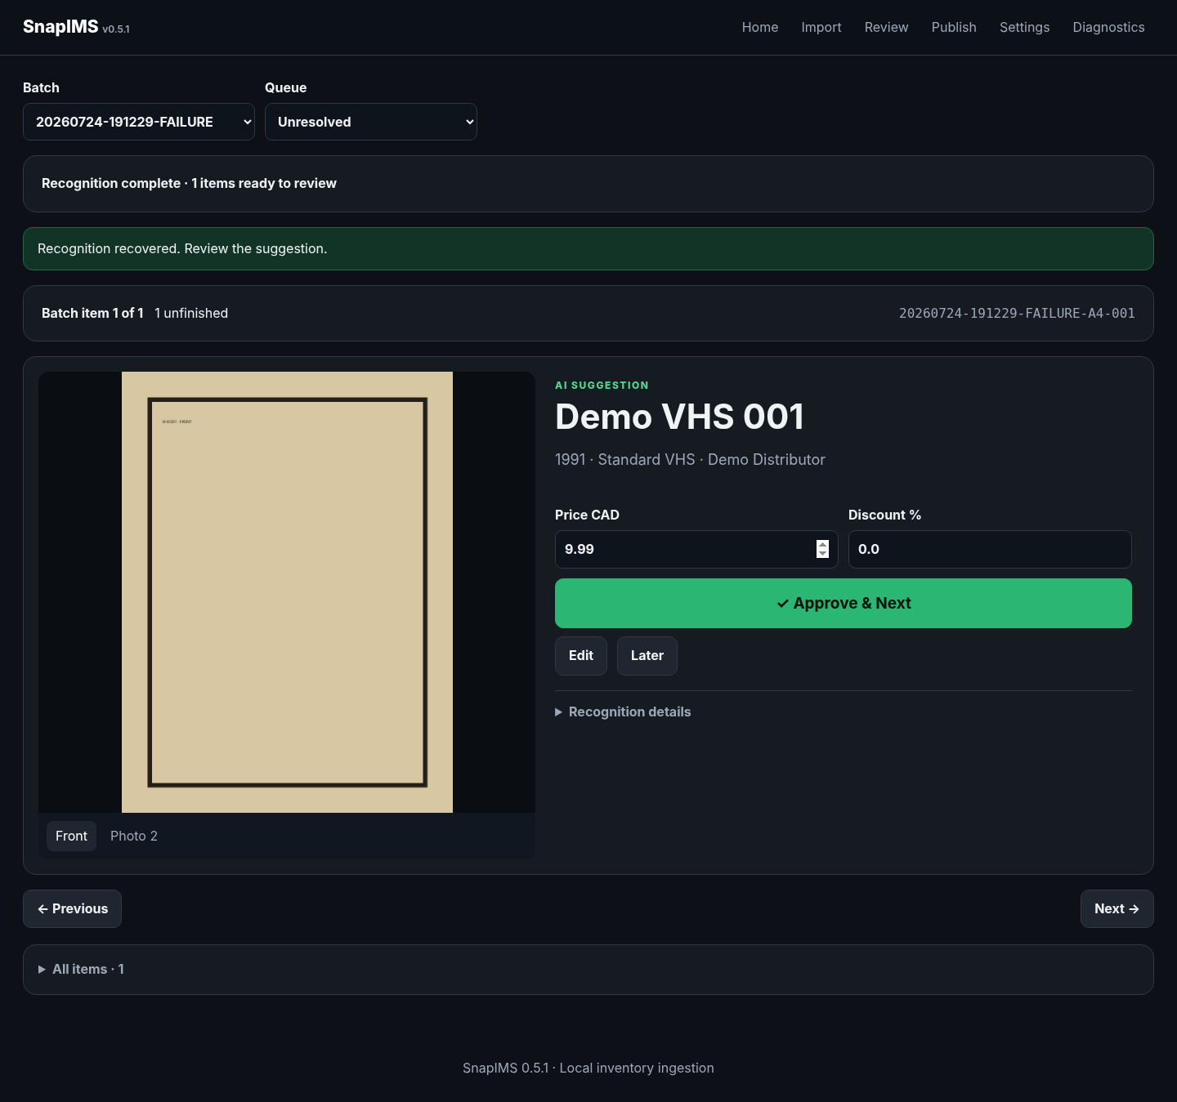
23-recognition-failure-recovered.png

Interruption fixture - Preview
A large deterministic batch keeps recognition visibly active long enough to test process interruption.
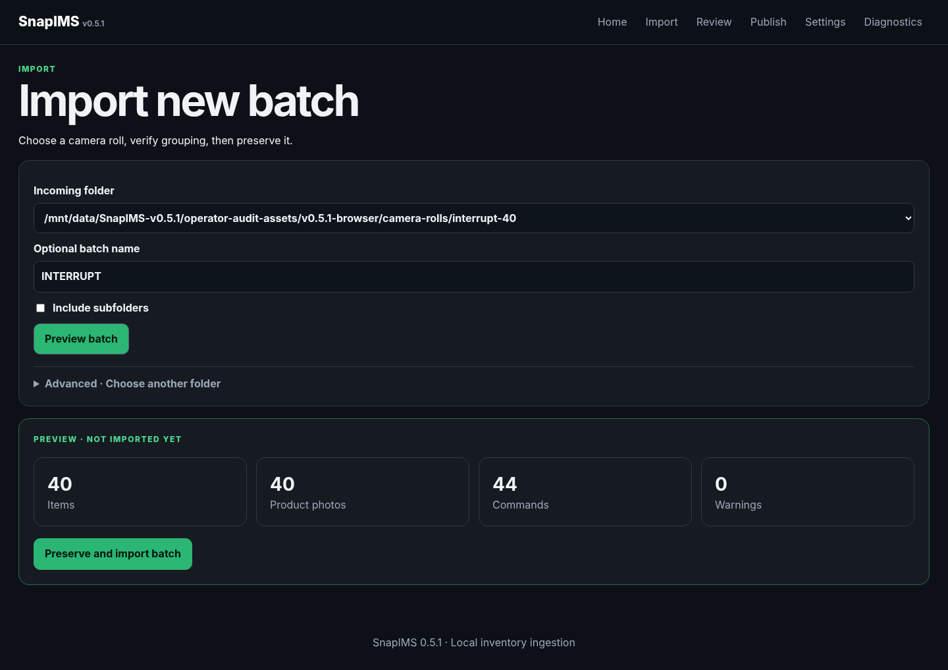
24-preview-not-imported.png

Interruption fixture - Import
The 40-item batch receives one durable identity before recognition starts.
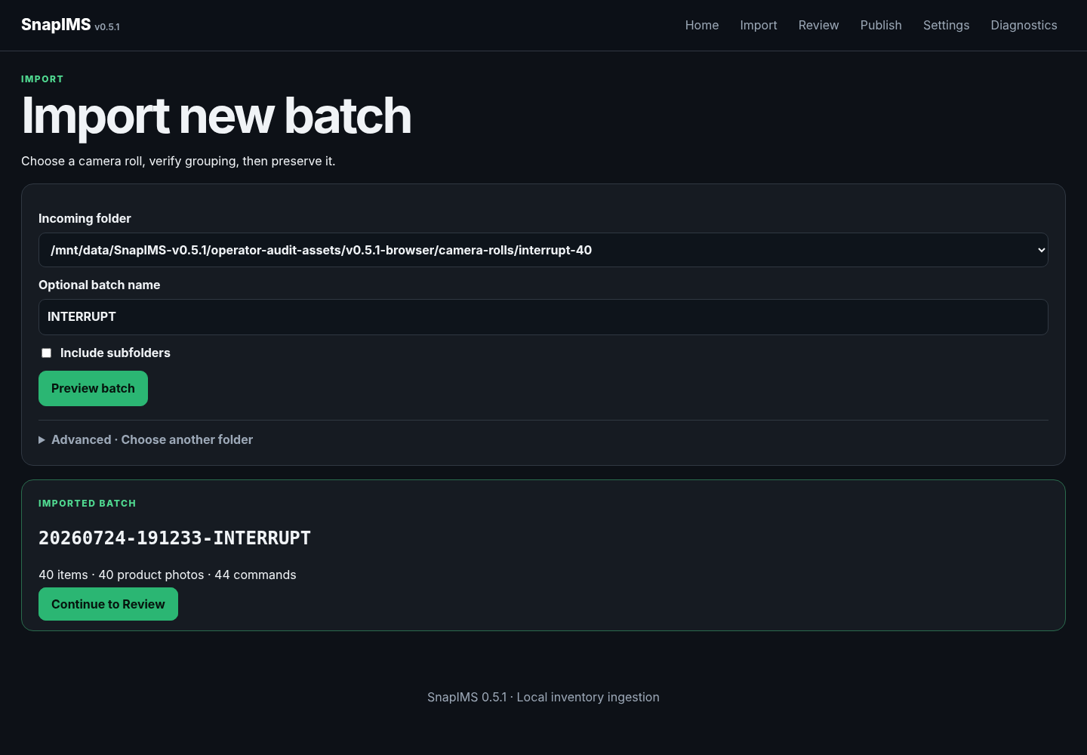
24-imported-durable-id.png

Recognition running
The browser shows committed progress before the application process is terminated.
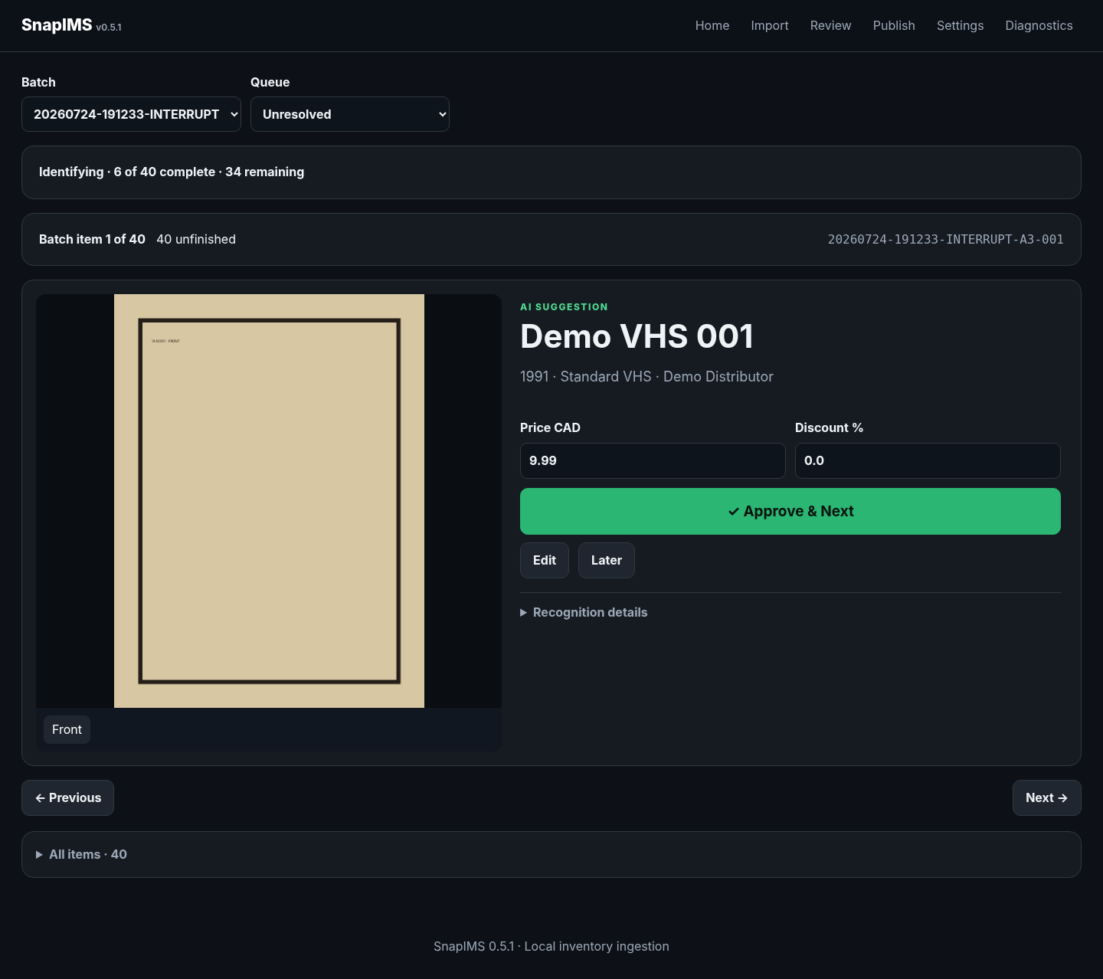
26-recognition-running-before-kill.png

Recognition paused after restart
Startup converts the orphaned Running job to Paused with exact completed/remaining counts and one Continue action.
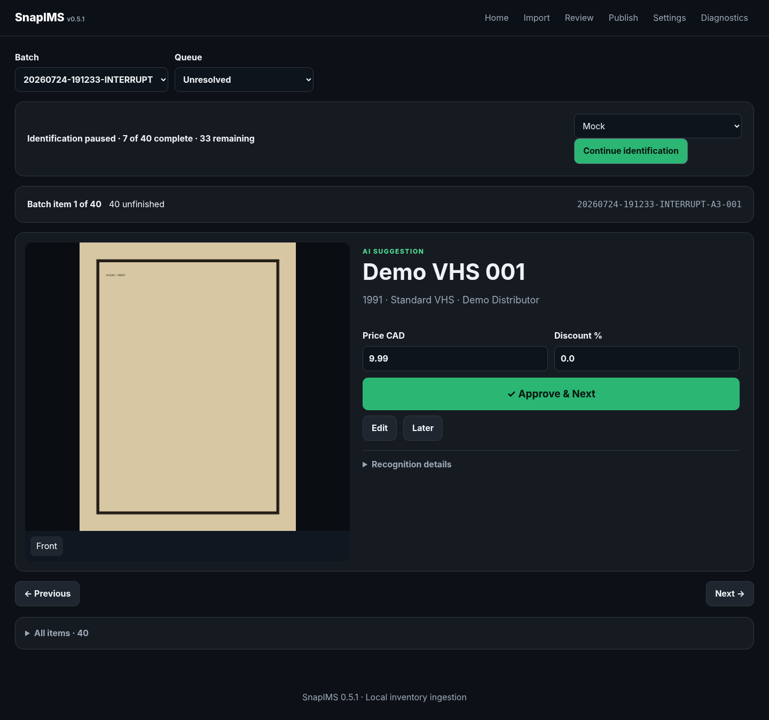
27-recognition-paused-after-restart.png

Continue interrupted identification
Continue resumes from committed boundaries and completes without duplicate recognition attempts.
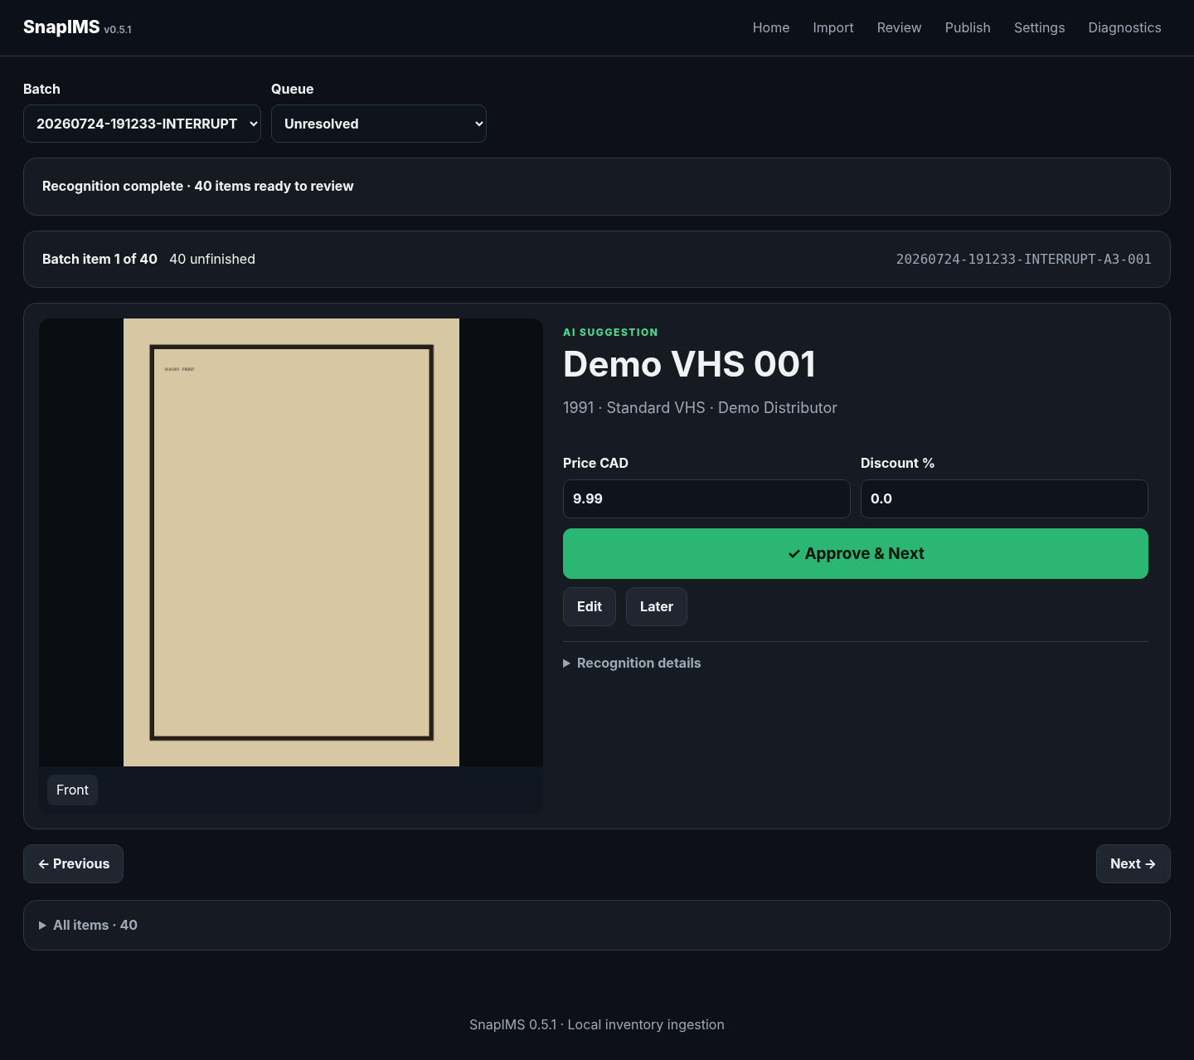
28-recognition-resumed-complete.png

Settings
Set the normal incoming folder, inspect recent folders, and confirm provider availability before a real pilot.
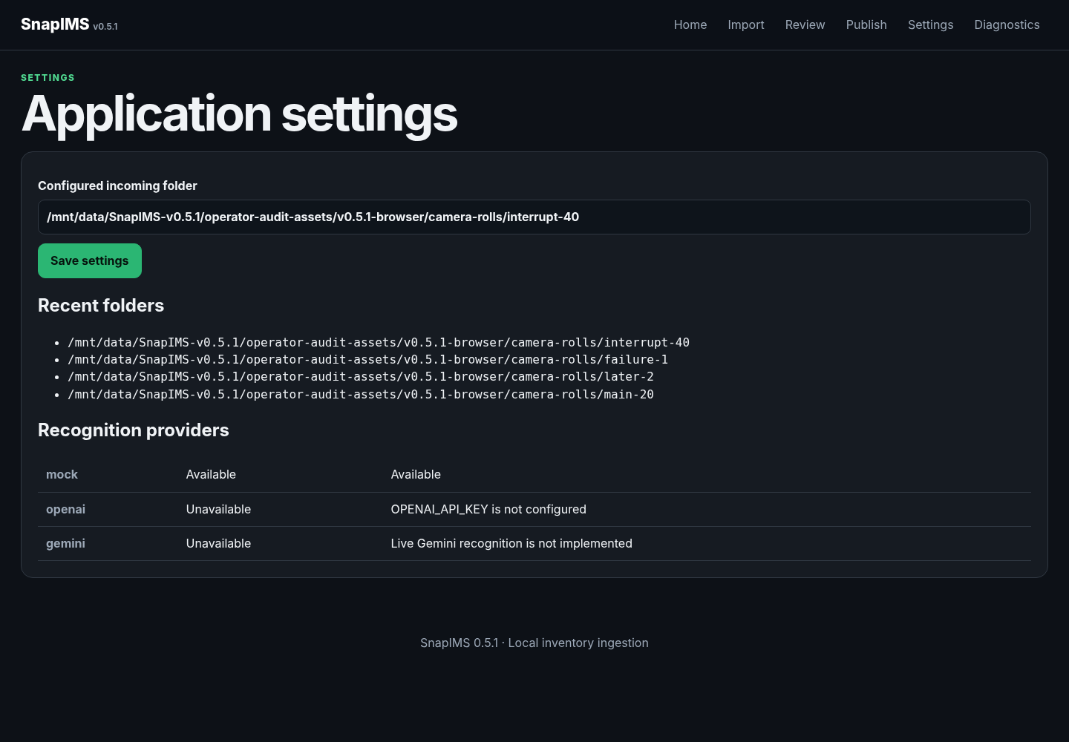
29-settings.png

Diagnostics
SQLite integrity must be ok, foreign-key violations zero, and schema version 5 before operation or restore.
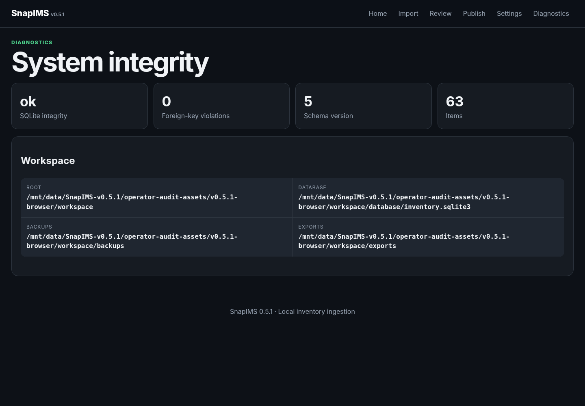
30-diagnostics.png

End-of-batch checklist
☐ Unfinished count is zero and Review shows Review complete.
☐ Every title matches the photograph.
☐ Quick-edited Price and Discount values are intentional.
☐ Shelf and Rare / Physical Review flags match the physical tape.
☐ Completed corrections retain the original Item ID.
☐ Publish simulation shows expected Ready and Blocked counts.
☐ The browser-downloaded CSV contains the same Item IDs and saved titles.
☐ During the first real pilot, keep Shopify in simulation until physical CSV reconciliation passes.
☐ For the live-draft acceptance test, create exactly one draft and inspect it in Shopify.

1.0 acceptance gate
Version 1.0.0 is forbidden until the real 20-tape Pixel pilot, live AI, one live Shopify draft, physical CSV verification, restart durability, independent guide walkthrough, browser verification, and blocker review all pass.

